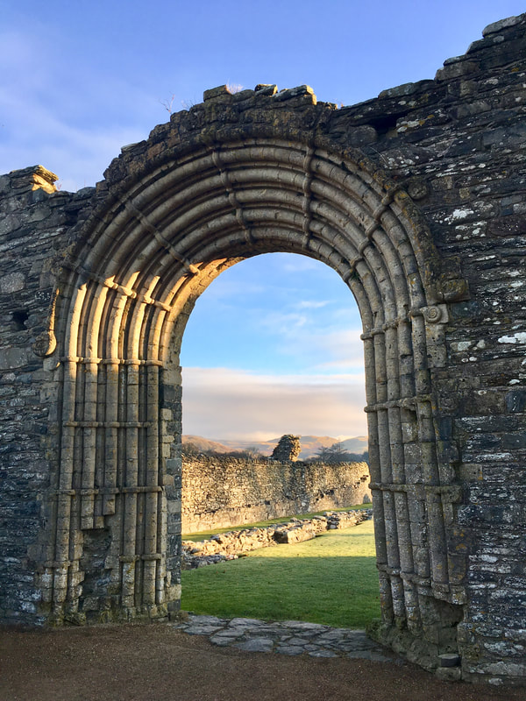
Strata Florida, latin for “vale of flowers”, was founded by Robert Fitz Stephen in 1164.However, it was Lord Rhys, ruler of the kingdom of Deheubarth who made Strata Florida an integral part of welsh history and culture as it is known today.
Deheubarth was the kingdom of Southern Wales.
“Deheubarth came into existence in 920 when Hywel Dda combined the former kingdoms of Dyfed and Seisyllwg “(The early welsh kingdoms, deheubarth)
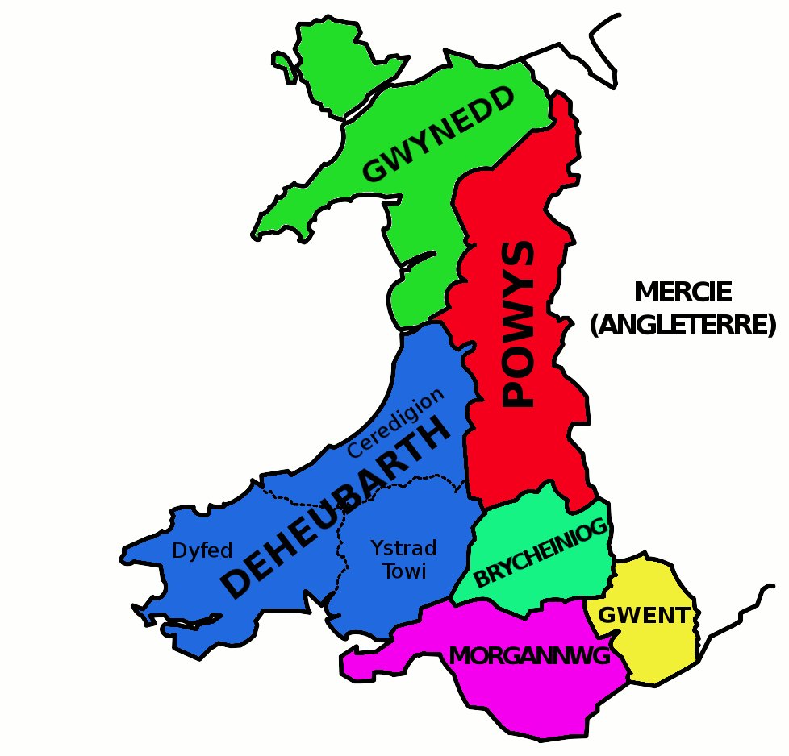
(File:Deheubarth.Png, no date)
The monastery was mainly occupied by the Cistercian monks, with the purpose of copying important Welsh texts, including the ‘Brut y Tywysogion’ or ‘Chronicle of the Princes’ as well as some of the stories that were later combined to become the Mabinogion in the 12th and 13th centuries.

“Brut Y Tywysogion or the Chronicles of the Princes of Wales in English, is one of the most important sources regarding the history of Wales prior to its conquest by King Edward I.” (Brut Y Tywysogion, the Chronicles of the Princes of Wales, 2023)

While under the rule of Lord Rhys and occupied by the Cistercian monks, the monastery became a hub of Welsh culture and religion, so much so that Strata Florida was the chosen meeting place when Llywelyn ap Iorwerth summoned the Welsh princes to pledge their allegiance to his son Dafydd in 1238 in an attempt at welsh independents.

“Cistercian, by the name White Monk or Bernardine, member of a Roman Catholic monastic order that was founded in 1098 and named after the original establishment at Cîteaux (Latin: Cistercium), a locality in Burgundy, near Dijon, France. The order’s founders, led by St. Robert of Molesme, were a group of Benedictine monks from the abbey of Molesme who were dissatisfied with the relaxed observance of their abbey and desired to live a solitary life under the guidance of the strictest interpretation of the Rule of St. Benedict.” (The Editors of Encyclopedia Britannica, 2019)

It is believed that the poet Dafydd ap Gwilym is buried at Strata Florida beneath an ewe tree, although St. David’s cathedral in Pembrokeshire also claims to be his final resting place so the truth of this is still debated. Most of what is known of Dafydd ap Gwilym is gathered from his work. It is believed he travelled all over Wales and that these travels are the inspiration for his work.his presence, as one of, if not the most influential and famous Welsh poets amplify the mysticism of strata Florida and solidifies it as the seat of Welsh culture.
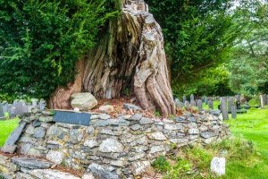
(Guilar, 2022)

Another interesting fact about Strata Florida is the tombstone for “the left leg and part of the thigh of Henry Hughes Cooper” Although not a major feature of the site I believe it gives a very interesting glimpse into the world of 1756 central Wales. The effort that went into the engraving of this tombstone was likely not for comedic purposes. Rather to display the reality that without a leg Mr cooper is as good as dead. The fact that the tombstone is in Strata Florida is interesting because it raises the question of why bury the leg here. Mr Cooper must have been wealthy or connected to the church in some way to earn such a spot in the graveyard, especially for his leg but not the rest of him.

Strata Florida is an epicentre of medieval Welsh history, arguably the most influential location regarding Welsh literature.

Reference List
(Brut Y Tywysogion, the Chronicles of the Princes of Wales, 2023)
Brut Y Tywysogion, the Chronicles of the Princes of Wales (2023) Historic UK. Available at: https://www.historic-uk.com/HistoryUK/HistoryofWales/Chronicle-Princes-Of-Wales-Brut-Y-Tywysogion/ (Accessed: October 19, 2023).

(File:Deheubarth.Png, no date)
File:Deheubarth.Png (no date) Wikimedia.org. Available at: https://commons.wikimedia.org/wiki/File:Deheubarth.png (Accessed: October 18, 2023).

(Guilar, 2022)
Guilar, L. (2022) Dafydd ap Gwilym’s “Love’s affliction”. (Cystudd Cariad) —, Liam Guilar. Available at: http://www.liamguilar.com/the-poetry-voice/2022/1/5/dafydd-ap-gwilyms-loves-affliction-cystudd-cariad (Accessed: October 19, 2023).

(Poetry Foundation, 2023)
Poetry Foundation (2023) Dafydd ap Gwilym, Poetry Foundation. Available at: https://www.poetryfoundation.org/poets/dafydd-ap-gwilym (Accessed: October 17, 2023).

(Strata Florida abbey, no date)
Strata Florida abbey (no date) Gov.wales. Available at: https://cadw.gov.wales/visit/places-to-visit/strata-florida-abbey (Accessed: October 17, 2023).

(The early welsh kingdoms, deheubarth, no date)
The early welsh kingdoms, deheubarth (no date) Castlewales.com. Available at: https://www.castlewales.com/debarth.html (Accessed: October 19, 2023).

(The Editors of Encyclopedia Britannica, 2017)
The Editors of Encyclopedia Britannica (2017) “Dafydd ap Gwilym,” Encyclopedia Britannica.

(The Editors of Encyclopedia Britannica, 2019)
The Editors of Encyclopedia Britannica (2019) “Cistercian,” Encyclopedia Britannica.

