University of Wales
Trinity Saint David
London

Coursework: Written Research Proposal

Investigating the Relationship between Perceived Brand Authenticity, Consumer Trust, and Brand Loyalty

Student name: Silviya Stancheva
Student number: 2310452
Module code: LCBB6014
Module name: Independent Project
Programme: BA(Hons) Business Management
Supervisor name: Dr Said Usman

Table of Contents

1. Introduction and Background 3
a. Research Aim 3
b. Research Objectives 3
c. Research Questions 3
2. Literature Review 4
Identified Research Gap 4
3. Theoretical Framework 5
4. Research Methodology 6
a. Research Philosophy 6
b. Research Approach 7
c. Research Design 7
d. Data Sources & Sampling 7
e. Data Collection 7
f. Data Analysis 8
g. Ethical Considerations 8
5. Expected Contribution 8
a. Theoretical Contribution 8
b. Practical Contribution 8
c. Policy Contribution 8
6. Limitations 9
7. Proposed Timeframe (Gantt Chart) 9
8. Conclusion 9
References 10

1. Introduction and Background
Modern businesses understand the value of personal relationships with customers to preserve trust and loyalty in a competitive market. According to Dwivedi et al. (2021), "perceived brand authenticity" measures a brand's transparency, honesty, and consistency. Being authentic will build customer trust and loyalty as digital marketing, social media, and consumer awareness grow. Lyu et al. (2025) found that perceived brand authenticity builds consumer trust, which leads to repeat purchases and brand loyalty. As a result of brand loyalty, customers' plans to buy, their level of satisfaction with the purchase, and their probability to buy again are all affected.
When customers feel an emotional connection with a company and trust that the company is honest and authentic, they are more likely to remain loyal to that company. There are various areas in which consumers' perspectives and product selections are influenced by honesty and transparency, particularly in highly competitive online markets (Sang and Cuong, 2025). Within the scope of this study, this research will investigate customer trust, brand loyalty, and the perception of the authenticity of the brand by using secondary research methodology.

a. Research Aim
The aim of this research will be to investigate the relationship between perceived brand authenticity, consumer trust, and brand loyalty.

b. Research Objectives
- To examine the effect of perceived brand authenticity on consumer trust.
- To analyse the relationship between consumer trust and brand loyalty.
- To evaluate the relationship between perceived brand authenticity and brand loyalty.

c. Research Questions
Research Questions
- How does perceived brand authenticity influence consumer trust?
- How does consumer trust influence brand loyalty?
- To what extent does perceived brand authenticity influence brand loyalty?

2. Literature Review
Authenticity in marketing has an effect on how people perceive a brand and how loyal they are to that brand. In accordance with the findings of Lyu et al. (2025), genuine brands are the ones that are transparent, unique, trustworthy, and consistent in both their words and their actions. Brands that are honest and convey their principles and beliefs will attract a greater number of customers because they will build trust and emotional ties with their target audience.
Reputable brands that are of high quality are more trustworthy. People are referring to "consumer trust." The Tahir et al. (2024) assert that the most important factors in establishing trust are positive experiences, open communication, and consistent firm behaviour. Customers that have faith in a brand are more likely to be satisfied, to remain loyal to that brand, and to return.
When a buyer feels an emotional relationship to a brand, they are more likely to continue purchasing things from that brand. According to the findings of Tristandinata and Kusumawati (2024), the factors that influence brand loyalty are consumer experience, perception of the brand, trust, and emotional investment. Increasing the loyalty of the customers allows to surpass the competitors and grow the business.
Research has shown that consumers are more likely to trust and remain loyal to brands that are authentic. On the other hand, in order to evaluate this association, a comprehensive empirical study is required. Using secondary analysis, this study will investigate the relationship between these characteristics, so contributing to the existing body of knowledge.

Identified Research Gap
With the constructs of perceived brand authenticity, consumer trust, and brand loyalty having received significant attention in the literature, the literature is theoretically disjointed and empirically constrained in its explanatory ability to describe how these constructs work in a coherent framework. The antecedents of perceived brand authenticity as a precursor to trust or loyalty have largely been studied separately in the previous researches. As an example, research by Lyu et al. (2025) and Tahir et al. (2024) focused on the importance of authenticity in promoting consumer trust, whereas research by Tristandinata and Kusumawati (2024) concentrated directly on how authenticity affects brand loyalty. Yet, these contributions are more inclined towards reductionist approach as these relationships are approached as discrete and linear instead of considering the complexity of consumer-brand relationships. In addition, most of the empirical studies are based on simplified models, which ignore how various important relationship constructs are interrelated, which restrict the explanatory capabilities of current results. More importantly, a lack of interaction with a holistic framework that would integrate authenticity, trust, and loyalty as mutually dependent elements of a larger relationship process is experienced. Existing research rarely explain why authenticity can be considered an independent predictor that does not interact with other relational variables, or do the research sufficiently discuss the overall theoretical effects of such a segmentation.
This leaves a gap in the cognition and relationally processing of authenticity among the consumers in the development of long term brand relationship. Moreover, existing studies are usually limited to either context-focused or limited methodological frameworks, which limit the extent to which these results can be generalised in other market environments and consumer groups. Consequently, there is a gap in the literature to have a strong, integrative model that reflects the dynamic and multi-dimensional consumer-brand interaction. To address these shortcomings, this paper aims to contribute to the existing body of literature by proposing and empirically validating a more comprehensive framework that integrates perceived brand authenticity, consumer trust, and brand loyalty into one, logical framework. In this way it goes beyond individual analyses and helps in a more theoretically-based insight into the working of authenticity in long-term consumer-brand relationships.

3. Theoretical Framework
Several different theoretical frameworks will be utilised in this study.
1. Relationship Marketing Theory
The concept that people will eventually come to love and trust brands is based on this principle. Authenticity in brand building helps to cultivate relationships and keeps customers.
2. Signaling Theory
According to the notion of signalling, brands may build trust by effectively communicating with their customers, being transparent, and maintaining consistency.

Proposed Framework

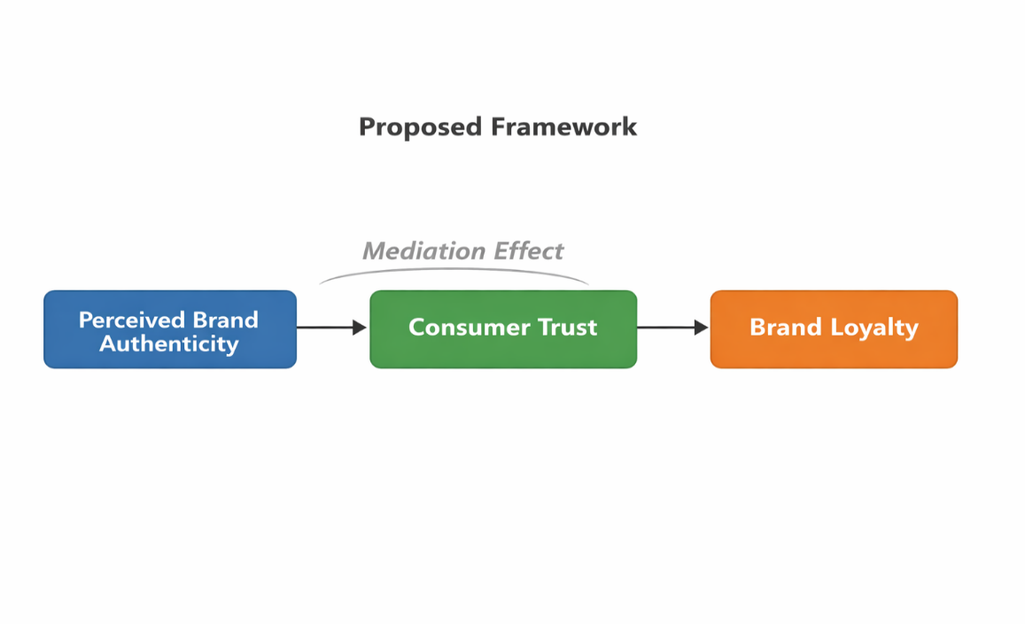

It is the combination of Relationship Marketing Theory with Signaling Theory that justifies the proposed framework of perceived brand authenticity→ consumer trust→ brand loyalty. According to the Relationship Marketing Theory, trust, emotional connection, and the provision of regular value create long-term customer relationships that enable the understanding that authenticity increases consumer trust resulting in consumer loyalty in the long-term. Likewise, Signaling Theory states that brands can convey their authenticity by use of transparency, consistency and credibility which are signals that create less uncertainty and develop trust amongst consumers. Integrating these theories, the intended framework is used to explain the psychological process by which authenticity affects consumer behaviour. Hence, this framework will enable the study to empirically test and confirm the impact of authenticity cues on trust and the consequent resultant effect of trust in loyalty, which will answer the gap outlined in the current literature.

4. Research Methodology

a. Research Philosophy
This research is based on positivism philosophy of research that focuses on objectivity and application of observable and evidence-based knowledge. This philosophy is relevant in a secondary research setting where it helps to conduct a systematic study of the existing academic literature in order to discern patterns and relationships that are established. The research is based on the already established results instead of coming up with new data thus making sure that conclusions made are of validated and reputable sources.

b. Research Approach
It takes a deductive approach, in which the existing theories of perceived brand authenticity, consumer trust and brand loyalty are critically assessed. The paper starts with the already known theoretical views and analyses their effectiveness in previous studies being approved or refuted. This enables to have an organised comprehension of the associations amongst the crucial constructs according to existing scholarly data.

c. Research Design
The study is guided by the secondary research design as it is founded on the synthesis of already available research. It is cross-sectional since it will analyse the findings reported in the literature at certain times. The design will be centered on incorporating findings of various studies in order to come up with a consistent understanding of the subject.

d. Data Sources & Sampling
Peer-reviewed journal articles, academic papers and recognised databases, including Google Scholar and Scopus are the only sources of data collected. To find relevant literature, a purposive sampling strategy is adopted.
Inclusion criteria:
- Research that concentrates on perceived brand authenticity, consumer trust, and/or brand loyalty.
- Relevant empirical and theoretical research on the subject.
- New and reputable scholarly sources.
- This will help to make sure that the chosen studies are relevant, reliable and academically rigorous.

e. Data Collection
Data collection is the process that consists of a systematic review of the chosen literature, in which important information is retrieved and systematised. This incorporates conceptual definitions, measurement methods, and reported findings in regards to core constructs. Only studies that have well-defined constructs and methodological rigour will be included to ensure the quality and consistency of data.

f. Data Analysis
The research uses a synthesis methodology. Instead of new empirical analysis, it will critically evaluate and compare results of various studies. This will be analysed in terms of:

- Determining patterns and themes.
- Comparison of conceptual and methodological approaches.
- Analysing similarities and differences in results.
- Forming a synthesized comprehension of the connections between the constructs.
- This method lets critically and thoroughly interpret the available body of knowledge.

g. Ethical Considerations
The study follows the set of ethical guidelines of secondary research. The sources will all be referenced accordingly, and no data will be manipulated or distorted. The research takes into account the intellectual property rights and utilises scholarly academic material that is publicly accessible.

5. Expected Contribution

a. Theoretical Contribution
The facts on authentic brands, customer trust, and brand loyalty from this study will improve marketing literature.

b. Practical Contribution
The study's findings can help companies improve customer service. Companies will be able to:
- build authentic brand communication
- improve customer trust
- increase brand loyalty
- enhance long-term customer relationships

c. Policy Contribution
The findings of this study can be utilised by businesses to improve their customers' trust in them by implementing more transparent branding.

6. Limitations
The research may have the following limitations:
- Relying on the availability and quality of available studies.
- Weaknesses in control over methods of data collection in original studies.
- Potential measurement scale discrepancies amongst studies.
- Possibility of publication bias in secondary sources.
- Weakness in creating causality outside of reported results.

7. Proposed Timeframe (Gantt Chart)
Activity | Month 1 | Month 2 | Month 3 | Month 4
Topic selection | ✓
Literature review | ✓ | ✓
Data collection |  | ✓ | ✓
Data analysis |  |  | ✓
Writing report |  |  | ✓ | ✓
Final submission |  |  |  | ✓

8. Conclusion
This proposal indicates that perceived brand authenticity is a very important aspect in determining consumer behaviour, especially in creating confidence and developing a long-lasting brand loyalty. The study shows that one of the main drivers of consumer trust is authenticity, which is revealed through transparency, consistency, and honest communication, by combining the experience of the current literature. Trust, in its turn is a crucial mechanism which enables the emotional bond between the customers and a brand and stimulates the repeat purchase behaviour. This helps in gaining a deeper insight into the ways brands can remain competitive in increasingly saturated markets. In general, this paper highlights that any organisation that wants to achieve success in the long run must focus on authentic practices and trust-building initiatives since these are critical in building meaningful and long-term relationships with consumers.

References

Dwivedi, Y.K., Ismagilova, E., Hughes, D.L., Carlson, J., Filieri, R., Jacobson, J., Jain, V., Karjaluoto, H., Kefi, H., Krishen, A.S. and Kumar, V., 2021. Setting the future of digital and social media marketing research: Perspectives and research propositions. International journal of information management, 59, p.102168.
Lyu, M., Wang, S. and Zhang, J., 2025. Unpacking the effects of brand authenticity on consumer trust and loyalty in nutrition: a psychological perspective. Frontiers in Nutrition, 12, p.1731800.
Sang, V.M. and Cuong, M.C., 2025. The influence of brand experience on brand loyalty in the electronic commerce sector: the mediating effect of brand association and brand trust. Cogent Business & Management, 12(1), p.2440629.
Tahir, A.H., Adnan, M. and Saeed, Z., 2024. The impact of brand image on customer satisfaction and brand loyalty: A systematic literature review. Heliyon, 10(16).
Tristandinata, M. and Kusumawati, N., 2024. BRAND AUTHENTICITY: A STUDY ON ITS IMPACT ON BRAND LOYALTY THROUGH BRAND RELATIONSHIP QUALITY IN THE LOCAL FOOTWEAR INDUSTRY. Journal of Social and Economics Research, 6(1), pp.2180-2198.

