

University of Wales Trinity Saint David
School of Engineering
BEng Manufacturing Systems Engineering
Mike Lewis
1909144
Stress Analysis and Dynamics ACMA5010

Contents
Table of figures 2
Introduction 3
Background 3
Calculation for second moment of area 4
Deriving the formula for point load on simply supported beam 5
Calculation including assumptions 5
Assumptions 7
Recalculation with FOS (Factor Of Safety) 8
Strain Gauges 8
Types of gauges 8
Electrical resistance strain gauge 9
Wheatstone bridge 10
Strain gauges for gantry crane 11
References 13
Works Cited 14

Table of figures
Figure 1 - Image of overhead gantry crane 4
Figure 2- Formula for deflection in simply supported beam with concentrated point load in centre 4
Figure 3 - I beam properties matrix 6
Figure 4 - Second moment of area for axis on I beam 6
Figure 5 - Dimensions of an I beam 7
Figure 6 - Typical overhead electric travelling crane in TATA 7
Figure 7 - Factor of safety for variable load on universal beam 8
Figure 8 - relationship for basic electrical strain gauge 9
Figure 9 - A Strain gauge being used in a Wheatstone Bridge 9
Figure 10 - Wheatstone bridge circuit 10
Figure 11 - Type of bridge circuit used and the resulting bridge factor 11
Figure 12 - Half bridge strain gauge circuit 11
Figure 13 - Gauge applied to beam with no load 12
Figure 14 - Gauge applied to beam with load 12
Figure 15 - Wheatstone bridge equation for relationship with voltage and mechanical movement 13

Introduction
In this assignment I will be looking at designing a suitable overhead travelling crane and calculating the minimum second moment of area for the bridge girder which is manufactured out of steel with a value of (E=210Gpa). The crane is required to lift a 5000kg weight and have a deflection, where the hoist connects to the bridge, to be limited to 10mm.
For this assignment I will be making assumptions based on my own experience and by carrying out research in to second moments of area, slope and deflection of beams theory, manufacturing of “I beams” and any other relevant information necessary for the completion of the assignment.

Background
Currently I work for Zimmer Biomet, which was established in April 2014 when Zimmer purchased Biomet Inc for $13.4 Billion. Zimmer Biomet is the world’s third largest medical device company, employing 18,200 people in more than 40 countries across the world and selling products in more than 100 countries. In 2019 Zimmer Biomet had a revenue exceeding $8 Billion dollars. Zimmer Biomet designs, develops and manufactures orthopaedic products including, Hips, Knees both partial and full, ankles, wrists, elbows and dental prostheses. In Bridgend, the UK’s only manufacturing plant, Zimmer Biomet employs approximately 700 people with a range of skills and specialties including engineering, NPD, quality, manufacturing, validation, biology, facilities and maintenance. Bridgend currently adopts a 24/7 and 24/5 shift working patters consisting of 4 12 hour shifts on and four days off and 5, 8 hour shifts of mornings, afternoons and nights.
The plant is generally split into two distinct areas, manufacturing operations and EOL. Manufacturing is where all products are machined, polished, etched and coated. EOL is where all the product is sterilized and cleaned before being sent away to customer via a stock location unit in Holland.
Prior to working for Zimmer Biomet I worked for Corus/TATA Steel in various roles of increasing responsibility. One such role was the Cranes, services and facilities engineer. For the purpose of this assignment I will use my experience to allow me to assume figures in order to resolve the calculations.

Calculation for second moment of area
The crane set up has been identified from the assignment brief as a simply supported beam with a centre load.
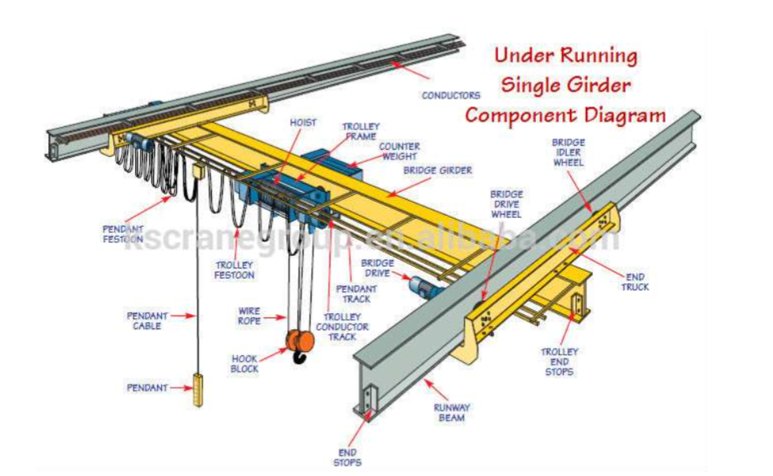
Figure 1 - Image of overhead gantry crane
(group, 2021)
The assignment brief also gives the following information, the deflection Ymax = 10mm, the mass of the load requiring lifting = 5000Kg and E, Young’s Modulus of 210 Gpa.
By looking at and understanding how to derive an equation for a central point load on a simply supported beam I obtained the formula
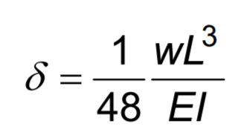
Figure 2- Formula for deflection in simply supported beam with concentrated point load in centre
(O'Rourke, 2007)
To obtain the formula for the bending moment being applied along the beam we need to look at the origin for $x$ at the beam centre as derived by (Hearn, 1997)

Deriving the formula for point load on simply supported beam
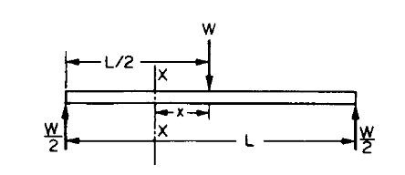
(Hearn, 1997)
$$Mxx=EI\frac{d^{2}y}{{dx}^{2}}=\frac{W}{2} \left(\frac{L}{2}-x\right)=\frac{WL}{4}- \frac{Wx}{2}$$
$$EI\frac{dy}{dx}= \frac{WL}{4} x- \frac{Wx^{2}}{4}+A$$
$$ELy= \frac{WLx^{2}}{8}-\frac{Wx^{3}}{12}+Ax+B$$
At $x=0, \frac{dy}{dx}=0 ∴A=0$
At $x= \frac{L}{2 }, y=0 ∴0= \frac{WL^{3}}{32}- \frac{WL^{3}}{96}+B$
$$∴B= - \frac{WL^{3}}{48}$$
$$y= \frac{1}{EI} \left[\frac{WLx^{2}}{8}- \frac{Wx^{3}}{12}- \frac{WL^{3}}{48}\right]$$
$$y_{max}=- \frac{WL^{3}}{48 EI} at the centre$$
(Hearn, 1997)

Calculation including assumptions
Length of span or I beam = 9M
The weight on the I beam will be a point load as the weight is being directly affected by the hook, which is connected to the lifting ropes, connected to the hoist and finally connected to the counter weight. W = 5000KG X 9.91 ${m/s}^{2}$ = 49050 Newton’s
$∴$ rearranging for EI= $\frac{-WL^{3}}{48 y_{max}}$
EI = $\frac{-49050 X 9^{3}}{48 X 0.01}$ = $\frac{35757450}{0.48}$ EI = 74494687.5 $∴$ I = $\frac{74494687.5}{210 X {10}^{9}}$ = 0.0003547366
0.0003547366 X 10⁸ = 35473.66 cm⁴
Now that I have worked out the value for the second moment of area I will look at a universal beams, I beam properties matrix.
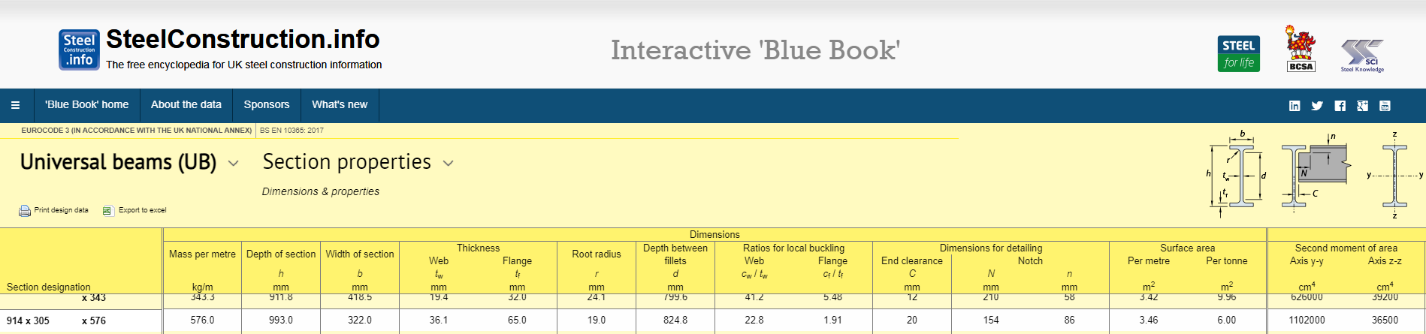
Figure 3 - I beam properties matrix
(institute, 2021)
The I value I have calculated is the value for I for section Z-Z on I beam. This has been taken from looking at the diagram in figure one and comparing it to figure 4 taken from the I beam properties matrix.
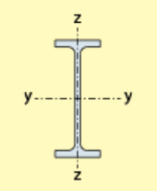
Figure 4 - Second moment of area for axis on I beam
(institute, 2021)
The section most suitable for the I beam for the overhead gantry crane is 762 x 267 x 147 which has a second moment of area of 36500 cm⁴ this has been taken directly from the I beam properties matrix in figure 4.
The sizes in mm of the I beam are as follows
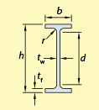
Figure 5 - Dimensions of an I beam
(institute, 2021)
b=322.0mm, h=993.0mm, d=824.8mm, $t_{w}$=36.1mm, $t_{f}$=65mm

Assumptions
By using my experience within Corus/TATA steel, I assumed the length of the beam to be 9 metres. This was a typical beam length for a crane used within the cast houses at TATA steel.
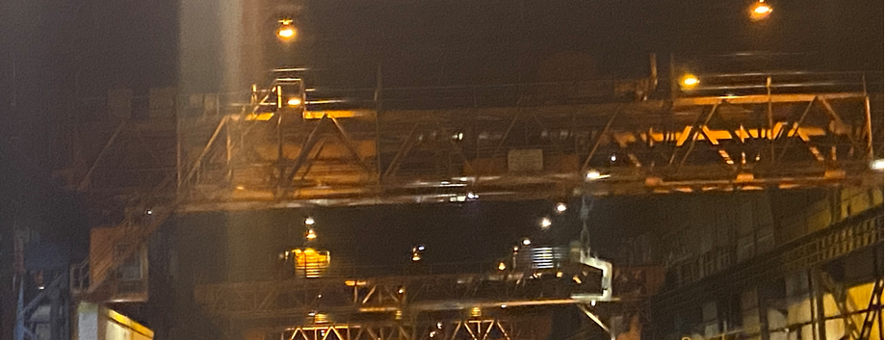
Figure 6 - Typical overhead electric travelling crane in TATA
I have assumed that the crane is a simply supported beam because the crane is allowed to rotate around the longest axis of the runway beam, so this is supported at either end by a drive wheel allowing movement along the length of the crane bay.
I have assumed that there is a point load applied to the beam due to the weight being lifted by a single hook, connected to the wire ropes and then connected to the hoist and trolley frame in the centre of the beam.
From the assumption that this is a single load applied to a simply supported beam I derived the calculation $$y_{max}=- \frac{WL^{3}}{48 EI} at the centre$$
I have assumed that the material of the crane is made from mild steel as it has an E value at 210 Gpa. The value for Young’s modulus of mild steel is between 190 Gpa – 215 Gpa.
The crane would need to have sufficient markings on the cross travel allowing the operator to know where the centre of the beam is to allow a maximum deflection of 10mm. This would be done by using rail blocks, an assembly compromising of a lobster clip and shoes bolted to the cross travel rail of the crane limiting moment to only around the centre. The trolley frame’s length would be deducted from the overall span of the beam and then the beam length divided by two allowing accurate placement of the rail blocks.
I would also assume a factor of safety for the load on the I beam. By looking at a steel beam calculator for standard factors of safety for an I beam, for variable loads the factor of safety is 1.5.
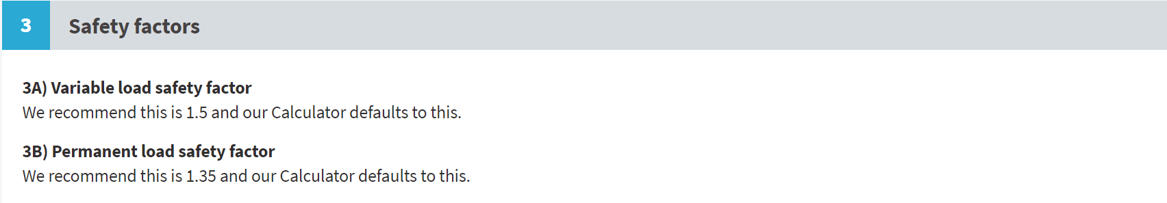
Figure 7 - Factor of safety for variable load on universal beam
(Walker, 2011)
The gantry crane will have a variable load as it will be used periodically to lift weight and not be under constant load like a beam supporting a floor. With this in mind for my original calculation I would need to multiply the load of 5000kg by 1.5 giving a total mass of 7500kg.

Recalculation with FOS (Factor Of Safety)

Weight is now 7500kg x 9.81 ${m/s}^{2}$ = 73575 Newtons
EI = $\frac{-73575 X 9^{3}}{48 X 0.01}$ = $\frac{53636175}{0.48}$ EI = 111742031.3 $∴$ I = $\frac{111742031.3}{210 X {10}^{9}}$ = 0.00053210491
0.00053210491 X 10⁸ = 53210.04911 cm⁴
The factor of safety has increased the second moment of area by 53210.04911 cm⁴ - 35473.66 cm⁴
=17736.8311 cm⁴
Taking into account the FOS the new size of I beam will again be determined by using I Beam properties matrix. Due to the increase in second moment of area a more substantial and greater sized I beam would be required for the gantry.

Strain Gauges

Types of gauges
Understanding strain and stresses within components is paramount to their engineering design. By determining the location of stresses within a component allows for more suitable design and less risk of failure. The most common use of stress analysis techniques today is the use of strain gauges.
(Hearn, 1997)
The first strain gauge was developed in 1939 by Arthur C. Ruge. He developed the strain gauge known as the SR4-strain gauge, it was used by one of his students to complete his thesis on stresses experienced by water towers during earthquakes. The strain gauge developed by Arthur C. Ruge was a simple design made up of four tungsten filaments, same as the ones used in lightbulbs, secured together in the shape of a diamond. By applying an electrical current across the wires no voltage can be measured, providing the tungsten filaments remain aligned. However, the filaments move then the resistance in the wires changes and the gauge provides a voltage proportional to the force.
(Feder, 2000)
There are many different types of gauges available and can be used in different ways. Some of the gauges available are

Electrical resistance strain gauge
This is a very simple gauge and works by having a length of wire shaped in to a continuous lattice. This is secured to a nonconductive backing and then secured directly to the surface of the component being measured.
The equation given for the strain gauge is $R=\frac{ ρL}{A}$ R= resistance ohms, $ρ$ = resistivity ohms metres, L = length metres, A = cross sectional area metres squared
The relationship is given by
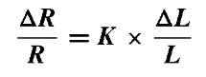
Figure 8 - relationship for basic electrical strain gauge
Any change in length or cross sectional area of a wire will result in a change of resistance. K being the gauge factor usually 2-2.2. Due to the changes being so small it is necessary to use a wheatstone bridge to help measure the small changes.
(Hearn, 1997)
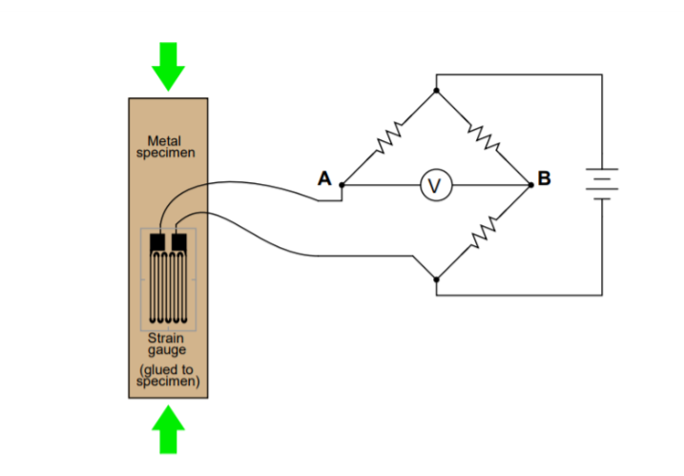
Figure 9 - A Strain gauge being used in a Wheatstone Bridge
(Lake, 2021)

Wheatstone bridge
A wheatstone bridge is a circuit used to measure changes in resistance. It is able to convert the change in resistance in to a corresponding change in voltage, a wheatstone bridge is also a very accurate measurement device.

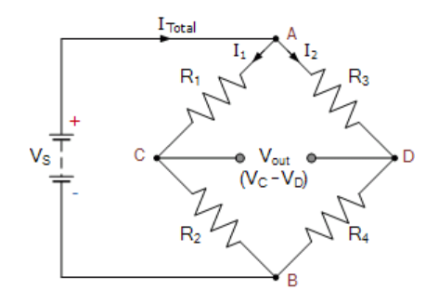
Figure 10 - Wheatstone bridge circuit
When $\frac{R1}{R2}= \frac{R3}{R4}$ there is zero voltage between the branches. Any change in the resistance will register a change in the voltage.
There are different strain gauges used for measuring different tasks. These can be full bridge, half bridge and quarter bridge. The gauges comprise of resistors fixed to or incorporated within the components being measured. Transducers supply very accurate values and therefore should always have full bridge circuits with strain gauges in all four arms.
Full bridge or half bridge circuits should be used for stress analysis when other influencing factors “interference” needs to be filtered out.
(An HBK company, 2020)
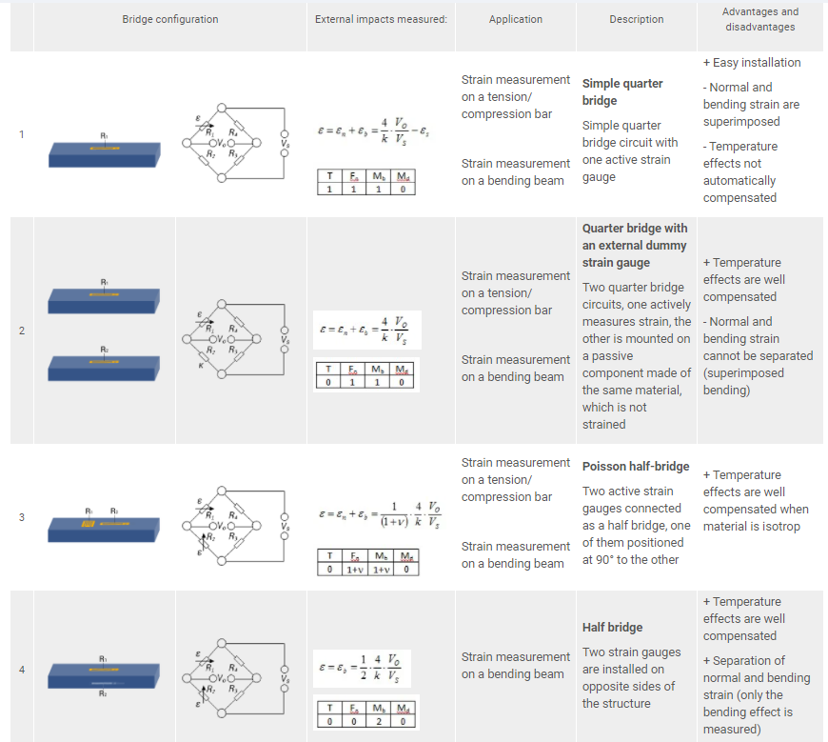
Figure 11 - Type of bridge circuit used and the resulting bridge factor
(An HBK company, 2020)
Other types of strain gauges include
- Mechanical gauges or extensometers.
- Pneumatic gauges.
- Semiconductor or Piezo-resistive gauges.
- Inductance gauges.
- Capacitance gauges.

Strain gauges for gantry crane
By using information gathered in Fig.11, the type of gauge I would use is an electrical resistance half bridge strain gauge.
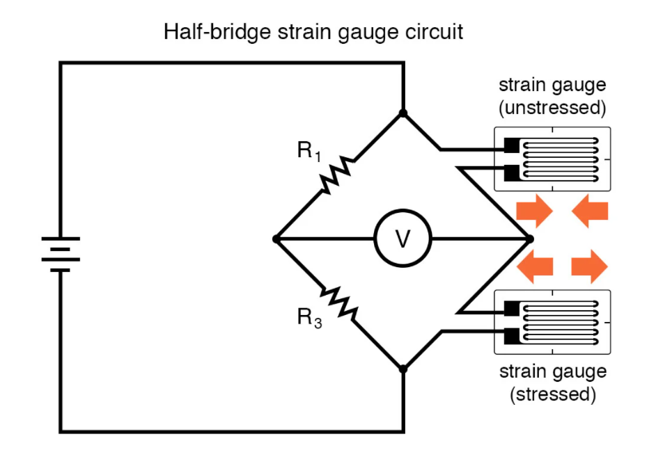
Figure 12 - Half bridge strain gauge circuit
(All about circuits, 2021)
To apply the gauge one of them would be attached to the top of the I beam and the other to underneath of the I beam in the centre of the beam where the trolley frame would be centred to allow safe operation whilst picking up weight.
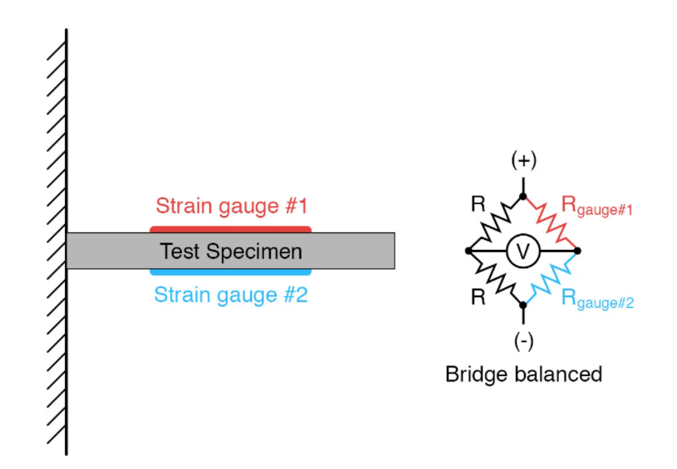
Figure 13 - Gauge applied to beam with no load
(All about circuits, 2021)
When no weight is applied to the beam, the strain gauges have the same resistance and the bridge circuit is balanced. When the weight is applied as the hook picks up the 5000kg load, the beam will deflect causing strain gauge 1 to flex downwards at the same time compressing strain gauge 2.

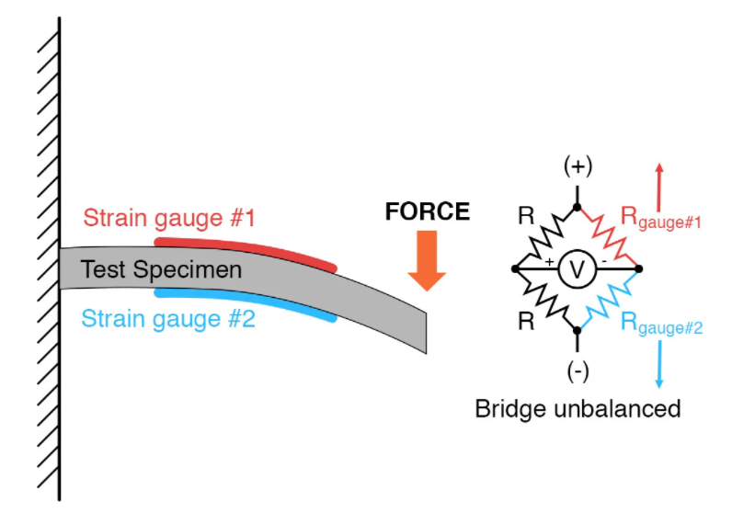
Figure 14 - Gauge applied to beam with load
(All about circuits, 2021)
The input Voltage $v_{i}$ to the bridge and by assuming that the two strain gauges are identical and are secured to the I beam, the following equation can be developed to show the relationship between Voltage in and the Voltage out Δv_{o}
$∆v_{o}$=$\frac{1}{2}$ . $\left(\frac{∆R_{1}}{R_{1}}- \frac{∆R_{2}}{R_{2}}\right)$.$v_{i}$

A wheatstone strain gauge can be used to monitor mechanical movement y, the sensors sensitivity K to the bridge output variation Δv_{o} in the equation
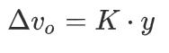
Figure 15 - Wheatstone bridge equation for relationship with voltage and mechanical movement
(Lobontiu, 2018)
Any change in Voltage can allow you to work out the deflection “y” by already knowing the sensors sensitivity 2-2.2.

References
All about circuits, 2021. Strain Gauges Chapter 9 - Electrical Instrumentation Signals. [Online]
Available at: https://www.allaboutcircuits.com/textbook/direct-current/chpt-9/strain-gauges/
[Accessed 16 April 2021].
An HBK company, 2020. The Wheatstone Bridge Circuit Explained. [Online]
Available at: https://www.hbm.com/en/7163/wheatstone-bridge-circuit/
[Accessed 16 April 2021].
Feder, B. J., 2000. Arthur C. Ruge, Inventor of Vital Stress Gauge, Dies at 94. [Online]
Available at: https://www.nytimes.com/2000/04/08/business/arthur-c-ruge-inventor-of-vital-stress-gauge-dies-at-94.html
[Accessed 16 April 2021].
group, K., 2021. Task Description, Swansea: University of Wales Trinity St David.
Hearn, E., 1997. Mechanics of Materials 2 : The Mechanics of Elastic and Plastic Deformation of Solids and Structural Materials. Third ed. Oxford: Butterworth-Heinemann.
Hearn, E. J., 1997. Mechanics of Materials Volume 1 : An Introduction to the Mechanics of Elastic and Plastic Deformation of Solids and Structural Materials. Third ed. Oxford: Butterworth-Heinemann. 1997.
institute, s. c., 2021. steel construction info. [Online]
Available at: https://www.steelforlifebluebook.co.uk/ub/ec3-ukna/section-properties-dimensions-properties/
[Accessed 13 April 2021].
Lake, K., 2021. Experimental stress analysis, Swansea: University Wales Trinity Saint David.
Lobontiu, N., 2018. System Dynamics for Engineering Students. [Online]
Available at: https://www.sciencedirect.com/topics/engineering/bridge-output-voltage
[Accessed 16 April 2021].
O'Rourke, L., 2007. The Mathematics of Simple Beam Deflection. [Online]
Available at: https://www.raeng.org.uk/publications/other/15-beam-deflection
[Accessed 12 April 2021].
Walker, K. T. &. N., 2011. Steel beam calculator. [Online]
Available at: https://www.steelbeamcalculator.co.uk/userguide
[Accessed 16 April 2021].

Works Cited
All about circuits, 2021. Strain Gauges Chapter 9 - Electrical Instrumentation Signals. [Online]
Available at: https://www.allaboutcircuits.com/textbook/direct-current/chpt-9/strain-gauges/
[Accessed 16 April 2021].
An HBK company, 2020. The Wheatstone Bridge Circuit Explained. [Online]
Available at: https://www.hbm.com/en/7163/wheatstone-bridge-circuit/
[Accessed 16 April 2021].
Feder, B. J., 2000. Arthur C. Ruge, Inventor of Vital Stress Gauge, Dies at 94. [Online]
Available at: https://www.nytimes.com/2000/04/08/business/arthur-c-ruge-inventor-of-vital-stress-gauge-dies-at-94.html
[Accessed 16 April 2021].
group, K., 2021. Task Description, Swansea: University of Wales Trinity St David.
Hearn, E., 1997. Mechanics of Materials 2 : The Mechanics of Elastic and Plastic Deformation of Solids and Structural Materials. Third ed. Oxford: Butterworth-Heinemann.
Hearn, E. J., 1997. Mechanics of Materials Volume 1 : An Introduction to the Mechanics of Elastic and Plastic Deformation of Solids and Structural Materials. Third ed. Oxford: Butterworth-Heinemann. 1997.
institute, s. c., 2021. steel construction info. [Online]
Available at: https://www.steelforlifebluebook.co.uk/ub/ec3-ukna/section-properties-dimensions-properties/
[Accessed 13 April 2021].
Lake, K., 2021. Experimental stress analysis, Swansea: University Wales Trinity Saint David.
Lobontiu, N., 2018. System Dynamics for Engineering Students. [Online]
Available at: https://www.sciencedirect.com/topics/engineering/bridge-output-voltage
[Accessed 16 April 2021].
O'Rourke, L., 2007. The Mathematics of Simple Beam Deflection. [Online]
Available at: https://www.raeng.org.uk/publications/other/15-beam-deflection
[Accessed 12 April 2021].
Walker, K. T. &. N., 2011. Steel beam calculator. [Online]
Available at: https://www.steelbeamcalculator.co.uk/userguide
[Accessed 16 April 2021].

