

UNIVERSITY OF WALES
TRINITY SAINT DAVID

WHO AM I TEACHING?
ECAD6007

ASSESSMENT 01
CRITICAL EVALUATION

WRITTEN BY
ELLIE JAYNE FLETCHER
1702942

29/10/2021

1.0: Introduction

A critical incident is any ‘unplanned or ‘unanticipated’ event that occurs both within and outside a classroom. These are identified as problems in particular contexts, however, are not justified as routine occurrences. (Joshi, 2018). Similarly, Trip, (2011) found the term ‘critical incident’ refers to some event or situation which is marked as a significant change in one’s life or an institution. Further, he suggests that these occurrences are not always obvious, however are uncomplicated commonplace events that occur in professional practice and appear to be standard rather than critical at first but can be adjudicated through analysis. A critical analysis (CA) is crucial in the role of reflective practice in teaching as analysing a critical incident allows a teacher to identify the good practices against the ones that are perhaps not working so well. Likewise, according to Richards and Farrell, (2010) CA is the documentation and evaluation of teaching incidents that allow one to review, improve and tailor practices to meet the needs of all learners based upon the previous evaluation.

Teaching is more than just educating. In the words of Gove, (2010) and Orchard et al., (2015) ‘teaching’ is a craft. Teachers must be adaptable, reflective practitioners that critically evaluate situations to improve. Tripp, (2011) implies that good teachers use good techniques and routines. However, these alone do not produce effective teaching, the art of teaching lies within being flexible, informed, critical, opinionated, and nevertheless self-aware. So, what does it mean to be an effective practitioner? Eisner, (2020) found that critical reflection has become a mandatory skill for teachers to adhere throughout their progression. Reflection allows teachers to understand their learners, gather information, and analyse lessons effectively to improve pupils' outcomes.

1.1: The role of critical reflection

Critical reflection (CR) is the process of reviewing a past event(s) from an analytical perspective. By doing so one can reflect on actions and consider what went well against not so well. (Smith, 2011; Sellars 2017). Similarly, (CR) is about continuous improvement through looking at what is being done currently and implementing strategies to move forwards. (Bassot, 2016). In terms of education, ‘critical reflection’ can be identified as ‘reflective teaching’. In simple terms is a philosophy of using reflective techniques to convey and analyse information with the desire of generating feedback. (Sellars, 2017). Being reflective as discussed previously is a continuous cycle that needs to be embedded within teaching strategies if one strives to achieve positive results. This suggests that reflection of particular incidents that arise in classrooms develops teaching practice. Application of Tripp’s (1993; 2012) model shown in figure 1.0 allows critical incidents (CI) to be linked with teaching standards and educational practices. Thus, analysing incidents makes us think about why we do what we do, and why we do it. In terms of education, this could be thinking about what teaching strategies are being used in the classroom and whether they are working or not. (Donald Schön, 1983). Moreover, the use of CR in CI strengthens practice whilst raising awareness of the interaction between students and teachers in a classroom. For example, this could raise awareness of existing learning abilities such as cognitive load (Sweller, 1998) and zone of proximal development (ZDP) (Vygotsky, 1978). Understanding these theories enables teachers to prepare for lessons to address any disruptive behaviour. Further, continuous criticality allows teachers to analyse and evaluate the reasons behind disruptions and use certain techniques to address them. Moreover, being critical enables teachers to understand their pupils and their needs and abilities. When teachers reflect on their practice this improves students’ performance, boosts engagement, develops critical thinking, enhances motivation, and improves creativity and efficiency. (McMillan & Weyers, 2013; Leon-Henri, 2021).

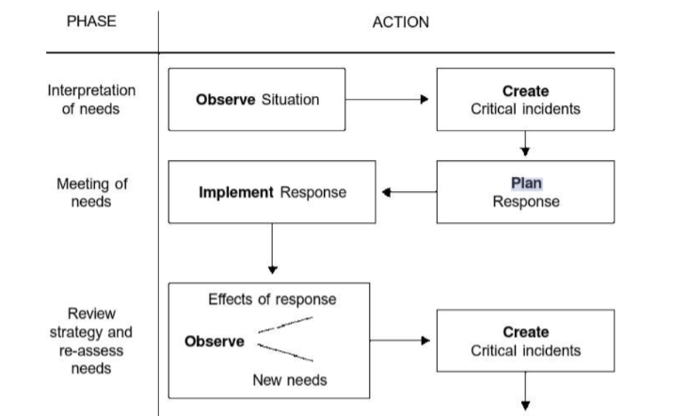

Figure 1.0: Trips Methodology of how to create a critical incident. (Tripp, 1993; 2012).

As outlined previously, reflection is the key to creating better futures. To put reflection in a practical example, the Welsh Government continuously reflects on teaching standards and is the reason why they introduced the new curriculum for Wales which is designed to give teachers flexibility over how and what they teach. They identified that in the changing developing society, educators need to shape students. According to the PISA results in 2012 Wales was one of the lowest-scoring countries in comparison to the rest. (Lewis, 2013; Gurria, 2014). These results formed the foundations of the Donaldson (2015) report and led to the reflection of the Welsh education system. The Welsh Government is focusing on consolidating learning and experience by compromising six areas: expressive arts, health and wellbeing, humanities, literacy and communication, mathematics and numeracy, science and technology. (Welsh Gov, 2018). This new and ever-changing curriculum has set new ambitions and expectations for teachers and learners by amplifying Donaldson’s (2015) four purposes towards creating respectable citizens of Wales. (Donaldson, 2015; Gov Wales, 2020).

There are numerous reflection models which teachers can follow to guide them during their practice. John Dewey, (1993) was the first to identify reflective practice as a tool to enhance self-awareness which as touched upon prior by Tripp, (2011) is key to great teaching. His theory has since formed the work conducted by theorists Kolb, (1984) and Gibbs (1998) who created theories based upon reflective thinking. (Bassot, 2013). The theories focus on reflective observation as a way to analyse and extract conclusions from experience with the aim to take forward the learning into new experiences.

1.2: observation (school & class context).

During the bridging experience, the practitioner was observing a year 8 class for a full day of lessons. The name of the school, staff and students will be kept anonymous throughout this essay to align with the Ethical Guidelines for Education Research. (BERA, 2019). During the reflection of the critical incident identified, the child will be referred to as (pupil A) and the teacher as (teacher A). This is to also align with the standards set by BERA to protect confidentiality.

Consequently, to provide a brief introduction of the school, the observation took place in an 11-16 English medium mixed comprehensive school. The school's population has been increasing over the past few years with the current number of pupils standing at 1,035. Around 29% of the school's population are eligible for free school meals. This is classified as significantly high as it is almost half of the national average (16.4%). 34% of their pupils are on the special needs register, with 5% having statements of special educational needs. Both figures listed are far higher than the national average of 23% and 2%. Further, very few of their students speak the Welsh language at home and 84% of their students come from a Whole British ethnic background. (Estyn, 2019). These are important figures for teachers to consider when planning lessons as they need to be aware of pupil backgrounds to avoid any discrimination or distress. For example, you could plan a lesson with activities where students need to use their phones to access a game quiz (Kahoot), this could cause great discomfort for students who perhaps don’t own one. Therefore, teachers must understand the school's culture prior to organising their lesson activities.

The class was observed for a five-hour period where observations and analysis were drawn on the standard of teaching and its effectiveness within the classroom. The first lesson observed was a maths lesson which was based on multiplication. The lesson consisted of multiple tasks ranging from individual to class discussions. During the lesson (child A) was very confused when (teacher A) began going through examples of how to answer multiplication questions, even when (teacher A) broke it down step by step (child A) was still unable to grasp the method. To prevent further confusion (teacher A) covered four different techniques of multiplication to facilitate the needs of all learners (child A). However, during the time spent with (child A), this disrupted the rest of the lesson as other students who had finished the task could not move on until (teacher A) had finished supporting (child A).

1.3: Critical incident referred to Donaldson’s four purposes.

The critical incident identified throughout the bridging day was during the maths lesson where the teacher used multiple techniques for a mathematical problem. The teacher uses their pedagogical skills to plan a lesson based on catering to the needs of all learners. This is an important element to encounter when planning a lesson as no two students are the same. Teachers need to diversify lessons to engage all their learners. As Cleg et al., (2016) indicate the ‘one size fits all' approach is outdated. To expand, teachers could find themselves in a class environment where they are faced with students who classify as ALN (additional learning needs) or with students who are MAT (more able and talented). Therefore, teachers need to be fully aware of how to effectively manage and provide meaningful lessons that all students can participate in. This is where differentiation becomes an important skill to put to practice to tailor lessons for all pupils.

With regards to Donaldson’s four purposes displayed below in figure 1.1, the first purpose to comply with the critical incident is creating ambitious capable learners. This is because the use of multiple techniques enables pupils to use numbers effectively in different contexts, allows understanding of how to interpret data and apply mathematical concepts and enables questioning and problem solving. Secondly, ‘healthy confident individuals’ comply with the critical incident as the pupils were stimulated to be able to participate within class tasks which increases confidence and engagement. It is believed that if a child fully understands how to complete a task, in this case, the math equation then their confidence in their ability to succeed increases meaning they will participate more often. (Kuh, 2008). In perspective to increased engagement, boosting confidence and encouraging efforts within learners can be seen as a type of motivation to enhance pupil progress. (Barkley, 2010). Additionally, being faced with multiple techniques encourages them to think creatively, reframe and solve problems which reinforces the purpose of enterprising creative citizens.

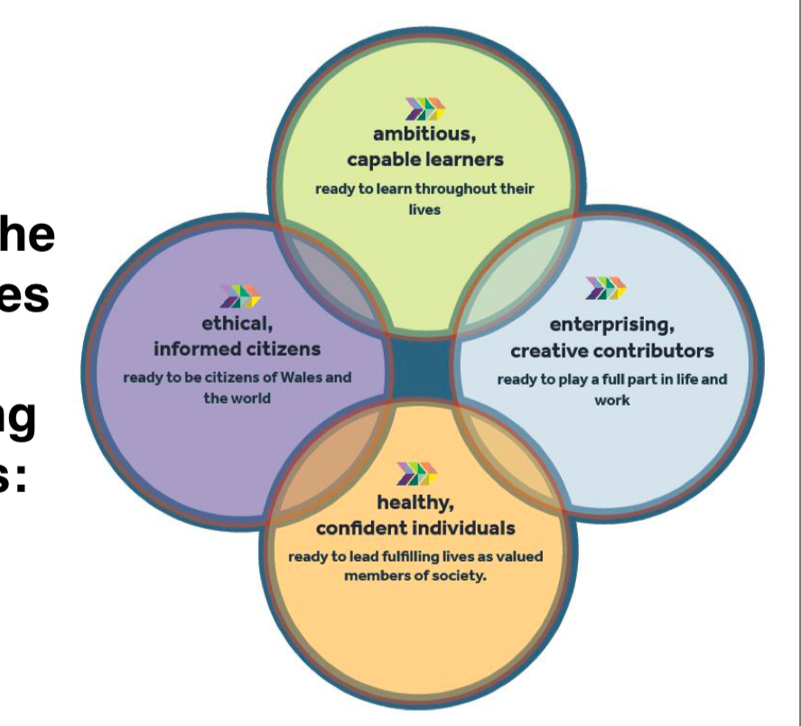

Figure 1.1: Donaldson’s Four Purposes. The Curriculum of Wales. (Donaldson, 2021).
2.0: Literature review

Today’s generation endures qualities that reflect diverse backgrounds, which was identified within the reports of the school that was critically observed. As more children join the classrooms with these backgrounds, educators need to meet the needs of all students. This is where differentiation comes into practice. (Bushie, 2015). Tomlinson, (2001) p.1, states that “a differentiated classroom provides different approaches to meeting content, processing information, making sense of situations and developing strategies for each student to learn effectively”. This suggests the great need for differentiation and its place in the classroom. Differentiation can be seen as a complex and wide-ranging skill that requires teachers to continuously plan and understand student differences to construct the way that they learn. She further claims that to be successful within this approach teachers need to be skilled in modern education. Thus, it is crucial to ensure all learners can access the curriculum. Differentiation is seen as a pedagogical approach that provides teachers with an indication towards meeting students' wide-ranging learning needs. (Smale-Jacobse et al., 2019). Differentiation can be used as a tool for behaviour and classroom management as it helps eliminate the possibility for pupils to display any disruptive behaviour. (Rogers, 2015). Differentiation is an important approach to understand. This is because classes can consist of students who are all possibly at different stages of cognitive, social and physical development. (Capel, 2019). Academic level is another aspect that can affect learning within the classroom. For example, a class could have a diverse range of students with different learning needs such as MAT learners, pupils with behaviour and or learning difficulties. This is where differentiation becomes a crucial tool for classroom and behaviour management. (Rabadi and Ray, 2017). Although, differentiation should not be referred to as a method of teaching but a method for creating a successful learning environment to cater to the needs of all learners. (Tomlinson, 2017). In connection to Donaldson, differentiation aligns with the purpose of ambitious capable learners because teachers are shaping students' motivation towards strengthening their learning. (Donaldson, 2015).

Muthomi, (2014) carried out research based on the effectiveness of differentiation on secondary students' achievement in maths. He found that students that were taught using differentiated instruction performed higher than students taught with no differentiation. Suggesting that differentiated instruction positively affects student achievement. In connection, similar research was carried out by Solberg, (2017) to assess the approaches to differentiation in secondary schools in English lessons and whether it is beneficial to improving student performance. The researcher found that even when there was a divide in the classroom between learning abilities, students still had the same achievement because of differentiation. Consequently, both of these findings provide evidence of the positive impact differentiation has on achievement. Although, the research does not cover responses on a broad scale meaning results are potentially biased. However, there is still sufficient indication to support the effectiveness of differentiation in teaching practice as this was demonstrated within two different subject areas in different schools along with supportive literature throughout.

Furthermore, it is identified that differentiation improves student engagement and ability, whilst shaping classroom and behaviour management. However, differentiation can be time-consuming for teachers as it requires careful planning, long hours of scheduling and organising. (Joseph et al., 2013). This is because differentiated instruction requires far more planning and teachers can find it difficult to find the extra time in their schedules. According to the department of education, the average time teachers spend on lesson plans per week is 10.6 hours, but if they were to include differentiated instruction within them it could possibly take around 16, demonstrating the significance in workload compared to normal lessons. (Esner, 2017). Similarly, differentiation was a topic identified for influencing teacher burnout. (Scott, 2019). Further identified was the difficulty of being able to differentiate certain tasks as you could be faced with a student who prefers working alone or someone who is unable to stretch their learning without support. Thus, these can be very challenging for teachers. Similarly, differentiation can sometimes cause disruption within the classroom for learners as lessons can be slowed down. For example, in the identified incident the teacher took time out to help the confused child, however, for the other students who had already finished the task, this delayed their learning. Therefore, teachers need to be mindful of timing in these situations.

As discussed previously, students each have their own way of learning and processing information. This can cause complications within a classroom as teachers can be dealing with a diverse range of learners. Sometimes when trying to process new or complex information our brains enter a mode of overload and are unable to absorb information. (Sweller, 1988; Vygotsky, 1978; Klingberg, 2009). Overload can happen to anyone; however, it is more common among students with special educational needs (SEN). According to the Welsh Government, as of 2021, the number of children with (SEN) in Wales is 125,569. As displayed in figure 1.2, SEN needs range from learning difficulties to behaviour, speech, hearing difficulty, dyslexia, the list continues. The most common SEN identified was general learning difficulties. (StatsWales.GOV, 2021). During the COVID-19 pandemic, education turned to home-schooling and virtual learning which severely affected learning. As per example, a survey carried out by WISERD Education found that even though students thought schools and teachers were doing everything they could to help them during the pandemic, the majority said they did not work better at home, think their education has been affected and are worried they are not able to catch up on the missed work. (Taylor, 2020). Further, this has become a problem for schools and teachers as they are having to fill the gaps of learning, with students having missed two school years’ worth of education. Since the return of school this year, teachers have noticed a decline in pupils' ability to learn, although this is expected. To put into perspective a class of year sevens first and last time being in school with access to an education returned this year being in year nine, which is extremely difficult for both the pupils and teachers to adapt to. More than ever, confusion is an arising problem in classrooms, therefore, teachers need to quickly adapt and resolve this matter.
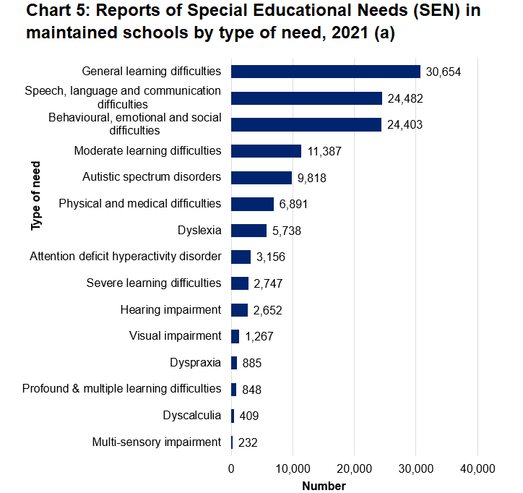

Figure 1.2: Special Educational Needs (SEN) in maintained schools by type of need in 2021. (GOV.Wales, 2021).

This is where cognitive load becomes an important theory for teachers to understand and demonstrate good differentiation skills. Cognitive load is when the brain has an overflow of information and struggles to process knowledge. One’s brain can only process a certain amount of new information at a time as they have limited working memory. (Sweller, 1988). When confronted with new tasks, this can cause distress and overload for individuals, therefore scaffolding can be used as a way of addressing cognitive load within a classroom. (Danilenko, 2010). Having control of learning by applying ranging differentiation skills is essential to maintaining classroom and behaviour management. Vygotsky, (1978) came across what is known as the zone of proximal development (ZPD). This can be defined as the distance between what someone can accomplish without help compared to when they are assisted by someone with expertise. He believes that when a child is in this (ZDP) if they are fully supported with the right assistance this will encourage them to achieve the task. Differentiated instruction provides each student with a suitable challenge for their understanding of a theory. (Taylor, 2017). Further, understanding someone's learning ability allows teachers to tailor lessons effectively. For example, you could have a student who learns visually compared to one who learns best by reading or writing. Therefore, differentiation provides students with a higher level of understanding.

There are many ways that teachers can avoid (ZDP), in particular, scaffolding is a technique used by teachers to offer support to students to help them develop and learn new skills. Scaffolding is a technique suggested by Carol Tomlinson, (2017) who implies incorporating various types of support within individual or group work is part of creating a better learning environment. Defined, scaffolding can be referred to as a structured guidance that helps individuals (pupils) build confidence, whilst stretching their learning abilities to develop and accomplish new skills. (Aubrey and Riley, 2019). In simple terms, scaffolding is when a teacher breaks the learning down into mini sections and provides structure to each section. As per example during the lesson, the teacher broke the maths equation down step by step and provided a range of techniques to meet the needs of all learners. As already identified, a classroom can be made up of different types of learners. (Capel, 2012; Clegg et al., 2012). Whether it be, their level of learning or their ability to process information, teachers need to tailor lessons to cover the ranging abilities within the classroom but at the same time be mindful of timings. Research suggests that the use of scaffolding in a classroom can sometimes be mistaken as a holistic approach, when in fact for some learners it takes away the control to grasp information at their own pace, whilst slowing down learning processes for MAT learners. (Hertberg-Davis, 2009). Exploration into the use of differentiation to cater behaviour and ranging abilities are proven to be beneficial, however, as proposed teachers need to be aware of the environment and timings when putting this technique into practice.

3.0: Reflection
The research conducted in the literature review above will form the basis of this reflection along with analysis of the CI. The structure of the reflection will be based on Gibbs’, (1998) reflective model as displayed in figure 1.3 below and will provide a detailed description of what happened during the incident. Gibbs’ model was based upon the idea of Kolb’s (1984) model and consists of six processes that review an occurrence: description, feelings, evaluation, analysis, conclusion and action plan. (Gibbs, 1998). His model is identified as one of the most famous and simplistic models to use when reflecting (Cottrell, 2015; Finlay, 2008). Gibbs’ states that the model helps you to break down an experience and reflect upon them as they happen. Thus, reflecting on a learning experience allows you to increase performance during and in the future. (Gibbs’ 1998).
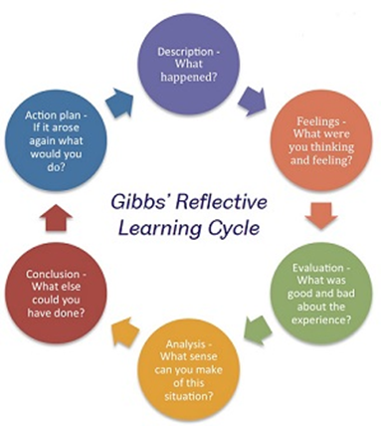

Figure 1.3: Gibbs’ (1998) Reflective Learning Cycle. (Gibbs’, 1998).

Description
This section will discuss what happened during the identified incident. The incident was based on a child who had entered ZDP and cognitive load during a lesson. The teacher tried to resolve this by providing multiple techniques on how to answer the task questions. However, the child was still unable to process any of the information and seemed to be in a zone of confusion. The teacher demonstrated the different examples on the board step by step until the pupil was able to fully understand one of the techniques. Once the child had a technique that suited them best the teacher monitored their performance to ensure they were on task.

Feelings
During this situation, I felt that the teacher handled the situation with great practice as they were able to identify that the child was confused and distressed. The teacher was able to apply a method within the lesson to help the pupil understand the task and steer away from confusion. The method applied is identified as a scaffolding technique that provides support and guidance to stretch learners' abilities to complete tasks. The teacher demonstrated this by breaking down the tasks to make it easier for the pupil to understand. This is a technique that is evidently successful within classrooms and is one that I will use in future lessons to meet the needs of all learners.

Evaluation and analysis
As discussed, the technique used to address the situation was effective as the student eventually understood how to do the task. However, the time spent trying to break down the task to the one student disrupted the progression of the lesson. This resulted in other learners losing effective learning time due to the distraction. This can become a problem for the MAT learners in the class as they had already finished the set task and were waiting for the teacher to move on. According to a report conducted by YouGov, students are potentially losing an hour a day of learning due to disruptive lessons. (Ofsted, 2014).
Analysing the incident, it is clear that the teacher demonstrated differentiation within the classroom. However, even though various strategies were covered for all types of learners, the time spent helping one student did disrupt the lesson. The knowledge gained from this experience has provided insight into the need for differentiation within the classroom as not all pupils learn in the same ways. As discussed, prior, COVID-19 caused a gap in learning and teachers need to be prepared by managing timing and lesson plans around this issue.

Conclusion and Action plan
Overall, the teacher demonstrated good differentiation skills as they provided tasks that were suitable for a wide range of learners. Although as discussed prior, time management was at fault. If in the future I were to be in a situation like this I would use the differentiation techniques, however, perhaps in this situation, I would have set other tasks for learners to complete whilst dealing with the confused child to maintain classroom management. In order to rise from this situation, below is an action plan on what I would continue to do and do differently in future lessons:
- Provide differentiation within the lesson (scaffolding technique).
- Be aware of timing.
- Set extension tasks for students who finish tasks early.
- Prepare lessons to fill the gap in learning caused by COVID-19.

4.0: Conclusion

In conclusion, as discussed, reflection allows teachers to understand their learners and their needs. (Tripp, 1993;2012; Schon, 1983). From this, information can be gathered to identify existing learning abilities within the classroom. (Vygotsky, 1978; Sweller, 1988). This allows teachers to analyse their practice and use certain techniques. For example, in the identified incident differentiation was the strategy used to address and resolve the problem. Differentiation allows teachers to meet the needs of all learners whilst acting as a tool that withholds classroom and behaviour management as it creates a successful learning environment that strengthens, shapes and motivates learners. (Tomlinson, 2017; Donaldson, 2015). Moreover, differentiation supports different abilities, as per example, a scaffolding technique was used to break down learning. However, sometimes this can cause disruption if teachers are not mindful of timing. Although, evidence supporting the importance of differentiation strengthens the requirement of this in practice. With regards to meeting the professional standards and pedagogical principles, differentiation supports learners by creating a learning environment that supports all pupils' outcomes, wellbeing and progress. This demonstrates that the teacher is aware of the pedagogical principle that generates a sustainable environment for creating ambitious learners which align with one of Donaldson’s four purposes. (Donaldson, 2015; GovWales, 2021).

5.0: Reference list

Appleyard, K. and Appleyard, N. (2015). Reflective teaching and learning in further education. Northwich: Critical Publishing Ltd.

Aubrey, K. and Riley, A. (2019). Understanding and using educational theories. 2nd ed. Los Angeles: SAGE.

Barkley, E.F. (2010). Student engagement techniques. San Francisco: John Wiley and Sons.
Bassot, B. (2013). The Reflective Journal. 2nd ed. London: Palgrave.

British Educational Research Association (BERA) (2018). Ethical guidelines for educational research. 4th edn. [online]. Available at: https://www.bera.ac.uk/researchers-resources/publications/ethical-guidelines-for-educational-research-2018 [Accessed 15th October 2021].

Bushie, C. (2015). Differentiation in education. Journal of Graduate Studies in Education, Volume 7, Issue 2. [online]. Available at: https://files.eric.ed.gov/fulltext/EJ1230703.pdf [Accessed 19th October 2021].

Cleg, S., Kornberger, M. and Pitsis., T.S. (2016). Managing organisations: An introduction to Theory and Practice. 4th ed. Sage.

Cottrell, S. (2013). The Study Skills Handbook. 4th ed. Palgrave Macmillan Publishers.
Danilenko, P. (2010). The Relationship of Scaffolding on Cognitive Load in An Online Self-Regulated Learning Environment. University of Minnesota.

Dewey, J. (1933). How We Think: A Restatement of the Relation of Reflective Thinking to the Educative Process. Boston, MA: D.C. Health & Co Publishers.

Donaldson, G., (2015). Independent Review of Curriculum and Assessment Arrangements in Wales. [online] GOV.Wales. Available at: <https://gov.wales/sites/default/files/publications/2018-03/succesful-futures-a-summary-of-professor-graham-donaldsons-report.pdf> [Accessed 19th October 2021].

Eisner, E.W. (2020). The Art and Craft of Teaching: Perspectives on effective teaching and the cooperative classroom. National Education Association. Washington, DC.

Esner, M. (2017). What is the difference between planning for learning and lesson planning? Department for Education. [online]. Available at: https://www.tes.com/news/what-difference-between-planning-learning-and-lesson-planning-sponsored-article [Accessed 19th October 2021].

Estyn. (2019). Estyn reports. Her Majesty’s Inspectorate for Education and Training in Wales. [online]. Available at: https://www.estyn.gov.wales/system/files/2020-08/Pentrehafod%2520School_0.pdf [Accessed 16th October 2021].

Finlay, L. (2008). Reflecting on Reflective Practice. 1st ed. The Open University. [online]. Available at: https://oro.open.ac.uk/68945/1/Finlay-%282008%29-Reflecting-on-reflective-practice-PBPL-paper-52.pdf [Accessed 21st October 2021].

Gibbs, G. (1998). Learning by Doing: A Guide to Teaching and Learning Methods. Further Education Unit. Oxford: Oxford Polytechnic.

Giroux, H.A. (2010). Rethinking Education as the Practice of Freedom: Paulo Freire and the promise of critical pedagogy. Policy Futures in Education. [online]. Available at: https://journals.sagepub.com/doi/pdf/10.2304/pfie.2010.8.6.715 [Accessed 14th October 2021].

Gov Wales. (2020). Education in Wales - Our national mission. [online]. Available at: https://gov.wales/education-wales-our-national-mission-update-october-2020-html [Accessed 20th October 2021].

GOV.Wales. (2021). Professional Standards for Teaching and Leadership. Welsh Government. [online]. Available at: https://hwb.gov.wales/api/storage/19bc948b-8a3f-41e0-944a-7bf2cadf7d18/professional-standards-for-teaching-and-leadership-interactive-pdf-for-pc.pdf [Accessed 14th October 2021].

GOV.Wales. (2021). Schools’ census results: April 2021. Welsh Government. [online]. Available at: https://gov.wales/schools-census-results-april-2021-html [Accessed 19th October 2021].

Gove, M. (2010). The importance of teaching: the schools whitepaper. Department for education. [online]. Available at: https://assets.publishing.service.gov.uk/government/uploads/system/uploads/attachment_data/file/175429/CM-7980.pdf [Accessed 14th October 2021].

Gurria, A. (2014). PISA 2012 Results in focus: What 15-year-olds know and what they can do with what they know. OECD Secretary-General. [online]. Available at: https://www.oecd.org/pisa/keyfindings/pisa-2012-results-overview.pdf [Accessed 20th October 2021].

Hertberg-Davis, H. (2009). Myth 7: Differentiation in the Regular Classroom Is Equivalent to Gifted Programs and Is Sufficient Classroom Teachers Have the Time, the Skill, and the Will to Differentiate Adequately. SAGE journals. Vol. 53, Issue. 4. p. 251-253.

Joseph, S., Thomas, M., Simonette, G. and Ramsook, L. (2013). The Impact of Differentiated Instruction in a Teacher Education Setting: Successes and Challenges. International Journal of Higher Education. Vol. 2, No. 3.
Joshi, K., (2018) Critical Incidents for Teachers’ Professional Development. Journal of NELTA Surkhet.

Klingberg, T. (2009). The overflowing brain: Information overload and the limits of the working memory. Oxford University Press.

Kolb, D.A. (1984). Experiential Learning: Experience as the Source of Learning and Development. Englewood Cliffs, New Jersey: Prentice Halls.

Kuh, G. D. (2008). Why integration and engagement are essential to effective educational practice in the twenty-first century. Peer Review, 10(4), 27-28.

Leon-Henri, D.D.P. (2021). 12 Benefit of Reflective Teaching and Learning. Reflective Journal of Learning. [online]. Available at: https://reflectiveteachingjournal.com/benefits-of-reflective-teaching/ [Accessed 14th October 2021].

Lewis, H. (2013). PISA 2012 Written Statement. Welsh Government. [online]. Available at: https://gov.wales/written-statement-pisa-2012 [Accessed 20th October 2021].

Linsin, M. (2021). Why do so many teachers struggle with classroom management? [online]. Available at: https://www.smartclassroommanagement.com/2021/04/03/teachers-struggle-with-classroom-management/ [Accessed 15th October 2021].

McMillan,K. and Weyersm J.D.B. (2013). How to improve your critical thinking and reflective skills. Harlow: Pearson.

Ofsted. (2014). Below the radar: low-level disruption in the country's classrooms. [online]. Available at: https://assets.publishing.service.gov.uk/government/uploads/system/uploads/attachment_data/file/379249/Below_20the_20radar_20-_20low-level_20disruption_20in_20the_20country_E2_80_99s_20classrooms.pdf [Accessed 16th October 2021].

Orchard, J., Winch, C. and Oancea, A. (2015). The contribution of educational research to teachers’ professional learning: philosophical understandings. Oxford Review of Education.

Payne, R. (2015). Classroom Behaviour Management: Educational psychologists’ view on effective practice. Educational Review.

Rabadi, S. and Ray, B. (2017). 5 Principles of Outstanding Classroom Management. [online]. Available at: https://www.edutopia.org/article/5-principles-outstanding-classroom-management [Accessed 15th October 2021].

Richards, J.C. and Farrell, T.S.C. (2010). Professional Development for Language Teachers: Strategies for Teacher Learning. Cambridge University Press.
Schon, D. A. (1983). The Reflective Practitioner. Aldershot: Ashgate.

Scott, S.B. (2019). Factors Influencing Teacher Burnout and Retention Strategies. University of Akron.

Sellars, M. (2017). Reflective Practice for Teachers. 2nd ed. Los Angeles: SAGE.

Sizmur, J., Ager, R., Bradshaw, J., Classick, R., Galvis, M., Packer, J., Thomas, D., and Wheater, R. (2019). Achievement of 15-Year Olds in Wales: PIAS 2018 National Report.
National Foundation for Educational Research (NFER). Welsh Government. [online]. Available at: https://gov.wales/sites/default/files/statistics-and-research/2019-12/achievement-15-year-olds-program-international-student-assessment-pisa-national-report-2018_0.pdf [Accessed 20th October 2021].

Smale-Jacobse, A., Meijer, A., Helms-Lorenz, M. and Maulana, R. (2019). Differentiated instruction in Secondary Education: A Systematic Review of Research Education. Department of Teacher Education. University of Groningen, Netherlands.

Smith, E. (2011). Teaching Critical Reflection. Teaching in Higher Education. Vol, 16, Issue,2.

StatsWales.GOV. (2021). Reports of Special Educational Needs (SEN) by type of need and type of provision. Welsh Government. [online]. Available at: https://statswales.gov.wales/Catalogue/Education-and-Skills/Schools-and-Teachers/Schools-Census/Pupil-Level-Annual-School-Census/Special-Educational-Needs/reportsofspecialeducationalneeds-by-typeofneed-typeofprovision [Accessed 19th October 2021].

Sweller, J., Merrienboer, V. J. and Paas, F., (1998). Cognitive Architecture and Instructional Design. Educational Psychology Review, 10(3), pp.251-296.

Taylor, C. (2020). The impact of COVID-19 on children’s learning in Wales. Wales Institute of Social and Economic Research and Data. [online]. Available at:
https://wiserd.ac.uk/news/impact-covid-19-childrens-learning-wales [Accessed 19th October 2021].

Tomlinson, A. (2017). How to differentiate instruction in academically diverse classrooms. 3rd ed. Alexandria, Virginia.

Tomlinson, C. A. (2001). How to Differentiate Instruction in Mixed-Ability Classrooms. 2nd ed. Alexandria: Association for Supervision and Curriculum Development.

Trip, D. (2011). Critical Incidents in Teaching (Classic Edition): Developing Teaching Professional Judgement. Taylor & Francis Group.

Tripp, D. (1993). Critical Incidents in Teaching: Developing Professional Judgement. London: Routledge.
Vygotsky, L. (1962). Thought and language. Cambridge, MA: MIT Press.

Waring, M. and Evans, C. (2013). Understanding Pedagogy; developing a critical approach to teaching and learning. London: Routledge.

Welsh Gov. (2012). Practical approaches to behaviour management in the classroom: A handbook for classroom teachers. [online]. Available at: ttps://gov.wales/sites/default/files/publications/2018-12/practical-approaches-to-behaviour-management-in-the-classroom-a-handbook-for-classroom-teachers-in-primary-schools.pdf [Accessed 17th October 2021].

Welsh Gov. (2018). How areas of learning and experience are being developed as a central element of the new curriculum. [online]. Available at:
https://curriculumforwales.gov.wales/2018/06/20/how-areas-of-learning-and-experience-are-being-developed-as-a-central-element-of-the-new-curriculum/ [Accessed 20th October 2021].

6.0: Appendices

Record 1

Date and time, year group: 9am, Year 8 Class.

Where and When: Context of the observation – subject/AOLE, general classroom context

Maths classroom.

What happened: a detailed description of the critical incident (the more detail the better to refer to in your later work)

The Maths lesson was based on long multiplication. The teacher was going through the topic on the board and set tasks to complete. During this time a pupil entered a mode of confusion and was unable to process any of the information. The teacher went through an example on the board. However, the child was still unable to understand how to complete the task. The teacher went through four different examples of how to do the multiplication on the board until the pupil was able to find on that suited them. However, during this time the lesson was put on pause and other students in the class were unable to move on until the teacher was finished dealing with the pupil.

Areas of possible exploration: what you think could be” under the hood” in these incidents? What avenues of research could you consider?

The teacher demonstrated differentiation skills as they scaffolded the question by breaking it down in to sections for the pupil to understand and also provided other possible techniques that can be used to complete the questions which provides a technique for all types of learners. However, timing was an issue during this lesson.

Notes: any details you can note (is it a busy environment, is it after lunch, are there lots of distractions, are directions made explicit - the more you can refer to the better here)

The lesson was the first of the day, pupils wouldn’t have been fully engaged and would need time to come around. Therefore, this could’ve been reason to why the pupil was unable to process the information properly.

Record 2

Date and time, year group: Year 8 Class, 11:20am.

Where and When: Context of the observation – subject/AOLE, general classroom context

Science classroom.

What happened: a detailed description of the critical incident (the more detail the better to refer to in your later work)

The science lesson was the third lesson of the day and just after the morning break. The pupils were not in their usual science classroom as another class needed to use it for an experiment, so they were not in their normal environment e.g., seating plans. When the pupils entered the class, they were very loud, chatty and disruptive. It took the teacher about ten minutes to calm the class down before being able to start the lesson. The lesson was based on hydrogen and the teacher had lots of video examples for the pupils to watch and make notes on. During the videos the pupils were constantly talking and being disruptive, one pupil threw a rubber at his friend’s head. The teacher gave the child a warning, however this did not stop him from being disruptive. The teacher began to add lines on the board, with each line representing 5 minutes of the whole classes lunch time. If any child were to be disruptive the teacher would add another line, but if the class behaved the teacher would completely get rid of the line on the board. This technique worked and resulted in the class being well behaved, at the end of the lesson the teacher wiped the line of the board.

Areas of possible exploration: what you think could be” under the hood” in these incidents? What avenues of research could you consider?

The class were being disruptive during the lesson, this could have been due to their lesson being in a different classroom with their seating plan being changed. The pupils were sat with their friends and this caused them to be disruptive. In order to address the issues, the teacher used assertive discipline which was rewarding their behaviour as if the class behaved, they would be returned the 5 minutes of their lunchtime. This is a good classroom management technique to use when dealing with disruptive pupils.
Notes: any details you can note (is it a busy environment, is it after lunch, are there lots of distractions, are directions made explicit - the more you can refer to the better here)

The lesson took place after the morning break along with the pupils not being in their ordinary classroom meaning they were sat with their friends. This would’ve played a major part to why they were being disruptive and loud.

Record 3

Date and time, year group: Year 8 class, 12:20pm.

Where and When: Context of the observation – subject/AOLE, general classroom context

ICT classroom.

What happened: a detailed description of the critical incident (the more detail the better to refer to in your later work)

This lesson was the fourth lesson of the day. The pupils had already been in a disruptive lesson prior and were disengaged. The teacher welcomed the class in and asked the pupils to log on to the computers. The teacher began the lesson and started to explain the tasks. One pupil turned up ten minutes late for the lesson and the teacher had to quickly re-explain the tasks. This created an opportunity for students to chat to their friends as the teacher was not watching the other students. The teacher told the pupils to get on with their work and went around to help those that needed any. When the teacher was checking on pupil’s progress, one student had not completed any of the tasks. The teacher told the pupil off and the pupil stormed out of the classroom.

Areas of possible exploration: what you think could be” under the hood” in these incidents? What avenues of research could you consider?

The teacher should have asked the student why they had not completed the tasks and supported them if they needed the help. The teacher should have not reacted to the situation as sometimes children will play up to get a reaction.

Notes: any details you can note (is it a busy environment, is it after lunch, are there lots of distractions, are directions made explicit - the more you can refer to the better here)

The lesson was just before lunch so pupils may have been disengaged and overloaded with information throughout the day which could have caused this lack of participation.

