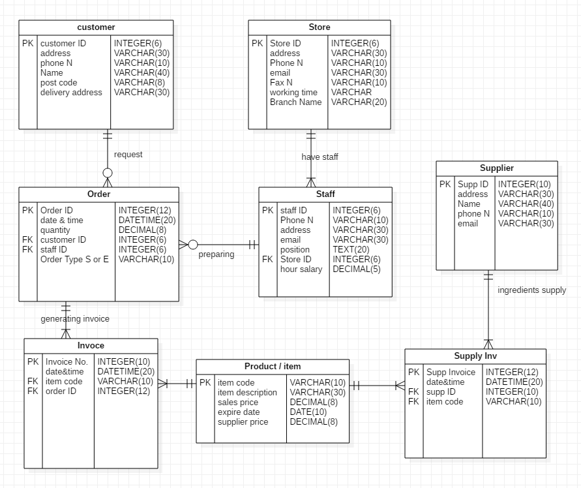

Initially I had 2 many to many relationships and I insert child table to avoid them. The two child tables are Supply inv and Invoice. I will record the type of order (catering, event, etc.) in the order table to know the type of the order and to help with decision for how many staff needs to carry on the order (delivery, waiters, etc.)
I will explain relationship between Store and staff. Needs to be one (and only one) to many (one or many) because it can’t be the store to operate without at least one staff member.

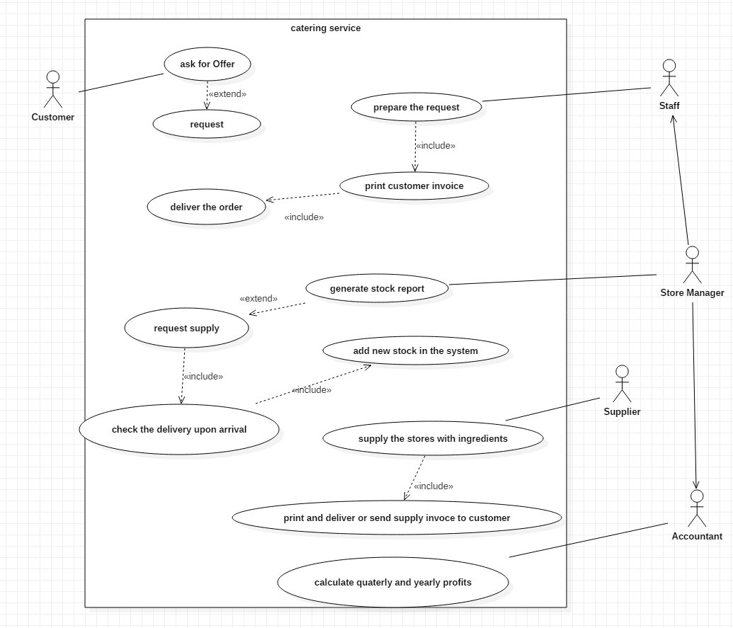

The customer can ask/request for offer but is not mandatory to request the order, that’s why the connection is extendable (<<extend>>). On the other side if store manager request supply he have to check the delivery and put the new amounts and products in the system. It is mandatory the supplier to generate and send or deliver the invoice of requested ingredients upon deliver.

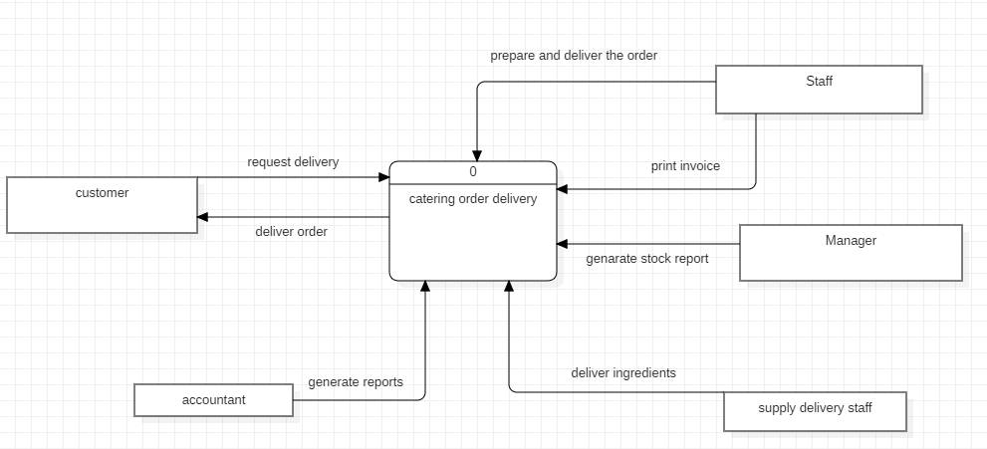

Customer is requesting order and receiving it, together with invoice. Staff is preparing and delivering orders to customers, printing and delivering or sending the invoices to the customers. Manager can generate stock reports and request delivery. The supplier is delivering ingredients. Accountant can generate yearly and quarterly profit reports.

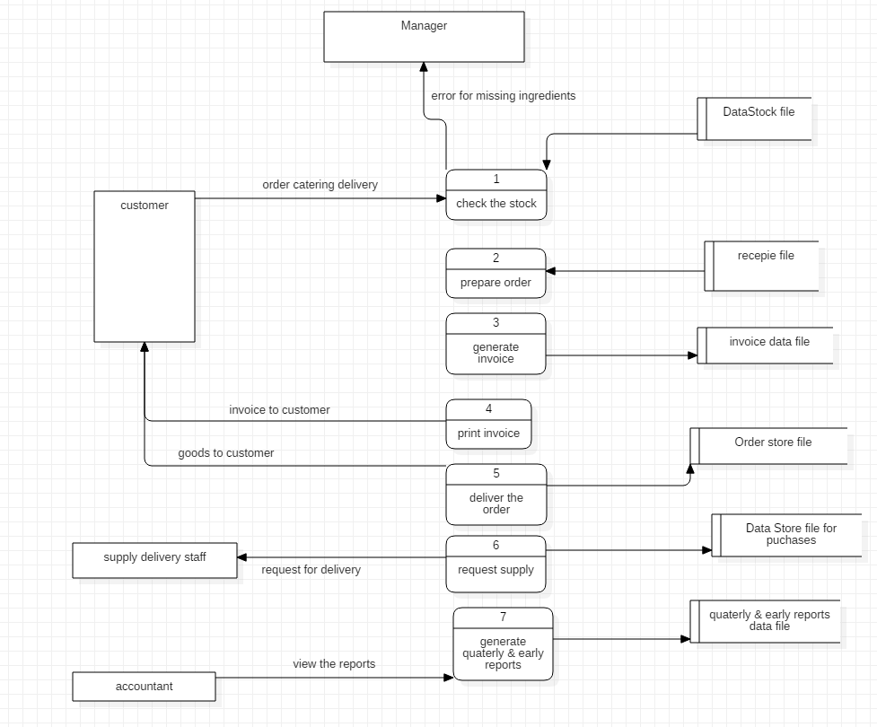

When the customer request is receive the first process is to check the stock. If everything for preparing the order is present staff starts to prepare the order if NOT the acknowledging message is sent to manager to request ingredients supply. In preparation process staff is using recipe info from recipe file. When the order is ready the invoice is generated and stored in INVOICE DATA FILE and the complete order info is stored in ORDER STORE file. All the supply requests are stored in data store file for purchases. Also all the report for profits are stored in quarterly and yearly reports data file.

