

MODULE HANDBOOK

ENTREPRENEURIAL INNOVATION

Module Code - BMBM4001

LEVEL 4

SCHOOL OF BUSINESS

INSTITUTE OF MANAGEMENT AND HEALTH

Semester 2 – February 2023

Tutor: Davina Wyn Evans

Entrepreneurial innovation Assignment 2

Individual Assignment / Presentation

Firstly; how does Coca-Cola use circular economy? Coca-Cola, as a global beverage company, has been implementing various initiatives and strategies to promote a circular economy. Here are some ways in which Coca-Cola uses the principles of the circular economy:

Packaging and Recycling: Coca-Cola aims to make all its packaging 100% recyclable by 2025. They focus on reducing the amount of plastic used in their bottles and promoting the use of recycled materials. Coca-Cola also actively supports and invests in recycling infrastructure and programs to increase the collection and recycling rates of their packaging.
PlantBottle: Coca-Cola introduced the PlantBottle, a packaging innovation made partially from plant-based materials, such as sugarcane or molasses. This reduces the dependency on fossil fuels and decreases the carbon footprint associated with packaging production.
Closed-Loop Systems: Coca-Cola has implemented closed-loop recycling systems in some regions where they collect and recycle their own bottles. This involves collecting used bottles, processing them, and then using the recycled material to make new bottles. It helps reduce waste and conserve resources.
“The future is 100% PET renewable plastic” this was stated on an article wrote by Lucia Langton, a member of the European partners on the coca-cola website, as a part of their journey is to reduce the waste to zero, to build a climate neutral continent by 2050, this transition could eliminate up to 200,000 tonnes of virgin fossil based plastics a year. 100% recycled PET has up to 70% lower carbon footprint than virgin fossil-based PET.
Water Stewardship: Coca-Cola focuses on water stewardship to ensure responsible water use and conservation. They have set a goal to replenish 100% of the water used in their beverages and production processes. Through water recycling and conservation efforts, they aim to minimise water waste and contribute to the sustainable management of water resources.
Collaboration and Partnerships: Coca-Cola collaborates with various stakeholders, including governments, NGOs, and recycling organisations, to promote and advance the circular economy. They work together to improve waste management systems, enhance recycling infrastructure, and develop innovative solutions for packaging and waste reduction.
Product Innovation: Coca-Cola continually explores innovative solutions to reduce environmental impact. They invest in research and development of new packaging materials, technologies, and sustainable practices. For example, they are exploring the use of plant-based resins, biodegradable materials, and alternative packaging formats to improve the sustainability of their products.
These initiatives and strategies demonstrate Coca-Cola's commitment to the circular economy by minimising waste generation, promoting recycling and reuse, conserving resources, and collaborating with partners to create a more sustainable future.

Some alternative solutions:
Coca-Cola can further enhance its circular economy efforts by implementing the following strategies:
Extended Producer Responsibility: Coca-Cola can take more responsibility for its products throughout their lifecycle. This includes not only making packaging recyclable but also actively participating in the collection and recycling of used packaging. By investing in collection infrastructure and collaborating with stakeholders, Coca-Cola can ensure a higher recycling rate for its products.
Adoption of Recycled Materials: While Coca-Cola has made progress in using recycled materials in its packaging, it can aim to increase the percentage of recycled content in its bottles and other packaging. By setting ambitious targets and investing in research and development, the company can explore new technologies and processes to incorporate more recycled materials without compromising product quality.
Packaging Innovation: Coca-Cola can continue to invest in packaging innovation to reduce waste and environmental impact. This includes exploring alternative packaging materials such as biodegradable or compostable options. Additionally, they can explore light-weighting techniques to reduce the amount of packaging material used while maintaining product integrity.
Promoting Refillable Systems: Coca-Cola can encourage the use of refillable systems for its beverages. This could involve partnering with retailers, restaurants, and other outlets to establish refill stations or vending machines that allow consumers to refill their bottles rather than purchasing new ones. Such systems can significantly reduce packaging waste.
Circular Design Principles: Coca-Cola can incorporate circular design principles into its product development process. This involves designing products with the intention of facilitating repair, reuse, and recycling. By considering the entire lifecycle of their products, Coca-Cola can create packaging that is easier to recycle or repurpose, leading to a more circular economy.
Education and Awareness: Coca-Cola can play a vital role in educating consumers about the importance of recycling, proper waste disposal, and the benefits of a circular economy. By raising awareness and providing clear instructions on how to recycle their products, Coca-Cola can help drive behaviour change and increase recycling rates.
Collaborative Partnerships: Coca-Cola can continue to collaborate with governments, NGOs, and other stakeholders to drive systemic change. By working together, they can advocate for improved waste management infrastructure, support policy changes that promote the circular economy, and develop innovative solutions collectively.
By implementing these strategies, Coca-Cola can further strengthen its commitment to the circular economy, reduce waste generation, conserve resources, and contribute to a more sustainable and environmentally friendly future.

Here's a business model canvas for Coca-Cola focusing on being more circular in the economy:
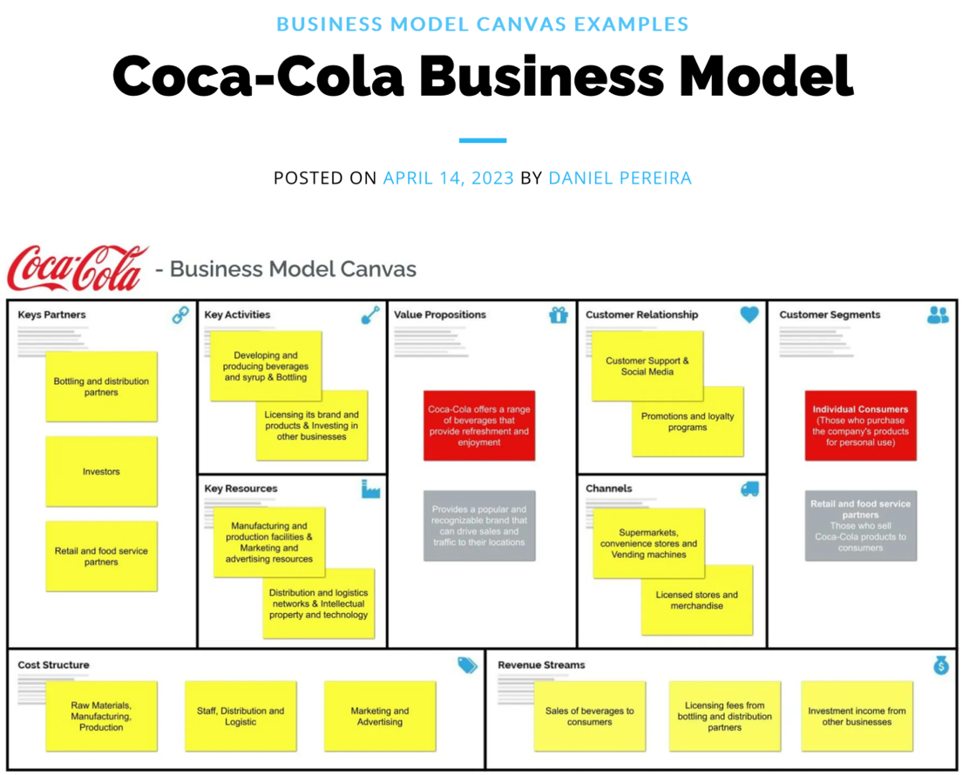

My BMC

Key Partnerships:
- Recycling organisations and NGOs
- Bottling and distribution partners
- Investors
- Packaging suppliers and manufacturers
- Government agencies and policymakers
- Retailers and food service partners
- Waste management companies

Key Activities:
- Research and development for innovative packaging materials
- Developing and producing beverages
- Licensing its brand and products plus investing in other businesses.
- Collaborating with partners to improve recycling infrastructure
- Education and awareness campaigns on recycling and circular economy
- Establishing refillable systems in collaboration with retailers
- Investing in collection and recycling programs
- Advocating for policy changes to support circular economy

Key Resources:
- Manufacturing and production facilities & marketing an advertising resources
- Distribution and logistics networks & intellectual property and technology.
- Packaging design and manufacturing capabilities
- Recycling infrastructure and facilities
- Research and development expertise
- Collaborative partnerships
- Marketing and communication channels
- Financial resources

Value Propositions:
- Coca-cola offers a range of beverages that ovine refreshment and enjoyment.
- Providing a popular and recognisable brand that can drive sales and traffic to their locations.
- Sustainable and recyclable packaging
- Reduced environmental impact
- Enhanced brand reputation and consumer trust
- Collaboration and partnerships for a circular economy
- Supporting the global sustainability agenda

Customer Segments:
- Individual consumer (those who purchase the company’s products for personal use)
Retail & food distribution service partners (those who sell Coca-cola products to consumers.)
- Consumers who prioritise sustainable and eco-friendly products
- Retailers and distributors seeking environmentally responsible partners
- Governments and policymakers focused on waste management and circular economy

Customer Relationships:
- Customer support and social media
- Promotions and loyalty programmes.
- Engaging with consumers through educational campaigns
- Collaborating with retailers and distributors to implement circular initiatives
- Building strong relationships with recycling organisations and waste management companies
- Collaborating with governments and policymakers to drive policy changes

Channels:
- Digital and traditional marketing channels
- Collaboration and communication platforms with partners
- Retail and distribution networks
- Recycling and waste management channels

Cost Structure:
- Raw materials
- Manufacturing
- Staff
- Distribution
- Logistics
- Research and development costs for sustainable packaging solutions
- Investment in recycling infrastructure and programs
- Marketing and promotional expenses for advertising awareness campaigns
- Operational costs for refillable systems and collection initiatives

Revenue Streams:
- Licensing fees
- Bottling & distribution partners
- Investment income from other businesses.
- Sales of Coca-Cola products
- Revenue from partnerships and collaborations
- Potential revenue from recycling and waste management initiatives
- Potential revenue from consulting and advisory services in the circular economy sector

This business model canvas outlines the key elements of Coca-Cola's circular economy approach, including partnerships, activities, resources, value propositions, customer segments, relationships, channels, cost structure, and revenue streams. It showcases how Coca-Cola can align its business model with circular economy principles and create value for both the company and stakeholders while minimising environmental impact.

My references:

- “Our interconnected approach to sustainability supports our science-based target to reduce our absolute greenhouse gas emissions by 25% by 2030 (compared to 2015 levels), as well as our ambition to achieve net-zero carbon emissions by 2050.” The Coca-Cola Company: 2023 Business, Environmental, Social, Governance and Sustainability Report. Page 88 of 88, publication date April 2023.
- “Investing in 100% PET (polyethylene terephthalate) is a part of the process to reduce our carbon footprint to zero. This transition could eliminate up to 200,000 tonnes of fossil-based plastic waste a year.” Stated by Lucia Langton CCEO an admin of the European partners. 2022 Feb 18^{th,} the official Coca-cola website for European partners and updates.

