Module Title - Marketing Essentials
Individual Presentation & Supporting Marketing Plan

Student Name: Adamache Anaida

Student ID:2026381

Lecturer’s name: Christopher Wilkin

Word Count:1564

Table of Contents
Component A: Marketing Plan 3
Introduction 3
Situation analysis 4
Objectives 6
Strategy 6
Tactics 7
Action 7
Control 9
Conclusion 10
Component B: Presentation 11
References 15
Appendix 17

Component A: Marketing Plan

Introduction
The SOSTAC model is a structured planning model used to plan and execute marketing strategies. It comprises six key components: Situation, Objectives, Strategy, Tactics, Action, and Control (Dokukina, A. A., 2015). The 4'Ps is a classic marketing mix model that helps define the key elements of a marketing strategy. The four Ps are Product, Price, Place, and Promotion. This model ensures that a product or service is well-defined, appropriately priced, effectively distributed, and promoted to the right audience (Dominici, G., 2009). Bowman's Strategic Clock is a framework that determines a product's position in the market based on price and perceived value. This model helps to analyze a product in relation to competitors and identify opportunities for differentiation (Tassabehji, R., & Isherwood, A., 2014). The marketing plan will be a detailed description of the current market position of Hilton Hotel. A marketing plan represents the current situation of an organisation and makes profitable recommendations based on the analysis of the internal and external factors of the organisation. Concerning that the market plan will include a SWOT and a PESTLE analysis to observe the internal and external factors along with that it will also include a Bowman's strategy clock to observe the competitors. The study will also include the 4Ps of the marketing mix for better profitability in the market along with an action plan and strategies to measure the success of the organisation. Combining these frameworks can aid in the development of a holistic marketing plan.

Situation analysis
The situational analysis can be critically done by the five Cs of marketing. The five factors in model consist of five major factors of the market such as company, customers, competitors, collaborators and climate (Nangpiire, 2022).
Company
The internal situation of the organisation can be greatly observed by a proper SWOT analysis which is following.
SWOT analysis of Hilton Hotel
Strengths | Weakness
Huge experience- The Hilton Hotel is providing services for the last 103 years which makes them and the experience the biggest strength of the organisation.  Strong asset portfolio- Hilton Hotel has over 4500 properties worldwide which is one of its biggest strengths. | Lower flexibility- Hilton Hotel is one of the biggest organisations in the hospitality industry of the UK which makes it slow in decision-making and strategy implementation.  Low market share- Despite of high asset portfolio the organisation has a low market share which can be stated as a weakness of the organisation.
Opportunities | Threats
Better customer experience- The strengths of the organisation like experience in the hospitality industry help them to provide better customer retention. | Loss of recognition- The lower flexibility and lower market share can make difficulties for the organisations as they can lose their brand value over time.

Customers
In order to gain customers segmentation and targeting can be impactful for Hilton Hotel (Wongsaichia, 2022).
Segmentation
Hilton Hotel provides luxury hotels and services to the market. Concerning that, it segmented the market between two groups higher class and a Lower class based on the income groups.
Targeting
The target market of Hilton Hotels consists of customers with high incomes. Proper targeting makes them profitable in the industry.
Competitors
Observing the competitors of the organisation's perceptual positioning map and Bowman’s strategy clock can be very helpful (Elisabeth, M.L.M., 2022).
Perceptual positioning map
The map refers to an illustration that is used by market analysts to see the target customer's views of the brand and its competitors. It helps Hilton Hotel to observe customer behaviour and position the organisation in a better place.
Bowman’s strategy clock
It is a comprehensive study and a strategic tool that provides various options for positioning the business over other competitors in the market (Ryan, 2022). It will help Hilton Hotel to place the hotel in the market by analysing the price and creating value for their service.
Climate
A PESTLE analysis will be very helpful in order to analyse the external factors of the Hilton Hotel (Fransson, 2022).
Political
The recent political situations are not stable in the government of the UK as the UK left the Europe Union. The situation will deduct the number of visitors in the UK which affect the revenue of the Hilton Hotel.
Economical
The economic factors include the interest rests, GDP of the UK, inflammation rate and anything related to the economy. After the Covid-19 pandemic, the interest rates have gone down which is helping Hilton Hotel to expand more.
Social
Hilton Hotel is very famous among international travellers. The financial aspects of the organisation can be greatly affected by the revenue that is generated from international customers who are different in their lifestyle, culture and gender.
Technological
Technologies around the world are developing day by day and adapting to those technologies can make Hilton Hotels profitable over others. Concerning to that adopting social media marketing can be helpful for the organisation.
Legal
Legal factors of the analysis include employment laws, consumer laws and other legal frameworks. Hilton Hotel needs to maintain the legal aspects in making strategies of the organisation.
Environmental
People around the world are getting knowledgeable towards safe environmental practices. The organisation need to have critical waste management to serve the customers.

Objectives
To increase the market share by 6 per cent within 10 months by introducing attractive deals to the people.
To enhance the brand image by 10 per cent within 14 months by implementing the latest technological ethics in the work process.
To increase the customer base by 12 per cent within 16 months by preparing better customer care service strategies in the organisation.
To enhance the sales of the organisation by 5 per cent within 12 months by refining services in the workplace.

Strategy
The value proposition can be referred to as the perceived value that can be got by the customers after using the product or attending a service of any organisation. Hilton Hotel provides unique and unmatchable services to its customers. Hilton Hotel also tries to build brand loyalty among its customers and tries to refresh them with its services. The value proposition also helps the organisation segment the market and position itself from others (Cooper, 2022). Based on those value propositions the organisation segments its customers between higher class and lower class depending on their incomes. The organisation provides different services to different segments of customers which make them stand out from other competitors in the market.

Tactics
The four Ps of the marketing mix can be very helpful for this segment.
Product
Hilton Hotel provides hospitality services to satisfy its customers. The services of Hilton Hotel are unique that help the customers to have personalised positive experiences. The organisation also provides pick-and-drop services to customers in some regions.
Place
Customers can access Hilton Hotel from any media platform and can make bookings through internet services. Customers can also book their stay from different parts of the world. Hilton hotel has efficient customer care providers that make the organisation stand out from others (Kelleci, A., 2022).
Price
The services of Hilton Hotel are excellent in quality and the prices project a high perceived value. Hilton has different categories in price range and the strategies behind the pricing strategies are based on the customer's tastes. The different price segments provide different benefits to the customers.
Promotion
Hilton Hotel will use various social media platforms for the promotion of its services. The organisation will also take part in various trade exhibitions to showcase its services to customers and other business competitors.

Action
A Gannt chart of marketing activities will show the marketing channels schedule, including the months of each marketing activity.
The analysis of market will also inform the marketing channels schedule, helping that the most channels are selected by customers and competitors.

Control
Controlling and measurement of the objective is very essential for any organisation as it helps the organisation to see the effectiveness of the strategies and also helps them to identify the risks (Turner, 2022). The SMART objectives of Hilton Hotel refer to the increment of market share, brand image, customer base and profitability in an achievable timespan. The market sharers can be measured by observing and analysing financial data collected from the market by the finance department of the organisation. The marketers can analyse the customer behaviour for measuring the increment of the customer base of Hilton Hotel. The financial revenue analysis can give the result of the profitability growth of the organisation.

Conclusion

The marketing plan has critically evaluated the various aspects of the market for a better profitability of the organisation. Concerning that the study has presented the organisation's strengths and weaknesses for strategy making and along with strategies to segment and target customers. The marketing plan also included a PESTLE analysis for describing the external environment analysis. The SMART objective has also been included to comprehend the marketing plan along with the value proposition to observe the effects of targeting customers. The marketing plan also included the 4Ps of marketing along with a Gannt chart to schedule the marketing processes along with processes to measure the activities.

References

Antevenio (2019). What is the SOSTAC methodology? [online] Antevenio. Available at: https://www.antevenio.com/usa/what-is-the-sostac-methodology/ [Accessed 17 Feb. 2023].
‌
CFI Team, (2022). 4 P’s of Marketing. [Online] Available at: https://corporatefinanceinstitute.com/resources/management/4-ps-of-marketing/[Accessed 21 1 2023].

Cooper, K., Dedehayir, O., Riverola, C., Harrington, S. and Alpert, E., (2022). Exploring consumer perceptions of the value proposition embedded in vegan food products using text analytics. Sustainability, 14(4), p.2075.

Dewi, F.M. and Sulivyo, L., (2022). Influence of Consumer Behavior and Marketing Mix on Product Purchasing Decisions. Aptisi Transactions on Management (ATM), 6(2), pp.151-157.

Dokukina, A. A. (2015). Strategic-based Integration of Modern E-techniques in the Company’s Operations: Experience and Prospects. Review of Applied Socio-Economic Research, 10(2), 20-36.

Dominici, G. (2009). From marketing mix to e-marketing mix: a literature overview and classification. International journal of business and management, 4(9), 17-24.

Elisabeth, M.L.M., (2022). PERCEPTUAL MAPPING OF BRANDED COFFEE CHAINS IN MANADO USING MULTI DIMENSIONAL SCALING ANALYSIS. Jurnal EMBA: Jurnal Riset Ekonomi, Manajemen, Bisnis dan Akuntansi, 10(2), pp.551-559.

Fransson, N., Sandvall, A., Karlsson, K., Unluturk, B., Romanchenko, D., Andersson, R., Nilsson, J., Aurora, Ö. and Liptow, C., (2022). REWARDHeat PESTLE Analysis.

Jobber, D. and Ellis-Chadwick, F (2020), Principles and practice of marketing. 9th ed. London
Kelleci, A., (2022). Four-stage model of value creation for sustainability-oriented marketing: en route to participatory marketing. Journal of Macromarketing, 42(1), pp.5-11.

Makienko, I. and Rixom, J., (2022). Using Marketing Mix Elasticities to Demonstrate Consumer and Producer Perspectives in Marketing Management Class. The International Journal of Management Education, 20(3), p.100689.

Nangpiire, C., Silva, J. and Alves, H., (2022). Customer engagement and value co-creation/destruction: The internal fostering and hindering factors and actors in the tourist/hotel experience. Journal of Research in Interactive Marketing, 16(2), pp.173-188.

Ryan, J. and Bowman, J., (2022). Teach Cognitive and Metacognitive Strategies to Support Learning and Independence. In High Leverage Practices and Students with Extensive Support Needs (pp. 170-184). Routledge.

Shewan, D. (2022). How to Do a SWOT Analysis (Examples & Free Template!). [online] WordStream. Available at: https://www.wordstream.com/blog/ws/2017/12/20/swot-analysis [Accessed 17 Feb. 2023].

Turner, L., Weickgenannt, A.B. and Copeland, M.K., (2022). Accounting information systems: controls and processes. John Wiley & Sons.

Tassabehji, R., & Isherwood, A. (2014). Management use of strategic tools for innovating during turbulent times. Strategic Change, 23(1‐2), 63-80.

Wongsaichia, S., Naruetharadhol, P., Schrank, J., Phoomsom, P., Sirisoonthonkul, K., Paiyasen, V., Srichaingwang, S. and Ketkaew, C., (2022). Influences of Green Eating Behaviors Underlying the Extended Theory of Planned Behavior: A Study of Market Segmentation and Purchase Intention. Sustainability, 14(13), p.8050.

Wales, in (2014). Impact Innovation & Growth Services Ltd. Business Management Consultants in Wales. Tel: 01633 215545. [online] Impact Innovation & Growth Services Ltd. Business Management Consultants in Wales. Tel: 01633 215545. Available at: https://www.impact-innovation.co.uk/pestle-analysis [Accessed 17 Feb. 2023].
‌

Appendix

Component B: Presentation

SOSTAC framework
Source: (Antevenio, 2019)

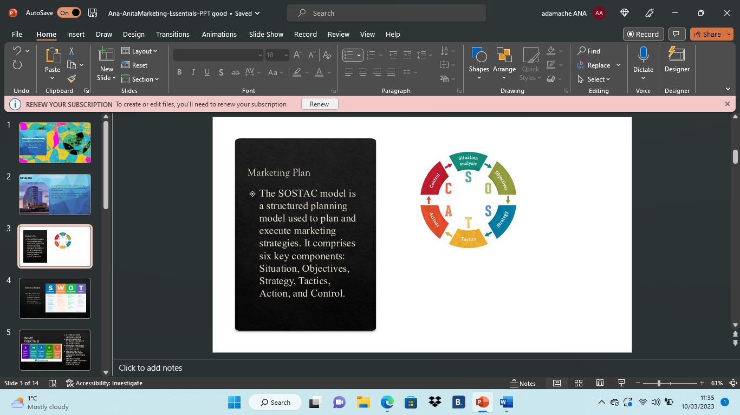

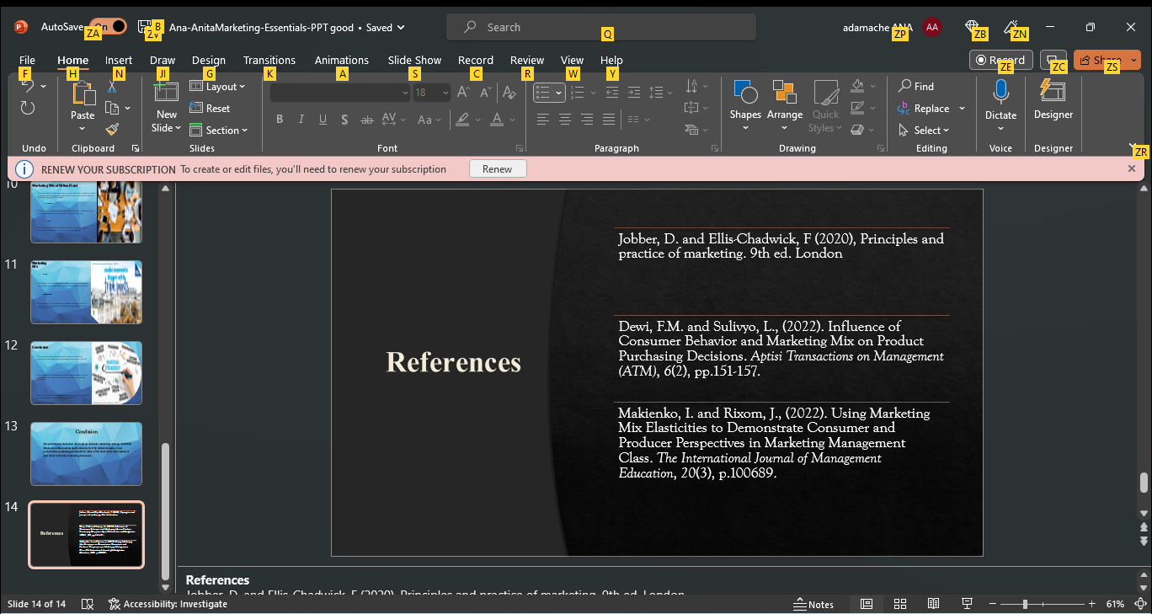
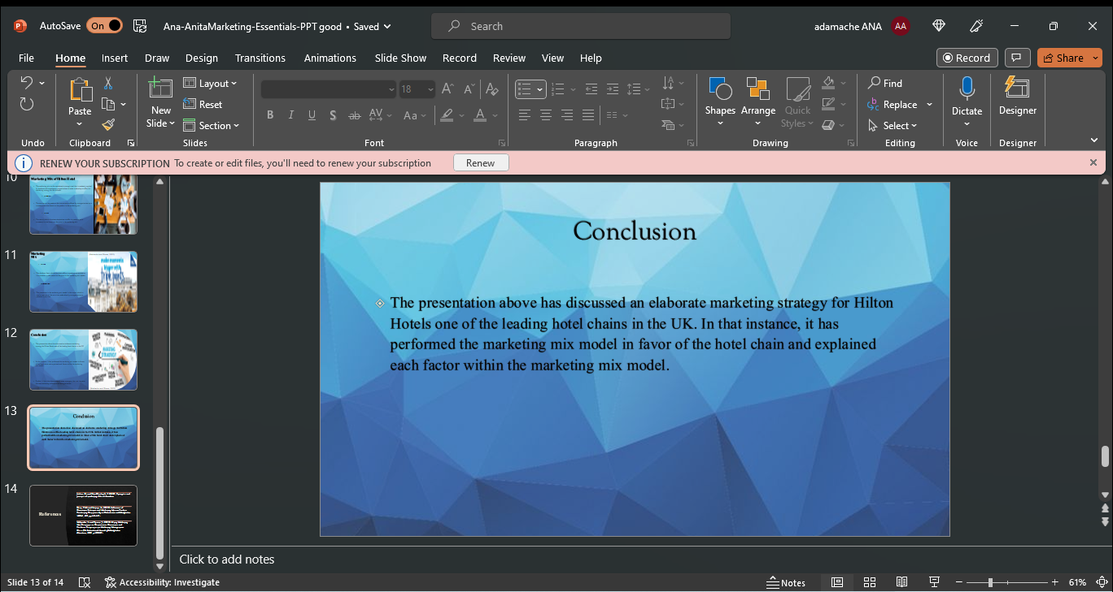
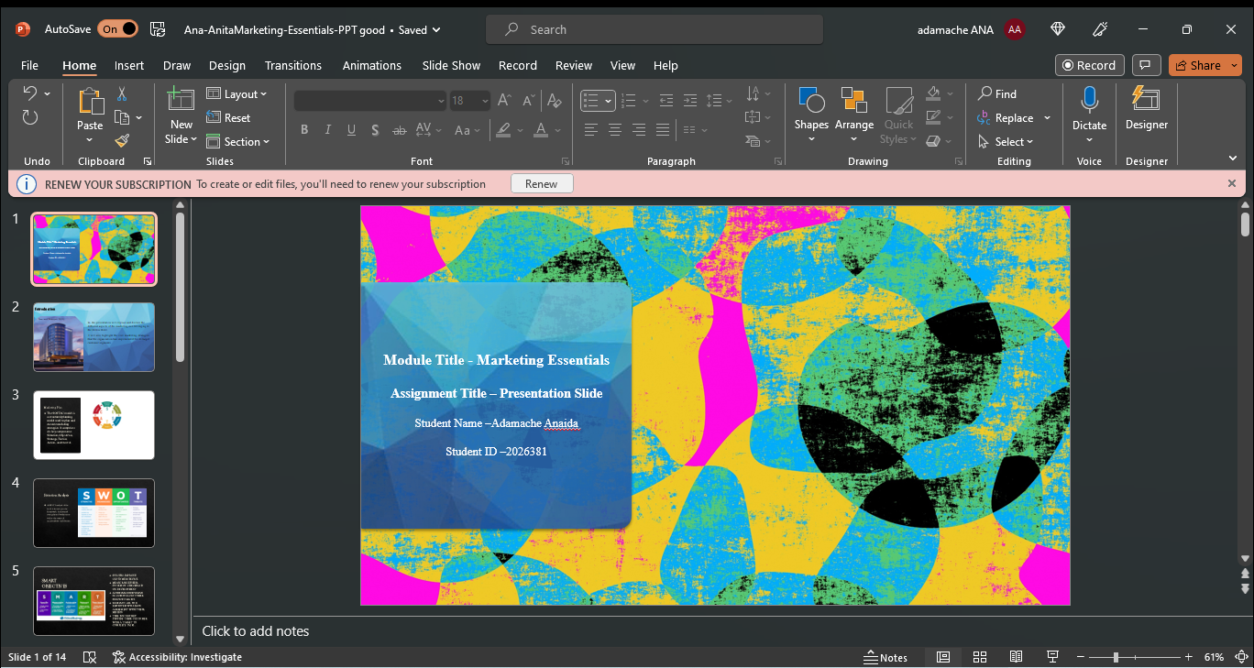

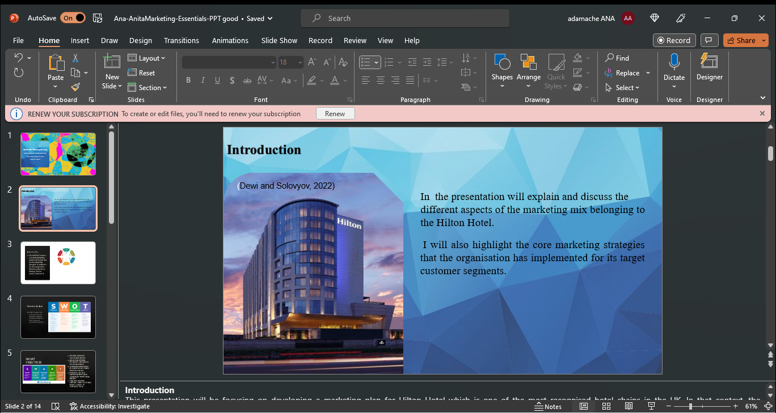
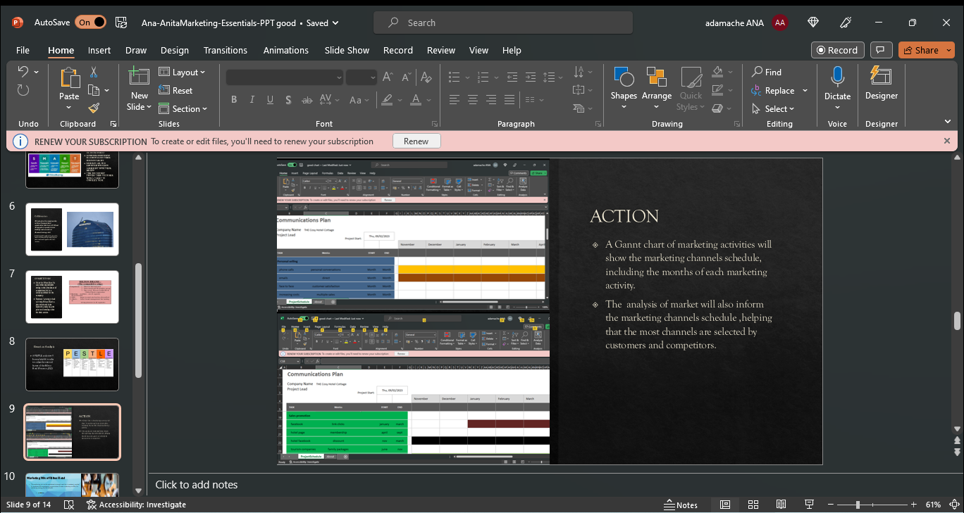
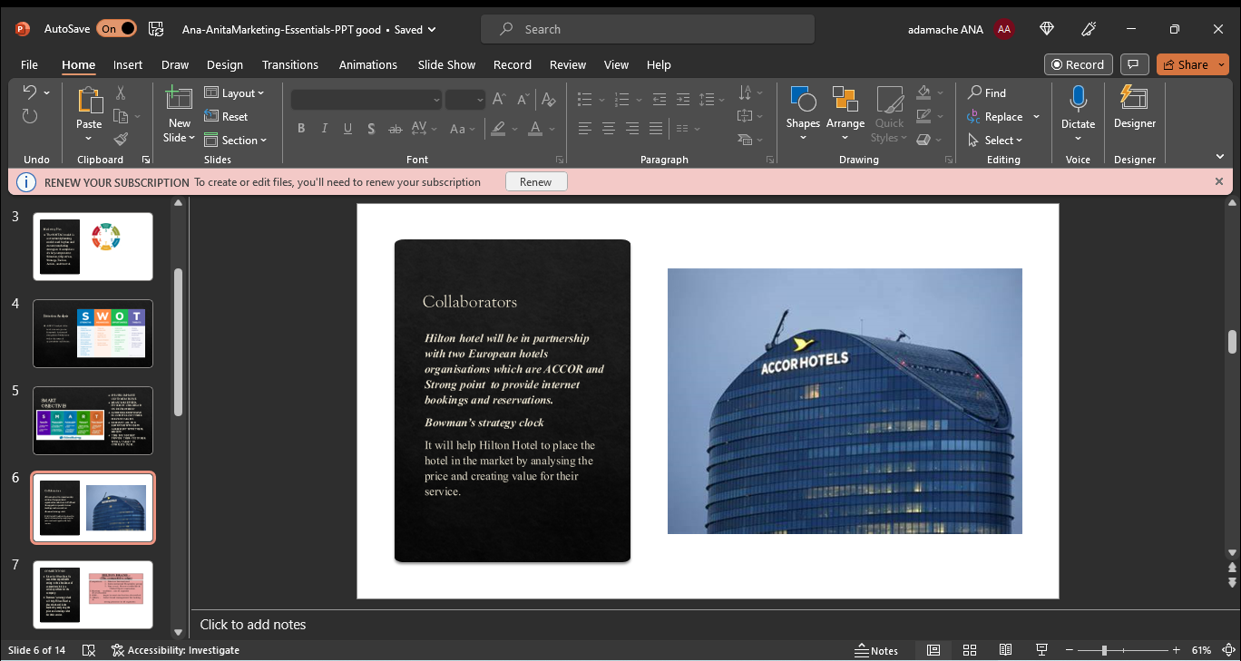
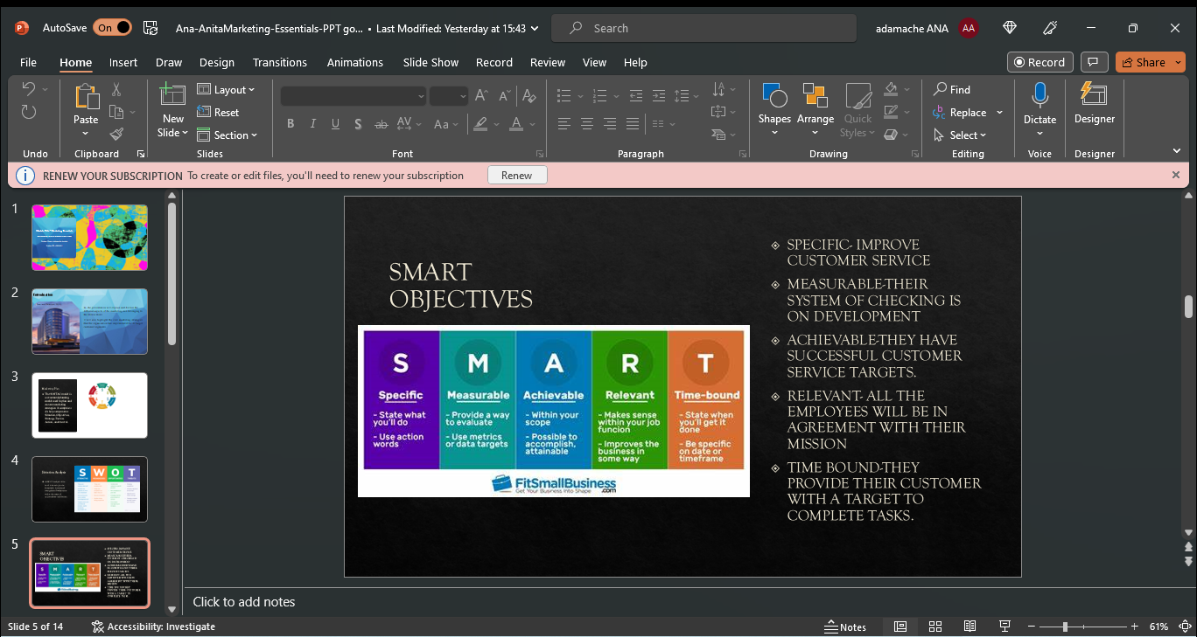
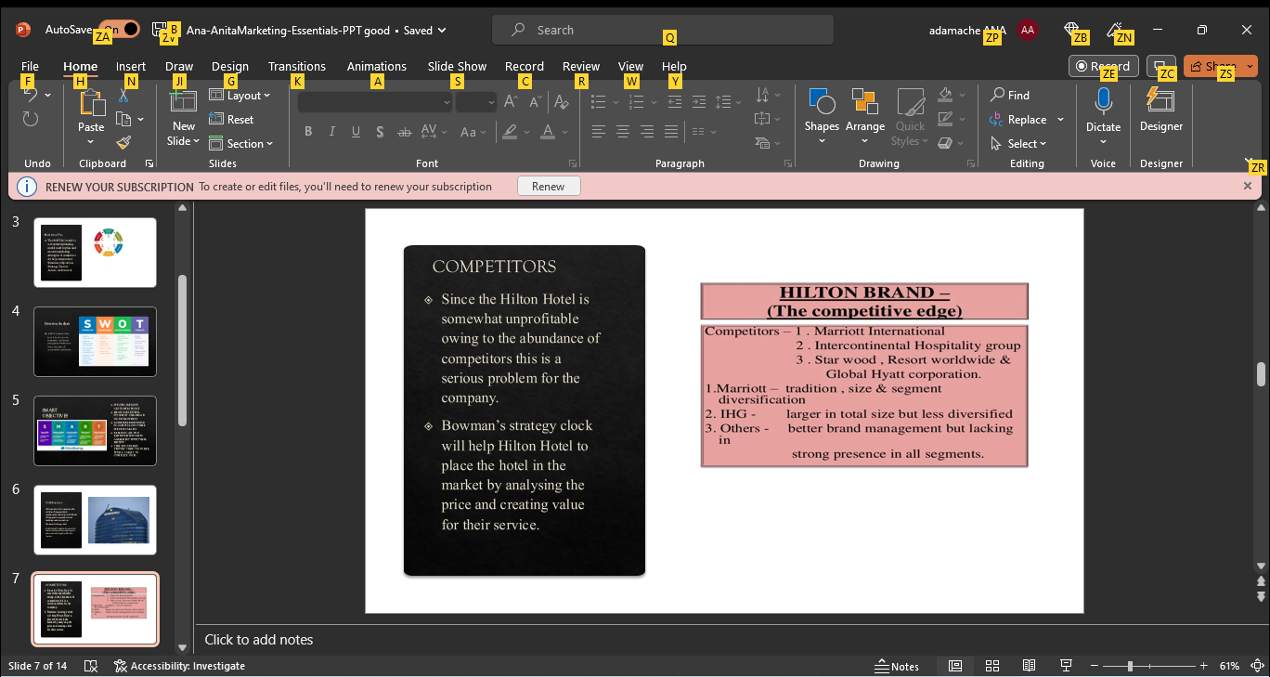

SWOT framework

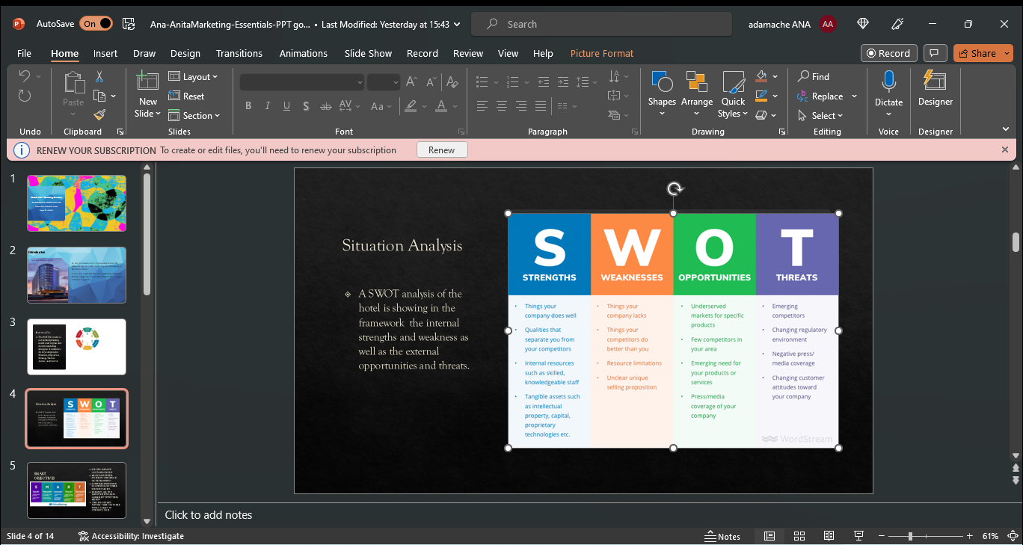

Source: (Shewan, 2022)

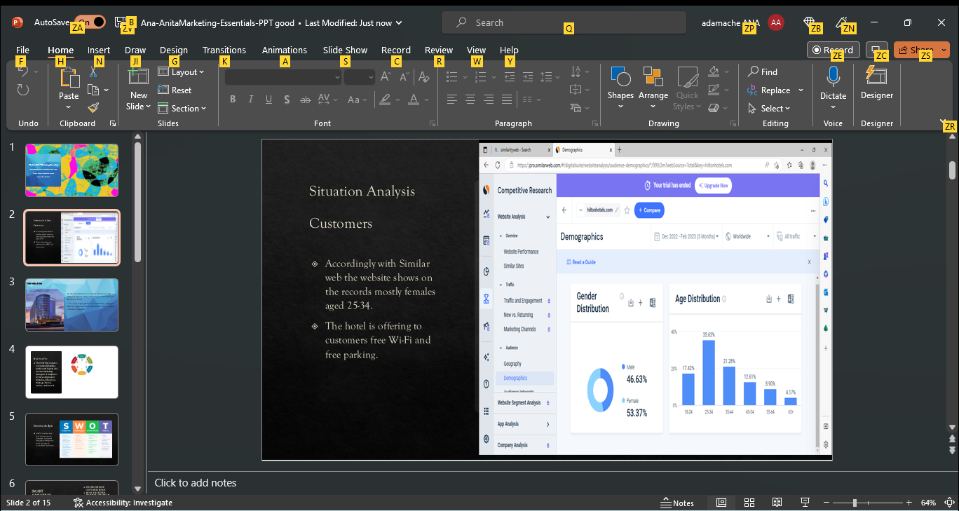
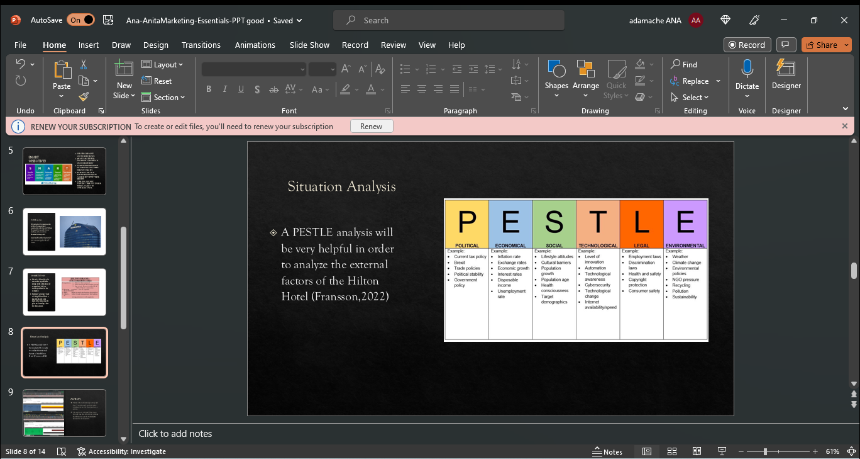

Pestle Framework



