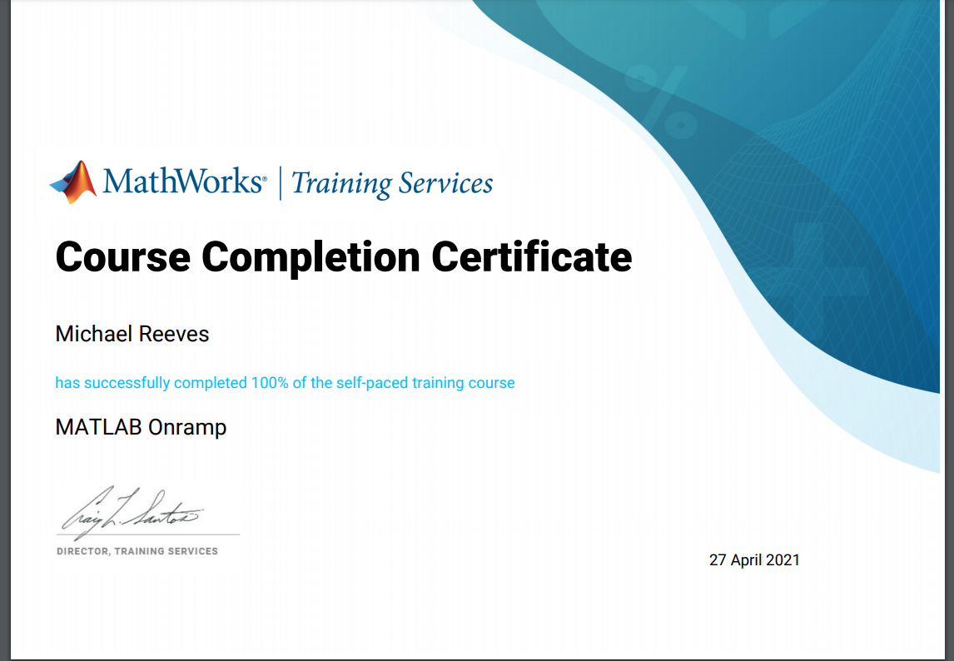
Michael Reeves Workshop and Practice Assignment 1905430 29/04/21
Matlab certificate but need 20 words to be able to submit to turnitin

