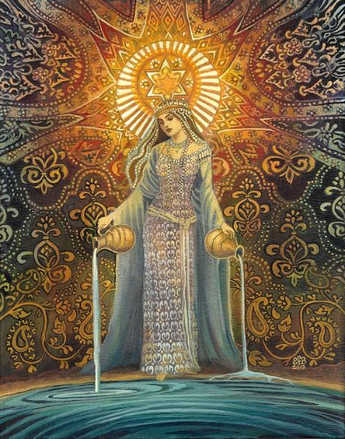
Michelle Smith 0452226 | BA Surface Pattern Design | December 11, 2020

Ways of Thinking
  - Portfolio of writing
Table of Contents
Manifesto writing – 500 words (with images) ………………………………………………………………………………….1
Observational writing (semiotics) 500 words ………………………………………………………………………………….6

Manifesto writing

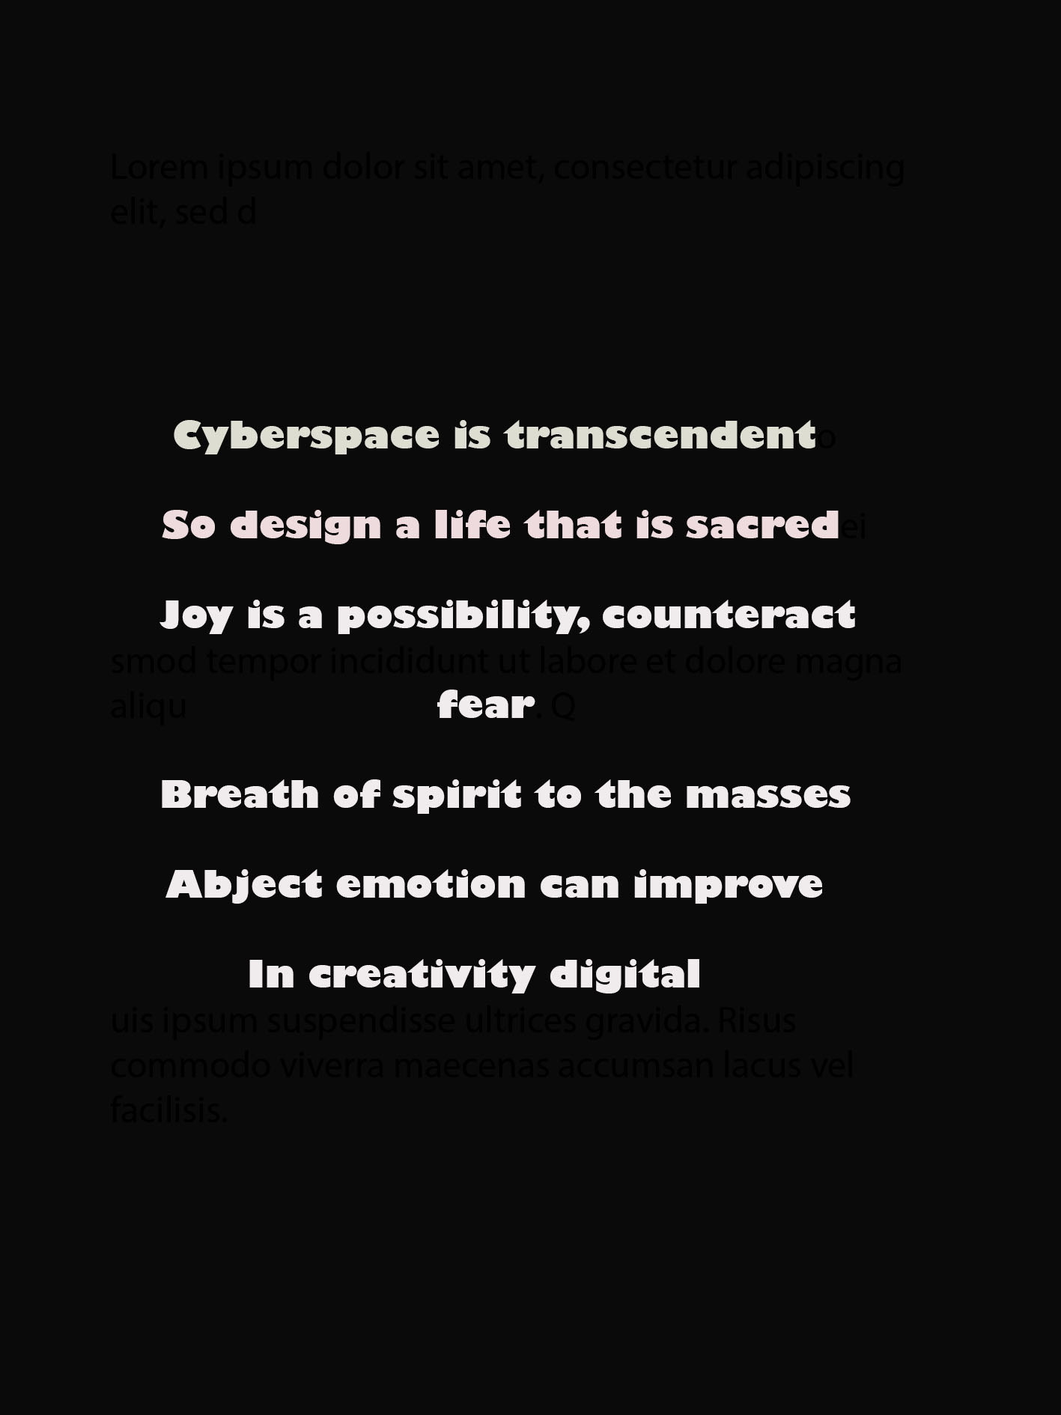

1 Life is sacred and meant to be full of beauty and meaning not just mindless consumerism.

2 Art and creativity transforms. It transforms ourselves and our environment and bad times while preserving and transmitting the good times

3 Product or art and design without soul is like a rotting corpse. Abject! This design work is the process of improving our current reality by injecting spirit into the corpse of materialism.

4 We believe in global action by local means to improve the present reality for everyone. Maintaining a local identity while utilizing our increasingly connected globalized world

5 Art is for the masses and is to be enjoyed and produced by the masses

6 We utilize the digital canvas and cyberspace to bring technological art to the masses. Straight into their hands wherever they are on their screens.

7 True creativity is transcendental and takes place in the realm beyond the limitations of matter in the place of spirit and possibility made manifest in the transient digital

8 By acting to create beauty and counteract the fear and hate based programming of our ego we can utilize a collective spiritual birth and help imagine a better future for all.
To describe the corpse of materialism as abject what do we mean? We live in a material world with many distinct qualities, its temporary subject to birth life and death, disease, decay and many things we may consider unpleasant while hiding behind an appealing packaging. According to Julia Kristeva in her book the “Powers of Horror” Abjection is the human reaction caused by the breakdown of meaning in the interaction between the the self and the other – this human reaction is akin to horror or the feeling of being sick, or what we experience with the sensation of skin on milk. It is similar to what you may experience when surveying a corpse, a reminder of our own materiality. So if material life is often abject and horrifying with many fearsome visions for the ego, then this offers the opportunity to experience something more than material life. It is in the material visions of horror that we may find the spiritual, transcendent. Kristeva writes in her book, “powers of horror” “Abjection then wavers between the fading away of all meaning and all humanity, burnt as by the flames of a conflagration and the ecstasy of an ego that, having lost its Other and its objects, reaches at this precise moment of this suicide the height of harmony with the promised land” (J, Kristeva, 1941)
My art can also find familiarity with the primitive art movements that were also part of Dadaism and surrealism. In primitive art then the sacred is mixed up with every day matters automatically, and includes artworks of spiritual matters from ways of living such as shamanism, including gods and goddess and a spiritual world beyond the physical. “Dadas only program was to have no program” (Evan Maurer, 1984) but this lead art to explode in all directions. The Dadaists were also reacting to the horrors of material life in that they had been emersed in war for years and felt that logic had lead them to this sorry state so they utilized natural forces such as random chance and synchronicity in their art which is something I seek to do also. The surrealists were influenced by psychologists such as Freud and Jung, as am I. Freud wrote “ the causation of primitive society is attributed to spirit forces and placed heavy emphasis on …. the power of mental forces to affect the world” (Maurer 1984) So it is this utilization of mental forces, hidden joy, peace, harmony, beyond the conscious in the realms of archetypes in the unconscious and collective unconscious which can be used to improve our reality. There is a change now in our ways of seeing art, in that in the past works would have been viewed in a gallery or in a special installation which enshrined the work. However, in the modern era, works of art are taken out of the gallery and put into the hands of people wherever they are on their screens via the camera and computer and internet. With older works this may lead to a painting being taken out of context but for modern artists there is opportunity to work with this new medium as a transcendent cyberspace. The digital era makes works of art more accessible than ever to the masses where they may otherwise easily see art now as part of their everyday life, on their screens.

Bibliography
Berger, J., 1972. Ways Of Seeing. London: BBC and Penguin.
Kristeva, J (1982) Powers of Horror, An essay on Abjection, New York: Columbia University Press.
Lucie-Smith, E (2001) Movements in art since 1945, New York. Thames and Hudson
Maurer, E., 1988. Dada and Surrealism. In Rubin, W. ed. Primitivism. New York. The museum of modern art, pp 535- 539
Porush, D (1993) Cyberspace, Portal to transcendence, Available at: http://project.cyberpunk.ru/idb/portal_to_transcendence.html (Accessed: 25/11/2020).

Observational Writing

The image I will be writing a semiotic analysis on is below , it’s the Star Goddess 0 Goddess of Hope by Emily Baviliet– I am gathering research for this writing and it will be done soon.

