A Handbook for Early Years Practitioners.
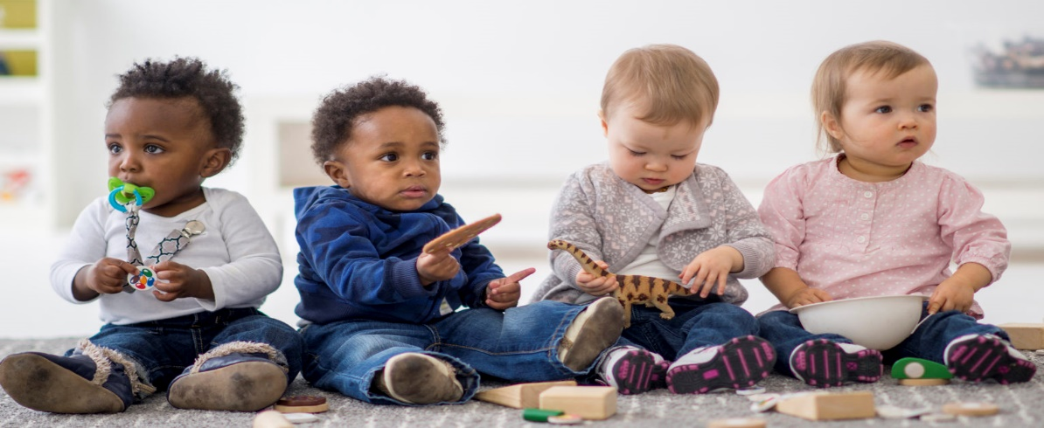
(Source: Tscpl.org, 2020)
This Photo by Unknown Author is licensed under CC BY-SA-NC
The importance of communication in successful transitions.
Emma Graham
Human Development ECEY4001

Contents Page No.

Introduction: Purpose of this handbook Page 3
Transitions in the early years Pages 3-4
The Needs of the Child Pages 5-7
The Role of the Adult: The parent/carer and Pages 8-9
practitioner in partnership.
Interventions: supporting the baby or young child Pages 9-10
and family through the transition process.
The importance of play, environment and the Pages 11-12
unique child.
Outcomes Page 13
References Pages 14-16

Introduction
This handbook is available to support and promote relationships and communication amongst those responsible for the care, development and wellbeing of a baby or young child during transitional periods.
Information within this handbook will support practitioners with best practice to ensure positive transitions for babies, young children and main caregivers. The handbook highlights evidence such as attachment theories, brain development and the significance of positive relationships and effective communication. Evidence shows that these areas play a pivotal role in supporting smooth and positive transitions for babies, young children and families.

Transitions in the Early Years
Transition – “A change or shift from one state, subject, place, etc. to another.”
(Merriam Webster, 2019)

Babies and very young children go through many changes in their earliest years and as they progress to toddlers, young children, adolescents and so on into adulthood. Transitions occur often in everyday life. Transition is a process that should happen gradually. A baby, young child or caregiver should not be expected to suddenly adapt to change. Time and patience are important to allow the brain time to adjust.
Change is the constant theme of transition; while it may be complex, transitions are significant and have an effect. The transition could be a simple move from one room to the next, like leaving the playroom to go to the bathroom for a nappy change or it could be a significant transition from the primary caregiver into a new setting. This change could be difficult for both the baby and the caregiver.
Providing support to babies, young children and caregivers during transitional periods is pivotal. It is typical for babies, young children and caregivers to feel anxious during transitions because of the unknown. According to Myler (2022), experiences that are interpreted by the sensory processing systems from birth produce small, dependable neural networks. The brain doesn't have to work too hard to predict what will happen next when it has a sense of what is about to happen. When a baby or young child is familiar with a caregiver, routine and having needs met the baby is satisfied, it is the anxiety of not knowing if their needs are going to be met when going through transitional stages. When the care giver or environment is consistent the baby feels safe, secure and positive social and emotional connections.
Transitions can be difficult for children and caregivers since it requires those to face uncertainty and give up comfortable, well-known routines. This may lead to insecurities about their needs and entitlements being met (Birth to 5 Matters,2021). All ages and stages of life can be affected by transition anxiety, but young people are more likely to experience it (Cruse Scotland, 2021).
Change does not have to be a negative experience. As professional practitioners, effective early years practice necessitates the communication and planning of positive transitions, these are essential for the emotional well-being and development of all babies and young children. Practitioners demonstrate an understanding that children with Special Educational Needs and/or disabilities, may require more advanced transition plans. All children can receive care of the highest calibres. Special education needs and disabilities (SEND) in children are promptly identified as to receive the additional assistance they require, enabling them to make progress (Gov.uk, n.d.)
During the transitional phase, communication is significant. Effective communication fosters positive relationships and supports the needs of the baby or young child and the family when it comes to the well-being and development of the child. This in turn aids in the child's social and emotional growth. Additionally, this fosters trust and strengthens the relationship that may already exist between the baby, primary caregiver, and practitioner.
Smooth transitions pave the way for successful future changes, promote growth and wellbeing, foster wholesome relationships, and help babies and children embrace a positive sense of identity. Children respond well to transitions that are consistent and lay a strong basis for future learning (ACT Government, n.d.).

The Needs of the child
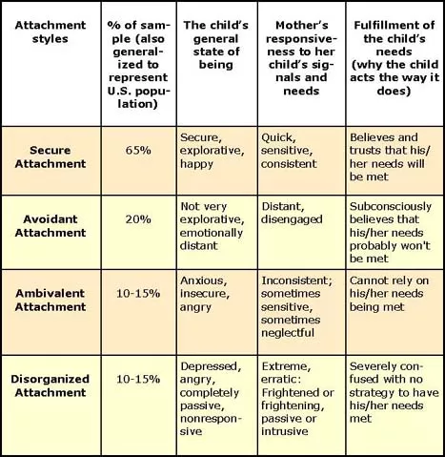
When working with babies and young children, it is important to recognize and value the significance of early relationships. Positive relationships with the main caregiver(s) can help establish a secure attachment and will benefit the child in their future development. Furthermore, this will then support any transitional periods the child experiences throughout their lifetime.
A visual of the four attachment styles.
The original attachment theory developed by psychologist and psychiatrist John Bowlby was refined through research that developmental psychologist Mary Ainsworth started back in the 1960s.
In order to better investigate and evaluate child attachment behavior in a controlled stressful environment, Mary Ainsworth developed the widely recognized lab procedure known as the ‘Strange Situation’ when the babies were approximately one year old.
Ainsworth found that the research found two categories of attachment styles
- Secure attachment
- Insecure attachment
- Avoidant attachment
- Ambivilant attachment
- Disorganised attachment (founded by Mary Main at a later date)
It was suggested that all four of the attachment styles have obvious long-term effects. Our early attachment styles,secure or insecure,have a big impact on who we are now. (Coste,2010)
Ainsworth’s theory suggests that a secure attachment is ideal. Secure attachment with the main caregiver would allow the baby to feel comfortable, enough to interact with those who are unfamiliar without displaying any long-lasting anxiety. However, it would still be considered normal for the young child to display some upset when separated from the main caregiver, but the child would be able to be comforted. Upon the main carers return, the child would be very pleased to see them (Sean MacBlain, 2022).
Image source: Coste, 2010
“Secure attachment typically develops in children in the first eighteen months of life.” (Attachment Project, 2020)
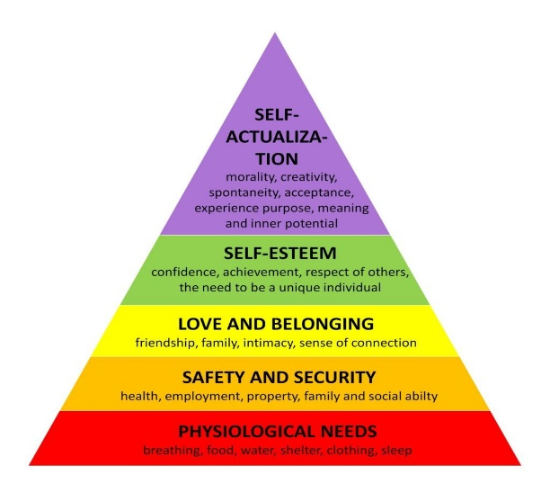
According to the Winnicott theory (1964), a mother's role as the baby's primary caregiver serves a very important purpose. A baby or very young child would not survive if there was no one to care for him/her. Winnicott acknowledges how brain development is supported and a positive relationship is channelled by the primary caregiver's love and care.
Maslow’s Hierarchy of needs pyramid.
Maslow's hierarchy of needs illustrates how, to move up the pyramid, the primary caregiver must first meet the baby's needs at the base. The diagram illustrates the baby's physiological needs, which include air, food, water, shelter, clothes, and sleep. Any human, regardless of size, must have these necessities to survive (Simplypsychology.org, 2023). This supports Winnicott's theory, according to which a baby cannot survive without their mother or primary care giver. Maslow’s theory suggests that these basic needs for the baby need to be met to promote and develop a ‘secure’ attachment with their caregiver. This needs to be consistent to secure the ‘secure’ attachment.
Source: Simplypsychology.org, (2023)
As a practitioner, it is necessary to understand and deliver these basic needs of the child. This, in turn, can help to adopt a positive relationship between the child and the caregiver in the new setting. This will allow the young child to build trust and a ‘knowing’ that his or her needs will be met in the new setting and will begin to feel more at ease and comfortable. Furthermore, allowing the child to develop new relationships, build confidence around the change and the brains plasticity in forming and developing new neural pathways in response to the new experiences. This further supports the brain development in the limbic system which is the centre of emotion, social behaviour and attachment.
As practitioners it is important that we communicate the needs of the child with the parent or main care giver. It can better comprehend and support the developmental growth of the child when families and caregivers interact and share what they see and experience. Inquiring, conversing, and paying attention to the child’s needs and family routines can facilitate continuity from the home to the new setting. Ensuring that the child has their needs met, that they feel safe, secure and loved can support further positive attachments to a parent, keyworker or caregiver within the new setting. This promotes positive relationships between the main caregivers of the young child and the keyworker and maintains consistency for the young child. Supporting parents and caregivers in developing healthy relationships with their children is important for anyone who works with children and families. A child's brain can develop healthily when they play and interact positively with caregivers (NSPCC,2021).

“Young children have a right to form strong emotional attachments to their parents or other caregivers, from whom they seek and require nurturance, care, guidance and protection, in ways that are respectful of their individuality and growing capacities.”
(UNICEF Office of Research - Innocenti, 2019).
It is significant for the new key worker to have good communication with the baby or young child. This can be through facial expression, body language and verbal communication such as smiling, hand gestures, cooing or talking to the young child. The baby will communicate its needs through body language, facial expression or crying (there may be a particular cry for a particular need that needs to be met) an example of this could be a high-pitched cry because of pain or lifting their knees to their tummy as a result of colic. The key worker will become familiar with these methods of communication as they become more aware of the baby and the relationship progresses.
All aspects of an infant's development, including communication, are impacted by relationships. For example, babies and young children learn through relationships what happens when they laugh, cry, or make a scared face. Babies learn to trust their caregivers, share emotions, respond to and regulate strong emotions, recognize the tone of voice and facial expressions associated with different emotions through these regular, appropriate, and individually sensitive interactions. When they receive consistent, loving care from sensitive caregivers, infants build trusting relationships that help them make sense of their social and communicative interactions and help them develop skills. (Virtual Lab School, n.d.)

The Role of the Adult: The parent/carer and the practitioner in partnership.
As early years practitioners, it is our responsibility to ensure that the transitional process is a smooth and positive experience for those involved.
Selecting childcare is an important choice that affects the entire family. The ideal nursery will take care of all your child's daily needs while also assisting them in learning, having fun, and making new friends (Pacey,2015). When a parent or other caregiver actively searches for the right care for their child, the transitional process may begin even before the baby is born, when the parent is in the stages of pregnancy. This will allow the caregiver the opportunity to talk about their preferences and how the nursery could respect and support their needs as a family. The practitioner can discuss routines, dietary restrictions, outings, safeguarding, key worker roles, policies and procedures within the setting, and how the setting can support the needs of the family and the child once they join them.
For a caregiver to make an informed choice, they need to know all this information. An open-door policy is implemented by some nurseries and day care settings, enabling parents and prospective parents to visit, take a tour, and speak with staff members. Relationships between parents and settings, who embrace joyful, transparent, and reliable partnerships, may benefit from this. This may not be the case for all settings. In this instance, practitioners would need to be aware of the policies, and these would need to be followed.
Transitions go more smoothly when there is effective communication. It creates a space for open communication where parents or caregivers can voice their concerns to the care provider in confidence that they will be taken seriously and handled in a secure setting. It could contribute to the safety of the baby or young child. IRIS, (n.d.) suggests that open communication ensures parents and caregivers feel comfortable enough to discuss any issues they may be having, particularly at home, which aids in safeguarding and child protection.
Of course, the needs of the child may be different to what the parent or main caregiver anticipated or previously wished. It is important that this is communicated effectively so that the needs of the young child can be met efficiently. All these steps along with effective communication can alleviate any anxieties that the caregivers may have about leaving their baby. This can help with the transition for the child as this way they will not be susceptible to any built-up anxieties that the parent or caregiver may have experienced should they not have pre visited or communicated with the setting, thus making the transition for the parent/caregiver and the baby a more positive experience. (Off to a flying start an early year’s guide to settling in 2, n.d.)
The role of the allocated key worker is to communicate and plan a settling in period with the caregiver and the setting to start the transition process. Marsh, (2018) states that it is important to be aware that some babies aged between 7 and 12 months may be more aware of strangers and unfamiliar faces, the baby may begin to experience separation anxiety when separated from their main carer and may not be unable to understand that the caregiver will return.

Interventions: supporting the baby or young child and family through the transition process.
- Settling in periods.
This is the opportunity for the baby and caregiver to come into the setting together and stay for a short time. This is the ideal time to introduce the baby to their key worker and for the main caregivers to talk about the child’s needs and routines with the key worker. This way the key worker can also observe the behaviours, likes and dislikes of the baby, and attachment with caregivers. There can be many of these settling in periods, as much that is needed for the successful transition. This will also support developing relationships between the caregiver and the key worker allowing for transparency between the caregiver and setting. Pacey (2018) suggests that a solid collaboration between caregivers and/or parents and practitioners is beneficial to children.

- Stay and play.
Another opportunity to settle the baby or young child, with the parent leaving them for a short period of time initially. This time can be built up gradually to support the needs of the baby, this will vary from child to child. This will also help develop the relationship between the baby and the key worker and help to form a secure attachment. Pacey, (2015) recommends that the baby is aware that you are handing them into the care of a new caregiver. Parents/ caregivers should say goodbye and reassure their child that they will be back, although some children may not yet have this understanding. The baby will learn over time that the caregiver will return (Marsh, 2018). At the end of these sessions the key worker should discuss any how the session went or any concerns. If the baby is very distressed, it may be that the caregiver is contacted, and the session is shortened.

- Transitional objects
The baby or young child may have an item such as a soft toy, blanket or a caregiver’s item of clothing, in which this can bring comfort to the baby whilst the parent is not around. Winnicott’s theory suggests that transitional objects are those that an infant creates or discovers for comfort and to support the developmental need to separate from their primary caregiver (Litt, 1986).
As the baby or young child becomes familiar with the key worker and the environment, a trust will begin to develop, and the baby will feel more comfortable in being left. As a result, settling quicker and being able to adjust to the changes. Throughout the child's stay, under the key worker's care, the practitioner has an obligation to make every effort to stay in communication with the parent about the child's needs and to share information about the child and their day, reporting and concerns or updates to their development. The parent or main care giver has the responsibility of informing the key worker of any changes to routine or transitions which may be happening in the home environment. For example, being moved from parent’s bedroom into their own bedroom or transitioning from pureed food to lumpier foods. This is so the key worker can maintain consistency, supporting the dietary change and ensuring kitchen staff are aware to prepare the food in advance. The key worker or staff member will be aware of the bedtime routine change and be available to support the baby during nap time should they become distressed or unsettled.
Transitional objects are these unique comforts. They assist babies and children in emotionally moving from reliance to self-sufficiency. They function in part because they are pleasant to the touch, cuddly, and soft. Another reason for their effectiveness is familiarity. Your child's scent clings to this as a reminder of the safety and comfort of their room.
(HealthyChildren.org, 2019)

Image source: HealthyChildren.org, 2019.

The importance of play, environment and the unique child
Pacey, (2018) recommends that childcare providers should establish a supportive atmosphere for the babies and children in their care, in addition to adhering to the fundamental health and safety regulations. Children learn and develop best in supportive environments with guidance and instruction from adults who attend to their unique needs and interests and help them to develop. When they are loved and given proper care, babies, toddlers, and young children flourish (GOV.UK, n.d.).
It is the role of the practitioner to provide a loving, nurturing environment for all children, taking into consideration any medical, cultural, religious, dietary or social factors, regardless of gender, additional needs or disability. All experiences within the setting should be positive and stimulating, paving the way for further, healthy brain development.
“For the exercise of their rights, young children have particular requirements for physical nurturance, emotional care and sensitive guidance, as well as for time and space for social play, exploration and learning.” (UNICEF Office of Research - Innocenti, 2019)


A child creates more than a million new brain connections every second during the first three years of their existence. These connections must be triggered for them to flourish. During this period, parents and other caregivers have a special opportunity to mold their baby's brain. Serve and return, a type of meaningful back-and-forth interaction, is one of the most effective ways to accomplish this. (Anon, n.d.)
The First Three Years: A Critical Window for Development.
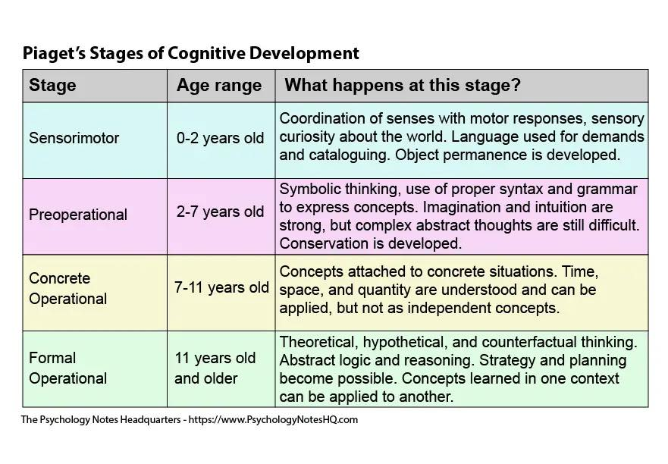
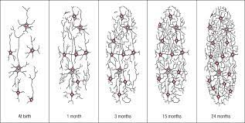
Appropriate amounts of stimulation can vary by baby, some babies may be able to tolerate more and some less. Sensory stimulation is important for early development. According to Nortje (2021), Piaget believed that cognitive development occurred in stages. One of the four stages of Piaget’s theory of cognitive development focuses on the sensorimotor stage, which goes from birth to around two years. It is throughout this stage that babies learn through using their senses. The babies and young children will use their senses to explore the world and environment, usually by using their mouth, touching objects or trying to get the objects to make a sound by banging them together. Consistent exposure to these stimuli, creates synapses (neural connections) in the brain. Synapses are microscopic electrical connections made by brain activity. The number of synapses that form in a baby or young child is directly influenced by the amount of stimulation they receive. These connections become permanent and stronger with repeated and consistent stimulation. This supports focus and recall ability. It enables the young child to comprehend situations and the responses of others. It improves their capacity for self-determination, empathy, and other social and relational skills. (OPENMINDS Psychiatry, Counselling & Neuroscience Centre, 2022)
Image source: Anon, n.d.
Image source: Main, 2022
Neuron Networks
Image source: revelpreview.pearson.com, n.d.
Babies and young children who don't experience basic interactions that excite and stimulate them often experience developmental delays. Intellectual delay is one of the minor psychological, emotional, and social consequences of minimal stimulation. However, should a baby or young child become overstimulated, this can result in the baby becoming tired and irritable. Young children need an appropriate duration of stimulation and rest.
GOV.UK, (n.d.) recommends that babies and young child are given the chance to play and explore freely, both inside and outside, with resources that are appropriate for their age and stage. This will enable them to benefit from hands-on learning while also developing their self-regulation. Opportunity to explore open-ended resources that can be utilised in a variety of ways, childcare providers and practitioners should make an effort to assist infants, toddlers, and young children in developing their own ideas.

Outcomes
When it becomes evident that a baby or young child is settled, the transition will be deemed successful. This will become clear when the baby or young child starts to regulate better during drop-off times. They will also start to form relationships with other staff members and become less reliant on the key person. Now that they are more at ease in their surroundings, the baby might exhibit signs of contentment when left, opting to explore with freedom and assurance. The child may also be developing an understanding that their parent or caregiver always comes back. Overall, the child will be happy, meeting milestones and engaging whilst developing new skills.
The practitioner can assess how the baby or young child is settling by making regular observations of the well-being and level of involvement during the sessions. This can then be relayed to the parent/caregiver at the end of the session. This will further support the relationship between the parent/caregiver, baby/ young child and practitioner.

“A successful transition is when a baby or toddler feels confident, comfortable, engaged and included in their environment.”
(Source: beyou.edu.au, n.d.)

References
Anon, (n.d.). The First Three Years: A Critical Window for Development. [Image] Available at: https://babysparks.com/2019/02/11/your-childs-rapidly-developing-brain/. (Accessed:28th November 2023)
‌ACT Government (n.d.). Effective transitions - Education. [online] Available at: https://www.education.act.gov.au/early-childhood/set-up-for-success-an-early-childhood-strategy-for-the-act/effective-transitions. (Accessed: 23rd November 2023)
Attachment Project. (2020). The Attachment Project: Learn Attachment Theory from Experts. [online] Available at: https://www.attachmentproject.com/. Accessed: 25th November 2023)
beyou.edu.au. (n.d.). Transitions for Babies and Toddlers. [online] Available at: https://beyou.edu.au/fact-sheets/development/transitions-for-babies-and-toddlers. (Accessed: 28th November 2023)
‌Birth To 5 Matters. (2021). Transitions-Birth To 5 Matters. [online] Birth to 5 Matters. Available at: https://birthto5matters.org.uk/transitions/ (Accessed: 7th November 2023)
Coste, B. (2010). The Four Infant Attachment Styles Spot On! [online] Positive Parenting Ally. Available at: https://www.positive-parenting-ally.com/attachment-styles.html. (Accessed: 27th November 2023)
‌Cruse Scotland (2021). The Impact of Transitions and How to Cope with Them: Cruse Bereavement Care. [online] Available at: https://www.crusescotland.org.uk/about-us/news-and-blogs/the-impact-of-transitions-and-how-to-cope-with-them/#:~:text=In%20transitions%2C%20it%20is%20common,familiar%20and%20known%20ways%20behind. (Accessed: 13th November 2023).
GOV.UK. (n.d.). Development Matters. [online] Available at: https://www.gov.uk/government/publications/development-matters--2/development-matters#introduction. (Accessed: 28th November 2023)
HealthyChildren.org. (2019). Transitional Objects. [Image] Available at: https://www.healthychildren.org/English/ages-stages/baby/Pages/Transitional-Objects.aspx. (Accessed: 28th November)
‌IRIS. (n.d.). Early Years – communicating with parents is the key to success. [online] Available at: https://www.iris.co.uk/blog/education/early-years-communicating-parents-key-success/#:~:text=Effective%20communication%20makes%20transitions%20throughout. (Accessed: 25th November 2023)
Litt, C.J. (1986). Theories of Transitional Object Attachment: An Overview. International Journal of Behavioral Development, [online] 9(3), pp.383–399. doi:https://doi.org/10.1177/016502548600900308. (Accessed: 25th November 2023)
‌MacBlain, S. (2021). Learning Theories for Early Years Practice. 2nd edn. London: SAGE.
Main, P. (2022). Jean Piagets theory of Cognitive Development. [image] www.structural-learning.com. Available at: https://www.structural-learning.com/post/jean-piagets-theory-of-cognitive-development-and-active-classrooms. (Accessed:28th November 2023)
‌Marsh, L. (2018). Developmental milestones separation and independence in babies. [online] BabyCentre UK. Available at: https://www.babycentre.co.uk/a6577/developmental-milestones-separation-and-independence-in-babies. (Accessed:23rd November 2023)
‌Merriam-Webster (2019). Definition of TRANSITION. [online] Merriam-webster.com. Available at: https://www.merriam-webster.com/dictionary/transition. (Accessed: 7th November 2023)
Myler, C. (2022). Tricky transitions – why they happen, what can help. [online] Maggie Dent. Available at: https://www.maggiedent.com/blog/tricky-transitions-why-they-happen-what-can-help/ (Accessed 14th November 2023)
McLeod, S. (2023). Maslow’s Hierarchy of Needs. [online] Simply Psychology. Available at: https://www.simplypsychology.org/maslow.html.
NSPCC (2021). Attachment and child development. [online] NSPCC Learning. Available at: https://learning.nspcc.org.uk/child-health-development/attachment-early-years. (Accessed: 25th November 2023)
Off to a flying start an early years guide to settling in 2. (n.d.). Available at: https://www.wiltshire.gov.uk/media/4692/Five-to-Thrive-Settling-In-Book/pdf/Five_to_Thrive_-_Settling_In_Book_FINAL.pdf?m=637354219429770000#:~:text=Settling%20in%20visits. (Accessed:27th November 2023)
‌OPENMINDS Psychiatry, Counselling & Neuroscience Centre. (2022). Importance of Early Childhood Stimulation -. [online] Available at: https://www.openmindscenter.com/early-childhood-simulation/. (Accessed: 28th November 2023)
‌Pacey (2015). Helping your child settle in. [online] Pacey.org.uk. Available at: https://www.pacey.org.uk/parents/working-with-your-childcarer/helping-your-child-settle-in/. (Accessed: 27th November 2023)
Pacey.org.uk. (2018). A safe and fun environment. [online] Available at: https://www.pacey.org.uk/parents/the-best-care-for-your-child/a-safe-and-fun-environment/. (Accessed:28th November 2023)
‌revelpreview.pearson.com. (n.d.). The Nervous System and Brain: The Foundations of Development. [online] Available at: https://revelpreview.pearson.com/epubs/pearson_feldman/OPS/xhtml/ch05_sec_03.xhtml (Accessed 28 November 2023).
‌Simplypsychology.org. (2023). [Image] Available at: https://www.simplypsychology.org/wp-content/uploads/maslow-needs3-1024x1024.jpg.
Tscpl.org. (2020). [Image] Available at: https://tscpl.org/wp-content/uploads/2020/02/toddlers-playing-508407558_crop-1536x758.jpg (Accessed: 25th November 2023).
‌UNICEF Office of Research - Innocenti (2019). The Convention on the Rights of the Child. [online] Unicef-irc.org. Available at: https://www.unicef-irc.org/portfolios/general_comments/GC7.Rev.1_en.doc.html. (Accessed: 23rd November 2023)
‌ Virtual Lab School (n.d.). Communication: An Introduction | Virtual Lab School. [online] Available at: https://www.virtuallabschool.org/infant-toddler/communication-and-language-development/lesson-1#:~:text=Through%20these%20consistent%2C%20appropriate%20and (Accessed: 25th November 2023).
‌Winnicott, D. (1964) The Child, The Family and the Outside World. London: Penguin

‌

