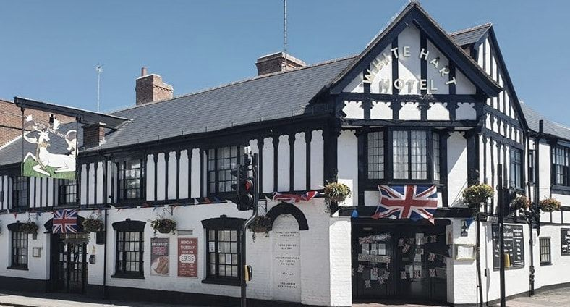  The White Hart Hotel, Witham | Level 6 Hotel Placement – Weekly Progress Tracker  Student Name: VICTORIA CHILIANU  Student ID Number: 2208500  The Module Title: Managing Guest Service Operations (BMIH6003)  Lecturer’s Name: KATHRYN ROBERTS

Acknowledgement of AI tool use

I acknowledge the use of Grammarly (https://www.grammarly.com/) on 15 January 2025 to check my work using the prompt:
- Please check the text for readability, grammar, and syntax.
i.e.,
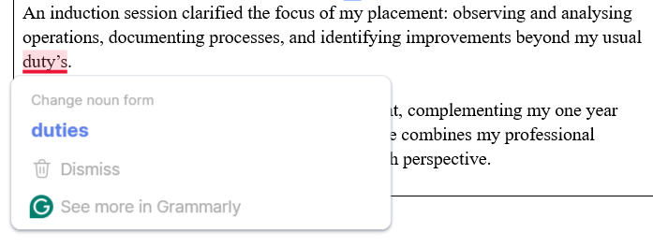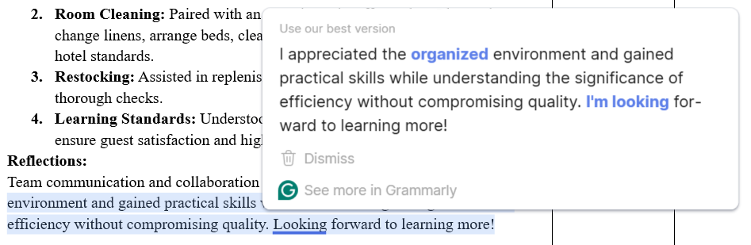
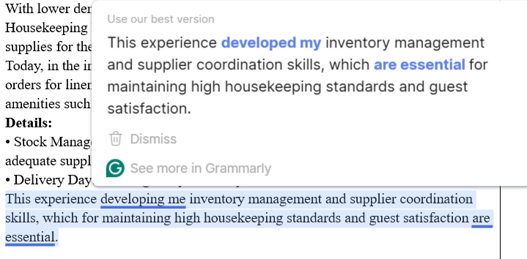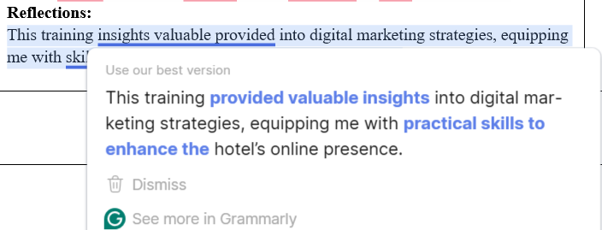
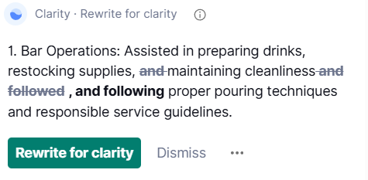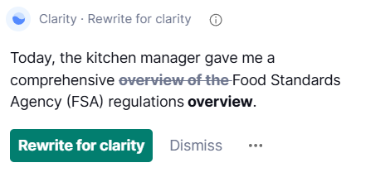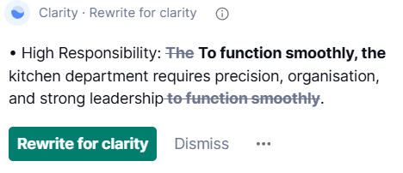
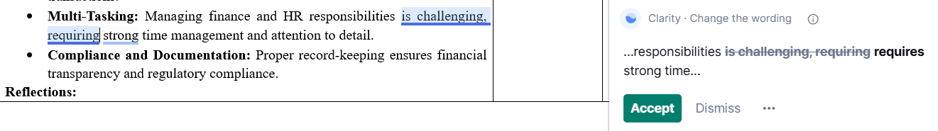
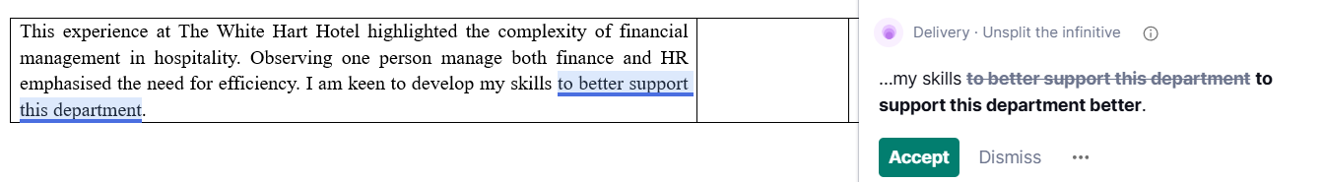
I confirm that I have not presented any AI-generated text as my own work. I confirm I have copies of my drafts, notes, and other resources I used before, and after the use of AI tools which I may be asked to provide in evidence.

I acknowledge the use of the Snipping Tool (https://markuphero.com/) on 15 January 2025 to write my notes into submission format using the prompt:
- Facilitate the inclusion of relevant images and screenshots, enhancing the document's clarity and visual appeal.
(i.e., Cover Page, Acknowledgement of AI tool, and Signatures).
I confirm that I have not presented any AI-generated text as my own work. I confirm I have copies of my drafts, notes, and other resources I used before, and after the use of AI tools which I may be asked to provide in evidence.
Weekly Progress Tracker

Week 1
Experiences/Tasks/Challenges/Lessons | Shift  (Date/Time) | Student Signature | Hotel Mentor Signature
Induction Day:  Today marked the start of my university placement, complementing my one year and four months as a Duty Manager. This new role combines my professional experience with academic insights, offering a fresh perspective.  1. Trainee Role  An induction session clarified the focus of my placement: observing and analysing operations, documenting processes, and identifying improvements beyond my usual duties.  2. Policy Review  Revisiting internal standards from an academic perspective highlighted their alignment with my studies and relevance to my final report.  3. Responsibilities  In addition to my regular tasks, I’ll evaluate check-in efficiency, guest satisfaction, and departmental collaboration while developing an improvement plan.  4. Reflections  It was insightful to realise that, even after over a year with the team, there are aspects of the operation I hadn’t previously considered from a student’s perspective. Today’s observations were focused on identifying operational strengths and areas that could benefit from optimisation. My colleagues were very supportive and offered valuable encouragement for this new role.  5. Impressions and Goals  This placement offers an exciting opportunity to apply theory to practice, grow professionally, and contribute innovative ideas to the team.  The induction day reinforced my passion for working at this hotel. While I’m already familiar with its operations, this placement pushes me to see things differently and contribute fresh ideas to the team’s growth. | 15 Jan 2025  9 am – 5 pm |  | Dave Arnott  
Back Office (Housekeeping):  Today, I continued learning the importance of details in delivering an excellent guest experience.  Activities:  - Morning Briefing: Tasks were assigned, and room preparations were outlined.  - Room Cleaning: Paired with an experienced staff member, I learnt to change linens, arrange beds, clean bathrooms, and ensure all details met hotel standards.  - Restocking: Assisted in replenishing towels, soaps, and essentials, ensuring thorough checks.  - Learning Standards: Understood the importance of maintaining quality to ensure guest satisfaction and high ratings.  Reflections:  Team communication and collaboration are vital. I appreciated the organised environment and gained practical skills while understanding the significance of efficiency without compromising quality. I am looking forward to learning more! | 16 Jan 2025  9 am – 5 pm |  | Sarah Lambeth

Week 2
Experiences/Tasks/Challenges/Lessons | Shift  (Date/Time) | Student Signature | Hotel Mentor Signature
Front Office (Reception):  Activities:  - Morning Routine: I reviewed the previous day’s reports, including room occupancy, guest requests, and reservation statuses. This essential routine ensures smooth shift handovers and helps avoid errors.  - Check-in and Check-out: I assisted early arrivals and ensured timely room turnovers while providing a personalised guest experience. Special attention to communication and a friendly tone resulted in positive guest feedback.  - Team Support: Familiar with all Front Office processes, I supported a new colleague, helping them adapt and understand their responsibilities.  - Problem-Solving: I managed a guest requesting a room change due to mismatched preferences, intervening promptly to find a satisfactory solution.  Reflections:  My familiarity with Front Office tasks enables me to spot areas for improvement. For instance, I identified a need to optimise how last-minute requests are managed. Implementing a digital communication system between departments could address this, as the White Hart lacks such software. The day was productive. I focused on enhancing guest experiences and supporting the team. This practice inspires me to keep developing professionally and contribute to the hotel’s success. | 21 Jan 2025  9 am – 3 pm |  | Tia Louise Brandreth  
FOH (Events Management):  Today, I worked alongside the hotel manager in the Events Department, focusing on organising and managing events in our Function Room. It was an insightful day that offered hands-on experience in this vital area of the hotel’s operations.  Activities:  - Elaboration Contracts: I observed how client contracts are created, detailing services, event timelines, guest numbers, and other logistics. Clear communication and attention to detail were emphasised as crucial.  - Venue Setup: I assisted in decorating the event space for an upcoming private function. This involved arranging tables and chairs to match the client’s preferences and ensuring the room looked polished and inviting.  - Recommending a DJ: A client requested a DJ for their event, and the manager provided options from a trusted network of collaborators. Maintaining such reliable partnerships is key to client satisfaction.  Takeaways:  - Efficient Coordination: Clear communication with the team and clients ensures smooth event execution.  - Creativity and Flexibility: Customising decorations and setups to suit clients’ needs is a vital skill.  - Relationship Management: Strong ties with suppliers and partners, such as DJs, enhance service quality.  Reflections:  This experience highlighted the complexity and creativity involved in event planning. It motivated me to further develop my organisational and communication skills within this dynamic department. | 22 Jan 2025  9 am – 5 pm |  | Joanne Street  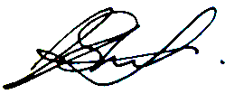

Week 3
Experiences/Tasks/Challenges/Lessons | Shift  (Date/Time) | Student Signature | Hotel Mentor Signature
F&B (Cellar Management):  Today, I gained hands-on experience in cellar maintenance, focusing on key tasks that ensure the bar operates efficiently and serves quality beverages to guests.  Activities:  - Gas Cylinder Management: I learnt how CO₂ and mixed gas cylinders are accustomed to dispensing beer. The mentor explained safe handling, replacing cylinders, and checking pressure levels to ensure consistent flow and carbonation and prevent service interruptions.  - Stock Rotation and Organisation: Assisted with keg rotation by delivery dates to reduce waste, emphasising a tidy cellar for safety and efficiency.  - Cooling Systems Inspection: Observed inspections to maintain correct beer temperature, ensuring drink quality through regular checks.  Takeaways:  - Safety Protocols: Proper handling of gas cylinders and awareness of pressure systems are crucial for maintaining a safe work environment.  - Efficiency: A well-organised cellar and properly functioning equipment reduce downtime and enhance staff productivity.  Reflections:  This day provided valuable insights into cellar maintenance’s technical and operational aspects. It highlighted how these behind-the-scenes efforts contribute to the overall guest experience and the smooth running of bar operations. | 27 Jan 2025  8 am – 10 am |  | Dave Arnott
Back Office (Maintenance):  Today, I joined the Maintenance Department and focused on addressing a specific issue impacting the restaurant: an unpleasant odour caused by a drainage problem.  Activities:  - Identifying the Issue: I observed the team locate the odour source, which was traced to a drainage blockage. This highlights the importance of thorough inspections.  - Resolving the Problem: Assisted in cleaning the drainage system and applying treatments, gaining hands-on technical experience.  - Preventive Measures: Learnt about regular cleaning and inspections to prevent future issues and maintain a pleasant environment.  Takeaways:  - Teamwork and Coordination: Effective department collaboration is essential for quickly resolving operational issues.  - Attention to Detail: Identifying and addressing the root cause of the problem ensures long-term solutions.  - Customer Experience: Maintaining a clean and welcoming environment in the restaurant is vital for guest satisfaction.  Reflections:  This experience in the Maintenance Department underscored the importance of proactive problem-solving and teamwork in ensuring the hotel operates smoothly and maintains high standards for guests. | 28 Jan 2025  9 am – 3 pm |  | Pete Hearn  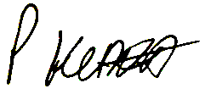
FOH (Bar and Restaurant):  Today, I gained hands-on experience in the bar and restaurant, focusing on service efficiency, customer interaction, and teamwork.  Activities:  - Bar Operations: Assisted in preparing drinks, restocking supplies, maintaining cleanliness, and following proper pouring techniques and responsible service guidelines.  - Restaurant Service: Took orders, served food, and engaged with guests to ensure a pleasant dining experience. Paid attention to presentation, timing, and customer preferences.  - Team Coordination: Communicated with kitchen staff and bartenders to ensure a smooth service flow and quick problem-solving.  Reflections:  - Speed and accuracy are essential in food and beverage service.  - Strong customer service skills enhance guest satisfaction.  - Teamwork and communication contribute to efficiency and a positive work environment.  It was a productive day reinforcing the importance of high-quality service in hospitality! | 29 Jan 2025  9 am – 7 pm |  | (Bar)  Taylor Hopkins    (Restaurant)  Tia Louise Brandreth
F&B (Beer Line Cleaning):  Today, I focused on beer line cleaning, an essential maintenance task to ensure the beer remains fresh, free from bacteria, and served at its highest quality.  Safety Measures:  Before starting the cleaning process, I ensured all necessary equipment was prepared, including:  - Beer line cleaning solution  - Large cleaning container (bucket)  - Protective gloves and safety goggles  - Brushes and cloths for tap cleaning  - CO2, 70/30 and 60/40 gases shut-off valves and couplers  I also followed key safety measures, such as turning off the CO2, 70/30, and 60/40 gas systems to avoid pressure-related hazards and wearing gloves to handle the cleaning solution safely.  Cleaning Process:  - Shutting Down the System: To prevent spills, the kegs were disconnected, the gas was turned off, and the pressure was released.  - Flushing the Lines with Water: Flushed beer lines with water until clear before adding cleaning solution.  - Applying the Cleaning Solution: Mix the cleaner with water, pump through the lines, and let it sit for 10–15 minutes.  - Scrubbing the Taps and Couplers: Scrubbed taps, couplers, and nozzles to remove buildup for a clean pour.  - Rinsing Thoroughly: Flushed lines with water to remove all cleaner, ensuring safe, great-tasting beer.  - Reconnecting and Testing: We reconnected the kegs, restored the gas supply, pulled fresh beer, and checked for leaks.  Reflections:  Regular beer line cleaning (typically every 7–10 days) prevents buildup and ensures fresh beer. Following exact procedures avoids contamination, while teamwork improves efficiency. Today’s experience highlighted the importance of maintenance in bar operations, enhancing quality and customer satisfaction. I feel more confident and ready to apply these skills in future shifts. | 30 Jan 2025  8 am – 11 am |  | Dave Arnott

Week 4
Experiences/Tasks/Challenges/Lessons | Shift  (Date/Time) | Student Signature | Hotel Mentor Signature
Back Office (Housekeeping Management):  With lower demand in January compared to the summer months, the Housekeeping Department takes this opportunity to conduct inventory checks and restock essential supplies for the busier period ahead.  Today, I participated in the inventory process. I was allowed to independently place orders for linen (County Linen (Chelmsford)), cleaning chemicals, and in-room amenities such as biscuits, tea, water, and coffee (Booker (Chelmsford)). The order was submitted via email and website and required confirmation and a personalised response.  Key Details:  - Stock Management: Orders are placed every Tuesday morning to maintain adequate supplies.  - Delivery Day: Every Thursday morning.  This experience developed my inventory management and supplier coordination skills, essential for maintaining high housekeeping standards and guest satisfaction. | 4 Feb 2025  9 pm – 3 pm |  | Sarah Lambeth
Back Office (Sales and Marketing):  I participated in social media training focusing on strategies to enhance the hotel’s online presence and engagement.  Activities:  - Understanding Brand Identity: Reviewed the hotel's branding, target audience, and tone of voice for social media communication.  - Content Creation and Scheduling: Learnt how to design engaging posts (i.e., high-quality images and captions using Pixabay and Google Pixel), use hashtags effectively, and schedule content for optimal reach (i.e., Meta Business Suite).  - Analytics and Performance Tracking: Explored tools for measuring engagement, tracking trends, and adjusting strategies based on audience insights (i.e., likes, shares, comments).  - Crisis Management and Customer Interaction: Discussed best practices for handling online reviews, responding to guest enquiries, and maintaining a positive digital reputation (i.e., promotions and food challenges).  Takeaways:  - Consistency and engagement drive social media success.  - High-quality content and data analysis improve reach.  - Positive interaction with guests boosts the hotel’s reputation and bookings.  Reflections:  This training provided valuable insights into digital marketing strategies, equipping me with practical skills to enhance the hotel’s online presence.  I participated in social media training focusing on strategies to enhance the hotel's online presence and engagement. | 4 Feb 2025  6 pm – 8 pm |  | Joanne Street
Back Office (Finance and HR):  This week, I gained valuable insight into the finance operations of The White Hart Hotel, learning key processes and systems used for financial management.  Activities:  - Till Reconciliation: Learnt how to calculate the three tills for the following day, ensuring each contains £150.  - SAGE Software: Observed how all costs and bank revenues are recorded.  - Supplier Management: Reviewed the hotel’s suppliers and how payments are processed.  - VAT Extraction and Documentation: Learnt how VAT is calculated and the required retention period for financial records.  - Payroll and HR Duties: Since one person handles finance and HR at The White Hart, I was also shown how staff salaries and annual leave entitlements are calculated.  Takeaways:  - Accuracy and Organisation: Financial tasks require precision, from reconciliation to VAT calculations and payroll management.  - SAGE Software: A vital tool for recording costs, revenues, and supplier transactions.  - Multi-Tasking: Managing finance and HR responsibilities requires strong time management and attention to detail.  - Compliance and Documentation: Proper record-keeping ensures financial transparency and regulatory compliance.  Reflections:  This experience at The White Hart Hotel highlighted the complexity of financial management in hospitality. Observing one person manage both finance and HR emphasised the need for efficiency. I am keen to develop my skills to support this department better. | 5 Feb 2025  9 pm – 6 pm |  | Tracy Arnott  
Week 5
Experiences/Tasks/Challenges/Lessons | Shift  (Date/Time) | Student Signature | Hotel Mentor Signature
F&B (Kitchen Management):  Today, the kitchen manager gave me a comprehensive overview of Food Standards Agency (FSA) regulations. It was an informative rather than practical day, focused on understanding the structure and operations of the kitchen.  We discussed each kitchen staff member, their roles, and their qualifications. I was also introduced to the seven suppliers we work with, five of whom deliver weekly and two on an occasional basis. These include James Fruit and Vegetables Farm, Booker, Brakes, Clip Meats, and Traymoor.  I was given the latest monthly order and daily count forms, which took me a few hours to understand fully. The detailed record-keeping and stock management required in the kitchen is an enormous responsibility.  Additionally, I was introduced to the kitchen cleaning procedures and how towels are managed. Since today was mainly theoretical, I was assured that next week, I would have a practical session where I would apply my knowledge—from checking food temperatures on delivery to organising stock across the nine fridges and four freezers.  Takeaways:  - Regulations & Compliance: Strict adherence to FSA guidelines is crucial for maintaining food safety standards.  - Supplier Coordination: Understanding order schedules and stock control is key to efficient kitchen management.  - Record-Keeping: Maintaining detailed order and stock records is vital but time-consuming.  - High Responsibility: To function smoothly, the kitchen department requires precision, organisation, and strong leadership.  Reflections:  This was one of my placement's most fascinating and challenging days. The kitchen department carries immense responsibility, requiring extensive knowledge and strict procedures. Ten weeks wouldn’t be enough to fully grasp kitchen management's complexities. | 11 Feb 2025  9 pm – 3 pm |  | Lisa Wilcox  
FOH (Bar):  As the bar opens at 11:00 am (Monday-Saturday), I spent the first two hours with the Duty Manager checking stock replenishment, which is usually done the night before. We went to the cellar to turn on the necessary gas for beer and soda and then received a stock delivery. During this process, we checked and signed all the required paperwork and had to return a case of six white wine bottles as one was damaged.  Activities:  Weekly Tasks – Wednesday:  - Staff cleaned all mirrors and rearranged the spirit’s display.  - Checked fridge temperatures for chilled drinks.  - Prepared the bar area, updating menus, promotions, and supplier-sponsored displays.  - Guinness provided promotional materials in support of the Rugby games.  I was also introduced to the cocktail menu and learnt the different pouring techniques for draught beers, as each has its own method. As the day was relatively quiet, I had the chance to learn gradually and retain key knowledge about working with alcohol. Additionally, I was given the alcohol supplier list and informed about delivery schedules. Key suppliers include Greene King, Booker, Matthew Clark, Mighty Oak, and Crouchvale Brewery.  Takeaways:  As a Duty Manager, my role usually focuses on the restaurant, but today, I gained valuable insights into bar operations, alcohol service, and licencing laws. I learnt about the following:  - Legal regulations regarding underage customers in the bar area.  - Service speed and efficiency in a busy environment.  - Recognising signs of overconsumption and how to handle such situations.  - Quality Control: Verifying deliveries and handling supplier returns ensure high standards.  - Bar Organisation: A clean, well-presented bar with updated promotions enhances customer experience.  Reflections:  This experience strengthened my knowledge of bar operations, supplier coordination, and responsible alcohol service, helping me develop skills beyond my usual restaurant-focused duties. Overall, this experience enhanced my confidence in bar operations, and I look forward to applying this knowledge to support the team more effectively. | 12 Feb 2025  8:30 am – 6 pm |  | Taylor Hopkins

Week 6
Experiences/Tasks/Challenges/Lessons | Shift  (Date/Time) | Student Signature | Hotel Mentor Signature
F&B (Kitchen Management):  Since hotel guests have breakfast between 7:00 – 9:00 AM (Monday to Friday) and 8:00–10:00 AM (Saturday and Sunday), the kitchen must be fully prepared to take orders from 7 AM. To better understand the morning procedures, I started my shift at 6:30 AM alongside the kitchen manager, who guided me through each step of the opening routine.  Activities:  - Opening Procedures: Switched on lights, fans, and gas supply, then dressed in the appropriate kitchen uniform.  - Daily Forms and Safety Checks: Completed and signed daily records, including:  - Checking and recording fridge and freezer temperatures.  - Inspecting and activating kitchen equipment to ensure functionality.  - Confirming the availability of cleaning chemicals and essential supplies.  - Stock and Order Management:  - Reviewed order forms, as Monday and Wednesday are the designated ordering days.  - Assessed current stock levels and made necessary adjustments based on booking forecasts.  - Placed supplier orders for small local businesses using WhatsApp messaging and online orders for larger suppliers.  Takeaways:  - Organisation is Key: Efficient morning routines ensure the kitchen operates smoothly for breakfast service.  - Accuracy in Stock Management: Understanding inventory levels and booking forecasts is crucial for minimising waste and ensuring availability.  - Supplier Coordination: Different ordering methods are used based on supplier size and structure, highlighting the importance of flexibility in procurement.  - Compliance and Safety: Regular equipment checks and temperature monitoring are essential for maintaining food safety standards.  Reflections:  This experience gave me a deeper understanding of the morning kitchen routine and its importance in maintaining smooth service. I realised how organisation, efficiency, and attention to detail are crucial in ensuring the kitchen operates effectively.  Learning about supplier coordination and stock management reinforced the importance of accurate forecasting to prevent shortages and minimise waste. I also gained insight into different ordering methods used for various suppliers, highlighting the need for flexibility in procurement.  Overall, this session enhanced my appreciation for kitchen logistics and showed me how structured processes and careful planning are essential to maintaining high operational standards. | 17 Feb 2025  6:30 am – 8 am |  | Lisa Wilcox
FOH (Reception and Restaurant):  Today, I wanted to observe another morning routine by assisting in the FOH, Reception, and Restaurant. The reception at The White Hart Hotel operates from 6:30 AM to 11:59 PM, as its small size does not require round-the-clock supervision. Hotel guests have breakfast included in their stay, offering a set menu and a continental breakfast.  It was a busy morning with 32 hotel guests at breakfast, so I supported my colleague during the early hours.  Activities:  - Opening Procedures:  - Deactivating the alarm and switching on the restaurant lights.  - Starting the coffee machine, which takes 20 minutes to warm up.  - Unlocking the security gates between the restaurant and hotel.  - Communication and Preparation:  - Coordinating with the kitchen team to confirm the number of breakfast guests.  - Preparing tills and cleaning supplies for the day.  - Turning on background music in the restaurant and terrace while keeping the bar and lounge silent to avoid disturbing guests in nearby rooms.  - Reading the daily handbook with special guest/staff requests noted the night before.  - Checking restaurant and hotel bookings to ensure smooth daily operations.  - Guest Service and Interaction:  - Taking orders, serving food, and clearing tables.  - Engaging with departing guests during check-out (by 10 AM on weekdays) to gather feedback and insights about their stay.  - Shift and Staff Rotation:  - Morning staff work from 6:30 AM to 3 PM, while the second shift manages lunch and dinner service, with the kitchen operating until 9 PM, depending on demand.  Takeaways:  - Efficiency in Morning Operations: Proper planning and organisation ensure a smooth start to the day.  - Guest Interaction is Key: Direct conversations with guests provide valuable feedback and enhance their overall experience.  - Attention to Detail: Simple tasks like music control, kitchen coordination, and tiling preparation contribute to seamless service.  - Shift Transitions Matter: Staff rotation is structured to ensure continuous service coverage throughout the day.  Reflections:  Although Front Office and Restaurant Management are my primary responsibilities at The White Hart Hotel, I continue to discover new aspects of the role each day. The variety of guests and situations makes this industry dynamic and engaging. This experience reinforced the importance of morning routines, guest communication, and smooth shift transitions in maintaining a well-organised and efficient hospitality service. | 18 Feb 2025  6:30 am – 2 pm |  | Tia Louise Brandreth
FOH (Staff Rota Management)  Today, I received a detailed explanation of rota planning for the kitchen and floor staff. Both departments follow the same principles, considering factors such as staff on leave, part-time (approx. 11) and full-time (approx. 15) employees, and the weekly demand fluctuations.  Rotas are structured based on weekday and weekend staffing needs. Typically, on weekends and public holidays, the rota includes:  - +2 additional staff in the kitchen  - +3 additional staff in the bar  - +1 or +2 extra staff in the restaurant  During the summer, the hotel hires seasonal staff to manage the increased demand on the terrace and the influx of hotel and restaurant guests.  Part-time staff usually work between 20–27 hours per week, while full-time staff can reach up to 47 hours, depending on operational needs and availability. Each team member must work at least one evening shift on the weekend, such as 5 PM – 12 AM.  Scheduling decisions are made through communication and mutual understanding, as hospitality does not follow strict working hours, making it an ideal field for individuals who prefer flexible shifts.  Activities:  - Learnt rota planning principles for kitchen and floor staff.  - Analysed staff availability, including full-time, part-time, and seasonal employees.  - Understood weekend and holiday adjustments to accommodate higher demand.  - Examined hourly work distribution, including shift flexibility.  - Spent time reviewing and summarising all the information gathered during my 6 weeks placement.  Takeaways:  - Strategic rota planning ensures smooth operations and optimal staff coverage.  - Flexibility is key in hospitality, requiring staff to adapt to changing demands.  - Weekend and peak period adjustments help maintain service quality.  - Effective communication is crucial for fair and balanced scheduling.  Additionally, I appreciated the opportunity to review my progress and consolidate the knowledge gained over the past few weeks. This reflection allowed me to assess my learning experience, helping me recognise areas for further growth in hospitality management.  Reflections:  Today’s session enhanced my understanding of the complexity of staff scheduling and how rota planning ensures an efficient and well-organised operation. Managing a dynamic workforce, particularly in a flexible industry like hospitality, requires thoughtful coordination and adaptability.  Additionally, I appreciated the opportunity to review my progress and consolidate the knowledge gained over the past few weeks. This reflection allowed me to assess my learning experience, helping me recognise areas for further growth in hospitality management. | 19 Feb 2025  6:30 am – 3 pm |  | (Bar and Restaurant)  Katrina Long    (Kitchen)  Lisa Wilcox

Source: Developed by Author

