Josh Jones (2501946)
Vigilant trust & aSSET Management Scenario
Networks and Cyber Security Essentials (ACCA4024)

Table of Contents
1 - Introduction 2
2 - Modern Threat Landscape 2
3 – Zero Trust & Frameworks 3
4 – Technical Mitigation Measures 4
5 –Monitoring & Incident Response 5
6 – Training & Awareness 6
7 – Conclusion 7
References 7

1 - Introduction
Vigilant Trust & Asset Management (VTAM) is engaged in a highly attractive segment from the point of view of modern cyber-attacks. Financial service companies possess high-value information like client information, history of transactions, and assets managed. As recent cyber-attacks show, they are very interesting targets for advanced cyber actors: the phishing campaign conducted by VTAM has been able to circumvent the traditional perimeter defence mechanisms, while another attack aimed to infect the network with ransomware.
The purpose of this research is to develop a comprehensive security policy following the Zero Trust principles – "never trust, always verify." The recommendations are based on the guidelines set out in NIST CSF 2.0 [1] in which the scope was enlarged to cover all industries, and a Govern function was added. [2]

2 - Modern Threat Landscape
Threats that VTAM face have become different and complex, with current security solutions becoming less relevant and effective in dealing with these problems.
The development of AI-powered Ransomware as a Service (RaaS) has made entry into cybercrime easy and effortless for hackers. Instead of needing technical knowledge, they can rent a ransomware toolkit from well-known criminal groups. [3] According to the NCSC Annual Review 2025, ransomware is identified as the most significant cybersecurity risk to UK organisations and although the hacker group LockBit was disrupted in 2024, its threat has diversified and stays resilient. [4] In today's ransomware attack, hackers use double extortion which means they not only encrypt the system but also threaten to leak sensitive data. [5]
Social engineering attacks are a growing trend and represent a serious threat to companies. Hackers make use of artificial intelligence to clone the voices of people like senior managers or even IT support personnel in order to convince employees of their legitimacy and ask them to give their credentials and allow any fraudulent transactions [6]. It should be noted that such an issue mirrors the social engineering aspect of the recent VTAM phishing campaign.
Supply chain weaknesses present a notable third-party threat. Knowing this, the NCSC has highlighted supply chain vulnerabilities as an area of focus, showing that there are attacks that leverage trust within business partnerships to get indirect access to target organizations. [4]
Adoption of cloud services and the shift towards hybrid working environments have increased VTAM's attack surface massively. With employees gaining access to organizational systems using personal devices through unsecured networks, the traditional network perimeter can be said to have disappeared, making identify and access management important. [7]

3 – Zero Trust & Frameworks
For mitigating the risks discussed above, it becomes necessary to develop a security policy architecture based on Zero Trust principles at VTAM. According to the NCSC, Zero Trust is "an approach to network security in which 'inherent trust is removed from the network'" [8]. So, no user and/or devices should be trusted by default regardless of where it exists relative to the corporate network.
In addition to this, the NCSC has provided eight design principles of Zero Trust architecture which includes understanding the architecture, confirming the identity of the user, controlling device access and working according to the principle of least privileges [9].
These principles are very similar to NIST CSF 2.0 [1] which provides an operational structure of cybersecurity activities through six core functions which are ‘Govern’, ‘Identify’, ‘Protect’, ‘Detect’, ‘Respond’, and ‘Recover’ [2].
At VTAM, adding board-level governance and defining risk appetites with documentation under ‘Govern’ will be needed where Zero Trust practices need to be implemented in all other five functions. To add on to this effort, ISO 27001 can help to provide a certifiable ISMS through access control, risk assessment, and incident management practices [10].

4 – Technical Mitigation Measures
VTAM will have to implement an appropriate multi-layer approach of technical controls based on Zero Trust architecture provided by the NCSC as shown in the architecture shown below.
To start with this project, we should implement Multi-factor authentication (MFA). As per the recommendations by NCSC, it should be phishing resistant MFA using FIDO2 security keys or passkeys in case of all types of administrative and remote logins, since simple passwords can’t be considered adequate protection against current threats. [11]
Secondly, VTAM will have to introduce ‘Endpoint Detection and Response’ (EDR) to protect all its corporate endpoints. EDR tools provide continuous monitoring and detection of malicious activities and threat containment (e.g., ransomware) before they spread in the network. [12]
Thirdly, ‘Security Information and Event Management’ (SIEM) like Microsoft Sentinel or Splunk will help monitor the events throughout the whole infrastructure of VTAM and alerting across VTAM’S entire environment in real time. If they integrate ‘Security Orchestration, Automation and Response’ (SOAR), it will allow them to bring out automated responses to threats that have been detected which reduce mean time to respond. [11]
The ‘Cloud Security Posture Management’ (CSPM) service will always monitor the cloud configuration of VTAM for any misconfigurations which as stated by NCSC, it is the leading cause for most cloud security threats [11]. The CSPM service also guarantees cloud workload compliance with security policy.
Lastly, network micro-segmentation will help prevent lateral movement which means even if one computer is compromised, the attacker will not be able to roam freely within VTAM's network space [9].
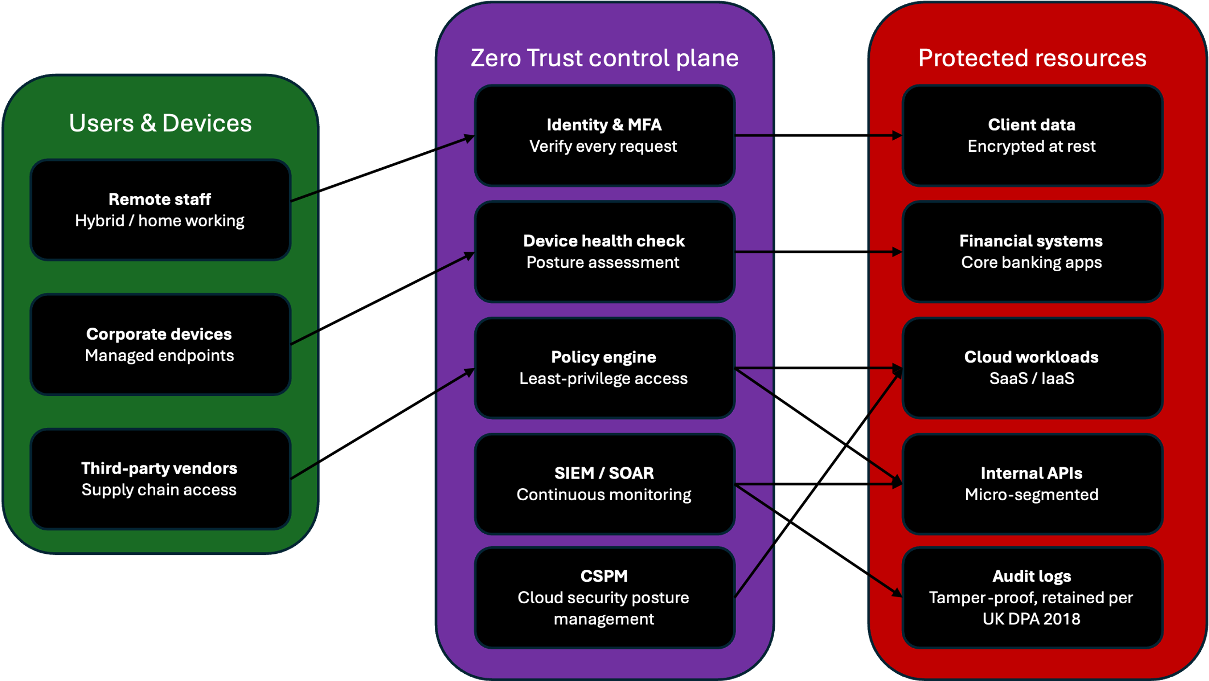

5 –Monitoring & Incident Response
A 24/7 monitoring system that is backed up by cutting-edge technology is vital to effective incident response. As discussed in the NCSC guidelines, alerts can come from various sources like SIEM systems, SOC teams, EDR systems and employee reports which need to be linked and reacted to quickly [13].
For VTAM, SIEM is the core of the security operations by collecting all the logs within the infrastructure and analysing them automatically with defined rules to find suspicious activities. The logs with cloud storage providers should be kept as per the ICO guidelines which generally vary from 12 to 24 months and providing options for real-time alerts and integrating SIEM solutions such as Microsoft Sentinel and Splunk is important [11].
Once a breach is found and alerted using SIEM, SOAR comes in handy to act upon it automatically. For lower severity breaches, SOAR can automatically block suspicious IPs and isolate infected machines without needing any human help, reducing response times [14]. In case of a critical issue like an ongoing ransomware attack, SOAR will immediately escalate the issue to the IR team which may contact the NCSC 24/7 incident management service if needed [13].
After an incident, there should be a structured review to establish what lessons can be learned, update playbooks and make sure that a report is made to the ICO within 72 hours after a data breach under UK GDPR requirements. [12]
The flowchart shown below shows this entire process.
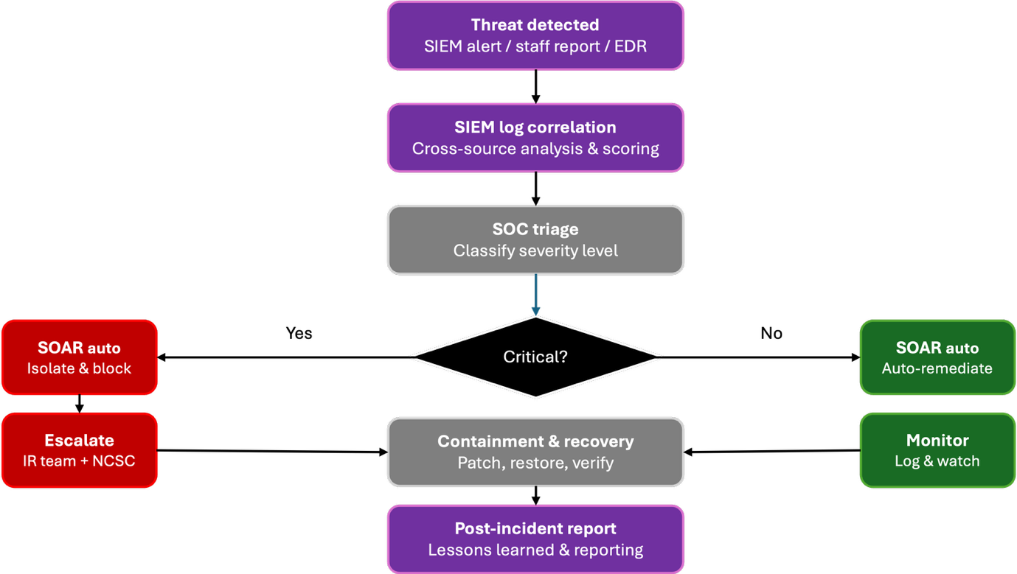

6 – Training & Awareness
Technical safeguards will not suffice in securing VTAM because humans will always prove to be the weakest link. The recommendation by NCSC's Annual Review 2025 calls for a shift in strategy to ensure that employees have a security culture rather than just comply with regulations [4]. This can only be achieved through training programs that focus on ongoing education as well as practical situations.
VTAM should conduct simulations to test employees' ability to detect threats. According to NCSC, the types of simulations that should be considered include phishing, social engineering, and AI-powered cyber attacks as these are the ones that will be most frequent [15].
According to KnowBe4's 2024 Phishing Benchmarking Report, a combination of regular phishing simulations together with awareness training helped organizations in the UK reduce their phishing click-through rate by 86%, from 32.3% to 4.5%. [14]
This shows the effect that can be quantified by a proper training program. Training needs to be expanded from within the organization to cover third parties who have access to VTAM systems, following NCSC guidelines on supply chain protection [4].

7 – Conclusion
The security breaches witnessed by VTAM represent an emerging trend of more complex security threats targeting financial institutions in the UK. Piecemeal approaches to security, based on protecting the perimeter, are becoming less useful. A Zero Trust approach is recommended by this report that follows the eight design principles provided by the NCSC [8], which complies with the recommendations of the NIST CSF 2.0 [1] and ISO 27001 [10]. The recommended security controls include MFA, EDR, SIEM, SOAR, and CSPM.
However, technology alone is not enough. Employees need to have continual training, and a culture of reporting without punishment is critical. These recommendations will allow them to defend against cyber threats and keep its clients’ information safe, comply with regulations, and uphold its reputation.

References
[1] National Institute of Standards and Technology, "The NIST Cybersecurity Framework (CSF) 2.0," NIST, Feb. 2024. [Online]. Available: https://csrc.nist.gov/news/2024/the-nist-csf-20-is-here
[2] Secure Controls Framework, "What Is NIST CSF 2.0?," SCF, 2024. [Online]. Available: https://securecontrolsframework.com/grc-fundamentals/common-cybersecurity-frameworks/nist-csf-2-0
[3] CyberSmart, "6 Key Takeaways from the NCSC Annual Report 2025," CyberSmart, Oct. 2025. [Online]. Available: https://cybersmart.co.uk/2025/10/6-key-takeaways-from-the-ncsc-annual-report-2025/
[4] National Cyber Security Centre, "NCSC Annual Review 2025," NCSC, Oct. 2025. [Online]. Available: https://www.ncsc.gov.uk/collection/ncsc-annual-review-2025/chapter-01-cyber-threat-to-the-uk
[5] Bitsight, "Ransomware Statistics 2025–26," Bitsight, 2025. [Online]. Available: https://www.bitsight.com/underground/ransomware
[6] Halcyon, "Last Year in Ransomware: Threat Trends and Outlook for 2025," Halcyon, Apr. 2025. [Online]. Available: https://www.halcyon.ai/blog/last-year-in-ransomware-threat-trends-and-outlook-for-2025
[7] Anjuna, "Governance, Zero Trust, and Data-in-Use: What You Need to Know About NIST CSF 2.0," Anjuna, Apr. 2024. [Online]. Available: https://www.anjuna.io/blog/governance-zero-trust-and-data-in-use-what-you-need-to-know-about-nist-csf-2-0
[8] National Cyber Security Centre, "Zero Trust Architecture Design Principles," NCSC, updated Jan. 2026. [Online]. Available: https://www.ncsc.gov.uk/guidance/zero-trust-building-a-mixed-estate
[9] Phoenix Software, "A Guide to the NCSC's Eight Zero Trust Design Principles," Phoenix Software, May 2026. [Online]. Available: https://www.phoenixs.co.uk/resources/blog/a-guide-to-the-ncscs-eight-zero-trust-design-principles/
[10] International Organisation for Standardisation, "ISO/IEC 27001:2022 — Information Security Management Systems," ISO, 2022. [Online]. Available: https://www.iso.org/standard/27001
[11] Compare the Cloud, "NCSC Cloud Security Principles 2025 and the Complete UK Enterprise Guide," Compare the Cloud, Dec. 2025. [Online]. Available: https://www.comparethecloud.net/articles/ncsc-cloud-principles-uk-2025
[12] Northdoor, "Cyber Security and Resilience Bill: Your UK Compliance Guide," Northdoor, Jan. 2026. [Online]. Available: https://www.northdoor.co.uk/solutions/get-gdpr-compliant/cyber-security-and-resilience-bill-compliance-guide-for-uk-businesses/
[13] National Cyber Security Centre, "Incident Response Overview," NCSC. [Online]. Available: https://www.ncsc.gov.uk/collection/incident-management/incident-response
[14] KnowBe4, "2024 Phishing by Industry Benchmarking Report," KnowBe4, Jun. 2024. [Online]. Available: https://markets.financialcontent.com/clarkebroadcasting.mymotherlode/article/bizwire-2024-6-4-knowbe4s-annual-phishing-benchmarking-report-reveals-uk-and-ireland-outperform-global-average-in-cybersecurity-awareness

