  - Learning in the Digital Era

Assignment 1: E-Portfolio
Jacob Hopkins
2003836
BSC Computing (Computer Networks and Cybersecurity)

TABLE OF CONTENTS HERE
Contents
e-Portfolio 3
Task 1 – Written Summary 3
Task 2 – Mind Map 4
Task 3 – Video Presentation 4
Task 4 – Academic Poster 5

e-Portfolio
  - Link
https://sites.google.com/view/digital-era-portfolio-2003836/written-summary
  - Screenshot
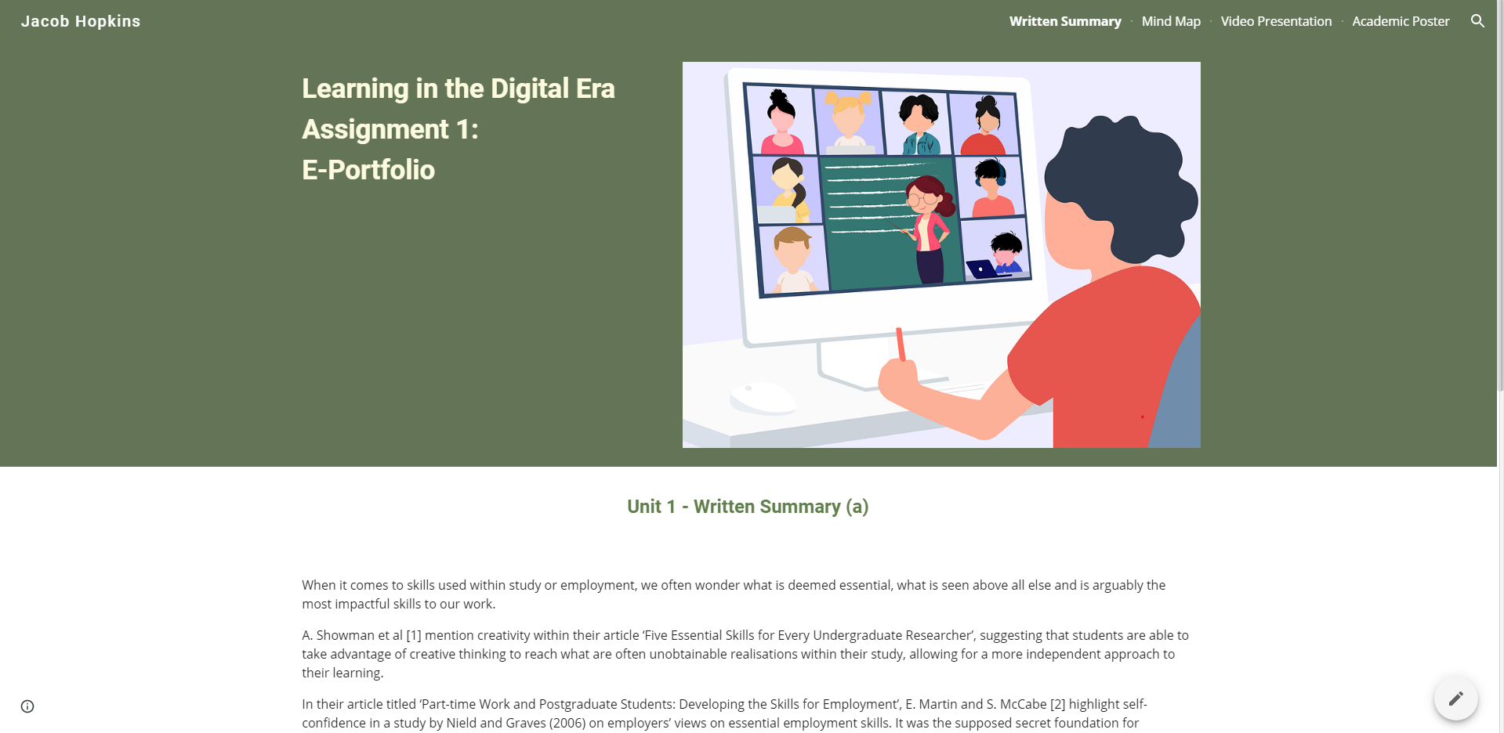

Task 1 – Written Summary
  - Link
https://sites.google.com/view/digital-era-portfolio-2003836/written-summary
  - Screenshot
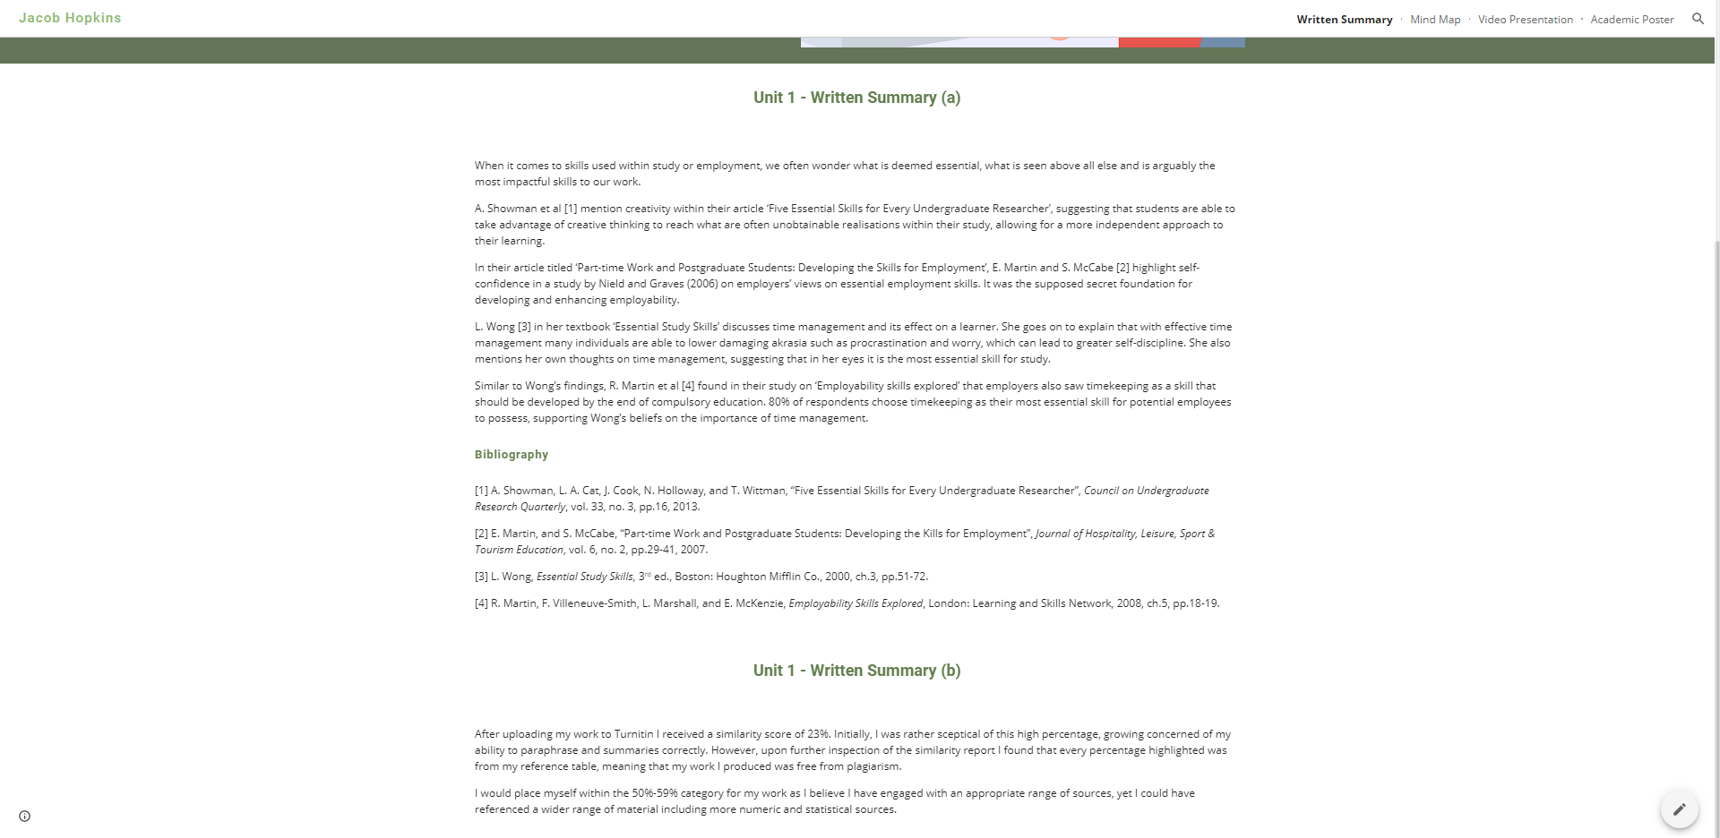

Task 2 – Mind Map
  - Link
https://sites.google.com/view/digital-era-portfolio-2003836/mind-map
  - Screenshot
  - 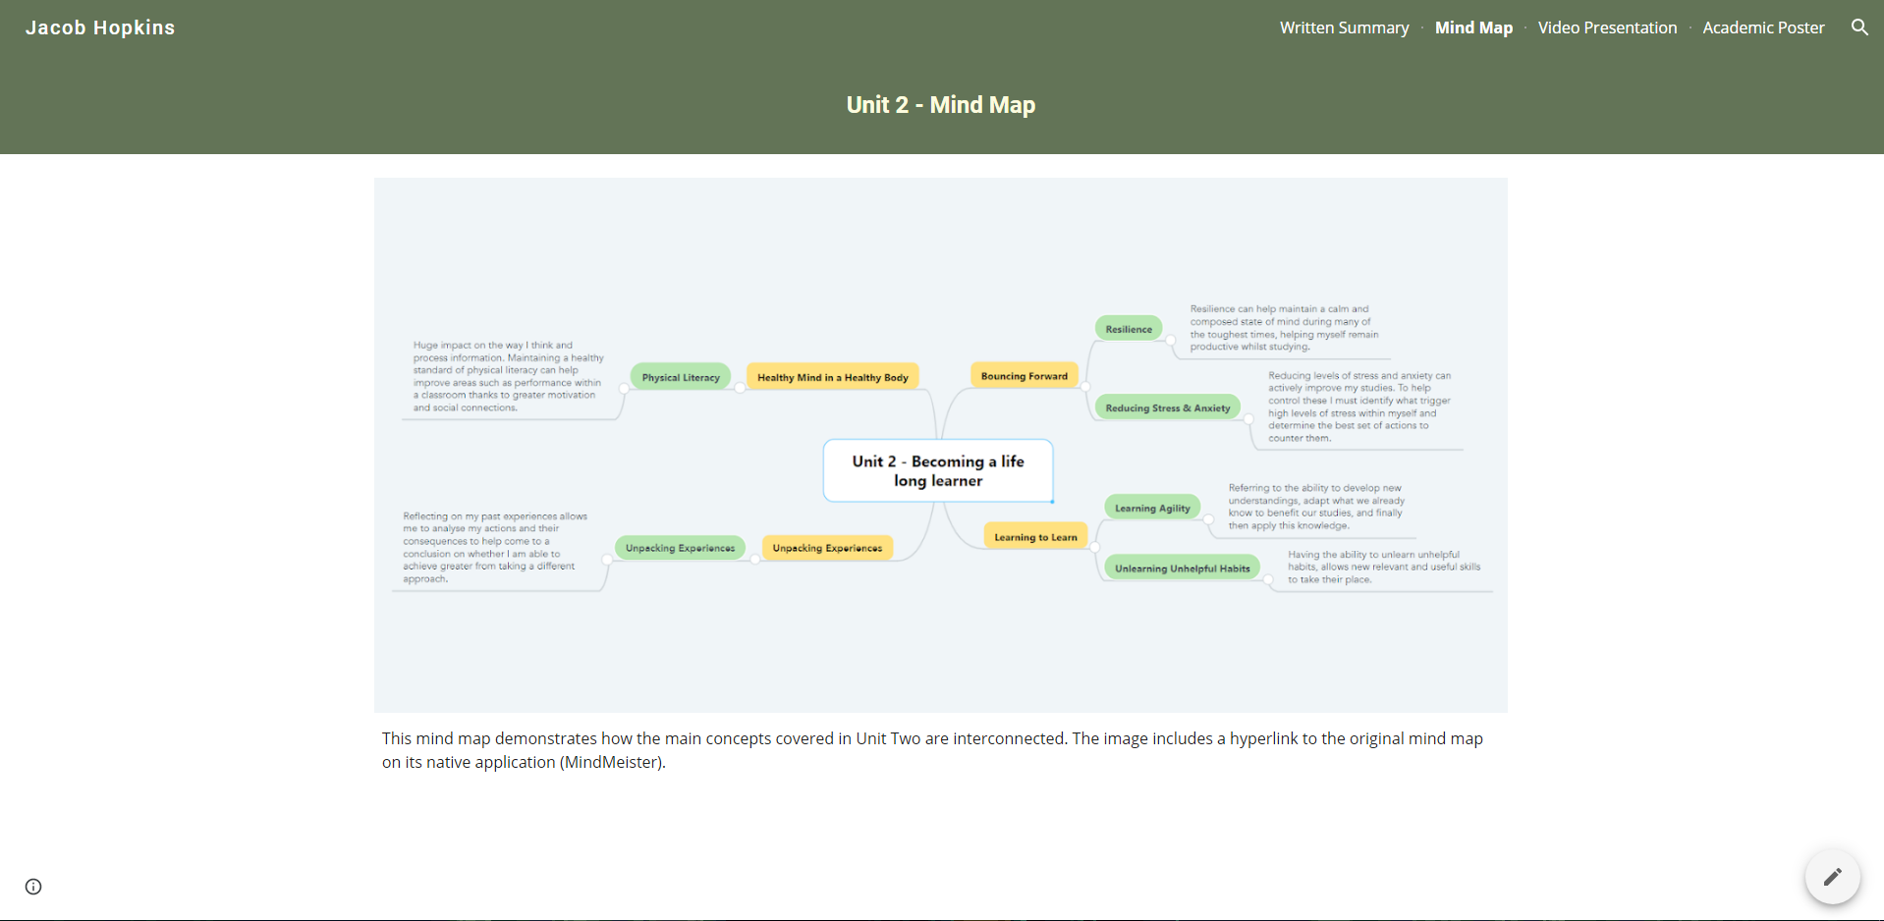
  - Original Mind Map Link
https://mm.tt/1688055098?t=NlwsGGDWn1

Task 3 – Video Presentation
  - Link
https://sites.google.com/view/digital-era-portfolio-2003836/video-presentation
  - Screenshot
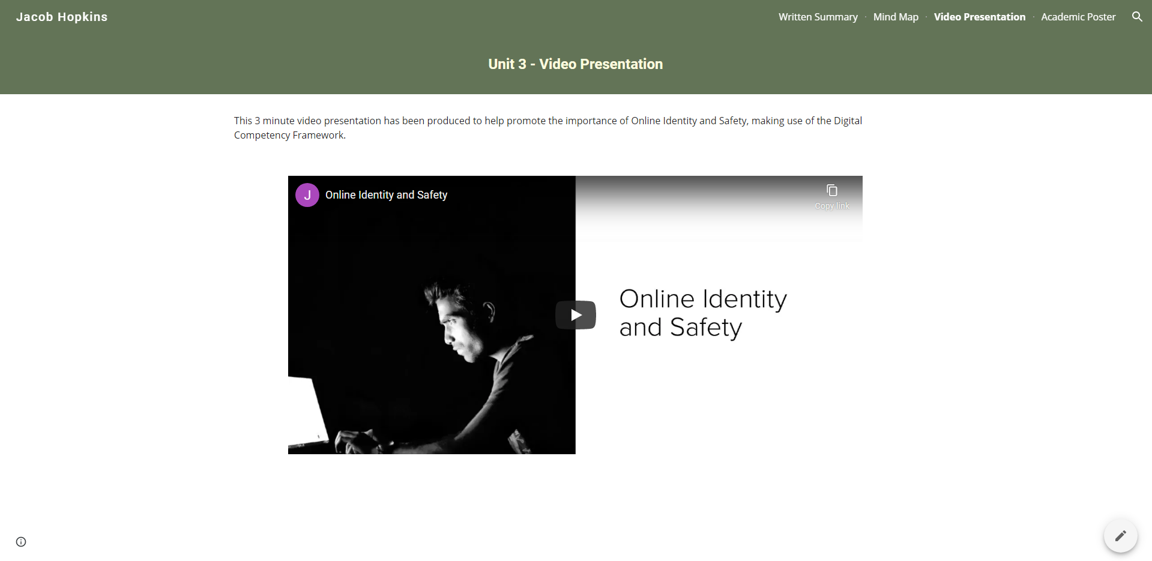
  - Original YouTube Video Link
https://youtu.be/RwwSOclajTs

Task 4 – Academic Poster
  - Link
https://sites.google.com/view/digital-era-portfolio-2003836/academic-poster
  - Screenshot
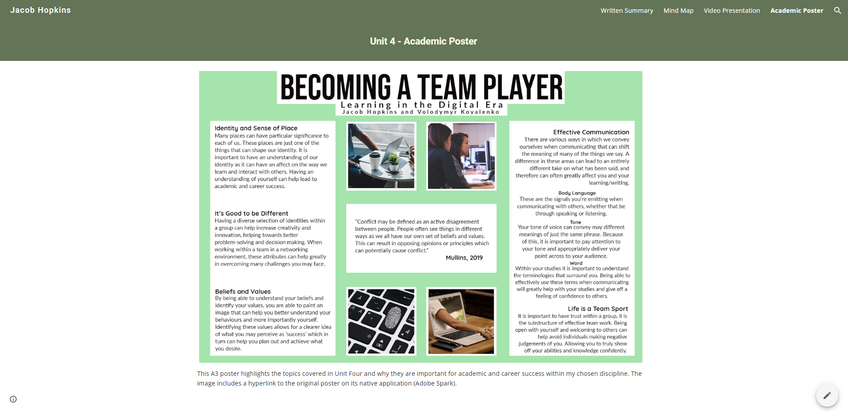
  - Original Poster Link
https://spark.adobe.com/post/XsmwinZQ7PiMe/

