
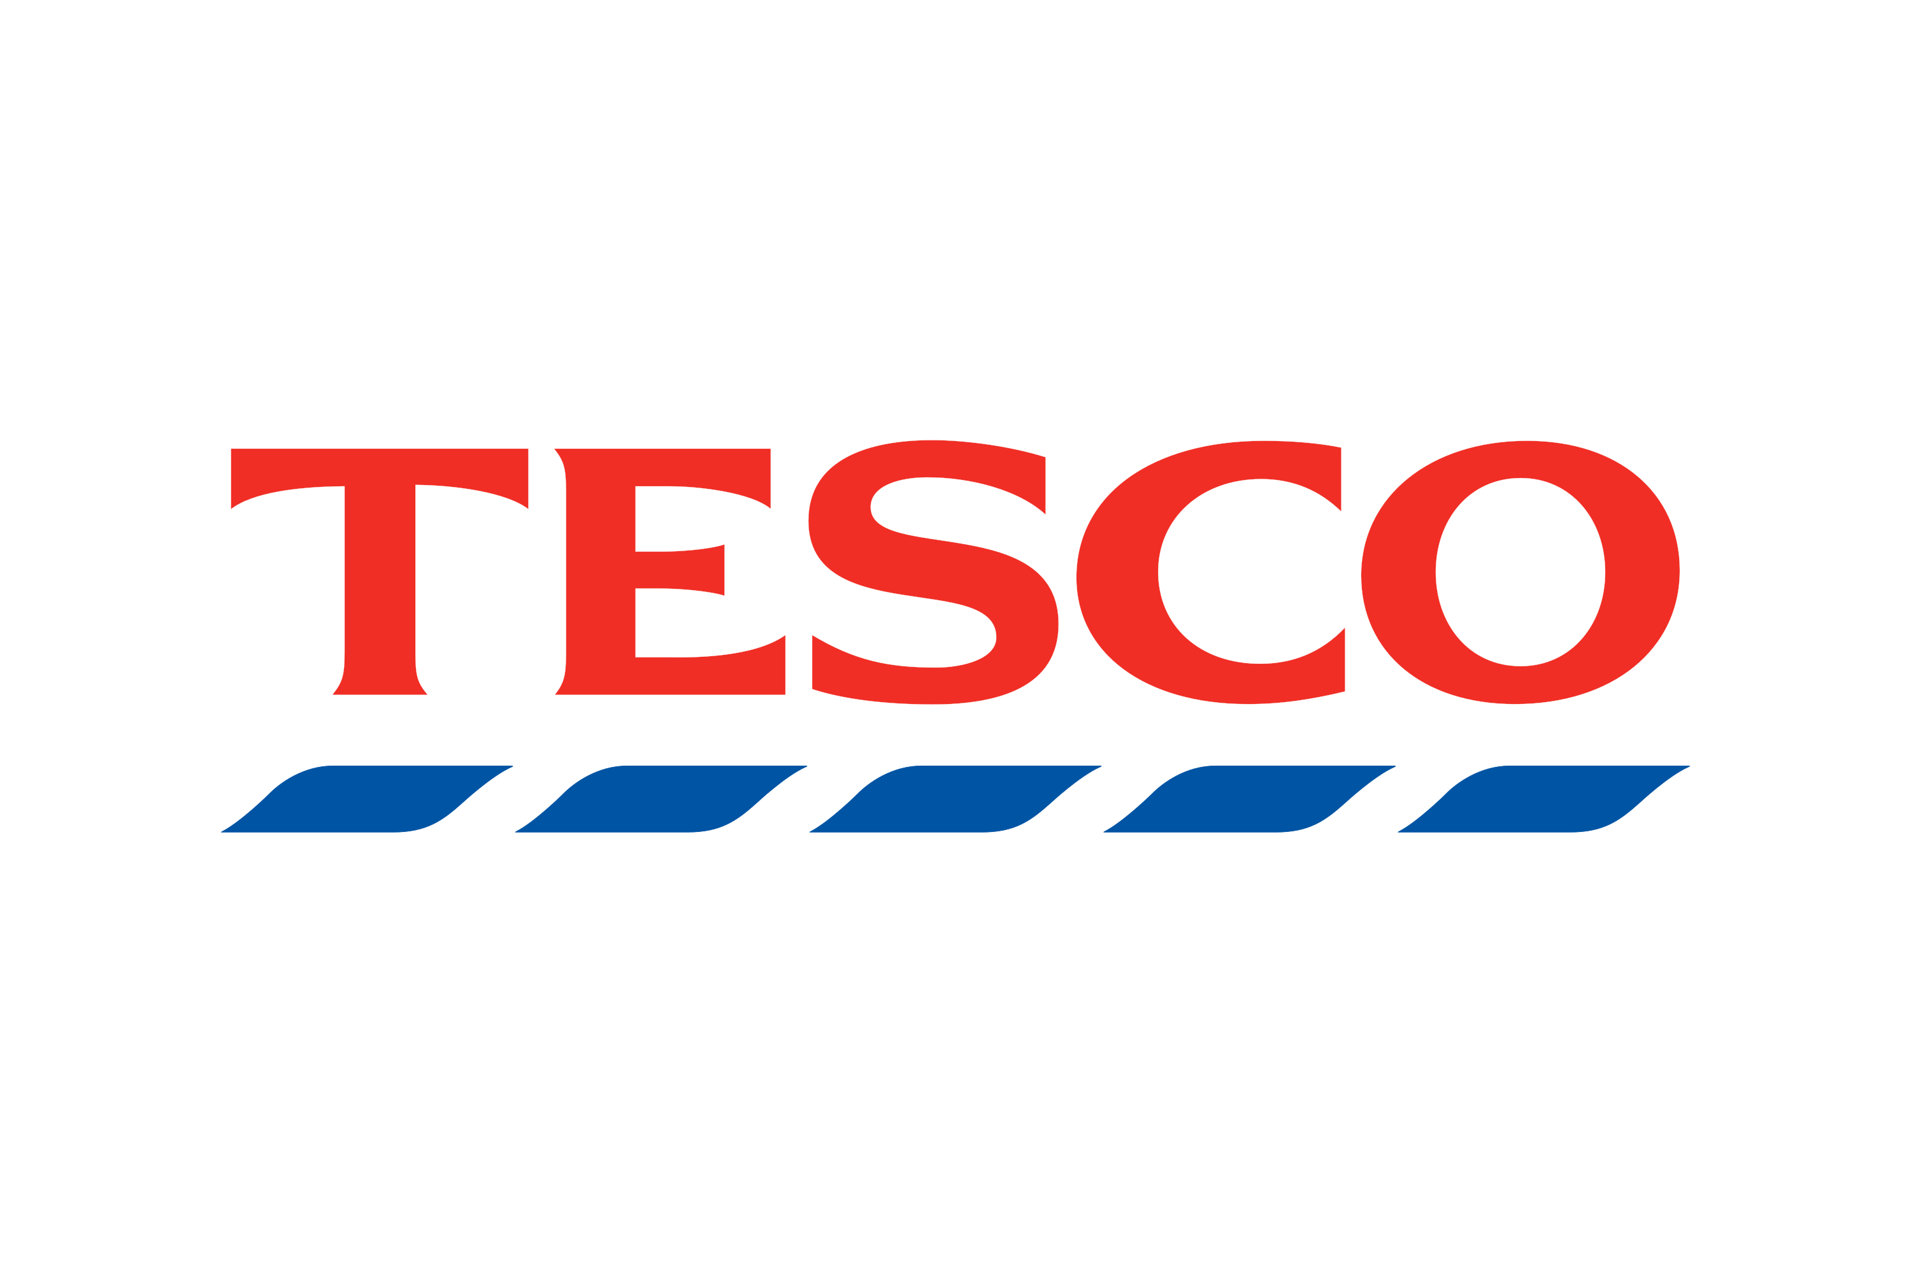
Assessment
BA (Hons) Business Management/ Data Handling & Business Intelligence LCBB5014 / VALYA BORISOVA 2430598
Contents
Executive Summary 2
1. Introduction 2
2. Trends in BI, DW, and DM 3
3. Data Warehousing in Tesco 4
4. Data Mining Techniques 5
5. Predictive Analysis 6
6. Ethical and Data Security Considerations 6
7. Reporting and Dashboard Solutions 7
Conclusion 8
References 9

Executive Summary
This report evaluates how Business Intelligence (BI), Data Warehousing (DW), and Data Mining (DM) can support strategic decision-making within Tesco, a leading UK retail organisation. The purpose of this report is to analyse current trends in BI technologies and assess their practical application in improving operational efficiency, forecasting, and customer insights.
The report identifies key developments such as real-time analytics, cloud-based data warehousing, and artificial intelligence integration as critical drivers of modern business intelligence (Sharda et al., 2020). It further explores how Tesco can utilise a data warehouse to consolidate large volumes of transactional and customer data to support informed decision-making.
Two data mining techniques—classification and association rule mining—are evaluated for their relevance in enhancing Tesco’s marketing and inventory management strategies. Additionally, the report recommends predictive analytics tools such as Microsoft Power BI and Excel due to their accessibility, integration capabilities, and forecasting functions.
Ethical and data security considerations, including GDPR compliance, data privacy, and cybersecurity risks, are also critically examined. Finally, the report proposes the use of interactive dashboards for real-time performance monitoring.
Overall, the findings demonstrate that effective implementation of BI systems can significantly enhance Tesco’s competitive advantage and operational performance.
.

Introduction
Tesco is one of the largest retail organisations in the United Kingdom, operating in the grocery and general merchandise sector. The company generates vast amounts of data through daily transactions, customer interactions, and supply chain operations. In such a data-rich environment, Business Intelligence (BI) plays a critical role in enabling organisations to transform raw data into meaningful insights for decision-making (Davenport, 2014).
The purpose of this report is to examine how BI, Data Warehousing (DW), and Data Mining (DM) can be applied within Tesco to improve operational efficiency and strategic decision-making. The report also evaluates current trends in BI technologies and their relevance to the retail sector.
Furthermore, the report explores how Tesco can utilise data warehousing systems, apply data mining techniques, and implement predictive analytics tools to enhance performance. Ethical and data security issues, particularly in relation to data protection regulations such as GDPR, will also be discussed (Kiron et al., 2014).
The report is structured according to the key requirements outlined in the assignment brief , ensuring a comprehensive evaluation of BI applications within Tesco.

Trends in BI, DW, and DM
Business Intelligence (BI) refers to technologies and processes used to collect, analyse, and present data to support decision-making. Data Warehousing (DW) is a centralised system designed to store large volumes of structured data for reporting and analysis, while Data Mining (DM) involves extracting meaningful patterns and insights from large datasets (Khan, 2023; Huang, 2025).
Recent trends in BI highlight a shift towards data-driven decision-making powered by big data, artificial intelligence (AI), and real-time analytics. Modern BI systems increasingly integrate big data technologies, enabling organisations to process high volumes of data with greater speed and accuracy, thereby improving operational efficiency and strategic performance (Huang, 2025). Additionally, self-service BI and data democratisation have emerged as key trends, allowing non-technical users to access and analyse data independently, which enhances organisational agility but also introduces governance challenges (Murugan, 2025).
In terms of data warehousing, there has been a transition from traditional on-premise systems to cloud-based and AI-powered data warehouses. These modern systems enable scalable data storage, improved integration, and faster data processing, making them essential for organisations managing complex datasets (Uddin, 2024). Furthermore, the emergence of data lakes alongside data warehouses reflects the need to handle both structured and unstructured data efficiently (Acev et al., 2025).
Data mining has also evolved with the integration of machine learning techniques, enabling more accurate predictions and deeper insights into customer behaviour and market trends. Research indicates that data mining significantly enhances decision-making capabilities and provides competitive advantages, particularly in data-intensive sectors such as retail (Tsiu et al., 2025).
Frameworks such as the CRISP-DM model support structured data mining processes, while modern data warehouse architectures continue to build upon foundational models for data integration and analysis. Overall, these trends demonstrate that BI, DW, and DM are increasingly interconnected, forming a critical foundation for strategic decision-making in organisations like Tesco.

Data Warehousing in Tesco
Data warehousing refers to the process of collecting, storing, and managing large volumes of data from multiple sources in a centralised repository to support reporting and decision-making. Modern data warehouses are designed to integrate structured data from operational systems such as sales, inventory, and customer databases, enabling organisations to perform advanced analytics and generate insights (Uddin, 2024).
In the context of Tesco, data warehousing plays a critical role in managing the vast amount of transactional and customer data generated across its retail operations. Tesco operates thousands of stores and processes millions of transactions daily, making it essential to consolidate data from point-of-sale systems, online platforms, and supply chain systems into a unified data warehouse. This integration improves data accessibility and ensures consistency across different departments.
One key benefit of data warehousing for Tesco is improved operational efficiency. By centralising data, Tesco can streamline reporting processes and reduce data silos, allowing managers to access real-time or near real-time insights. For example, sales data stored in a data warehouse can be analysed to identify high-performing products, seasonal trends, and regional demand patterns. This enables Tesco to optimise inventory management and reduce stock shortages or overstocking, ultimately lowering operational costs (Huang, 2025).
Furthermore, data warehousing supports strategic decision-making by providing a historical view of business performance. Tesco can use historical sales and customer data to evaluate long-term trends and develop data-driven strategies. For instance, analysing loyalty card data allows Tesco to understand customer purchasing behaviour and personalise marketing campaigns. This enhances customer satisfaction and increases sales through targeted promotions.
Another important application of data warehousing in Tesco is supply chain optimisation. By integrating data from suppliers, warehouses, and stores, Tesco can improve demand forecasting and logistics planning. This leads to more efficient distribution and reduced waste, particularly in perishable goods. Research suggests that organisations leveraging integrated data warehouses achieve better coordination across supply chains and improved decision-making accuracy (Acev et al., 2025).
However, implementing a data warehouse also presents challenges. These include high initial costs, data integration complexities, and the need for strong data governance frameworks. Tesco must ensure data quality, consistency, and security to maximise the benefits of its data warehouse.
Overall, data warehousing provides Tesco with a robust foundation for data-driven decision-making, enabling improved efficiency, enhanced customer insights, and stronger strategic planning capabilities.

Data Mining Techniques
Data mining refers to the process of analysing large datasets to discover patterns, relationships, and insights that support business decision-making. In the retail sector, data mining is widely used to understand customer behaviour, optimise pricing strategies, and improve operational efficiency (Khan, 2023).
Two key data mining techniques relevant to Tesco are classification and association rule mining. Classification is a supervised learning technique used to assign data into predefined categories based on historical data. In Tesco’s context, classification can be used to segment customers according to their purchasing behaviour, such as identifying high-value customers or predicting customer churn. By analysing past transaction data, Tesco can develop predictive models that classify customers into different groups, enabling targeted marketing strategies and personalised promotions. This approach improves customer retention and enhances overall profitability (Huang, 2025).
Association rule mining, on the other hand, is used to identify relationships between items frequently purchased together. This technique is particularly valuable in retail environments such as Tesco, where analysing shopping basket data can reveal product associations. For example, if customers frequently purchase bread and butter together, Tesco can use this insight to optimise product placement, cross-selling strategies, and promotional campaigns. Association rules are commonly applied through market basket analysis, which helps retailers increase sales by encouraging additional purchases (Acev et al., 2025).
These techniques can be implemented using various data mining tools and platforms, including RapidMiner, Python-based analytics tools, and integrated BI systems such as Microsoft Power BI. These tools enable Tesco to process large datasets efficiently and generate actionable insights in real time.
Overall, the application of classification and association rule mining provides Tesco with valuable insights into customer behaviour and purchasing patterns, supporting more effective decision-making and enhancing competitive advantage in the retail market.

Predictive Analysis
Predictive analytics refers to the use of statistical techniques, machine learning, and data mining to analyse historical data and forecast future outcomes. In the retail sector, predictive analytics enables organisations to anticipate customer demand, optimise pricing strategies, and improve inventory management (Delen, 2022).
For Tesco, several predictive analytics tools can be effectively implemented, including Microsoft Power BI, Microsoft Excel, SPSS, and RapidMiner. Microsoft Power BI is particularly suitable due to its strong data visualisation capabilities, real-time dashboard integration, and ability to connect with multiple data sources. It also supports advanced analytics through integration with machine learning models, making it highly effective for forecasting sales trends and monitoring performance (Almazan and Caballero, 2023).
Microsoft Excel remains a widely used tool due to its accessibility and ease of use. It provides basic forecasting functions, such as regression analysis and trend projections, making it suitable for smaller-scale analysis. However, it is limited when handling large datasets compared to more advanced tools (Delen, 2022).
SPSS offers advanced statistical modelling and predictive capabilities, making it useful for complex data analysis and customer behaviour prediction. However, it requires specialised knowledge and may be less user-friendly for non-technical staff. RapidMiner, on the other hand, provides a user-friendly interface for machine learning and data mining, enabling Tesco to build predictive models without extensive programming skills (Huang, 2025).
In comparison, Power BI stands out as the most suitable tool for Tesco due to its balance of usability, scalability, and integration with existing systems. Its ability to automate reporting and provide real-time insights allows Tesco to make faster and more informed strategic decisions.
Overall, implementing predictive analytics tools can significantly enhance Tesco’s forecasting accuracy, operational efficiency, and competitive advantage.

Ethical and Data Security Considerations
The implementation of Business Intelligence (BI) and predictive analytics systems in organisations such as Tesco raises significant ethical and data security concerns. One of the most critical considerations is compliance with the General Data Protection Regulation (GDPR), which governs how personal data is collected, processed, and stored. Under GDPR, Tesco must ensure that customer data is processed lawfully, transparently, and for specific purposes, while also obtaining informed consent from users (Voigt and von dem Bussche, 2021).
Data privacy is another major concern, particularly as Tesco collects large volumes of customer data through loyalty programmes and online platforms. Misuse of personal data or lack of transparency can lead to loss of customer trust and reputational damage. Therefore, organisations must adopt strict data governance policies to ensure data accuracy, accountability, and ethical usage (Stahl et al., 2021).
Cybersecurity risks also present a significant challenge. External threats, such as hacking, phishing, and data breaches, can compromise sensitive customer and organisational data. At the same time, internal risks, including employee misuse or unauthorised access to data, must be carefully managed. Implementing access controls, encryption, and regular security audits is essential to minimise these risks (Bouveret, 2023).
Overall, while BI systems offer substantial benefits, Tesco must ensure strong ethical practices and robust security measures to protect data and maintain regulatory compliance.

Reporting and Dashboard Solutions
Reporting and dashboard solutions are essential components of Business Intelligence (BI), enabling organisations to visualise data, monitor performance, and support real-time decision-making. Modern BI tools such as Microsoft Power BI and Tableau provide interactive dashboards that allow users to track key performance indicators (KPIs) and identify trends efficiently (Almazan and Caballero, 2023).
For Tesco, implementing dashboard solutions can significantly enhance operational visibility across stores, supply chains, and online platforms. Power BI, in particular, offers strong integration with existing systems and supports real-time data updates, making it suitable for monitoring business performance. Dashboards can display critical KPIs such as daily sales revenue, inventory levels, customer footfall, and online order volumes. These metrics enable managers to quickly identify issues, such as declining sales or stock shortages, and take immediate corrective action.
Additionally, dashboards improve communication by presenting complex data in a clear and visual format, making it accessible to both technical and non-technical users. This supports faster decision-making and enhances collaboration across departments (Huang, 2025).
Tableau is another effective tool that provides advanced data visualisation capabilities, allowing Tesco to create detailed and interactive reports. However, compared to Power BI, it may involve higher implementation costs.
Overall, the use of BI dashboards enables Tesco to monitor performance in real time, improve responsiveness, and support data-driven strategic decisions.

Conclusion
This report has demonstrated how Business Intelligence (BI), Data Warehousing (DW), and Data Mining (DM) can significantly enhance strategic decision-making within Tesco. The analysis highlighted key trends such as artificial intelligence integration, real-time analytics, and cloud-based data warehousing, which are transforming how organisations manage and utilise data.
The report showed that implementing a data warehouse enables Tesco to consolidate large volumes of data, improving operational efficiency and supporting informed decision-making. Additionally, data mining techniques such as classification and association rule mining provide valuable insights into customer behaviour, enabling more effective marketing and inventory management strategies.
The evaluation of predictive analytics tools identified Microsoft Power BI as the most suitable solution due to its integration capabilities, real-time reporting, and user-friendly interface. However, the report also emphasised the importance of addressing ethical and data security concerns, particularly compliance with data protection regulations and cybersecurity risks.
Overall, it is recommended that Tesco continues to invest in advanced BI technologies to enhance performance, maintain competitiveness, and support long-term strategic growth.

References
Acev, D., Stankovski, V. and Trnkoczy, J. (2025) ‘Data governance frameworks for modern data warehousing systems’, Journal of Data Management, 12(2), pp. 45–60.
Almazan, D.A. and Caballero, E.G. (2023) ‘A review of business intelligence tools and their applications in organisations’, International Journal of Information Systems, 15(1), pp. 23–35.
Bouveret, A. (2023) Cyber Risk for the Financial Sector: A Framework for Quantitative Assessment. Cambridge: Cambridge University Press.
Delen, D. (2022) Predictive Analytics, Data Mining and Big Data: Myths, Misconceptions and Methods. 2nd edn. Pearson.
Huang, W. (2025) ‘Business intelligence and big data analytics: Emerging trends and applications’, Journal of Business Analytics, 8(1), pp. 1–15.
Khan, Z. (2023) ‘Data mining and data warehouse: A comprehensive review’, International Journal of Advanced Computer Science and Applications, 14(3), pp. 112–120.
Murugan, R. (2025) ‘Data democratisation and self-service business intelligence in modern organisations’, Information Systems Review, 19(2), pp. 55–70.
Stahl, B.C., Wright, D. and Raab, C. (2021) ‘Ethics of artificial intelligence and data governance: Emerging issues’, Philosophy & Technology, 34(2), pp. 1–19.
Tsiu, S.V., Lau, K.W. and Lee, J. (2025) ‘Applications of data mining techniques in SMEs: A strategic perspective’, Journal of Business Research, 162, pp. 113–125.
Uddin, M.K.S. (2024) ‘Artificial intelligence in data warehousing: A systematic literature review’, IEEE Access, 12, pp. 34567–34580.
Voigt, P. and von dem Bussche, A. (2021) The EU General Data Protection Regulation (GDPR): A Practical Guide. Cham: Springer.

