Name: Ben Brown

Student Number: 2419961
__________________________________________________________

WORKSHEET 5 – TESTING (Hunting for Treasure)

For this worksheet, the program can be implemented in a number of different ways and demonstrate different features.
Create your own test set to demonstrate strengths and/or limitations of your solution. Use as many of the template boxes below as you need.

Test: Randomised location of treasure

Screenshot(s) of output:
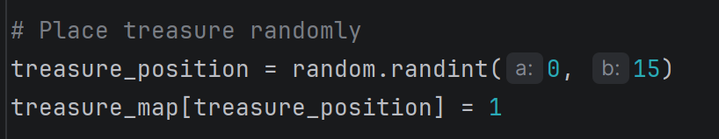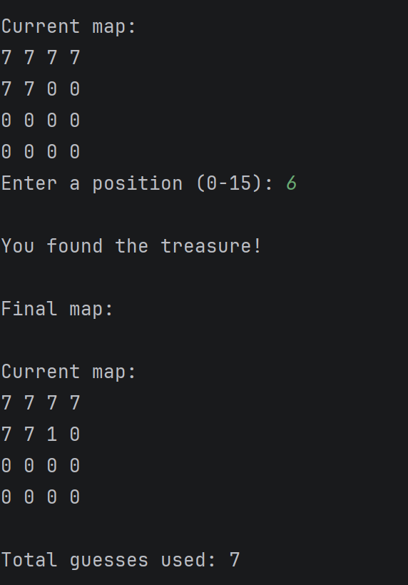
Result: Did the programme behave as expected ie syntactically and logically correct?
YES
The program has been set to randomise the treasure location. This has been tested multiple times, with no issues.

Test: Number of guesses took to find the treasure

Screenshot(s) of output:
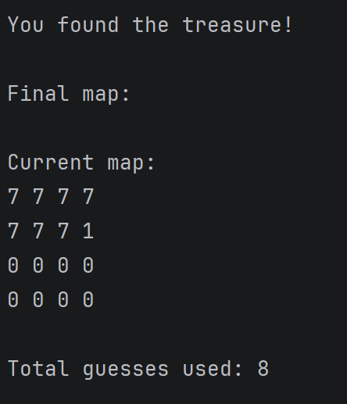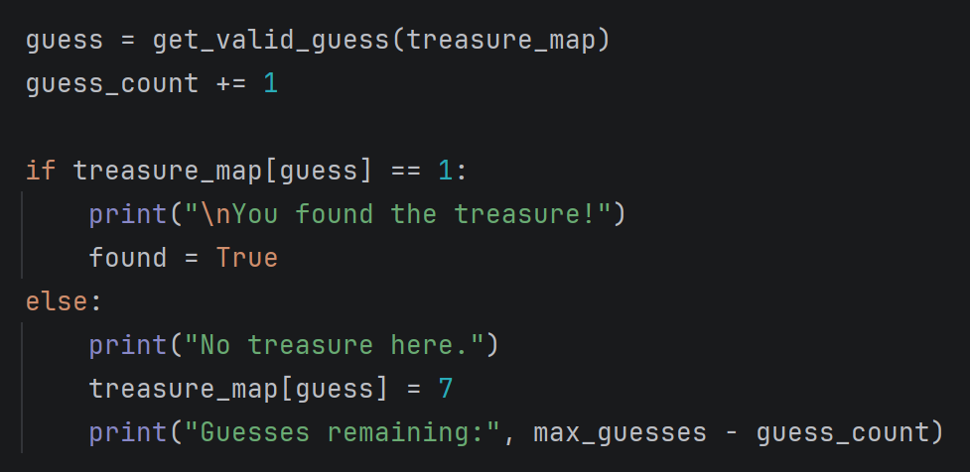
Result: Did the programme behave as expected ie syntactically and logically correct?
YES
The program tracks how many guesses it took for the user to find the treasure successfully.

Test: Limiting the number of guesses allowable

Screenshot(s) of output:
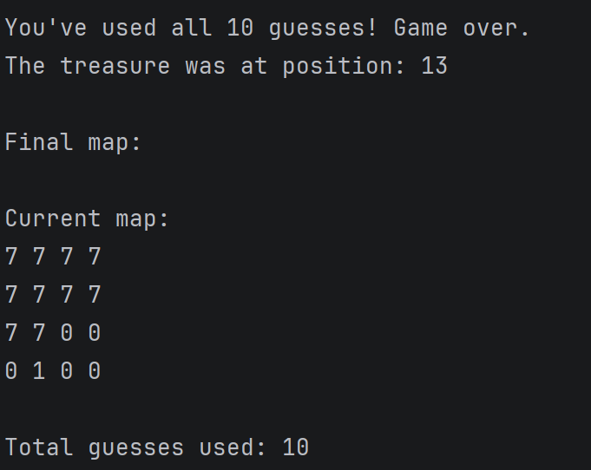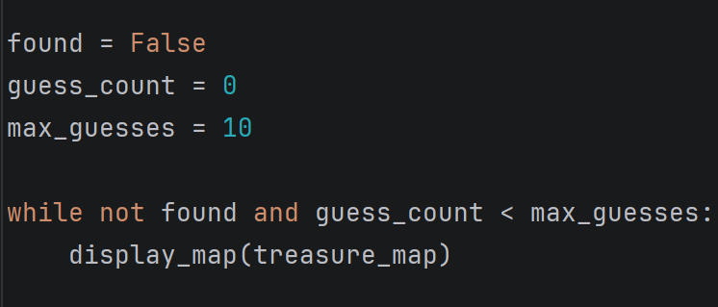
Result: Did the programme behave as expected ie syntactically and logically correct?
YES
The program limits the number of guesses to 10, ending the game if not guessed within these attempts. The game then shows where the treasured was.

Test: Display the board in a traditional grid format rather than in one row

Screenshot(s) of output:
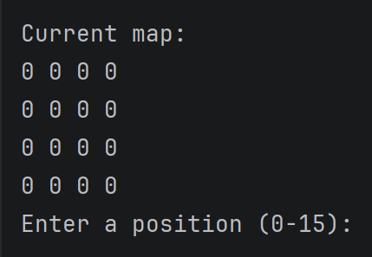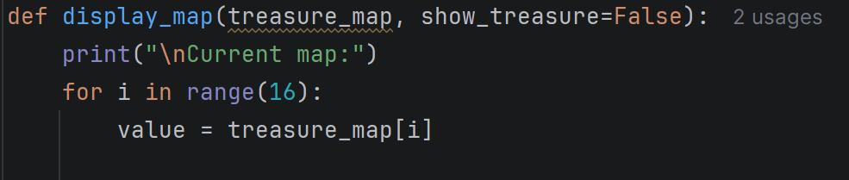
Result: Did the programme behave as expected ie syntactically and logically correct?
YES
The program displays the treasure map in a traditional format.

Test: Use functions for certain repeating parts of your code for efficiency

Screenshot(s) of output:
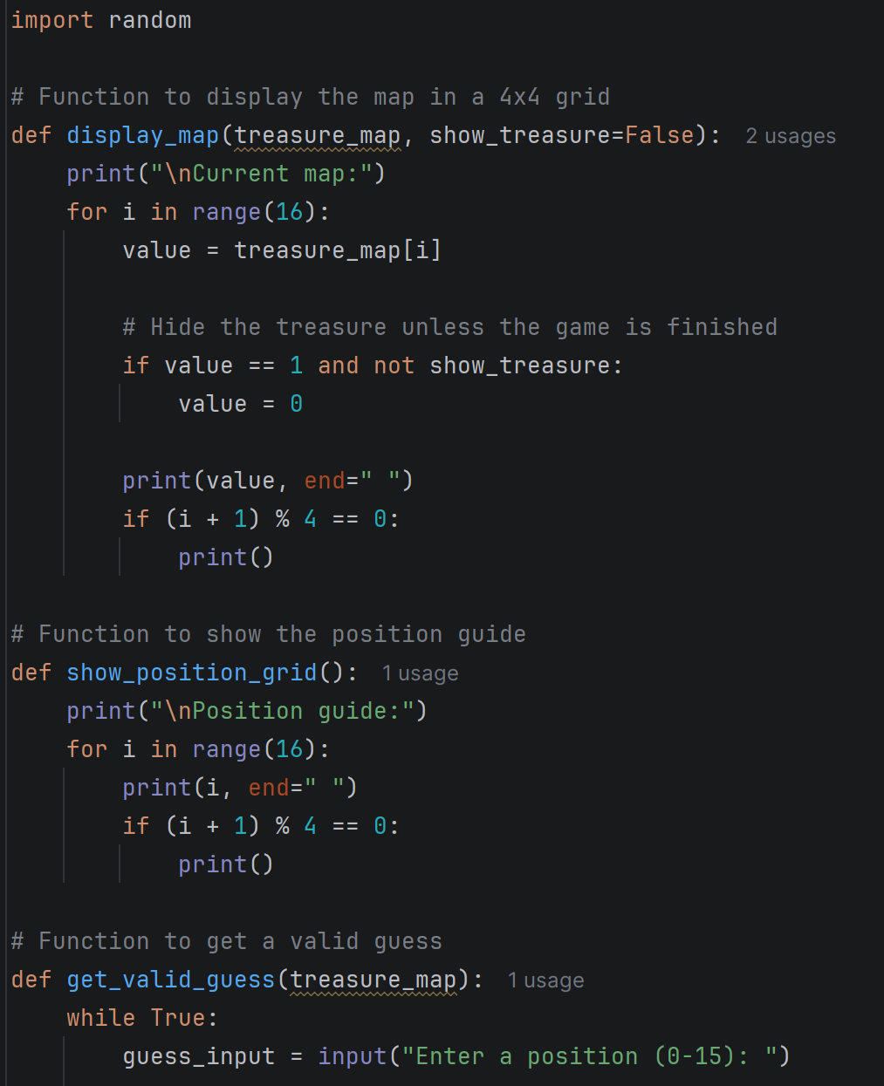
Result: Did the programme behave as expected ie syntactically and logically correct?
YES
The program is split into different sections and formatted correctly to minimise repeating parts.

Test: Validate for out-of-range entries

Screenshot(s) of output:
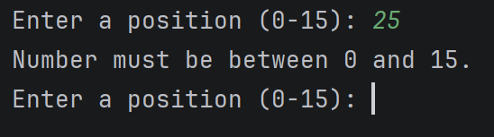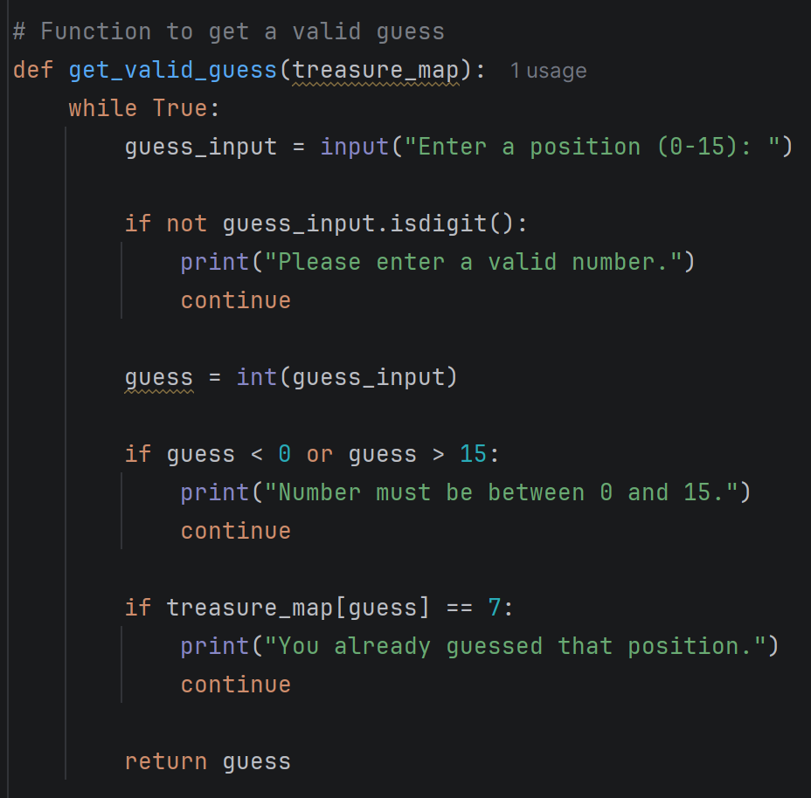
Result: Did the programme behave as expected ie syntactically and logically correct?
YES
The program was validated to only accept guesses from 0-15, if the user enters a number not within this, the user is prompted to enter a valid number.

Test: Position guide for user to understand the map

Screenshot(s) of output:
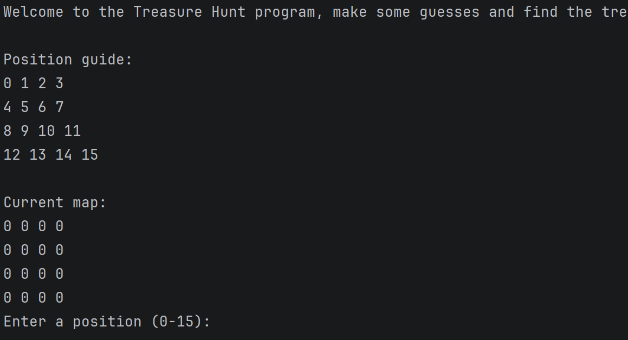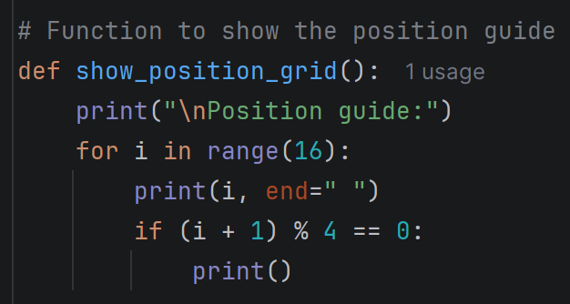
Result: Did the programme behave as expected ie syntactically and logically correct?
YES
The program shows the user a guide of the numbers to guess within the map, to avoid confusion when entering their guess.

Final code:

[Copy and paste your code here – note, do not use a screenshot.

Note that there is no “before” and “after” code for this Worksheet because it is “Open” – not done in class. Therefore just post your final code below]

import random
def display_map(treasure_map, show_treasure=False):
print("\nCurrent map:")
for i in range(16):
value = treasure_map[i]
if value == 1 and not show_treasure:
value = 0
print(value, end=" ")
if (i + 1) % 4 == 0:
print()
def show_position_grid():
print("\nPosition guide:")
for i in range(16):
print(i, end=" ")
if (i + 1) % 4 == 0:
print()
def get_valid_guess(treasure_map):
while True:
guess_input = input("Enter a position (0-15): ")
if not guess_input.isdigit():
print("Please enter a valid number.")
continue
guess = int(guess_input)
if guess < 0 or guess > 15:
print("Number must be between 0 and 15.")
continue
if treasure_map[guess] == 7:
print("You already guessed that position.")
continue
return guess
treasure_map = [0] * 16
treasure_position = random.randint(0, 15)
treasure_map[treasure_position] = 1
print("Welcome to the Treasure Hunt program, make some guesses and find the treasure!")
show_position_grid()
found = False
guess_count = 0
max_guesses = 10
while not found and guess_count < max_guesses:
display_map(treasure_map)
guess = get_valid_guess(treasure_map)
guess_count += 1
if treasure_map[guess] == 1:
print("\nYou found the treasure!")
found = True
else:
print("No treasure here.")
treasure_map[guess] = 7
print("Guesses remaining:", max_guesses - guess_count)
if not found:
print("\nYou've used all 10 guesses! Game over.")
print("The treasure was at position:", treasure_position)
print("\nFinal map:")
display_map(treasure_map, True)
print("\nTotal guesses used:", guess_count)

