Strategic Management
Module code: LCMB7003
Assignment title: Strategic Management Report
Lecturer Name : prof Amare Desta
Student Name : Iosif Tcaciu
Student Id no : 2022775

Table of Contents
Task: Individual Report 3
Introduction 3
Organisational overview 4
Challenges of virtual management for BT Group Plc 5
Opportunity of virtual management for BT Group Plc 6
Conclusion 9
References 10
Appendix 12
Task : Group Task 12
Presentation 12
Precise of the selected paper 21
Summary (Individual) 23
Introduction of the paper and argument 23
Identification of the problem or issues with the paper 23
Summary of the results 24
Analysis of the conclusion 24

Task: Individual Report

Introduction
A virtual organisation can be defined as the operations of an organisation with a geographically scattered workforce, and it does not have a head office where employees are encouraged to work from home or offered remote work facilities. With the rapid technological revolution, organisations in almost every sector are facing intense competition. As a result, they are trying to find out some other ways to meet the needs of their customers and clients and get competitive benefits. The concept of virtual organisation has become one of the solutions to the organisation that reduces additional expenditure and makes it lucrative for business professionals, as virtual organisation enables business professionals to reduce the expense of physical office rent, necessary arrangements for the employees at the office, and many more. Where employees are needed to comply with some principles at traditional organisations, virtual organisations offer sufficient flexibility to the employees. However, virtual organisations have some advantages and disadvantages. The purpose of the report includes an exploration of how the concept of virtual organisation is practiced at BT Group Plc and the emergence of virtual organisation. It also includes the challenges as well as the opportunities of virtual organisation management from the perspective of BT Group Plc, taking into consideration the discussion of various scholarly articles, books, and other sources.

Organisational overview
BT Group Plc, also known as British Telecommunication, is one of the largest telecommunications giants in the world. It is the largest telecommunications company in the UK and offers various communication services to its customers, which include subscription television, mobile services, broadband, etc. The ability of the company to serve more than 32 million homes and businesses, 68% of the coverage of the UK population by the 5G network, more than 1.2 million business customers, etc. have made the business the business leader of the UK and get competitive benefits in the long run (BT Group Plc, 2023). The international presence of the company in 180 countries around the world has also made the company hold a strong position in the UK telecommunications sector. The principles of virtual organisation management can also be noticed in the organisation. The application of the virtual organisation management principle was significantly noticed in the pre-pandemic situation, which began at the beginning of 2020 (Yang, 2022). As part of this, the company provided flexible working arrangements for the employees of the organisation, e.g., remote work, flexible hours, digital transformation, enhanced remote work policies, etc. However, BT Group Plc is not a virtual organisation, as it has several physical offices in the UK and other parts of the world. The initiatives undertaken by the company to facilitate remote work, flexible working hours, digital tools, etc. are some examples of the applications of virtual management in the organisation.

Challenges of virtual management for BT Group Plc
A virtual organisation has some unique characteristics that differentiate it from other traditional organisations. A virtual organisation's management focuses on several things, e.g., the work-life balance of the employees, flexible hours, more open work spaces, and technological arrangements. BT Group Plc may face several challenges in converting the company into a virtual organisation or a semi-virtual organisation. The challenges a company a company may face have been discussed as follows:
- Employee engagement and well-being: Every organisation has specific arrangements for ensuring employee engagement and well-being, e.g., a safe working environment, mitigating risks in the working environment, first aid arrangements, etc. However, employee engagement and well-being will be different in a virtual organisation where there are fewer physical offices and fewer chances for meeting employees face-to-face. The arrangements undertaken by the company in 2020, due to the impact of COVID-19, have a negative impact on the employees in the long run. For instance, remote work creates a sense of isolation, which may lead to several mental illnesses. A study found that 20% of the remote workers struggled with loneliness, which led to depression and other mental health issues (Galanti et al., 2021). That is why the organisation should undertake several specific actions to ensure employee engagement and well-being based on individual differences caused by a diversified workforce worldwide.
- Performance management: Traditional performance metrics focused on hours worked, presence, etc., which are not suitable for managing the performance of remote workers. On the other hand, traditional performance management has the scope to identify the performance gap behind poor performance easily, but it is hard to find out the gap properly in a remote work environment (Franken et al., 2021). That is why the company may need to follow some examples from other industries. For instance, GitLab tracks objectives and key results (OKRs) as part of a transparent performance management system (Shamsub, 2024). Additionally, regular feedback, goal setting, and the use of project management tools are needed to ensure effective performance management for the company.
- Communication barrier: The communication barrier is one of the biggest challenges for virtual organisations. As BT Group Plc operates in 180 countries around the world, the communication barrier for the organisation to apply the concept of the concept of virtual management will be difficult. Where virtual organisations allow flexible working hours for their employees, time zone differences in many countries may make communication ineffective (Morrison-Smith and Ruiz, 2020). Additionally, it will be difficult for the organisation to share any important notice with the important representatives of the company in different countries. IBM, a tech giant headquartered in New York, successfully implemented “follow-the-sun” to manage global teams (Kiron and Spindel, 2020). As a result, it has been able to enhance communication significantly. That is how BT Group Plc may take examples from various sectors.
- Cyber security and data privacy: BT Group Plc is one of the largest organisations in the world in the telecommunications sector. It offers various IT and communication services to customers in both homes and businesses (BT Group Plc, 2023). The nature of the offering and the organisation of the company demonstrate that the company uses advanced technological measures to prevent cyber security and data privacy-related issues. However, the risks of cyberattacks and data breaches cannot be avoided. The cost of the data breach report was $4.24 million in 2021 (Almulihi et al., 2022). Although various technologies have been updated day by day, cybercrime and data breaches are increasing gradually as well. As a virtual organisation, data breaches may cause significant reputational damage and competitive disadvantages for the company.
All of the above are potential significant challenges for the organisation while thinking about virtual organizations. Effective mitigation of the challenges may bring significant positive outcomes for the company.

Opportunity of virtual management for BT Group Plc
The concept of virtual organisation reduces the need for significant physical appearance in the market. Additionally, the employees get flexible working hours and make the organisational structure flatter, which contributes to reducing communication barriers derived from hierarchy. As a result, an organisation aiming at virtual management gets several opportunities. They have been discussed as follows:
- Improved flexibility and agility: Virtual management in an organisation allows their employees to work from home in flexible time. The employees can manage their personal and professional tasks smarter together by staying at home. On the other hand, employers who are involved in the decision-making process can make decisions without significant resistance from the employees (Asatiani et al., 2021). That is why BT Group Plc has the opportunity to gain better flexibility and agility based on the macroenvironment of the business. As there will be no significant barrier to relocating any office of the organisation, the agility of the company will be enhanced.
- Cost-saving: The virtual management will reduce the need for physical arrangements, e.g., electricity, machines, furniture, etc. As a result, the overall costs of the company will be reduced. Although the company provided all the arrangements for remote work to the existing employees in different locations, they might be encouraged to manage their hardware and tools by themselves if any repairs are needed. Examples of cost-saving strategies can be noticed in several well-known organisations. Twitter is a living example in this regard that was transmitted to a virtual organisation model called “a remote-first model.” (Saura et al., 2022).
- Access to global talent: virtual management practice enables employees to work from any geographical location. As part of this, BT Group Plc has the opportunity to recruit employees from different countries by considering their talent and experience. People from different parts of the world of the world have different types of skills and abilities. The company can leverage these to ensure sustainable growth of the company as well as become a market leader. The World Economic Forum stated that organisations based on advanced technologies need diverse digital skills (Vecchi et al., 2021). A global talent pool via remote work would meet the need for skilled employees in technology-based organizations. According to a study, report workers are 13% more productive than traditional workers (Jooss et al., 2021). The performance of remote workers is also scalable by using several tools, which will help BT Group Plc take significant measures on the way to virtual management.
- Business continuity and disaster recovery: The practice of virtual management will provide BT Group Plc with the opportunity to ensure the continuity of business as well as be helpful for disaster recovery. As mentioned earlier, the company made some arrangements for remote work for the employees, which helped the company significantly reduce costs during the pandemic. During any disaster, cost reduction and ensuring the continuity of a business are the biggest challenges. As part of this, although revenue fell 2% in 2022 compared with 2021, profit before tax increased to 9% of the company (BT Group Plc, 2022). It demonstrates the impact of virtual management on an organisation's business continuity and disaster recovery.
- Employee satisfaction and retention: As mentioned earlier, virtual organisations provide better flexibility and work-life balance to their employees. That is why the practice of virtual management for BT Group Plc will enable the company to have a satisfied workforce internationally, reduce the extra effort of the organisation, and increase employee retention. A survey conducted by Owl Labs demonstrated that 74% of the remote workers were less likely to leave the company (Bichsel et al., 2021). That is how the organisation can ensure employee satisfaction and reduce employee retention by largely providing remote work options.
All of the above are opportunities for BT Group Plc to practice virtual management. As it is not a fully virtual organisation, the organisation can perform certain functions virtually. As part of this, the organisation will be able to utilise its access to a global talent pool to make the operation of the business more efficient.

Conclusion
Where traditional business organisations need head offices in various regions, the concept of a virtual organisation reduces the need for physical appearance. Employees can work from home, which contributes significantly to managing work-life balance. The virtual management practice will provide several opportunities to BT Group Plc, which include improving the flexibility and agility of the company, cost-saving, access to global talent, employee satisfaction and retention, business continuity, and disaster recovery in an adverse macro business environment. On the other hand, the virtual management practice also poses some challenges to the company, which include challenges to employee engagement and well-being due to a sense of isolation, performance management complexity, communication barriers due to different time zones in various countries, and cyber security and data privacy threats. However, the organisation can overcome the challenges by applying the effective strategies applied by various world-class organisations in different sectors of business.

References
Alharbi, R. and Alnoor, A., (2022). The influence of emotional intelligence and personal styles of dealing with conflict on strategic decisions. PSU Research Review, (ahead-of-print).
Almulihi, A.H., Alassery, F., Khan, A.I., Shukla, S., Gupta, B.K. and Kumar, R., (2022). Analyzing the Implications of Healthcare Data Breaches through Computational Technique. Intelligent Automation & Soft Computing, 32(3).
Asatiani, A., Hämäläinen, J., Penttinen, E. and Rossi, M., (2021). Constructing continuity across the organisational culture boundary in a highly virtual work environment. Information systems journal, 31(1), pp.62-93.
Bichsel, J., Fuesting, M. and McCormack, M., (2021). Providing Remote Work Opportunities Will Aid Your Retention Efforts. College and University Professional Association for Human Resources.
BT Group Plc, (2022). Annual reports - financial reporting & news - investors: BT plc, Annual reports - Financial reporting & news - Investors | BT Plc. Available at: https://www.bt.com/about/investors/financial-reporting-and-news/annual-reports (Accessed: 27 June 2024).
BT Group Plc, (2023). Annual reports - financial reporting & news - investors: BT plc, Annual reports - Financial reporting & news - Investors | BT Plc. Available at: https://www.bt.com/about/investors/financial-reporting-and-news/annual-reports (Accessed: 27 June 2024).
Franken, E., Bentley, T., Shafaei, A., Farr-Wharton, B., Onnis, L.A. and Omari, M., (2021). Forced flexibility and remote working: Opportunities and challenges in the new normal. Journal of Management & Organization, 27(6), pp.1131-1149.
Galanti, T., Guidetti, G., Mazzei, E., Zappalà, S. and Toscano, F., (2021). Work from home during the COVID-19 outbreak: The impact on employees’ remote work productivity, engagement, and stress. Journal of occupational and environmental medicine, 63(7), pp.e426-e432.
Jooss, S., Burbach, R. and Ruël, H., (2021). Examining talent pools as a core talent management practice in multinational corporations. The International Journal of Human Resource Management, 32(11), pp.2321-2352.
Kiron, D. and Spindel, B., (2020). Rebooting work for a digital era: how IBM reimagined talent and performance management.
Morrison-Smith, S. and Ruiz, J., (2020). Challenges and barriers in virtual teams: a literature review. SN Applied Sciences, 2(6), pp.1-33.
Saura, J.R., Ribeiro-Soriano, D. and Saldaña, P.Z., (2022). Exploring the challenges of remote work on Twitter users' sentiments: From digital technology development to a post-pandemic era. Journal of Business Research, 142, pp.242-254.
Shamsub, H., (2024). OKRs for Remote Work: Achieving Success and Productivity in a Virtual Environment. Arisia.
Vecchi, A., Della Piana, B., Feola, R. and Crudele, C., (2021). Talent management processes and outcomes in a virtual organization. Business Process Management Journal, 27(7), pp.1937-1965.
Yang, S., (2022). Equity Research-BT Group PLC (Master's thesis, Universidade de Lisboa (Portugal).

Appendix

Task : Group Task

Presentation

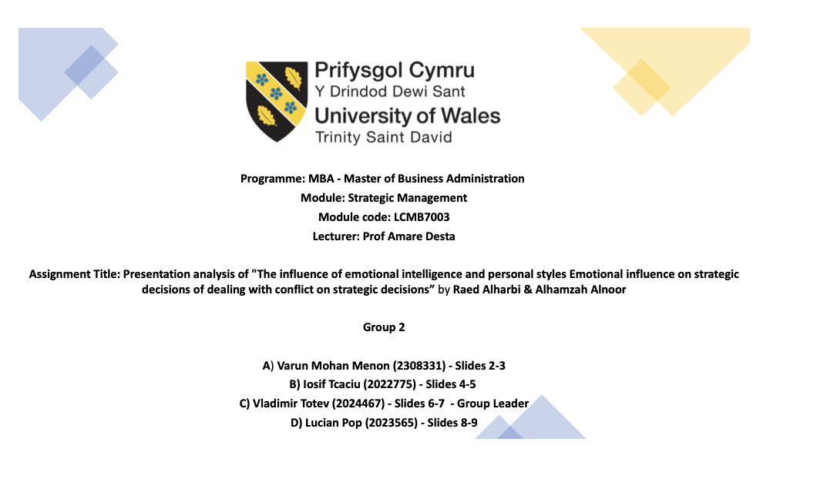

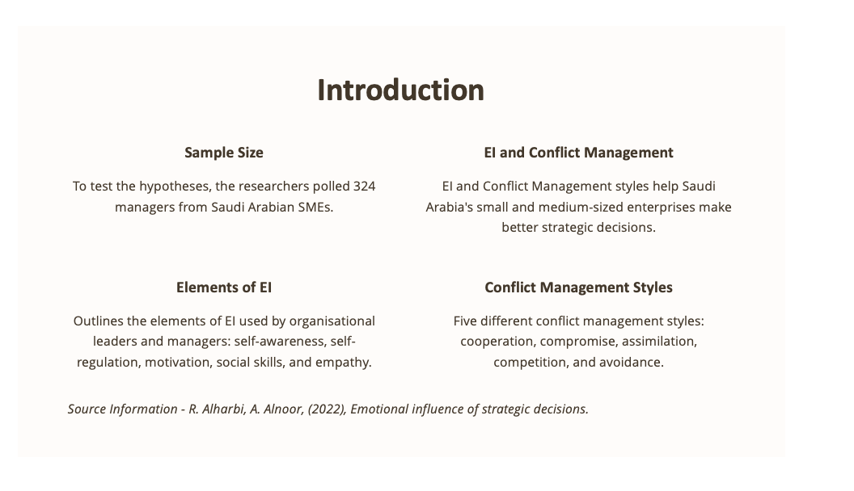

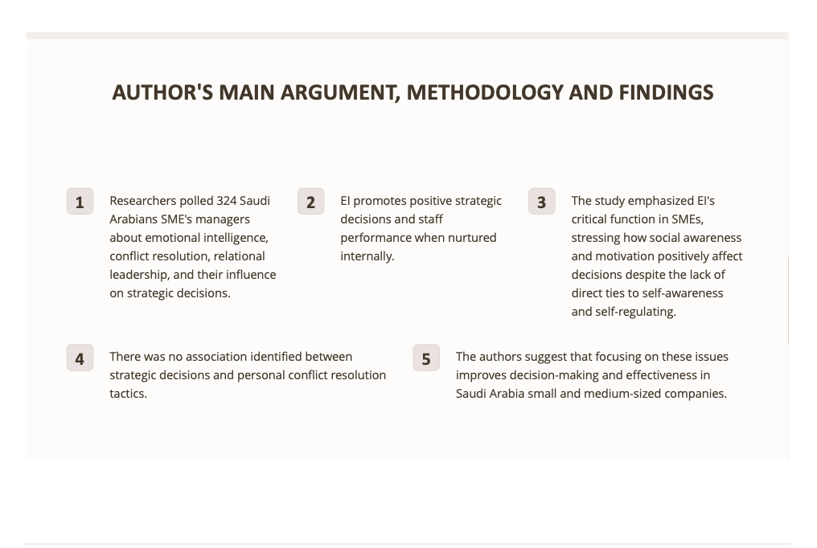

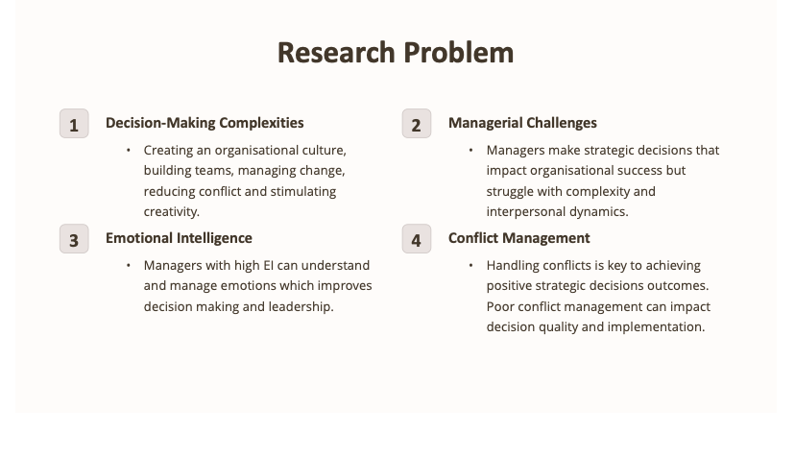
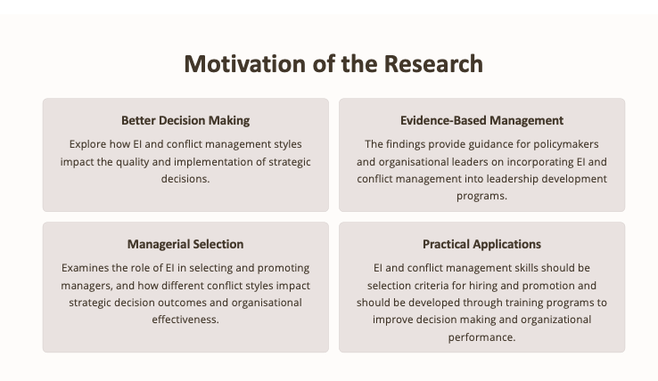

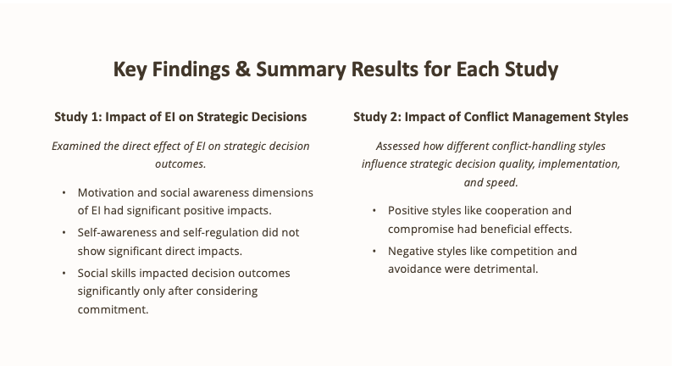

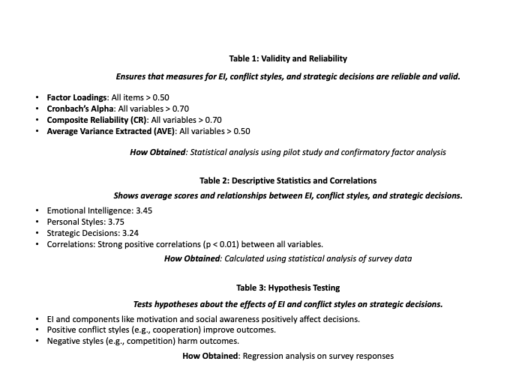

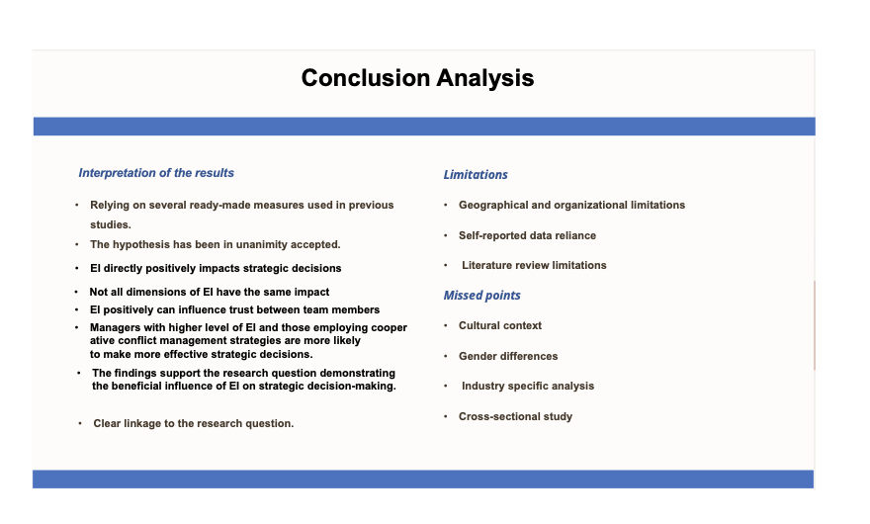
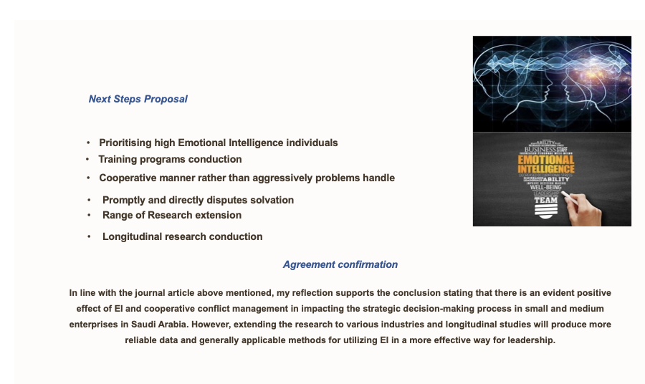

Precise of the selected paper
Alharbi, R. and Alnoor, A., (2022). The influence of emotional intelligence and personal styles of dealing with conflict on strategic decisions. PSU Research Review, (ahead-of-print).
Purpose: The study explores the role of emotional intelligence (EI) and personal conflict management styles in enhancing strategic decision-making in organizations. It also explores the contribution of various factors affecting the effectiveness of decision-making within organisations. Additionally, it also suggests how organisations may recruit middle-level managers by considering the factors affecting effective decision-making and how to improve them. Furthermore, it highlights the necessity of the relational skills of leaders and managers of all levels for conflict resolution and making decisions effective.
Methodology: A sampling method has been used to carry out this research article. The sample consists of 324 managers of different small and medium business organisations in Saudi Arabia. The sample of 324 managers was taken from a population of 1200 managers working at the middle level of the organisation and executing the strategic decisions of the top-level management. The respondents to the research work were selected randomly.
Findings: The key findings of the research include a positive correlation between emotional intelligence (EI) and strategic decision-making, the impact of various dimensions of EI, conflict management styles for achieving mutually beneficial outcomes, and the role of relational readership for effectiveness in decision-making. As part of the positive correlation between EI and strategic decision-making, the authors of the research work stated that managers with a high level of EI get better, more significant outcomes in decision-making. They also measured the effectiveness of various dimensions for becoming emotionally intelligent and making effective decisions. The dimensions are self-awareness, self-regulation, motivation, social skills, etc. Among the EI dimensions measured, motivation, social awareness, and self-awareness showed a positive influence on strategic decisions. Self-regulation and social skills, on the other hand, do not have a significant impact on emotional intelligence. As part of conflict management styles, they argued for cooperative management styles characterised by collaboration and compromise, which have a significant contribution to conflict resolution. This conflict management style will make both parties involved in a decision-making process mutually beneficial. As part of the role of relational leadership, they explained the relationship between emotional intelligence (EI) and strategic decision-making. They discussed that emotion can be good or bad, but intelligence is the ability of individuals to accept the right one and reject the wrong one by being relational. That is how relational leadership has a significant positive impact on making strategic decisions effective for organisations. Finally, the authors emphasise the importance of training employees within organisations to develop social skills, as they are helpful for making strategic decisions.
Limitations: The research has been conducted by taking a sample of respondents from the managers of various small and medium enterprises (SMEs) in Saudi Arabia. The management practices as well as strategic management practices of this country are not similar to those of other countries because the nature of the people in Saudi Arabia is different from that of the UK. That is why the application of the findings of the research is narrow.

Summary (Individual)

Introduction of the paper and argument
The paper "The Influence of Emotional Intelligence and Personal Styles of Dealing with Conflict on Strategic Decisions" by Raed Alharbi and Alhamzah Alnoor highlights the impact of emotional intelligence (EI) and conflict management styles on strategic decision-making within organisations. As part of this, the authors of the paper provided various literature reviews with a view to providing an understanding of the contents of the paper as well as meeting the objectives of the paper. As part of the literature review, the authors provided the importance of various dimensions of emotional intelligence (EI), how personal styles could be impacting conflict management within an organisation, which have a significant contribution to making organisational decision-making effective and efficient, various dimensions effecting the decision-making process, and types of learning that make decisions effective. Additionally, they analysed the relationship between emotional intelligence (EI) and strategic decisions in organisations. The research has been conducted by considering a sample of 324 middle-level managers of different SMEs in Saudi Arabia. It provides significant implications for how emotional intelligence (EI) is influenced by several dimensions and conflict management styles characterised by compromise and collaboration with employees.

Identification of the problem or issues with the paper
The paper focuses on the identification of the challenges of strategic management. Strategic management does not only include analysing data and making effective decisions based on the analysed data but also includes some skills other than technical and cognitive skills. Particularly, the paper focuses on the impact of emotional intelligence and effective conflict management styles, which also have a significant impact on the effectiveness of strategic management. As part of this, the authors break down emotional intelligence by differentiating various dimensions such as self-awareness, self-regulation, social awareness and empathy, social skills, etc. According to them, all the dimensions of emotional intelligence (EI) have a significant impact on emotional intelligence except social skills and self-regulation. It provides a significant implication for understanding the most influential dimensions of emotional intelligence. The authors also place importance on conflict management for making effective strategic decisions. As part of this, they highlighted four points of conflict discussed by Whetten and Cameron, which are the inevitability of the conflict between individuals and organisations, the enhancement of managerial practices due to the conflict over various facts, the avoidance of conflict despite the intellectual ways to conflict management, and managing all forms of personal conflict and being adapted to conflict management. By considering all the things, three points are discussed that must be understood by managers to solve challenges in strategic management, which include understanding the process of generating inputs, understanding cultural factors affecting decision-making, and understanding the dimensions of strategic decision-making.
Increased recognition for emotional intelligence (EI) is the motivation of the paper. That is why the author provided various literature reviews to understand the impact of emotional intelligence (EI) on organisational decision-making and discussed various dimensions of emotional intelligence. Strategic management enables business leaders to make effective decisions and execute those decisions by motivating all employees towards the goals. That is where various collaborations and compromises take place. The paper provides a greater understanding of the factors that could improve emotional intelligence and provides an understanding of why emotional intelligence should be a priority in the management of organisations.

Summary of the results
Managers with a high level of emotional intelligence have a better ability to bring better outcomes from strategic decision-making for organisations. As part of the statistical analysis, the correlation coefficient between EI and decision-making quality was found to be 0.65. It demonstrates a strong positive correlation between emotional intelligence (EI) and better decision quality. Some other statistics have been shown, e.g., EI and personal styles, EI and strategic decisions, and personal styles and strategic decisions, the values of which are all 0.467, 0.794, and 0.754, respectively, which demonstrate positive correlations.

Analysis of the conclusion
Through the analysis of various statistical measures, including correlation analysis, the author found a significant relationship between emotional intelligence and strategic decisions, emotional decisions and personal styles, and personal styles and strategic decision-making. Based on the analysis and some literature review, the author provided some suggestions that could help organisations develop emotional intelligence and a cooperative approach to conflict management. The findings of the research paper link with the research question of the research paper. However, the authors have identified a limitation of the research paper. The limitation of the research paper is that the author did not include any new ideas about the concept of emotional intelligence and strategic decision-making, and it is limited to the literature on emotional intelligence and strategic decision-making. The authors missed another limitation of the research paper. The findings of the research will be impactful only for the organisations in Saudi Arabia, which will not fit for other non-Muslim countries. Finally, the authors provided some suggestions that could be helpful for making managers emotionally intelligent for making effective strategic decisions that will be helpful for organisations in the long run.



