In a contemporary world, why are we as individuals still listening to societal body standards?
Student Name: Megan Cox
Student Number: 2000710
Course of Study: Photography in the Arts
Module: ADAA6000
Word Count: 5057

List Of Figures:

Figure 1. Unnamed, Lewis Capaldi [2022] Accessed from: https://metro.co.uk/2022/09/06/lewis-capaldi-promotes-new-single-by-posing-in-underwear-on-billboards-17307863/ (Accessed on November 6th 2022)

Figure 2. Unnamed, Billboard Insider [2021) Accessed from: https://billboardinsider.com/daily-billboard-blogs-3-of-a-kind-mens-undies/ (Accessed on November 7th 2022)

Figure 3. Victoria secret, Jax [2022] Accessed from: https://genius.com/Jax-usa-victorias-secret-lyrics (Accessed on November 7th 2022)

Figure 4. 1989, Taylor Swift [2014] Accessed from: https://www.capitalfm.com/news/taylor-swift-1989-album-release-date-track-list-songs/ (Accessed on December 2nd 2022)

Figure 5. On Photography, Susan Sontag [1977] Accessed from: https://dauntbooks.co.uk/shop/books/on-photography/ (Accessed on November 9th 2022)

Figure 6. The Tribuna of Uffizi, Zaffany [1777] Accessed from: https://www.rct.uk/collection/406983/the-tribuna-of-the-uffizi (Accessed on November 30th 2022)

Figure 7. Unnamed, Catherine Goodman [2020] Accessed from: https://www.bucksfreepress.co.uk/news/18200490.classicist-mary-beard-explains-posed-life-drawings/ (Accessed on December 2nd 2022)

Figure 8. Unnamed, namastehannah [2021] Accessed from: https://www.instagram.com/namastehannah/ (Accessed on November 15th 2022)

Table of Contents
List Of Figures: 2
Abstract 4
Introduction 4
Chapter One: Billboards 5
Chapter Two: The Female Body 9
Chapter Three: The Contemporary Nude 13
Conclusion 18
References: 20

Abstract
Within this thesis there is an examination of the importance of body image and stereotypes. Three significant academic sources have been explored, these being, Laura Mulvey’s Male Gaze, Susan Sontag: On Photography, and Mary Beard’s Nude in the Western Art. These sources have been enhanced using articles, songs and billboards that help to portray the importance of the body image. Furthermore, this thesis has demonstrated an understanding that there is a problem with how the body is portrayed, specifically, in the contemporary world, it has been found that the media, advertisements and individuals themselves, have caused the problems faced today.

Introduction
This thesis is an attempt to address the importance of body image and how body standards have become very toxic and unrealistic in the contemporary world with social media being one of the biggest routes of these problems. The reason being that I have decided to speak on this topic is because upon research I have found that this is a problem that goes back many years. Although, the majority of body positive and negative issues are targeted towards women, this is not always the case, therefore, because of this I have decided to talk about all genders and not just women within my thesis. Even though I have decided to talk about all genders, the greatest number of cases are still pointed towards women which is why a lot of my examples will be linked to women. The growing problem of unrealistic body standards also caused a lot of mental health issues including anxiety, depression, anorexia and so many more which is why I feel that this is such an important matter to discuss.
My thesis will be slit into three chapters, Chapter One: Billboard. Within this chapter I will go into how the artists Lewis Capaldi has gone against all body standards for his advertisement, I will compare this to another billboard and look at how Laura Mulvey’s Male Gaze challenges both of these, Chapter Two: The Female Body. Within this chapter I will be discussing the singer Jax who released a song called ‘Victoria Secret’, mainly looking at her album cover as this shows photographically the problems that she is singing about, I will then compare this artists with another and mention On Photography by Susan Sontag using this as my academic source. Finally Chapter Three: The Contemporary Nude, where I will be discussing Mary Beards Podcast Nude in the Western Art and comparing sources with it to explore the complicated relation we have with our bodies today. Splitting my work into these chapters will further help separate my work to show the importance of each piece that I am discussing. My Thesis aims to help make sense of the confusing and often misrepresented phenomenon that is the photographed human body.

Chapter One: Billboards
Within the first chapter, I will be comparing a billboard featuring Lewis Capaldi who is a singer songwriter with 1.4million Twitter followers and over 5.6 million followers of Instagram with a Michael Kors billboard, I will be comparing both billboards that have been used for advertisement. I will also talk about the research by Jasmin McGhee as this is very relevant with my work, within she discusses body image whilst interviewing young boys. After discussing this, I will move on to discuss Laura Mulvey’s, The Male Gaze Theory linking it to the billboards.
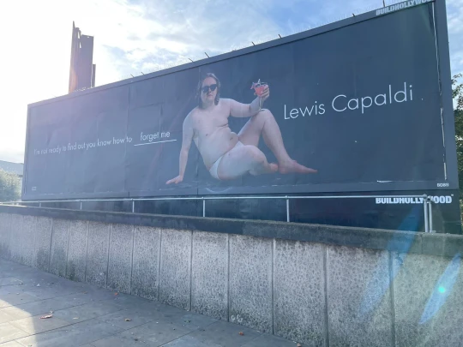
To promote his new album release “Sex Cells” (2022), Capaldi recently rented billboards across big cities in the United Kingdome. The billboard pictures Capaldi in his underwear wearing sunglasses posing with a drink, next to him is a quote from his new song and his name. The billboards as a whole is a very simple billboard as there is just a plain black background but it has drawn the attention of thousands. The reason that I have chosen to mention the Capaldi billboards is because of the attention that it has garnered it has been written about in various new paper articles, some with good reviews and some with bad reviews. According to the Daily Record, Capaldi has said that “he chose to do it because he wanted to utilise his greatest strength – his body” (Daily Records, 2022) not only does calling his body his greatest strength mean that he is being very playful with his work, but he uses his platform to challenge this by having fun with it, but it also means that Capaldi is not playing into this stereotype of his body needing to look a certain way for it to be considered a strength. Although, with that being said, Capaldi also took to Twitter and Instagram to advertise this billboard with the caption saying “Took my clothes off and traumatised the general public all in the name of a shameless self-promotion. Sex Cells” (Capaldi, 2022). Capaldi is considering his body his greatest strength and breaking stereotypes with body image and one again he’s continuing the playful nature he has developed in his persona. Capaldi also compares himself to the classic billboard, for example, Capaldi is wearing loose white underwear, which is othering to Calvin Klein boxers, or how Capaldi’s body is othering to the stereotypical body for a man. Capaldi was aware of this which I why he did it.
Fig. 1
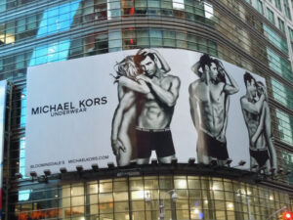
In contrast, the 2011 Michal Kors billboard which pictures both a male and female who are being posed very seductively just to advertise underwear, the man within this image plays into the body standards and stereotypes of a man as he is muscular and is with a woman. The models, Corey Bond and Valerie Avdeyeva are pictured posed three different ways, each very provocative as the female is pictured in no clothes and the male is pictured in his underwear. The man (Corey Bond) pictured in the billboard has very clearly been working on his body which then also feeds into this expectation of men looking a certain way. Not only does the male play into this stereotype, but the female within the advert is also playing into the objectification of women and she is clinging to him and acts as an accessory, why else would she be pictured in the nude within an underwear advert? Another example of a man of a particular image being used for advertisement is Kalvin Klein as they picture men in tight white underwear having a specific body type.
Fig. 2
Looking at ‘In Depth: Looking into Modern-Day Male Beauty Standards’ Jasmine McGhee (2021) which is about the standards that men are faced with in today’s age, she mentions how she interviews school children who ended up shying away from her questions as if too embarrassed to answer, when giving feedback to her advisor, he said that the reason they may shy away is because of how taboo the subject is. She then goes on to talk about how the media and pressure has a huge effect on body image, talking about Instagram and Tiktok. “Different types of social media posts are rising in popularity, especially fitness and beauty posts. Many influencers upload pictures or short videos of themselves hitting the gym or highlighting that they fit beauty standards” (McGhee, 2021), unfortunately this is something that is happening on the majority of platforms, not only setting unrealistic body standards for both men and boys, but also making them feel self-conscious of their current look, which could lead to a lot of mental health issues. McGhee then goes on to talk about how social media can have a positive impact on someone saying, “One person may suddenly develop a set of new insecurities, or others use this as a motivation to work on themselves” (McGhee, 2021), someone should not have to look at a certain body type to decide to work of themselves, the decision to focus and better themselves should be one that is not made through looking at someone else his reflects the impact advertising has on how we consider our own bodies.
Comparing both billboards it is very clear to see that the classic advertisement for a man in his underwear always has a physically fit form so seeing the billboard of Lewis Capaldi is refreshing as he is showing that he is someone with a large platform who doesn’t feel the need to look a certain way. We can see that he was having fun with his photoshoot. Although when thinking of the two, they are also similar as they are both trying to sell something with their bodies. This also links into toxic masculinity which is where men feel that they should look a certain way because they are men.
Reading into The Male Gaze Theory written by Laura Mulvey in 1973, a feminist film theory on how women are portrayed by men within the Hollywood film industry. It’s about how women are created by men, to be seen by men. Due to men overseeing the production process, making decisions that appeal to their own interests and values leading to women being immensely objectified for the pleasure of a man. Mulvey says “women are simultaneously looked at and displayed, with their appearance coded for strong visual and erotic impact” (Mulvey, 1973, p. 809) but isn’t this what both these billboards are doing? Although The Male Gaze was written about how women are seen by men within the Hollywood film industry, it also applies to everyday life and not just film. Capaldi chose to advertise the way that he did and the people in the Michal Kors billboards also chose to take that specific job. Capaldi was aware that he was self othering within his advertisement and the models in the Michael Kors advert were aware that they fit into the body stereotypes, although, with this being said men’s bodies are also there for other men to look up to, but not in a positive way.
Mulvey also mentions how “pleasure in looking has been split between active/male and passive/female” (Mulvey, 1973, p. 808), which is essentially showing how men are playing into this role and so are women. The role of the woman as an accessory and that Capaldi has a much easier opportunity to play with these ideas because he is a male is really playing into this. The Male Gaze is not natural, and it is something that we should be questioning, women are presented a certain way and they are not doing much to change this. We need to start questioning that it is not normal.
Concluding on chapter one, I have discovered that The Male Gaze is something that has impacted us for a long time, I believed that it only affected women, but I now know that is where I was wrong, The Male Gaze is something that affects all genders. We are very aware of The Male Gaze, but we are not doing anything about it. If the Capaldi billboard is normalizing this body type, does that mean that in ten years’ time billboards will better reflect the people looking at the? As billboards now are very alienated for the average looker. And looking at the billboards through The Male Gaze, do we need to start accepting that photography can be fun?

Chapter Two: The Female Body
Moving on, within chapter two I will be discussing how women’s bodies are portrayed within visual media, firstly discussing the artist Jax who sings “Victoria’s Secret” (2022), the song is about how the company Victoria Secret is owned by a man, a man who has created extremely high body standards for not only the women who work within the company but also for the people who are looking up to these models, or have a dream to work within the business, I will then move on to talk about another artists, Taylor Swift who does not sing about body standards but instead sings about romance and is the opposite to Jax within her music. The main point of discussing these two points is two show how Jax’s album cover is a visual representation of the problems she sings about. Taylor Swift’s album cover focuses on her body but omits her face. After discussing both of these points, I will talk about Susan Sontag: On Photography.
Thinking about Jax’s song, a lyric that really stood out to me within the song is when Jax sings “she’s an old man who lives in Ohio, making money off of girls like me, cashin’ in on body issues, sellin’ skin and bones with big boobs” (Jax, 2022). This particular part stood out a lot to me because of the part where she sings about skin and bones, suggesting that these models are expected to be extremely thin with big boobs so that they are appealing, which is mostly for the male audience and that is also setting unrealistic and high body standards for the younger generation.

As well as this, the album cover is the biggest reason that I have chosen to discuss this song by Jax, the cover is clearly Photoshopped to make it look like Jax has bigger features which are considered more attractive. It’s as if Jax is poking fun at the company because of how clear the Photoshopping is, the way that the whole image has been changed just by enlarging certain areas, for example, what looks like a door frame is no longer straight, and the shadow of Jax accentuates just how manipulated the image has become. How she has posed herself has also affected the way show looks, her arms being in the air has helped make her stomach look smaller and her rib cage show a lot more.
Fig. 3
Thinking back to Jax and her music, even though the whole purpose and the meaning behind the song is very important, Jax has written a whole song about how a company has created an image for younger women to look up to in a toxic manor, but Jax has this body type, so she is essentially singing and promoting a body standard that she fits into. Giving the right message in her song but has the wrong body type for it. Although, whilst Jax fits the image, she is questioning it with a degree of honesty, considering reflectively why she takes part in it.
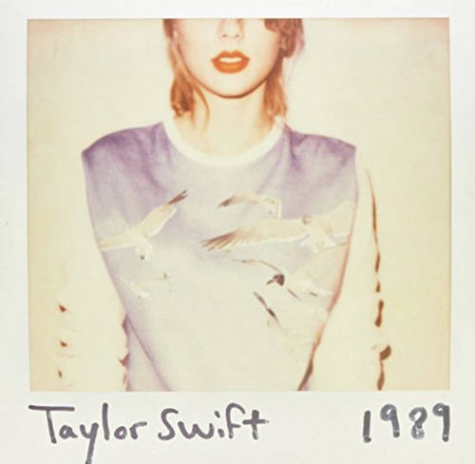
Another singer that fits into this category is Taylor Swift, she is a popular singer known for her country music who fits into the beauty standards that women face, not only her body but her whole look, small figure and blond hair. She sings a lot about romance and love, but also sings pop songs too. A very talented singer who does not sing about her body.
Fig. 4
Although that does not mean that she does not suffer with her body image. According to Variety, Taylor Swift suffers with an eating disorder, she was talking about “a picture of me where I feel like I looked like my tummy was too big, or… someone said that I looked pregnant… and that’ll just trigger me to just starve a little bit – just stop eating” (Chris Willman, 2020) so assuming that because she looks a certain way and does not suffer with that also plays into that stereotype. Although reading something about someone does not necessarily mean that it is true. Taylor Swift also uses her album covers to promote her songs in a more negative way than Jax. For, example, the cover for 1989, although it seems like an innocent cover, her arms almost blend into the background, so we are drawn towards her breasts and we are also not able to see most of her face, apart from her red lips, which is considered a sexual colour, the same applies to her album cover of red.
To compare both artists, Swift’s album cover perpetuates the Male Gaze, as they are very sexualised. Jax on the other hand is challenging this. If The Male Gaze is old and outdated, then why did she feel the need to create a song about it?
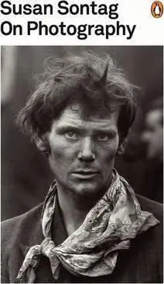
On Photography written by Susan Sontag in 1977 is a book which consists of six philosophical essays, all of which explore how big of a role photography plays in a contemporary world and how history has been portrayed though the lens of a camera. Within this book she mentions how “photography is not practiced by most people as an art. It is mainly a social rite, a defence against anxiety, and a tool of power” (Sontag, 1977, p.176). This is no surprise as people start to take interest in photography from a young age and this has a lot to do with mobile phone cameras as they play a huge role in how we see the world today, with the quality of these being equally and some even better than a digital or film camera. Technology has advanced so much where we no longer need a physical camera to take photos. Within the book, Sontag also mentions how taking photographs is “a way of certifying experience, taking photographs is also a way of refusing it – by limiting experience to a search for the photogenic, by converting experience into an image, a souvenir” (Sontag, 1977, p. 177) which almost everyone is guilty for, we are able to see on social media what influencers are doing when they are doing it because they are taking photos of it and then posting said photo onto their social media platform for their followers approval.
Fig. 5
She then discusses how photography is also considered a coping mechanism for anxiety, this makes me think about the way people use photography on social media to pose themselves a certain way for likes, everyone is guilty of doing this, as social media allows us to pretend that we are a star, and everyone is looking at us. She says how work driven individuals use photography as a means to cope with their work anxiety while on vacation. Which then leads on to “it seems positively unnatural to travel for pleasure without taking a camera along” (Sontag, 1977, p.177) this led me to thinking about the last time I travelled and did not take a photograph of what I am doing, when I am doing it.
Linking Sontag to not only Jax and Taylor Swift, but also all artists. Most artists, no matter what age have social media platforms, where they document their lives. Whether these platforms are controlled by them or their management, photography is a huge part of their lives. They use it as advertisement for everything that they do.
So, to conclude on this chapter, Susan Sontag: On Photography is something that relates to almost everyone’s day to do life, the way that we present ourselves on social media is not the same as we do in real life. Discovering that we should never judge someone on the way that they look, as even those who fit the beauty standards still suffer with mental challenges. Photography is a way to make memories and for some it is not as serious as others, but more of something that they cherish. Also, Taylor Swift is what we are used to seeing and she stands for something that is opposite to Jax, but is that necessarily a bad thing?

Chapter Three: The Contemporary Nude
Within chapter three, I have decided to talk about Mary Beard, whose podcast called Nude in the Western Art in 2020 is a Forty-minute talk from the ‘History Extra Podcast’ about whether there is a difference between nude in art and “soft porn for the elite” (Beard, 2020). Within the podcast Beard discusses multiple art works that include some form of nudity, in the majority of these the nude art is of women with a man being the viewer. Firstly I will be discussing some examples that stood out to me within Beard’s podcast, these examples from Beard’s work help to identify the complex nature of our relationship with the body in contemporary society. will then move on to talk about some examples of this, using beard as my academic source to link everything together. The examples that I have found related to this source, the first being an article that was once in a British newspaper that recently has gotten banned, and the second being an Instagram page that I have recently come across.
The first artwork from Beards podcast that I will be discussing is ‘Origin of the World’ a piece created by Gustave Courbet. It is a detailed painting of a woman where you cannot see her head or her limbs, just her genitals in a lot of detail. Beard questions this by asking “how do we explain why this is in a gallery and is considered a masterpiece?” (Beard, 2020). The painting is hung in the Musee d’Orsay in Paris where the public can visit. The name of the painting ‘Origin of the World’ is because this is where we all came from, the female genitals is the origin of where we all came from, the painting should be considered a masterpiece, for not only the detail within, but also the message that the name and piece has. Comparing this to my contemporary examples previously discussed, would these be considered art to be hung in a museum or are they something that is just considered playful?
Following from this, she mentions how even though the male body has been seen nude in art a lot longer than what the female body has, the male body was not necessarily seen or associated with desire, “it was associated with virtue, with good citizenship” (Beard, 2020). Meaning that men were seen as strong willed, not much has changed since this, men are not nearly as sexualised as much as females. Not only sexualised, but they do not have to live up to the body standards as they do. Now, in the contemporary world the male body is a lot more restricted with what you can and cannot show in comparison to the female body. But with this being said, men are still living up to the standards that they have to be strong and look a certain way, and are certainly still very sexualised, as seen above in the Michael Kors advertisement. Although the majority of cases of women being sexualised is from men, not all, but most. Once again thinking of my pervious example, the way that we view the bodies of Lewis Capaldi and the male body within the Michael Kors adverts compared to how we view Jax’s body will be completely different as the female body is associated with desire and the male is not as much.
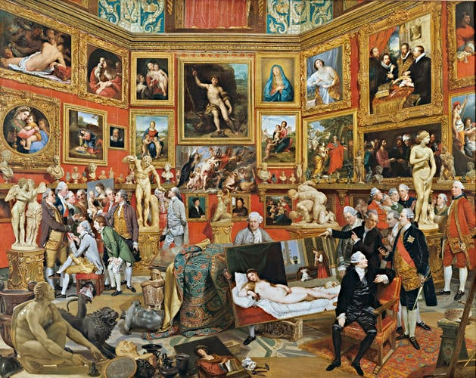
This leads me onto the next piece of art work, ‘The Tribuna of Uffizi’ which was created in 1772 by Zaffany. This painting depicts a gallery that primarily showcases paintings and sculptures most of which are of nude women, and the rest being of just women. The people looking at the art are all men and Zaffany made it a point to paint most men being him in different outfits and poses. Within this art is the ‘Venus de’Medici’ sculpture created by Cleomenes, a nude sculpture of a women where there is a man who is using a magnifying glass to look at her and the rest of the men are standing behind her looking, “What Zoffany is outing here is that very fragile boundary between, you know, love and sex and over-love of art” (Beard, 2020) which is essentially questioning the male perception of love, do they love for looking, or do they love for love? She then goes on to say “it’s not a new discovery to say that nudes promote male desire, Zoffany got there a long time ago” (Beard, 2020). A lot of paintings including nudity are considered masterpieces which then questions why men feel that desire towards it, it’s a painting, an inanimate object which means that the desire that they feel is not shared.
Fig. 6
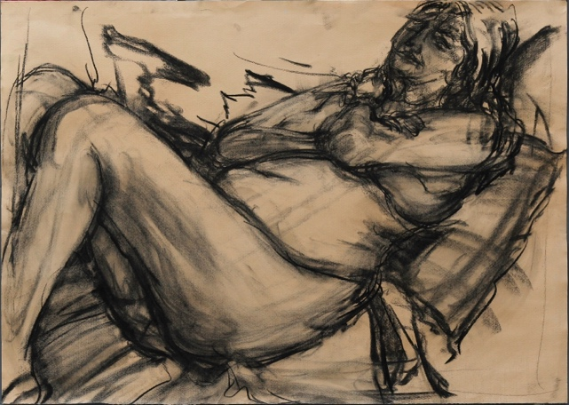
Beard is questioning nude in art by challenging the theories by taking part and posing nude for art. which is very clever on her behalf, she is trying to show that we shouldn’t be too serious when it comes to art and that we should start having fun with it. Beard is questioning the body type we always see within art, she says how people may be questioning why she decided to do it, “shouldn’t 65-year-old women keep their clothes on? But that is also part of the point of this whole series. Whose bodies do we see? Whose are deemed ‘okay for art?’ Don’t old people have bodies too?” (BucksFreePress, 2020). Here she is talking about how bodies within art are all the same, small women are who fit the standards that we all play into, Beard is not only normalising bodies, but doing so through art of herself whilst also bringing her age into it as a positive factor. This once again relates to Lewis Capaldi’s billboard as the image he used is not what we normally see for advertisement.
Fig. 7
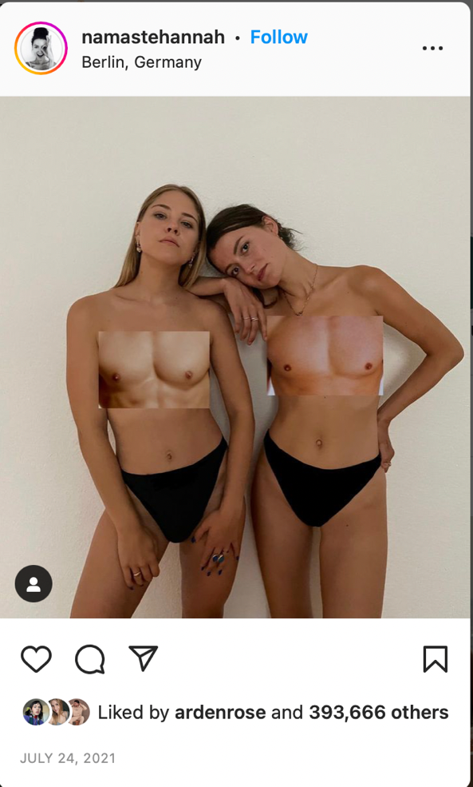
As further examples of the contemporary nude, ‘Page 3 Girl’ from The Sun, a British newspaper that included topless images of women for more than 44 years. This page is something that young boys and girls were able to look at with very easy access within supermarkets. Page 3 set unrealistic body standards and also gave unrealistic expectations of what to expect from your average person. Although, page 3 girl no longer exists as The Sun completely scrapped said page from not only their papers, but also online articles too. The page was to some considered sexist and offensive. Which then leads to the debate around the female nipple, it is not the breast itself that has been sexualised, but the nipple. Both men and women have them so why it is considered something of desire toward women and not men?
This then links to an Instagram account that I have recently come across called ‘namastehannah’ who claims to be a feminist but her Instagram account holds a contradiction. She recently posted images of herself and another in just their underwear and covering their top half is a cropped photograph of a male chest showing the male nipple. At first glance, I personally found this post very interesting but after looking at it for a while, I realise how strange it actually is. The reason that I found this to be so interesting is because of how perfect the cropped images fitted onto both of their bodies, but then I realised that they are posed in their underwear that is also fitted onto their bodies to make their bodies look a lot more flattering, not only this but they are also posed a certain way to make themselves look better. Not only this, but the underwear that they are wearing looks very high quality which further gives the message that they were trying to show off their underwear as well.
Fig. 8
Whilst trying to show the difference between the male and female body, they have created an outcome that has almost four hundred thousand likes from people who believe that she is trying to be body positive. Although, this is not how I see the image, I see that namastehannah is both body positive and body negative towards all genders, especially women. She is trying to be body positive, but she has the body to be positive about, and we are looking up to her as inspiration because of how she portrays herself on social media.
This is not the only post on this Instagram account that is like this, a lot of which are negatively aimed towards men to stop sexualising the female body, but the posts she is sharing are also sexualizing the female body, so why is it right for her to do it, but not others?
Concluding on chapter three, through Mary Beard’s example, we can see that she has highlighted the complexity of the contemporary nude that it applies not only to art but all things. Beards academic piece is being honest, whereas Namastehannah is not, she is promoting something that she herself should not be promoting. So within this chapter I have discovered that the majority of platforms that promote body positivity are from people who are able to be body positive. Comparing both Beard and Namastehannah, both are exposing their bodies for different reasons, this highlights the difficulty in representing and understanding the human form. There is never a middle ground when it comes to this, it goes from one extreme to another. Page 3 is an example of change, the page was completely scrapped, but since then not much has changed when it comes to this subject.

Conclusion
All three chapters within my thesis include some very excellent academic pieces that have some very good points within them. After discussing The Male Gaze within the first chapter, I have come to realise that we as a society are very aware of The Male Gaze, we have recognized that this is a problem and yet, here we are, still talking about it and even going to the extreme of creating music around the subject. Although, that does not mean that there has not been change, for example, Page 3 being removed and Capaldi advertising is body is a huge change compared to what was happening in the past. On Photography by Susan Sontag is also something that we use I everyday life, most people do not consider themselves photographers, but they are still aware of what photography is and partake in the activity on a day to day basis. And lastly, Mary beard’s podcast is the most relevant academic source that I decided to use, the reason for this is because I wanted to include both old and new within my thesis to show how long this problem has been going on.
The majority of examples that I have used within my thesis are very recent which then goes on to show how we are a lot more aware of the topic now than what we were a couple of years back.
It is worth that all academic pieces that I have chosen are all created by women, so does this mean that it is mostly females who have realised what problems we are facing every day? Or is it that it is mostly females who are willing to speak out about it?
Mary Beard’s podcast shines light on the contemporary conditions of the nude, the reason being for this is because it is the most recent piece of work within my thesis which relates not only to my work, but everyday life.
So, to conclude on my thesis, I have discovered that in a contemporary world, the problem is perpetuated by media, advertisement – and more confusingly: ourselves. While we appear more aware of the issues surrounding our body, it is very clear that our relationship with it remain as complex as ever.

References:
billboardinsider (2021). Daily Billboard Blog’s 3 of a Kind: Men’s Undies. [online] Billboard InsiderTM. Available at: https://billboardinsider.com/daily-billboard-blogs-3-of-a-kind-mens-undies/
‌Bucks Free Press. (n.d.). Classicist Mary Beard explains why she posed for life drawings. [online] Available at: https://www.bucksfreepress.co.uk/news/18200490.classicist-mary-beard-explains-posed-life-drawings/
‌Capital. (n.d.). ’1989 – Taylor’s Version’ is coming – here’s every single detail. [online] Available at: https://www.capitalfm.com/news/taylor-swift-1989-album-release-date-track-list-songs/
‌Entertainment Daily. (2020). Why was Page 3 banned and who was the youngest model? [online] Available at: https://www.entertainmentdaily.co.uk/tv/why-page-3-banned-youngest-model/.
McGhee, J. (2021). In-Depth: Looking Into Modern-Day Male Beauty Standards. [online] Westminster Paw Prints. Available at: https://westminsterpawprints.com/features/2021/12/10/in-depth-looking-into-modern-day-male-beauty-standards/.

McStay, K. (2022). Lewis Capaldi says reason for naked billboard was to utilise greatest strength. [online] Daily Record. Available at: https://www.dailyrecord.co.uk/entertainment/celebrity/lewis-capaldi-says-reason-naked-27921166.

Morin, A. (2020). What Is Toxic Masculinity? [online] Verywell Mind. Available at: https://www.verywellmind.com/what-is-toxic-masculinity-5075107.
‌Mulvey, L. (1975). Visual Pleasure and Narrative Cinema. London Afterall Books.
O’Connor, R. (2022). Lewis Capaldi promotes new single by posing in underwear on massive billboards. [online] Metro. Available at: https://metro.co.uk/2022/09/06/lewis-capaldi-promotes-new-single-by-posing-in-underwear-on-billboards-17307863/.
On Photography by Susan Sontag. (n.d.). [online] dauntbooks.co.uk. Available at: https://dauntbooks.co.uk/shop/books/on-photography/.
PopBuzz. (n.d.). People are meme-ing Kendall Jenner’s walk at the Victoria’s Secret Fashion Show. [online] Available at: https://www.popbuzz.com/internet/viral/kendall-jenner-walk-victorias-secret/
‌scribe.usc.edu. (n.d.). Uncovering the Female Nipple. [online] Available at: https://scribe.usc.edu/uncovering-the-female-nipple/
Sontag, S. (1977). On Photography. New York Picador.
www.gettyimages.co.uk. (n.d.). Calvin Klein Billboard Nyc Photos and Premium High Res Pictures - Getty Images. [online] Available at: https://www.gettyimages.co.uk/photos/calvin-klein-billboard-nyc.
‌www.rct.uk. (n.d.). Johan Joseph Zoffany (Frankfurt 1733-London 1810) - The Tribuna of the Uffizi. [online] Available at: https://www.rct.uk/collection/406983/the-tribuna-of-the-uffizi.

https://www.instagram.com/namastehannah/

