Assessment Form

Module: Preparing for Professional Policing
Student Name: Hannah Jones
Module Tutor (s): Kelly Andrews
Question | 1  Situation | 2  Task | 3.  Action | 4.  Result |  | Total Mark
1 | 3/5 | 3/5 | 8/15 | 4/5 |  | 18/30
2 | 4/5 | 4/5 | 12/15 | 3/5 |  | 23/30
3 | 3/5 | 4/5 | 11/15 | 3/5 |  | 21/30
 |  |  |  |  |  | Total Mark 62 /90
Key
No Reference | Minimum | Satisfactory | Exceptional
0 | 0-4 | 5-10 | 11-15

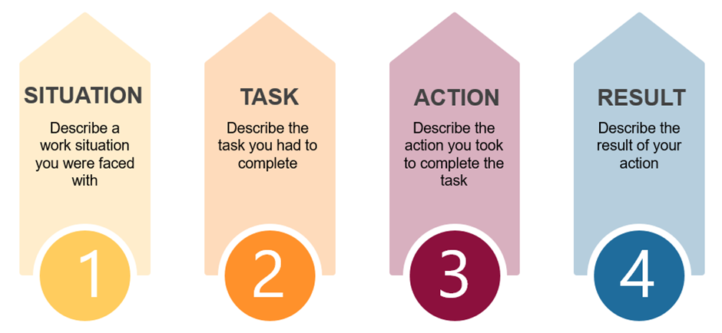

Question | Comments
1 | Q3  University example:  Provided with an opportunity to attend schools to discuss law with children.  Task was to inspire the children to taken on a role within law.  What I did was put together presentations with how they could do this and teach them different things about the law, I did this for a few months.  I had feedback from the children and some of them had decided to look at a career in law.  Needed a prompt for more detail around communication skills –  More detail was provided – remember to address all elements of the question in full and use STAR to help structure the answer.
2 | Q5  Work example; help point – police volunteer  My job is to attend scenes in a nighttime economy.  Provided various examples which added context which was good.  Report of a intoxicated lady – needed to bring her to the help point.  Actions: Got to the patient, got her in a wheelchair, as we were moving, she started to wake up, my colleagues started to panic, I needed to manage my team and keep them safe and the lady  Started to delegate tasks. I got someone to manage traffic – another to get a police officer.  Managed to get her to the help point safely.  Really good example – well described and STAR followed.
3 | Q7  Work example:  On shift and witnessed a couple abusing their children.  I notified a manager – everyone was keeping an eye on this couple –  Task – I needed to watch and keep and eye to see if there was any physical abuse going on there was a lot of verbal abuse. Just in case I needed to provide evidence.  A colleague was going to approach the couple, I didn’t think this would be a good idea, I explained it could make the situation worse.  Communication various reasons to her.  We came to an agreement to sit back and watch – the children left with the parents – the police were called.  Could have provided more detail around how this was communicated to the colleague.  .

.

.

