What are the current challenges that the industry is facing that is affecting employee retention

Student name: Cristian Paveliuc
Module title: Personnel Resourcing & Development (BMIH5005)
Lecturer name: Emma Roberts

Contents
Introduction 3
Analysis 3
Brexit 4
Covid 19 4
Pestel Analysis 6
Political 6
Economic 7
Social 7
Technological 7
Environment 7
Legal 8
SWOT Analysis 8
Weaknesses 9
Opportunities 9
Threats 9
Solutions 10
Conclusion 11
Reference list: 11

Introduction
The hotel chosen for this report is Marriot hotel. Marriot hotel was founded by J. Willard Marriott and his wife, Alice. It first started as a root beer stand. Later they transformed the stand into a franchise along with a family friend. In 1957, Marriott entered in hospitality industry under the management of J. Willard’s son. In 25 years, the hotel became a global enterprise and it expanded internationally.

Analysis
Tourism and hospitality industry is constantly growing providing 6.1% from the global GDP. However, it also confronts employee and guests loss because of the natural disaster such as pandemics, economy fall and growing prices. (Armstrong, 2020)
Besides organisational expansion and improvement, the company’s success depends also on the employees. In order to succeed into the industry, the organisations need to avoid the loss of employees by improving employee retention strategies.
Employee retention is the goal of the organisation by creating a nice work environment to encourage engagement, expressing gratitude to employees, offering competitive compensation and benefits, and promoting a healthy work-life balance. In order to maintain a good communication and to keep employee retention, the companies have specific retention strategies.
According to Armstrong (2020) retention strategies must be based on understanding of the aspects that influence the employees staying or leaving. (Armstrong’s Handbook,2020)
The daily interaction of employees in the tourism and hospitality industry sector with guests and clients from all over the world results in stress. As a result, their level of satisfaction can decrease, and they might decide to resign.
The current factors that could impact the retention in a hotel are ambiguous job expectations, management miscommunication, lack of flexibility, unhealthy environment, lack of recognition, minimal growth opportunities.
According to Comparably website, Marriott is in the Top 30% in its ability to retain quality employees. However, in the last 2 years the industry, including Marriott Hotel suffered a big employee loss.
In practically all industrialised nations, the hospitality and tourist sector form the greatest share of the service economy. UK hotels employ a very high proportion of migrant employees while having the highest sectoral concentration of low-wage jobs. Therefore, it has been the subject of research and analysis from a variety of angles, including those on general skills shortages affecting the sector, including complexities such as language skills shortages as well as those involving hotels in specific; the role of migrant workers and their economic impact; and, more recently, on the issue of Brexit and aspects as to its extended impact.

Brexit

The UK had been receiving migrant labour from other EU members, a position that was emulated in other member states. Many foreign workers were hired by UK hospitality establishments like pubs, restaurants, and cafés, for instance. In the years prior Brexit, the industry employed around 400,000 migrant workers. Since Brexit, neither migrant employees nor UK-based businesses are subject to the free movement rule. Finding international employees has been harder for employers and moving to the UK is no longer as appealing to migrant workers as it once was. One of the largest publicly traded pub groups in the UK, Mitchells and Butlers, was reported to have lost 9,000 of its 39,000 employees, or over a quarter, as a result of Brexit. (The Guardian).
Only 3% of GDP is composed of industries that were severely impacted by both COVID-19 and Brexit. But few industries are exempt from damage; 69% of the economy is composed of industries that have been negatively impacted by the pandemic, Brexit, or both.

Covid 19

According to the Government website, after the pandemic 3% have been made permanently redundant, 3% resigned, 65% returned to work. Most job losses in Hospitality and entertainment industries occurred in the first six months of the pandemic, but employment continued to decline in the first few months of 2021 as well. This illustrates how severely the pandemic affected these industries despite substantial support for them through the CJRS, business awards, and other measures. 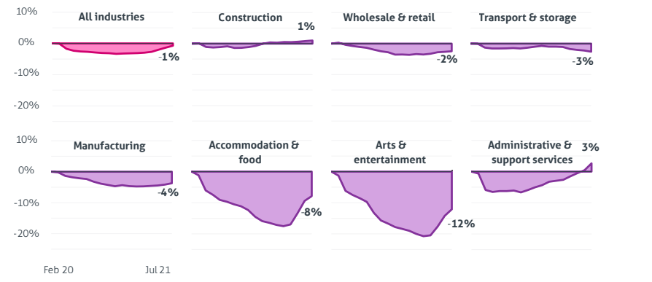
Despite significant job growth since the economy began to recover in spring 2021, employment in these industries is still far below that of the pre-crisis period. During pandemic, the CEO of Marriott, Arne Sorenson, decided to lessen the financial strain on staff, the manager sacrificed his salary for the year and the other executives agreed to cut their pay in half. (Forbes, 2020) One of the hotel’s strategies is to care for employees so they can care for the guests. The managers also think about employees well-being. David Rodriguez, Marriott’s global chief HR officer states that “the future success of the hotelier’s business is completely dependent on its ability to foster a sense of well-being among employees.” (Forbes,2020)
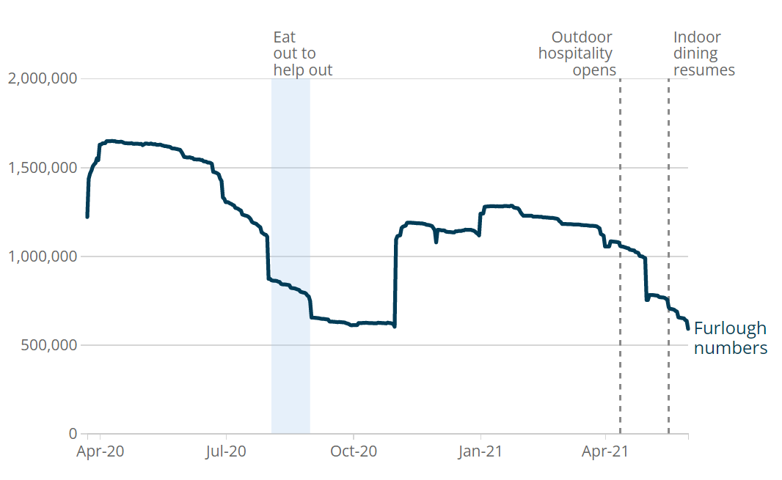

Pestel Analysis

Political

One of the most popular models used in the assessment of the external business environment, which is very dynamic, is the PESTLE analysis. It is utilised as a situational analysis tool for business evaluation purposes. The threat of terrorism, international relations, and the political atmosphere in well-known tourism areas are the main political issues that might have an impact on Marriott. A terrorist attack or a military war that could obstruct international air transport or discourage individuals from travelling pose the greatest hazard in this situation.

Economic

Understanding economic variables like the foreign exchange/interest rate, the state of the job market, inflation, saving rates, etc. is crucial for Marriott International since they affect the nation's overall economic climate. Marriott International can benefit from having a thorough awareness of the financial situation , predict the industry and organization's growth trajectory.

Social

Marriott International's marketing division can use the data from sociological and environmental analyses to target specific consumer groups and make the things it offers more appealing to potential customers. For worldwide commercial enterprises like Marriott International, changes in demographic patterns including the ageing population, migration trends, and socioeconomic characteristics are of the utmost importance.
The emergence of social media and e-commerce has pushed consumers to shop online. Because younger consumers are more likely to shop online than older consumers, Marriott International needs to understand the generational disparities in online shopping behaviour. When creating marketing and communication plans, it is important to take into account the rising use of mobile devices and social networking sites.

Technological

The fourth component of the PESTEL analysis is "technology." The significance of comprehending technical elements during the process of strategic decision-making has increased due to the rapid growth of technology and its global spread. In order to attain specific business advantages, such as growing profitability, accelerating the innovation process, and improving operational efficiency, Marriott International can benefit from a thorough understanding of the technology environment.

Environment

Environmental analysis is now a significant component of PESTEL analysis due to rising environmental awareness and changing climatic circumstances. Various markets have distinct environmental norms, rules, and regulations. Marriott International's global reach necessitates that the company carefully weigh these distinctions in order to prevent undesirable situations. Prior to opting to launch a new product line or enter a new market, a thorough environmental investigation is essential.

Legal

The PESTEL study' sixth element is "Legal." Without carefully examining the legal framework and regulatory framework of the new consumer market, Marriott International cannot enter that market. To avoid major difficulties, a detailed assessment of legal issues is necessary. Ignorance in this area may result in unfavourable events for Marriott International, such as a loss of competitive advantage due to a violation of intellectual property rights and a damaged organisational reputation as a result of a violation of standards for the protection of customers, employees, and the environment.

SWOT Analysis
SWOT analysis is a strategic planning framework that business managers can use to successfully analyse the company's situation.
One of Marriott’s strengths is that they have high customer satisfaction especially because of the loyalty programs. One of the most devoted customer bases in the entire world is that of Marriott. There won't be any other hotels added to replace Marriott. To help its clients, the business also provides a variety of reward programmes. Another strength is the acquisition. Marriott has acquired additional hotels like Gaylord, Ritz Carlton, Bulgari Hotel, and Resorts Worldwide with great success. The company's revenue has increased significantly as a result of such acquisitions. To lessen competition, Marriott has teamed up with some of the biggest businesses in the world, like Alibaba. Customers were given the chance to book reservations without having to pay a deposit. Most significantly, it gave the brand an advantage over rivals.

Weaknesses

The success of any organisation depends on following professional standards and regulations. The rules at Marriott are so stringent that they are stifling the staff. As a result, their productivity, performance, and level of job satisfaction are all dropping. Another weakness is unprotected data. In 2018, hackers compromised the Starwood Marriott hotel's internet security system. Over 500 million clients had their personal information exposed. It contained private information including account numbers, passport numbers, names, email addresses, and so forth. It raised a significant trust and secrecy issue.

Opportunities

The clients of the twenty-first century have highly luxurious lifestyles in their homes. As a result, satisfying them is a huge problem for the hotel sector. If Marriott provides them with specialised services that are unique to each customer. By giving the hotel and restaurant brand a significant competitive advantage, it would assist the company in differentiating itself.
To accommodate the affluent, business-class travellers, developing nations lack a large number of luxurious hotels. To take advantage of the market domination in those nations, Marriott.

Threats

The Marriott is a 5-star hotel that offers its diverse clientele first-rate lodging options as well as other amenities. In order to make a statement, the terrorists frequently target upscale 5-star hotels with a large international guest population.
The covid-19 epidemic struck the world in 2020, which also saw a global economic downturn. After the epidemic and throughout it, many of individuals lost their jobs. Although the industry recovered, this year the inflation affected the word’s economy including hospitality industry.

The category of upscale hospitality includes Marriott. The company was hardest hit by the pandemic. It is for this reason that the chain hotel brand's annual revenue and net profitability both significantly decreased.

Solutions

- Investing in employee’s career
Employees are aware of the necessity to maintain their skills current in order to be competitive and advance in the workplace in today's environment. By offering mechanisms like mentorship programmes and funding further education for their staff, businesses may capitalise on their employees' drive for growth. Online professional education programmes like those Emeritus provides assist firms in reskilling and upskilling their workforce, expanding their talent pool and boosting employee happiness.
- Managers training
Another solution for employee retention is to provide manager training. The employee leaves their jobs not only because of a better job or career development but also because of the poor management. If the managers cannot communicate with the employees because of the lack of experience and interest, the company will loss its employee.
- Recognize employee’s contribution in the company’s success
Companies should encourage managers to acknowledge the contributions oftheir immediate reports. They can even go a step farther and recognise employees that go above and beyond on a divisional or corporate level. That understanding is particularly crucial during the pandemic, when many employees have been required to handle challenging situations despite constantly shifting circumstances.
- Improving organisational culture
Although corporate culture may appear to be subjective, it has real effects on retention. One of the major influences on job satisfaction is corporate culture. Strong corporate cultures share key characteristics, such as: having and upholding clearly articulated values, appreciating and seeking out employee input, being strongly committed to diversity, equity, and inclusion, and implementing supportive leadership, although the components of a strong culture vary somewhat from one workplace to another.

Conclusion
To conclude, Marriott International is focusing on its employees, trying to provide them the necessary skill, benefits and everything that is necessary in order to have a good communication, and happiness at work. However, there are unforeseeable situations such as pandemic, natural disaster or inflation that will affect the industry, the company cares for its employees is trying to provide them all necessary requirements.

Reference list:
Armstrong, M. and Taylor, S. (2020) Armstrong’s Handbook of Human Resource Management Practice. [BibliU version] 15th ed. London, Kogan Page.
Bratton J, Gold J. Human Resource Management [BibliU]. 6th ed. London: Bloomsbury Publishing; 2017. [Cited 2022 Dec 02]. Available from: https://bibliu.com/app/#/view/books/9781137586681/pdf2htmlex/index.html#page_C1
Caterer.com, 2021, The impact of Brexit and Covid on the UK hospitality workforce, Available at: https://www.caterer.com/recruiter-advice/the-impact-of-brexit-and-covid-on-the-uk-hospitality-workforce [Accessed on 22 November]
Census,2021, Coronavirus and its impact on UK hospitality: January 2020 to June 2021, Available at: https://www.ons.gov.uk/businessindustryandtrade/business/activitysizeandlocation/articles/coronavirusanditsimpactonukhospitality/january2020tojune2021
Gibbons, S., 2020, 3 Things You Can Learn From Marriott About Taking Care Of Employees, Available at: https://www.forbes.com/sites/serenitygibbons/2020/04/30/3-things-you-can-learn-from-marriott-about-taking-care-of-employees/?sh=721380442bca [Accessed on 22 November]
James, W., 2021, The impact of Brexit on the hospitality sector; what’s the post-Brexit outlook?, Available at: https://stint.co/learning-hub/the-impact-of-brexit-on-the-hospitality-sector/ [Accessed on 22 November]
Marriot International, Our story, Available at: https://www.marriott.com/about/culture-and-values/history.mi [ Accessed on 21 November]
Marriott, Retention Score, Available at: https://www.comparably.com/companies/marriott/retention [Accessed on 22 November]
Pope, T., 2021, The Coronavirus Job Retention Scheme, Available at: https://www.instituteforgovernment.org.uk/sites/default/files/publications/coronavirus-job-retention-scheme-success.pdf [Accessed on 22 November]
Tetlow, G., 2020, Economic impacts and policy response, Available at: https://www.instituteforgovernment.org.uk/sites/default/files/publications/brexit-coronavirus-economic-impact.pdf [Accessed on 22 November]
Work Institute, 2022, Retention Report, Available at: https://info.workinstitute.com/hubfs/2022%20Retention%20Report/2022%20Retention%20Report%20-%20Work%20Institute.pdf

