
International Hotel Management

Sustainable Hospitality & Tourism Management BMIH5006
(Assignment 2)

Eco-Friendly Innovations in Hospitality Transport

Student Name: Nicoleta Cornelia Mocanu
Student ID: 2220990
Tutor's Name: Kathryn Roberts, Christopher Wilkin

Report

Eco-Friendly Innovations in Hospitality Transport

Contents
- Executive Summary
- Introduction
- Sustainable Transport in the Hospitality Industry
- Eco-Friendly Transport Initiatives in Hospitality
- Challenges of Implementing Sustainable Transport in Hospitality
- Future of Sustainable Transport in Hospitality
- Conclusion and Recommendations
- References

Introduction
Transport systems are crucial in the hospitality industry as they help bring in guests, support logistics, as well as tourism. On the other hand, conventional transportation is a major contributor to greenhouse gas emissions, air pollution, and resource depletion (Legrand, Chen, and Laeis, 2022). To optimize the guest experience while minimizing environmental impact, sustainable transport solutions such as electric vehicles, hyperloop technology and carbon-neutral airline programs are being levered by the industry (Wan, Shen and Choi, 2019). Sustainable transport in hospitality is the environment-friendly mobility solutions of hotels, resorts, and tourism-related business. Among these initiatives are renewable energy hotel shuttles, partnerships with green-certified airlines, and public transport encouraged instead of private car use (Prakash et al., 2023). More and more industry players are adopting sustainable travel projects to match world environmental goals like the United Nations Sustainable Development Goals (AlKetbi and Rice, 2024). This figure will explore the sustainable transport trends in hospitality today, assess the major sustainable transport initiatives and the pros and cons of doing so. Moreover, it will be discussed how sustainable transport in general is shaping the future and spacing between green mobility solutions and hospitality (Dibene-Arriola et al., 2021).

3. Sustainable Transport in the Hospitality Industry
The adoption of sustainable transport solutions is becoming more prevalent in the hospitality industry, enabling companies to reduce their environmental impact and improve their guest experience. Sustainable transport describes mobility solutions that reduce carbon emissions, increase energy efficiency and promote long-term ecological balance (Legrand, Chen, and Laeis 2022). As eco-conscious travellers are on the rise, hotels, resorts, and tourism operators are adopting green mobility options that allow the customers to rely on electric shuttles, renting hybrids, or to partner with green carriers (Pereira, Silva, and Dias, 2021) . In line with global environmental policies, such as the Paris Agreement and the UN Sustainable Development Goals, hospitality businesses are embracing strategies to reduce carbon emissions (AlKetbi and Rice, 2024). A smart transport system incorporates Internet of Things (IoT) sensors and AI-powered fleet management, which increase efficiency of travel logistics and sustainability (Dibene-Arriola et al., 2021). Although there are advancements, you can see that sustainable transport solutions are difficult due to issues with high initial investment costs, insufficient charging infrastructure, and regulatory constraints (Han et al., 2018) This has led to a rise in consecutive innovations in this sector, fuelled by increasing government incentives and consumer demand for eco-tourism experiences (Abreu et al., 2024). In this section, we look at the importance of sustainable transport in hospitality and address the current trends driving the industry towards greener mobility.

3.1 The Importance of Sustainable Transport
The hospitality industry, becoming one of the most successful in the world, has a big challenge to help solve: sustainable transport. Conventional modes of transportation are major causes of air pollution, noise emissions, and global warming, which affect both natural ecosystems and the spatial urban structure (Wan, Shen, and Choi, 2019). Hospitality businesses can reduce their carbon emissions and strengthen sustainability efforts by embracing electric vehicles, green aviation partnerships, and high-speed rail networks (Prakash et al., 2023) In addition to being beneficial for the environment, sustainable transport increases brand reputation, attracts eco-conscious travellers, and places businesses in line with regulatory sustainability requirements (Dibene-Arriola et al., 2021). Note: Sustainability in hospitality operations should also offer green transport options to remain competitive among travellers .
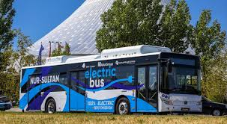

3.2 Current Trends in Sustainable Transport for Hospitality
The transport arm of sustainability within the hospitality industry is booming. One notable trend involves the use of electric and hybrid vehicles in hotels and resorts fleets, which decreases dependency on fossil fuel and lowers operational costs (Legrand, Chen, and Laeis, 2022) . A lot of top hotels provide electric-powered shuttle services and charge stations (for guests driving electric cars) (Pereira, Silva, and Dias, 2021). In line with this trend, hospitality brands collaborate with carbon negating airlines, promote carbon offset programs and the use of sustainable aviation fuel (Han et al., 2018). Moreover, the emergence of high-speed trains as substitutes for domestic flights has begun to provide an alternative, whose emissions are as many as ten times lower than those of short-haul flights and can offer more seamless journeys (Dibene-Arriola, 2021). At the same time, the implementation of smart mobility technologies, including AI-based transport planning, as well as IoT-based vehicle monitoring, are making hospitality transport operations even more efficient and sustainable (AlKetbi and Rice, 2024). Sustainable transport is now a core operation of contemporary hospitality as industry leaders evolve and generate efficiencies.
4. Eco-Friendly Transport Initiatives in Hospitality
The movement towards sustainable transport within the hospitality industry is motivated by environmental considerations, cost effectiveness and changing traveller expectations. To reduce their carbon footprint, hotels, resorts, and tourism operators are embracing green mobility solutions that provide tourists convenient, green alternatives to traditional transportation (Legrand, Chen & Laeis, 2022). Some examples of these initiatives are sustainable hotel shuttle transports, electrical and hybrid means of transportation, green packages with airline companies for tourism, tourism over green cruise and in railway (Pereira, Silva, and Dias, 2021). Research studies have highlighted various regulatory frameworks which promote policy making to diminish emissions of tourism related transportation (Abreu et al., 2024), such as the European Green Deal and the United Nations Sustainable Development Goals. Host communities already have many opportunities to benefit economically from tourism, and many additional opportunities may develop with new public transport infrastructure, particularly to improve guest experiences and transportation sustainability (Han et al. 2018).
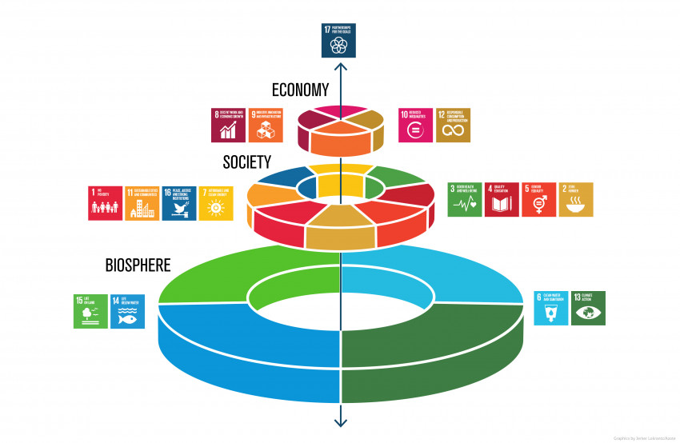

4.1 Sustainable Hotel Shuttle Services
The use of green hotel shuttle services is one of the most popular sustainability measures for hospitality transport. Electric, hybrid or biofuel-powered vehicles are increasingly used to transport guests — to and from airports, local attractions and business districts (Legrand, Chen and Laeis, 2022). According to Pereira, Silva, and Dias (2021), the most meaningful actions that can be taken with the least amount of effort, is by replacing diesel and petrol powered shuttles with low-emission alternatives, so hotels can significantly reduce their carbon footprint and operating costs. The introduction of electric vehicle (EV) shuttles by luxury hotel chains (e.g., Marriott, Hilton, and InterContinental) is another technique that helps provide sustainable transportation for their guests while meeting the emission laws in most cities (Dibene-Arriola et al., 2021). Moreover, several hotels scale incentives to guests picking a shared electric shuttle (reducing traffic jams and hence total energy use, Han et al, 2018). Moreover, solar-powered charging stations are being created at eco-friendly hotels, whereby the shuttles will be run with renewable energy sources instead of traditional electrical grids (Prakash et al., 2023). With low-emission zones being introduced in an increasing number of urban areas, sustainable hotel transport solutions will become increasingly important for regulatory compliance and for supporting a worldwide shift toward green mobility.

4.2 Electric and Hybrid Transportation in Hospitality 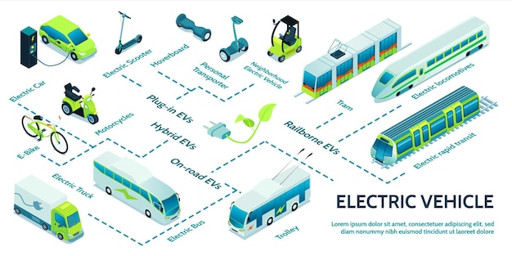
Electric and hybrid vehicles are becoming more popular as the hospitality sector adopts and implements cleaner forms of transportation for its guests. So, many hospitality businesses are embracing the use of EV rental services, self-driving electric taxis, and hybrid luxury transport to enable these sustainability goals to be met (Legrand, Chen and Laeis, 2022). The Peninsula Hotel Group, for instance, has rolled out a fleet of Tesla electric limousines for guest transfers, providing luxury while being environmentally friendly (Pereira, Silva, and Dias, 2021). At the same time, hybrid vehicle partnerships have emerged at many hotels in Europe and Asia, where guests can rent eco-friendly cars while they are on the property (Dibene-Arriola et al., 2021) . Supporting these efforts, governments and city planners are broadening the EV charging infrastructure, increasing the feasibility of electric transport in the hospitality sector (Han et al., 2018). Innovations in hydrogen as a fuel deliver an alternative to battery powered transport, lowering dependence on lithium, with on the road sustainability for longer distances (AlKetbi and Rice, 2024) . Investment in transportation through electric vehicles is on the rise and that aligns well with corporate sustainability policies, as well as consumer push for environmentally friendly travel solutions. By offering electric and hybrid transport solutions, hotels can improve brand reputation and customer loyalty, all while lowering operational costs and greenhouse gas emissions.

4.3 Green Travel Packages and Airline Partnerships
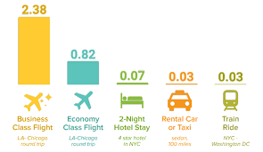
The hospitality and aviation sectors are teaming up to boost damper travel solutions with eco-friendly travel bundles and airline partnerships These measurements inspire carbon offset schemes, sustainable aviation fuel (SAF) employment and reimbursements for eco-friendly travellers (Legrand, Chen, and Laeis, 2022). Major hotel chains are teaming up with airlines, such as Accor with KLM and Lufthansa, to market packages that enable guests to offset the carbon attributable to trips through projects in reforestation and renewable energy (Pereira et al., 2021). In addition, a number of hotels are responding by providing discounted rates, complimentary green transport options, or loyalty points for guests who fly eco-friendly (Han et al., 2018)[23] cape town travel. Airlines are guided towards sustainable aviation fuel (SAF), which can curb carbon footprints to a considerable extent. In the UK, British Airways and Air France will commit to further compulsory SAF usage and the hospitality sector has also begun initiatives towards green tourism (Dibene-Arriola et al., 2021). Green alternative hotels are being booked by eco-friendly travellers who are increasingly considering hotels with combined transport partnership, paving the way for responsible tourism. Such collaborations establish traditional and emerging industries positively impacting international borders enabling greater regulatory sustainability objectives while enhancing the guest experience through seamless low emission travel offerings .

4.4 Sustainable Cruise and Railway Tourism
The cruise tourism and rail travel industries are witnessing remarkable sustainability changes. Cruise ships are traditionally among the biggest polluters in the marine environment, but new ships are increasingly being gripped by liquefied natural gas (LNG) propulsion, hybrid engines, and solar energy systems in order to lower their emissions (Legrand, Chen, and Laeis, 2022) . Norwegian Cruise Line, for example, along with Royal Caribbean, are building low-emission fleets, with reduced levels of air pollution and marine biodiversity (Pereira, Silva and Dias, 2021). Lately, some luxury cruise outfits offer such carbon-neutral voyages, collaborating with conservation organizations to mitigate emissions through marine protection initiatives (Han et al., 2018). By contrast, rail travel should be a more sustainable alternative to shorter flights. Compared to Eurostar and a variety of European airlines, Eurostar allows much lower CO₂ emissions per passenger (Dibene-Arriola et al., 2021). Countries like Japan and China are pioneering advancements in magnetic levitation (Maglev) and solar-powered trains, transforming the face of sustainable travel (AlKetbi and Rice, 2024). Many hotels alongside theels major train hubs are adding rail-inclusive packages, making them worth cost-accruing low-carbon alternatives to traditional international air and car travel. When taken into account as part of a broader hospitality transport strategy addressing moving solutions that avoid fossil fuels, emerging cruise and rail methods will become both a necessity in attracting more environmentally conscientious customers and an efficient means of slashing emissions and lowering environmental footprints.

5. Challenges of Implementing Sustainable Transport in Hospitality
Although sustainable transport has many advantages, there are some barriers for the widespread applicability within the hospitality industry. These barriers comprise high initial costs, infrastructural constraints, regulatory challenges, and consumer adoption challenges (Legrand, Chen, and Laeis, 2022). Small to medium-sized businesses (Pereira, Silva and Dias, 2021). Even large hotel chains have to weigh these costs against profitability, hence the need for long-term return-on-investment strategies (Han et al., 2018). A third big issue is infrastructure. Many regions do not have the requisite EV charging networks, green aviation fuel supply chains and/or railway connectivity for sustainable travel options (Dibene-Arriola et al., 2021). This means that hotels and tourism providers need to work with governments and transport agencies to upgrade the offerings. On the other hand, technical environmental regulations are complex and differ from one region to another, making it difficult for businesses that operate in different regions (AlKetbi and Rice, 2024). Sustainability law compliance– Many of the sustainability laws implemented require monitoring compliance, reporting and penalties for non-compliance. Accumulating consumer awareness and behavioural change also present challenges. Although there is a growing demand for more sustainable travel, many guests continue to prioritize cost and convenience over the environmental aspect (Prakash et al., 2023). Hospitality companies need to be very targeted about informing consumers about how the sustainable forms of transport benefit them and rewarding customers for making more sustainable options through loyalty and pricing incentives. Overcoming these barriers will require a concerted push from government authorities, hospitality companies and technology firms to make sustainable transport more available, affordable and appealing to travellers.

6. Future of Sustainable Transport in Hospitality
Technological innovations, policy initiatives, and shifting consumer preferences are shaping the future of sustainable transport in hospitality. Real-time data analytics also allows hotel chains and their suppliers to invest more in AI-powered mobility solutions, hydrogen-powered transport, and smart next-gen e-mobility solutions (Legrand, Chen, and Laeis, 2022) to reach the sustainability goals of a hotel chain. The real-time emissions monitoring, AI-based fleet management, and IoT-enabled vehicle monitoring are some popular smart transport technologies that will enable hotels to minimize sustainable transport operations and costs associated with them (Dibene-Arriola et al., 2021). At the same time, autonomous electric shuttles and ride-sharing networks will increase the efficiency of the projects and reduce their impact in the environment (Pereira, Silva, and Dias, 2021). Global systems and incentives will further drive the shift to the use of sustainable transport for hospitality. It is anticipated that carbon taxes, subsidies for electric transport infrastructure and stricter emission regulations will lead many more companies to adopt low-carbon mobility offerings (AlKetbi and Rice, 2024) Another big driver of change is consumer demand. The transport offering will need to be of the highest order if they wish to stay competitive (Han et al., 2018) as environmentally conscious travellers make their booking decisions with sustainability in mind. Transitioning in the hospitality world requires a long-time approach that includes the incorporation of renewable energy sources, as well as development of high-speed rail networks and sustainable aviation, which would influence the guests on creating their own sustainable travel impact.

7. Conclusion and Recommendations
Sustainable transport is also an important part of the hospitality industry movement towards environmental sustainability. Notably, this report has examined the leading eco-friendly transport initiatives such as electric hotel shuttles, hybrid transport services as well as airline partnership efforts, and do sustainable cruise and railway tourism (Legrand, Chen, and Laeis, 2022). While such initiatives can bring economic, environmental and operative benefits, their application is limited by cost barriers, infrastructure systems, government policies, and consumer behaviours (Pereira, Silva and Dias, 2021). Some recommendations for improving sustainable transport at hospitality, are as follows: Investment in Green Infrastructure ‐ hotels should install EV charging stations, implement renewable energy sources, and work with government agencies to enhance public transport connectivity (Dibene-Arriola et al., 2021). Strategic Partnerships - The hospitality sector should support with sustainable airlines, railway operators and mobility service providers to provide seamless low-emission travel experiences (Han et al., 2018). Financial Incentives and Guest Engagement – Hotels can also motivate green transport adoption with discounted green travel packages, loyalty rewards for green travellers, and educational campaigns (Prakash et al., 2023). Regulatory Compliance and Advocacy – Businesses must keep up to date with ever-evolving environmental regulations while advocating for policies that will foster the adoption of cost-effective, sustainable transport solutions (AlKetbi and Rice, 2024). The hospitality industry can greatly reduce its carbon footprint, while improving guest satisfaction and operational efficiency through innovative transport, advanced technology, and sustainability.
References:
- Abreu, L.A., Walkowski, M.C., Perinotto, A.R.C., & Fonseca, J.F. (2024). Community-Based Tourism and Best Practices with the Sustainable Development Goals. Administrative Sciences, 14(2), 36. https://doi.org/10.3390/admsci14020036 (Accessed: May 10, 2024)
- AlKetbi, A., & Rice, J. (2024). The Impact of Green Human Resource Management Practices on Employees, Clients, and Organizational Performance: A Literature Review. Administrative Sciences, 14(4), 78. https://doi.org/10.3390/admsci14040078 (Accessed: May 10, 2024)
- Alreahi, M., Bujdosó, Z., Kabil, M., Akaak, A., Benkó, K.F., Setioningtyas, W.P., & Dávid, L.D. (2023). Green Human Resources Management in the Hotel Industry: A Systematic Review. Sustainability, 15(1), 99. https://doi.org/10.3390/su15010099 (Accessed: May 10, 2024)
- Brooks, C., Waterton, E., Saul, H., & Renzaho, A. (2023). Exploring the relationships between heritage tourism, sustainable community development and host communities’ health and wellbeing: A systematic review. PLOS ONE, 18(3), e0282319. https://doi.org/10.1371/journal.pone.0282319 (Accessed: May 10, 2024)
- Dangi, T.B., & Jamal, T. (2016). An Integrated Approach to “Sustainable Community-Based Tourism”. Sustainability, 8(5), 475. https://doi.org/10.3390/su8050475 (Accessed: May 10, 2024)
- Dibene-Arriola, L.M., Carrillo-González, F.M., Quijas, S., & Rodríguez-Uribe, M.C. (2021). Energy Efficiency Indicators for Hotel Buildings. Sustainability, 13(4), 1754. https://doi.org/10.3390/su13041754 (Accessed: May 10, 2024)
- Dumont, J., Shen, J., & Deng, X. (2017). Effects of green HRM practices on employee workplace green behaviour: The role of psychological green climate and employee green values. Human Resource Management, 56(4), 613–627. https://doi.org/10.1002/hrm.21792 (Accessed: May 10, 2024)
- Guttentag, D. (2010). Virtual reality: Applications and implications for tourism. Tourism Management, 31, 637-651. https://doi.org/10.1016/j.tourman.2009.07.003 (Accessed: May 10, 2024)
- Han, H., Lee, J.-S., Trang, H.L.T., & Kim, W. (2018). Water conservation and waste reduction management for increasing guest loyalty and green hotel practices. International Journal of Hospitality Management, 75, 58-66. https://doi.org/10.1016/j.ijhm.2018.03.012 (Accessed: May 10, 2024)
- Hong, P., Schmid, B., De Laender, F., Eisenhauer, N., Zhang, X., Chen, H., ... Wang, S. (2022). Biodiversity promotes ecosystem functioning despite environmental change. Ecology Letters, 25(2), 555-569. https://doi.org/10.1111/ele.13936 (Accessed: May 10, 2024)
- IUCN. (2012). Building and operating biodiversity-friendly hotels. Retrieved from https://portals.iucn.org/library/sites/library/files/documents/2012-018.pdf (Accessed: May 10, 2024)
- Khalid, S., Ahmad, M.S., Ramayah, T., Hwang, J., & Kim, I. (2019). Community Empowerment and Sustainable Tourism Development: The Mediating Role of Community Support for Tourism. Sustainability, 11(22), 6248. https://doi.org/10.3390/su11226248 (Accessed: May 10, 2024)
- Kim, S.-H., Lee, K., & Fairhurst, A. (2017). The review of “green” research in hospitality, 2000-2014: Current trends and future research directions. International Journal of Contemporary Hospitality Management, 29(1), 226-247. https://doi.org/10.1108/IJCHM-11-2014-0562 (Accessed: May 10, 2024)
- Lawson, E. (2023, January 20). Effective methods of waste management in the hotel industry and why it’s important. eHotelier. Retrieved from https://insights.ehotelier.com/insights/2023/01/20/effective-methods-of-waste-management-in-the-hotel-industry-and-why-its-important/ (Accessed: May 10, 2024)
- Legrand, W., Chen, J.S., & Laeis, G.C.M. (2022). Sustainability in the Hospitality Industry: Principles of Sustainable Operations (4th ed.). Routledge. https://doi.org/10.4324/9781003081128 (Accessed: May 10, 2024)
- Pereira, V., Silva, G.M., & Dias, Á. (2021). Sustainability Practices in Hospitality: Case Study of a Luxury Hotel in Arrábida Natural Park. Sustainability, 13(6), 3164. https://doi.org/10.3390/su13063164 (Accessed: May 10, 2024)
- Prakash, S., Sharma, V.P., Singh, R., Vijayvargy, L., & Nilaish. (2023). Adopting green and sustainable practices in the hotel industry operations- an analysis of critical performance indicators for improved environmental quality. Management of Environmental Quality, 34(4), 1057-1076. https://doi.org/10.1108/MEQ-03-2022-0090 (Accessed: May 10, 2024)
- Risfandini, A., Yulianto, I., & Wan-Zainal-Shukri, W.H. (2023). Local community empowerment for sustainable tourism development: A case study of Edelweiss Park Wonokitri village. International Journal of Sustainable Development and Planning, 18(11), 3617-3623. https://doi.org/10.18280/ijsdp.181127 (Accessed: May 10, 2024)
- Said, D., Youssef, K., & Waheed, H. (2017). Energy efficiency opportunities in Hotels. Renewable Energy And Sustainable Development, 3(1), 99-103. https://dx.doi.org/10.21622/resd.2017.03.1.099 (Accessed: May 10, 2024)
- Wan, C., Shen, G.Q., & Choi, S. (2019). Waste Management Strategies for Sustainable Development. In: W. Leal Filho (Ed.), Encyclopedia of Sustainability in Higher Education. Springer, Cham. https://doi.org/10.1007/978-3-319-63951-2_194-1 (Accessed: May 10, 2024)

