Sustainability in the Lake District

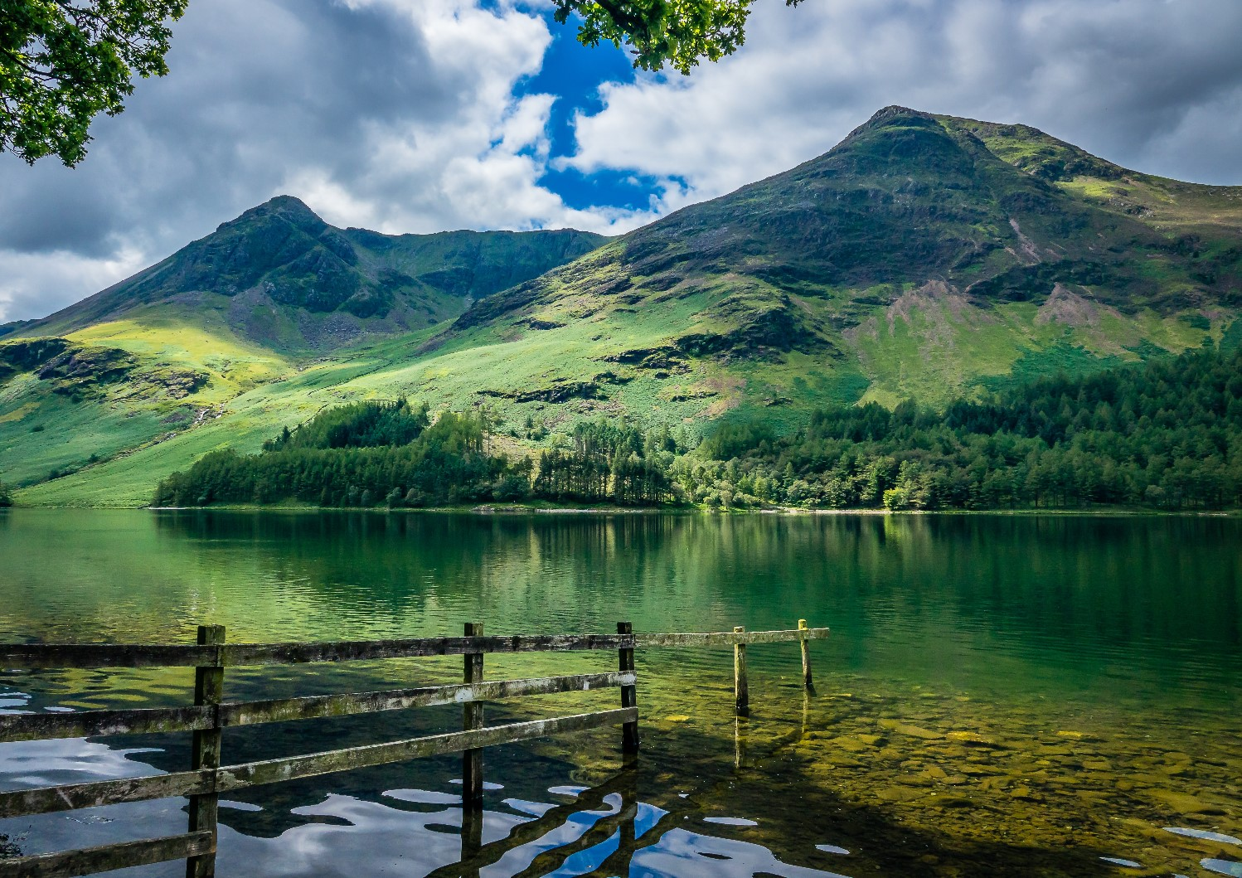

(Picture from Keswick Adventures,2021)

To firstly define Sustainability according to the Brundtland commission report (1987) it is ‘meeting the needs of the present without compromising the ability of future generations to meet their own needs’. The UNWTO (2023) states that sustainable tourism development guidelines and practices will be essential in all forms within the tourism industry to include niche and mass tourism. Said principles signify the economic, socio-cultural and environmental aspects. Otherwise known as the three pillars. In 2017 the National Park was awarded the UNESCO Word Heritage Status.

The positive impacts of tourism help create new job opportunities, the support of local shops and produce such as fruit, veg and animal produce. Money that has come in from these local shops and tourist areas will be used to help conserve and improve the community. The negative impacts of tourism within the Lake District include congestion, environmental damage and footpath erosion. The Lake District is widely known for its lakes, forests and mountains and is an Area of Outstanding Natural Beauty. It has associated itself with the likes of Beatrix potter and William Wordsworth and is a very popular holiday destination. Sustainability within the Lake District is continuously growing, and it is at the core of what the National Park Authority do.

The lake district follows the United Nations Sustainability goals. Where they have set out goals they would like to achieve. From the Decent work and economic growth to help improve stations and recovery plans due to covid. The zero-hunger sustainable goal which helps allow farmers with support on how to successfully apply for different schemes. which can help increase understanding to those that who wish to recover from both climate and nature loss. . Including the development of the farming in protected landscapes programme which helps support climate, people and nature.
The Lake District has a Partnership’s management plan 2020-2025 by which it reflects entirely on the position as both a national park and a world heritage site. With visions for 2030 including a prosperous economy, vibrant communities, world class visitor experience, spectacular landscape, wildlife and cultural heritage. An initiative that the Lake District are using is the Go Lakes Travel programme which cost £6.9m to help travelling more sustainable. It is funded by the department of transport and is partnered with Cumbria Tourism and the Cumbria County Council. Their goal back in 2011-2015 was to help improve public transport services and to reduce congestion through developing safe routes for walking, cycling and those in wheelchairs. Reducing delays and making payments a lot easier when travelling. To include pay as you go car and cycle hire. Other projects include the fixing of the footpath erosion which is led by the National Trust which helps prevent further erosion to paths by maintaining and repairing frequently. Another project that the lake district is utilising is the Lake District Foundation which was founded in 2017. Formerly known as the Nurture Lakeland it offers sustainable programmes which has now gained recognition nationally. As well as schemes like the low carbon cottages that have an aim to reduce emissions and usual costs of typical holiday cottages. By meeting the highest of environmental standards .

The fix the fells project helps raise money to restore and repair the paths that are most used. They look for donations to help and 100% of this goes to help fix so people do not injury themselves and to cherish what we already have. They work on roughly 400 paths and the money goes towards the expertise, tools and equipment of those restoring.

Within the Lake District supply and demand is really important by having their own water supply the Thirlmere is entirely filled up by rainwater/ rainwater and one of the purest water sources within the country which has 220 million litres of water per day flowing through the water treatment works. This helps create a circular economy. A circular economy is a perfect way to both reuse and regenerate materials continually in an environmentally friendly way.

Environmental regulations within the Lake District include the ‘historic Environment Strategy’. Which runs by the side of the 5-year cycle of the National Park and is a conservation policy. Conservation areas have a special character whereby they are needed to be preserved and enhanced. Other qualities of a designated conservation area include the townscape character created by the buildings and its spaces. The sound, smell and what happens within an area to give it, its unique character. The only time it may need to change is when the demands or pressure change in any way. any forms of sustainable developments will be somewhat beneficial in comparison to detrimental. There are a number of policies and guidance which can help with change and not bother the area. Lake District GOV (2023).

The countryside code according to the Visit Lake District website (2023) is a simple form of code of conduct in regard to respecting people, protecting everything to do with the environment and enjoying the visits. Respecting the people who work within the countryside/ environment whilst following paths and making sure gates are closed. Protecting the beauty is important especially when people go camping and litter. It is essential to take it home with you as littering is a criminal offence. If anyone plans on going out in the water the greener boating code will need to be followed. The three steps for this are check clean and dry.

Sustainable Travel and Transport within the Lake District is paramount. As low carbon travel is an essential part of travelling in the 21st century. As health and well-being is number one priority and being active can be very beneficial. New technology is being introduced as well as the digital aspects like mobile ticketing to be more sustainable. With a 2040 vision there will be new transport opportunities which will enable over 50% more visitors to arrive at the park by rail to showcase other areas within the Lake District. There is also world class integrated water transport and zero carbon busses which will carry 30% more visitors than before. The bases of these transport options can be transformed into explorer hubs.
Other forms of transport that are seen as sustainable include walking and cycling to this destination. They have created over 120 kilometres of user trails. As a result of these themes It could be argued that it will help decrease those visiting travelling by car and being reliant on it. As there is an anticipated growth in the visitor numbers with a potential 22 million visitors per year coming to lake district by 2040. According to ITV news the number of trips people will take could double with investment. It states that the investments would help deliver economic growth and help people access services and jobs.

Within the Lake district, the Lake District Hotels 2023 company are extremely environmentally conscious and have an aim to help reduce impacts on the world. Features within these hotels include thermostatic radiators, low flush toilets, vegan duvets made from plastic bottles, energy saving lights, refillable toiletries, use recycling methods kitchen oil is recycled, energy efficient tumble dryers and washing machines. Old equipment is donated, electric car charging areas. Supporting the red squirrel habitat. All training is done online so there is no paper being used. Roughly 81% of staff will live in accommodation which contributes to the carbon footprint. In two of the hotels there are biomass boilers. The Lake district county hotels company have access to their own herds of sheep and cattle as local produce. As well as growing their own vegetables and herb gardens. They also so a lot of replanting and using their wood for fires in winter. Other forms of accommodation include eco- lodges and cottages where water is used from their own wells, their own heat pumps and electricity that is generated by heat. Green weddings are also very important in the Lake District with local and organic food with flowers being right on everyone’s doorstep.
A lot of people when looking for holidays to lake district will mainly look for sustainable travel offers. With sustainable itineraries and fun days out.

Climate change has a huge impact as the world is heating up a lot. Meaning there will be hotter summers and wetter winters and a lot more extreme events. The Lake district already suffers from drought and floods. There is also the potential loss of local animals and plants being extinct like the artic charr which is a fish that has lived in LD since the ice age. Migration is a major issue within the lake district as animal habitats will move further up mountains as a result of the extreme weather conditions which makes them even more vulnerable. As previously mentioned, the zero carbon Cumbria partnership is led by 8 organisations that’s aim is to work towards a net zero by 2037. This includes better quality of life and people being able to have a balance with both sustainability and the environment.

The national trust take care of over 20% of the national park. This includes 100+ mountains, lakes, wooded areas, coasts and paths. The national trust has a climate and environmental policy which applies to any national trust location. They manage all of their responsibilities through a system called Climate and Environmental management System otherwise known as CEMS. It is a framework that is dedicated to identifying and both setting and tracking progress when it comes to the objectives set as this will help improve their aims further down the line. As a charity their goal is to become net zero by 2030 and to help prevent sewage systems from herbicides .

A greening business can be described as a company that does not have any negative impacts on the environment, economy or community. They consider the environmental concerns way in advance. They aim to help balance the needs of planet, people and profits. (Green Still Water,2023). They look to help minimise pollution and waste through reducing emissions and disposing of waste. The Lake District Foundation (2020) is an organisation that help protect the greening business.

References

ITV, 2023. ‘Number of trips on Lakes Line could double with investments’. Available at: https://www.itv.com/news/border/2023-02-04/council-says-rail-investment-could-double-number-of-journeys-on-lakes-rail-line ( Accessed 5/04/23)

Keswick Adventures, 2021. ‘Top Activities in the Lake District. Available at:’https://keswickadventures.co.uk/blog/top-activities-in-the-lake-district/ (Date Accessed: 5/04/23)

Lake District Country Hotels, 2023. ‘Sustainability’ Available at:https://www.lakedistrictcountryhotels.co.uk/sustainability-environment ( Accessed 5/04/23)

Lake District Foundation, 2020. ‘Lake District Green Business’. Available at: https://www.lakedistrictfoundation.org/green-business/ (Date Accessed 18/04/23)

Lake District Hotels, 2023. ‘Sustainability’ Available at: https://www.lakedistricthotels.net/blog/sustainability/ (Accessed 5/04/23)
Lake District, 2023. ‘Delivering the Sustainable Development Goals in the Lake District through action’. Available at: https://www.lakedistrict.gov.uk/caringfor/lake-district-national-park-partnership/management-plan/delivering-sustainable-development-goals

UN, 1987. ‘`Sustainability’. Available at: https://www.un.org/en/academic-impact/sustainability ( Date Accessed: 5/04/23)

UNWTO, 2023. ‘ Sustainable Development’. Available at: https://www.unwto.org/sustainable-development (Date Accessed 5/04/23)

