Assessment 3: Creating a Carbon Footprint

For this assessment, you can use either data from a production you are working on or the provided case study data below. Make sure to also complete the 'Evaluate Your Production’s Footprint’ task once you have created your production’s carbon footprint to complete the assessment.
This will evidence that you have ‘calculated a production’s carbon footprint using the albert carbon footprint calculator, and discussed solutions to reduce the environmental impact of a production’.

- Using the albert Calculator
Log in here to use the albert student toolkit and calculate a draft of the production's carbon footprint. Your logins will be provided to you by your tutors.
Your tutors will also walk you through how to use the albert student toolkit, including how to set up a production, use the carbon footprint calculator to calculate a draft and final footprint, and submit it for assessment.
If you are not working on your own production, you can use the Case Study: Scripted Location-Based HETV at the bottom of this document.

- Evaluate Your Production’s Footprint
Once you have input all the data into your draft/projected footprint calculation, screen grab it for comparison later. With reference to solutions offered in the case studies, produce and/or discuss a sustainability action plan that will reduce your production’s impact.
Update and finalise your data in the production footprint and screen grab your final carbon footprint for comparison. Alongside these, submit your action plan while considering the below:
- What are the biggest areas of impact in your production’s carbon footprint and why?
- With reference to research and industry case studies, how might you adapt your working practice to reduce your carbon impact?
- What other things are the industry doing to reduce carbon impact that are not accessible or relevant to your production? What would need to change for them to become accessible and/or relevant?

Case Study: Scripted Location-Based HETV

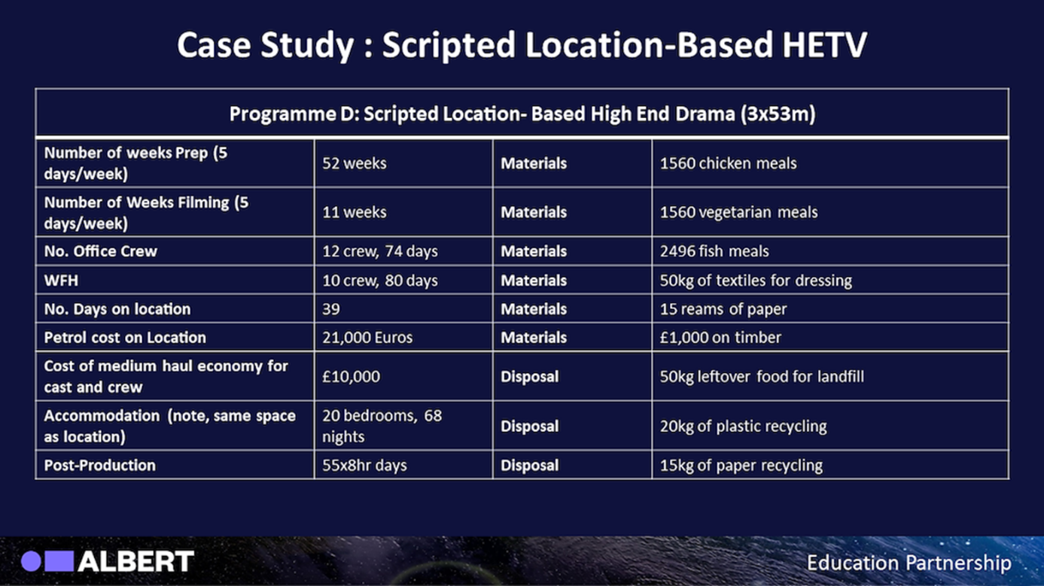
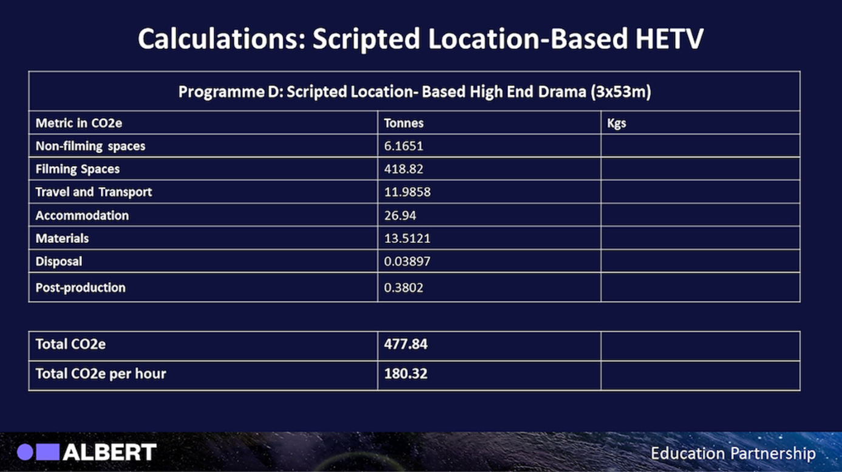

Your footprint should look like this:

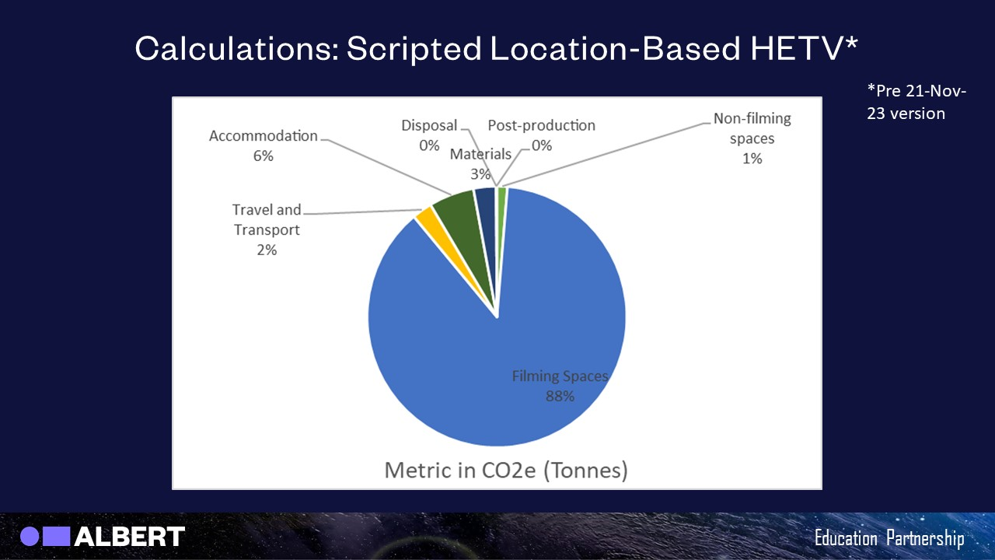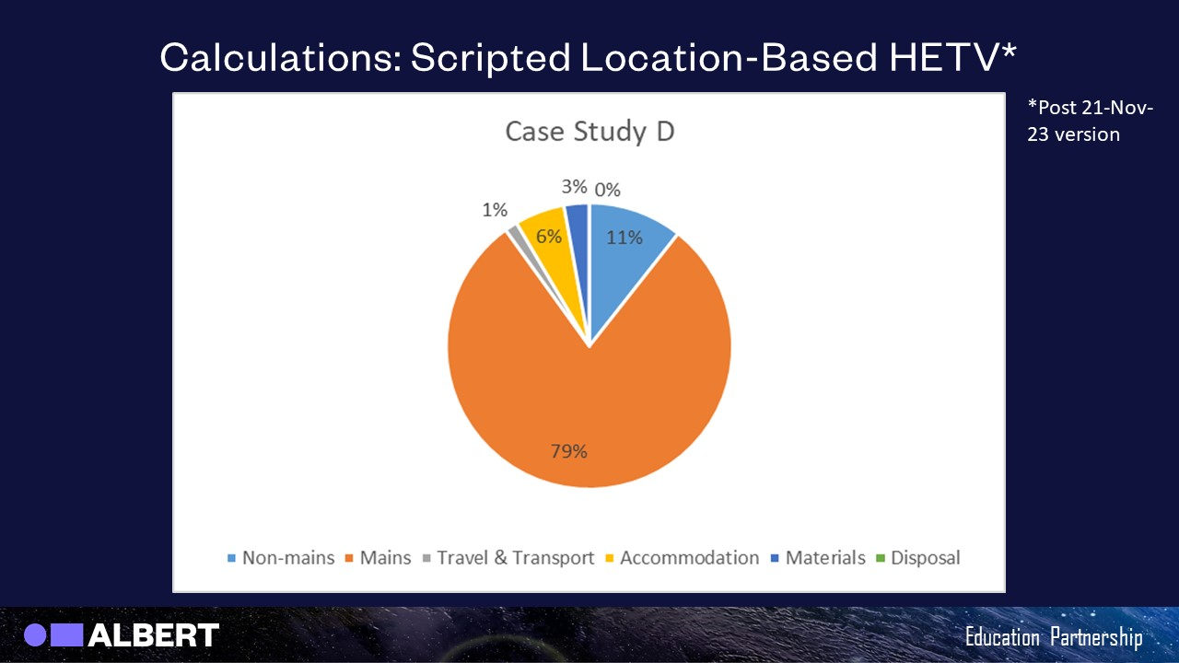

Case Study: Unscripted Studio Entertainment Show

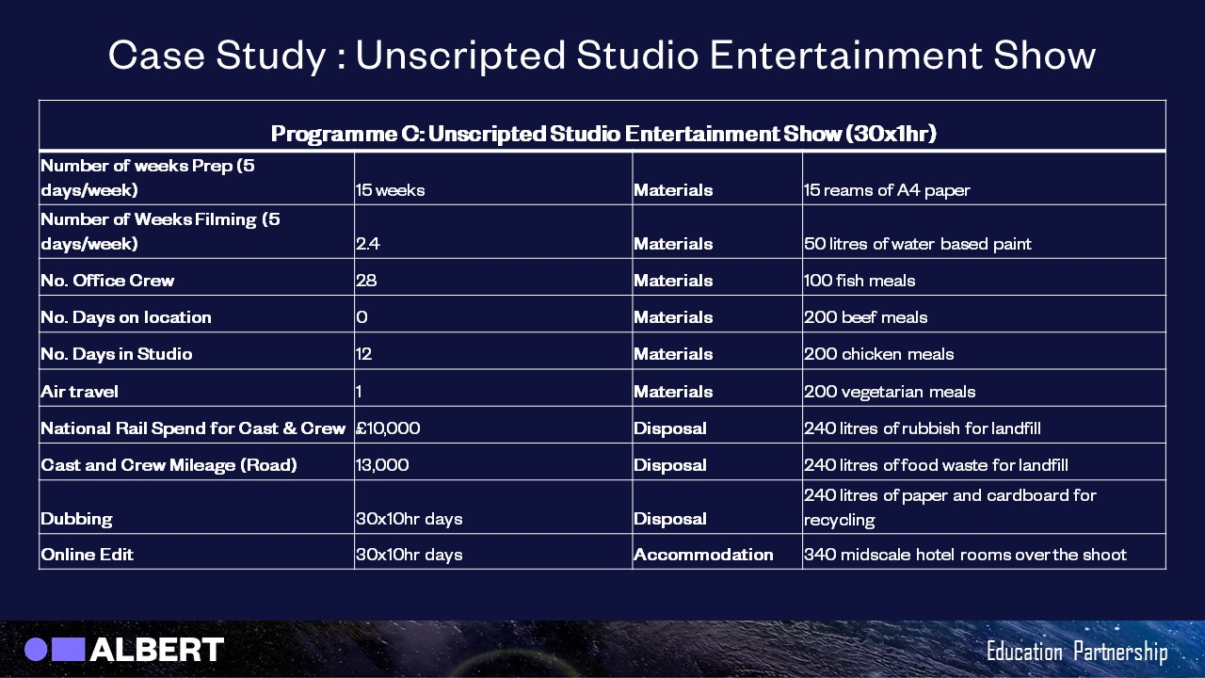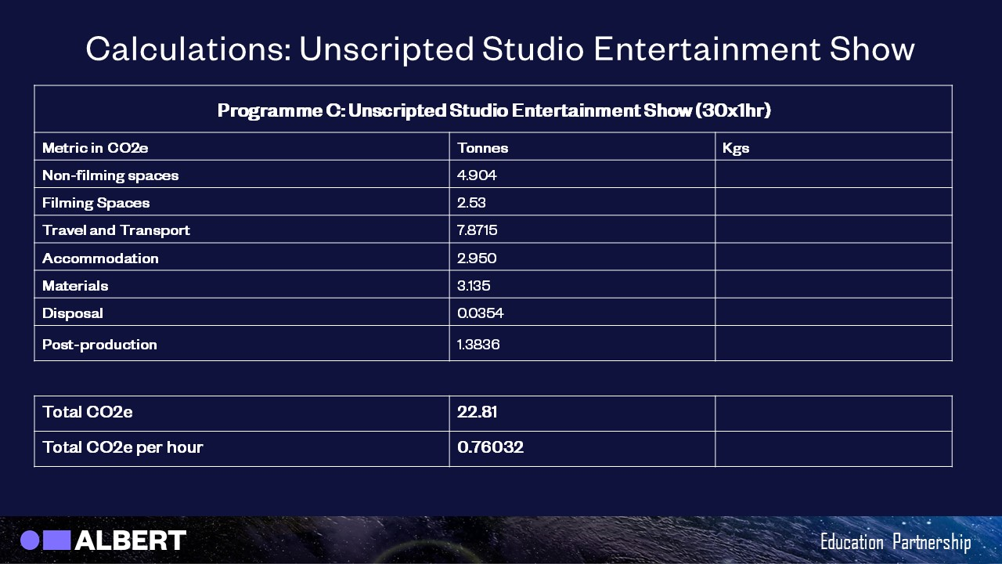
Your footprint should look like this:



