

Assessment 1 – Reading Task Template
PART 1: Upload your photo of your A3 in-class notes here:
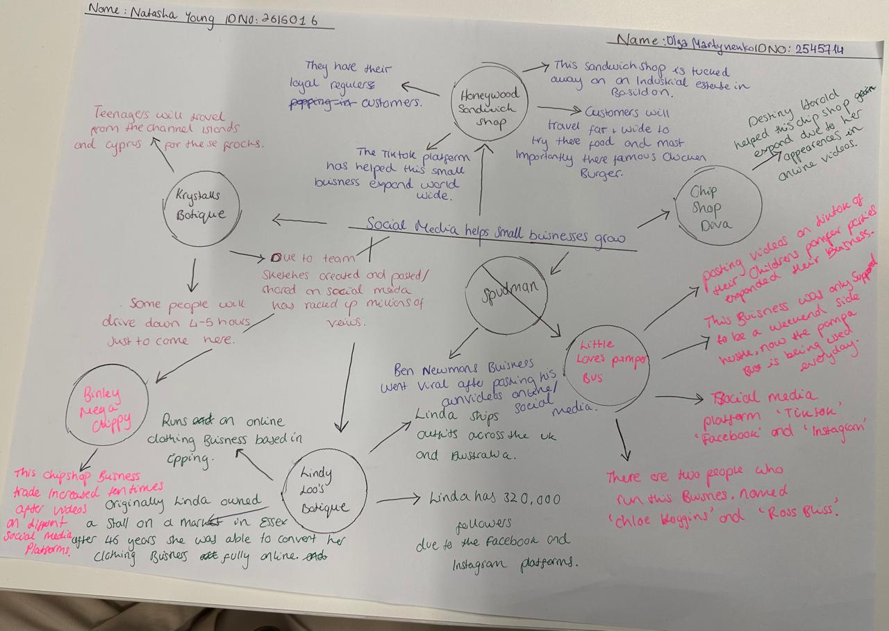

- What is the main idea of the whole text?
The main idea of the text is that social media makes you or your business noticeable, sometimes even without direct advertising. People share their experiences, emotions and travels, and it attracts attention to products. These personal stories build trust and encourage others to try the same thing.

- What is one key point that supports the main idea, and which specific example from the text shows this?
People shared their experiences on social media platforms and it helped businesses become popular.
Honywood Sandwich Shop posted its own video, but it really took off when customers started sharing theirs. And now people travel up to three hours just to try its chicken burger there.

- What is a different key point that supports the main idea, and which specific example from the text shows this?
Social media can make ordinary people famous and bring attention to the business where they work.
Destiny Harold became an internet star after videos of her serving at Merchants Fish and Chip Shop. We know her as “Chip Shop Diva” now.

- Which part of the text do you think is most important, and why?
The first paragraph of the text is the most important for my opinion. It shows the main idea of the article. The article describes how different businesses became popular after people posted videos on social media platforms. It makes you and your business noticeable to the world.

Reflection:
- What did you find difficult in this task (including in-class components), and why was it difficult?
I struggled to find key information and summarise the main idea briefly. This was because the information was new to me.

- What helped you with this difficulty, and how did it help you?
I started remembering what our teacher had taught us. Then I began putting it into practice. It helped me complete this task.

