
BSc Health and Social Care

Student name: Hasna Ur Rehman

Student id: 2329511

Module code: BMHP5015

Lecturer name: Olufemi Oluranti

Assignment title: Component 1: Online Portfolio of Set Exercises

Submission deadline: Wednesday 25th March 2026

Task 1 – Personal Brand
Write about your own person brand and how you could develop this to enable you to reach your employment goals (200 words- 2 referenced sources)
Introduction
I understand personal branding as how I present myself professionally and how others perceive my values, skills and behaviours. Research suggests that personal branding plays an important role in employability (Gorbatov, Oostrom and Khapova, 2024).
Main Body
I currently view my personal brand as being centred on empathy, professionalism and reliability, which I demonstrate through active listening, communication and punctuality. These qualities are particularly important within mental health settings, where trust and ethical practice are essential. Critically reflecting on my professional development, I recognise that my professional identity is not fixed but continues to develop through experience and reflection. Fitzgerald (2020) highlights that professional identity is shaped over time through values, skills and ethical practice, rather than simply through job roles or titles. This has helped me recognise that while I have strong interpersonal skills, I need to further develop my confidence in professional communication and reflective practice as I work towards becoming a CBT therapist. Developing these areas will support the alignment of my personal brand with the professional expectations of mental health services.
Conclusion
Critically reflecting on my personal brand has highlighted the importance of ongoing self-development and reflective practice in shaping my professional identity. Strengthening my communication skills and confidence will support my progression towards a future role as a CBT therapist and enhance my employability.

Task 2 - Network Map and Rationale
Create a map of your own network considering career, support, social and community dimensions. Additionally you should provide a supporting rationale explaining and critically assessing this (200 words- 2 referenced sources).
Lecturers
University career services

Siblings
CBT Practitioners (future)
Family

Support
Career
Aspiring CBT Practitionerr Theory. Cambridge, MA: Harvard University Press.
Putnam, R., Leonardi, R. and Nanetti, R. (1993) Making Democracy Work: Civic Traditions in Modern Italy. Princeton: Princeton University Pre

Social
Community

Friends
University peers
Mental Health Charities
Mental Health Services

Bonding social capital
Bridging social capital
Linking social capital
Bridging social capital

My current network can be described as a hybrid network, combining strong close relationships with a smaller number of selective professional connections. As shown in my network map, the strongest aspects of my network sit within the support and social dimensions, particularly family members, friends and university peers. These relationships represent bonding social capital, as they are based on trust, shared experiences and emotional support. Bonding capital is valuable because it promotes cooperation and support that help individuals achieve goals that may not be possible alone (Putnam, Leonardi and Nanetti,1993).
Support from my family and the university wellbeing team provides emotional stability and guidance, which is important for maintaining wellbeing while progressing towards my goal of becoming a CBT practitioner. In addition, my social network of friends and university peers offers encouragement, shared learning and motivation during my studies.
However, critical reflection highlights weaknesses in my bridging and linking social capital. I currently have limited connections with individuals from different professional backgrounds and few relationships with people in positions of authority within mental health settings. This limits access to professional opportunities and career guidance. Phillips and Ellinas (2014) emphasise the importance of developing diverse and mutually beneficial networks. To strengthen my network, I aim to build self-created social capital through volunteering, placements and professional engagement within mental health services.
Task 3- Blog
Write a blog exploring a current topic or issue of your choice within the health and social care sector in the UK. The purpose of this is to inform a specific target audience of your choosing (300 words)
Raising Awareness of Mental Health Inequalities for Non-Verbal Autistic Children
Introduction
Access to mental health support in the UK has increasingly shifted towards digital and talking-based interventions. While this development has improved availability for many people, it has also widened inequalities for non-verbal autistic children who face significant barriers when accessing appropriate care. As awareness of autism increases, it is essential that mental health services adapt to meet the needs of children who communicate differently (Good Things Foundation, 2024).
Main Body
Non-verbal autistic children often experience anxiety, emotional distress and behavioural challenges. However, traditional mental health services frequently rely on verbal communication, creating clear inequalities in access. These children may struggle to engage with standard talking therapies such as Cognitive Behavioural Therapy (CBT) without appropriate adaptations, limiting their ability to benefit from early mental health support (National Autistic Society, 2023). 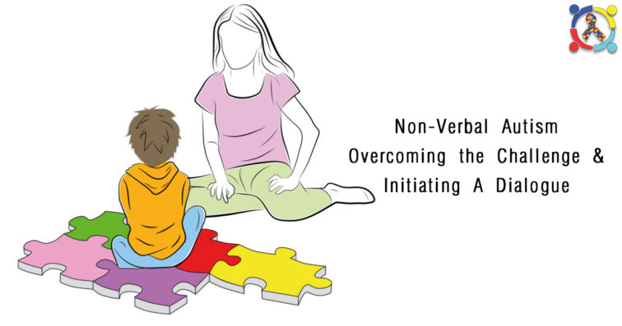
Figure 1:supporting communication with non-verbal autistic children (source: Autism Connect).
In recent years, digital mental health services have expanded across the NHS, offering online therapy and remote consultations (NHS, 2025). Despite this progress, digital exclusion remains a major issue for vulnerable families, particularly those with limited access to technology or digital skills (Good Things Foundation, 2024). This can further disadvantage non-verbal autistic children whose needs already fall outside mainstream service design.
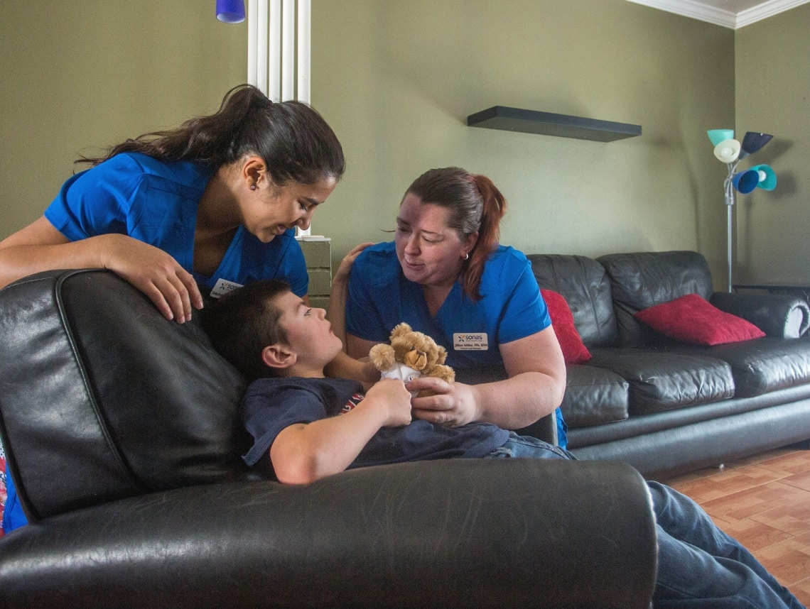
Figure 2:Therapist interacting with non-verbal autistic child using supportive communication approaches (Source: Care Option for Kids).
The NHS has recognised the importance of inclusive digital approaches in improving access to mental health services. For non-verbal autistic children, this includes developing flexible approaches such as visual communication tools, play-based CBT techniques and multi-sensory interventions. Without these adaptations, children risk being excluded from early intervention, which is critical for long-term emotional wellbeing (NHS England, 2022).
Conclusion
In conclusion, non-verbal autistic children face significant mental health inequalities due to reliance on verbal communication and increasing digitalisation of services. Although progress has been made, further adaptations are needed to ensure services are inclusive and accessible. Improving awareness, reducing digital exclusion and implementing flexible therapeutic approaches are essential steps in reducing mental health inequalities and supporting the emotional wellbeing of non-verbal autistic children.

Task 4- NHS Equality, Diversity and Inclusion Quiz (250 words equivalent)
- What is the primary goal of the NHS Equality, Diversity, and Inclusion Improvement Plan?
The Primary goal of the NHS Equality, Diversity and Inclusion Improvement Plan is to reduce inequality and discrimination and ensure fair treatment and opportunities for both staff and patients.

- How does the NHS EDI Improvement Plan propose to tackle the gender pay gap?
The NHS EDI Improvement plan proposes to tackle the gender pay gap by improving pay transparency, supporting flexible working and increasing opportunities for women to progress into senior and leadership roles.

- What is meant by the term ‘intersectionality’ as used in the NHS EDI Improvement Plan?
Intersectionality means that different parts of a person’s identity, such as race, gender, disability or sexuality, overlap and are connected. These overlapping identities can shape how someone experiences discrimination or disadvantages in different ways.

- Why is it important for the NHS to create a psychologically safe work environment?

A psychologically safe workplace allows staff to speak up, share concerns and ask for support without fear. This improves staff wellbeing, teamwork and patient safety.

- How does the NHS EDI Improvement Plan suggest improving the experience of internationally recruited staff?
The plan supports internationally recruited staff through better induction mentoring and fair treatment at work. It also aims to reduce discrimination and improve career progression.

- What role does leadership play in advancing EDI objectives according to the NHS Improvement Plan?
Leaders are responsible for promoting equality, challenging discrimination and inclusive workplaces. They must also be accountable for making sure EDI policies are followed.

- Identify one way the NHS EDI Improvement Plan aims to reduce health inequalities within the workforce.
The plan aims to reduce health inequalities by improving access to well-being support and making reasonable adjustments for staff with different needs.

- Why does the NHS EDI Improvement Plan emphasise the importance of collecting and analysing data on protected characteristics?
Collecting data helps the NHS identify inequalities and understand where certain groups are disadvantaged. This allows targeted actions to improve equality and inclusion.

- Explain how flexible working policies can contribute to equality and inclusion in the NHS workforce.
Flexible working helps staff balance work with caring responsibilities, health needs or disabilities. This supports inclusion and helps retain a diverse workforce.

- What is one strategy mentioned in the NHS EDI Improvement Plan to combat bullying and harassment in the workplace?
One strategy in the NHS EDI Improvement Plan to combat bullying and harassment is creating a psychologically safe workplace where staff feel able to speak up without fear. This is supported by inclusive leadership that sets clear expectations for respectful behaviour.
Task 5- A Letter to Yourself
Think of a time in the past when you may have been experiencing issues or difficulties, and after considering what you have learned in this module about emotional intelligence and resilience write a letter to your younger self explaining how these attributes were important at that time and perhaps how developing these areas could have been useful (250 words)

Dear Me,
There was a time when you listened to everyone around you and allowed their voices to guide your decisions. You believed that doing what your parents wanted, becoming a teacher, was the right thing to do, even though you had not explored your own dreams or desires. At that point in your life, you did not feel emotionally aware enough to question your choices or understand why something felt missing.
You often stayed quiet and avoided speaking up, thinking that if everyone else was happy, then you should be happy too. You focused on pleasing others rather than listening to yourself and you didn’t take the time to explore who you truly were or what you wanted from life. This lack of self-awareness affected your wellbeing and left you feeling disconnected from your own emotions.
Looking back now, developing emotional intelligence earlier could have helped you recognise and understand your feelings. Being emotionally aware would have allowed you to acknowledge your own needs instead of suppressing them. You could have learned that your happiness matters just as much as the happiness of others.
Resilience would also have helped you during this time. Learning to cope with uncertainty, set boundaries and trust yourself would have made it easier to face difficult conversations and make choices aligned with your values. With greater emotional intelligence and resilience, you could have felt more confident, authentic and in control of your own path.
Remember, your voice matters and it is never too late to listen to it.
From,
Hasna.

Task 6- GANTT Chart (200 words equivalent)
Compile a Gantt chart which illustrates the tasks you have to complete to achieve your future employment goals
Gantt Chart: Future Employment Goals (CBT Pathway) | Jan | Feb | Mar | Apr | May | Jun | Jul | Aug | Sep
Task 1: Complete Health and Social Care degree
Task 2: Reflect on my skills and career goals
Task 3: Research CBT training requirements
Task 4: Gain relevant experience/skills development
Task 5: Apply for CBT training
Task 6: Develop emotional intelligence and resilience

This Gantt chart illustrates the key tasks required to achieve my future employment goals, with the main focus on completing my Health and Social Care degree. Completing the degree is shown across the majority of the timeline, as it is the foundation for developing the knowledge, skills and understanding needed for a career in health and social care.
Alongside my studies, time is allocated to reflecting on my skills and career goals. This reflection supports self-awareness and helps me identify areas for personal and professional development. Researching CBT training requirements is planned after this stage to ensure I understand the expectations and entry criteria for further training. Gaining relevant experience and developing key skills runs alongside these tasks, allowing me to apply theoretical knowledge in practical settings and strengthen my employability.
Applying for CBT training is scheduled later in the timeline, once sufficient preparation has been completed. Throughout the process, developing emotional intelligence and resilience is shown as an ongoing task, as these skills are essential for working effectively in health and social care environments.
Overall, the Gantt chart demonstrates realistic planning, effective time management and a structured approach to achieving my future employment goals.

Task 7- Making Changes- Report
You are the manager of a care home and want to make changes your workplace. Identify one specific change that you want to implement and write a brief report on how this is going to be achieved considering the necessary skills needed and addressing possible barriers to success. Relevant change models can be highlighted (250 words- 2 referenced sources).
Introduction
As the manager of a residential care home, I plan to introduce a digital care planning system to replace paper-based records. The aim is to improve accuracy, communication and safety in care delivery while supporting staff efficiency and person-centred practice.
Planning the Change
The change will follow Lewin’s three-stage model: unfreeze, change and refreeze (Lewin, 1951).
First, staff will be informed about problems with paper documentation and why improvement is necessary. Creating awareness helps prepare staff psychologically for change.
Next, training sessions and demonstrations will support staff in using the digital system. Ongoing support and clear communication will reduce uncertainty and encourage engagement.
Finally, the new practice will become routine through monitoring, feedback and supervision. Structured change approaches improve implementation and sustainability in healthcare settings (Harrison et al., 2021).
Skills Required
Key skills required include leadership, communication and teamwork. The manager must motivate staff, address concerns and provide clear guidance throughout the process. Problem-solving and training skills are also necessary to ensure staff confidence and competence using the new system. Effective leadership increases staff engagement and reduces resistance during organisational change (Kotter, 1995).
Barriers and Solutions
A major barrier may be staff resistance due to fear of technology. This can be reduced by providing hands-on training and reassurance. Another barrier may be time pressure during implementation. Scheduling phased training and allocating support staff can minimise disruption. Involving employees in the change process increases engagement and adoption (Manchester et al., 2014).
Conclusion
Implementing a digital care planning system will improve safety, organisation and quality of care. Using a structured change model alongside staff support strategies will help ensure successful and lasting change.

Task 8- Self-Reflection
Using one of the highlighted models of reflection, reflect on what you have learned about yourself during this module ,as well as the knowledge you have gained, and explain how this has developed your skills and informed your future practice (250 words- you must reference the model you use)
Using Gibbs Reflective Cycle (Gibbs,1988), I reflected on my learning throughout this module.
Description:
This module explored personal branding, social capital, employability, digital technology, identity, wellbeing and emotional intelligence, problem solving, change management and reflective practice. Key tasks included developing a personal brand, mapping bonding and bridging networks, creating a Gantt chart and applying structured change models.
Feelings:
At the beginning, I felt uncertain about my professional identity and future direction. Writing reflectively about myself was emotional it felt like meeting a younger version of me I had lost over time, while also recognising a stronger and more resilient version emerging. This process increased my self-awareness and confidence.
Evaluation:
Mapping bonding and bridging social capital helped me understand how emotional support and professional connections both influence career development. I was surprised by how useful the Gantt chart was for organising tasks and managing deadlines. Learning about wellbeing and emotional intelligence strengthened my resilience and ability to manage pressure.
Analysis:
I realised that employability is not only about academic achievement but also about networking, communication, adaptability and structured planning. Studying change management demonstrated that each stage preparation, involvement and leadership is essential for successful implementation. Reflection helped me connect theory to real-life professional practice.
Conclusion:
Overall, this module supported both my professional growth and personal development.
Action Plan:
I will continue expanding my professional network, use structured planning tools and maintain reflective practice to prepare for a future role in healthcare.

Reference List
AutismConnect (n.d.) Non-verbal autism: overcoming the challenge and initiating a dialogue. Available at: https://www.autismconnect.com/blogs/non-verbal-autism-overcoming-the-challenge-initiating-a-dialogue/ [Accessed: 15 February 2026].
Care Options for Kids (2018) How to communicate with a nonverbal child. Available at: https://careoptionsforkids.com/blog/how-to-communicate-with-a-nonverbal-child/ [Accessed: 15 February 2026].
Coleman, J. (1990) The Foundations of Social Theory. Cambridge, MA: Harvard University Press.
Fitzgerald, A. (2020) Professional identity: a concept analysis, Nursing Forum, 55(1), pp. 1-26.
Good Things Foundation (2024) Digital inclusion: What the main UK datasets tell us. Available at: https://www.goodthingsfoundation.org/ [Accessed: 1 February 2026].
Gorbatov, S., Oostrom, J.K. and Khapova, S.N. (2024) Work does not speak for itself: examining the incremental validity of personal branding in predicting knowledge workers employability, European Journal of Work and Organizational Psychology, 33(1), pp. 40-53. https://doi.org/10.1080/1359432X.2023.2276533
Harrison, R., Fischer, S., Walpola, R.L., Chauhan, A., Babalola, T., Mears, S. and Le-Dao, H. (2021) Where do models for change management, improvement and implementation meet? A systematic review of the applications of change management models in healthcare. Journal of Healthcare Leadership, 13, pp.85-108.
Kotter, J.P. (1995) Leading change: Why transformation efforts fail. Harvard Business Review, 73(2),pp.59-67.
Lewin, K. (1951) Field theory in social science: Selected theoretical papers. New York: Harper & Row.
Manchester, J., Gray-Miceli, D., Metcalf, J., Paolini, C., Napier, A., Coogle, C. and Owens, M. (2014) Facilitating Lewin’s change model with collaborative evaluation in promoting evidence-based practices of health professionals. Evaluation and Program Planning, 47, pp.82-90.
NHS England (2022) Why digital inclusion matters to health and social care. Available at: https://digital.nhs.uk/about-nhs-digital/corporate-information-and-documents/digital-inclusion/digital-inclusion-in-health-and-social-care [Accessed: 1 February 2026].
National Autistic Society (2023) Autism and communication. Available at: https://www.autism.org.uk/advice-and-guidance/topics/communication [Accessed: 1 February 2026].
NHS (2025) Find NHS talking therapies for anxiety and depression. Available at: https://www.nhs.uk/nhs-services/mental-health-services/find-nhs-talking-therapies-for-anxiety-and-depression/ [Accessed: 1 February 2026].
Putnam, R., Leonardi, R. and Nanetti, R. (1993) Making Democracy Work: Civic Traditions in Modern Italy. Princeton: Princeton University Press.

