Team Protect Services Ltd provides top-tier protection services. The company's organizational structure is designed to enhance efficiency and responsiveness. The team is structured to ensure clear lines of communication and accountability, enabling the delivery of high-quality services to clients.
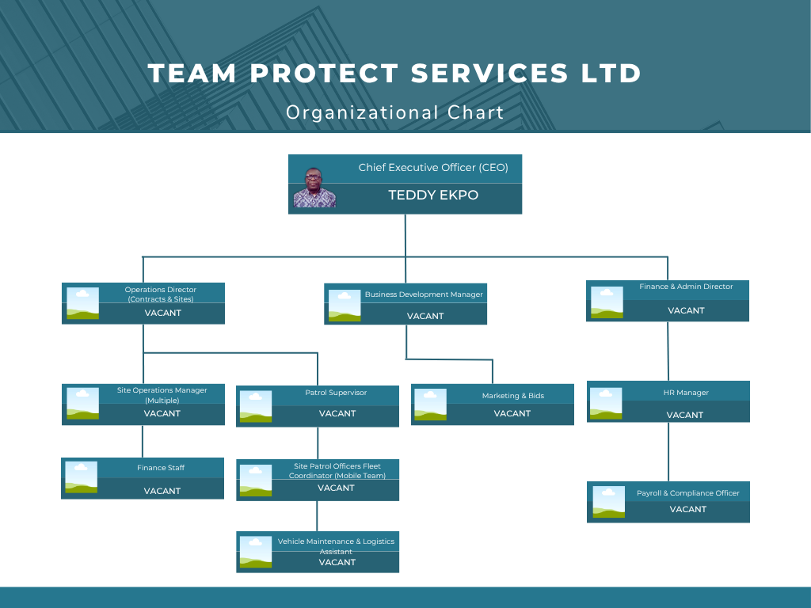
Roles & Responsibilities Summary
Managing Director / CEO
- Overall leadership and strategic direction.
- Government and high-level client engagement.
Operations Director
- Manages service delivery across all client sites.
- Ensures SLAs and KPIs are met.

Site Operations Managers
- Directly supervise deployed site staff (security & concierge).
- Report issues, maintain client relations.
Patrol Supervisor
- Leads the mobile patrol team.
- Conducts unannounced site visits to ensure quality control.
Patrol Officers
- Roving team for supervision, emergencies, and support.
- Ensure compliance, discipline, and safety on sites.
Fleet Coordinator
- Manages patrol vehicles and logistics support.
Business Development Manager
- Secures new contracts, handles tenders and government bids.
- Liaises with marketing and proposals team.
Finance & Admin Director
- Oversees financial records, billing, procurement, insurance.
HR Manager
- Handles recruitment, training, vetting, and site induction.
Payroll & Compliance Officer
- Manages time sheets, payslips, and statutory compliance (e.g., SIA, insurance, pensions).

