Assignment 2- Community Development
Student name: Ciprian Feraru
Student ID: 2418352
Year: 2023-24
Module leader: Navdeep Randhawa
Table of Content
Introduction 4
Main body 4
Distinctive community 4
Factors suiting the community 5
Concepts employed for community and challenges faced 7
Community development processes 8
Conclusion 9
References 10

Table of figures
Figure 1: Unemployment rate in the United Kingdom 6

Introduction
The community development is considered as the long term process that aims on to the improvement of quality of life for the community members (Masum et al., 2020). This process involves the aspects to make community members to work together by identifying issues, setting agendas and taking collective action for creating solutions.
The report will be focusing on the areas of community in local areas of London and the approaches used for fostering growth. It will also include several factors and message to suit the community. It will also show concepts employed for behavioural change and community development process for sustainable improvement.

Main body

Distinctive community
One of the distinct communities in London, United Kingdom is Bangladeshi community in Tower Hamlets. This is one of the vibrant areas known for its rich land of culture with the neighbourhood like Whitechapel and Brick lane. This community mainly thrive because of the formal and informal initiatives which are aimed on for steering growth and development by preserving their unique identity. The binding characteristics of Bangladeshi community are linked with the factors of shared heritage, language, religious practises and strong cultural traditions. Alongside to this, it also includes some of the common socio-economic challenges like access to quality education and employment opportunities (Edgeman & Eskildsen, 2014).
There are certain efforts to support and develop this community, which are driven by the combination of government initiative, local organisations and community led projects. all of these aspects focus on social economic empowerment followed by the intergenerational unity and cultural preservation. For example, Tower Hamlet Council have partnered their operation with various sources and local organisations for creating programs for addressing different issues. They focus on the issues related to the housing and employment and educational attainment. With the councils, local community fund, funds are also located for supporting the skill building initiatives in the areas like IT training and language courses. This makes them to aim on enhancing job prospects and integration for the first generation immigrants that are struggling because of the language barriers.
Education and development in areas of this community, works as the central aspects for growth of Bangladeshi community. The organisations like Tower Hamlet education partnership works with local schools in the areas to bridge educational groups by ensuring that all the young people from this community are appropriately educated. They also support the aspects with the help of mentorship tutoring and extracurricular activities. This entire program helps directly by inspiring the confidence and ambitions in youth to equip and pursue with the higher education and their career goals in appropriate ways.
The community hubs and cultural Centre is like Brady Art Centre and Kobi Nazrul Centre play one of the critical roles in the preservation of the culture identity for Bangladeshi community. These spaces also work on providing a platform based on cultural expressions of art, music, and literature for strengthening the community bond and offering them with the opportunity to have cross cultural exchange with other communities. Additionally, there are different religious institutions like Mosque, which are central for the community to provide social support services with the aspects of worship places.
Certain local businesses along Brick lane are mainly owned by Bangladeshi community, which helps them in fostering community development, including attraction from the side of tourism and employment. Lastly, there are certain advocacy groups like Bengali workers association, and local networks which work on addressing the issues linked with racial discrimination and social inequality. By partnering with such policy makers and taking community lead campaigns, they can directly advocate for the fair housing policies, improved social services, and easy access to healthcare for the Bangladeshi community (Cronin, 2017).

Factors suiting the community
The Bangladeshi community in Tower Hamlets London demonstrates advanced approach towards the communication and outreach which is tailored with the factors like cultural society, economic and environmental context. The effective messaging within this community makes use of culturally resonant imagery and works on addressing core issues with sensitivity that values and challenges the community by fostering connection and driving engagement.
The imagery plays one of the most critical roles for community messaging. For example, the cultural significant visual like Bangladeshi art, traditional clothing and culinary staples like biryani are some of the commonly used aspects of the community centres and local businesses. This helps them to evoke the sense of pride and heritage. All of these visual assist both the younger as well as the older generations to connect as a shared symbol by reinforcing cultural identity.
Culturally, this community properly values is strong familiar and religious connections. The messaging under these factors is often delivered on the basis of trusted channels like community leaders and cultural hubs. It also includes the events and services advertised in mosque and community centres which encourage participation from all the community members (Peredo & Chrisman, 2006). It primarily focuses on the messages like health, education, and social services which are effective to be communicated in familiar spaces.
Socially and economically, the Bangladeshi community faces challenges linked with high unemployment and housing in securities. The organisations working with this community works on addressing the issues by offering a tailored message, emphasising economic empowerment and support services. For example, the job training programs are used for promoting the promise of upward mobility and economic stability by resonating the community members to seek better opportunities.
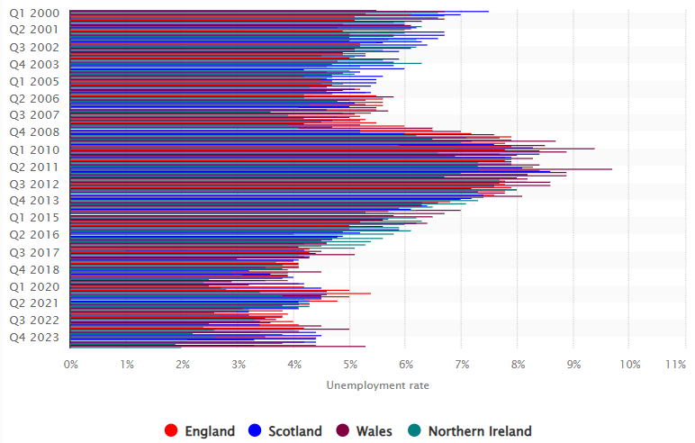
Figure 1: Unemployment rate in the United Kingdom
(Source: Statista, 2024)
For instances, the unemployment rates in United Kingdom was at the levels of 3.8% in England during quarter 4 of 2023. This has reached the range of 4.4% in quarter 3rd of 2024 (Statista, 2024). Thus, highlighting the increasing issues for the community in the areas of London, United Kingdom.
Politically, this community is also engaged within the advocacy around the issues linked with social inequality and discrimination. They also have advocacy groups and local politicians that carefully trailer the messages for addressing these issues by reflecting the voice and aspirations of community. They also come up with different campaigns focusing on educational inequality and antiracism aspects which are aligned with the community concerns. They also make use of inclusive languages which helps them in fostering the unity, respective of age and gender. By framing all of these issues in terms of justice and fairness, the advocate can help their community to connect with the collect desires for a better quality of life and representation in their working area (Banks, 2013).
Lastly, in terms of environmental factors, the communities are responsive with the messages on urban sustainability which are linked with the aspects of affordable housing and green spaces. Their messages are also linked with the environmental quality for addressing the issues related to the health, benefits, family welfare, and housing affordability.

Concepts employed for community and challenges faced
Approaches for behavioural change in Bangladeshi community utilises the culturally informed strategies for addressing health, educational and social engagement. There are several key concepts that under these approaches which includes community engagement, culturally tailored interventions and social support networks. However, there are certain challenges like language barriers, trust in external organisations and social economic constraints which complicates the effectiveness of these interventions. One of the core concepts is based on community engagement that seeks to involve members in design and implementation programmes. It also helps enforcing the sense of ownership and relevance. It is particularly effective in the areas of health initiatives (Maclure, 2023). For example, the public health program, targeting diet and exercise are more successful when they help in engaging with the community leaders, Imams and Local influencers. They appropriately help in engaging with the community by communicating messages aligned with the cultural values. However, reaching the overall community can be challenging because of several differences linked with openness to change. This can be special case among the older generations that might adhere strongly with the traditional practises.
The culturally tailored interventions are another essential approach which ensures that the program reflect the unique, social and religious context of the community. As per the educational initiative, the messaging is emphasised with the value of knowledge and advancement, which is appealing for both the culture and religious motivation for personal growth. For the youths of this community, the after school programmes and mentorship initiatives are framed as the personal pathway of opportunity. It helps in capturing the understanding with the help of parental support in crucial terms (F. Amauchi et al., 2022). Education, educational materials under these are often bilingual including Bengali and English teaching to bridge the generational divides.
Social support networks also works as the backbone of behavioural changes by placing the strong reliance on family and communal ties. Interventions under these factors are leverage with these networks to promote the behavioural changes linked with the social welfare. It also includes the aspect of encouraging women participation in employment and education. However, challenges can be faced because of the long-standing society norms that conflicts with the progressive goals. For example, gender expectations can limit down women involvement in the economic activities or educational opportunities. This creates the need of the programmes that can help in balancing respect for cultural values by empowering the goals.
Despite of these targeted approaches, the behavioural change efforts face significant obstacle. The language barriers persist for the first generation immigrants that have limited English proficiency. It also limits down the access to health education and social services that are not appropriately translated culturally tuned. Additionally, there are several trust issues that undermines the effort by external organisations which are perceived to be unfamiliar as per the community requirements (Peredo & Chrisman, 2006). Also, the development of trust is backed by the value of sustained engagement that can be difficult in terms of maintaining appropriate development because of funding, limitations and competing priorities.
Lastly, the economic constraints also hinder the participation in programmes which are aimed on behavioural changes. The low income families directly prioritise the immediate needs over the factors of long-term benefits. They mainly reflect on the values of attending health seminar or enrolling within the educational programmes. Addressing such barriers constantly requires with innovative solutions like offering with the flexible program schedules or providing individuals with the financial incentives. This can appropriately help by ensuring proper participation and engagement from the community.

Community development processes
The community development process for Bangladeshi community in London is emphasised over the culturally tailored programmes. It also includes economic empowerment and social inclusion factors for driving sustainable improvement. Efforts are laid by the local Council community groups and cultural organisation by focusing on the accessible education, job training, and health initiatives. The programs are delivered with the help of trusted channels like mosques and cultural Centres. For sustainability, the initiatives like small business support and bilingual education resources are also provided which empowered the residence to economically preserve their cultural identities (Maclure, 2023). Challenges within these areas include overcoming language barriers, limited resource availability and social economic constraints. All of these aspects can impact on the long-term participation from the side of community. Addressing these aspects required with the continuous funding and adaptive outreach for the community led involvement by ensuring that the programmes meet with the evolving need of the community. It also looks on promoting self-reliance and resilience across different generations.

Conclusion
The report has concluded about the identification and analysis of a distinct community within the areas of London United Kingdom. This has also shown the approaches undertaken for fostering growth and development of this community. It has also stated about the use of imagery and other factors, including their impact and the tailored messages for shooting the given community. It has also included about the key concept employed within to understand about the behavioural changes in this community and the challenges faced by them are also included. Lastly, the evaluation for the community development process with the sustainable improvement is also included in it.

References
Statista, (2024). Unemployment rate in the United Kingdom [Online] Available through: <https://www.statista.com/statistics/279990/unemployment-rate-in-the-uk-by-country/> [Accessed on 13 November 2024]
Masum, A., Aziz, H. H. H. A. A., & Hassan, M. (2020). Corporate social responsibility and its effect on community development: An overview. Journal of Accounting Science, 22(1), 35-40. https://doi.org/10.9790/487X-2201053540
Edgeman, R. Eskildsen, J. (2014). Modelling and Assessing Sustainable Enterprise Excellence. Business Strategy and the Environment, Vol. 23 (3), p.173-187.
Cronin, M. J. (2017). Managing for social impact: innovations for responsible enterprise, Springer.
Peredo, A. M. & Chrisman, J. J. (2006). Toward a Theory of Community-Based Enterprise. The Academy of Management Review, 31(2), 309–328.
Banks, S. (2013). Managing community practice : principles, policies and programmes (2nd ed.). Policy Press.
Maclure, L. (2023). Augmentations to the asset-based community development model to target power systems. Community Development, 54(1), 4-17. https://doi.org/10.1080/15575330.2021.2021964
F. Amauchi, J. F., Gauthier, M., Ghezeljeh, A., L. Giatti, L. L., Keats, K., Sholanke, D., ... & Gutberlet, J. (2022). The power of community-based participatory research: Ethical and effective ways of researching. Community Development, 53(1), 3-20. https://doi.org/10.1080/15575330.2021.1936102

