University of Wales Trinity Saint David

School of Engineering

Energy in a Flywheel
Engineering Science M4X00385

Vinicius Dreher

1900011

03/12/2019

Contents
1 Introduction 1
1.1 Objective 1
2 Materials and Methods: 2
2.1 Materials 2
2.2 Experiment Procedure 4
3 Results 6
3.1 Time deviation 8
3.2 Error in Height 10
4 Analysis I 15
4.1 Analyses II 16
4.2 Analyses III 17
4.3 Analyses IIIV 18
4.4 Analyses V 19
5 Conclusions 22
6 Evaluation 23
6.1 Error sources: 23
6.1.1 Human Error 23
6.2 System error: 23
7 Further work 24
8 References 25

Introduction
Does a falling object have potential energy or Kinect energy or both? This technical report will introduce the theory and practical experiment results obtained from the difference between potential and Kinect energy and how it can change from one to the other. It will show you that:
- Potential energy is converted into kinetic energy and back.
- Energy store in different ways.
- Energy is neither created nor destroyed. (Mayer, 1841)

Objectives
- Collect data to calculate the amount of energy in a system at different moments.
- Gather evidence and data to support the law that is, conservation of energy.
- Determine how the total energy in a system is broken up into different types of energy at different moments and how that is related to the law of conservation of energy.
- Compare two different experiments and compare the results.
- To compare the theoretical and experiment value of moment of inertia for flywheel

Materials and Methods:

Materials
Table 1 List of material
Part | Quantity | Description
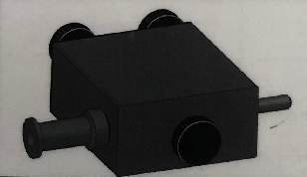  Figure 1 (TecQuipment). | 1 | Flywheel Block
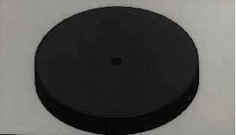  Figure 2 (TecQuipment). | 1 | Flywheel
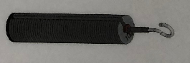  Figure 3 (TecQuipment). | 1 | Weight Hanger
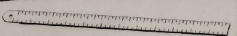  Figure 4 (TecQuipment). | 1 | Magnetic Rule
  Figure 5 (TecQuipment). | 1 | Nylon Cord
  Figure 6 (Dreher, 2019). | 1 | iPhone 8
  Figure 7 (Dreher, 2019). | 1 | Work Panel

Experiment Procedure
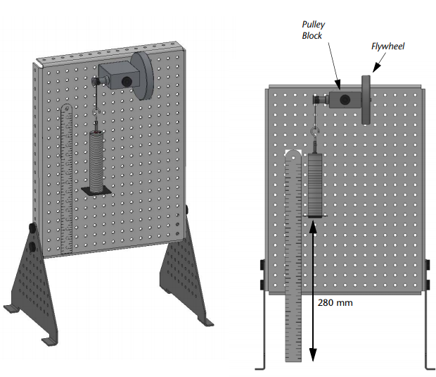
Figure 8 (TecQuipment).
The first part of the experiment was set up the equipment allowed the lower part of the weight hanger to be at a height of 280 millimetres at its highest point as shown in the figure 8. The next step, 90 grams has been added to the weight hanger, resulting in a total mass of 100 grams.
With the total weight of 100 grams in the weight hanger the experiment was started by turning slowly the flywheel to lift the weight hanger until the bottom of the weight hanger reaches 280 millimetres on the rule. Using a cell phone (figure 7) to measure how many seconds it takes for the weight hanger to fall from its 280 millimetres position to the 0-millimetre position and be back up to its maximum height. The experiment was repeated a total of twelve times with the respective weight hanger masses: 0.1 kilograms, 0.2 kilograms, 0.3 kilograms, 0.4 kilograms and 0.5 kilograms (3 times for each mass).
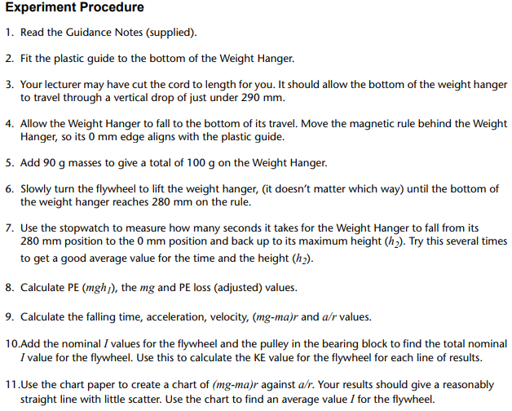
Figure 9 (TecQuipment)
The experiment procedure clearly shows each step that need be done. Below are two photographs illustrating the begin and end of the procedure in the laboratory.
BEGIN
END


Figure 10 (Dreher, 2019). Figure 11 (Dreher, 2019).

Results
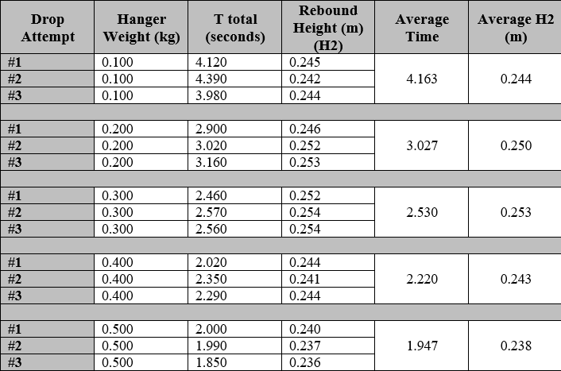
Figure 12 (Dreher, 2019)
With the data obtained above it was possible to calculate the following parameters:

Figure 13 Given parameters.

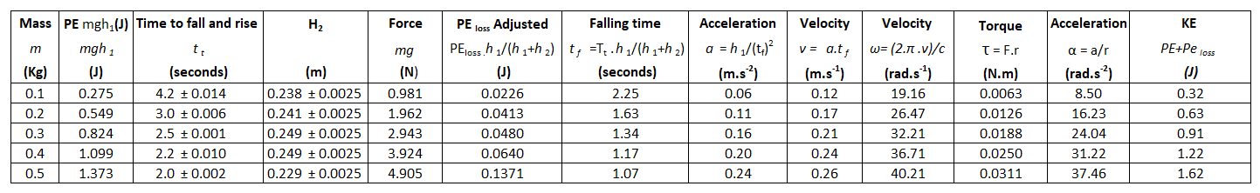
Figure 14 Results calculated from ES9 Worksheet.

Figure 15 Graph of total inertia from the experiment.

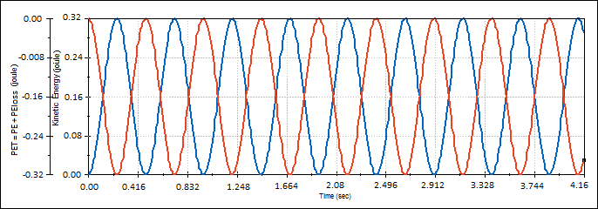
Figure 16 Graph of total potential energy (potential energy + loss potential energy) and total Kinect energy.

Time deviation
‘The standard deviation of a random variable, statistical population, data set, or probability distribution is the square root of its variance. It is algebraically simpler, though in practice less robust, than the average absolute deviation (Gauss, (1816))’
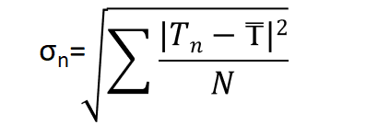
Figure 17 formula standard deviation (SPECTRE, 2016)

Where:
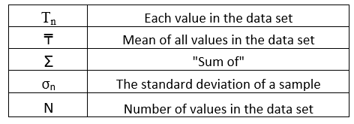
Figure 18 Standard deviation symbols (Dreher, 2019)

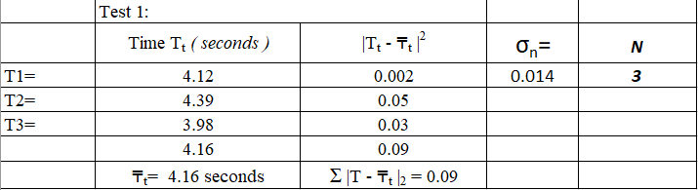
Figure 19 Standard deviation test 1 (Deher, 2019)
Altogether, five standard tests had been done and are located in the chapter appendices.

Error in Height
If the same object is measured with the same instrument by two different people, or even measured again by the same person, two different measurements may result. This uncertainty in metrology is referred to as “variation” or “error”. In this context, the word “error” does not mean a mistake. (Roberts, p. 2018) An error in measurement is the difference between a taken measurement and the known actual value (the accepted true measurement) of what is being measured. The error depends on the instrument you are measuring with and how it is calibrated. However, as a rule: (Roberts, p. 2018) The degree of accuracy is half a unit each side of the unit of measure. (Roberts, 2018)

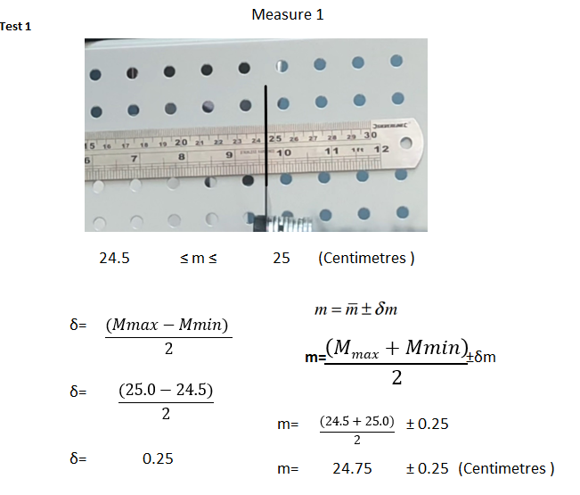
Figure 20 Height standard deviation calculation.
The same procedure had been done 15 times for each attempt drop.

Analysis I
This section summarizes and compare the experiments results with the nominal data given in the worksheet.
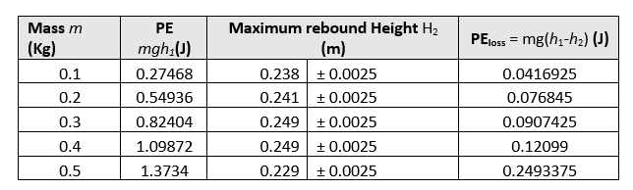
Figure 21 Results from table 4
The higher up an object is the greater its potential energy.
The larger the distance something falls through the greater the amount of potential energy the object loses as it falls. As most of this potential energy gets changed into Kinect energy, the higher up the object starts from the faster, it will be falling when it hits the ground. Thus, a change in gravitational potential energy depends on the height an object moves through, also depends on the mass of the object that is changing height.
The result for the experimental Inertia is 0.00079 kg.m². The nominal value is 0.00047 kg.m^{2.}

. Analysis II
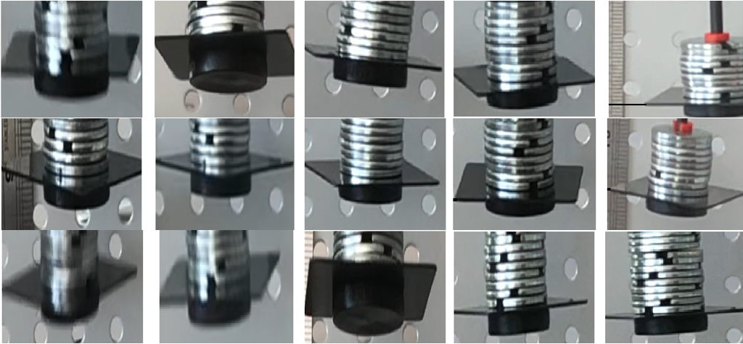
Figure 22 Weight hanger maximum position (Dreher, 2019)
The figure 22 shows a sequence of photos taken from the laboratory experiment. Each photo was taken at the maximum height (H₂) that the weight hanger reached in each test. In total there were 15 attempts which resulted in 15 photos. It is clear in the images above, the weight hanger is not aligned vertically, consequently energy loss occurs.

Analysis III

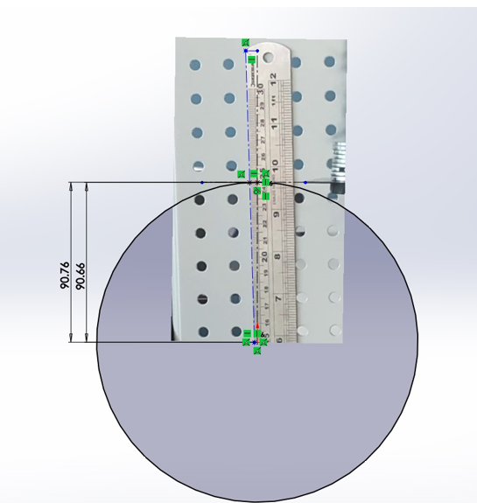
Figure 23 parallax error. (Dreher, 2019)
Alignment is a common source of uncertainty in a dimensional measurement. For example, when a measurement of the distance between two parallel surfaces is made, it should be perpendicular to the surfaces. Any angular deviation from the perpendicular measurement path will result in a cosine error, in which the actual distance is the measured distance multiplied by the cosine of the angular deviation.

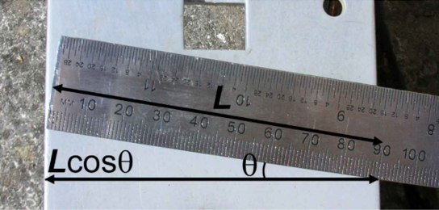
Figure 24Ruler cosine error. (Dreher, 2019)

Analysis IV
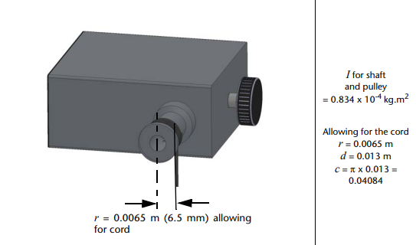
Figure 25 Total inertia of pulley and shaft. (TecQuipment)
In various subfields of engineering, a nominal value is one for which the “name” for the value is close to, however not the same as, the actual value. The figure 25 is showing a value of 0.0000834 Kg.m². This value represents a much larger difference than can be called nominal as shown below:
The formula for inertia is ‘I=0.5 x mass x R².’ Thus, ‘mass= I ÷ (0.5 x R²)’.
Considering the values:
Table 2 Values given ES9 worksheet
I= 0.0000834 Kg.m²
R=0.0065 metres
Nominal mass result: 3.95 Kg.
Mass obtained digital scale: 0.0324 Kg.
The real mass of the shaft and pulley is 0.0324 Kg which makes the nominal value 122 times higher than the actual value obtained through a digital scale.
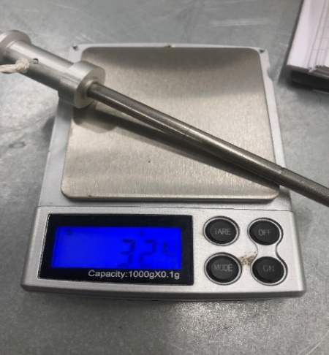
Figure 26 Real mass shaft and pulley (Dreher, 2019)

Analysis V
It is assumed that the experimental results represent the real behaviour of the object under test with specific measuring errors, on the other side the simulation results represent the behaviour of the same object based on its theoretical model whereas analytical results are accurate as these are obtained by proven mathematical manipulation. Take for example a baseball being dropped from the hand. Few assumptions as no air resistance, neglect the balls internal energy (i.e. its temperature), the energy of the ball remains constant and can be described by its potential energy (a function of its height from the floor) and Kinect energy (a function of its speed). As the ball is released and just before it begins to fall, all of its energy is potential. As it begins to fall, the potential energy is converted into kinetic energy thanks to gravity. In other words, it accelerates downward, increasing its speed and decreasing its height from the floor. At the instant before it hits the ground, all its potential energy has been converted to Kinect energy.
Solid works provide a way to simulate the motion of your models in a virtual world complete with gravity, forces, springs, etc. The experiment shown below was created with the emphasis of comparing the flywheel graph experiment and the graph energy in an ideal scenario using Solidworks,

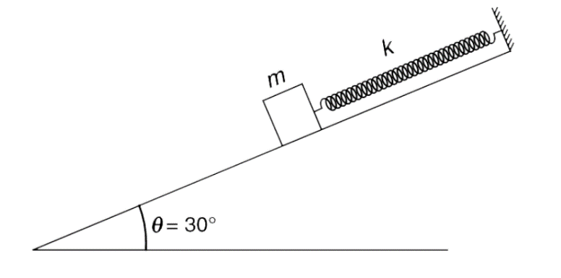
Figure 27 (Irodov, 2018)
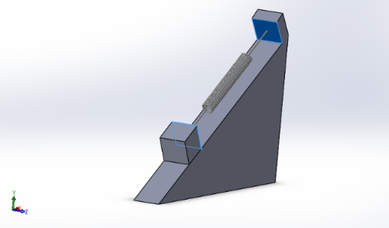  Figure 28 Solidworks assembly | 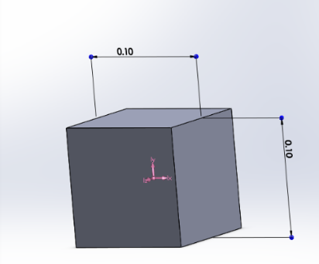  Figure 29 Solidworks assembly
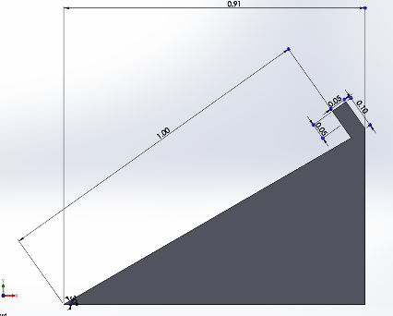  Figure 30 Solidworks assembly | -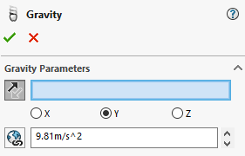  Figure 31 Solidworks assembly
  Figure 32 Solidworks assembly | 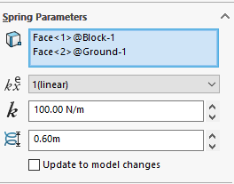  Figure 33 Solidworks assembly

Figure 34 Solidworks assembly
Solidworks assembly
The option ‘motion study’ had been used to recreate the motion scenario therefore a graph of ‘energy’ has been created.

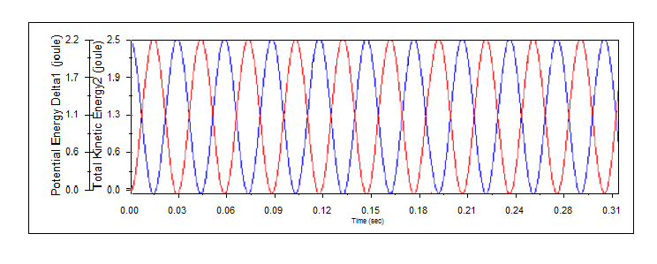
Figure 35 potencial and Kinect energy vs Time (with contact friction). (Dreher, 2019)
With the energy graph from the Flywheel experiment and the graph from Solidworks, both obtained same shape.

Conclusions
From the experiment, the moment of inertia of flywheel had been studied in which results in the dependency of mass and radius of the wheel as stated in the equation I=½MR². From here, as the weight hanger mass is increased, the moment of inertia is also increased. However, in the comparison of experimental value to the theoretical value, it is found that there is a huge deviation from the theoretical one which can be conclude the error was done by human mistakes however due to the error had been found at moment of inertia of the shaft and pulley disqualifying the nominal value for comparisons.
It was expected that the experiment would show when the mass increased, potential energy increased as the result time taken decreased.
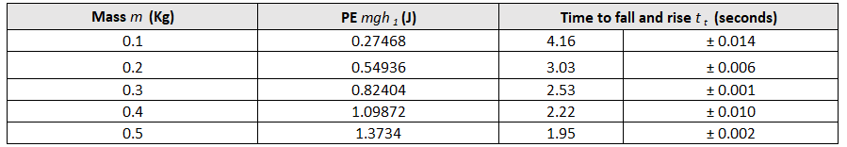
Figure 36 (Dreher, 2019)
Kinect energy is defined as one half times mass times velocity squared; Moreover, increasing speed it will increasing Kinect energy.
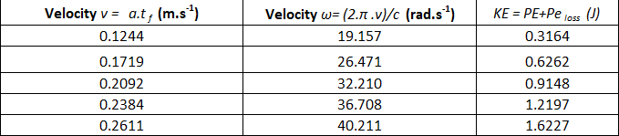
Figure 37 (Dreher, 2019)
The total work done of an object is merely the change in Kinect energy or change in potential energy. As the object moves away from earth surface, the work needed to do this against gravitational force is then stored or converted as potential energy as the figure 12 below clearly demonstrates.
Figure 38 Graph of total potential energy (potential energy + loss potential energy) and total Kinect energy.
Based on what has been demonstrated the total energy of the system must remain constant with the Kinect energy changing inversely. This is a fact what the plot shows, notice as the Kinect energy (blue) is at its maximum, the potential energy (red) is at its minimum.
Thus, is concluded that energy is neither created nor destroyed, potential energy is converted into Kinect energy and back.

Evaluation
To ensure understating of the experiment, objectives and criteria, the project was dynamic and clear, despite the results has found partially invalid, due to instrument errors and human measurement errors.
The practical element of the experiment can be improved along with a worksheet correction. Improvements will be addressed in ‘Further Work’.

Error sources:

Human Error
- There are parallax errors and limitation of measuring equipment for measuring the distance between the ground and weight.

- Reaction time in time recording.

System error:
- Friction occurs during the experiment but is not included in the analyses calculation.
- The flywheel may not be uniform distributed as assumed in the calculation.
- The actual lengths and masses of all the apparatus used may be different from the provide data.

Further work
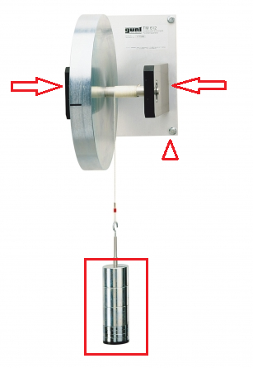
Figure 39 (G.U.N.T, 2019)

The above experiment demonstrates improvements that are vital to data acquisition and minimize external errors. Simple changes such as attaching the flywheel base to the wall will reduce vibration, thereby reducing energy loss. Another significant change in view of project improvement would be larger weights to avoid energy loss.

References
Deher, V. (2019).
Dreher, V. (2019). Dreher's own private collection. Swansea.
G.U.N.T. (2019). GUNT HAMBURG. Retrieved from https://www.gunt.de/en/products/engineering-mechanics-and-engineering-design/dynamics/kinetics-basic-experiments-on-dynamics-and-moment-of-inertia/kinetic-model-flywheel/040.61200/tm612/glct-1:pa-148:ca-17:pr-1412
Gauss, C. F. ((1816)). Bestimmung der Genauigkeit der Beobachtungen.
Irodov, S. (2018, 03 18). fazaquestao. Retrieved from http://fazaquestao.com.br/questao/plano-inclinado-trabalho-e-energia/
Mayer, J. R. (1841). Remarks on the forces nature.
Roberts, D. (2018). Error in Measurement. Retrieved from MathBitsNotebook.com: https://mathbitsnotebook.com/Algebra1/Units/UNError.html
SPECTRE, H. (2016, april 16). SDC. Retrieved from Standard Deviation (σ) Calculator: https://standarddeviationcalculator.co/standard-deviation-calculator/
TecQuipment. (n.d.). ES9 Potencial and Kinetic Energy Kit. Parts List, Nottingham.

Appendices

Time deviation
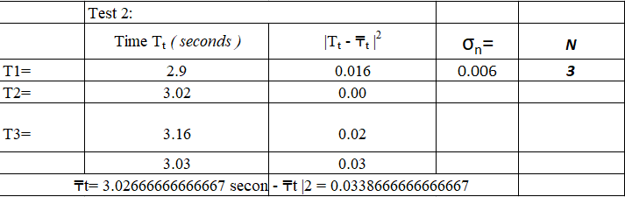
Figure 40 Standard deviation test 2 (Deher, 2019)
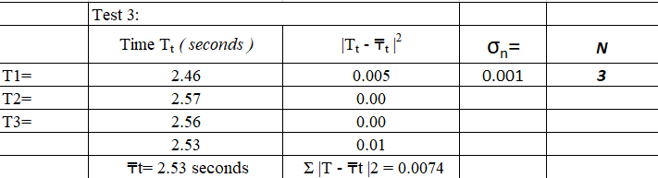
Figure 41 Standard deviation test 3 (Deher, 2019)
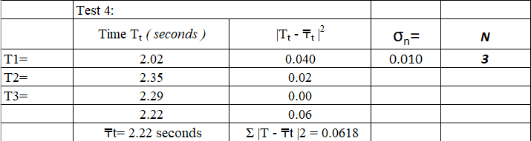
Figure 42 Standard deviation test 4 (Deher, 2019)
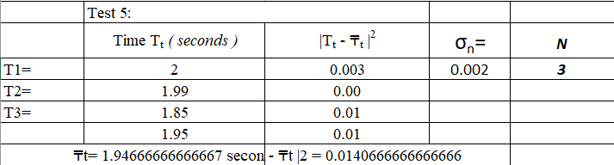
Figure 43 Standard deviation test 5 (Deher, 2019)

