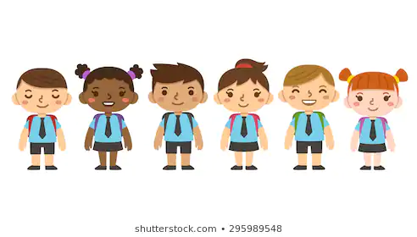
YSGOL GLYNDŴR
Here at Ysgol Glyndŵr, we always strive to uphold the highest possible standards for our pupils. It is our role to prepare each child for their future through an encouraging, supportive and inclusive school environment in order to start each child off on a brilliant path towards attainment and happiness. We nurture every child’s confidence, imagination and creativity through education on human and children’s rights.
This is an informative pamphlet aimed to help parents and careers gain more understanding of what children’s rights are, their significance within society and how we implement children’s rights in our school..

WHAT ARE HUMAN RIGHTS?

In 1945, the United Nations adopted the Universal Declaration of Human Rights (UDHR) , it is a milestone document in history put in place to serve as a benchmark for basic human wants and needs. The UDHR has been translated in over 500 languages, it allows us to live with dignity, freedom and equality.
Human rights are:
- Universal: applied to ALL with no conditions
- Indivisible; interlinking with one another
- Inalienable; they cannot be sold or given away
- Unconditional: You cannot forfeit your rights through undesirable behaviors.
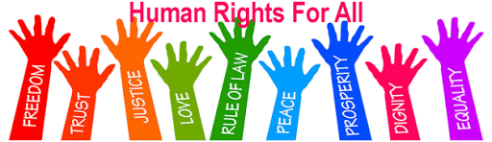
WHY DO CHILDREN NEED SEPARATE RIGHTS?

Children are the most vulnerable in our society. It us our duty as caregivers to make sure they are protected from situations they are not physically or emotionally developed for. Children also face limitation with the law, they need adapted rights to cover their needs. The United Nations Convention on the Rights of the Child, or UNCRC, produced 54 articles on what children’s rights are and how it is adults across society and the government’s responsibility to make sure that every child’s rights are being met in order for children to enjoy their rights and childhood. The convention covers all aspects of a child’s life, ensuring that every child’s social, cultural, economic, civil and political rights are being met. We strongly encourage you to read a summary of each article included in the index.

CHILDREN’S RIGHTS IN WALES

Wales has committed to children’s rights through the introduction of new policies and legislations:
- The adoption of the UNCRC
- Rights of children’s and young persons measure
- The Right Way
- Introduction of the world’s first children’s commissioner
- The 7 Core aims.
We closely follow all legislation involving children’s rights and hold them in it’s highest regard.

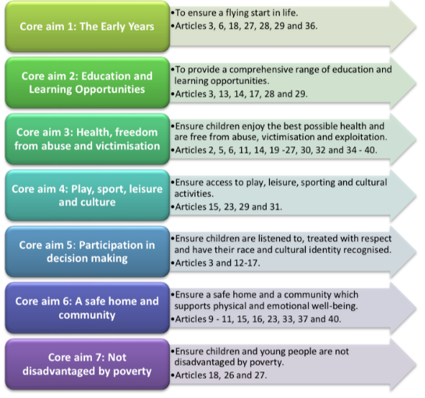

WHAT ARE THE 7 CORE AIMS?

The 7 core aims are influenced by the UNCRC’s 54 articles, intended by the welsh government to guide all their work for children and young people. These 7 core aims ensure that children live their lives as freely and happy as possible. The core aims center largely around play and how positive, encouraged free play develops children in incredible ways. Included here is a summery from the Welsh Government’s programme for children and young people. The image states each core aim and what purpose it fulfills, as well as highlighting which of the children’s rights articles it fulfils.
Following such legislation is at the heart of our school community. We believe it essential to encourage each child to be physically active, present at school and knowledgeable of their mental health.
- We hire the most passionate, qualified staff and provide opportunities to attend additional workshops and courses to keep our teachers up to date with modern teachings and curriculum. This is all to ensure your child is receiving the best education we can provide. (Following articles 28 and 29; Right to education, goals of education).
- At Ysgol Glyndŵr, we encourage a healthy, active lifestyle. We have wonderful school dinners packed with fruit, veg, vitamins and minerals as well as catering to halal, kosher, vegetarian, vegan, dairy and gluten free diets.
- We offer free breakfast club to ALL pupils, not just those in receipt of free school meals. We provide this to ensure that each child starts the school day off well-fed and prepared to learn, no matter their personal circumstance. We also run a food bank very close to the school grounds in order to offer a helping hand to our families who may need it. If you would like more information, please contact our headteacher.
- We encourage our children to express their own thoughts and beliefs and include them in decisions which affect their experience at school and their education. We want our pupils to feel heard and respected in our school. This is why we have our School Council with elected pupil representatives who discuss issues they believe to be important. As well as what they can implement to have a warmer school environment. (Following articles 12, 13 and 14; respect for the views of the child, freedom of expression and freedom of thought, belief and religion)
An additional way in which our school adheres to article 14 is through allowing each of our pupils to express their individual religion, and to feel included in religious celebrations.
- This is why we celebrate Rosh Hashana, Hanukkah and Yom Kippur, Eid Al-Fitr and Edi Al-Adha, Christmas, Easter and Diwali. We do this to allow each of our children to be accepting of differences amongst one another. Fear stems from ignorance, we aim to tackle this.
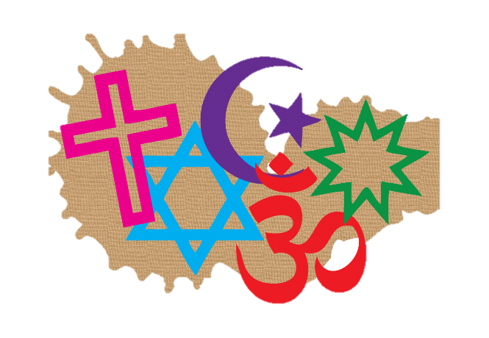
- We also have a separate room within our school grounds for our pupils and staff who practice Islam to undertake their afternoon prayers with no outside distractions. This has proved invaluable in boosting Muslim pupils’ self-esteem and feelings of inclusivity.

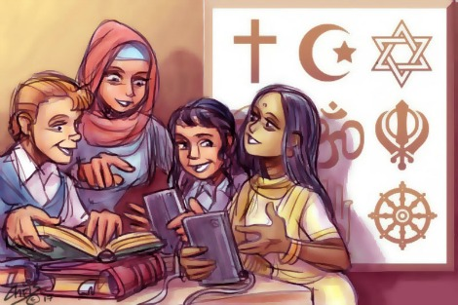

FOLLOWING ARTICLE 29; GOALS OF EDUCATION

We know how essential it is for the growing generation to understand environmental issues that will impact them later in life. We believe that thorough education on climate change, its causes and impacts will allow our
children to be more mindful on what they can do personally to influence a healthier lifestyle and planet. We have an Eco Council housed of two representations from each year group. This past year the Eco Council organized a beach litter pick-up and greatly reduced single use plastic within the school as it was a great source of concern for them. Making these and other positive, green changes allowed Ysgol Glynŵr to receive the Green Flag Eco School Award. An achievement we hold very close to our hearts.

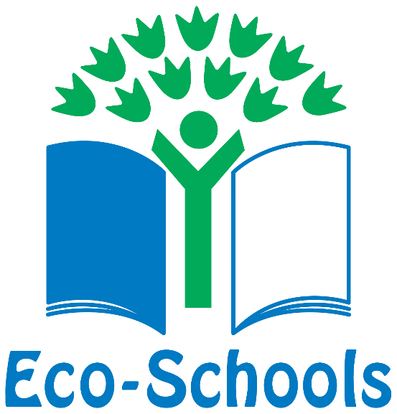

PROVISION

Every child has the right to adequate standards of living, healthcare, education and services that enable play and recreation.
PROTECTION

Every child has a right to be protected from abuse, neglect, exploitation and discrimination.
PARTICIPATION

Every child has the right to freedom of expression in views and beliefs of matters that concern them.

Through our implementation of children’s rights throughout our school, we have been recognized as a GOLD LEVEL Rights Respecting School. This incredibly prestigious award was earned through having children’s rights fully imbedded in our curriculum, in our policies and in our teaching. It has fully enabled us to be a more compassionate, friendly and aware school. We pride ourselves on this award and so should your children-they helped us gain it. Da iawn ti!
All of our information regarding Safeguarding is through advanced training course provided through the NSPCC. It is mandatory for ALL staff to receive the highest level of training on this. It is our TOP PRIORITY to keep YOUR CHILD safe. (Safeguarding and child protection in schools | NSPCC Learning, 2020)

SAFEGUARDING AT YSGOL GLYNDŴR
What is safeguarding?
- protecting children from abuse and maltreatment
- preventing harm to children’s health or development
- ensuring children grow up with the provision of safe and effective care
- taking action to enable all children and young people to have the best outcomes.
Child protection is at the core of safeguarding. It is our role as a school to make sure that every child flourishes in a safe and happy school. We foster healthy relationships between parents and the school and hope to continue this indefinitely.
How do we safeguard in our school?
- creating safe environments for children and young people through robust safeguarding practices
- ensuring that adults who work in the school, including volunteers, don't pose a risk to children
- making sure staff are trained, know how to respond to concerns and keep-up-to-date with policy and practice
- teaching children and young people about staying safe
- maintaining an environment where children feel confident to approach any member of staff if they have a worry or problem.

Safeguarding follows Article 19; protection from violence, abuse and neglect. Article 26; Social Security and 32; Child labour.

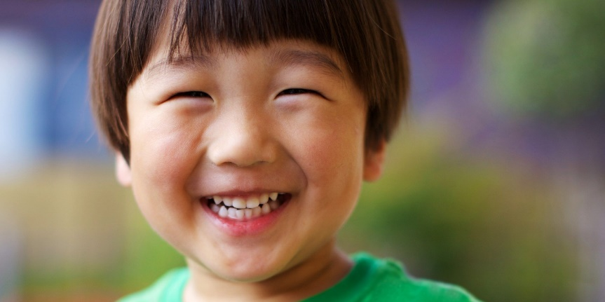
Safeguarding ties very closely in with well-being and mental health. Every year we explore themes of mental well-being and the importance of prioritizing mental health in early developmental years. We have a children’s safeguarding officer within the school as well as a mental-health team who are prepared for any difficulty your child may face. We are always here to help.

If you feel that a child’s basic human rights are not being met or if their home life is not adequate, it is important that this concern doesn’t go unheard.
- If the child attends Ysgol Glyndŵr, contact either Headmistress Keeva Parry (07638928444) or our Safeguarding officer, Rosie Mari (07746379403)
- NSPCC helpline: 0808 800 5000
NSPCC email address:help@nspcc.org.uk
National Domestic Abuse helpline: tel: 0808 2000 247
Childline helpline: 08001111

BIBLIOGRAPHY
- Eco Schools. 2020. Awards - Eco Schools. [online] Available at: <https://www.eco-schools.org.uk/about/howitworks/the-awards/>
- n.d. Cartoon Of School Children. [image] Available at: <https://www.shutterstock.com/search/cartoon+children+school+uniform>
- Savethechildren.org.uk. 2020. Children's Rights | Save The Children UK. [online] Available at: <https://www.savethechildren.org.uk/what-we-do/childrens-rights#!>
- NSPCC. 2020. NSPCC Helpline. [online] Available at: <https://www.nspcc.org.uk/keeping-children-safe/our-services/nspcc-helpline/>
- Playwales.org.uk. 2020. Play Wales | Seven Core Aims. [online] Available at: <https://playwales.org.uk/eng/sevencoreaims
- Aglobalworld.com. 2020. Religious Holidays Calendar. [online] Available at: <https://aglobalworld.com/international-religions/religious-observances.php>
- National Assembly for Wales. 2020. Rights Of Children And Young Persons (Wales) Measure 2011. [online] Available at: <https://www.assembly.wales/en/bus-home/bus-third-assembly/bus-legislation-third-assembly/bus-leg-measures/business-legislation-measures-rightsofchildren/Pages/business-legislation-measures-rightsofchildren.aspx>
- NSPCC Learning. 2020. Safeguarding And Child Protection In Schools | NSPCC Learning. [online] Available at: <https://learning.nspcc.org.uk/safeguarding-child-protection-schools/>
- Cyc-net.org. 2020. The Three P's Of Children's Rights: Provision, Protection And Participation. [online] Available at: <https://cyc-net.org/cyc-online/cycol-0500-threepees.html> [Accessed 7 April 2020].
- Unicef UK. 2020. UN Convention On The Rights Of The Child (UNCRC) - Unicef UK. [online] Available at: <https://www.unicef.org.uk/what-we-do/un-convention-child-rights/>
- Un.org. 2020. Universal Declaration Of Human Rights. [online] Available at: <https://www.un.org/en/universal-declaration-human-rights/index.html>
- Welsh Government xaq2999iug, 2015. Programme For Children And Young People. fairer futures division.
- Rights Respecting Schools Award. 2020. What Is Gold: Rights Respecting? - Rights Respecting Schools Award. [online] Available at: <https://www.unicef.org.uk/rights-respecting-schools/getting-started/gold/what-is-gold/>

