MODULE CODE: Digital Skills for
Personal Development and Business
Growth BMSW4008
ASSESSMENT COMPONENT:
PORTFOLIO
STUDENT NAME: Sarka Zupkova
STUDENT NUMBER:2512681
LECTURER: Aqsa Shabir

Contents
Part 1
Jisc discovery tools …………………………………………………………………….. p3
700 word reflective essay (5 references) …………………………………………. P3,4
Part 2
LinkedIn learning certificate …………………………………………………………… p3,4
Part 3
Excel chart ………………………………………………………………………………….. p5
1000 word essay on the relevance of excel in the personal and professional life
(8 references) ……………………………………………………………………………….p5,6
Reference list ………………………………………………………………………………..p7

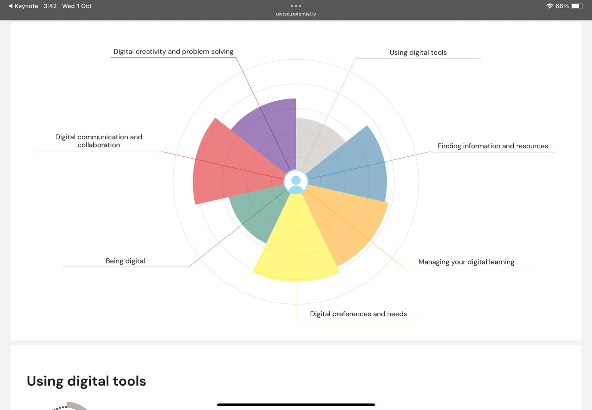
Part 1

Digital skills include the ability to use computers, smart devices, and internet access digital skills can include many things from websites to using different tools and technologies. An example of digital skills could be anything from connecting your device to the internet to creating a excel spreadsheet. Digital skills are important for businesses because that way the business can raise awareness across their platforms the ability to understand and use social media effectively is a core and valued skill every student should have.( Sanchez, C 2023). Basic level of digital skills could be skills that allow you to have the ability to preform simple tasks such as touching a screen, operating word, managing files, sending emails (Sanchez, C2023).
The ability to access and understand digital skills effectively is a valued skills that every professional should have, businesses need to use digital tools to reach the audience to achieve their goal. Data analytics is being able to organise big data and statistics (Adam’s, T 2022) digital skills are now required in almost all jobs so digital skills is something that everyone needs to have. (Sanz Fernandez, L 2025)
At the start of the course we had to fill out a survey which theme created a chart for me and in this report I will assess the results in a more explained version.
Digital creativity and problem solving involves the ability to use different digital tools to create new content and find innovative solutions and make decisions based on digital evidence. In the chart under digital creativity and problem solving I have quite a good understanding to creating new content and problem solving, this means that I have a good understanding.
Digital communication and collaboration include the use oof digital tools and platforms to exchange information and working with other people. In the chart under digital communications and collaboration I have a good understanding when it comes to working with other people in a team or pair, I know how to communicate with people in a way for the specific person to understand.
Being digital means when you have the skill set to use digital tools and able to use different tools and techniques. From the chart above I have a little bit of a understanding when it comes to different digital tools, such as PowerPoint, word etc.
Digital preferences and needs include a students skill set and how they use and adapt to their own digital needs such as interacting with technology in a way that the person understands or different communication channels. The chart above tells me that I have. Good understanding with how to communicate in different ways and I am able to provide myself the support I require.
Managing your digital learning includes using digital tools to plan and organise and execute educational goals. An example of this is setting up a learning environment, tracking your progress and maintaining focus. (Redecker, C. 2020) From the chart above it tells me that I have a good understanding of managing my learning and I am able to give myself the right environment and I’m good at tracking my work.
Finding information and sources includes searching through digital tools and finding the correct information that is needed. This includes going onto the Hwb library or the web and finding the information needed. From the chart above I have a good understanding when it comes to finding information and sources I am able to find the information I need to and I am able to find out how credible this information is.
Using digital tools is using software and online resources to preform tasks and enhance efficiency and communication. These tools range from communication platforms to software such as PowerPoint, excel, google.(Van Lar, E. Van Deursen, A. Van Dijk, J. Dee Haan, J. 2020) From the chart above I have a decent understanding towards using digital tools for example I know how to create word document and PowerPoint however I am still unsure how to use excel so that’s why the chart doesn’t show much of a high mark.
From the chart I can see that I have a mostly good understanding towards the several aspects of digital skills as there are many things that are included in the digital skills, these Digital tools such as PowerPoint or excel or word document. The sources are usually credible but there are some that are biased and not equal so that is something to be wary of. That is why it is good to look through a lot of sources and just read and making sure I can understand the source I am reading through.

Part 2
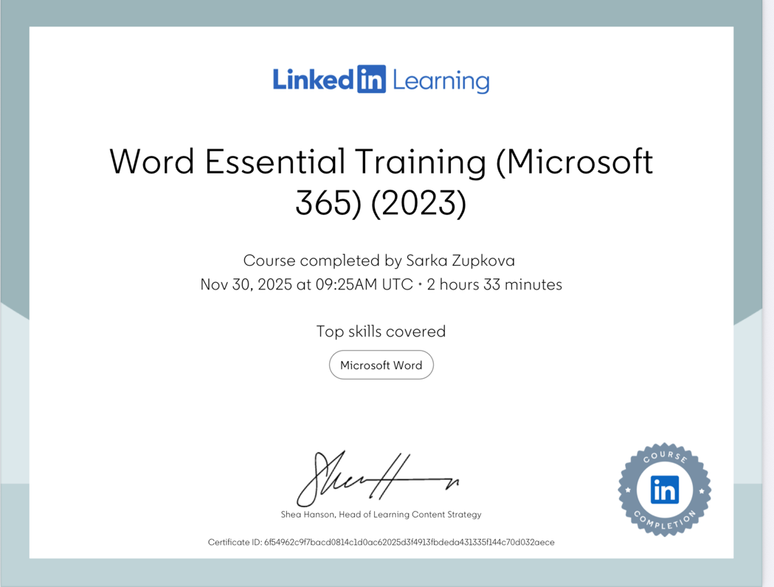
LinkedIn learning
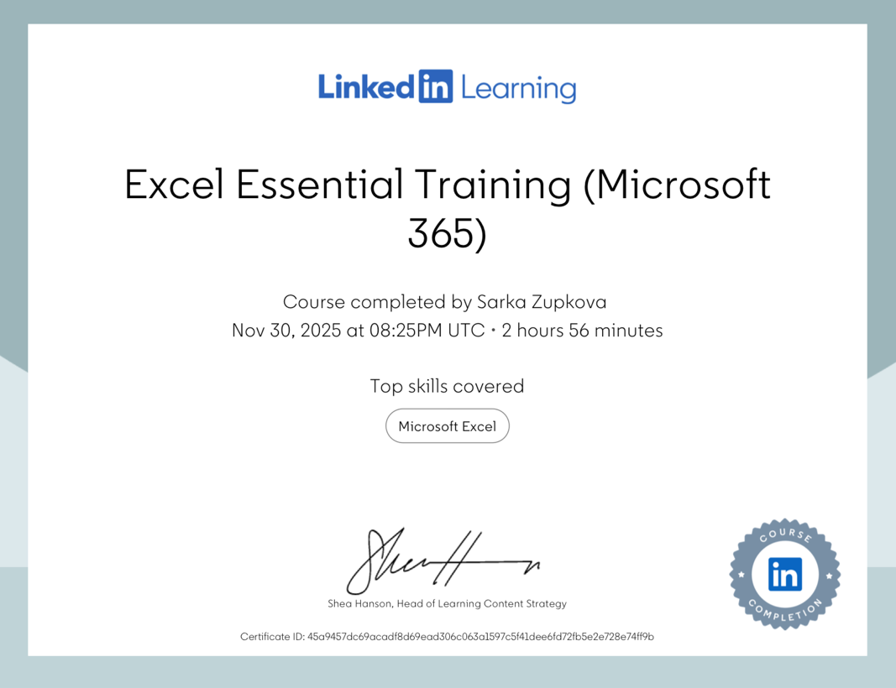
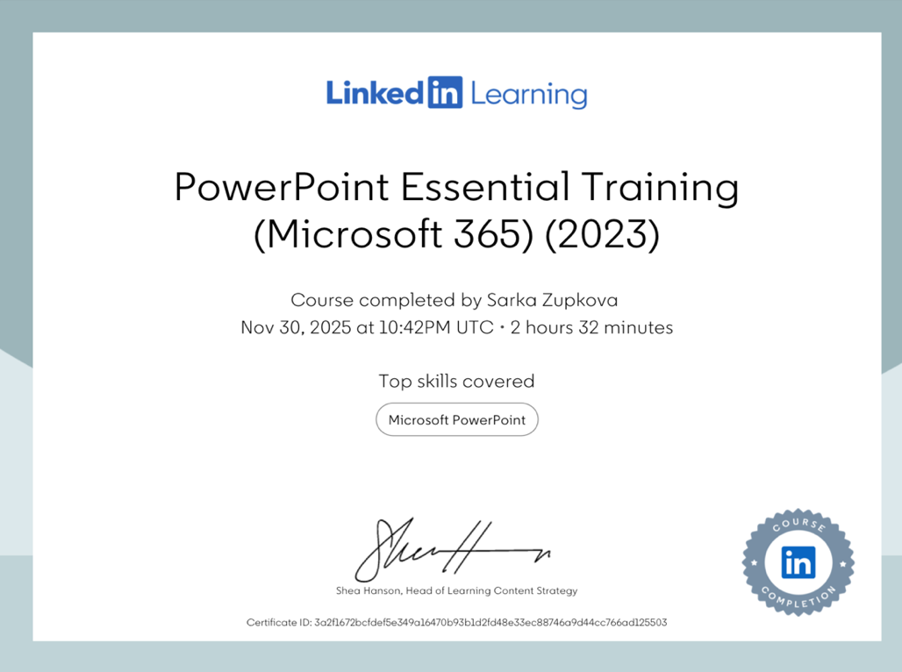

Part 3
)
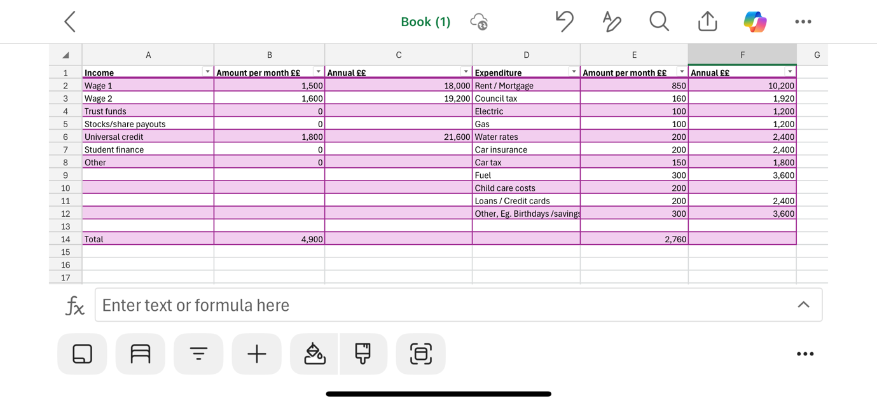
Part 3

Microsoft Excel is one of the most used software in the world for understanding and organising data, Many people think excel can only be used in your professional life but excel is actually used by many people who use it in their daily life it can help with planning tasks, budgeting, keeping track of personal goals. In the work place excel is usually used to analyse data, create reports and work more efficiently. It is important that I discuss this in the report in more detail. It is important that we explore this as most of the word has gone digital so tools like excel is more useful than ever because excel is easy to use but also very powerful tool as it can hold any data or information you need to store, (Keen, J 2020). Excel also benefits students in their studies.This report will help to understand how Excel can be used in the professional and personal life and why learning to use excel is a vital part in life.
Excel is highly relevant in the work life because it is one of the most versatile meaning that everyone ca use it and managing data, solving problems. In many company’s employees are asked to use excel to create charts and tables because the company’s have large amounts of data so they need their employees to use excel because it will ensure it is in a clear structure and will help with efficiency allowing them to track the data and monitor performance and keep important information. (Pett, D 2020) Excel has features such as formulas, pivot tables and charts and conditional formatting. With excel employees are allowed to create formatting such as planning projects and managing them projects with clear information. Excel in the work place is also used for easy tasks such as creating creating reports or even just sharing your information with your coworkers and have different information accurately. Many employers consider Excel skills to be very essential for the position. Excel is important in the workplace because it increases employees productivity and efficiency also it supports better communication and organisation. (UK Government. 2021). Accountants as-well as financial analysts, use excel to create budgets and forecasts as-well as to outline various results. Excel helps with boosting productivity, efficiency and decision making because it will help you create the task that you need to wether that is needing to create a conditional formulas and managing data. (William, J 2022).

Excel can be used in your personal life and I will write about it in some more detail to get a better understanding of using excel. Many people use excel on a daily basis for their personal life and one of the things people can use excel for is to creat shopping lists, create rotas, what I mean by creating a rota is that people can create a rosy for cleaning the house between the household or shopping for food a specific day. (Jansen, M 2021) Excel has many features that people on a daily basis can use and this is important because with tools like excel the ability to create some kind of structure to your life an will help u keep on top of the information you have to store, going back to storing information it will be very likely that people need to store some documents for important items and using excel will help keep that structure and cleanliness (digitally). (Ms Excel 2025) personal finance management this means that you can creat budget spreadsheets, track your expenses and analyse spending patterns. Excel can also be used to track your fitness and health this means that you can easily creat your own workout logs to track your progress to see if your losing weight. (Asen Georgiev 2023). One way you can use excel is planning how you will pay off your debts by listing your loans or credit cards and plan how you will pay it off. You can set final goals and track your progress using excel you will be able to track your spending so you can see where your spending most of your money and then you can fix that issue. (Butts, J 2024).
In conclusion there is many ways to use excel and a lot of tools that you can use in your professional life and personal life, excel is essential to digital tools that support both sides of life and in the work place excel allows employees to create data and analyse information and creating budgets, excel offers many tools to use such as creating formulas, charts, and conditional formatting. employees will improve on productivity and helps with better decision making including finances, business administration and project management excel will also increase employability. In personal life excel is useful for staying organised and managing everyday tasks. People can use excel to create shopping lists, budgeting sheets, cleaning rotas, schedules and keeping track of important information. Having excel skills will ensure that your everyday life will be easier just by staying more organised and confident which will help you with your daily tasks in greater ease. Excel will help with your productivity and helps create structure and keeps the data in a place that will keep your information safe but also easy to access and easy to understand.

Reference list
Sanchez, C(2023)
Sanchez, C(2023)
Adam’s, T (2022)
Sanz Fernandez, L (2025)
Van Lar, E. Van Deursen, A. Van Dijk, J. Dee Haan, J. (2020)
Keen, J 2020
Pett, D.(2020)
UK Government. (2021)
William, J (2022)
Jansen, M (2021)
Ms Excel (2025)
Asen Georgiev, (2023)
Butts, J (2024)

