Name: Ross Van Den Eeckhaute-Jones
Student P Number: P151366
Module Title: Internet Security
Module Code: ACCA5000
Assignment Title: Synthesize a solution to a potential real life scenario
Module Lecturer: Dr Carlene Campbell
Date: 28/03/2018

Ross Van Den Eeckhaute-Jones
University of Wales Trinity St. David
Swansea, Wales
Rvandeneeckhaute-jones.151366@student.uwtsd.ac.uk

Abstract— This document will research the wide range of Computer Forensics tools available for multiple investigation situations. The Computer Forensics tools will be categorized based on what type of evidence they gather.
Keywords— UWTSD, Computer Forensics, Digital Forensics,

Introduction
There are many tools available to be used in the gathering of evidence in computer forensics cases. There is no single tool that is used in all situations. Many tools are specific in the kinds of evidence that they can recover. [1,2,3]
This report will go in to detail of the various kinds of Computer Forensics tools available for different situations. Each discussed tool will be placed into a category depending on what kind of evidence the tool is designed to gather.
Following the Computer Forensics tools research and analysis, an investigation report will be provided for a case study involving a terrorism incident. A step by step analysis of each part of the investigation will be documented along with the precautions and tools used in the investigation.

Table of Contents

Section | Page Number
Cover Sheet | 1
Abstract | 2
Introduction | 2
Figures and tables | 3
Research on Computer forensics tools | 4-7
Case study report | 8-11
Conclusion | 12
References | 13

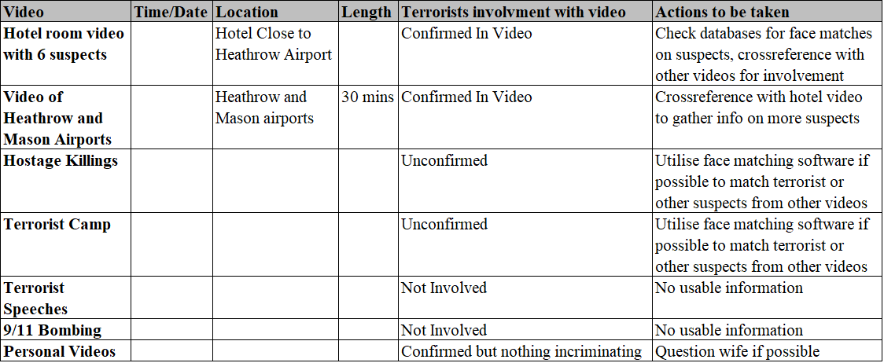
Figures and Tables

Figure 1. Detailed list of videos and actions to be taken.
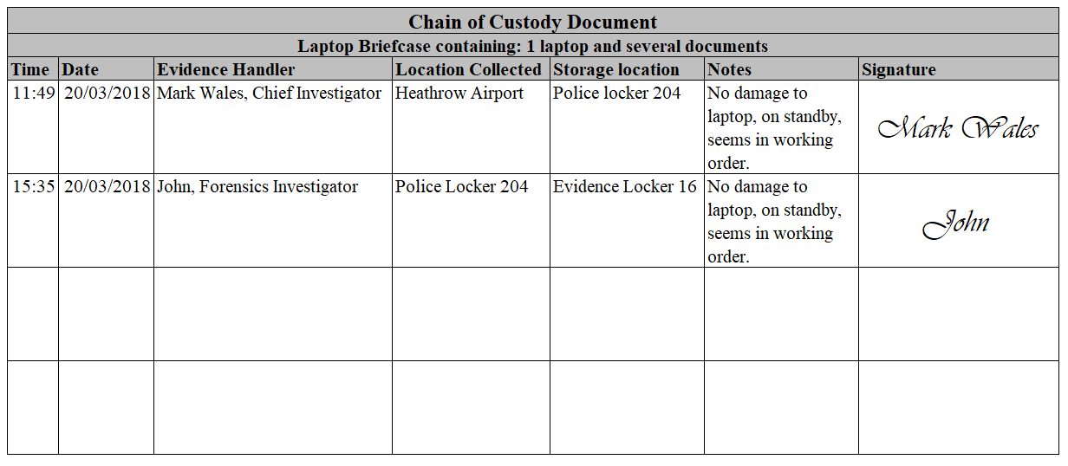

Figure 2. Chain of Custody document

Research on Computer Forensics Tools

Disk and Data capture tools.

Disk and data capture tools allow the extraction of data from a media device. A media device can be any device that can store files, whether it be word documents, email logs, pictures, spreadsheets or any other form of data. [1,2]

Data is usually stored on a disk. A disk is a physical storage device such as a SATA Hard drive, or Digital Card used in a digital camera. Other storage devices can include USB drives, Solid State Drives or CD/DVD/BLU-RAY. [1,2]

The goal of a Forensics investigator is to safely extract evidential data from devices while also maintaining the integrity of the device, this is where specific tools come in to reduce the chances of any evidence being thrown out due to mishandling of data, as well as capturing data that may not be reachable without such tools. [1]

It is essential to capture every byte of data that could possible hold incriminating evidence. Even if it may seem that sector of a disk is empty, it is possible to retrieve previously stored data from these sectors. A disk which may seem half full, could have hidden data present on the slack space of the drive. It is best practice to capture a byte-level image of a drive to ensure no data is lost, and that all possible chances of acquiring evidence are available. [2]

X Ways Forensics is a tool which allows portable extraction of data from a disk. This allows the investigator to maintain integrity of the device as the system is being run from the portable dongle, which write blocking the original devices disk. [6]

X Ways Forensics utilizes file carving to search through file headers and signatures, searching through unallocated space (including free space and slack space) on the disk to ensure no data goes unchecked. [1,6]

EnCase is a widely used forensic tool. It uses a dongle to primarily extract disk images, including hidden or deleted data. EnCase utilizes a bookmarking tool, to allow investigators to mark evidence as they find it to allow easier case construction. [7]

The file viewing aspect of EnCase allows viewing of a single file in multiple file types, to ensure every possible form of a file is covered. [7]

FTK is another disk imaging tool which can be used to extract data from physical and logical drives, along with USB drives. FTK is a portable tool which can be used on live running machines. The file format of this tool us “ADF” known as AccessData format. [8]

FTK can recover previously deletes or overwritten files. A fundamental feature of FTK is the ability to rebuild an image of a device in windows explorer, allowing safe viewing of files while maintaining integrity of the original disk. [1,8]

File viewers
A file viewer allows the computer forensics investigator to view, read or open files, sometimes even corrupted or inaccessible files. File viewers can read for example, OST and PST files from an email application, without the need of the actual application. [2,3,9]

As mentioned above, disk and data capture tools usually offer file viewing capabilities to allow the captured data to be viewed in a presentable fashion. X Ways Forensics, EnCase and FTK all offer file viewing/analysis capabilities. [6,7,8]

File analysis tools
File analysis tools give investigators the ability to retrieve metadata such as creation date, modification dates, file size, file type, author, resolution, file name and much more. Metadata can provide strong evidential evidence in an investigative case. [1,2,3]

Data capture tools usually include file analysis tools to allow investigators to analyze data that has been captured from the suspect device. Different tools store extracted data in different file formats to be viewed and analyzed by the respective tools. [2,3]

X Ways Forensics uses file carving to discover file metadata information. X Ways Forensics has a light utilities tool which allows non-forensics specialists to view and analyze data extracted from suspect devices. [2,6]

EnCase makes use of a bookmarking feature to pinpoint key pieces of evidence found while analyzing extracted data. EnCase supports strong hashing calculation standards such as CRC MD5 and SHA which are globally trusted and admissible in court. [7]

FTK can emulate an extracted disk image to allow deep analysis of the drive while maintaining the integrity of the original device. [8]

Registry analysis tools
Registry analysis tools can allow an investigator to view what kind of programs are installed on a computer. There are specific tools available for example Registry Recon, that allow an investigator to reconstruct registry data that has been deleted or modified, or to create an image from a certain set of registry data. [3,4,10]

These kinds of tools are extremely helpful in discovering valuable information which the suspect may have tried to hide/delete or would be otherwise undetectable using other tools. [10]

X Ways Forensics can also produce automated registry reports from windows registry files. These files can be viewed to discover what kinds of applications or settings are present or have been present on a device. [6]

Internet analysis tools
Internet analysis tools allow an investigator to view internet history, download history, internet browsers used, messaging systems used, email systems used and many sources of valuable information that can lead to a successful case. [3,4]

Belkasoft is a tool that can discover “footprints” left on a computer’s hard drive by a wide range of sources. Belkasoft supports data extraction from multiple popular web browsers, multiple regularly used chat messaging systems, social networking platforms and other peer to peer applications. Belkasoft can also extract valuable data from many email clients such as outlook, windows live and more. [11]

Email analysis tools
Email analysis tools can provide valuable evidence in the form of email headers. Email headers contain routing information such as IPs, sender, recipient, send date, subject and sometimes browser versions used. This information can lead to the identification of people sending malicious emails. [3,4,9]

Belkasoft can extract evidence from popular email clients such as outlook, outlook express and windows live mail to provide evidence of malicious emails, threats or other malicious activity which could be incriminating. [11]

Oxygen Forensic Suite is a mobile forensic tool which can access emails and messages, including previously deleted or hidden messages. [12]

Mobile devices analysis tools
Mobile device analysis tools are used to analyze portable devices such as phones, smart phones, tablets and essentially any portable device capable of communicating over the internet. [4]

Different versions of Mobile Device Analysis Tools usually cater to one type of device, for example since Android and Apple devices work very differently. However, some tools are updated to be used with multiple device types/versions. [4]

MSAB XRY is a tool that works with iOS 11 along with lots of new Android devices and software versions. Using XRY, investigators can rip all data (including hidden, deleted and protected data) from a device while maintaining the integrity of the device. [13]

Magnet AXIOM is another Mobile Device Analysis tool that offers extensive support in gathering deleted, encoded or encrypted data. AXIOM can also scan through a Micro SD card and use file carving techniques to retrieve data that may be missed by other similar tools. [14]

Mac OS analysis tools
Due to Macs having different software compared to windows computers, they require different tools to conduct investigations. Mac OS analysis tools are specifically designed to extract and analyze data from Mac desktops/laptops. [4]

MacQuisition is a tool that is specialized in acquiring system images from Mac systems. MacQuisition functions by using a USB dongle to safely boot from the suspect device, while write blocking the device to maintain integrity. Once booted using the MacQuisition dongle, the investigator can access any information stored on the Mac such as images, emails or documents which could be used as evidence in a case. [15]

Network Forensics tools
Network forensics tools can allow investigators to capture and analyze packets. Wireshark is widely used packet sniffer tool which displays data packets sent between a client and server. Packet data can contain information such as send/receive time and date, packet info, which protocol is used, source and destination. [4]

The captured packet information can lead to identification of suspects due to the display of IP addresses and time/date stamps. User activity could also be monitored using the info tab which can display websites accessed, servers accessed and any inbound or outbound connections. [4,18]

Software Forensics tools
Software forensics tools allow investigators to follow up cases that involve software code. Tools like CodeSuite give investigators a way to compare source code and executable code to identify copyright infringements, patent violations, theft of Intellectual Property and other code related cases. [4,16]

Anti Forensics
Anti-forensics is the practice of attempting to thwart an investigation by performing actions that would make it hard or impossible for an investigator to safely extract useful data from a device. [17]

There are a few areas of Anti-Forensics that branch out into other smaller areas explained below.

Data hiding can be achieved with encryption. There are many encryption techniques that can be used for various aspects of computer hardware/software. Password encryption, file encryption, email encryption, mobile device encryption and much more. [17]

Another technique of hiding data is Steganography. Steganography is the process of making something appear as something it is not. This can result in malicious images/videos seeming normal to the untrained viewer, whereas the intended material will be able to be viewed by the intended recipient.

Steganography can be implemented at many levels. It can used on images, audio, video, applications, files, file systems as well as cloud services. [17]

Artifact wiping is the process of going a few extra steps to get rid of data than simply deleting it. When data is deleted from a hard drive, the hard drive simply allocates that space of data to be written to as the data is no longer needed. This is the reason deleted data can sometimes be recovered as it is still stored on the drive until written over. [17]

The only way to truly delete data short of destroying the hardware is to perform specialized wiping techniques. These wiping techniques can perform full drive writes to ensure a drive consists of only data that has been written to the disk using a certain program, and that no previous data can possibly exist on the rewritten drive. [17]

Trail obfuscation is the act of hiding one’s digital footpath through various techniques discussed below:

IP address spoofing can be used to make it seem like you are operating a computer from another country or impersonating a targeted person by using their IP. [17]

Mac Address spoofing can be used to protect a user’s own mac address from showing up on network logs of websites used, or networks that a user has tried to gain access to. [17]

Using a proxy server can make it impossible or at the very least, hard to track a user’s internet usage due to the connection being rerouted via various different connections. [17]

Case study analysis

The case study involves a terrorist that was shot down at Heathrow International Airport. The terrorist had plans to bomb the Mason International airport at Fiji. His face matched with a face from a terrorist database. The terrorist attempted to escape when confronted by police and was subsequently shot. The terrorist was carrying a laptop briefcase at the time.

John the investigators first contact with the laptop briefcase along with the Dell Laptop was when he was given it by the police department. John was also given photographs of the crime scene and fingerprints that matched the terrorist.

Before John was given the evidence, the police should have recorded information that could be used in the chain of custody for the evidence. The information recorded by the police should include:

- Date and time of collection
- Location of evidence before collection
- Name of evidence collector
- Name of the media owner
- Type of evidence
- Condition/state of the evidence
- Any notes which may alter or improve the process of extracting evidence from the media
- Signatures of all involved

An example Chain of Custody document could look something like this:
Figure 2. Chain of Custody Document

After John has successfully collected the evidence from the police, he must then add his information to the chain of custody document.

The first step of the investigation should be to make a safe copy of the drives located in the laptop. To accomplish this John may use a tool such as FTK, EnCase, X Ways Forensics or any other tool capable of extracting disk data from a Windows XP Professional machine running Service Pack 2.

Assuming the Laptop is still in standby mode as described by the police, it may be more effective and yield higher quality evidence if a “Live-Extraction” was carried out. FTK is capable of live extracting data from running machines, while maintaining the integrity of the original device and its data.

Due to the evidence being stored on a laptop, it may be necessary to open up the laptop to ensure no hidden or unconnected drives are inside the case which may contain more evidence.

John should document his method of extracting data, including the following information:

- Date and time of extraction of data
- Location of data extraction
- Name of investigator(s) carrying out data extraction
- Incident/case number
- Make and model numbers of all devices
- Serial numbers of all devices
- Method of data capture (which tools used, including version numbers)
- Storage capacities of device and copies
- Description of device condition and state (on or off/damaged)
- Hash values of original media
- Hash values of extracted media
- Name of extracted image files
- Notes of any backup copies of disk images that were created
- Notes about any issue encountered while investigating the media
- Signatures of all involved
Once John has carried out the initial data extraction and is essentially done working on the original evidence, the laptop must be stored in a safe and secure place. A fireproof safe in a hidden location would be suitable to reduce any chances of the data being stolen, damaged or sabotaged.

At this point, should John have followed procedure, he will have multiple copies of the laptops disk images to work on risk free. If anything happens during the investigation of the captured images, he will have backup images to resume the investigation on.

John can now safely proceed with locating incriminating evidence that is stored on the laptop. John has been asked to extract the following files from the laptop:

- MS Word
- Excel
- PDF
- Images (jpeg, png, giff, bmp, tiff)
- Videos (avi, mpeg dat, mov, mp4)
- Audio (mp3, wav, rm)

Disk extraction tools such as FTK, EnCase and X Ways Forensics are capable of finding all types of documents as well as hidden or previously deleted files.

FTK would be a suitable tool to extract the above file types. FTK will allow John to extract, view and analyze any of the above file types, including files that have been hidden or deleted previously.

John must also collect email and messaging application files, as well as various temporary files shown below:

- MS Outlook contacts
- Emails sent and received
- Messenger chat history
- Cache files
- Temporary internet files

Belkasoft would be a suitable tool to extract the above data types. Belkasoft is a tool that can capture MS Outlook contacts along with previously sent, received and deleted emails as well as chat logs and contact information from regularly used messaging applications. Belkasoft is also capable of extracting temporary internet and cache files from multiple popular web browsers and social network platforms.

John has successfully extracted the required files and has started to go through the video files. John finds that there are multiple videos including content including:

- 9/11 Bombings
- Terrorist practicing at a Terror camp
- Killing of Kidnapped Hostages
- Motivational speeches from leaders of various terrorist outfits
- Personal videos including the terrorist spending some light moments with his wife and 2 small kids
- A 30 Minute Video of the Heathrow International Airport and Mason International airport at Fiji
- Videos taken at a hotel room along with 6 other suspects

John should make a detailed list of the videos that could lead to more information, or detainment of other suspects. An example document may look like this:

See Figure 1. Page 3.

This list displays the video along with the terrorist’s involvement, and any further actions that could be taken base on the video. Most of the information will be available in the files metadata such as time, date, length and potentially location, which could be vital in confirming facts in a case leading to more information or capturing of more suspects such as those involved in the hotel video.

Some videos will have limited information, or useless information. For example, it is not known with the information we have if the 9/11 bombing video, motivational speech video or the hostage killing video are of the terrorist’s creation, or if they are just propaganda videos or videos from the internet that the terrorist has simply stored on his laptop.

What we do know is that the terrorists voice is evident in the personal video with his family. His voice recording could potentially be used to identify him in further videos such as the video with 6 other suspects in the hotel, or the 30-minute videos of the airports.

All this information gathered from the videos on the terrorist’s laptop can be cross-referenced with other terrorist videos on police databases to create any links or add any other information to the current case. Or to potentially identify the 6 suspects from the hotel video.

With the information gathered from the messaging contacts and email contacts, it could be possible to identify the 6 suspects in the hotel video using IPs from the send/receive header information from the email application.

The multiple documents relating to making bombs, preparing for jihad, how to be a suicide bomber and one document that contained instructions from a few people on how to spread terror at the Mason International airport show the terrorists intentions along with the videos taken at the airport and hotel.

Multiple contact names discovered from the extraction of email and messaging contact lists matched to the names found in the terrorism instruction documents, as well as the documents found on the laptop.

Bank details including amounts, names and fund transfers between the terrorist and suspects which further prove his involvement with the terrorist groups found in multiple documents both stored on the laptop, and paper documents found in the briefcase, including immigration visas.

Due to the terrorist being shot at the scene, an incident handler would usually be sufficient for this situation.

However, there are several suspects of which there is incriminating evidence in the form of emails, messages, terrorism inscriptions and bank transfers that link to the dead terrorist. If the police force would want to peruse this as an ongoing case a forensics investigator would be required to use the current evidence to dig deeper and find more identifying information on the living suspects. The forensics investigator may have to present evidence in court should any suspects be caught and put on trial.
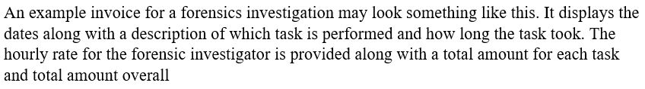

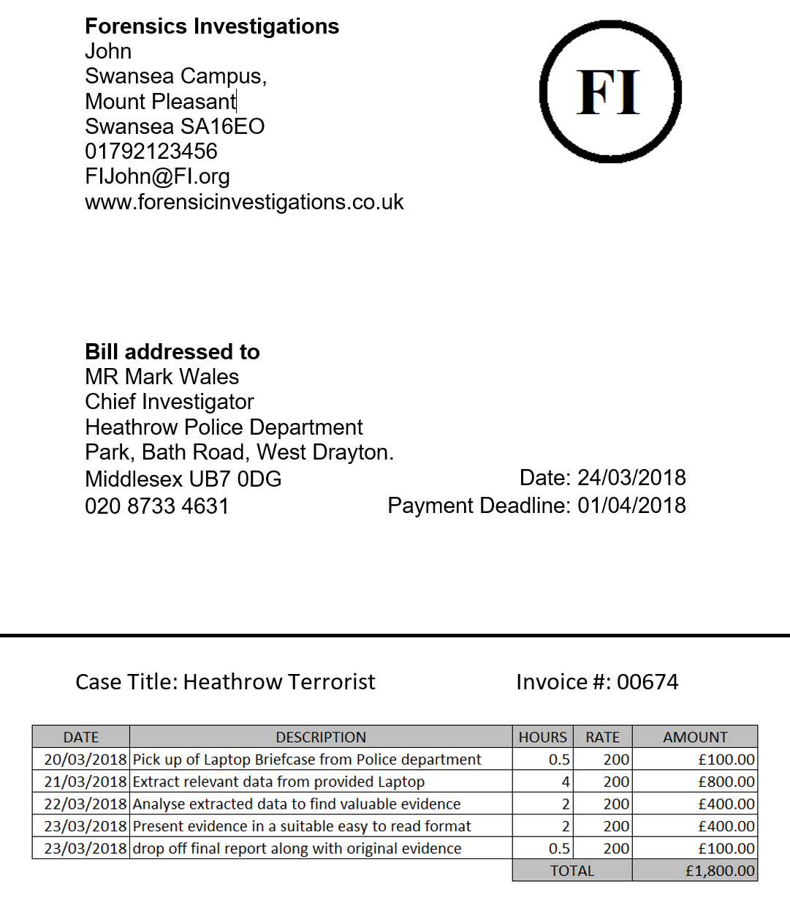

Conclusion
John discovered multiple files and documents proving the terrorist’s involvement with numerous terrorist’s groups.

The evidence includes multiple incriminating videos, bank transfers between the terrorist and confirmed contacts from his email and terrorism instruction documents. The briefcase also contained immigration visas as well as other documents that made clear his intentions and links with other terrorist organizations.

It is clear that the terrorist had intentions to spread terror among the public at the Mason International airport in Fiji, evidenced by his research into bombing tactics and bomb creation and information gained from other terrorists.

The videos and documents found on both the laptop and in the briefcase could lead to further suspects being caught, particularly the bank transfers and instructional documents which contain names matching contacts in the terrorist’s email and messaging contacts lists.

Due to the initial suspect being shot at the scene, and evidence suggesting multiple terrorists being involved in this terrorist group, it would be likely that the police would press on with the investigation requiring a full forensics investigation of all involved terrorists.

There are already multiple leads for the investigation in the form or emails, IPs, names, bank information that would aid this investigation should it be carried out. This would mean that a forensics investigator will have to attend court appearances should any suspects be put on trial.

References
[1] “COMPUTER FORENSICS: THE MODERN CRIME FIGHTING TOOL - ProQuest.” [Online]. Available: https://search-proquest-com.ezproxy.uwtsd.ac.uk/docview/232577591?accountid=130472&rfr_id=info%3Axri%2Fsid%3Aprimo. [Accessed: 27-Mar-2018].
[2] B. Carrier, “File System Forensic Analysis,” Chapters 1(p12-p18),3(p43-52),8(p129-p138), 2005.
[3] “Read: Digital Forensics with Open Source Tools.” [Online]. Available: https://www-dawsonera-com.ezproxy.uwtsd.ac.uk/readonline/9781597495875. [Accessed: 20-Mar-2018].
[4] “Commercial Computer Forensics Tools.” [Online]. Available: http://resources.infosecinstitute.com/category/computerforensics/introduction/commercial-computer-forensics-tools/. [Accessed: 20-Mar-2018].
[6] “X-Ways Forensics: Integrated Computer Forensics Software.” [Online]. Available: http://www.x-ways.net/forensics/. [Accessed: 27-Mar-2018].
[7] “Digital Forensic Investigations - EnCase Forensic.” [Online]. Available: https://www.guidancesoftware.com/solutions/digital-forensic-investigations?cmpid=nav_r. [Accessed: 27-Mar-2018].
[8] “Forensic Toolkit.” [Online]. Available: https://accessdata.com/products-services/forensic-toolkit-ftk. [Accessed: 23-Mar-2018].
[9] “Free OST File Viewer to View, Read &amp; Open OST File Without Outlook.” [Online]. Available: https://www.sysinfotools.com/recovery/ost-file-viewer.php. [Accessed: 23-Mar-2018].
[10] “Arsenal Recon - Computer Forensics Tools by Computer Forensics Experts.” [Online]. Available: https://arsenalrecon.com/weapons/recon/. [Accessed: 23-Mar-2018].
[11] “Belkasoft Evidence Center 2017.” [Online]. Available: https://belkasoft.com/ec. [Accessed: 27-Mar-2018].
[12] “Oxygen Forensics - Mobile forensics solutions: software and hardware.” [Online]. Available: https://www.oxygen-forensic.com/en/. [Accessed: 27-Mar-2018].
[13] “XRY - Extract – MSAB.” [Online]. Available: https://www.msab.com/products/xry/. [Accessed: 23-Mar-2018].
[14] “Magnet AXIOM Smartphone - Magnet Forensics Inc.” [Online]. Available: https://www.magnetforensics.com/axiom-smartphone/. [Accessed: 23-Mar-2018].
[15] “MacQuisition | Forensic Imaging, Live Data Acquisition, and Targeted File Collection for Mac and OS X Server Computers.” [Online]. Available: https://www.blackbagtech.com/software-products/macquisition.html. [Accessed: 23-Mar-2018].
[16] “SAFE Corporation - Software Analysis and Forensic Engineering - offers a suite of patented tools.” [Online]. Available: http://www.safe-corp.com/. [Accessed: 27-Mar-2018].
[17] K. Conlan, I. Baggili, and F. Breitinger, “Anti-forensics: Furthering digital forensic science through a new extended, granular taxonomy,” Digit. Investig., vol. 18, pp. S66–S75, Aug. 2016.
[18] “Wireshark · Go Deep.” [Online]. Available: https://www.wireshark.org/. [Accessed: 28-Mar-2018]

