Student Name: Nikoletta Dudas
Student Number: 1814105
Module Title: Managing People LCBB5004
Assignment Title: Essay
Lecturer’s Name: Rexon Nting

Contents
1, Introduction: 2
2, Atypical contract types: 2
0-hour Contract: 3
Part-Time Contract: 3
Fixed-term Contract: 4
Atkinson’s Flexible Firm: 4
3, Advantages and disadvantages of atypical contracts: 5
4, The importance of the employee engagement: 7
5, Conclusion: 8
References: 8

Atypical employment contracts

1, Introduction:
In recent years the atypical contracts attracted more attention because the demands of the changing world have led to the emergence of new forms of employment which, although qualifying as employment relationship differs in some essential respect from the classic picture of the employment relationship. For the quick and fluent service, the hospitality companies are preferring the atypical contracts, Pure is no exception.
The Pure is based in London and specialized for selling freshly made healthy, mostly vegan, and vegetarian foods and coffees. The business was found in 2009, Pure is a fast growing and profitable firm, the company currently has 22 shops and more than 326 employees in London. (HEALTHY RETAIL LIMITED - 2020)
The purpose of this essay is to present and analyse different atypical contracts. Also, provide an example for a few with a chosen company. My chosen organisation is the Healthy Retail Ltd, the shops are known as Pure.
The roadmap of the essay is the following: the second part of the study will demonstrate the spread and types of atypical contracts through the chosen company. In the third part, I will analyse the advantages and disadvantages of atypical contracts. The part four is a discussion about the importance of employee engagement. And the last part is the conclusion.

2, Atypical contract types:
“An employment contract is a relationship between an employer and an employee”. (Acas, 2020) If we are talking about an employment contract, then everyone thinking about the traditional full-time permanent contract. Nowadays this has changed, economic changes have brought a whole new trend into the world of employment contracts. The faster life requires faster service. In order for the companies to be able to comply with the new principles, they have redesigned their well-established systems. As a result, atypical contracts are more frequent. There is currently no accepted definition for these types of contracts. Some examples of atypical contracts: 0-hour contracts, part-time, short fixed term, and non-written contracts, working from home or even the self-employed status. (Good Work Plan, 2020)

0-hour Contract:
A 0-hour employment contract means that the employer, despite establishing a permanent employment relationship with the employee, is not obliged to provide the employee with a minimum working hour.

At the same time, the employee is not obliged to accept the job just offered. Employers, on the other hand, even though they do not guarantee an hour’s work.
The most common work areas for the use of 0-hour employment contracts are in education, healthcare, hospitality, and agriculture. In 2016, 2.4% of all contract employees had a 0-hour contract in the UK. (Koumenta, Williams,2019) It does not seem like a high number, but this percentage is rising from year to year. Employees with such a contract, 75% would like to become a full-time permanent worker. (Brinkley, 2018)
The Pure refused to employ their workers by 0 hours contract. (Thoughtful | Pure, 2020). The reasons for this are the lack of engagement of employees. As well as the company has big attention to the satisfaction of their employees.

Part-Time Contract:
A part-time contract is not very different from a traditional full-time contract. The difference is that a part-time contract employee works fewer hours. Such employees usually receive all training and coaching from the employer. (Fernández-Kranz, Paul and Rodríguez-Planas, 2014) They are flexible in terms of their working hours and, usually called to work during a busy period.
Pure works exclusively with part-time contractors for jobs that require less expertise. Examples are kitchen and shop positions. Although they make a difference in terms of the hourly pay between the barista and the cashier, but they both work part-time. In the case of a retailer, we can negotiate two different part-time contracts. One is 30 hours per week and the other is 15 hours per week. Both contract types based on an hourly wage. The 30-hour employees will open and close the shops, while the 15-hour employees will be distributed during busy periods to help provide faster service. This is a very clear example of workforce planning.

Fixed-term Contract:
A fixed-term contract is for a pre-determined time interval. Upon termination, the employment will be terminated unless further agreement or extension is made.” A fixed-term employee has the right not to be treated less favourably than a comparable permanent employee.” (Acas, 2020) This type of contract is usually used for a season work, or if the employee is employed for the purpose of completing a specific project and, covering maternity leave. If an employee has had such a contract for at least 4 years, he or she will automatically receive the permanent employment contract.
In the hospitality industry, stores are facing increased demand from time to time. In the case of Pure, for example, the Christmas period, when a lot of orders arrive for various corporate events. During this 6-weeks period, the company employs staff with a fixed-term contract to meet demand.
We got to know some atypical employment formats. What they have in common is the requirement of flexible working. For companies, flexible working is synonymous with reducing costs, maintaining competitiveness, or acquiring them. And last but not least, they can improve the quality of their service. And it provides working people with a significantly better work-life balance.
As early as the mid-1980s, Atkinson (1984) developed the theory of a flexible company, in which only central, key employees were bound indefinitely.
With a full-time contract to the employer, while others were only linked to the central firm with part-time or fixed-term contracts or various versions of commercial contracts, such as temporary employment, self-employment, or subcontracting.

Atkinson’s Flexible Firm:
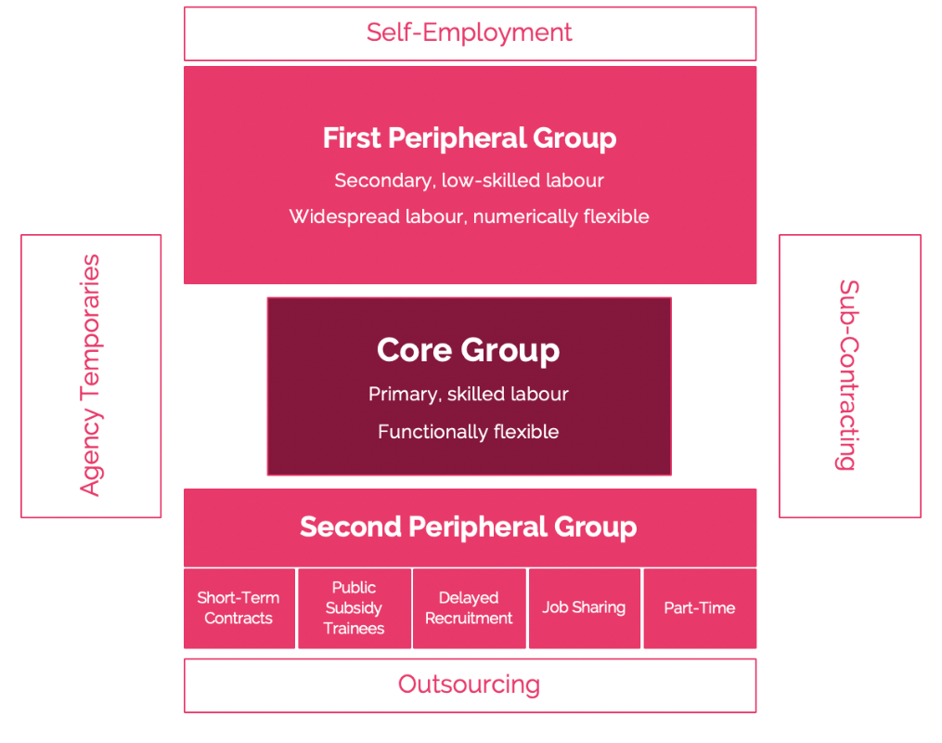
Source: (Atkinson's Flexible–Firm Model – BusinessBalls.com, 2020)

This theory also applies exactly to Pure. The Core Group is the skilled employees, permanent workers such as shop managers and head office workers.
The first peripheral group is employees with a 30-hour permanent contract on an hourly wage. This group takes middle management positions, such as a supervisor. Their work is flexible, and they have easy-to-learn skills only.
Next is the second peripheral group, composed of 15-hour permanent contracted and fixed-term contracted staff. They have no special abilities, relatively easy to replace them.

3, Advantages and disadvantages of atypical contracts:
Atypical contracts have been created to meet the changing needs of the market. Atypical and flexible employment has benefits and disadvantages for both employees and employers. Nevertheless, employers are the clear winners of the spreading of these types of contracts. The reasons are as follows:
- They allow employers to react quickly and effectively to market conditions
- Only have to pay for the actually worked hours
- Can also be used for intermittent or long-term tasks
- Great efficiency in workforce planning (Taylor, 2017)
- Flexible, cost-effective solution

It also hides disadvantages for the employers:
-Not easy to recruit for
- High fluctuation
- Lock of loyalty to employees

Advantages of employees:
- It is more easily reconciled with family responsibilities and learning
- Greater flexibility in work schedules
- Easier to enter to the labour market
- Better work-life balance
- Better finance planning

Disadvantages for employees:

- Unpredictable work schedule
- More difficult to get a better position
- Difficult to know the employment rights (CIPD, 2019)
- It is necessary to account for the insufficient number of working hours

From an employee perspective, the realization of advantages and disadvantages are quite subjective. For example, in a student's case can be categorized as an advantage in flexible shifts for part-time employment. After all, they get the opportunity to earn income, build relationships and gain work experience. The same is true for first-time employees. This results in they more engaged with the employer.
In contrast to those workers who simply could not find another way to work. For them, this form of employment does not mean financial security, nor do flexible shifts help to create a better work-life balance.
They also have an effect on the employer, so in their case, it is necessary to examine exactly what qualifies as an advantage or disadvantage in their case with a contract of this nature.
For example, in the case of Pure, the lack of loyalty to employees is not an appropriate statement in the above list. The company’s donkey is one of the biggest demands of its employees is its willingness to work flexibly. Therefore, most of their workers, students and employees who want to work specifically in part-time or temporarily. Since they get the jobs from the company for exactly what they need, they will be loyal with great probability.
These observations may vary for pros and cons at different skill levels, in different industries, or even by company.

Companies have a number of options to offset the disadvantages. An example is reward management. Pure offers its employees the opportunity to earn extra income every week. It is very important for the company that its customers get perfect service and then return on a daily basis. This is checked every week by a so-called mystery shopper. If this shopper is at least 90% positive about the service than the shop all employees will receive an extra £ 1 for each hour worked that week. Even if the employee was not working on the inspection day or were not in the service area. With this reward method, the company simultaneously motivated its employees and builds on the importance of team spirit. It also achieves a much higher level of service and, a very good example of emotional engagement, build by the company.

4, The importance of the employee engagement:
Nowadays, the judgment of atypical employment contracts is quite mixed. Yet, as is clear from the above, this type of employment has several advantages. A key element of non-typical employment is the ability of companies to integrate these employees into their own system. First of all, they have to make sure that these employees get the same treatment as their permanent contracted colleagues. The theory of employee engagement, it plays a significant role in the acceptance of these types of work. According to Saks (2006), individuals repay the resources they receive from the organization with different levels of commitment.
This can also have an impact on business results. More and more research support that employee engagement is directly or indirectly related to corporate success and business performance important factors such as higher productivity and sales, faster business growth, lower recruitment costs.

We can see that the importance of employee engagement is not just commonplace, it can really benefit companies, either in terms of business performance or the labour market situation. However, we must not forget that commitment is one "Two-way connection". For employees to be truly engaged, the employer also needs to do something.
Employee engagement is a complex phenomenon, the increase of which cannot be based exclusively on the satisfaction of the basic needs of employees. According to CIPD (CIPD,2019,), commitment is not about driving people to work harder, but about providing conditions in which they work more efficiently. (Armstrong, Taylor, 2014)
Employees usually become really committed when it comes to the company they feel like a valuable and useful member, they see how they contribute to corporate success and the achievement of goals. In addition, if they pay attention to their opinions, they can have a say in the organization they also feel that the company is really interested in them, cares about them, recognizes their outstanding performance and career advancement provides their future with a greater chance of engagement.
In view of the above, if jobs can change their HRM methods, atypical contracts may be much more acceptable and popular.

5, Conclusion:
A distinction needs to be made in terms of flexibility of some sort unpredictable economic, market coercion - generating coercive atypical employment - or autonomous, independent atypical employment that consciously formulates new responses as a result of the changing, evolving economic environment. Atypical forms of employment should offer a choice in both cases. As human resources and the associated labour costs are one of the most important factors in the operation of companies, management must in most cases initiate change. (Schoukens,2017)
In the global economy, competition from companies is intensifying demands flexibility, which they must also adapt to in employment. As the labour costs account for a significant share of firms ’expenditures, and if not performance, the employment of workers cannot be financed. An employer will go bankrupt if it cannot keep up with the competition. In this case, jobs will be lost. From an employer perspective, therefore, what seems uncertain today is more certain in the long run.

References:

Acas.org.uk. 2020. What an Employment Contract Is | Acas. [online] Available at: <https://www.acas.org.uk/what-an-employment-contract-is> [Accessed 11 May 2020].
Archive.acas.org.uk. 2020. Fixed Term Work | Acas Advice and Guidance | Acas. [online] Available at: <https://archive.acas.org.uk/index.aspx?articleid=4587> [Accessed 12 May 2020].
Armstrong, M., - Taylor, S. (2014): Armstrong's Handbook of Human Resource Management Practice, Kogan Page, London, GB.
Atkinson, J. (1984) Manpower Strategies for Flexible Organisations. Personnel Management, 16, 28-31.
Beta.companieshouse.gov.uk. 2020. HEALTHY RETAIL LIMITED - Filing History (Free Information from Companies House). [online] Available at: <https://beta.companieshouse.gov.uk/company/06878814/filing-history> [Accessed 31 March 2020].
Brinkley, I., 2018. In defence of zero hours contracts. CIPD, [online] (CIPD Voice: Issue 14). Available at: <https://www.cipd.co.uk/news-views/cipd-voice/issue-14/defence-zero-hours-contracts> [Accessed 11 May 2020].
Businessballs.com. 2020. Atkinson's Flexible–Firm Model – Businessballs.Com. [online] Available at: <https://www.businessballs.com/organisational-culture/flexible-firm-model/> [Accessed 12 May 2020].
CIPD, 2019. ATYPICAL WORKING A guide to successfully implementing atypical work in your organisation. [online] p.3. Available at: <https://www.cipd.co.uk/Images/7904-atypical-working-guide-web_tcm18-61555.pdf> [Accessed 13 May 2020].
Fernández-Kranz, D., Paul, M. and Rodríguez-Planas, N., 2014. Part-Time Work, Fixed-Term Contracts, and the Returns to Experience. Oxford Bulletin of Economics and Statistics, 77(4), pp.512-541.

GOV.UK. 2020. Good Work Plan. [online] Available at: <https://www.gov.uk/government/publications/good-work-plan/good-work-plan> [Accessed 11 May 2020].
Koumenta, M. and Williams, M. (2019) ‘An anatomy of zero‐hour contracts in the UK’, Industrial Relations Journal, 50(1), pp. 20–40.
Pure. 2020. Thoughtful | Pure. [online] Available at: <https://www.pure.co.uk/thoughtful/> [Accessed 31 March 2020].
Saks, A., 2006. Antecedents and consequences of employee engagement. Journal of Managerial Psychology, 21(7), pp.600-619.
Saks, Alan. (2006). Antecedents and Consequences of Employee Engagement. Journal of Managerial Psychology. 21. 600–619. 10.1108/02683940610690169.
Schoukens, P., & Barrio, A. (2017). The changing concept of work: When does typical work become atypical? European Labour Law Journal, 8(4), 306–332.
Taylor, D., 2017. Acas Strategy Unit. ACAS, [online] p.5. Available at: <https://archive.acas.org.uk/media/4878/Aint-that-typical-Everyday-challenges-for-an-atypical-workforce/pdf/Everyday-challenges-for-an-atypical-workforce.pdf> [Accessed 13 May 2020].

