STUDENT NAME:CATALIN SORIN TANASE
the global business environment ASSESSMENT 1
STUDENT NUMBER:1714717
MODULE TITLE:LCBB4005 THE GLOBAL BUSSINESS ENVIRONMENT
ASSIGNMENT TITLE: ENVIRONMENTAL ANALYSIS OF AN INDUSTRY
LECTURER:REXON NTING

Contents
INTRODUCTION 2
TASK - A 3
CAR MANUFACTURING INDUSTRY IN UK 3
MAJOR FORCES THAT AFFECTS AUTOMOBILE INDUSTRY, UK 4
TASK - B 6
SWOT ANALYSIS OF MERCEDES-BENZ 6
PESTLE ANALYSIS OF MERCEDES-BENZ 7
PORTER’S 5 FORCES ANALYSIS OF MERCEDES-BENZ 9
CONCLUSION 12
REFERENCES 13

INTRODUCTION
Business environment means the collection internal and external factors that directly affect the operations and profits of the organisation. Internal factors are those which are in the control of the organisation such as employees, customers need and expectations, management of the company, clients, agents etc. external factors are those which are not in the control of the organisation such as political, economic, social, technological, legal, and environmental (Wetherly, 2014). Despite the current global economic turmoil and unique economic challenges currently faced by Europe, the UK business environment remains positive, forward-looking, and open for business. The UK government is committed to creating the supportive business environment that will encourage a private-sector-led economic recovery. The report discusses the eternal forces that affect the car manufacturing companies in the context of Mercedes (Camillus, 2016).
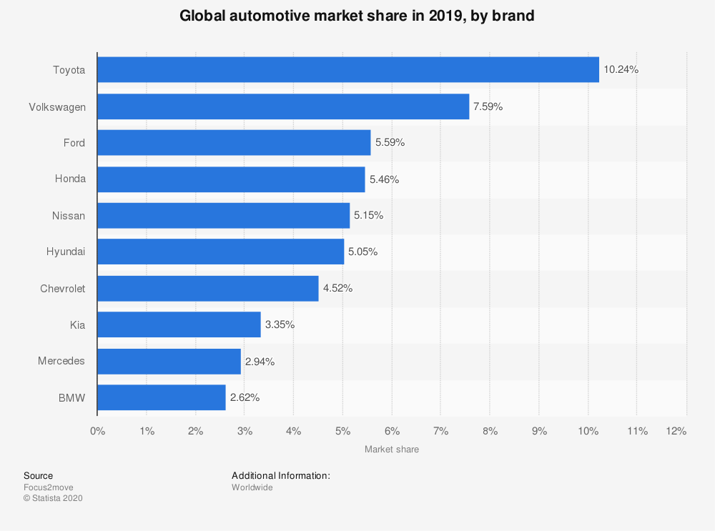
Figure 1: Global automobile market share
Source: (Martin et al., 2015)

TASK - A

CAR MANUFACTURING INDUSTRY IN UK
The automobile industry is a place where the making of parts of vehicles takes place and there buying and selling is done. UK is known for the largest exporter of cars and automobile brands in all over the world. As compare to the previous year production of passenger cars declined to 1.3 million units in the year 2019. In UK the leading manufacturers were Range Rover, Jaguar followed by Nissan. As per the survey reports Ford Fiesta was the second bestselling car with 77,880 units in March, 2020. Automobile industry in UK suffered a lot due to the Coronavirus pandemic worldwide. The latest survey shows that the sale of passenger cars fell down by 1 million units from 1.35 units in 2016 (Rawlinson and Wells, 2016).
One of the largest sellers of premium cars is Mercedes with the selling of 2.31 million passenger cars till date. The company has maintained the reputation of its quality and durability by continuously delivering quality products to their customers and enhance their customer satisfaction level. The company have widest range of products like Mercedes–Benz S-Class, Mercedes-Benz Citan, and Mercedes-Benz T-Class etc. The sales and marketing of all automobile products and services in UK is managed by the Mercedes Benz UK. That also includes trucks, vans, cars, parts etc. the opening year of Mercedes Benz are 2006 and it has welcomed near about 1.5 million customers till date. More than 500 trainees have passed their professional qualification during on the job training period in Mercedes Benz organisation (Bharadwaj, 2018; Daimler, 2019).

MAJOR FORCES THAT AFFECTS AUTOMOBILE INDUSTRY, UK
One of the fastest growing industries is automobile industry in current market situation. The automobile industry has huge range of products like manufacturing of trucks, vans, buses, passenger cars etc. for the manufacturing of these products the process includes welding, moulding, assembling of products etc. Other than this there are many other forces that have affected the automobile industry that are discussed below
- Falling demand: before the pandemic has arrived, the car demands have been tremendously falling as there are many people who are not able as well as interested in buying cars. For health purpose also people prefer cycles rather than cars as this will keep their body healthy. As petrol prices are rising day by day this is also one of the reasons for lack in the demand of cars (Ibis, 2019; Thomas, 2019; Wormald, 2020).
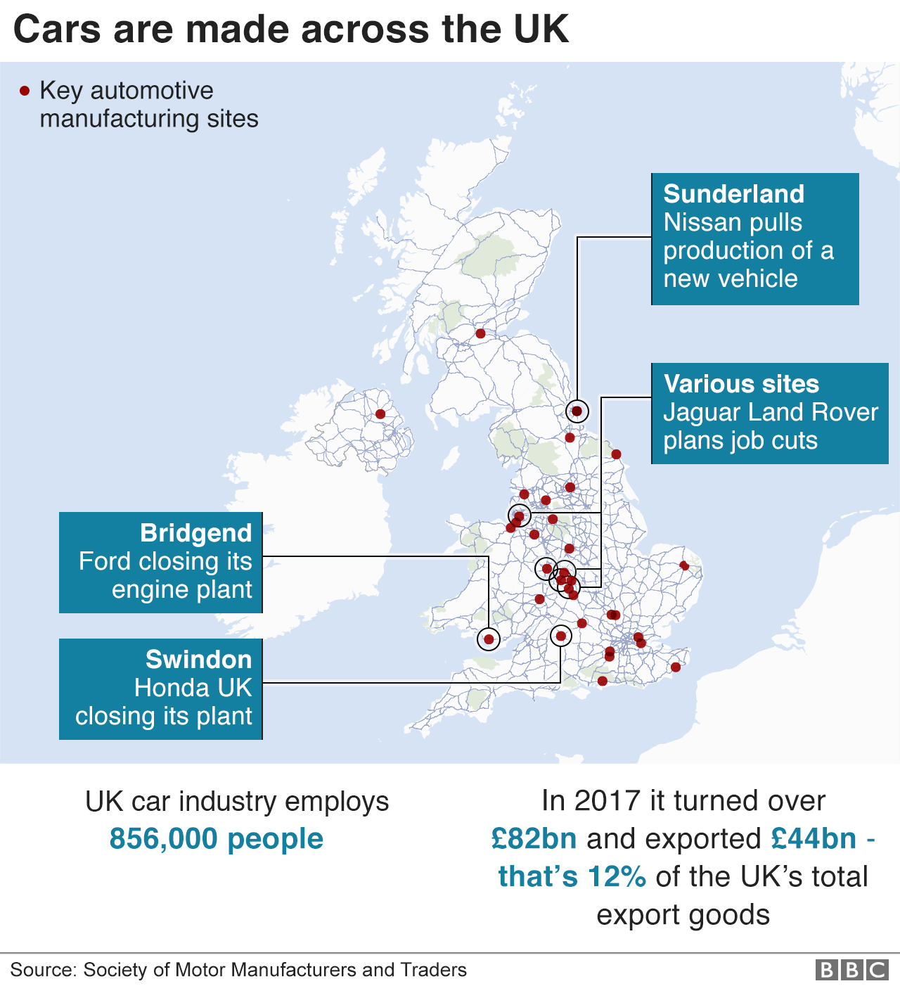
Figure 2: UK market of automobile industry
Source: (Thomas, 2019)
- Emissions woes: In Europe, emissions issues are main cause for the automobile industry. Air quality concerns and taxation changes have led to a big drop-off in diesel sales, contributing to a 7% fall in new car registrations in the UK in 2018. More challenging, perhaps, is the introduction of tough new CO2 emission standards, designed to tackle global warming, that make it much more expensive to build cars. From 2021, manufacturers will face big fines in the EU if their fleets break agreed emissions limits, and these targets will get progressively tougher.
- The electric challenge: to decrease the emission level in the environment automobile companies are working on the electric vehicles rather than fuel vehicles but there is a huge obstacle for this motive that lots of car makers are having problems in producing electric cars as this would change their total process and operations of working.
- Shifting from ownership: If cars without drivers go main stream for next 15 years, then the public would prefer to rent their cars and earn some money that means this could become new innovating business in future.
- Brexit: In the UK, automobile industry has been continuously warned for the loss that they are going to suffer due to Brexit. Since the EU referendum in 2016. And investment in the UK car industry has fallen in the last two years, slumping 46.5% in 2017 alone. The problem, analysts say, is that British car plants rely heavily on components imported from the EU, while most of the finished cars they produce are exported to the European mainland (Ibis, 2019; Thomas, 2019; Wormald, 2020).

TASK - B

SWOT ANALYSIS OF MERCEDES-BENZ
STRENGTHS | WEAKNESS
- A well-established brand with various product ranges like Mercedes–Benz S-Class, Mercedes-Benz Citan, and Mercedes-Benz T-Class etc.  - Focuses on events that attract the quality crowd like New York fashion week.  - Won first constructors’ championship as a top team in F1 in 2014.  - Generate the manufacturing facility worldwide amongst 6 continents and 26 countries that include passengers as well as buses production that lowers the operational cost.  - The company focuses on the continuous innovation in its product as per the market trends. | - The servicing and maintenance cost of Mercedes is high as compare to its purchasing price.  - The conflicting opinions of the parent company Daimler may cause harm to individual brands.  - Although Mercedes could expand strongly, because it is found to have a stunted growth as it keeps distribution of its vehicle very much exclusive, that affects its supply chain and therefore its brand equity.
OPPORTUNITIES | THREAT
- Due to rise in the disposable incomes the company is planning to shift their growth to Asian markets such as China, India, and other Asian nations.  - There is increase in the demand of premium vehicles.  - This can prove smart strategy for Automobile companies. By applying special capabilities and merging with other organisations.  - Advancement in technology can help Mercedes to become a market leader like innovation of Hybrid cars. | - Strong competitors like AUDI, BMW, and Volvo etc.  - Determining factor for the growth of Mercedes is fluctuation in the fuel prices and use of alternative fuels like CNG etc.  - Unemployment, recession, uncertainties in market is the major reason that affects the automobile industry for long period of time.  - Implementation of government policies like reduction in road permits, fuel prices, global warming, reduced use of personnel vehicle, restriction on the entry of outside vehicle are some reasons that affects the industry at large.
Table 1: SWOT analysis of Mercedes Benz
Source: (Daimler, 2019; Kowalska-Pyzalska, 2020)

PESTLE ANALYSIS OF MERCEDES-BENZ
POLITICAL | Post-Brexit the automobile industry of UK had a secured deal that includes zero per cent import tariff. It also reduces the frictions at the UK and EU border that allows easy movement of suppliers, staff, and other products between the two without any restrictions.
ECONOMIC | - Automobile industry is one of the major pillars for UK economy as it contributes £20.2 billion annually, employs over 1,68,000 people and shares 12.8% of all UK export in goods.  - Near about 200000 people are employed in new car retails and over 45000 are employed in UK based car finance firms.
SOCIAL | - The test drive by the company spoils the thought of an individual and forces them to purchase such premium products even if the consumer cannot afford that product.  - The social preferences of customers are changing now a days as due to health reasons many of the customers prefer pollution free manufacturers and vehicles like hybrid cars, electric cars, solar cars etc.
TECHNICAL | - In recent years there has been a significant development in the development and production of the hybrid and electric vehicles that presents a new opportunity to the industry  - Automation can help reduce the complexity and issues of the manufacturing process  - The AEB systems in the cars are installed that generate signals to the driver prior any accidents or collusions. If no actions are taken by driver than AEB will automatically stop the vehicle such technologies are acting as a competitive advantage for the businesses developing them.
LEGAL | - Post Brexit there is a potential for changes in the immigrant laws and the employment laws of UK. This may lead to restriction on part of the employer in employing the EU nationals.  - Government is making people use the Hybrid cars to reduce the consumption of fuels for reducing pollution and prefer other modes like CNG gases etc.  - Post Brexit change in the trade and import/export laws may affect the industry negatively.
ENVIRONMENTAL | - There is an inclination towards electric and hybrid cars that require substantial R&D expenditure that may in turn affect the profitability of the industry.  - Need for applying various engine emission control methods to controls pollution requires research related substantial investment that may adversely affect the profits of the industry.
Table 2: PESTLE analysis of Mercedes-Benz
Source: (Gödecke et al., 2019; Daimler, 2019; BW, 2019; Ibis, 2019; Dorr et al., 2020)

PORTER’S 5 FORCES ANALYSIS OF MERCEDES-BENZ
- Competitive Rivalry: The automobile industry is highly competitive. Some of the major competitions of Mercedes are AUDI, BMW, and Lexus etc. the products of different manufacturers differ in size, design, functions and luxurious. Mercedes Benz was the second highest seller in 2015 as it sold more than 1.8 million units. The strong position of the company makes the threat of competitive rivalry to be moderate for the company (Alavi et al., 2020).
- Threat of new entrants: The automobile industry is an oligopoly type of market that restricts the entry of new player in the market because the industry requires a lot of investment and product quality. Many of the new commerce have tried to enter in the market but could not sustain because of the already established brands that have enjoyed their brand value over the time. Hence the threat of new entrants can be considered to be low.
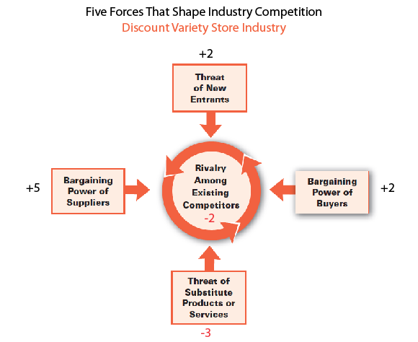
Figure 3: Porter’s 5 Forces model
Source: (Isabelle et al., 2020)
- Bargaining power of suppliers: a car is manufactured by assembling different parts/sub-parts and these are collected from various suppliers. The suppliers of Mercedes include wood designer, interior product manufacturer, etc. However, the availability of many suppliers reduces the threat of suppliers to a low level. (Paolo, 2013; Daimler, 2019; BW, 2019; Alavi et al., 2020).
- Bargaining power of buyers: There are many manufacturers of luxury vehicles and every one offers different products so the customers have variety of options to choose from. As the vehicle from different brand provides different exposure, facilities etc. Hence, the bargaining power of the buyers can be considered to be high for the company.
- Threat of substitutes: Most of the manufacturers have their inherent specialities in the produced vehicle however, most of the features are similar. The buyers can easily seek an alternate from the competitor while making a purchase decision hence the threat of the substitutes can be considered to be high (Rawlinson and Wells, 2016; Daimler, 2019; BW, 2019; Alavi et al., 2020).

PRODUCTS LIFE CYCLE ANALYSIS
Each and every product has its decline at some point of time after the product is manufactured.in auto mobile industry name of all the vehicles that are going to retire in the end of the year or will not be manufactured by the company for sale are released. This shows that vehicles do have certain life period after that their demand also declines and also to make space for new innovations and manufacturing’s in the market. The product life cycle includes four stages that make huge impacts on the business. Below discussed are the four major stages of a product (He et al., 2020).
- Introduction stage: The stage when the product is established and introduced to the public. In this stage the product distinguish itself from other market competitors. Make efforts like sales promotion, advertising. Market campaigns etc.
- Growth stage: In this stage the profit grows with the public visibility. The manufacturers or producers keep making those efforts that they were making in first stage and abandon those schemes that failed to impress or attract customers.
- Maturity stage: The product reaches its maturity when product has achieved market saturation and has an intense competition with competitors. This stage is longest of all the four stages as this stage includes concept of marketing mix. The producer launches new products to attract the new target customer and broadens distribution channel etc.
- Decline stage: In this stage the profit of the organisation declines and states that keeping the production of the particular product open is no longer justified.
When the whole product life circle is finished it does not mean that the organisation is out of the market. In automobile industry the product life cycle takes a detour that is worth in investing in it and that does not even affect the small business organisations (Kishita et al., 2016).

CONCLUSION
Recent economic crises have increased the deep structural changes in the automobile industry due to the pandemic sale of vehicles has been increased as people prefer personal vehicle rather than public transports. The automobile industry has a great potential to grow in the emerging market like china and India. The rising prices of crude oil continuously increase the prices of fuel that directly affects the automobile industry. The increased import cost of different countries that declines the domestic capacity of different manufacturing centres of different organisations. The report analysed all the above points and also the global business environment in the context of Mercedes-Benz.

REFERENCES
Alavi, A., Shokri, M., Zhiani, B. and Zhiani, S., 2020. Analysing competitive advantage of Iranian automotive industry using Porter's diamond model, case study: Iranian car manufacturers. International Journal of Business and Systems Research, 14(3), pp.298-313.
Bharadwaj, A., 2018. Evolution of the Global Automobile Industry. In Environmental Regulations and Innovation in Advanced Automobile Technologies (pp. 1-9). Springer, Singapore.
BW, 2019. The Future of the UK Automobile Market, 2019 - Trends, Outlook and Growth Opportunities. [online] Business Wire. Available at: < https://www.businesswire.com/news/home/20190208005394/en/The-Future-of-the-UK-Automobile-Market-2019---Trends-Outlook-and-Growth-Opportunities---ResearchAndMarkets.com> [Accessed 23 November 2020].
Camillus, J.C., 2016. The wicked challenge of the business environment. International Journal of Business Environment, 8(1), pp.19-31.
Daimler, 2019. Annual Report and Full Year Results 2019 | Daimler. [online] Daimler. Available at: <https://www.daimler.com/investors/reports-news/annual-reports/2019> [Accessed 23 November 2020].
Dörr, C., Lessi, S., Adolph, M., Marx, V. and Veik, F., 2020. The drivetrain for the new Mercedes-Benz compact cars. In CTI SYMPOSIUM 2018 (pp. 87-96). Springer Vieweg, Berlin, Heidelberg.
Gödecke, T., Schildhauer, C., Weinert, F. and Frick, A., 2019. The Plug-in Hybrid Powertrain for Compact Cars from Mercedes-Benz. MTZ worldwide, 80(11), pp.32-39.
He, B., Luo, T. and Huang, S., 2019. Product sustainability assessment for product life cycle. Journal of cleaner production, 206, pp.238-250.
IBIS, 2019. Motor Vehicle Manufacturing in the UK. [online] Ibisworld. Available at: < https://www.ibisworld.com/united-kingdom/market-research-reports/motor-vehicle-manufacturing-industry/> [Accessed 23 November 2020].
Isabelle, D., Horak, K., McKinnon, S. and Palumbo, C., 2020. Is Porter's Five Forces Framework Still Relevant? A study of the capital/labour intensity continuum via mining and IT industries. Technology Innovation Management Review, 10(6).
Kishita, Y., Ohishi, Y., Uwasu, M., Kuroda, M., Takeda, H. and Hara, K., 2016. Evaluating the life cycle CO2 emissions and costs of thermoelectric generators for passenger automobiles: a scenario analysis. Journal of Cleaner Production, 126, pp.607-619.
Kowalska-Pyzalska, A., Kott, J. and Kott, M., 2020. Why Polish market of alternative fuel vehicles (AFVs) is the smallest in Europe? SWOT analysis of opportunities and threats. Renewable and Sustainable Energy Reviews, 133, p.110076.
Martin, N.P., Bishop, J.D., Choudhary, R. and Boies, A.M., 2015. Can UK passenger vehicles be designed to meet 2020 emissions targets? A novel methodology to forecast fuel consumption with uncertainty analysis. Applied energy, 157, pp.929-939.
Rawlinson, M. and Wells, P., 2016. The new European automobile industry. Springer.
Thomas, D. 2019. Five reasons the car industry is struggling. [online] BBC. Available at: < https://www.bbc.com/news/business-48545733> [Accessed 23 November 2020].
Wetherly, P., 2014. The business environment: themes and issues in a globalizing world. Oxford University Press.
Wormald, J., 2020. The UK Automobile: Post-Brexit. Centre for Brexit Studies.

