
MARKETING MANAGEMENT-ASSESSMENT 1
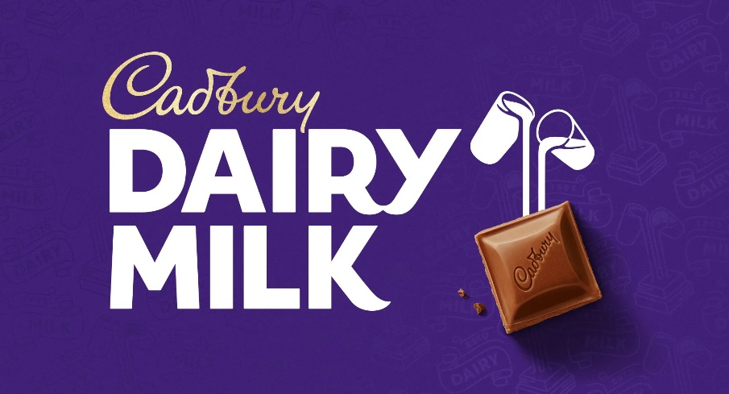
STUDENT NAME – KHUSHI JITESHBHAI DHOLA
STUDENT ID – 2240745
PROGRMME – MBA – Master Of Business Administration
MODULE - Marketing management
MODULE CODE - LCMB7001
LECTURER NAME – Tushara Balendran
SUBMISSION DATE – 30 AUG 2023
Executive summary
The paper delivers a brief explanation of the Cadbury comprehensive approach to customer engagement by mapping its journey and describing its touchpoints through different frameworks and models. The role of Integrated Marketing Communication and the relationship of the Shannon and Weaver Macro model with the company has been briefly illustrated in this paper. It is evaluated that the company uses social media platforms and advertisements as its promotional strategies for attracting consumers to the brand. However, some new promotional strategies have been recommended that can increase the awareness of the brand in its operating market effectively. Moreover, the role of the Total Engagement Model with the Cadbury Company has also been illustrated with the help of emotional connection that endures advocacy and loyalty of the people towards the firm.

Table of Contents
Introduction 3
Brief background of the company 4
Communication 4
Explanation of a communication model 4
Integrated Marketing Communications 6
Current promotions used by the Cadbury 6
New promotional strategies the firm should use to raise brand awareness 7
Branding and brand equity 8
Relationship with Keller’s Brand Equity Model with Cadbury 9
Discussion of customer journey and customer touchpoints of the company 10
Relationship of the Total Engagement Model with Cadbury 14
Conclusion 16
References 17

Introduction
In the current trend, customers play an important role in a brand in different aspects. The perception, behaviours and introduction of the consumer can significantly impact the success growth and reputation of a brand. Best on this fact, most organisations have to maximize their consumer satisfaction rate by emphasizing different touch points that can enhance their interest in the particular business. The companies create innovative marketing strategies and use different integrated communication channels to attract consumers to the brand. The primary objective of the paper is to discuss the role of communication, Integrated Marketing Communication, branding and brand equity of the Cadbury Company which is selected for this assignment. The paper will also discuss the new promotional strategies, customer journey map and the communication model used by the firm for attracting the consumer towards the brand. Moreover, the paper will also discuss the relationship between the brand with the killer brand equity model and the total engagement model respectively.

Brief background of the company
Cadbury is one of the leading British multinational confectionery organisations which has been owned by Mondalez International (Kraft Foods) since 2010. The company was established in 1824 and from that time it become a part of British society and culture. The founder of the firm is John Cadbury who opened his first store in Birmingham City Centre selling coffee, tea, cocoa and drinking chocolate (Bailey and Alexander, 2019). Currently, the headquarters of the firm is located in Uxbridge Business Park, Greater London, England. The CEO and chairman of the company is Dirk Van de Put and currently sells gums, candies and chocolates to different age groups of people across the world. The company is present across 60 countries of the Nations where they employ more than 46000 workers in this country's markets. Preferably the company is well known for its Creme Egg, Dairy Milk chocolate and Roses selection box. Besides, the mission statement of the company is to maintain the quality of the offered items by building the reputation of the firm and sustaining the commitment to continuous improvement of the products.

Communication
Communication is preferably viewed as a transmission of information from one person to another through sharing a meaning. For this chosen company, advertising is considered a means of communication channel between the users and the business of a product or a service. The advertisement refers to the messages paid by companies for influencing people to purchase their goods or services from the market. According to the cognitive dissonance theory, communication enables individuals to maintain consistency between their actions and beliefs (Dores Cruz et al. 2021). Besides, in marketing, it is important to address the potential post-purchase dissonance by reinforcing the positive aspects of the goods or services towards the buyers.

Explanation of a communication model
The communication model that should be used by Cadbury for maintaining an effective communication system in business operations is Shannon and Weaver's macro model. The model was developed in 1949 and represents that communication is a linear process that involves a sender, a channel a message, a potential source of interference or noise and a receiver (Krishen et al. 2021). The model emphasizes the one-way flow of data or information from sending to the receiver. The Cadbury company should use this model for shipping communication strategies and ensure that effective introduction is maintained with their target audiences. The model can be used by the firm in the following ways:
Message encoding and clarity
Cadbury can use this model to ensure that the messages sent to the consumers are imported accurately and clearly. Well-structured and clear messaging can help the company prevent misunderstanding and ensure that the appropriate meaning is easily transferred to its target audience.
Selection of channel
The model helps the company to select appropriate communication channels such as television ads, social media, in-store displays and packaging design so that it can easily attract its target consumers (Schaefer et al. 2021).
Noise reduction
The model helps Cadbury to easily identify the potential sources of interference that could disturb their communication medium. To understand the very potential barriers to communication such as conflicting messages or cultural differences the organisation can take steps to minimise this noise and improve its clarity of communication.
Incorporation of feedback
The chosen model can effectively help the company to incorporate feedback from its consumer's true reviews, social media introductions and surveys. This feedback helped the firm communication strategy best on the responses of their customers
Consistency in brand interaction
The model helps the company to use this principle to ensure that the brand message is aligned across different touchpoints and channels (Wahab et al. 2021). This consistency improves the brand image and enables the consumer to develop a complete understanding of the company's offerings and values respectively.

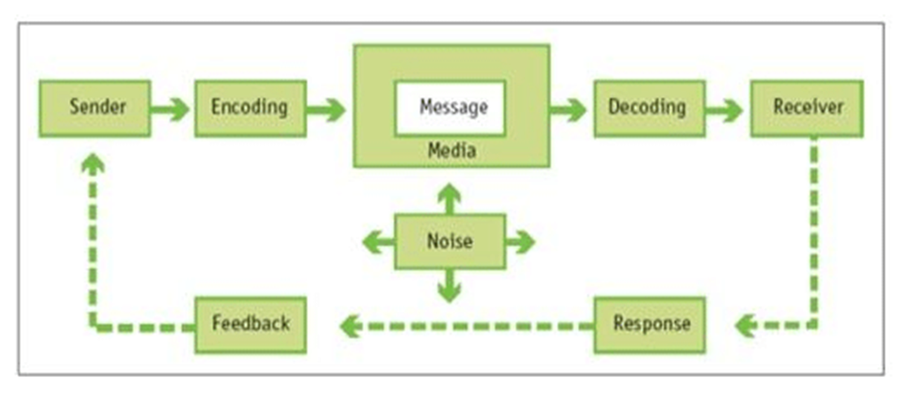
Figure 1: Shannon and Weaver Macro Model of Communication
(Source: Wahab et al. 2021)

Integrated Marketing Communications
Integrated Marketing Communication refers to the form of communication along with messages that are carefully linked with each other. It demonstrates that all promotional tools should work together in harmony and help the company to achieve its marketing goals effectively. IMC also involves the coordination of different promotional elements to deliver a consistent and unified message to the target audience (Waisbord, 2020). According to the Hierarchy of Effects model, the IMC channel ensures that the company should strategically guide the consumer regarding their offered items by making integrated promotions in its operating market.

Current promotions used by the Cadbury
The promotional strategy of Cadbury is focused on generating a strong emotional connection with its customers. The current promotional strategies used by the companies are provided below:
Usage of the story-based advertising campaign
The advertising campaigns offered by the company preferably feature heartwarming stories that celebrate love, togetherness and joy (Kushwaha et al. 2020). Besides they use different marketing slogans for their very product range. However, the primary aim of arranging this marketing campaign is to gain more consumers towards the brand by showing them how chocolates can bring joy and happiness in their life
Engagement through the digital platform
The company also engages with its customers through social media such as Twitter, Facebook, Instagram and YouTube which encourage them to share their experience and stories after purchasing a product from their brand. With the help of this platform, the company share their new product promotion and launches and even draws competition to create a sense of community around the firm and keep the consumer engaged.
Promoting through brand ambassadors to attract consumers
Another current promotional strategy used by the farm is that they involve various actors or artists as their brand ambassadors for different types of products so that each of the items can create a good impression in the mind of its target audience (Rėklaitis and Pilelienė, 2019). When people notice the famous personality of each of the food items offered by the brand then they automatically get interested in purchasing the item from the market.

New promotional strategies the firm should use to raise brand awareness
Apart from the above-mentioned promotional strategies, Cadbury can also use new promotional and marketing strategies to raise the awareness of the brand in the UK country market. The new strategies that should be helpful for the company are provided below:
Interactive virtual events
One of the promotional strategies is that the company should arrange virtual events that allow the customers to engage with the company in an interactive and immersive manner. In this virtual event, the forms should provide a virtual tour of their life in chocolate-making workshops, chocolate-making procedures or introductive testing that can easily increase the people's interest in teaching the different confectionery items provided by Cadbury (Krizanova et al. 2019).
Sustainability initiatives
The marketing strategy that should be used by Cadbury is that they should learn sustainability campaigns that showcase the company's effort in reducing environmental impact. In this situation, the company should focus on promoting activities through maintaining eco-friendly packaging, community initiatives and ethical Sourcing of ingredients for making the confectionery products (Othman et al. 2020).
Personalised experienced
Another effective promotional strategy that should be used by Cadbury is that they offer personalised recommendations or experiences to the consumer by using data river insights. To provide a personalised experience the company should involve creating personalized packaging, suggesting unique combinations of chocolates all offering exclusive discounts on their food items best on individual preferences.
Introduction of social media challenges
To promote the brand in the UK country market, the firm can use the strategy of introducing social media challenges where they can create shareable content related to the company using a specific hashtag and also influence people to create unique hashtags that can easily attract the consumers towards the brand (Buhalis and Volchek, 2021). The presence of the strategy can easily increase the organic reach and user-generated content which overall enhances the interest of the target onions toward the offered items of Cadbury.
Making partnerships with influencers
Another marketing strategy that should be helpful for Cadbury is that they should collaborate with different social media influencers to gain the attention of their consumers. With the help of the influencer, the company can align the values with the target audience and create authenticated and engaging content featuring the product to reach a more engaged and wider audience of the market.

Branding and brand equity
Branding
Branding demonstrates the process of creating a memorable and distinct identity for the product, company, service or organisation in the market. It involves shaping the emotions perceptions and associations that the customers have with the company. Branding incorporates different elements such as brand logo, name, values, design, messaging and overall verbal and visual identity (Greenland et al. 2023). Effective branding is essential for our company to differentiate it from the competitors, building a recognisable and strong presence in the consumer's mind and establishing a unique position in the market.
Brand equity
Brand equity is defined as the intangible value along with the influence that a brand has in the market beyond its product and physical assets (Arya and DineshBabu, 2021). It preferably reflects the community impact on the company's reputation, perceived quality, recognition and consumer loyalty. It is evaluated that a brand with high brand equity seems to be well-regarded, trusted and often preferred by the customers over other alternatives present in the market. Brand equity is useful for maintaining a positive and consistent experience of the company, effective marketing and creating emotional connections with the consumers targeted by the brand. Moreover, it contributes to the ability to generate consumer loyalty by creating premium pricing and extending a new product by maintaining its success rate in the market.

Relationship with Keller’s Brand Equity Model with Cadbury
Keller's brand equity model helps the company generate a product with an appropriate name when compared to its generic equivalent. This brand equity model maintains a relationship with Cadbury to ensure that the consumer has an appropriate kind of experience with the products offered by the business (Wilson-Nash et al. 2020). The relationship of Keller's brand equity model with Cadbury is provided below:
Salience
Cadbury maintains a very high brand salience while dealing with the areas of brand name recall and recognition with consumers by instantly relating it with its trademark purple colour.
Performance
Cadbury maintains high brand performance with a rich history of chocolate manufacturing. It is analysed at the company maintenance quality, taste and richness in chocolate (Weber and Chatzopoulos, 2019). However, this model created minor issues with the packaging and quality in the past but currently, Cadbury has overcome this problem effectively.

Imagery
Cadbury maintains its solid brand attributes by considering its key values and the fact that Can attract people to the brand. However, they do not differentiate their product range on any ground and this creates some issues relating to their purchase of the goods in the operating markets.
Judgment
The company maintains high product quality and brand image due to its rich history. The customer feels secure and trusts the brand which overall increases the selling rate of the products across the nation. However, it is noticed that in early 2007, the company announced recalls of the product range due to errors in labelling (Kokins et al. 2021). For this reason, potential energy issues were orchid at the time which negative impact the judgement of people in purchasing the goods from this company. Currently, all these errors have been removed and the items are again remanufactured to remove their allergen.
Feelings
Cadbury is one of the brands that not only attract individual consumers but also the family together. This fact easily satisfied the individual requirements of the people and they were immensely attracted by the product of food by the company.
Resonance
The company maintains a large consumer group that consists of children senior citizens adults and teenagers. In many countries, the product of food by the company is considered a substitute item for dessert and this creates a strong consumer base all over the nation (Alvarez et al. 2020).

Discussion of customer journey and customer touchpoints of the company
Discuss the customer journey and customer touchpoints for Cadbury
In marketing, the customer journey refers to the paths chosen by different customers to purchase a product or service from a specific organisation (Hamilton et al. 2021). The end-to-end customer journey mainly represents all of the different interactions between a customer being entirely unaware of an organisation through becoming aware, investigating, buying, using and assimilating it while telling others that they need to use the same by becoming an advocate of the product or service. Primarily, there are five stages in the customer journey, which include awareness, consideration, decision, retention and advocacy.
From the perspective of large-scale companies like Cadbury, awareness of the customers regarding its products is generally increased by using different aspects like advertisement, word-of-mouth, digital marketing and others. After customers become aware of the products sold by Cadbury, they usually conduct research to select the best options from the available ones. The third stage of the customer journey is associated with the decision, where customer prospects are ready to select their preferred products from all of the available options. In this stage of the customer journey, both online and offline reviews are very crucial (Kuehnl et al. 2019). The next stage is very crucial since it reflects on the ability of an organisation to retain its customers over a long period. Cadbury is known for doing extensively well in the retention stage, which helps them to gather a loyal customer base. In the last stage, customers of Cadbury actively spread positive views about the company.
Customer touchpoints are primarily created in every aspect when a customer interacts with the products or services of an organisation (Wang et al. 2019). Cadbury uses social media, online advertisement, events and digital media content to create pre-purchase customer touchpoints. Besides that, the company uses product reviews and catalogues to create touchpoints during purchase. The company asks for customer reviews to make after-purchase touchpoints.
Explanation of a customer journey map for Cadbury
A customer journey map can be identified as the visual representation of every different experience that a customer has while purchasing any product or service from an organisation (Alvarez et al. 2020). Generally, a customer journey map states the entire story of a customer’s experience with a specific brand starting from original engagement to long-term customer-buyer relationship. A customer journey map can help recent organisations like Cadbury observe the brand from the perspective of a customer (Bascur et al. 2019). It can easily help Cadbury gain proper insight regarding the common pain points of the existing customers while improving the overall customer experience. Organisations like Cadbury can have some determinant information regarding the customers' prospects required to complete a purchase. Furthermore, Cadbury can also gain proper insight regarding how customers interact with the organisation. The organisation can also identify the existing development priorities to attract more customers.
Primarily, there are four phases of a customer journey map that include scoping, mapping out the customer experience, improvement and maintenance. Firstly, Cadbury needs to define the different customer phases. After that, it is necessary for the company to identify customer touch points and conduct extensive research on customer experience to determine the points of friction (Siebert et al. 2020). Determining the points of friction will definitely help the company to map out its customer experience effectively. After that, the identified problems and issues while mapping out customer experience must be resolved so that customers can be attracted effectively. After that, Cadbury reviews and remaps the entire customer journey regularly. Since a customer can be engaged with an organisation from multiple touchpoints, there can be multiple customer journey maps from the perspective of a large-scale company like Cadbury. A customer journey map from the perspective of Cadbury is represented below:

Customer Journey Map | Awareness | Discover | Purchase | Use | Bond
Website |  |  |  | Providing reviews about the chocolate in terms of taste, quality and quantity
Store | Customers visiting stores and supermarkets to buy chocolate | Compare Cadbury’s products with the products of other competitors | Purchase the chocolate
Call Centre
Facebook | Customers see Cadbury’s advertisement on Facebook
Web Forums |  | To review other perceptions about the taste and value for money of Cadbury’s products
Word of Mouth | Hear positive things about the products of Cadbury |  |  |  | Tells everyone about the positive aspects of chocolate
Email
Post
Figure 2: Customer Journey Map
(Source: Learner)

Critical Analysis of Cadbury’s Customer Journey Map
The customer journey map of Cadbury is quite effective in increasing customer experience via multiple methods. For instance, customers of the company can be aware of its products from different stores, websites and word of mouth. Besides that, the customers of the company do not face any extensive problems when comparing Cadbury’s products with the products of other similar companies before making purchase decisions. However, customers generally buy Cadbury’s products only from different stores and they do not usually use online methods to order their desired products (Alvarez et al. 2020). It can limit the purchase ability of the customers since they need to visit stores while trying to buy products of Cadbury. After purchasing the products, customers have the ability to rate those products online so that others can have some effective ideas regarding the quality and quantity of Cadbury’s products. When customers start to talk positively about the products of Cadbury, it forms a word-of-mouth advertisement for the company, which is helpful in raising the awareness of other customers about the products of Cadbury.

Relationship of the Total Engagement Model with Cadbury
The Total Engagement Model (TEM) is a framework that focuses on measuring and creating comprehensive and meaningful customer engagement with a company (Shiratori et al. 2021). It is analysed that this model has maintained an effective relationship with the business operation of Cadbury through the following ways:
Cognitive engagement
The model enables the company to engage with the customers through educational and informative content about their product such as how chocolates are made, flavour profile and cocoa sourcing. With the help of short videos, block posts, photos and an interactive website section the form has maintained a community engagement with their consumer through this model.
Emotional engagement
Cadbury also uses this model to create an emotionally resonant campaign that connects the consumers with the brand on a personal level. It is analysed that Cadbury always provided heartwarming stories regarding the joy and happiness of eating Cadbury chocolates with loved ones during different special occasions occurring all over the world (Santos et al. 2023).
Behavioural engagement
The company also uses the TEM model to encourage the desired behaviours of the people through cos to actions such as sharing user-generated content that features products of the companies, arranging contests for the consumers and providing loyalty programs for exclusive offers.
Social engagement
With the help of this chosen model, Cadbury also facilitates a social introduction with the consumer by creating opportunities for them to connect through online forums community or social media platforms. The reason for doing the social engagement is to allow the consumer to share their experiences regarding the company's products that they purchase from both the online and offline markets (Naeem and Ozuem, 2021).

Conclusion
The paper concludes that Cadbury is one of the leading confectionery organisations of the UK which was established in 1824 by John Cadbury. It is evaluated that the company uses advertisement as one of the communication channels to attract people to the brand. To communicate with the consumers properly the company preferably uses Shannon and Weavers macro model which helps them to provide a clear message to the people regarding their offerings in the market. Besides, it is evaluated that the firm uses a story-based advertising campaign, and digital platform and introduce a brand ambassador to attract consumer toward the company. However, the new promotional and marketing strategies of the brand should be arranging interruptive virtual events, providing a personalized experience and maintaining sustainability initiatives to increase consumer interest in the brand. Moreover, the relationship of the Keller Brand Equity model with the company has also been described briefly in this context. The customer journey map and the customer touch points have also been discussed in the paper with proper analysis. Furthermore, the multifaceted approach of the different dimensions of TEM is also demonstrated briefly in this context.

References
Alvarez, J., Léger, P.M., Fredette, M., Chen, S.L., Maunier, B. and Senecal, S., 2020. An enriched customer journey map: How to construct and visualize a global portrait of both lived and perceived users’ experiences? Designs, 4(3), p.29.
Arya, N.A. and DineshBabu, S., 2021. Influence of Colour Identity and Brand Recognition on Consumer Purchasing Behaviour: A Special Reference to Packaging of Cadbury Chocolates. Annals of the Romanian Society for Cell Biology, 25(6), pp.11212-11218.
Bailey, A.R. and Alexander, A., 2019. Cadbury and the rise of the supermarket: innovation in marketing 1953–1975. Business History, 61(4), pp.659-680.
Bascur, C., Rusu, C. and Quiñones, D., 2019. User as customer: touchpoints and journey map. In Human Systems Engineering and Design: Proceedings of the 1st International Conference on Human Systems Engineering and Design (IHSED2018): Future Trends and Applications, October 25-27, 2018, CHU-Université de Reims Champagne-Ardenne, France 1 (pp. 117-122). Springer International Publishing.
Buhalis, D. and Volchek, K., 2021. Bridging marketing theory and big data analytics: The taxonomy of marketing attribution. International Journal of Information Management, 56, p.102253.
Dores Cruz, T.D., Nieper, A.S., Testori, M., Martinescu, E. and Beersma, B., 2021. An integrative definition and framework to study gossip. Group & Organization Management, 46(2), pp.252-285.
Hamilton, R., Ferraro, R., Haws, K.L. and Mukhopadhyay, A., 2021. Traveling with companions: The social customer journey. Journal of Marketing, 85(1), pp.68-92.
J. Greenland, S., Gill, R., Moss, S. and Low, D., 2023. Marketing unhealthy brands–an analysis of SKU pricing, pack size and promotion strategies that increase harmful product consumption. Journal of Strategic Marketing, pp.1-16.
Kokins, G., Straujuma, A. and Lapiņa, I., 2021. The role of consumer and customer journeys in customer experience driven and open innovation. Journal of Open Innovation: Technology, Market, and Complexity, 7(3), p.185.
Krishen, A.S., Dwivedi, Y.K., Bindu, N. and Kumar, K.S., 2021. A broad overview of interactive digital marketing: A bibliometric network analysis. Journal of Business Research, 131, pp.183-195.
Krizanova, A., Lăzăroiu, G., Gajanova, L., Kliestikova, J., Nadanyiova, M. and Moravcikova, D., 2019. The effectiveness of marketing communication and importance of its evaluation in an online environment. Sustainability, 11(24), p.7016.
Kuehnl, C., Jozic, D. and Homburg, C., 2019. Effective customer journey design: consumers’ conception, measurement, and consequences. Journal of the Academy of Marketing Science, 47, pp.551-568.
Kushwaha, B.P., Singh, R.K., Varghese, N. and Singh, V.N., 2020. Integrating social media and digital media as new elements of integrated marketing communication for creating brand equity. Journal of Content, Community & Communication, 11(6), pp.52-64.
Naeem, M. and Ozuem, W., 2021. Developing UGC social brand engagement model: Insights from diverse consumers. Journal of Consumer Behaviour, 20(2), pp.426-439.
Othman, B.A., Harun, A., De Almeida, N.M. and Sadq, Z.M., 2020. The effects on customer satisfaction and customer loyalty by integrating marketing communication and after sale service into the traditional marketing mix model of Umrah travel services in Malaysia. Journal of islamic marketing, 12(2), pp.363-388.
Rėklaitis, K. and Pilelienė, L., 2019. Principle differences between B2B and B2C marketing communication processes. Organizacijø Vadyba: Sisteminiai Tyrimai, (81), pp.73-86.
Santos, S., Gonçalves, H.M. and Teles, M., 2023. Social media engagement and real‐time marketing: Using net‐effects and set‐theoretic approaches to understand audience and content‐related effects. Psychology & Marketing, 40(3), pp.497-515.
Schaefer, S.D., Terlutter, R. and Diehl, S., 2021. Talking about CSR matters: Employees’ perception of and reaction to their company’s CSR communication in four different CSR domains. In Leveraged Marketing Communications (pp. 186-207). Routledge.
Shiratori, E.K.A., Trevisan, A.H. and Mascarenhas, J., 2021. The customer journey in a product-service system business model. Procedia CIRP, 100, pp.313-318.
Siebert, A., Gopaldas, A., Lindridge, A. and Simões, C., 2020. Customer experience journeys: Loyalty loops versus involvement spirals. Journal of Marketing, 84(4), pp.45-66.
Wahab, O.A., Mourad, A., Otrok, H. and Taleb, T., 2021. Federated machine learning: Survey, multi-level classification, desirable criteria and future directions in communication and networking systems. IEEE Communications Surveys & Tutorials, 23(2), pp.1342-1397.
Waisbord, S., 2020. Family tree of theories, methodologies, and strategies in development communication. Handbook of communication for development and social change, pp.93-132.
Wang, W., Wei, T., Zhang, Y. and Wang, Y., 2019. A method of intelligent product design cue construction based on customer touchpoint correlation analysis and positive creativity theory. Advances in Mechanical Engineering, 11(1), p.1687814018819347.
Weber, M. and Chatzopoulos, C.G., 2019. Digital customer experience: the risk of ignoring the non-digital experience. International Journal of Industrial Engineering and Management, 10(3), p.201.
Wilson-Nash, C., Goode, A. and Currie, A., 2020. Introducing the socialbot: a novel touchpoint along the young adult customer journey. European Journal of Marketing, 54(10), pp.2621-2643.

