The Design and Simulation of Transistor Amplifiers

Contents Page
1. Introduction……………………………………………………………….…………….3
2. Objectives………………………………………………………………….……………3
3. Research………………………………………………………………...………………3
3.1 Common Emitter………………………………………………..……………..4
3.2 Common Collector…………………………………………………………….4
3.3 Common Base………………………………………………………………....5
3.4 Selection of Transistor………………………………………...………………5
4. Components / Equipment / apparatus / software……………………………………….6
5. Experimental procedure / methodology………………………………………………..7
6. Results…………………………………………………………………………………11
7. Impedance……………………………………………………………….…………….16
8. Bypass Capacitor…………………………………………………………………..….17
9. Frequency Response…………………………………………………………………..18
10. Two-Stage Amplifier…………………………………………………………....…...19
11. Analysis………………………………………………………………………….......21
12. Conclusion…………………………………………………………..……………….21
13. References………………………………………………………………………...…22

1. Introduction
The aim of this report is to show how to design and simulate transistor amplifier circuits and what can affect the gain and other values. I will design and analyse a single stage and two stage amplifiers using LTspice software, providing all design and simulation calculations along with a circuit schematics and populated values. I will simulate the circuits using a suitable software and produce a set of simulation results to confirm the performance of my specified design. I will justify and explain the use of my components for my design and examine the efficiency and reliability of my designed circuit.
2. Objectives
The objectives of this report are going to be to design and simulate a transistor amplifier and evaluate the results of the design and the differences that the change of values and the change of capacitors will create. I will research the differences in transistor amplifiers and decide the most suitable transistor amplifier for my given specifications, explaining the reasoning behind my decision. The results will be laid out with the simulation values taken from LTSpice. The specification of my amplifier circuit has been decided through random choice. I am student 3 so will be working with the specification of an input of +10V and a voltage gain of 7.
3. Research
Through research I have found three types of transistor amplifiers. The three types being:
- Common Emitter Amplifier
- Common Collector Amplifier
- Common Base Amplifier
The three different configurations have different advantages for certain circuit types. The most used type is that of a Common Emitter Amplifier.

3.1 Common Emitter Amplifier
The common emitter amplifier is used as a voltage amplifier. It is one of three single-stage bipolar junction transistors. The input of the amplifier is taken from the base terminal whereas the output is taken from the collector of the transistor. The emitter is common to both the base and collector terminals. The basic circuit layout for the common emitter amplifier is shown below:
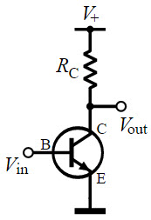

3.2 Common Collector Amplifier
The common collector amplifier is used as a voltage buffer. It is also known as an emitter follower. It is another one of the three single-stage bipolar junction transistor amplifiers. Where it varies from the common emitter is that the base terminal acts as the input whereas the emitter acts as the output. The collector is common to both terminals. The basic circuit layout for the circuit is shown below:
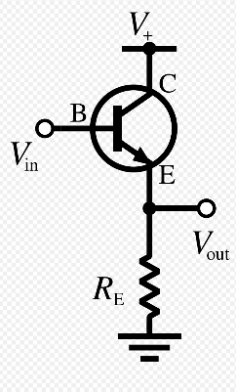

3.3 Common Base Amplifier
The common base amplifier, also known as the grounded-base, is commonly used as a voltage amplifier or a current buffer. It is the last of the single-stage bipolar junction transistor amplifiers. Where it differs from the other two amplifier types, the emitter terminal is the input, and the output is collected from the collector. The base terminal is connected to ground or “common.”
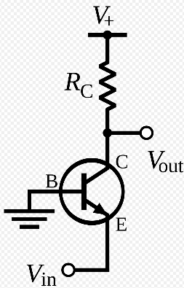

3.4 Choosing Transistor Amplifier
As a result of the research done. I will select the Common Emitter Amplifier as my design. I have chosen this design because the common emitter amplifier is used as a low frequency voltage amplifier meeting the requirements of the assignment. The common base amplifier requires two dc power supplies to power it and usually has less gain than the common emitter circuit. The common collector amplifier is not suitable as the voltage gain is usually at best a little less than 1. This would not allow me to meet the specification of a voltage gain of 7.

4. Components and Software
The software I will be using will be LTSpice. I have chosen to use LTSpice as it is reliable and is good simulation software with a good library for components. I will also be able to be able to get the results of the simulation from the software easily.

The components I need to complete my design will consist of the following:
- Transistor – I will select an NPN 2N2222 transistor. I have selected this transistor due to its current gain of 100-300. I will be using the transistor with a current gain of 200.
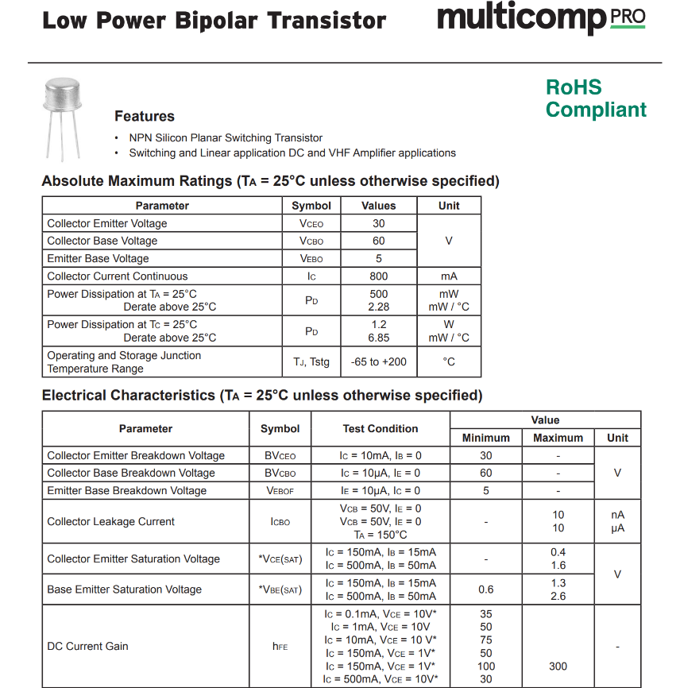
- Resistors – I will select 4 resistors for my circuit. R1 and R2 will act as potential dividers in the circuit and a resistor for the emitter and one for the collector. R1, R2 and RE will form the voltage biasing and stabilization circuit.
- Capacitors – There will be 3 capacitors in my design. I will use an input capacitor which will couple the signal to the base terminal of the transistor. I will use an emitter bypass capacitor which works parallel to RE allowing a low reactance path to the amplified AC signal. Without one there would be a voltage drop across RE. In the second part of my design, I will be using a coupling capacitor to connect the first stage of the amplifier to the next.
5. Experimental Procedure/Methodology
With the chosen transistor amplifier (common emitter amplifier) selected. I will design the amplifier with the specs in mind. My given specifications being Vcc of 10V and gain of 7 and a load impedance of 600 ohms. I will also be using my researched transistor 2N2222 with a β of 200. The design of my common emitter amplifier will be as shown below:

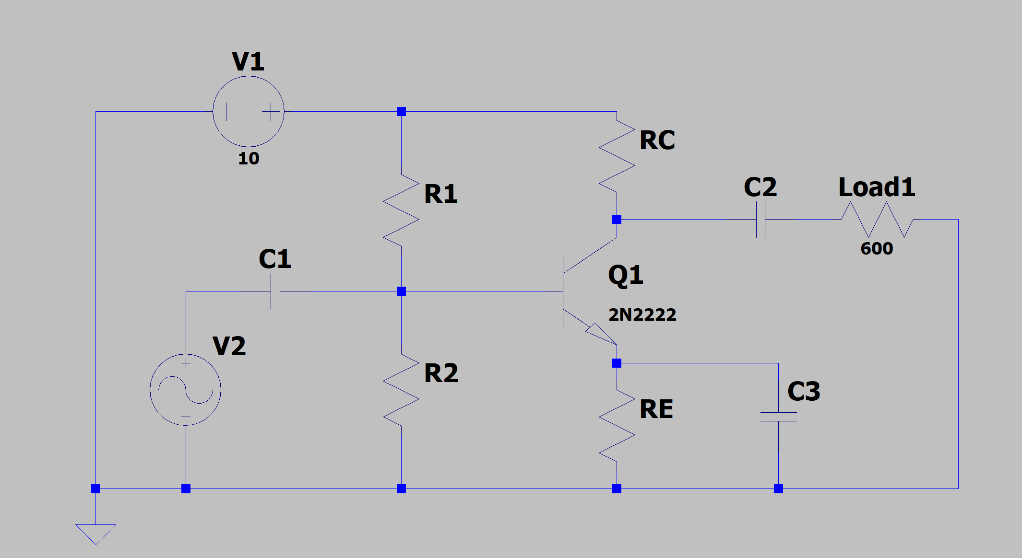

The calculations of the values for the common emitter amplifier are shown below:
$$V_{c}=\frac{1}{2}×V_{cc}$$
$$V_{c}=\frac{1}{2}×10$$
$V_{c}=5$V
For maximum power transfer I will select $R_{c}=Load1$, so therefore $R_{c}=600$Ω.
$$I_{c}=\frac{V_{c}}{R_{c}}$$
$$I_{c}=\frac{5}{600}$$
$$I_{c}=8.3mA$$
Given a gain of 7 I can work out $R_{E}$:
$$A_{V}=\frac{R_{C}}{R_{E}}$$
$$R_{E}=\frac{R_{C}}{A_{V}}$$
$$R_{E}=\frac{600}{7}$$
$R_{E}=85.71$Ω
Using a β of 200 found on the datasheet I can work out $I_{B}$:
$$β=\frac{I_{C}}{I_{B}}$$
$$I_{B}=\frac{I_{C}}{β}$$
$$I_{B}=\frac{8.3×{10}^{-3}}{200}$$
$$I_{B}=41.5μA$$
With $I_{C}$ and $I_{B}$, I can now work out $I_{E}$:
$$I_{E}=I_{C}+I_{B}$$
$$I_{E}=8.3×{10}^{-3}+41.5×{10}^{-6}$$
$$I_{E}=8.3415mA$$

For a more accurate result I will also work out the internal resistance of $R_{E}$:
$$r^{'}e≅\frac{25mV}{I_{E}}$$
$$r^{'}e≅\frac{25×{10}^{-3}}{8.3415×{10}^{-3}}$$
$r^{'}e≅2.997$Ω
So, $R_{E total}=R_{E}+r^{'}e$
$$R_{E total}=85.71+2.997$$
$R_{E total}=88.707$Ω
Using $R_{E total}$ and $I_{E}$, I can now use ohms law to determine the answer for $V_{E}$:
$$V_{E}=I_{E}×R_{E total}$$
$$V_{E}=0.74V$$
Using $V_{E}=0.74V$, I can work $V_{B}$, using $V_{BE}=0.7V$ to turn on the transistor:
$$V_{B}=V_{E}+V_{BE}$$
$$V_{B}=0.74+0.7$$
$$V_{B}=1.44V$$
Now having worked out the above, I will work out $I_{R1}$ and $I_{R2}$. As a rule of thumb $I_{R1}=10I_{B}$and $I_{R2}=11I_{B}$:
$$I_{R1}=11×41.5×{10}^{-6}$$
$$I_{R1}=0.457mA$$
$$I_{R2}=10×41.5×{10}^{-6}$$
$$I_{R2}=0.415mA$$
With $V_{B}=V_{R2}$, then $V_{R2}=1.44V$. Using $V_{CC}=V_{R1}+V_{R2}$, I will be able to calculate $V_{R1}$:
$$V_{R1}=V_{CC}-V_{R2}$$
$$V_{R1}=10-1.44$$
$$V_{R1}=8.56V$$
Finally having the voltages for $V_{R1}$ and $V_{R2}$, I can work out the resistance values for $R_{1}$ and $R_{2}$.
$$R_{1}=\frac{8.56}{0.457×{10}^{-3}}$$
$R_{1}=18730.85$Ω
$$R_{2}=\frac{1.44}{0.415×{10}^{-3}}$$
$R_{2}=3469.88$Ω
Having worked out all my calculations and making a few modifications to the circuit, I can now populate the circuit with the values above.
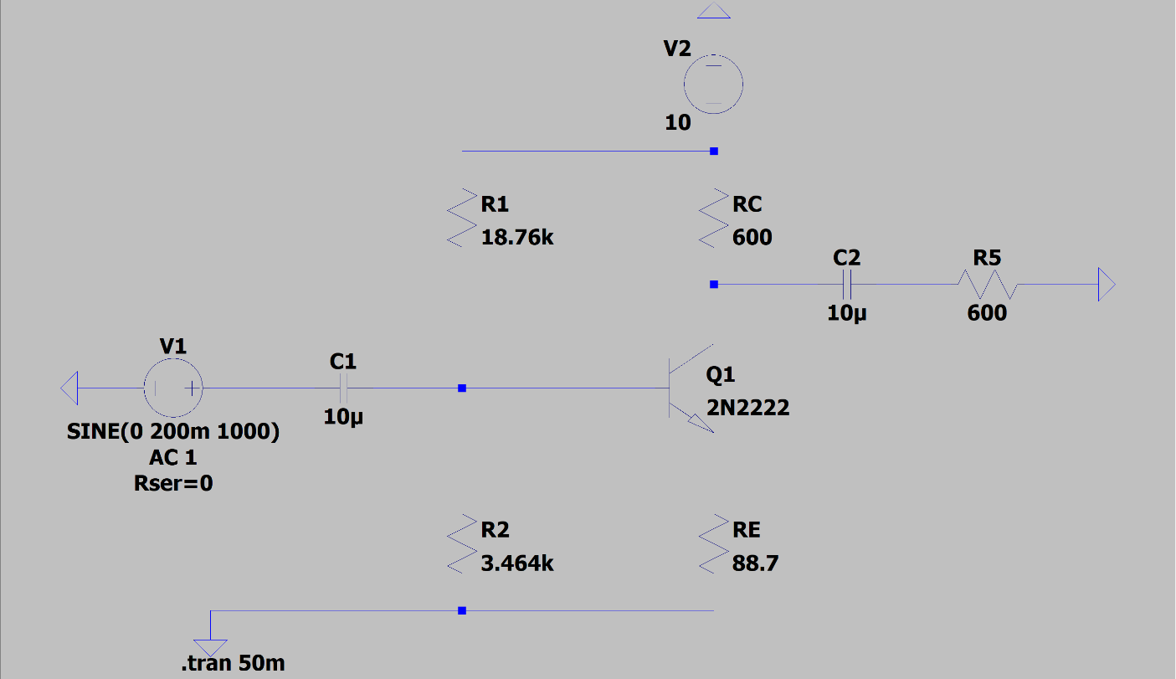
I have chosen capacitor values of 10$μF$and a signal of 100mVAC at 1000Hz for my circuit. I have chosen 1000Hz as it will provide a steady gain and waveform. Less than 1000Hz will cause a change in waveform and create an unstable and less reliable gain.

6. Results
The input of my simulation is shown below:
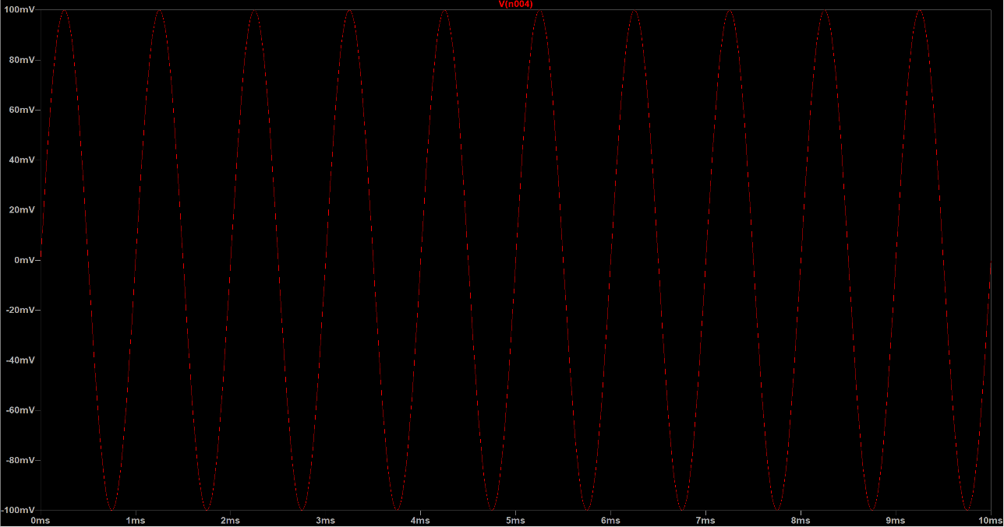
The waveform shows an input of 100mV at 1000Hz.

Below shows the output signal connected to a load of 600 ohms:
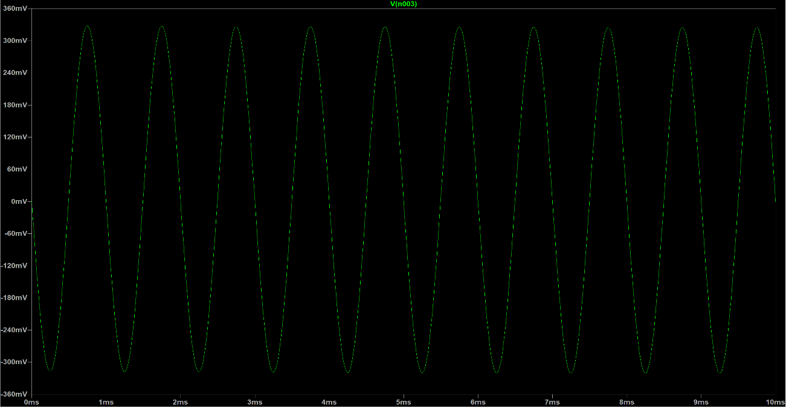The output shows an output of 340mV at 1000Hz. To work out the gain, I will use the formula$Gain=\frac{V_{out}}{V_{in}}$
$$Gain=\frac{340}{100}$$
$$Gain=3.4$$

The output gain shows a gain of 3.4. The required gain of the simulation needed is 7. The gain of the simulation is halved due to the load. To check this, I have disconnected the load and checked the output. This is seen below:
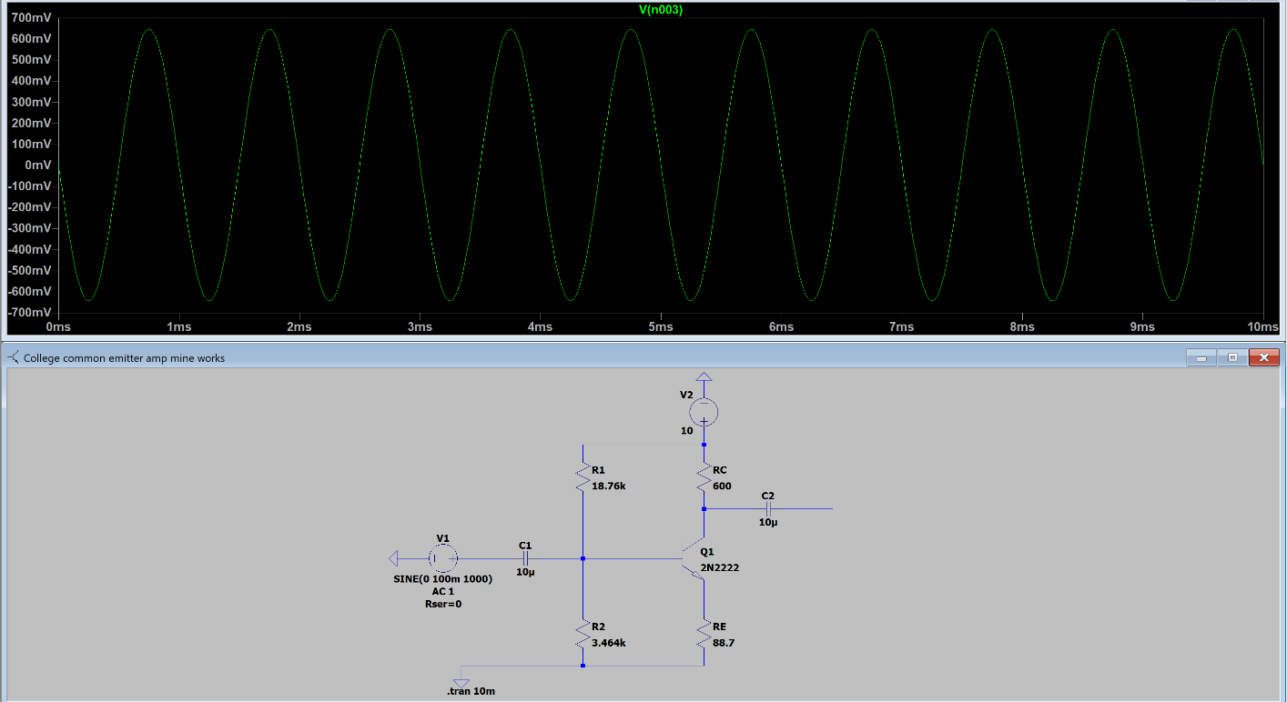
Without the load connected I get a gain of 6.7. To get the required gain of 7 I will need to work off a gain of 14. This will be halved by the load giving me the required gain of 7. I have recalculated my values to allow me for a gain of 7 with the load attached. This is shown below:

My new calculations are working off a gain of 14 but it is still using the input of 10V.
$$V_{c}=\frac{1}{2}×V_{cc}$$
$$V_{c}=\frac{1}{2}×10V$$
$$V_{c}=5V$$

$$I_{c}=\frac{V_{c}}{R_{c}}$$
$$I_{c}=\frac{5}{600}$$
$$I_{c}=8.3mA$$
Working from a gain of 14:
$$A_{v}=14$$
$$A_{v}=\frac{R_{c}}{R_{E}}$$
$$R_{E}=\frac{600}{14}$$
$R_{E}=42.857$Ω

$$β=200$$
$$β=\frac{I_{c}}{I_{B}}$$
$$I_{B}=\frac{I_{c}}{β}$$
$$I_{B}=\frac{8.3}{200}$$
$$I_{B}=41.5μA$$

$$I_{E}=I_{C}+I_{B}$$
$$I_{E}=41.5μA+8.3mA$$
$$I_{E}=8.3415mA$$

$$r^{'}e=\frac{25mV}{I_{E}}$$
$$r^{'}e=\frac{25mV}{8.3415mA}$$
$r^{'}e=2.997$Ω
$$R_{E_{Total}}=R_{E}+r^{'}e$$
$$R_{E_{Total}}=42.857+2.997$$
$R_{E_{Total}}=45.854$Ω

$$V_{E}=I_{E}×R_{E_{Total}}$$
$V_{E}=8.3415mA×45.854$Ω
$$V_{E}=0.382V$$

$$V_{B}=0.382+0.7$$
$$V_{B}=1.082V$$

$$I_{R2}=10I_{B}$$
$$I_{R2}=10×41.5μA$$
$$I_{R2}=415μA$$

$$I_{R1}=11I_{B}$$
$$I_{R1}=11×41.5μA$$
$$I_{R1}=456.5μA$$

$$V_{cc}=V_{R1}+V_{R2}$$
$$V_{R1}=10V-1.082V$$
$$V_{R1}=8.918V$$

$$R=\frac{V}{I}$$
$$R_{2}=\frac{1.082V}{415μA}$$
$R_{2}=2607.23$Ω

$$R_{1}=\frac{8.918V}{456.5μA}$$
$R_{1}=19535.60$Ω
Having worked out the new values for my circuit I will populate the circuit and simulate the results. This is seen below in the graph:
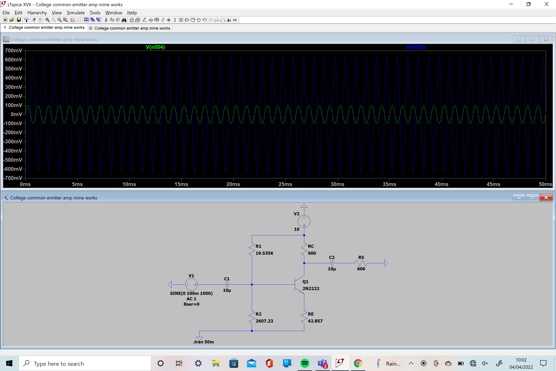

Working off a gain of 14 and with an attached load of 600Ω, I have populated my circuit with the values above. Using the formula $Gain=\frac{V_{out}}{V_{in}}$, I will calculate the new gain:
$$Gain=\frac{670mV}{100mV}$$
$$Gain=6.7$$
The above shows me a gain of 6.7 when I was after a gain of 7. Given the –0.3 difference I am happy to proceed with my design as it is a small value and the values have given me my required specifications.

7. Impedance
The input impedance of the CE amplifier is worked out by calculating $Z_{in}=\frac{V_{in}}{I_{in}}$. The output impedance is calculated by $Z_{out}=\frac{V_{out}}{I_{out}}$. My input impedance is $Z_{in}=\frac{100mV}{55μA}$, therefore,$Z_{in}=1818.18$Ω. My output impedance is $Z_{out}=\frac{670mV}{1.1mA}$, therefore, $Z_{out}=609.09$Ω. My output impedance is equal to RC for maximum power transfer.

8. Bypass Capacitor
The addition of a capacitor in parallel with RE will increase the amplifiers’ AC gain. The bypass capacitor allows the AC signal to bypass RE. Effectively removing it from the output gain, resulting in an increase in the amplifiers' AC gain. This is shown from the simulations below.
Common Emitter Amplifier with Bypass Capacitor
Gain = 16.7
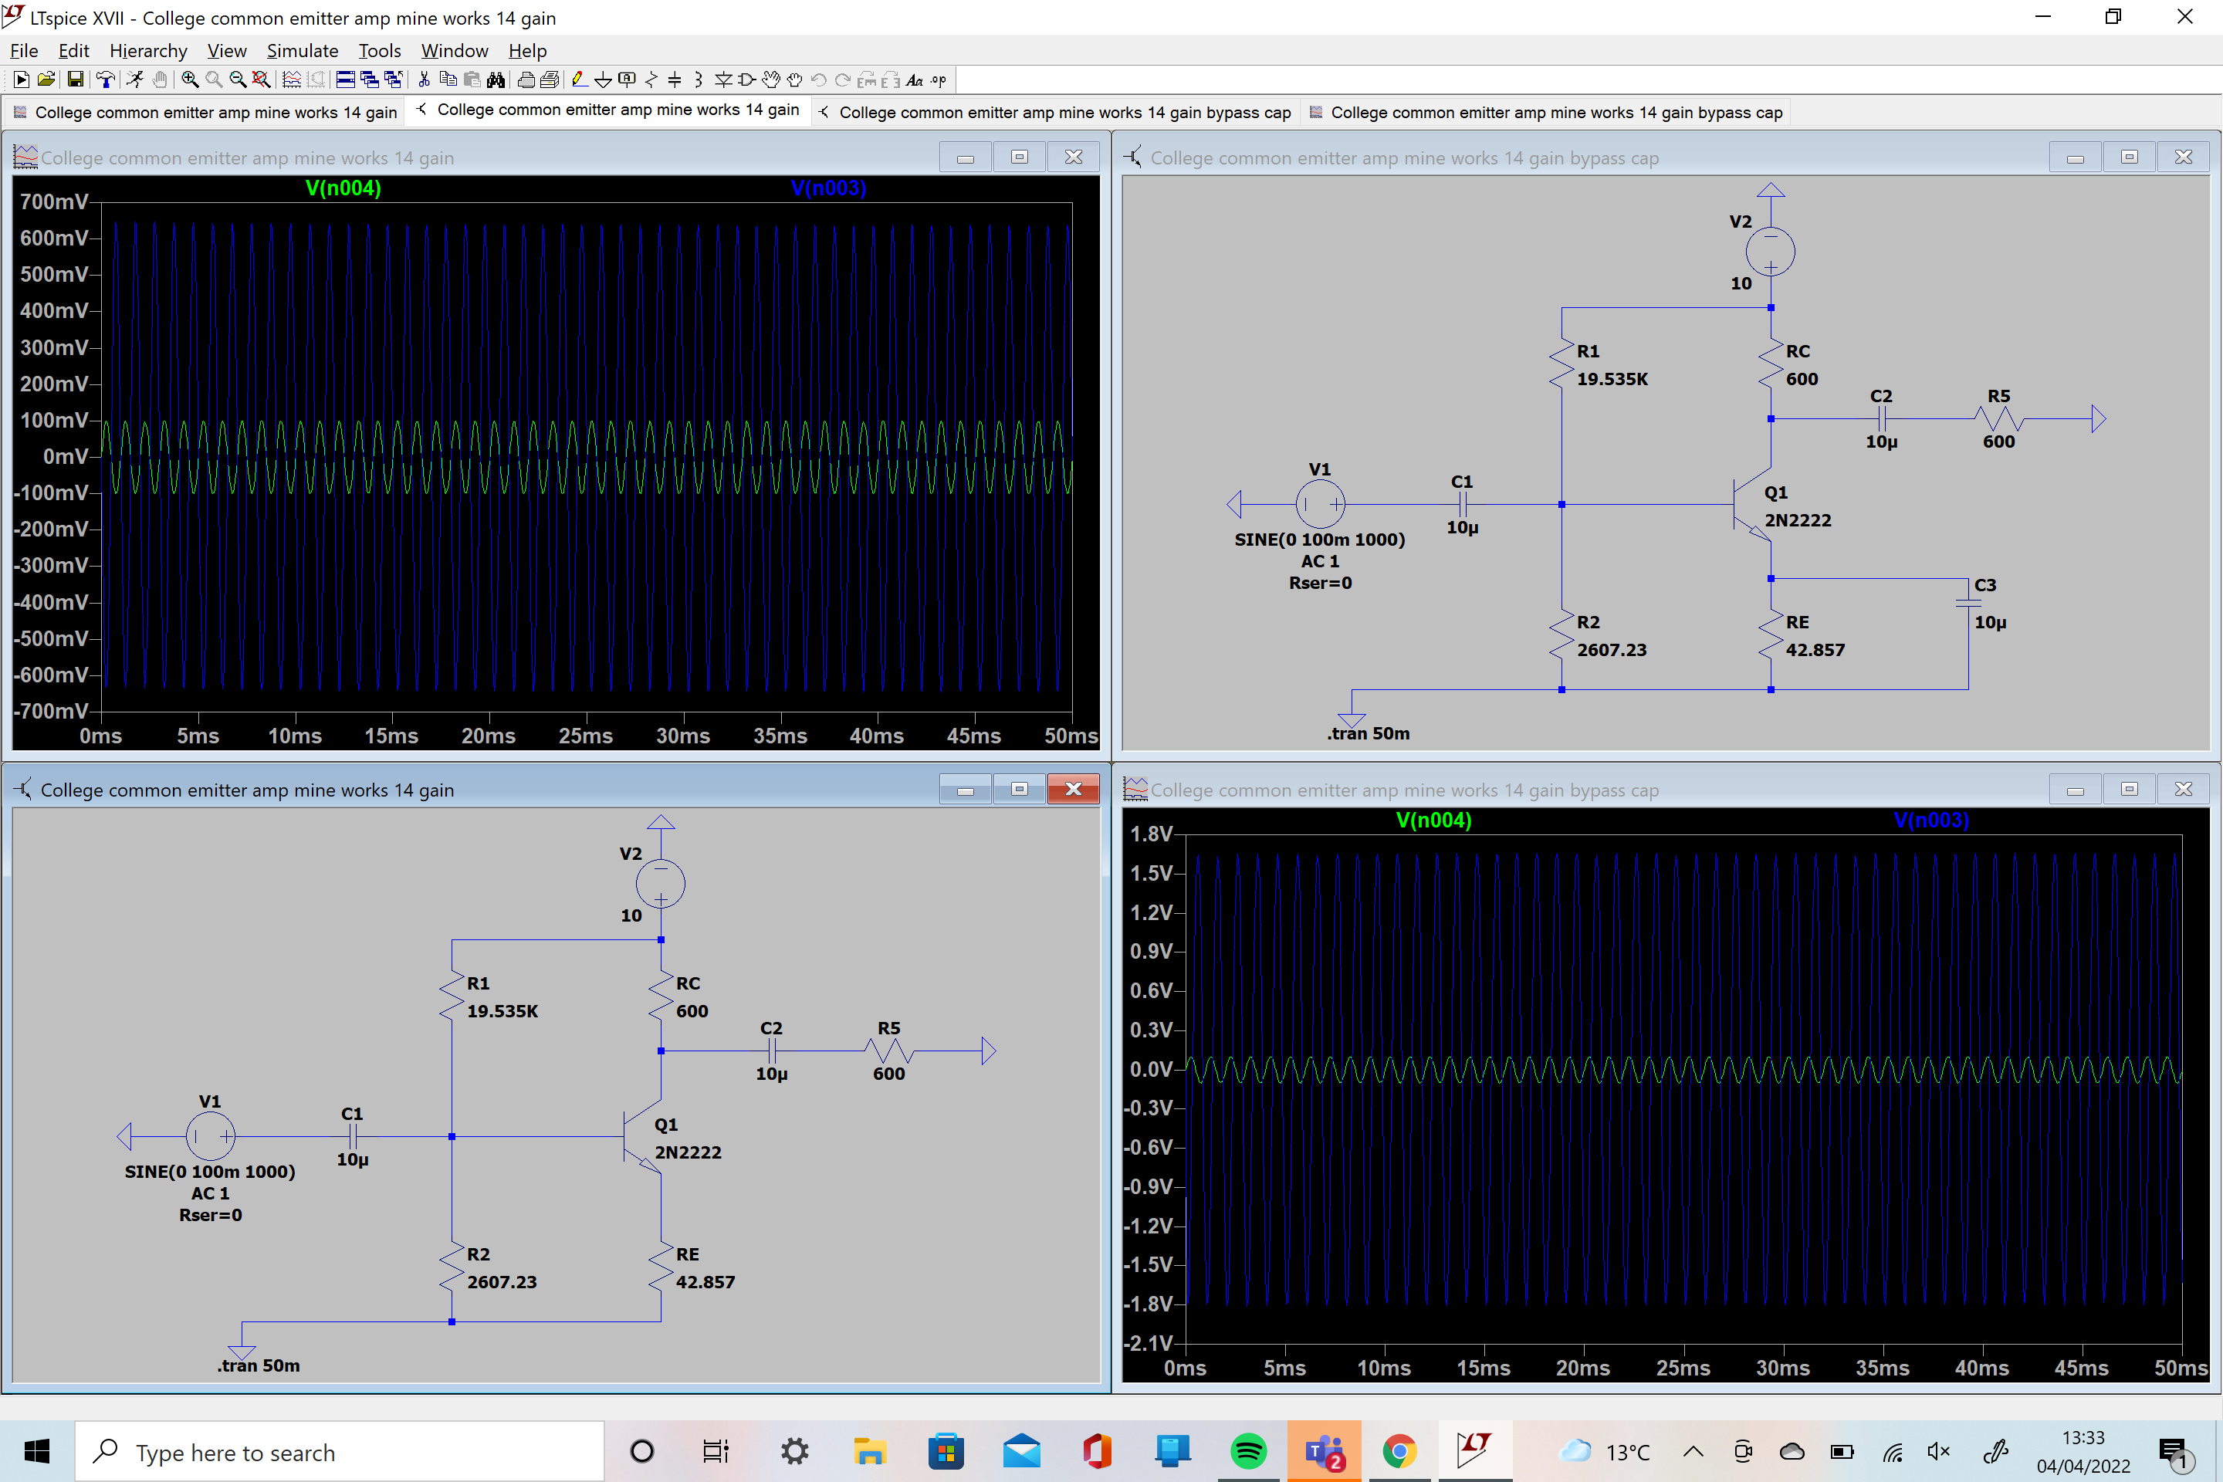
Common Emitter Amplifier without Bypass Capacitor
Gain = 6.7
The values of the resistors in the circuit are identical, the only difference being that the bypass capacitor has been put in parallel with RE. This shows an increase of gain by adding in the bypass capacitor.
9. Frequency Response
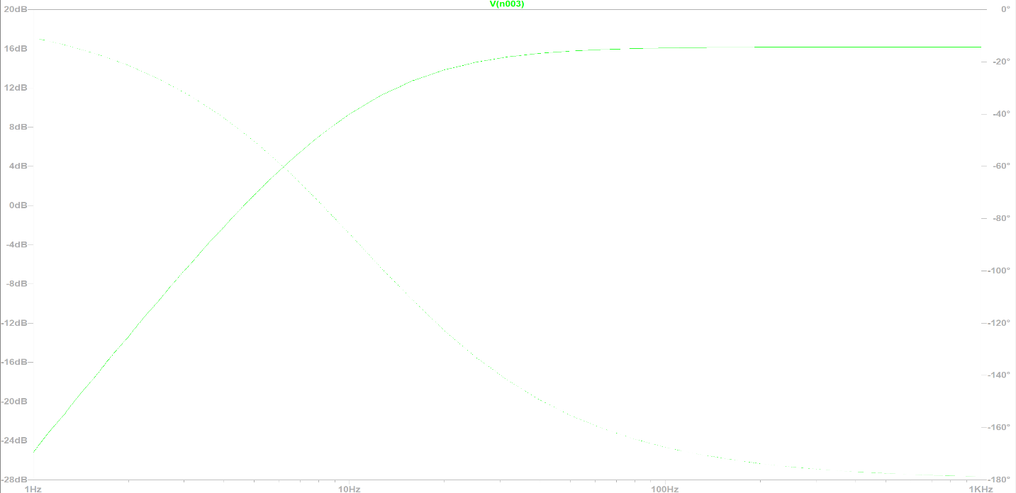The frequency response shows that at 1000Hz, the gain is steady and stable whereas at lower frequencies the gain would be unstable and less reliable.

10. Two Stage Common Emitter Amplifier
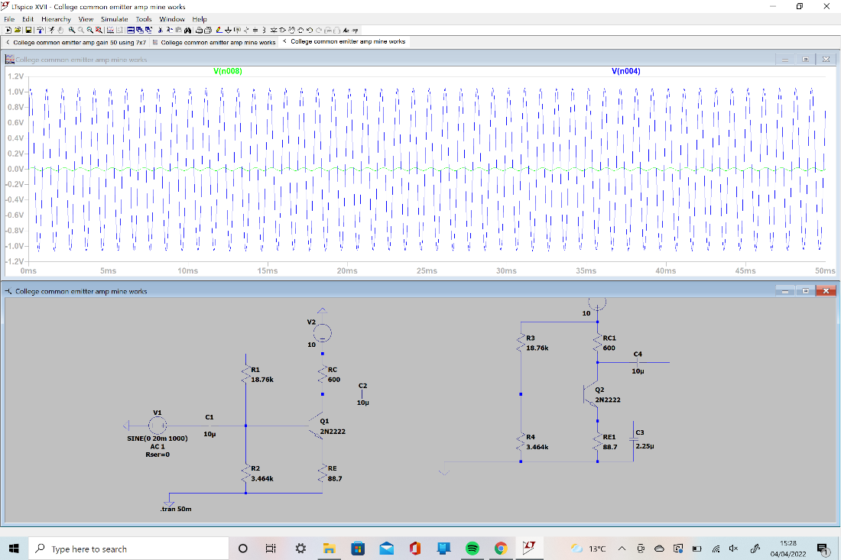
Above shows a two-stage amplifier with a gain of 50. The input for the above CE amplifier is 20mV. As my amplifier is a small voltage amplifier, I needed to reduce the input to allow for a gain of 50. This was achieved by duplicating my one stage amplifier and connecting it via a coupling capacitor. As my one stage amplifier has a gain of 7, duplicating gives me a gain of 49. Therefore, by adding a bypass capacitor in, I am able to achieve the required voltage gain of 50.
This is worked out using the formula for gain $Gain=\frac{V_{out}}{V_{in}}$, where $Gain=\frac{1V}{20mV}$, therefore $Gain=50$.

11. Analysis
The results I have achieved in my simulations and circuits have proved the relevant theories above correct. The design of the common emitter amplifier and the calculations worked to give me the desired result. The common emitter amplifier I have designed has potential uses as an audio amplifier or it could be used in a radio frequency circuit to amplify weaker signals coming through an antenna. This will be beneficial in these applications as a common emitter amplifier is typically used in the low-frequency voltage amplifiers. Some of the disadvantages of my design are the ability to respond to high frequencies, and despite the presence of resistors, there are still chances of thermal instability in the circuit.
Through the simulations of my design a drop is seen by adding a load resistance. The load of 600Ω halved the gain from 7.0 to 3.4. By halving the load resistance to 300Ω the gain would lower to about two thirds of the gain, the value of which being around 5.25 gain. This is due to the high impedance output of 600Ω.

12. Conclusion
In conclusion to this task, I have found out that my common emitter amplifier design does have its limitations in it being mainly used as a small voltage amplifier and the temperature conditions of the amplifier can make it unstable. I have found uses for the amplifier I have designed in low-frequency amplifiers and radio frequency circuits. Overall, I have designed and calculated all the values in my one stage amplifier to the correct specification of 7, as well as designing a two-stage amplifier with the gain of 50.
I have researched and discovered the effect of a bypass capacitor on the overall gain. Raising the gain to 16.7 of 6.7 with a 10$μ$F capacitor. I also discovered the effect of a load on the overall gain on the circuit. The load of 600Ω halved my gain and changing the load to different values also influenced the gain. Halving the load to 300Ω reduced the load by $\frac{2}{3}$.
Overall, I have proven that I can use a suitable design and simulation software to create a one and two stage amplifier. I have also shown that I am able to calculate all values necessary to complete the design of my amplifier and simulate and prove my calculations are to specification.

13. References:
[1] Common Emitter Amplifier Circuit Working & Its Characteristics by Tarun Agarwal [online] Available from: https://www.elprocus.com/common-emitter-amplifier-circuit-working/ [Accessed 08/03/2022]
[2] Common Collector by R. Victor. Jones [online] Available from: Basic BJT Amplifier Configurations (archive.org) [Accessed 08/03/2022]
[3] Figure 1: Basic NPN common collector circuit [online] Available from: https://en.wikipedia.org/wiki/Common_collector#/media/File:NPN_emitter_follower.svg [Accessed 08/03/2022]
[4] Common base by R. Victor. Jones [online] Available from: Basic BJT Amplifier Configurations (archive.org) [Accessed 08/03/2022]
[5] Figure 1: Basic NPN common base circuit [online] Available from: https://en.wikipedia.org/wiki/Common_base#/media/File:NPN_common_base.svg [Accessed 08/03/2022]
[6] Disadvantages of CB Amplifier [online] Available from: http://electronicshelpline.blogspot.com/2015/07/advantages-and-disadvantages-of.html#:~:text=Disadvantages%20of%20CB,common%20emitter%20amplifier. [Accessed 08/03/2022]
[7] Disadvantages of CC Amplifier [online] Available from: http://electronicshelpline.blogspot.com/2015/07/advantages-and-disadvantages-of.html#:~:text=The%20Voltage%20gain%20of%20a%20common%20collector%20amp%20is%20at%20best%20slightly%20less%20than%201 [Accessed 08/03/2022]
[8] Datasheet [online] Available from: https://www.farnell.com/datasheets/2869789.pdf [Accessed 08/03/2022]
[9] Circuit Elements and their Functions [online] Available from: https://www.elprocus.com/common-emitter-amplifier-circuit-working/#:~:text=Input%20Capacitor%20(C1,two%20coupled%20circuits. [Accessed 08/03/2022]
[10] INPUT AND OUTPUT IMPEDANCES OF AMPLIFIERS by Boris Poupe [online] Available from: https://www.electronics-lab.com/article/input-and-output-impedances-of-amplifiers/#:~:text=If%20we%20consider,Zout%3DVout/Iout [Accessed 22/04/2022]

[11] What is a Bypass Capacitor? [online] Available from:
https://www.etcourse.com/news-blog/bypass-capacitor-what-its-importance-amplifier-circuit#:~:text=A%20bypass%20capacitor%20is%C2%A0added%20to%20an%C2%A0amplifier%20circuit%C2%A0in%20order%C2%A0to%C2%A0allow%20AC%20signals%20to%20bypass%20the%20emitter%20resistor.%20This%20effectively%20removes%C2%A0it%20from%20the%20output%20gain%20equation%20resulting%20in%20an%20increase%20to%20the%20amplifiers%20AC%20gain. [Accessed 04/04/2022]

[12] Pros and Cons of Using the Common Emitter Amplifier Configuration [online] Available from: Common emitter configuration of BJT (electricalclassroom.com) [Accessed 21/04/2022]

Common Emitter Amplifier Circuit Working & Its Characteristics by Tarun Agarwal [online] Available from: https://www.elprocus.com/common-emitter-amplifier-circuit-working/ [Accessed 08/03/2022]
Common Collector by R. Victor. Jones [online] Available from: Basic BJT Amplifier Configurations (archive.org) [Accessed 08/03/2022]
Figure 1: Basic NPN common collector circuit [online] Available from: https://en.wikipedia.org/wiki/Common_collector#/media/File:NPN_emitter_follower.svg [Accessed 08/03/2022]
Common base by R. Victor. Jones [online] Available from:Basic BJT Amplifier Configurations (archive.org) [Accessed 08/03/2022]
Figure 1: Basic NPN common base circuit [online] Available from: https://en.wikipedia.org/wiki/Common_base#/media/File:NPN_common_base.svg [Accessed 08/03/2022]
Disadvantages of CB Amplifier [online] Available from: http://electronicshelpline.blogspot.com/2015/07/advantages-and-disadvantages-of.html#:~:text=Disadvantages%20of%20CB,common%20emitter%20amplifier. [Accessed 08/03/2022]
Disadvantages of CC Amplifier [online] Available from: http://electronicshelpline.blogspot.com/2015/07/advantages-and-disadvantages-of.html#:~:text=The%20Voltage%20gain%20of%20a%20common%20collector%20amp%20is%20at%20best%20slightly%20less%20than%201 [Accessed 08/03/2022]
Datasheet [online] Available from: https://www.farnell.com/datasheets/2869789.pdf [Accessed 08/03/2022]
Circuit Elements and their Functions [online] Available from: https://www.elprocus.com/common-emitter-amplifier-circuit-working/#:~:text=Input%20Capacitor%20(C1,two%20coupled%20circuits. [Accessed 08/03/2022]
INPUT AND OUTPUT IMPEDANCES OF AMPLIFIERS by Boris Poupe [online] Available from: https://www.electronics-lab.com/article/input-and-output-impedances-of-amplifiers/#:~:text=If%20we%20consider,Zout%3DVout/Iout [Accessed 22/04/2022]
What is a Bypass Capacitor? (online) Available from: https://www.etcourse.com/news-blog/bypass-capacitor-what-its-importance-amplifier-circuit#:~:text=A%20bypass%20capacitor%20is%C2%A0added%20to%20an%C2%A0amplifier%20circuit%C2%A0in%20order%C2%A0to%C2%A0allow%20AC%20signals%20to%20bypass%20the%20emitter%20resistor.%20This%20effectively%20removes%C2%A0it%20from%20the%20output%20gain%20equation%20resulting%20in%20an%20increase%20to%20the%20amplifiers%20AC%20gain. [Accessed 04/04/2022]
Pros and Cons of Using the Common Emitter Amplifier Configuration [online] Available from: Common emitter configuration of BJT (electricalclassroom.com) [Accessed 21/04/2022]

