

BA (Hons) Leadership and Management Skills for the Workplace

Student Name: Ana Cojan 2109647
Module name: Leading and Implementing workplace change.

Module code: BMSW6103

Module Lecturer: Nadeem Mirza

Individual Report on Change Management Plan for Tesco

Executive Summary
The purpose of writing this report is to focus on various aspects of Tesco and the external factors by which Tesco was affected during and post-COVID situation and Change Management system. Tesco is a well-known international grocery store chain. Tesco is picked for this study because it has a large part of the market, stores all over the world, and a history of being able to adapt well to outside forces that bring about change. A number of business analysis tools have been used to back up the research in this report. For example, PESTEL analysis can be used to look at the outside forces that are causing change. Kotter's 8-Step Change Model and Lewin's Change Management Model can be used to look at Tesco's change efforts. Tesco might be able to handle uncertainty and make the most of new opportunities by using different types of strategy change, good leadership, and actioning good plans. Tesco is a leading multinational grocery company, and it has a total of 330,000 employees. Tesco is the largest supermarket in the UK with 3801 stores. In 2021, the total group sales volume of Tesco was around €53.4 billion and increased from €49.9 billion in 2020. Tesco has implemented several strategies such as agile business operations so that the business can adopt the changing conditions of the market, customer requirements, digital transformation in terms of e-commerce infrastructure, online shopping platforms and capabilities of digital marketing, and customer experience by which Tesco provides preferences to their customers in terms of cleanliness, safety, and health security. Transformational, Adaptive and Collaborative leadership styles have been taken by Tesco to manage change during and post-COVID situations effectively. Among three change management models, Kotter's 8-step change management model identified suitable strategic change. Tesco will improve and assess its change readiness by including key partners in this project. Tesco will create a solid transformation strategy that aligns with its long-term aims and the business review. A detailed strategy with goals, benchmarks, and deadlines will be created.

Table of Contents

Introduction 4
Section 1- Critical Evaluation of the Adopted Change Management Process and Identification of the Suitable Strategic Change Option 4
Overview of Tesco 4
External Factors Driving Change and Change Management Process 6
PESTEL Analysis 6
Strategies taken by Tesco 9
Leadership Style in Change Management 9
Impact on Organisational Culture 9
Areas that need to be improved by Tesco 10
Section 2- Critical Evaluation of the Change Management Models 11
Lewin's Change Management Model 11
Section 3- Proposal and Implementation of Change Strategy 17
Suitable change management plan based on Kotter's 8-Step Change Model 17
Suitable leadership style for the suggested change strategy 19
Step-by-step Process to Implement the Change Strategy 20
Impact of the Implementation of the Change Strategy on Tesco’s Culture 21
Conclusion and Recommendations 22
References 24

Introduction
Tesco is a well-known international grocery store chain. The main goals of this report are to take a critical look at their change management process and find the best strategic change options for dealing with the challenges that come with a business environment that is always changing, especially during and after COVID-19. Tesco was picked for this study because it has a large part of the market, stores all over the world, and a history of being able to adapt well to outside forces that bring about change. A number of business analysis tools will be used to back up the research in this report. For example, PESTEL analysis can be used to look at the outside forces that are causing change. Kotter's 8-Step Change Model and Lewin's Change Management Model can be used to look at Tesco's change efforts. There will be many parts to the study, and each one will focus on a different part of Tesco's change management process. These parts will talk about the group as a whole, the outside forces that want things to change, the different types of leadership, how the changes will be made, and how they will impact the organization's culture. The study's goal is to give Tesco useful information and suggestions on how to make the business more successful in the long run, better able to deal with new business problems, and better at managing change. Tesco might be able to handle uncertainty and make the most of new opportunities by using different types of strategy change, good leadership, and actioning good plans. Over time, these steps will help Tesco compete better in the world market for shopping.

Section 1- Critical Evaluation of the Adopted Change Management Process and Identification of the Suitable Strategic Change Option

Overview of Tesco
Brief overview of Tesco with its existing history of dealing with changes (annual report)
A global retailer company, Tesco was founded in 1919 and it has a strong track record of giving responses according to market changes. It has broadened its product offerings, gone global and embraced technological improvements so that it can improve its client experience. Tesco is a leading multinational grocery company, and it has a total of 330,000 employees (Tesco, 2024). Tesco is the largest supermarket in the UK with 3801 stores. In 2021, the total group sales volume of Tesco was around €53.4 billion and increased from €49.9 billion in 2020 (Peachy Essay, 2021). In 2022–2023, the revenue of Tesco in the UK and Republic of Ireland was approximately 60.25 billion British pounds, which is roughly 14 times the company's revenue in Central Europe (Statista, 2024). Tesco has shown resilience by taking calculated risks so that it can maintain its competitive edge despite obstacles like changing consumer tastes and downturns.

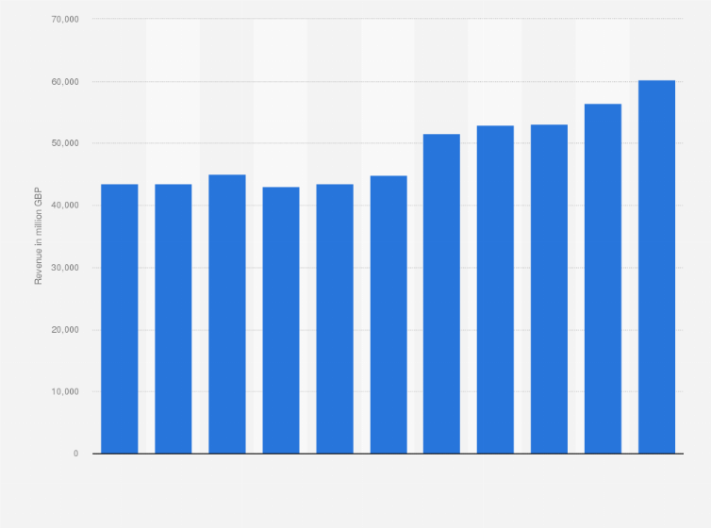
Figure 1: Annual Revenue of Tesco
(Source: Statista, 2024)
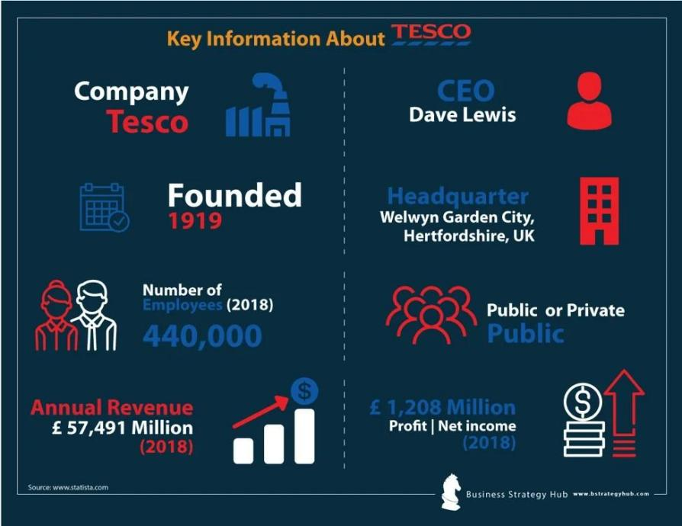
Figure 2: Key Information About Tesco
(Source: Peachy Essay, 2021)

External Factors Driving Change and Change Management Process
It is essential for Tesco to make strategic changes in its operational procedures as well as business model both during and after the Covid-19 pandemic because there are several external factors that act like change drivers of Tesco and manage the changing situation. The multiple external factors that had a huge impact on the whole operational systems of Tesco and these factors become drivers of the change of Tesco. As Tesco is a global supermarket, it is affected by various external factors (Rosnizam et al., 2020). All the external factors that can be found after performing a PESTEL analysis of Tesco.

PESTEL Analysis
Political Factors
Political factors played an essential role during and post-covid time because the whole system of Tesco had changed.
Government Regulations: Modification to laws pertaining to social isolation, shutdown limits and occupational safety and health requirements impacted the operations of Tesco (Moore et al., 2021). Tesco had implemented these government regulations so that it could handle the pandemic situation as well as come out from this situation.
Policy Response: The financial organising and allocation of resources of Tesco were influenced by government efforts so that Tesco could mitigate the economic effects of the epidemic through funding, promotions and stimulus packages.
Economic Factors
Economic factors play an important role in influencing the performance and strategic decisions that are taken by Tesco. Tesco is a global company so global economic conditions such as growth rates, exchange rates, and inflation can be affected by the changing economy of Tesco.
Economic Downturn: The Covid-19 epidemic impacted the income and profit margins of Tesco as loss of employment, financial instability and a decline in consumer purchasing were caused by Covid-19 (Béné et al., 2021).
Supply Chain Disruptions: Disruptions in the stock management of Tesco, distribution networks and purchasing procedures were experienced by Tesco because of the limitations on travel, lockdowns as well as the shutdown of Tesco plants as a result distribution network was affected worldwide.
Social Factors
Social factors also play a crucial role in the business of Tesco because cultural norms, beliefs, lifestyles, and attitudes are influenced by social factors. The behaviour of the customers of Tesco as well as their beliefs, thoughts, and methods of purchasing products from Tesco changed during and post-COVID.
Changing Consumer Behaviour: Due to the Covid-19 pandemic, the whole operational system of Tesco was rapidly going digital as the changes in consumer preferences such as contactless payment methods, delivery at home as well as internet shopping (Díaz-Martín et al., 2021).
Health Concerns: Tesco focuses on implementing sanitary regulations and health inspections so that Tesco can raise health and hygiene awareness and the aim of this purpose is to provide safety to both customers and employees.
Technological Factors
In the operation of the business and the growth of Tesco technological factors have had an impact on us a lot. All the production and purchasing methods in Tesco are totally done by using improved technologies. The retail industry rapidly evolved with technological advancements so Tesco also needs to embrace innovation so that it can enhance customer experience and increase its distribution network (FourWeekMBA, 2023).
Digitalisation: To manage the COVID situation, online visibility and customised customer experiences of Tesco were improved by the quicker adaptation of digital technologies such as mobile applications, data analytics and e-commerce sites.
Automation: Tesco invested in automation technologies such as robotics fulfilment centers, stock management systems that are driven by Artificial Intelligence as well as systems of self-checkout in order to increase operational efficiency as well as cut down on labor costs.
Environmental Factors: Environmental factors play an essential role in Tesco as it takes sustainability initiatives and spreads awareness regarding climate change (The Business Model Analyst, 2024).
Sustainability initiatives: Increasing demands from customers regarding packaging that is environmentally friendly, carbon-free activities and ethical items have a huge impact on the purchasing products policies of Tesco.
Climate Change: The procedures regarding energy-efficient, waste reduction initiatives as well as solutions for renewable energy have been implemented by Tesco as a result of growing awareness of the problems that are directly associated with changing climate and preservation activities (Olarewaju et al., 2024).
Legal Factors
The operational systems of Tesco are affected by legal factors as Tesco is a global company, so it needs to follow all the rules and regulations in order to manufacture products as well as distribute them.
Requirements of Compliance: Industry norms, governmental safety guidelines and health recommendations regarding COVID procedures, employee safety and food hygiene requirements were followed by Tesco (The Business Model Analyst, 2024).
Employment Laws: Tesco modified labor laws, worker rules and employment laws and these regulations impacted the hiring, training and relation with employees procedures of Tesco.
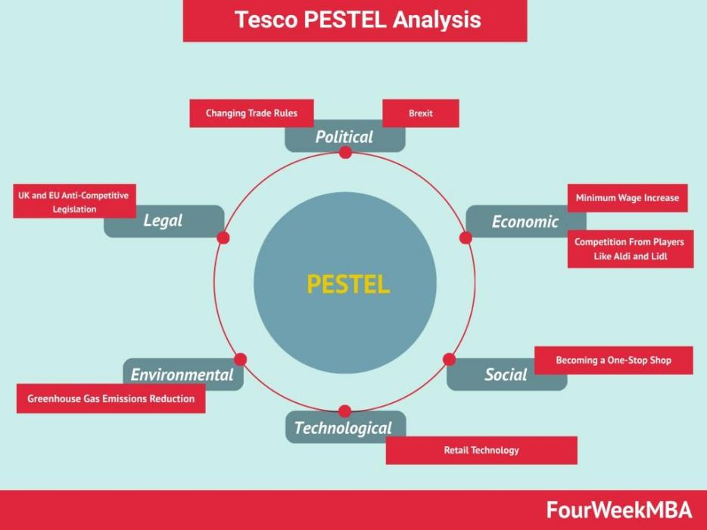
Figure 3: PESTEL Analysis Of Tesco
(Source: FourWeekMBA, 2023)

Strategies taken by Tesco
According to Amah and Ogah, 2023, to manage the change during and post-covid situation, Tesco had implemented several strategies such as agile business operations so the business can adopt the changing conditions of market, customer requirements, digital transformation in terms of e-commerce infrastructure, online shopping platforms and capabilities of digital marketing, customer experience by which Tesco provide preferences to their customers in terms of cleanliness, safety and health security.

Leadership Style in Change Management
In order to manage change during and post-COVID situations effectively, Tesco used various leadership styles such as
Transformational Leadership: Tesco supports and encourages innovation, teamwork, and the acceptance of change by workers by using transformational leadership style (Masenya, 2020). The challenges of the pandemic and return better by cultivating a culture of adaptability and flexibility can be negotiated effectively by Tesco.
Adaptive Leadership: Adaptive leadership abilities can be demonstrated by the executives of Tesco by adapting quickly to the situation-shifting conditions, unpredictability, and difficulties during COVID-19. Tesco reduced interruptions and guaranteed the continuity of the company so that they could handle new problems.
Collaborative Leadership: Tesco has used collaborative leadership by promoting shared accountability, collaboration and cooperative culture between all departments, operations, and organisational levels so that Tesco can manage change effectively during and post-covid situations (Bhattacharya and Fayezi, 2021). Tesco also focuses on open communication, problem-solving sessions as well as cross-functional partnership.

Impact on Organisational Culture
The organisational culture of Tesco was significantly impacted by the creation and execution of the transformation. A number of changes that were adopted by Tesco in terms of digital transformation, responding to market conditions, and providing priority to customer preferences can be experienced by the organisational culture of Tesco both during and post-covid situation (Polyaninova, 2021)
Shifts towards Innovation: An innovation culture was fostered by Tesco during and post-covid situation in terms of giving motivation to the employees so that they can experience novel concepts, suggestions of trying out cutting-edge tools, and come up with innovative answers to arising problems.
Emphasis on Flexibility: The employees of Tesco gained the ability to respond quickly to the shifting market conditions, demands of clients' preferences, and market dynamics (Kumar et al., 2021). Adaptation of flexibility helps a lot in understanding market conditions and changing situations and demands during and post-COVID conditions.
Customer Focus: The key components of Tesco's customer-centric culture include both online and offline stores by which Tesco can recognise and satisfy the changing requirements and preferences of their customers. During a post-COVID situation, Tesco focused on a customer-centric approach by giving services via online platforms as the customers did not want to come in store because of the pandemic.

Areas that need to be improved by Tesco.
Both during and post-COVID situation, Tesco displayed various successful management strategies, but there are still certain areas that require improvement by Tesco.
Communication: Tesco needs to better use its communication channels so that they guarantee to provide prompt and transparent information regarding rules of changes, practices and strategies to their employees (Dekimpe and van Heerde, 2023). Employee involvement and connections with company objectives can be enhanced by the improvement of communication as well as reducing confusion.
Employee Engagement: Tesco should have focused on employee engagement by doing a better job of asking for feedback, including making decisions so that Tesco can keep staff members engaged during the transition. A sense of responsibility and dedication can be encouraged by improved employee engagement.
Cultural Transformation: Tesco should focus on cultural transformation by fostering a more inclusive and cooperative atmosphere at the workplace (Johnsen et al., 2022). Diversity, equality and inclusiveness can be encouraged through open communication, and it also fosters an ongoing culture of learning and adaptation so that Tesco should transform culture within the organisation for better employee engagement.

Section 2- Critical Evaluation of the Change Management Models
The three Change Management Models include Lewin's Change Management Model, Kotter's 8-Step Change Management Model, and the ADKAR Model.

Lewin's Change Management Model
The Lewin's Change Management Model is one kind of framework that describes the change management of various organisations. This model was founded by Kurt Lewin in the year 1940 (Burnes, 2021). This foundational framework model has three stages Unfreeze, Change and Refreeze.
Unfreeze: The organisations or individuals become aware of the requirements of shifts, perspectives, and behaviors in this phase. The objective of this phase is to overcome opposition and shifts so that organisations can facilitate the integration of fresh approaches to behaviour and thoughts (LinkedIn, 2021).
Change: The real change of any kind of circulation can be put into practice through this phase. The introduction of new procedures, frameworks, systems, or behaviors can be accepted by all parties involved in this phase. Communication, assistance, and training are frequently involved in this stage (LinkedIn, 2021).
Refreeze: After the end of the change stage, the refreeze stage begins by placing concentration on stabilising the new state by repeating the changes and integrating them into new systems, procedures as well as culture of the company (LinkedIn, 2021).
Pros and Cons
Pros of Lewin's Model
Basic and Easily Comprehended: A simple framework for managing change with the help of three steps such as unfreeze, change, and refreeze are offered by Lewin's approach.
Highlights Crucial Preparation: Planning and preparations are required for shifts in any kind of situation, and this is highlighted by this model by recognising before effecting change, current behaviours and attitudes (Nwachuku, 2023).
Cons of Lewin's Model
Lack of Flexibility: All projects cannot benefit from this model but that particular project has a constant call for adaptation and flexibility can benefit from this model.
Restricted Attention to Human Factors: People must adjust to change, and it can be recognised by this model (Harrison et al., 2021). This model cannot recognise the psychological and emotional aspects of change management.
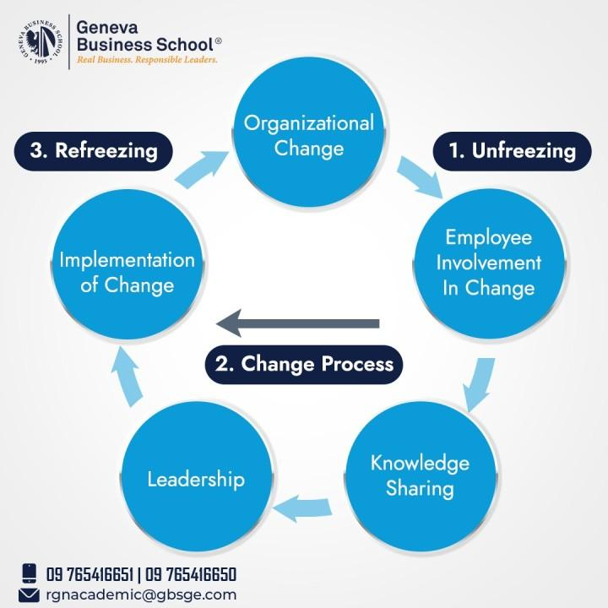
Figure 4: Lewin's Change Management Model
(Source: LinkedIn, 2021)

Kotter's 8-Step Change Management Model
Kotter's 8-step change management model is one kind of change management framework which was developed by John Kotter, and it gives a thorough method for managing organisational change successfully. There are eight subsequent steps in this model such as
Creating a sense of urgency: It is critical to develop a strong case for change and it is highlighted by Kotter in order to inspire change and push past complacency (Lucidity, 2024).
Form a Powerful Coalition: Assemble a strong steering committee with adequate ability and knowledge that can ensure effective leadership and support throughout the transition process.
Create a Vision for Change: If an organisation can able to create an attractive and understandable vision then it helps in assisting in bringing stakeholders together and providing a change in the focus of projects.
Share the Vision: The vision and its advantages should be kept in front of staff members, and it encourages comprehension, dedication, and participation (Lucidity, 2024).
Empower Employees for Broad-Based Action: The organisation should encourage employee empowerment and eliminate the barriers that come in the organisation, and it enables active participation of the staff members in the transformation endeavour.
Generate Short-term Wins: The organisation should highlight and cherish short-term victories and it also gives strength to the initiatives of transformation, efficacy, growth and enthusiasm (Lucidity, 2024).
Consolidate Gains and Produce More Change: It is based on the early victories where leaders keep continuing to change by recognising and resolving ongoing problems (Lucidity, 2024).
Integrate New Approaches into the Organisational Culture: Long-term sustainability will be guaranteed by the integration of new approaches into the organisation, and it also guards against a return to previous methods.
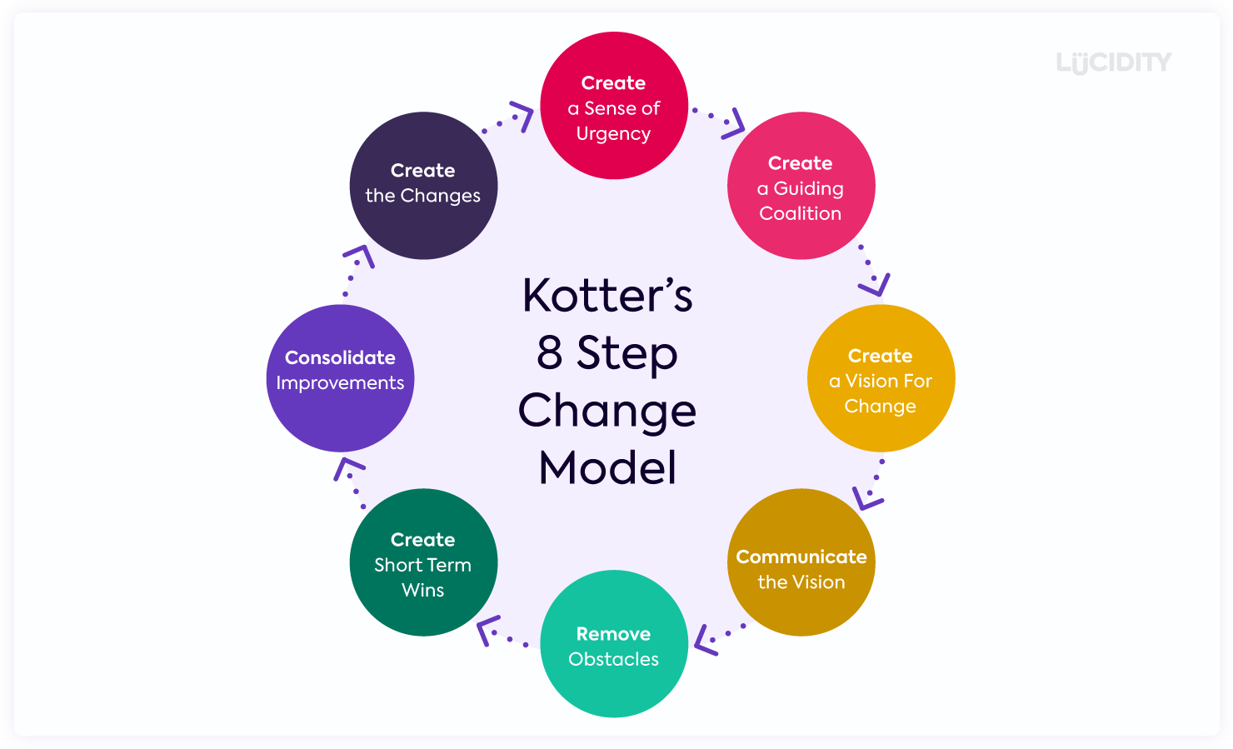
Figure 5: Kotter's 8-Step Change Model
(Source: Lucidity, 2024)
Pros and Cons of Kotter's 8-Step Change Management Model
Pros: A detailed road map for organisational transformation can be offered by this model. This model also takes part in addressing everything from establishing a change of corporate culture to generating a feeling of urgency. This model highlights the importance of leadership and communication through the process of transition, and it helps to guarantee stakeholder engagement and commitment (Mouazen et al., 2023).
Cons: With the help of the eight steps of Kotter's Change Management Model, it appears difficult for smaller organizations or less sophisticated change initiatives. It can be a prolonged process of putting all eight steps together into practice as well as it becomes difficult to place in a hectic work setting or when there is a pressing need for change (Mayo, 2021).
ADKAR Model:
The ADKAR model is a framework that manages change individually. This model was developed by Jeff Hiatt and this model consists of five steps.
Awareness: With the help of these steps, the person can realise the need to make change as well as understand the reason behind its importance and how it will affect them specifically (CrowJack, 2022).
Desire: People become more and more inclined to take part in it after becoming aware of the advantages and drawbacks of the change.
Knowledge: The abilities, information and resources that are required for a successful adaptation are known through this step. This step also helps to gain knowledge and comprehension of changing procedures (CrowJack, 2022).
Ability: The people use knowledge and abilities so that they can carry out the intended tasks and behaviours and the capacity to successfully incorporate the change into their daily activities can be exhibited by them.
Reinforcement: Lastly, with the help of time the change is maintained and reinforced in terms of incentives, rewards, and support systems so that it can promote persistent adherence to the altered procedures and behaviours (CrowJack, 2022).
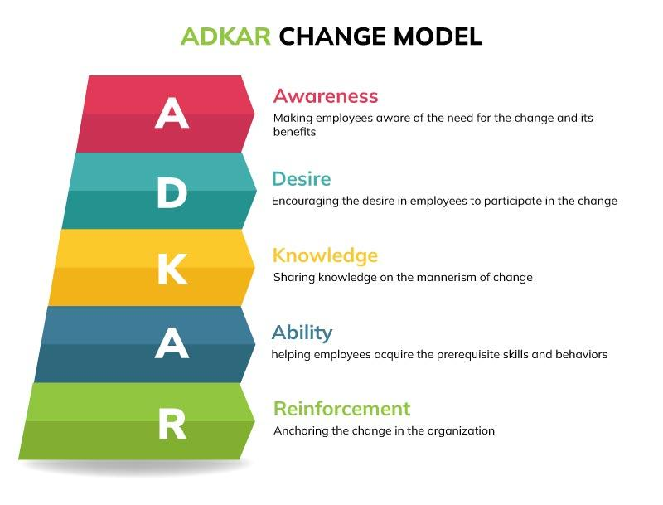
Figure 6: ADKAR Model
(Source: CrowJack, 2022)
The most suitable change management model that is used to implement the identified suitable strategic change for Tesco is Kotter's 8 Steps Change Management Model. Tesco is an international grocery company so it needs to identify various strategic changes over the years so that Tesco can adopt changing conditions of market and customer preferences both during and post-covid situations. Tesco uses Kotter's 8 Steps Change Management Model in such ways,
as creating a Sense of Urgency
The pressing needs for implementing sustainable practices are conveyed effectively with the help of the leadership of Tesco in terms of highlighting the interrelated nature of environmental issues, customer inclinations and legal restrictions. Tesco provides data on focusing patterns of market change, shortage of resources and climate change so that they can highlight the need for change (Paavola and Cuthbertson, 2022).
Create a strong Coalition: A broad coalition of interested parties such as suppliers, managers, employees, and environmental specialists are brought together by Tesco. The resources and talents of Tesco can be pooled together so that they can make the change advance by working together because of creating a common vision for sustainability.
Create a Vision for Change: An attractive sustainability vision is presented by Tesco and Tesco also takes part in imagining a time when they will be the front runner of the retail sector in terms of environmental responsibility (Paavola and Sele, 2020). Preserve profitability and consumer pleasure are the goals of Tesco rather than promoting ethical sourcing, reducing carbon emissions, reducing waste materials as well and improving community engagement rather than Communicate the Vision: Many communication channels are used by Tesco so that they can ensure the vision of sustainability spread widely throughout the organisation. Every worker of Tesco is aware of the justification of changes and the methods of fitting into the larger picture of sustainability.
Empower Employees for Broad-Based Action: The freedom of participating in sustainability projects to the employees is given by Tesco and they also create cross-functional teams so that they can carry out the implementation of green projects by giving training to the employees regarding sustainable practices and as a result it encourages employee creativity and ownership (Sughra, 2020).
Generate Short-term Wins: The advantages of sustainability and creating a wave of change are found in Tesco. Environmental-friendly product categories and energy-saving techniques are included in this stage. Recognition of these accomplishments serves the organisation as a dedication towards sustainability.
Consolidate Gains and Produce More Change: The efforts given by Tesco have increased to be sustainable throughout the company in terms of building its early success (Chkanikova and Sroufe, 2021). Tesco takes part in distributing resources, improvement of procedures, and duplicating best practices so that they can integrate sustainability into essential corporate activities.
Anchor New Approaches in the Culture: Tesco focuses on establishing sustainability as a fundamental principle and customary practice. Sustainability measures are incorporated by Tesco in terms of performance reviews, honor, and encouragement of their staff members and their employees to support environmentally friendly projects to achieve common sustainability objectives (Shewmake et al., 2020).

Section 3- Proposal and Implementation of Change Strategy

Suitable change management plan based on Kotter's 8-Step Change Model
Phase | Activities
Diagnosis and Assessment | Thoroughly assess the company's prospects, dangers, vulnerabilities, and strengths.  To assess change readiness, involve key parties.
Vision and Strategy Development | Define the change the company seeks and make sure it supports Tesco's strategic aims.  Plan with clear goals, deadlines, and benchmarks.
Leadership Alignment and Mobilization | Help Tesco's management team coordinate transformation strategy and vision.  Coaching and leadership development initiatives equip leaders.
Communication and Stakeholder Engagement | Create a comprehensive communication plan to ensure the change message is clear, consistent, and transparent.  Allow stakeholders to voice their issues through feedback mechanisms.
Capacity Building and Support | Give employees the tools, resources, and support they need to adapt.  Promote growth by fostering creativity and learning.
Implementation and Monitoring | Implement the strategic plan's transformation initiatives.  Track progress against benchmarks and metrics.  Be proactive about risks and difficulties.
Evaluation and Adjustment | Regularly assess how change initiatives affect stakeholder satisfaction, Tesco's performance, and culture.  Improve the change management approach based on user feedback and knowledge.

Tesco uses Kotter's 8-Step Change Model to manage change. Communication, leadership, and partner input are crucial at each phase of this process (Colley & Spyridonidis, 2022).
Tesco will examine its current structure. Market possibilities and issues will be examined (Rosnizam et al., 2020). Tesco will improve and assess its change readiness by including key partners in this project. Tesco will create a solid transformation strategy that aligns with its long-term aims and the business review. A detailed strategy with goals, benchmarks, and deadlines will be created.
Managers at Tesco will collaborate on the transformation strategy and aim. Leaders will receive training and education to implement transformation programmes. Clear, transparent, and regular communication will inform many about the changes. This is attainable with a proper communication plan. People's feedback will help Tesco address issues and learn more. People will converse and collaborate more after this.
Tesco employees will receive the support, resources, and tools they need to expand their knowledge and abilities. Learning and being artistic will encourage growth and experimentation. The strategic plan outlines Tesco's transformation initiatives. Success will be monitored against KPIs and targets. To ensure a smooth deployment, any issues will be identified and resolved (Ocran, 2022). To assess Tesco's success, culture, and partners' pleasure, changes will be examined often. Enders et al. (2020) suggest Tesco can handle business changes since the change management strategy has been revised and enhanced based on feedback and lessons gained.

Suitable leadership style for the suggested change strategy
A lot of different types of leadership and ideas could help Tesco start and carry out the planned strategy shift. One style of leadership that stands out as very important is transformational leadership. It talks about how to get staff members excited and motivated to work together to make things better. Transformational leaders at Tesco can bring up new ideas, create a mindset of always getting better, and give an interesting plan. People on staff are much more open to change and willing to work on projects that bring about change when their boss leads them in this way (Jensen, Potočnik and Chaudhry, 2020). As things are being changed, a joint leadership style would also help get people from different areas to work together and reach their goals. People from different levels and places of Tesco can work together, share information, and trade ideas with each other. Fostering a creative environment is a good way for Tesco to use different ideas and experiences to make real changes and reach common goals. Leaders also need to be able to adapt to the fact that things like the COVID-19 spread make the workplace always different. The people in charge at Tesco need to be able to change their plans and goals quickly to take advantage of emerging opportunities. Having an open attitude will help Tesco get through tough times and finish projects to change its strategy.

Step-by-step Process to Implement the Change Strategy
Step | Process
1. Planning | Develop a detailed change management plan, outlining objectives, timelines, and resources.
2. Communication | Establish clear and transparent communication channels to convey the change vision and rationale.
3. Stakeholder Engagement | Engage key stakeholders at all levels of the organization, soliciting feedback and addressing concerns.
4. Leadership Alignment | Align Tesco's leadership team around the change vision and empower them to champion the initiative.
5. Training and Development | Provide comprehensive training and development programs to equip employees with necessary skills and competencies.
6. Pilot Implementation | Conduct a pilot implementation of the change initiative to identify potential challenges and refine the approach.
7. Full Implementation | Roll out the change initiative across the organization, ensuring proper support and resources are provided.
8. Monitoring and Evaluation | Continuously monitor progress against predefined metrics, evaluating the effectiveness of the change strategy.
9. Feedback and Adaptation | Solicit feedback from stakeholders and make necessary adjustments to the change strategy as needed.
10. Celebration and Recognition | Celebrate milestones and successes, recognizing individuals and teams for their contributions to the change effort.

Impact of the Implementation of the Change Strategy on Tesco’s Culture

The way Tesco works is going to change a lot because of the plan they are putting in place. People might change the way they think about being creative and flexible if they get new tools, methods, and ways to do things. Workers could learn to be more adaptable, which would help the company grow and be more creative all the time. Some workers, especially those who don't like change, may be scared and unsure, though. For Tesco's long-term success, it's important for leaders to back the change and for workers to be involved. This will help lower resistance and make a good culture shift (Errida and Lotfi, 2021).

Conclusion and Recommendations
Tesco can adapt to outside factors that bring change, notably during and after COVID-19, if its change management methodology is examined. Tesco employs change management methods and strategic change choices like Kotter's 8-Step Change Model to demonstrate its commitment to stability and competitiveness in the global retail business. Politics, the economy, society, technology, the environment, and the law affect Tesco's operations. The strategy must be adjusted to reduce risks and capitalise on new opportunities. Tesco uses change tactics to encourage innovation, adaptability, and customer focus. Effective leadership, dynamic, inventive, and flexible, led these plans. Leaders must be better trained, workers must be more involved, and communication must improve. Programs that empower individuals, improve communication, and train leaders might solve these issues.

Recommendations for Tesco's future success include:

- Short-term: In the short run, letting more people into the company and making communication better so that everyone knows about the change and can be a part of it (Williams and Wade-Golden, 2023).
- Mid-term: Taking courses to improve leadership that teach leaders how to run change projects well and promote an open culture that is flexible and open to new ideas (Errida and Lotfi, 2021).
- Long-term: Looking at the structure of the company to make it more adaptable and urge teams to work together. In this way, Tesco will be able to react faster to changes in the market and seize new chances (Williams and Wade-Golden, 2023).
Tesco might not be able to keep up with the competition in the global shopping scene if these ideas aren't put into action. They could make people unwilling to change, lead to issues with communicating, and lead to missed chances for growth and new ideas. The way Tesco handles change is aggressive, with strong leadership, a clear strategic vision, and active partner participation. This sets the company up for long-term success and the flexibility to adapt to today's fast-paced business world. To deal with future issues, Tesco will need to see change as a chance to improve and grow. This will help the company become stronger and more adaptable than ever.

References

Amah, O.E. and Ogah, M., 2023. Post-COVID Operational Excellence: Behavioural Operations Management. In Leadership and Organisational Effectiveness Post-COVID-19: Exploring the New Normal (pp. 171-191). Cham: Springer International Publishing. https://link.springer.com/chapter/10.1007/978-3-031-32763-6_10
Béné, C., Bakker, D., Chavarro, M.J., Even, B., Melo, J. and Sonneveld, A., 2021. Global assessment of the impacts of COVID-19 on food security. Global Food Security, 31, p.100575. https://www.sciencedirect.com/science/article/pii/S2211912421000833
Bhattacharya, A. and Fayezi, S., 2021. Ameliorating food loss and waste in the supply chain through multi-stakeholder collaboration. Industrial Marketing Management, 93, pp.328-343.https://www.sciencedirect.com/science/article/pii/S0019850121000171
Burnes, B., 2021. Lewin, Kurt (1890–1947): The Practical Theorist. In The Palgrave Handbook of Organizational Change Thinkers (pp. 937-950). Cham: Springer International Publishing.https://link.springer.com/content/pdf/10.1007/978-3-030-38324-4_13.pdf
Chkanikova, O. and Sroufe, R., 2021. Third-party sustainability certifications in food retailing: Certification design from a sustainable supply chain management perspective. Journal of Cleaner Production, 282, p.124344. https://www.sciencedirect.com/science/article/pii/S0959652620343894
Colley, J. and Spyridonidis, D., 2022. Leading Change in Turbulent Times. In Unprecedented Leadership: Learning to Lead in Turbulent Times (pp. 95-117). Cham: Springer International Publishing. https://link.springer.com/chapter/10.1007/978-3-030-93486-6_5
CrowJack. 2022. Comprehensive Explanation of the Prosci ADKAR Change Model. (Online) Available at:https://crowjack.com/blog/strategy/change-management-models/prosci-adkar-model [Accessed on 13 March 2024]
Dekimpe, M.G. and van Heerde, H.J., 2023. Retailing in times of soaring inflation: What we know, what we don't know, and a research agenda. Journal of Retailing. https://www.sciencedirect.com/science/article/pii/S0022435923000301
Díaz-Martín, A.M., Quinones, M. and Cruz-Roche, I., 2021. The post-COVID-19 shopping experience: thoughts on the role of emerging retail technologies. In Marketing and Smart Technologies: Proceedings of ICMarkTech 2020 (pp. 55-67). Springer Singapore.https://link.springer.com/chapter/10.1007/978-981-33-4183-8_6
Enders, T., Benz, C., Schüritz, R. and Lujan, P., 2020. How to implement an open data strategy? Analyzing organizational change processes to enable value creation by revealing data. https://www.researchgate.net/profile/Tobias-Enders-3/publication/341821156_How_to_Implement_an_Open_Data_Strategy_Analyzing_Organizational_Change_Processes_to_Enable_Value_Creation_by_Revealing_Data/links/5ed603a592851c9c5e7257c9/How-to-Implement-an-Open-Data-Strategy-Analyzing-Organizational-Change-Processes-to-Enable-Value-Creation-by-Revealing-Data.pdf
Errida, A. and Lotfi, B., 2021. The determinants of organizational change management success: Literature review and case study. International Journal of Engineering Business Management, 13, p.18479790211016273.https://journals.sagepub.com/doi/abs/10.1177/18479790211016273
FourWeekMBA. 2023. Tesco PESTEL Analysis. (Online) Available at:https://fourweekmba.com/tesco-pestel-analysis/ [Accessed on 13 March 2024]
Harrison, R., Fischer, S., Walpola, R.L., Chauhan, A., Babalola, T., Mears, S. and Le-Dao, H., 2021. Where do models for change management, improvement and implementation meet? A systematic review of the applications of change management models in healthcare. Journal of healthcare leadership, pp.85-108. https://www.tandfonline.com/doi/abs/10.2147/JHL.S289176
Jensen, M., Potočnik, K. and Chaudhry, S., 2020. A mixed-methods study of CEO transformational leadership and firm performance. European Management Journal, 38(6), pp.836-845.https://www.sciencedirect.com/science/article/pii/S0263237320300773
Johnsen, T.E., Caniato, F., Meqdadi, O. and Miandar, T., 2022. Swimming against the tide: supplier bridging roles in diffusing sustainability upstream and downstream in supply networks. International Journal of Operations & Production Management, 42(10), pp.1605-1629. https://www.emerald.com/insight/content/doi/10.1108/IJOPM-02-2022-0110/full/html
Kumar, G., Meena, P. and Difrancesco, R.M., 2021. How do collaborative culture and capability improve sustainability?. Journal of cleaner production, 291, p.125824. https://www.sciencedirect.com/science/article/pii/S0959652621000445
LinkedIn. 2021. Lewin’s 3 stage CHANGE MODEL. (Online) Available at:https://www.linkedin.com/pulse/lewins-3-stage-change-model-sonal-preet [Accessed on 13 March 2024]
Lucidity. 2024. How to Successfully Implement Kotter’s 8 Step Change Model. (Online) Available at: https://getlucidity.com/strategy-resources/guide-to-kotters-8-step-change-model/ [Accessed on 13 March 2024]
Masenya, T.M., 2022. Integrating talent and knowledge management practices in the new normal business environment: Developing future leaders in public sector organizations. In Navigating the new normal of business with enhanced human resource management strategies (pp. 113-144). IGI global.https://www.igi-global.com/chapter/integrating-talent-and-knowledge-management-practices-in-the-new-normal-business-environment/297405
Mayo, M.A., 2021. Pandemic Preparation & Response: A Case Study Applying Kotter’s 8 Step Change Management Theory to Improve Pandemic Response in an Acute Care Setting.https://medica-musc.researchcommons.org/theses/559/
Moore, S., Ball, C., Cai, M., Flynn, M. and Mulkearn, K., 2021, March. Research into Covid-19 workplace safety outcomes. Trades Union Congress and University of Greenwich.http://gala.gre.ac.uk/id/eprint/33634/
Mouazen, A.M., Hernández-Lara, A.B., Abdallah, F., Ramadan, M., Chahine, J., Baydoun, H. and Bou Zakhem, N., 2023. Transformational and Transactional Leaders and Their Role in Implementing the Kotter Change Management Model Ensuring Sustainable Change: An Empirical Study. Sustainability, 16(1), p.16.https://www.mdpi.com/2071-1050/16/1/16
Nwachuku, A., 2023. MODELS AND APPROACHES TO CHANGE AND CHANGE MANAGEMENT IN MODERN ORGANISATIONS. J-MIND (Jurnal Manajemen Indonesia), 8(2), pp.109-120.https://ojs.unimal.ac.id/jmi/article/view/14435
Ocran, J.N., 2023. The Tesco Group and Sustainable Operations Management. Journal of Earth and Environmental Science Research. SRC/JEESR-264. J Ear Environ Sci Res, 5(12), pp.2-6. https://www.onlinescientificresearch.com/articles/the-tesco-group-and-sustainable-operations-management.pdf
Olarewaju, T., Dani, S., Obeng-Fosu, C., Olarewaju, T. and Jabbar, A., 2024. The Impact of Climate Action on the Financial Performance of Food, Grocery, and Supermarket Retailers in the UK. Sustainability, 16(5), p.1785.https://www.mdpi.com/2071-1050/16/5/1785
Paavola, L. and Cuthbertson, R., 2022. Redefining capabilities as drivers of adaptation, incremental change, and transformation: Recognizing the importance of strategic and operational intent on performance. Journal of Management & Organization, 28(3), pp.522-539. https://www.cambridge.org/core/journals/journal-of-management-and-organization/article/redefining-capabilities-as-drivers-of-adaptation-incremental-change-and-transformation-recognizing-the-importance-of-strategic-and-operational-intent-on-performance/B576AAA46B63F596DDB43C856D4F06DC
Paavola, L. and Sele, K., 2020. Algorithmic Food–How “Software is Eating the World”.https://aisel.aisnet.org/hicss-53/os/ai_and_organizing/2/
Peachy Essay. 2024. EXTERNAL ENVIRONMENT OF TESCO AND MARKET POSITIONING IN THE DIGITAL ECONOMY. (Online) Available at: https://peachyessay.com/sample-essay/external-environment-of-tesco-and-market-positioning-in-the-digital-economy/ [Accessed on 13 March 2024]
Polyaninova, T., 2021. Digitalization of convenience retail in Ireland: How Irish convenience retail companies adapt to changing market demands with aid of digital transformation (Doctoral dissertation, Dublin, National College of Ireland).https://norma.ncirl.ie/5361/1/tayapolyaninova.pdf
Rosnizam, M.R.A.B., Kee, D.M.H., Akhir, M.E.H.B.M., Shahqira, M., Yusoff, M.A.H.B.M., Budiman, R.S. and Alajmi, A.M., 2020. Market opportunities and challenges: A case study of Tesco. Journal of the community development in Asia, 3(2), pp.18-27. http://ejournal.aibpmjournals.com/index.php/JCDA/article/view/807
Rosnizam, M.R.A.B., Kee, D.M.H., Akhir, M.E.H.B.M., Shahqira, M., Yusoff, M.A.H.B.M., Budiman, R.S. and Alajmi, A.M., 2020. Market opportunities and challenges: A case study of Tesco. Journal of the community development in Asia, 3(2), pp.18-27.http://ejournal.aibpmjournals.com/index.php/JCDA/article/view/807
Shewmake, T., Siegel, A. and Hiatt, E., 2020. The history and progression of sustainability programs in the retail industry. Channel strategies and marketing mix in a connected world, pp.247-274.https://link.springer.com/chapter/10.1007/978-3-030-31733-1_10
Statista. 2024. Percentage change in sales at Tesco in Great Britain compared to a year earlier from January 2015 to October 2023. (Online) Available at:https://www.statista.com/statistics/386598/tesco-sales-percentage-change-great-britain-uk/#:~:text=Tesco%20in%20numbers&text=The%20company%20made%20a%20revenue,company%20make%20in%20Central%20Europe [Accessed on 13 March 2024]
Sughra, G., 2020. Socially Responsible Retailing. The Palgrave Handbook of Corporate Social Responsibility, pp.1-26. https://link.springer.com/content/pdf/10.1007/978-3-030-22438-7_65-1.pdf
Tesco. 2024. About Us. (Online) Available at:https://www.tescoplc.com/about/#:~:text=About%20Us,an%20easier%20way%20of%20living [Accessed on 13 March 2024]
The Business Model Analyst. 2024. Tesco PESTLE Analysis. (Online) Available at: https://businessmodelanalyst-com.cdn.ampproject.org/v/s/businessmodelanalyst.com/tesco-pestle-analysis/amp/?amp_gsa=1&amp_js_v=a9&usqp=mq331AQIUAKwASCAAgM%3D#amp_tf=From%20%251%24s&aoh=17103136751023&referrer=https%3A%2F%2Fwww.google.com&ampshare=https%3A%2F%2Fbusinessmodelanalyst.com%2Ftesco-pestle-analysis%2F [Accessed on 13 March 2024]
Williams, D.A. and Wade-Golden, K.C., 2023. The chief diversity officer: Strategy structure, and change management. Taylor & Francis. https://books.google.com/books?hl=en&lr=&id=cg7JEAAAQBAJ&oi=fnd&pg=PT10&dq=change+management+strategies&ots=eRLkXJ_tsj&sig=nUpce86gUisGKposRsVuvloyMaM

