Skills and Research Methods
Impact of the Virtual Learning Environment (VLE) – Moodle on the learning experience of students

STUDENT NAME: Ana-Maria Visan
STUDENT ID: 1921995
LECTURER: Husam Alharahsheh

Table of Contents
Introduction 2
Secondary Data 3
Aim and Objectives 5
Methodology 6
Results 7
Findings and Analysis 11
Conclusion 13
Reference 14
Appendix: Survey Questionnaire 15

Introduction
This report has been produced to analyse the impact of the Virtual Learning Environment (VLE) – Moodle on the learning experience of students at the University of Wales Trinity Saint David London Campus.
A virtual learning environment (VLE) is the web based educational technology for the use of the digital aspects in the study courses that are typically used within the educational institution. The VLE present activities, interactions and resources in the course structure and make provision for the various assessment stages (Kalayci, 2015). The interest related to VLE has enhanced as the internet is commonly used by institutions, students and professors thus making it possible to provide support to learning.

Secondary Data
Background of VLE
Online education has been challenging, however, especially in current times when the world is in the grasp of a global pandemic and social distancing and lock down have to be enforced, both students and institutions have used online platforms to ensure the course is not hindered even if physical classes had to be discontinued or be held with scheduled intervals observed Balint and Allbeck (2017). The acceptance of VLE and educational technology has made it possible to achieve indicators pertaining to the learning requirements of the students. The VLE has made it possible to acquire as well as store the interactions of students in relation to their activities. According to Ismail (2019), such digital log of data is assessable for the identification of the patterns in behaviour that offer indicators for education practice.
Data that is acquired by means of user interaction with the technology is evaluable and this has the promise of aiding the improvement in understanding of the learning process opined Hampel and Dancsházy (2014). Analysis of learning includes assessment of the learning data that permits the teacher, designers of the courses and also the VLE administrators to search information and patterns that are fundamental in the learning process. Shandilay (2018) was of the opinion that the use of the VLE has made it possible for the teachers to adequately plan the lessons, manage work that is administrative in nature, track the performance of the student, keep track of the activities and also maintain engagement and provide more information and support to those who require the same.
Moodle – Learning Management System
Moodle is an open source and free learning management system (LMS) that is distributed under GNU General Public License and written in PHP. Moodle has been developed on the pedagogical principles and used for distance learning, blended learning, flipped classroom and also other projects that are e – learning based in educational institutes, work places and also in other sectors observed Dwi (2014). Moodle has customizable features and therefore is used for the creation of private websites so that online courses used by trainers and educators can achieved the desired learning goals. The learning environment can be tailored and extended with the use of Moodle using the community sourced plug – ins.
Benefits and Drawbacks of Moodle
The main benefits of the system is its availability at a low cost with different abilities being offered to the administrators and teachers in teaching thus being easy to implement. Moodle also permits different content formats to be available and uploaded for the instructor and students to use. Along with distance and online learning, Moodle enables resources to be made available for students who are in classes that are instructor led. Joh (2015) added that there are different tools and options available for supporting communication in the form of blogs, chats, forums and messages.
However, there are certain drawbacks of the system; these include Moodle not being developed enough to cope with the larger projects. As more students access the platform, the system tends to get slow which is not ideal for the students when there is a quiz or a test opined Xu and Mahenthiran (2016). There are also chances of the website shutting down and blocking the students from accessing the course material. Users have also complained about the customisation experiences with Moodle once there has been extensive use.

Aim and Objectives
Aim
The aim of the study is to analyse the impact of the Virtual Learning Environment (VLE) – Moodle on the learning experience of students. For this purpose, the University of Wales Trinity Saint David London Campus will be used for collecting primary data.
Objectives
- To assess the aspect of VLE and its relevance
- To evaluate the advent of Moodle within the learning environment of educational institutions
- To analyse how students at University of Wales Trinity Saint David London Campus use Moodle for a better learning experience

Methodology
The study includes both primary and secondary sources of information to add value to the research, secondary data has been sourced by referring to different literary sources like books, articles, blogs, journals and other published work (Trafimow, 2013). Such secondary information is beneficial for the development of the research informative base. Collection of primary data aids in obtaining quantitative data for the study that provides an insight into the influence of the VLE system of the students at the University of Wales Trinity Saint David London Campus. The first hand response gathered from the participating students is analysed and evaluated with the support of graphs and charts.

Results
20 students were provided with the survey questionnaire online; their responses have been represented graphically below:
Q1. How long have you been studying at the University of Wales Trinity Saint David London Campus?
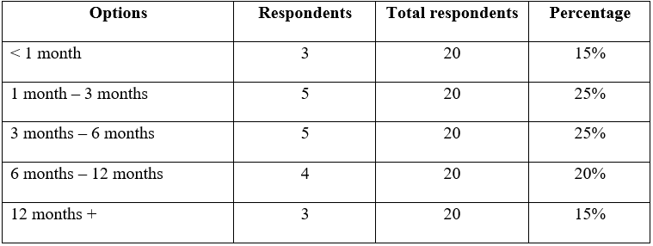
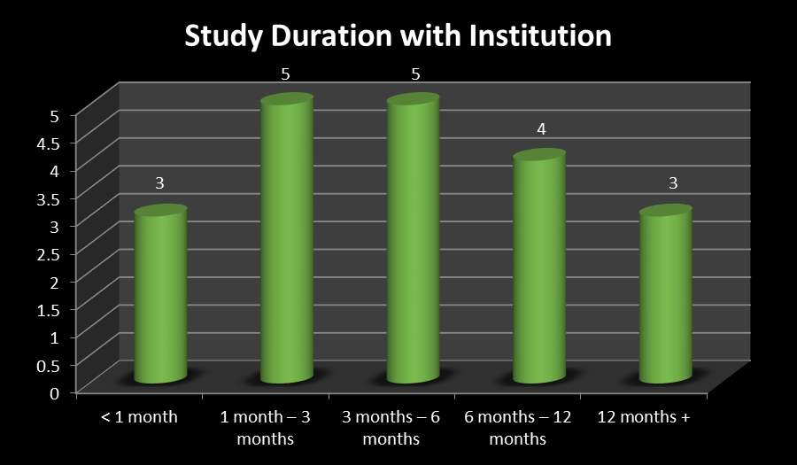
Q2. Have you ever used the VLE?
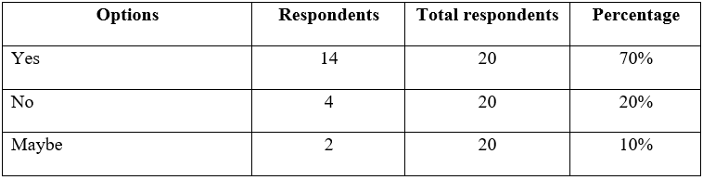
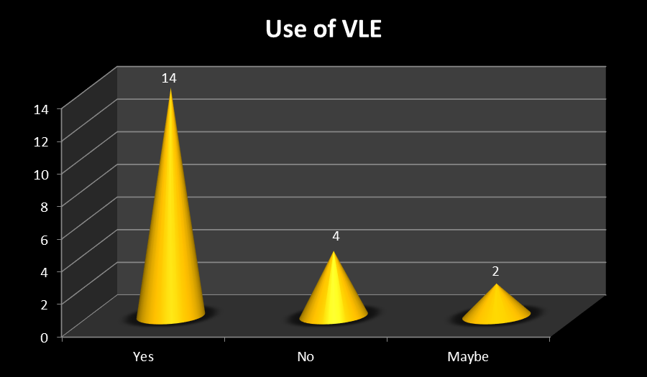
Q3. Do you agree that Moodle has been useful in your course?
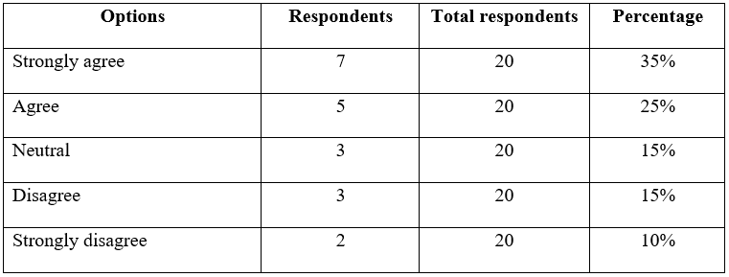
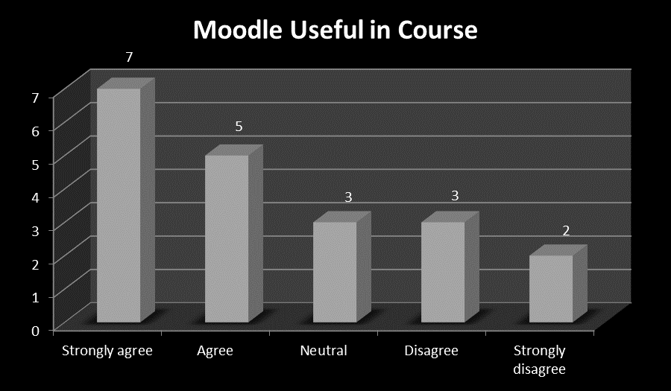
Q4. Rate your experience with Moodle on a scale of 5 to 1 with 5 being highest
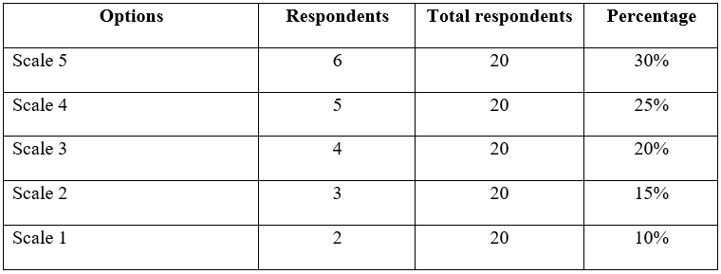
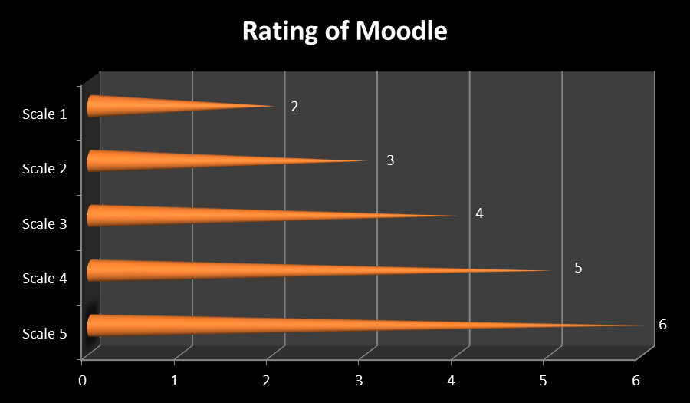
Q5. Do you believe Moodle has room for improvement?
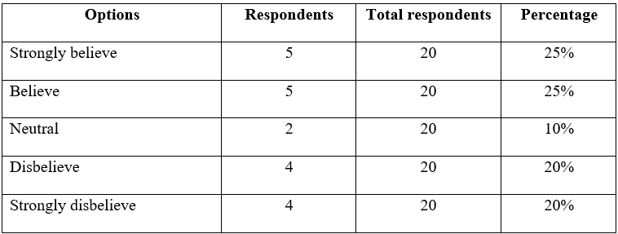
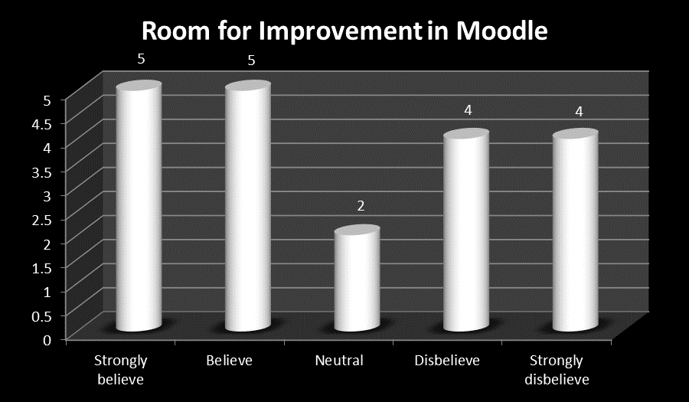
Q6. What is your recommendation for Moodle?
Options | Respondents | Total respondents | Percentage
Higher speed | 3 | 20 | 15%
Ease of navigation | 4 | 20 | 20%
Improved content | 5 | 20 | 25%
More interactive interface | 6 | 20 | 30%
Others | 2 | 20 | 10%

Findings and Analysis
The research survey was conducted considering the students at the University of Wales Trinity Saint David London Campus as participants whose response contribute towards quantitative primary data for the research. As a result of the on - going pandemic situation, the survey was conducted online and not through inter – personal communication. This was adhered to for the well – being and safety of the students. 20 participants were included in the survey to analyse the impact of the Virtual Learning Environment (VLE) – Moodle on the learning experience of students.
The first question was about the duration of studying at the University of Wales Trinity Saint David London Campus. 15% respondents said they had been associated with the institute for less than 1 month, 25% respondents said they had been associated with the institute for 1 month to 3 months, 25% respondents said they had been associated with the institute for 3 months to 6 months, 20% respondents said they had been associated with the institute for 6 months to 12 months and 15% respondents said they had been associated with the institute for more than 12 months. Having diversity among the respondents helped in getting different perspectives thus reducing the scope of partiality or bias.
The second question asked the respondents if they had ever used a VLE to which 70% responded positively, 20% responded negatively and 10% were uncertain in their response. VLE is an integral part of educational course work in current times, therefore it is extensively used to facilitate students, professors and institutes in current times in ensuring the course work reaches the right person with the use of the right resources.
The third question asked the respondents if Moodle was useful in their course work to which 35% strongly agreed, 25% agreed, 15% were neutral in their response, 15% disagreed and 10% strongly disagreed. VLE like zoom, Dashboard and Moodle are used to make the online learning system easier. Especially in the wake of the current pandemic where institutions are having norms for social distancing and scheduled classes where majority of the interaction is made online.
The fourth question asked the participants to rate Moodle on a scale of 5 to 1 with 5 being highest to which 30% gave the highest rating of Scale 5, 25% gave the rating of Scale 4, 20% provided an average rating of Scale 3, 15% responded with Scale 2 and the lowest Scale 1 was given by 10% respondents. Rating of Moodle was provided by the participants based on their experience with the VLE. Participants who could use the system to the best of its ability provided a high rating while those who struggled with the use of Moodle would give ratings according to their use.
The fifth question pertained to if Moodle needed improvement to which 25% strongly believed, 25% believed, 10% were neutral in their response, 20% disbelieved and another 20% strongly disbelieved. As observed in the disadvantages of Moodle discussed in the literature review, extensive use makes the system slow and there is also issues related to the content where large projects tend to be at a disadvantage. Also at times, the system shuts down which is inconvenient for the students. Therefore the respondents had mixed responses to the question.
The last question asked the students about their recommendation for Moodle to which 15% said higher speed, 20% said ease of navigation, 25% said improved content, 20% said more interactive interface while 10% had other responses. The respondents shared their opinion based on their experiences with the system. They would obviously provide opinion on those aspects which had been problematic for them.
The responses collected from the participants shed light on the view of the users and the acceptance of Moodle among the student community. Since it was not feasible to take into consideration all the students of University of Wales Trinity Saint David London Campus, 20 participants were considered to gauge the attributes of all the students.

Conclusion
The utility of the VLE is undeniable and appropriate for the current times where the students are obtain help in pursuing their courses effectively. Also due to the Corona Virus spread, VLE have been extensively used all over the world to facilitate institutions and students to seamlessly continue with the course and not discontinue when half the world was under lock down. The current study that takes into consideration the opinions of students at the University of Wales Trinity Saint David London Campus, it is evident that VLE is a useful system that has been designed efficiently for supporting the students in accessing diverse study material, learning requirements and help the students execute their projects efficiently. As VLE is informative, interactive and fast, students can continue with their courses even if it is conducted online and aid their process of learning. Moodle being free and customisable, the learning goals are duly met. Also since Moodle can be accessed on mobile apps, google Play, Windows Phone Store, iOS App Store and F – Droid, it is convenient for the students to access it anywhere anytime using different gadgets. This makes the learning process more engaging with interaction of the professor and student and ensuring that the course work achieves the desired outcome level.

Reference
Balint, J. and Allbeck, J., 2017. ALET: Agents Learning their Environment through Text. Computer Animation and Virtual Worlds, 28(3-4), p.e1759.
Hampel, G. and Dancsházy, K., 2014. Creating a Virtual Learning Environment. Journal of Agricultural Informatics, 5(1).
Herman Dwi, H., 2014. The Evaluation of a Moodle Based Adaptive e-Learning System. International Journal of Information and Education Technology, pp.89-92.
Ismail, S., 2019. Using a Virtual Learning Environment for Problem Based Learning (P.B.L). SSRN Electronic Journal,.
Joh, H., 2015. Quantitative Risk Assessment in Moodle Learning Management System. International Journal of Software Engineering and Its Applications, 9(8), pp.253-262.
Kalayci, S., 2015. Students’ Attitudes Towards Collaborative Tools In A Virtual Learning Environment. Educational Process: International Journal, 4(1-2), pp.71-86.
Shandilay, D., 2018. Virtual Learning Environment Scenario in Higher Education (Web-based Learning). International Journal Of Management And Economics Invention, 04(05).
Trafimow, D., 2013. Considering Quantitative and Qualitative Issues Together. Qualitative Research in Psychology, 11(1), pp.15-24.
Xu, H. and Mahenthiran, S., 2016. Factors that Influence Online Learning Assessment and Satisfaction: Using Moodle as a Learning Management System. International Business Research, 9(2), p.1.

Appendix: Survey Questionnaire


