
Problem Solving and Decision Making
BMSW4004 – London Campus

By: Cristian Radu (2125545)
Lecturer: Laila Maazouz

Table of Contents
Introduction 4
Cause and effects 5
FISHBONE DIAGRAM 5
Situational Analysis Models 5
PESTLE ANALYSIS 5
Range of Alternative Solutions 6
Evaluation of Alternative Solutions 6
DECISION MAKING MATRIX 7
Implementing the solution 7
GANNT CHART 8
Communication Plan with Stakeholders 9
INFLUENCE AND INTEREST MATRIX 10
STAKEHOLDER COMMUNICATION PLAN 11
MONITORING AND REVIEWING TECHNIQUES 12
CONCLUSION 14
REFERENCES 14
APPENDIX 15
Appendix Role Play slide 1 15
‌Appendix Role Play slide 2 15
Appendix Role Play slide 3 16
Appendix Role Play slide 4 16
Appendix Role Play slide 5 17
Appendix Role Play slide 6 17
Appendix Role Play slide 7 18
Appendix Role Play slide 8 18
Appendix Role Play slide 9 19

Introduction

Problem solving and decision making are the important skills that are necessary for success on both personal and professional life. Problem solving involves identifying and solving problems, whilst decision making involves choosing the best course of action from a range of options. Both skills require the ability to think critically and creatively, and to consider multiple perspectives.
Effective problem solving and decision making require a clear understanding of the problem or decision at hand, as well as the ability to gather and estimate information, generate, and evaluate potential solutions, and make a well-informed choice.
These skills can be developed and improved over time through practice and experience.
Essex Roofing LTD, is facing a common problem that many companies encounter. Some of its employees are struggling financially due to low salaries. This issue can lead to a range of negative consequences, including low morale, high turnover, and difficulty in attracting and retaining top talent. To address this problem, the company needs to implement a solution that addresses the root cause of the issue and ensures that employees are fairly compensated for their work.
Financial difficulties due to low salary
The main problem at Essex Roofing Ltd is that some employees are experiencing financial difficulties due to low salaries. This issue is not unique to this company, but it can have serious consequences for both the employees and the organization.

Cause and effects

FISHBONE DIAGRAM
Social
Economical

Tax rates –
Tax regulations –
Policies and regulations -
Personal
Political
Individual income –
Spending habits -
Resource availability –
Cost of public services -
Health care -
Inflation -
Unemployment rates -
Wages -
Low salary, financial difficulties

In Essex Roofing Ltd case, we have interviewed one of our employees that has experienced physical stress due to working overtime due to his financial constraints.
Working overtime can have both positive and negative impacts on an organization. Can help the organization to complete important projects or meet deadlines, raising more productivity and profits.
On the negative side, employees working overtime could also have a adverse impact on the organizations interests. For example, decreasing employee’s productivity and morale on a long term, which they could become dissatisfied with their job and look for other opportunities.
After implementing research using the fishbone diagram, I have found out, that, the real cause that is dissatisfying the employee is based on the following factors, low salary, inadequate benefits, and lack of opportunities for financial growth.

Situational Analysis Models

PESTLE ANALYSIS
Political factors
- Government regulations and policies related to the construction industry could affect the operations and profitability of Essex Roofing ltd.
- Changes in the political climate, such as shifts in government leadership, could impact the business environment and demand for the company’s services.
Economic factors
- Changes in the economy, such as interest rates and unemployment rates, can affect the demand for roofing services and the profitability of Essex Roofing LTD.
- Competition from other roofing companies can also impact the pricing and profitability of the business.
Social factors
- Changes in the demographics, such as population growth or aging, can affect the demand for roofing services.
- Consumer attitudes and preferences towards roofing materials and sustainability can also affect the business.
Technological factors
- Advances in roofing technology, such as the development of new materials or construction methods, can impact the business.
- The use of technology, such as project management software, can affect the efficiency and productivity of the company.
Legal factors
- Changes in laws and regulations, such as health and safety regulations, can impact the business.
- Intellectual property issues, such as patent disputes, can also affect the company.
Environmental factors
- Extreme weather events, can impact the business operations in Essex Roofing LTD.
- Sustainability concerns and use of eco-friendly materials can also affect the company’s daily routine.

Range of Alternative Solutions

- Solution1: Provide training to improve skills
- Solution 2: Propose a salary review
- Solution3: Offer performance-based bonuses

Evaluation of Alternative Solutions

According to Indeed Career Guide. (n.d.). What is a Decision Matrix? (With Benefits and Tips). A decision matrix may be essential for an organization and its stakeholders to make complex business decisions. Professionals use it to streamline project considerations for their organization by evaluating alternatives that may be necessary. Understanding this tool and how to implement it can be helpful for your project management.

DECISION MAKING MATRIX
Importance | Factors | Provide training to improve skills | Offer a salary review | Offer performance-based bonuses
1 | Costs | 2x1=2 | 4x1=4 | 3x1=3
2 | Performance | 2x2=4 | 3x2=6 | 3x2=6
3 | Productivity | 2x4=8 | 3x4=12 | 4x4=16
4 | Sustainability | 4x3=12 | 4x3=12 | 4x3=12
Score |  | 26 | 34 | 37

In this matrix, the weight of each solution reflects its relative importance and value.
The higher the weight, the more favourable the solution. Based on the score assigned, the solution that I would favour is offering performance-based bonuses. This solution has a majority score of 37, which is higher than the scores of the other two solutions. However, it is important to consider the factors for each solution and how the aligned with the goals and values of the company.

Implementing the solution
An implementation plan for a performance-based bonus solution outlines the steps that need to be taken to successfully implement this type of program in the organization. Here are the key components of an implementation plan for a performance-based bonus program:
- Identify goals, such as identifying the goals, determine the performance metrics that will be used to evaluate employee performance. For example:
- Sales volume
- Customer satisfaction score
- Efficiency measures
- Plan developing, such as setting clear performance targets for each employee. These should be based on the performance metrics and should be achievable, but also challenging.
- Communicating the plan. Explaining to employees the performance metrics that will be used, the criteria for receiving a bonus and the timeline of evaluation.
- Setting an implementation deadline, by selecting a start and end date.
- Monitoring the effectiveness, by using data or feedback to track the progress towards performance targets.

GANNT CHART
A Gannt chart is a graphical representation of a project schedule that shows the start and end dates of tasks and their dependencies on one another. It is often used to visualize the progress of a project and to identify any potential delays or blockages.
According to the Project Management Institute’s (PMI), A Guide to the Project Management Body of Knowledge (PMBOK Guide), a Gannt chart “is a bar chart that illustrates the breakdown of a project into its component tasks, and the relationship between tasks and the project schedule.”
The PMBOK Guide also notes that Gannt charts can be used to “depict the start and the finish dates of the terminal elements and summary elements of a project, including the dependencies between the terminal elements.” In other words, a Gannt chart is a visual tool that helps project managers and team members understand the tasks that need to be completed, the order in which they need to be completed, and how they fit into the overall project timeline. It is often used to track progress, identify potential issues and adjust the project plan as needed.
Task Activity Predecessor Duration(weeks)
Task 1 | Brainstorming | - | 2
Task 2 | Defining | 1 | 1
Task 3 | Developing | 2 | 2
Task 4 | Communicating | 3 | 1
Task 5 | Implementing | 4 | 1
Task 6 | Monitoring | 5 | 4
11

Communication Plan with Stakeholders
A Communication plan is a document that outlines how and when you will communicate with stakeholders. It is a tool that helps you effectively share information and updates with the people who are impacted by your work or have a stake in its success.
A communication plan typically includes:
- A list of stakeholders: Identifies who the stakeholders are, including employees, customers, suppliers, shareholders, community members, and any other individuals or groups that have interest in the organization.
- Communication goals: Outlines the specific goals of the communication plan, such as keeping employees informed about company news and updates, engaging customers, and gathering feedback, or building relationships with suppliers.
- Target audience: Indicates the specific groups of stakeholders that the communication plan is targeting, such as employees, customers, or shareholders.
- Message: Defines the key messages that will be communicated to stakeholders, including any important information or updates that need to be shared.
- Communication channels: Identifies the specific channels that will be used to reach the stakeholders, such as emails, newsletters, social media, meetings, or telephone calls.
- Timing: Establishes a schedule for communication with stakeholders, including the frequency and timing of updates, newsletters, and other communication activities.
- Evaluation: Outlines how the effectiveness of the communication plan will be measured, including any metrics or scales that will be used to assess the plan’s success.
In Essex Roofing Ltd company’s case, the stakeholders are:
- Internal: Employees, Management team, and Board of Directors
- External: Customers, Suppliers, Local Community, Government, and Investors

INFLUENCE AND INTEREST MATRIX

According to Finance, (2015). Stakeholder engagement within a programme or project | Department of Finance. A stakeholder matrix is another simple technique. It illustrates the level of impact of the change on stakeholders against the importance of the stakeholders to the success of the change.
high
Meet Their Need
Key Player

Influence of Stakeholder
Keep Informed
Low Priority

low
high
low
Interest of Stakeholder

STAKEHOLDER COMMUNICATION PLAN

Stakeholders | Interest | Key interest & issues | Communication  Vehicle | Frequency | Comments
Employees | high | Opportunities for growth and development, changes to policies and procedures | Internal email updates, staff meetings, suggestion boxes | Weekly/monthly  Monthly staff meetings | It is important to keep employees informed and involved for positive work environment and increase engagement and retention
Management | high | Financial performance updates | Management team meetings, emails | Monthly, as needed email updates | Effective communication with the board is essential to ensure goal alignment
Board of Directors | high | Financial performance, compliance with laws and regulations | Board meetings, board reports, executive presentations | Quarterly board meetings, as-needed board reports and presentations | It is important to keep the board of directors informed and updated on the company’s performance and plans
Customers | high | Changes to pricing or policies | Emails, newsletters, social media, customer service | Monthly newsletters, social media updates, etc. | Keeping customers informed and addressing any concerns they may be essential for maintaining good relationships
Suppliers | low | Updates on payment schedules, changes of prices or terms of business | Email updates, phone calls, etc. | As-needed email updates, monthly check-ins | Maintaining good communication with suppliers is important for ensuring a smooth and efficient collaboration
Local Community | low | Updates on company operations and the impact on the local community | Newsletters, social media | Monthly newsletters, as-needed social media updates | Engaging with the local community and keeping them informed about the company’s operations can help to build trust and support
Government | high | Updates on company operations and their impact on local community, any changes to law and regulations | Meetings with government officials, email updates, public press releases | As needed meetings and updates | Maintaining a good communication with government officials is ensuring a compliance with laws and regulations
Investors | High | Financial performance updates, dividends, strategic planning | Investor presentations, earning calls, annual reports | Quarterly investor presentations, earning calls after each financial quarter, annual report | Keeping investors informed about the company’s performance and plans is essential for maintaining the confidence and support

MONITORING AND REVIEWING TECHNIQUES

According to Indeed Career Guide (n.d.). ADKAR Model: What it is and how to us it (With Benefits). When a business is implementing a company change, such as using a new software or changing the organizational structure, it can be beneficial to use a change management method. The ADKAR method a simple framework for all employees to use before, during and after the change happens and provides clear goals for employees to track their development and successes. Companies that are planning an organizational change may benefit from considering the ADKAR model or method to ease the transition.
Here is a breakdown of what the ADKAR model stands for and how companies use it when implementing a change:
- Awareness: The first step, which focuses on understanding the reason for change
- Desire: After employees become aware of why they need the change, they can learn how it can benefit them and find the desire to make the change.
- Knowledge: The next step is to identify the knowledge they’re going to need to learn how to successfully make the change.
- Ability: Involves the confidence and tools required to effectively gain the skills or behaviours intended because of the transition.
- Reinforcement: The final step, which provides a follow-up process to ensure the change is permanent.

In Essex Roofing management situation, the ADKAR model is applying on the following

AWARNESS | DESIRE | KNOWLEDGE | ABILITY | REINFORCEMENT
Communicating the rationale for introducing performance-based bonuses, such as the desire to improve the employee motivation and productivity. | Highlighting the benefits of performance-based bonuses to employees, such as the opportunity to earn higher pay based on their efforts and achievements. | Provide employees with the knowledge and skills they need to succeed under the new bonus system. This might involve training on how the bonus system will work, what is expected of employees, and how they can track their ow performance. | Help employees develop the ability to apply what they have learned in the new bonus system. This might involve providing ongoing support and coaching to help employees understand how to meet the expectations of the bonus system. | Reinforce the system by recognizing and rewarding the employees for their efforts and achievements. This can help to ensure that the changes are sustained over long term.

CONCLUSION

Problem solving and decision making are crucial skills for organizations to effectively operate and achieve their goals.
Problem solving allows organizations to identify and solve problems in timely and efficient manner whilst decision making, ensures that the best possible course of action is chosen to address a given problem.

REFERENCES

- Cajade Sánchez, D. and Solar Serrano, P. del (2019). Integration of the BIM execution plan with the guide to the project management body of knowledge (PMBOK®) of PMI (Project Management Institute) = Integración del plan de ejecución BIM con la guía para la dirección de proyectos (PMBOK®) de PMI (Project Management Institute). Building & Management, 2(3), p.24. doi:10.20868/bma.2018.3.3839.
- Finance. (2015). Stakeholder engagement within a programme or project | Department of Finance. [online] Available at: https://www.finance-ni.gov.uk/articles/programme-and-project-stakeholders.
- ‌ Indeed Career Guide. (n.d.). ADKAR Model: What It Is and How To Use It (With Benefits). [online] Available at: https://www.indeed.com/career-advice/career-development/what-is-adkar-model.
- Indeed Career Guide. (n.d.). What Is a Decision Matrix? (With Benefits and Tips). [online] Available at: https://www.indeed.com/career-advice/career-development/what-is-decision-matrix.

APPENDIX

Appendix Role Play slide 1

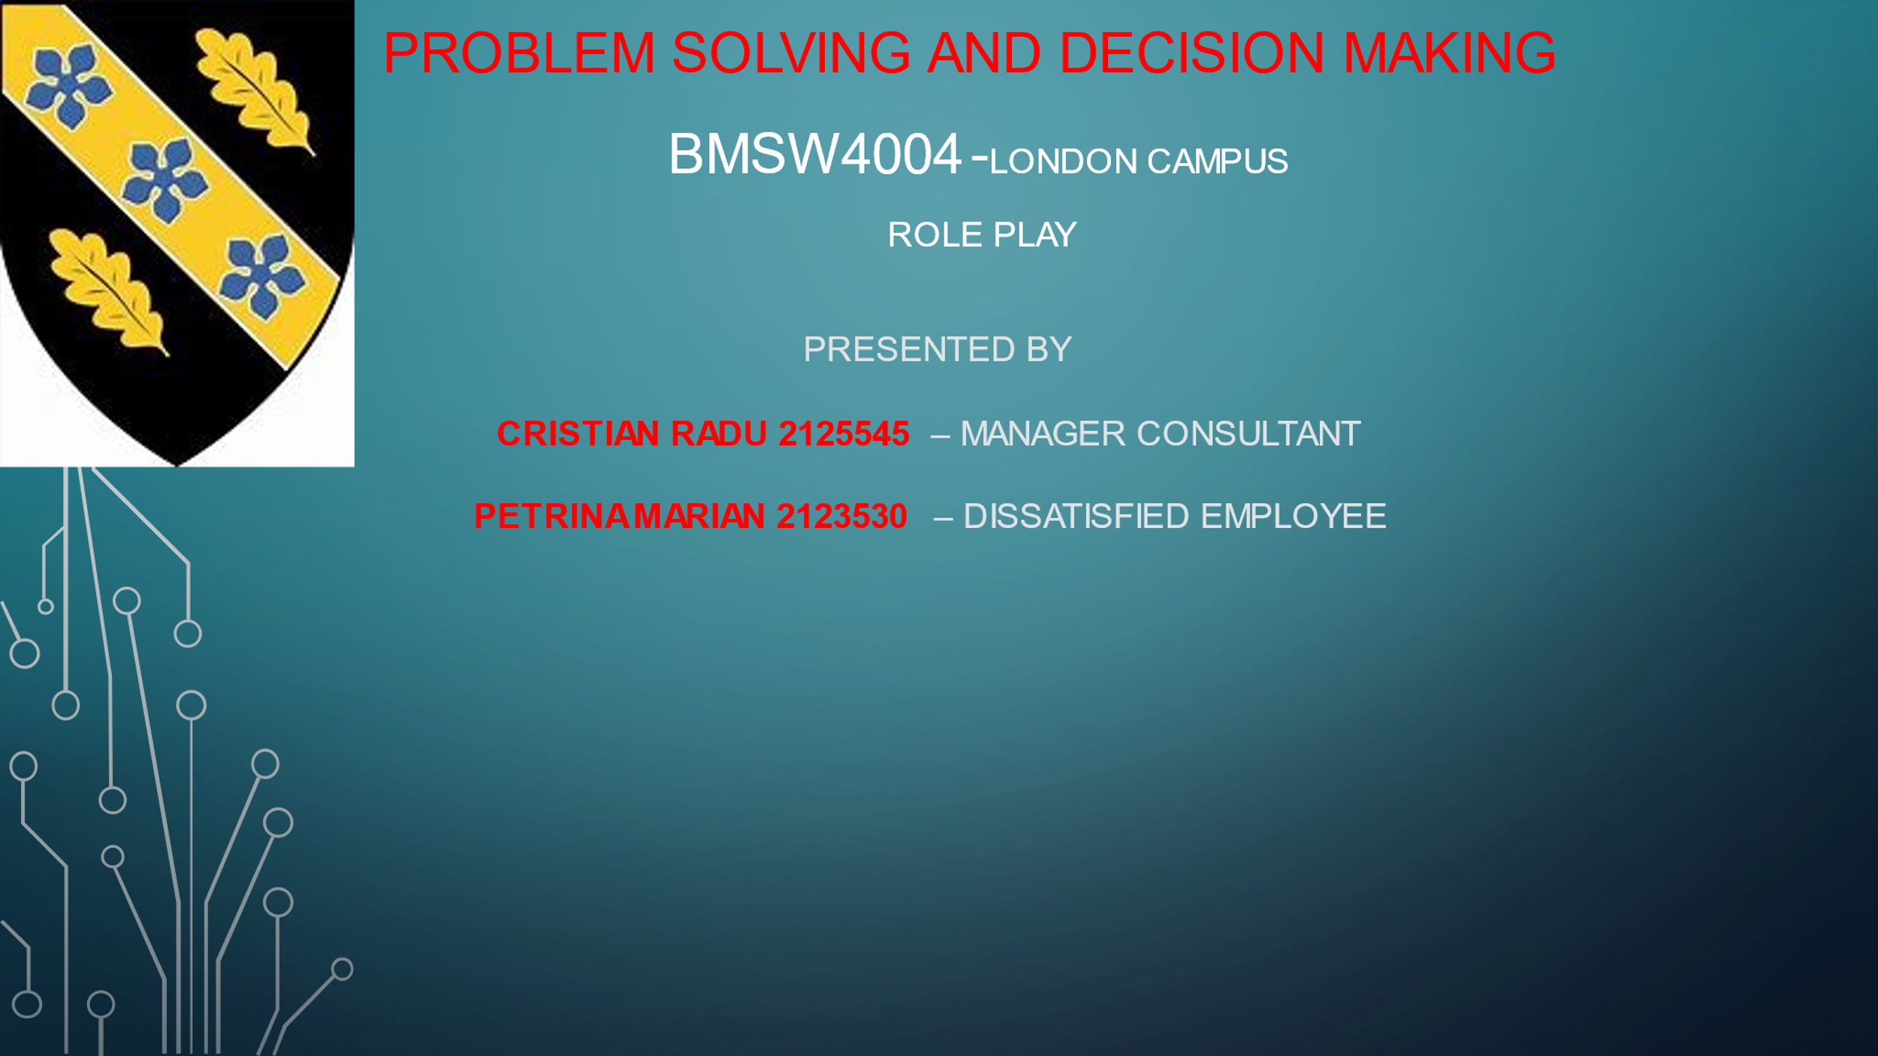

‌Appendix Role Play slide 2

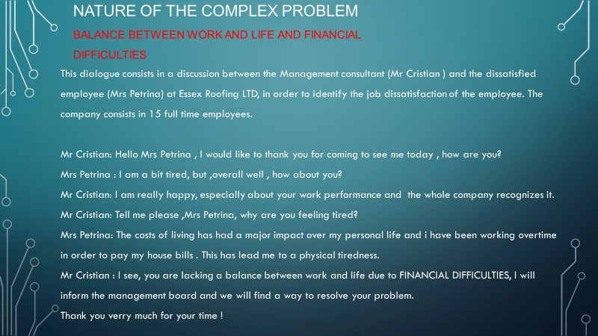

Appendix Role Play slide 3

‌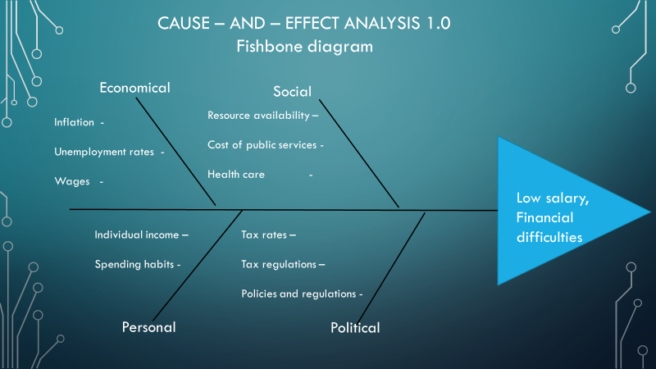

Appendix Role Play slide 4
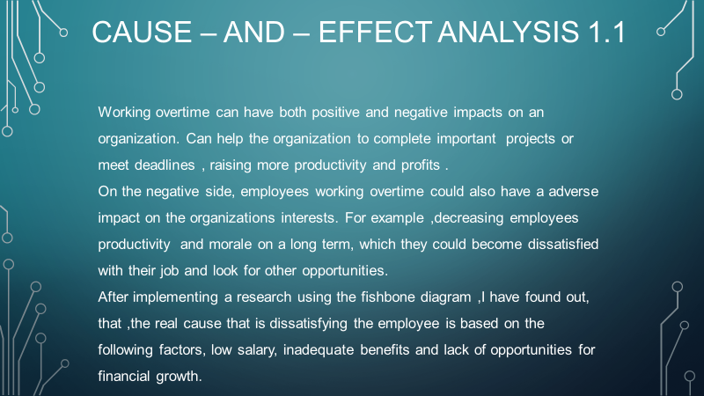

Appendix Role Play slide 5

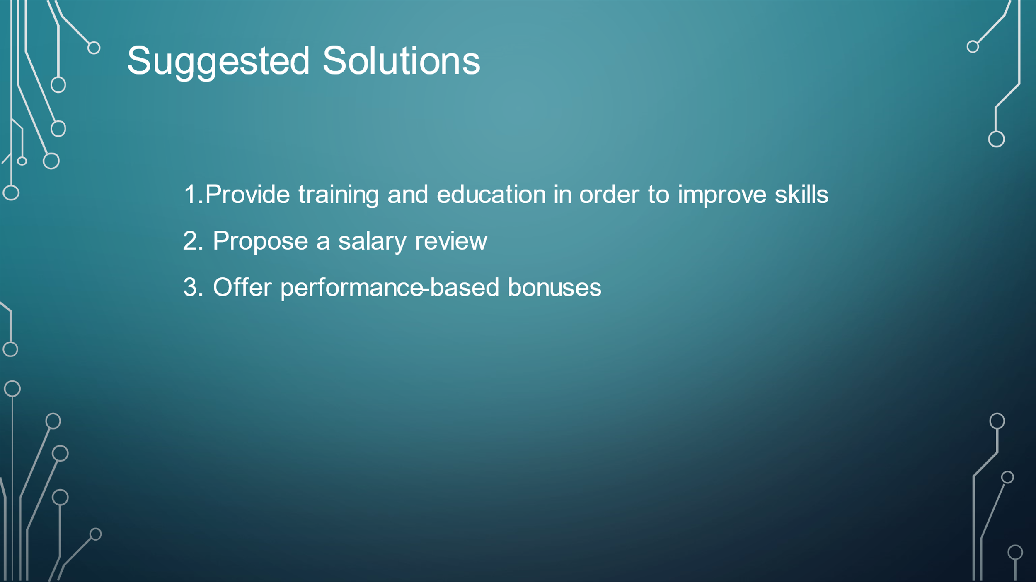

Appendix Role Play slide 6

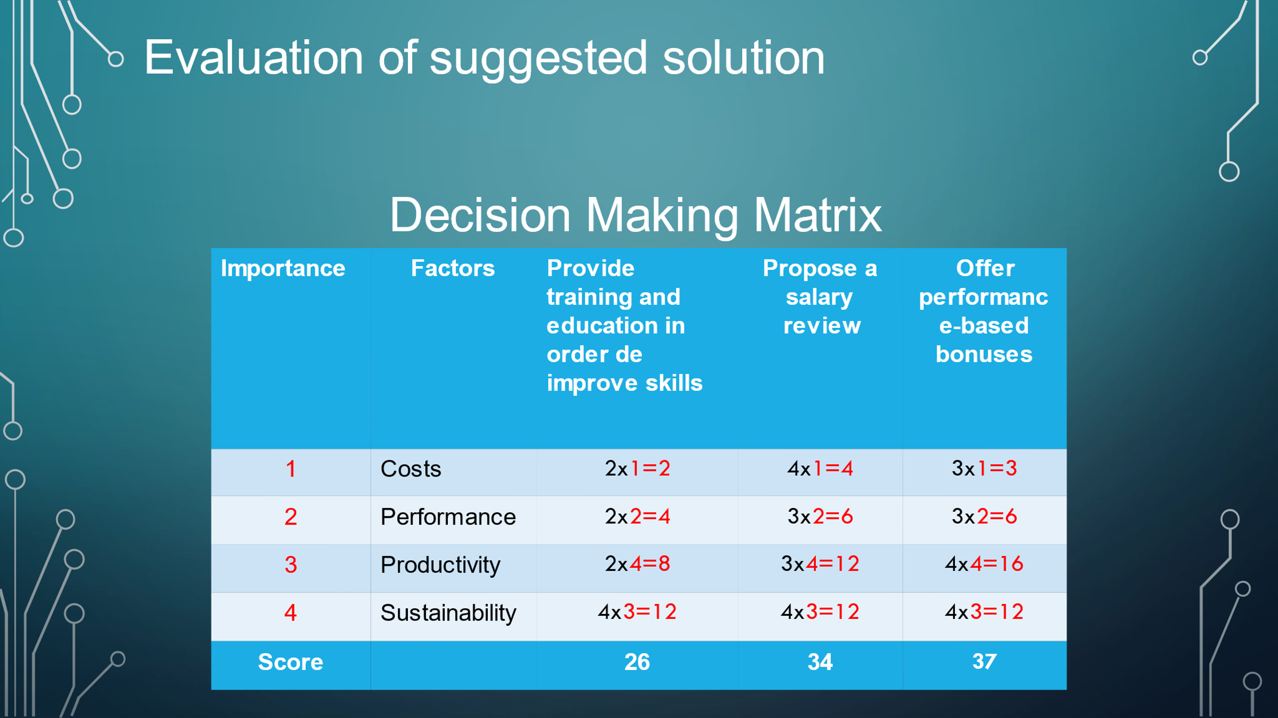

Appendix Role Play slide 7

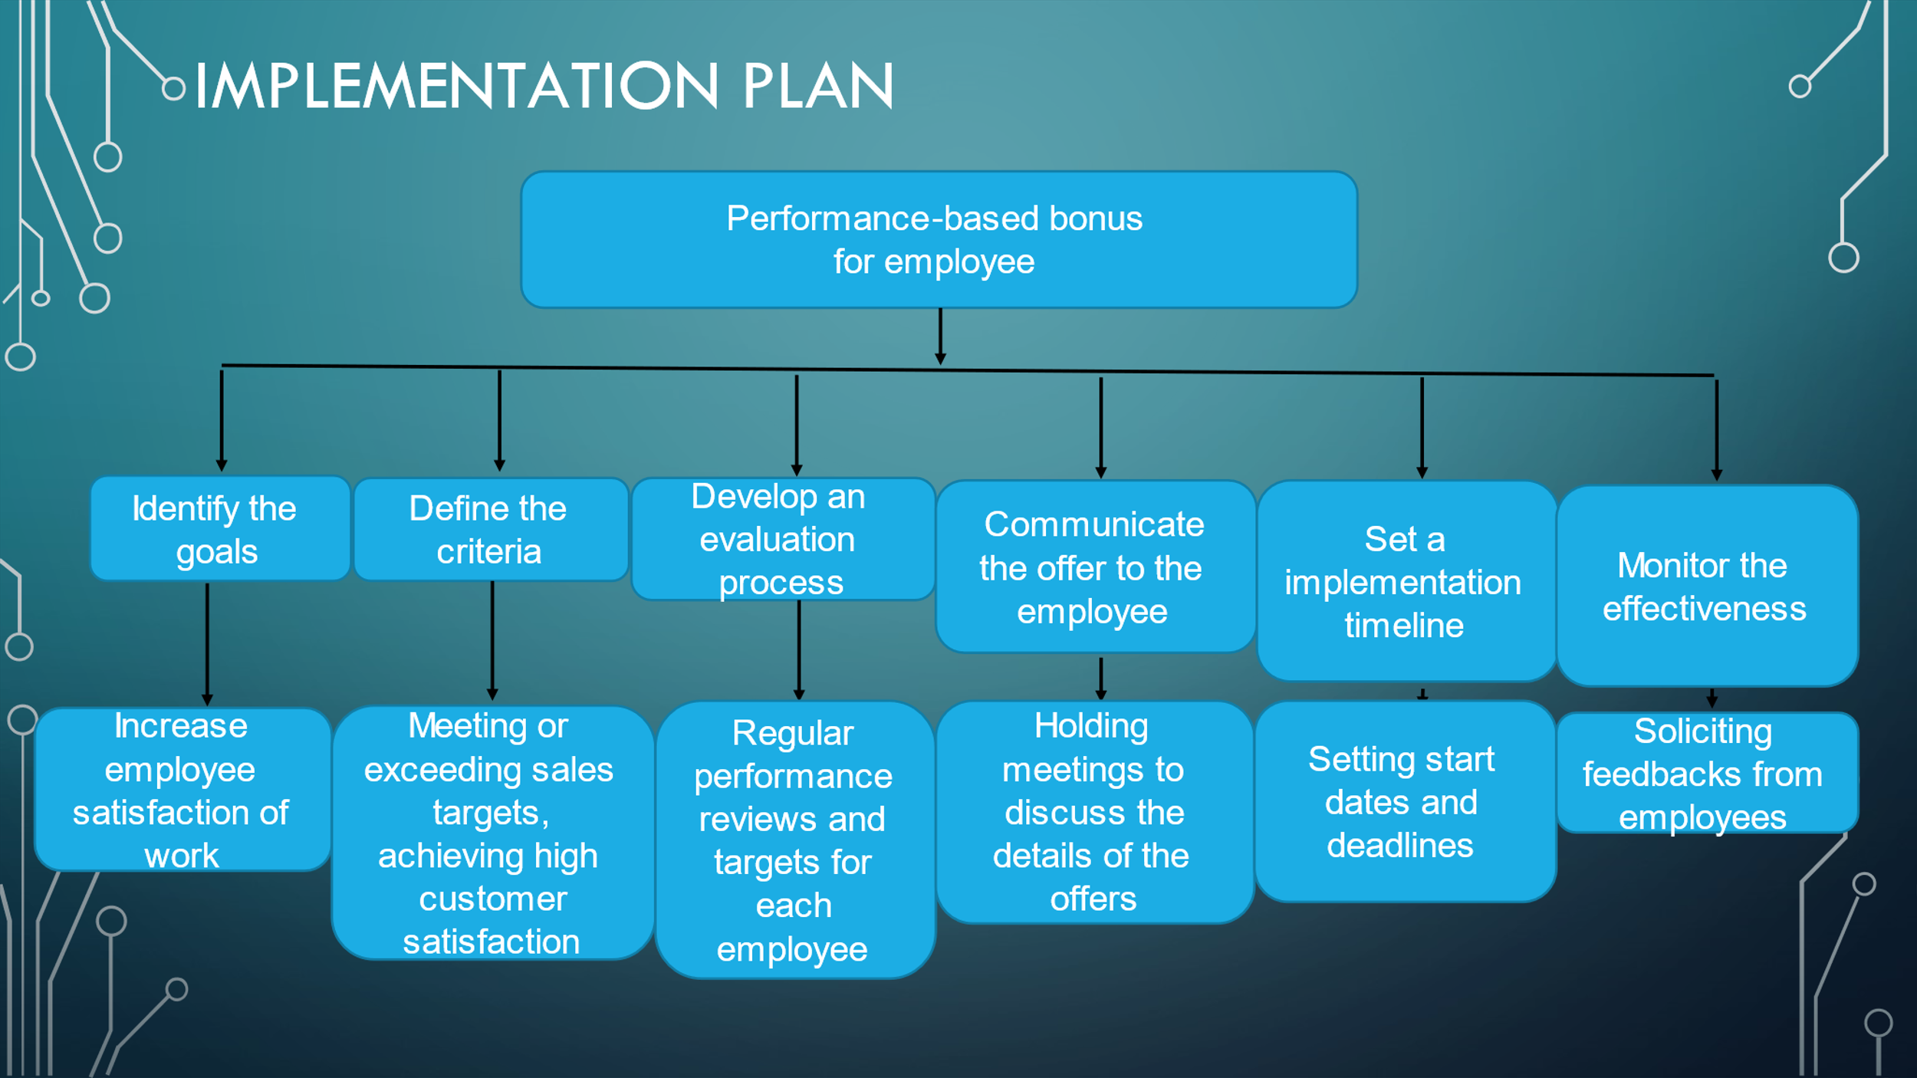

Appendix Role Play slide 8

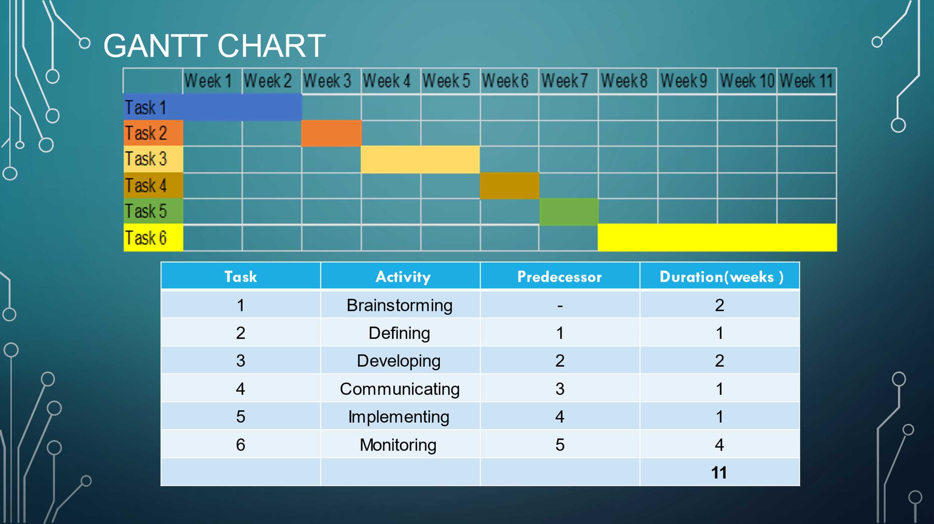

Appendix Role Play slide 9



