Nathan Mackechnie
2116209
ACMA5010
Dynamics
UWTSD

Contents
Table of Contents
Task A 2
1. Introduction 3
2. The Development of Centrifugal Clutches 3
2.1. Historical Overview 3
2.2. Development of the Centrifugal Clutch 4
3. What is a Centrifugal Clutch? 4
3.1. Clutch Plate 4
3.2. Spider 4
3.3. Friction shoes 4
3.4. Drum 5
3.5. Spring 5
4. Function of a centrifugal clutch 5
5. Applications and operating conditions of a centrifugal clutch 5
5.1. Applications of a centrifugal clutch 5
5.2. Operating conditions 6
6. Advantages and disadvantages of a Centrifugal Clutch 6
6.1. Advantages of a centrifugal clutch 6
6.2. Disadvantages of a centrifugal clutch 7
7. Electromagnetic clutches 7
7.1. Function of an Electromagnetic Clutch 7
7.2. Application of an Electromagnetic Clutch in Modern Automation Manufacturing 8
7.2.1. Industrial Robotics 8
7.2.2. CNC Machining 9
7.2.3. Automated Assembly Lines 9
8. Conclusion 10
Task B 11
References 12

Task A

Introduction
This report will discuss two different types of clutches, firstly, the centrifugal clutch which works on the basis of centrifugal force to engage and disengage. A wide range of uses of this clutch will be presented along with the advantages and disadvantages.
Secondly, this report will then discuss electromagnetic clutches and how these are used in modern day manufacturing automation.

In the following section, the development of the centrifugal clutch will be presented, discussing the history followed by the development of the clutch.

The Development of Centrifugal Clutches
In this first section the report, the development of centrifugal clutches will be discussed, providing an historical overview along with an analysis on the evolutionary development.

Historical Overview
The exact date of the invention centrifugal clutches is unknown which is attributed to numerous developments by multiple inventor's overtime. However, in the 19th century, they were known to be used largely for locomotive applications (MechStudies, 2017). One of the earliest documented patents was filed to the United States by a British engineer, Frederick Lanchester in 1898 (Clark, 2011). Prominence grew in the early 1900’s, where it was then used in Armstrong Siddeley cars which was then sold as a high-end automatic vehicle. Figure 1 below shows an image of an Amstrong Siddeley car.

Figure 1 Armstrong Siddeley Typhoon (Honest John Classics, 2013)
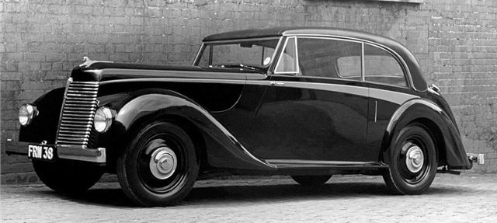

Development of the Centrifugal Clutch
With many engineers and inventors working on their variation of the Centrifugal Clutch, there were many developments over the years. The design itself remained simple and similar to the original, however, the chosen material for the components changed over the years to create a more cost effective, lightweight and durable clutch.

What is a Centrifugal Clutch?
A centrifugal clutch is a mechanical device that is used on equipment that is rotary driven, commonly used with a combustion engine (Engineersguide, 2019). Figure 2 shows a diagram of a centrifugal clutch and its components, this will be discussed below.

Figure 2 Diagram of a centrifugal clutch (ElectricalWorkbook, 2021)
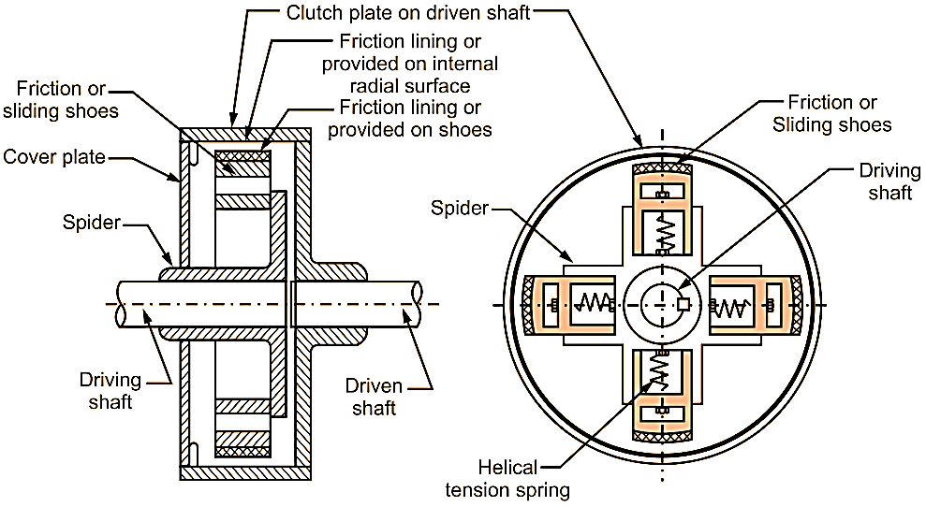

Clutch Plate
The clutch plate is fixated to the driven shaft, is cylindrical in shape and has friction lining on its internal surface.

Spider
The Spider is a hub which is mounted on the driving shaft and has 4 equally spaced radial guides.

Friction shoes
The shoes move outward and are held in position with springs and are responsible for making contact the drum.

Drum
The drum serves as a housing for all components and connects the whole assembly to the driven shaft allowing torque to be transmitted through.

Spring
The springs engage the shoe with the drum at high centrifugal forces and disengages when this force lowers. (MechStudies, 2017).

Function of a centrifugal clutch
Centrifugal force, the force which makes objects move outwards while in rotation (StudySmarter, 2020), is utilised to drive the driveshaft. At lower engine speeds, the clutch remains disengaged allowing the engine to operate without transferring any engine power to the driveshaft. As engine speed is increased, the centrifugal force also increases causing the clutch to engage creating a mechanical connection between the engine and the driveshaft.

Applications and operating conditions of a centrifugal clutch
In this section the applications of a centrifugal clutch will be discussed, highlighting their diverse usage within a range of industries and machinery. Following this, the subsequent section provides the details of the operating conditions relating to a centrifugal clutch.

Applications of a centrifugal clutch
The centrifugal clutch is commonly used in small, motorised equipment such as dirt bikes, go-karts, chainsaws, construction equipment and even industrial machines (BLM, 2019). A centrifugal clutch is utilised for these applications as it offers a simple and reliable method of controlling power transfer based on engine speed.
The automatic engagement of the clutch based on engine speed, eliminates the need for a manual clutch and allows the vehicle or equipment to operate without manual intervention (Orthwein, 2004). When engine speed decreases, the clutch will automatically disengage. This safeguard against abrupt stalls that might otherwise damage equipment or pose risk to the operator, rending this clutch an excellent choice for small, motorised equipment such as chainsaws.
The smooth transfer of power allows for precise control, thus making this clutch a good choice for material handling. Enabling operators to precisely control their movement within warehouse and manufacturing facilities (Adenwala, 2020).

Operating conditions
Depending on specific application and material choice, operating conditions of centrifugal clutches can vary. However, there are several common operating conditions and considerations.
It is vital that the clutch is well lubricated for reliable and smooth operation, if the clutch is not lubricated correctly excessive wear may occur causing the clutch to prematurely fail (BMIKarts, 2019).
The load applied to the clutch must also be known for safe and successful operation. If too high of a load is applied to the clutch, then a failure could occur. For example, a load of a centrifugal clutch which is used in a go-kart is calculated from factors such as resistance which includes air and friction and weight of the kart and driver.

Advantages and disadvantages of a Centrifugal Clutch
The advantages and disadvantages of centrifugal clutches will be presented and discussed in the following section.

Advantages of a centrifugal clutch
There are many reasons to opt for a centrifugal clutch rather than alternatives. Kumar (2010) explains that centrifugal clutches automatically engage and disengage, meaning there is no requirement for a control mechanism as the mechanism relies on centrifugal forces, this advantage is also highlighted by Gupta (2020). Another benefit of automatic disengagement is the prevention of sudden jerks or stalls when engine speed decreases, enhancing safety in what could be considered a dangerous operation.
Centrifugal clutches are simple in design with less components that other types of clutches. This allows for a more cost-effective manufacturing process allowing manufactures to keep costs low for the customer.

Disadvantages of a centrifugal clutch
Although centrifugal clutches have numerous advantages there are situations where manual clutch alternatives are more suitable. Under heavy loads, a user may experience slip or sudden increases in torque. This is because they have very limited torque handling and are not well suited for applications requiring high torque transmission (Nunney, 2013).
Centrifugal clutches are typically unidirectional and therefore only transmit power in one directional. For example, in equipment such as chainsaws the chain is only required to move in one direction deeming it a suitable choice. However, in vehicles such as cars the ability to transmit power in both directions is essential, making this a disadvantage.

Electromagnetic clutches
In the following section, the report will now discuss another form of clutch known as an Electromagnetic clutch. The function of an Electromagnetic clutch will be explained, followed by a discussion of their widespread use in modern automation of manufacturing processes.

Function of an Electromagnetic Clutch
The Electromagnetic Clutch is more complex than the basic Centrifugal clutch, Figure 3 below shows a diagram of the modern Electromagnetic Clutch.
Figure 3 Diagram of a Electromagnetic Clutch (EMWORKS, 2017)
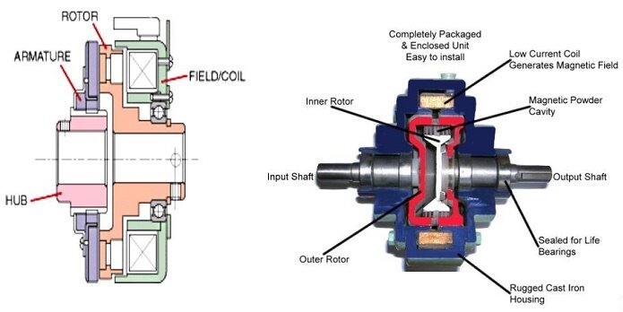
The main components of this type of clutch are an armature, rotor, hub and fieldcoil. The activation of the engine prompts the rotation of the rotor which is coupled with the engine shaft. The clutch operates on the principles of Electromagnetic induction, this is done by a direct current supplied from a DC Battery which generates an attracting electromagnetic force on the armature. In turn, force is then exerted onto the friction plate causing the plate to move towards the already spinning rotor, initiating the rotation of the hub. The rotation of the hub then allows the transmission of torque when engaged (TestBook, 2021).

Application of an Electromagnetic Clutch in Modern Automation Manufacturing
With the ability of handling high torque loads, precision and rapid response, Electromagnetic Clutches have found applications within modern manufacturing automation (jbj Techniques, 2016). In the following section, the role of Electromagnetic Clutches in modern automation manufacturing with be explained.

Industrial Robotics
Industrial robotics require extreme precision in orddr to perform tasks in the manufacturing industry. At Sony UKTec in Pencoed, Yumi robots are used to accurately place components onto circuit boards as shown in Figure 4 below.
Figure 4 Yumi Robots at Sony Pencoed (SonyUKTec, 2021)


Electromagnetic clutches enable industrial robotics such as those depicted in Figure 4 nuanced motion, regulation the movements of the robot (Sepac, 2022)

7.2.2. CNC Machining
CNC machines use electromagnetic clutches to control the engagement of the spindle. Due to the rapid engagement of these clutches, CNC machines are able operate too precise detail, maintaining a standard of high quality (Overby, 2010).

7.2.3. Automated Assembly Lines
Conveyor belts have been introduced into the manufacturing industry to automatically transport material and product along a production line. Figure 5 below shows an automated assembly line at Sony UKTec.

Figure 5 Automated Assembly Line at Sony UKTec (Aerospace Wales, 2023)
With the use of magnetic induction, vibration from the clutch is eliminated allowing for smooth transport of product along the line. The instantaneous response of the clutch safeguard's users by allowing the conveyor to instantly stop if required in an emergency

Conclusion
Centrifugal clutches were first seen in the 19th century, mainly utilised in locomotive applications. They were then introduced the vehicles in the early 1900’s, specifically Armstrong Siddeley vehicles. Although designed in the 19th century, the centrifugal clutch remained basic in design, the main components consisting of a clutch plate, spider, friction shoes, drum and spring.
The clutch works on the principle of centrifugal force, which increases as engine speed increases, causing the clutch to engage and therefore creating a mechanical connection between the engine and the driveshaft. The advantages and disadvantages of centrifugal clutches depend on the application. One key advantage to centrifugal clutches in equipment such as chainsaws is automatic disengagement which safeguards the user from sudden jerks from the equipment.
In modern day manufacturing, electromagnetic clutches which rely on magnetic induction have been utilised within many automated processes. Electromagnetic clutches offer precise precision, ideal for processes which require precision.
Overall, the basic design of centrifugal clutches are a cost-effective solution for small engine vehicles or equipment. Working on the principle of centrifugal force, as engine speed increases, so does the force causing the clutch to engage, thus creating a connection between the engine and the driveshaft. Today, although more expensive, electromagnetic clutches which allow for instantaneous engagement, higher loads and precision.

Task B

Consider the centrifugal clutch above that comprises of four ‘shoes’ symmetrically attached to the ‘spider’. Each shoe with its friction lining has a mass of 275 grams and is attached by means of a linear mechanical spring with a stiffness value of 7.5 kN/m. The coefficient of friction of the material attached to the shoes is 0.35. The centre of mass of each of the shoes is at a radius of 95 mm from the shaft centres in the rest position shown above and has a clearance distance of 9 mm to the outer drum. The outer drum has a wall thickness of 4 mm.
Questions
- What is the diameter of the outer drum?
- Determine the engagement speed of the centrifugal clutch. You should provide your answer in RPM (revolutions per minute) and rounded to the nearest whole value of RPM.
- Calculate the radial force acting on the clutch face when the driving shaft is rotating at a speed of 550 RPM.
- At the driving shaft speed of 550 RPM, what will be the value of torque transmitted to the driven shaft?
- Using either MatLab or MS Excel, calculate and plot on a suitable graph the transmitted torque at the driven shaft against driving shaft speed, from 450 RPM to 700 RPM in increments of 25 RPM.
- Undertake the same analysis as in point 5 above but adopt a coefficient of friction of 0.3 and 0.4. Discuss the effect of changing the coefficient of friction of the shoe material on the torque transmitted when comparing the three values of coefficient of friction.
- For the maximum possible transmitted torque determined from either point 5 or 6 above, and given that the mass of the drum is 750 grams and can be considered as a solid disc, what is the angular acceleration of the drum to achieve the maximum possible torque

Question 1 Solution

The diameter of the outer drum can be calculated by considering the clearance distance, wall thickness and the radius which is all provided in the question. However, there is a required value that is missing, which is the thickness of the shoes. Therefore, the following solution will neglect this factor.

Diameter = 2(R + Clearance Distance + Wall Thickness) (equation – 1)

Where,

- R= 95mm
- Clearance Distance = 9mm
- Wall Thickness = 4mm

Therefor substituting the values above into equation 1,

Diameter = 2 x (95+9+4)
= 216mm
= 0.216mm (Outer edge of the drum)

Question 2 Solution

Engagement speed is the speed at which the centrifugal force overcomes the spring force, causing the clutch to engage, this is also referred to as lock up speed.

The centrifugal force can be calculated by the following formula:

$$Fc = m × {\left(w\right)}^{2} × r$$ (equation - 2)

The spring force is given by equation 3 below:

$$Fs = k × d$$(equation - 3)

With the spring force being the resistive force and the centrifugal force being the force acting on the shoes, equation 2 can be made equal to equation 3.

Giving,

$$k×d = m×{\left(w\right)}^{2} × r$$

Where,

- M (Shoes Mass = 275g = 0.275kg
- k (Spring Stiffness) = 7.5kN/m = 7500N/m
- r (Radius) = 95mm = 0.095m
- d (Clearance Distance = 9mm = 0.009m
- W (Angular Velocity) = ?

Now rearranging equation to solve for angular velocity,

$$w = \sqrt{}\frac{k×d}{m×r}$$ (equation – 4)

Next substituting the values listed into equation 4 using SI units,

$$ω = \sqrt{\frac{7500×0.009}{0.275×0.095}}$$

$$ω = 50.83$$
Next converting the value above to Revolutions per Minute (rpm) by using equation 5 below,

$$RPM = ω×\frac{60}{2π}$$ (equation – 5)

$$∴$$$$∴$$Engagement speed = 485 RPM

Question 3 Solution

Radial force is proved by equation 6 below,

$$Fr​=Fc​ − Fs$$(equation – 6)

Fc is the centrifugal force and Fs is the spring force which is subtracted .

Therefore, first calculating Fc using the values given in the question.

- M (Shoe Mass) = 275 = 0.275kg
- R (Radius to inner drum edge) = 95mm = 0.095m
- W (Angular velocity) = 550rpm = 57.6rad/s

Next substituting the values listed into equation 2 using SI units,

$$Fc = 0.275 × {\left(57.6\right)}^{2 }× 0.095$$
$$Fc = 86.676N$$(Force of 1 shoe)

The spring force is given by equation 2,

$$Fs = 67.5N$$(Force of 1 spring)

Therefore, solving using equation 6 for all 4 shoes and springs,

$$Fr = \left(86.676×4\right) − \left(67.5×4\right)$$
$$Fr = 76N$$

Question 4 Solution

Torque can be calculated from substituting values from question 1 and 3 into equation 7 below.

$$τ = r × F × μ$$(equation – 7)

The centre of mass of the drum must be considered to calculate the radius

$$radius = 95mm+9mm$$
$$radius = 104mm$$
$$radius = 0.104m$$

The friction coefficient is provided in the question which is,

$$μ =$$0.35

The force is calculated in question 3, therefore substituting all values using SI units into equation 7,

$$τ = 0.104×76 × 0.35$$
$$τ = 2.77Nm$$
Question 5 Solution

References

Adenwala, N. (2020). Centrifugal Clutch. [Online]. Dizz. Available at: https://dizz.com/centrifugal-clutch/ [Accessed 17 September 2023].

Aerospace Wales. (2023). Sony UK Technology Centre. [Online]. Aerospace Wales Forum. Available at: https://www.aerospacewalesforum.com/item/sony-uk-technology-centre/ [Accessed 30 October 2023].

Overby, A. (2010). CNC Machining Handbook: Building, Programming, and Implementation. [Online]. McGraw Hill LLC. Available at: https://www.google.co.uk/books/edition/CNC_Machining_Handbook_Building_Programm/UlsgWOIjgfYC?hl=en&gbpv=0 [Accessed 30 October 2023].

BLM. (2019). Advantages and Disadvantages of Centrifugal Clutches. [Online]. blm-cm. Available at: https://www.blm-cm.com/blog/advantages-disadvantages-centrifugal-clutches/#:~:text=Centrifugal%20clu [Accessed 23 August 2023].

BMIKarts. (2019). 10 Things to Know about a Centrifugal Clutch. [Online]. BMIKarts. Available at: https://www.bmikarts.com/10-Things-about-Centrifugal-Clutch#:~:text=By%20properly%20oiling%20your%20 [Accessed 30 October 2023].

Clark, C. (2011). Lanchester, Frederick William (1868-1946). [Online]. Jaguar. Available at: https://www.jaguarheritage.com/frederick-lanchester/ [Accessed 24 September 2023].

ElectricalWorkbook. (2021). What Is A Centrifugal Clutch?. [Online]. Electrical Workbook. Available at: https://electricalworkbook.com/centrifugal-clutch/ [Accessed 23 August 2023].

EMWORKS. (2017). Electromagnetic Clutch. [Online]. emworks. Available at: https://www.emworks.com/application/electromagnetic-clutch [Accessed 15 October 2023].

EngineersGuide. (May 2019). Centrifugal Clutch Explained. [Online]. Lancereal. Available at: https://www.lancereal.com/centrifugal-clutch-explained/ [Accessed 21 August 2023].

Gupta, S. (2020). A Textbook of Automobile Engineering. [Online]. S. Chand Limited. Available at: https://www.google.co.uk/books/edition/A_Textbook_of_Automobile_Engineering/b3HmDwAAQBAJ?hl=en&gbpv=0 [Accessed 6 September 2023].

Guo, Y. (2020). Magnetic Clutch Offers Variety of Benefits for Belt Conveyor Application. [Online]. Magnadrive. Available at: https://magnadrive.com/magnetic-clutch-offers-variety-of-benefits-for-belt-conveyor-application/ [Accessed 31 October 2023].

Honest John Classics. (2013). Armstrong Siddeley. [Online]. HonestJohn. Available at: https://www.neilstoolbox.com/harvard-generator/reference-website.htm [Accessed 17 October 2023].

jbj Techniques. (2016). Electromagnetic Clutches. [Online]. jbj. Available at: https://www.jbj.co.uk/electromagnetic-clutches.html [Accessed 30 October 2023].

Kumar, V. (2010). Analysis and Design of Machine Elements. [Online]. I.K. International Publishing House Pvt. Limited. Available at: https://www.google.co.uk/books/edition/Analysis_and_Design_of_Machine_Elements/kfHD1ess3kMC?hl=en&gbpv=0 [Accessed 6 September 2023].

MechStudies. (2017). Centrifugal Clutches – Definition, Parts, Types, Working, Application. [Online]. MechStudies. Available at: https://www.mechstudies.com/centrifugal-clutches-parts-types-working/?expand_article=1 [Accessed 19 September 2023].

Nunney, M. (2013). Light and Heavy Vehicle Technology. [Online]. Elsevier Science. Available at: https://www.google.co.uk/books/edition/Light_and_Heavy_Vehicle_Technology/afn8BAAAQBAJ?hl=en&gbpv=0 [Accessed 19 September 2023].

Orthwein, W. (2004). Clutches and Brakes. [Online]. Taylor & Francis. Available at: https://www.google.co.uk/books/edition/Clutches_and_Brakes/GilKJ2jGecUC?hl=en&gbpv=0 [Accessed 17 September 2023].

Sepac. (2022). ELECTROMAGNETIC CLUTCHES AND BRAKES FOR THE ROBOTICS INDUSTRY. [Online]. Sepac. Available at: https://sepac.com/industries/robotics/ [Accessed 30 October 2023].

SonyUKTec. (2021). Sony Manufacturing. [Online]. Sonypencoed. Available at: https://www.sonypencoed.co.uk/sony-manufacturing/ [Accessed 30 October 2023].

StudySmarter. (2020). Centrifugal Force. [Online]. StudySmarter. Available at: https://www.studysmarter.co.uk/explanations/physics/physics-of-motion/centrifugal-force/ [Accessed 23 August 2023].

TestBook. (2021). Electromagnetic Clutch: Know Diagram, Working, Advantages, Disadvantages and Uses. [Online]. .testbook. Last Updated: 2023. Available at: https://testbook.com/mechanical-engineering/electromagnetic-clutch [Accessed 17 October 2023].

