

UNIVERSITY OF WALES:TRINITY SAINT DAVID
SCHOOL OF BUSINESS
LONDON CAMPUS
Impact of Advance Technology on Supply Chain Management in Fashion Industry UK.

VISIONS FOR THE FUTURE:
Theoretical Perspective
on Management
LCDB7006
Word Count:7,500

TABLE OF CONTENTS
1. Introduction………………………………………………………………………………..4
2. Overview of Supply Chain Management, Fast Fashion and Advance Technology
2.1. Supply Chain Management (SCM)……………………………………………………5-6
2.2 Fast Fashion Vs Traditional Supply Chain Management……………………………6-7.
2.3. Advance Technology in SCM……………………………………………………………8
3. Identified Reasons of Changing Fashion Supply Chain Systems
3.1. Emergence of New Consumer Buying Cycle……………………………………........9
3.2. Need of Flexibility in every stage of SCM……………………………………………10
3.3. Demand for Quality & Transparency in SCM……………………………………10-11
3.4. Customer Expected Mass Customization Product………………………………...12
3.5. The rise of digitally driven Ecosystem in SCM…………………………………12-13
4. Evaluation of Disruptive Technology in Fashion Supply Chain
4.1. Product Design & Development…………………………………………………13-14.
4.2. Manufacturing………………………………………………………………………15-18
4.3 Distribution and Inventory…………………………………………………………18-19
4.4 Distribution…………………………………………………………………………...20
4.5. Retail & Virtual Merchandising……………………………………………………21-22.

5. Critically analysis of Fast Fashion Retailers-ZARA & H&M
5.1. Vertically Integrated SCM system………………………………………………….23
5.2. Quick New Product Introduction Capability………………………………………23-24
5.3. Advance Technology in SCM………………………………………………….………24
5.4. Lean Inventory Management……………………………………………………….24-25
5.5. Customer Oriented Retailer…………………………………………………………..25
6. Future Vision of Technology in Fashion Industry
6.1. Personalized Designer Clothes with Artificial Intelligence……………………26-27
6.2. Smart Clothes………………………………………………………………………27-28
6.3. Shopping through Virtual Mirrors…………………………………………………28-30
6.4. Tech Shopping Centre………………………………………………………………..30
7. Adverse Effect of Technology in Fashion Industry.
7.1. Physical Stores Scales Down……………………………………………………31-32
7.2. Higher Percentage of Product Return……………………………………………32-34
8. Conclusion…………………………………………………………………………….34-35
9. References…………………………………………………………………………….36-40

1. Introduction
In Fashion Industry, there is a growing attention seen in the fashion retailing due to rapid development in the global markets and brands. According to Mc Kinsey Global fashion index, the fashion industry has seen huge sales growth between the years 2016 and 2018 which was 1.5 percent and increase from 3.5 to 4.5 percent in U.K. (Mckinsey & Co., 2017). According to the report, the fashion industry of U.K.contributed 32 billion in 2018 to the economy as compared to last year, which is 5.4% increase .The UK Fashion industry is a big employment which is denoted as giving 890,000 jobs to industry and recognized as a big financial sector (Sliegh, 2018).
The modern supply chain management became an important topic with the growing power of big retail groups where there is now mandatory requirement for quick and reliable supplies, focus on product quality ,speed up information flow, competitive pricing strategy ,accurate transportation, inventory control and accurate demand planning ,these are all critical elements in supply chain management. To improve the supply chain performance, retailers have to be very quick in understanding customer needs and demands so as to fulfill with the help of upstream members. In the global fashion market, the luxury fashion brands such as Hermes, Louis Vuitton and fast fashion brands such as Zara, H&M being ranked as top 100 brands around the globe along with other giant brands Apple, Amazon and Wal-Mart(Wen, Choi and Chung, 2018).
Currently, fashion markets have high pressure to provide products to consumers with shorter lead times with minimum price due to consumers are moving into digitization and it made the market highly competitive there has seen the emergence of ‘fast fashion’ concept. The aim of this paper is to evaluate the various factors of advance technology impacting on fashion supply chain system while finding reasons which forced to change supply chain system and critically analyze fast fashion retailers who impacted in Fashion Industry. The author also revealed some views about how the fashion industry will look like in Future and what could be the possible adverse effects of technology in Fashion Industry.

2. Overview of Supply Chain Management, Fast Fashion and Evolution of Advance technology in SCM
2.1. Supply Chain Management.
The roots of the supply chain management has been developed and discussed by Peter ducker’s (1962) article on ‘the economy’s dark continent’ where he expressed his views about distribution was one of the key areas to achieve target and saved costs for the organization. After next two decades, the real impact of supply chain management has begun to seen in 1980’s where logistic functions such as warehousing, transport and inventory management also considered to be a part of supply chains rather than separated and all parts are enabled by technology (Sparks, 2010).To elaborate the concept of supply chain management, other author said that it consists of all the parties involved such as manufactures, supplier, transporter, warehouse and retailers to fulfill customer request. The below diagram shows, the raw material supplier supply industrial products to the manufacturers and then they make the product and sale to distributor, again the distributor sale to retailers in small lots and finally customer got the product from retailer(Basak et el 2014).

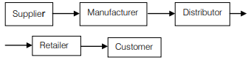
Exhibit1: Supply Chain Stages
Source: Basak et el 2014

In addition to this line of argument, author explained that in a simple way the linkage between two or more legally separated organizations by managing efficient inventory control, material transfer, information and financial flows (Basak et el 2014).
2.2. Fast Fashion vs. Traditional Supply Chain System
In today ‘s world, fast fashion is winning the price war due to immediately changes in clothing trends,styles,accessories,shoes and fashion garments at affordable prices as found in traditional retail store. Fast fashion concept has been developed in Europe, where teenagers and young adult women demand was to get short cycle, trendy and inexpensive clothing which are easily available from small retail shops and boutique (Ciarniene and Vienazindiene, 2014). On the Contrary, the typical life cycle in 1980’s of Fashion industry were consisted of basic pattern of Spring/Summer and Autumn/Winter ranges resulted in developing seasonal range for the whole one year. During the beginning of 1990’s, retailers started focusing on updated product range and quick response on the ‘newness’ of the fashion trends and developing ‘freshed products’ rather than only cost effectiveness. Due to changes in consumer lifestyle, the addition of new three to five mid seasons pressured on suppliers to deliver products in smaller batches with short lead time and Liz Claiborne introduced six seasons instead of just two(Bhardwaj and Fairhurts, 2010).
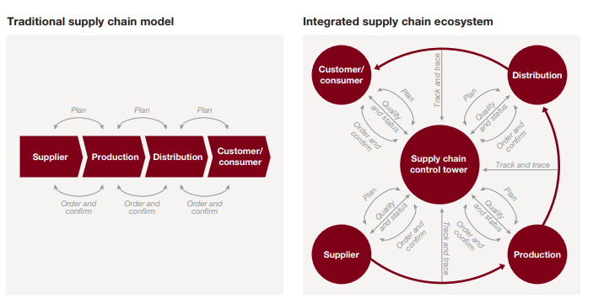

Exhibit 2:Digitial Supply Ecosystem Vs Traditional
Source: Schrauf and Berttram, 2016
As shown in above diagram,the author elaborates and states that there was difficult in traditional times due to long lead time, where whole supply chain took 18 months to deliver the products for a new season. The average lead time for the apparel industry in the eighties was about 66 weeks from raw material to consumers ,where it consist 11 weeks to manufacturing and 40 to warehousing and transit which consisted various bureaucratic in the process. The final fifteen weeks for the garments to wait into the store and then it come down to 6 months in 1990’s but mostly sold at discounted prices (Lipol, 2015). Unlike the business concept of traditional, integrated supply chain system has been developed where every branded marketer and retailers offering right product at appropriate time to the customer by shortening the lead time to 2-6 weeks only and selling at full price, and also denoted by demand driven supply chain management through the implementation of quick response and agile supply chains (Detexcorp, 2019).
The author states that upcoming styles and trendy clothes should reach to the consumer with limited amounts so as to keep them back to retailers over and over again. The retailers have clear focus on Fast fashion objective described below to retain their customers which are as follows (Detexcorp, 2019):
- Focus on increase in sales online and in person retail.
- To keep the cost lower of ownership of goods.
- Focus on decrease in stock levels.
- Need to improve cash flows.
- Reduction in cost of goods.
- Retail store traffic should be increased.
- Gain Competitive advantage.
- More collections of new trends every year.

2.3. Evolution of Advance Technology in Supply chain management
According to author, it has seen that the evolution of logistics and supply chain has passed from different phases according to the timeline. The retail stores in 1970’s were taking deliveries directly from wholesalers and retailers. The control of deliveries has started through Distribution centers (DC’s) after a year in 1980’s.Due to global sourcing in 1990’s, the development of import centers by retailers started to receive and process mostly containerized imports. The rapid expansion of e commerce business has seen in 2000, with internet only where retailers start developing e-fulfillment distribution networks (kayikei, 2019).
Additionally other author supported and state that the transformation has begun from Industry 3.0 in 1970’s with the beginning age of information sharing using digital computer to Industry 4.0, where organizations operated themselves through e-commerce, digital marketing, social media and customer experience and the new business model has emerged through vertical integration of research and development, marketing and all internal operations are based on these advance technologies. The new ecosystem has developed and based on the implementation of advance technologies such as cloud computing, big data, 3D printing, augmented reality, internet of things and others. The transformation of advance technology in supply chains intertwined two trends. One trend where new technologies of cloud computing, big data analytics and internet of things pushing to the markets and other trend of high expectations of consumers and business partners are pulling organizations to develop responsive and agile supply chains(Schrauf and Berttram, 2016).

3. Identified Reasons of Changing Supply Chain in Fashion Industry.
The technology implementation becomes necessary in all internal processes along with supply chains and in consumers side as well. The author identified the challenges facing by organization which forced them to re-think and revise their strategies in their processes of supply chain system which are described in detail as follows:-
3.1. Emergence of New Consumer Buying Cycle
The author states that social media is the biggest contribution in changing buying behavior of consumers. While seeing new trends on social media, consumers follow the strategy of ‘See Now, Buy Now’ so companies need to change according to this strategy due to keep them competitive in the market and increase their profits. Some of the companies such as Kate Spade and Fenwick are able to identify customer needs with the use of ERP systems by controlling their stock and collection of samples. The companies with the use of sample tracking tools observe which trend were most liked by press, influencers or stylists in the product launch campaign and then they plan their productions ahead so as to reduce potential losses and optimize resources(Gulberti, 2018).
According to Business Fashion report, the consumers are now mobile obsessed as they feel convenient while making transactions through mobile payments .The report states that mobile data traffic has increased as compared to desktop which is half of millennial are spending three hours per day on the devices, which six hours in total in mobile devices per week while searching their apparel items. The fashion companies have seen these opportunity and applying in their internal system such as Tommy Hilfiger and Far fetch are more focused in deep customer engagement by providing digital wardrobes, pay by app and connecting to social accounts and Fast Fashion companies like Zara, H&M etc (Mskinsey & Co. (2017). .
3.2. Need of Flexibility in every process of Supply Chain System
According to author, the measurement of procuring and monitoring data in every step of supply chain will allow companies to take more accurate decisions while achieving high level of efficiency. There are such few issues which can affect supply chain system such as materials may not reach as per said time, chances of being delayed of shipments and quality samples can be rejected and forced to re –evaluate the companies vendor mix. These situations are mostly seen in retail sector where timely deliveries and product quality is important which could be rectified if the internal processes are based on automated systems. The ability to rapidly respond on these challenges would result in meeting profit goals of the organization along with missed sales and markdown (Gulberti, 2018).
3.3. Demand for Quality and Transparency in the supply chain system.
The another factor which is responsible for the organizations to make changes in the supply chains are quality and transparency is required .According to the report, it has been stated that Fashion revolution has the power to influence the brands to become more transparent as customer want to know who made our clothes. There are total 200 global fashion brands has been reviewed in 2019 on the basis of the level of information the organizations disclosed about their suppliers, supply chain policies and practices and social and environmental impact and the results revealed that average score is 21% for all brands and retailers out of 250 possible points and still more work need to be done (Fashion Revolution.org, 2019).

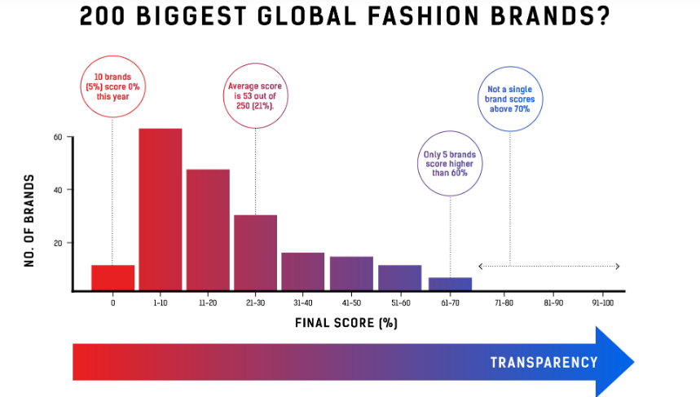

Exhibit 3: Fashion Transparency Index 2019.
Source: Fashion Revolution.org, 2019.

The above figure shows that only 5 top brands scored 60% score in revealing transparency, out of 5 ,three of them listed here which are Adidas, Reebok and Patagonia and no major brands got score above 70%.The fashion industry was always said to be based on secrecy and opaqueness but disruptive technologies made companies more transparent. Transparency is essential if they knew where their products are made with good quality material otherwise it will be difficult for the companies to make decisions if they do not know whether human rights are respected, working conditions are feasible and environment is safe. Fashion Revolution believes there is a need of radical paradigm shift so as to change the system in a positive and fundamental way (Fashion Revolution.org, 2019).

3.4. Customer Expected Mass Customized Products
As the fast fashion emerging in a rapid speed, customers are keener to customized clothes as per their requirement. Manufacturer and retailer are becoming more flexible in their internal systems to produce clothing items according to customer specifications. Customers make the decision of their clothes as per their preferences such as color, design, fabric, trim and size from different options and then create through interactive system and then develop their personalized clothing as per body measurement. Mass customization benefits to the customer and organization both as customer could get product as per their developed design and manufacture could get competitive cost in the marketplace, reduction at inventory level and less volume of production. The companies who are providing these services to the customers are limited such as Levi Strauss, Swimwear, Second Skin and custom foot (Nayak et al., 2015).
In comparison with mass production, it produces very less volumes which required more flexible manufacturing system for cost effective production. There are some issues in mass customization for every organization such as quick response and cost effectiveness which could be achieved reconfigurable machining system. The challenge for the companies are eliminating problems within department due to occurrence of quick response needed when quick demand comes from customer side(Nayak et al., 2015).

3.5. The rise of digitally driven supply chain ecosystem
The digital age is transforming every organization worldwide and the companies who do not adapt will be dying. The companies who disrupt the markets are Fast Fashion retailers which providing strong value propositions to the customers in this age of digitization. There are two types of value proposition which organizations could adapt ‘Order qualifier’ and ‘Order Winner’. Due to strong market competition companies should focus on optimizing production flows in regard with quantity, location and also most importantly timing in your supply chain systems, which is called order qualifiers by sourcing globally with the best price. On the other hand, focusing on optimize interrelationships between whole supply chain ecosystem with the approach of developing and integrating a broad network of customers and suppliers so that to produce collaborative development of new products and sharing information across supply chain. For instance, the company Zara is fully digitally operated and vertical integration from design to production and order winner in distributing the products (Consulting.ey.com, 2016).

4. Evaluation of Disruptive Technology in Fashion Supply Chain Management
The author of this paper evaluates all the major changes which are happening due to disruptive technologies in the every stage of Supply chain system from the past years. The author explained that how technology is shaping the whole fashion industry from traditional supply system and now it became integrated digitally driven supply ecosystem where every system is worked with Internet of Things.

4.1. Product Design & Development
Tech helps to build flexibility in every process
4.1.1. Artificial Intelligence Make Product Designs
The author described that Artificial Intelligence was first coined by John McCarthy in 1956 and after that countless definitions has been proposed but if we conclude all of them in simple term then it is described as computer as a digital device can be used with the right software to solve human problems. In other sense, it is a human intelligence operated by machines, systems, automation and improves on human thinking (Gesing, Peterson and Michelsen, 2018).Artificial intelligence is reshaping fashion industry by predicting what customer want new clothing.Today, retailers with the help of algorithms designs product by analyzing images, copy the most popular styles use data to watch on particular products which are sold or not. According to business of Fashion report, the demand forecast by AI-based approach would help to decrease 50% errors (Walch, 2019).On the contrary,other author suggested that AI-based supply chain systems could be dangerous for human, for instance, self driving or autonomous vehicles are driven by complex AI algorithms which allows to monitor surrounding sound of humans and if there will be incorrect prediction it could be fatal for persons and other risk could be weak cyber security(Thomas.net, 2018).
4.1.2. AI impact on Online Fashion Retail
AI is denoted as black box in today’s fashion industry where you feed data and get instant results.AI algorithms learn from past historical data and make predictions according to the human liking. According to the survey, almost three quarters of fashion retailers are going to spend in Artificial Intelligence in the next 24 months. Online giant Alibaba who is involved heavily in fashion sector has already spent $15bn in Research & development in 2018 so as to become a leader in Artificial Intelligence (Kellett, 2018).The other companies who are in this race are Stitch Fix, Zalando, they made collaboration with Google and Tommy Hilfiger with Fashion Institute of technology and IBM had already developed Artificial Intelligence technology in their fashion Design Process (Makulova, 2018).
Today customer expectations are high they do not want to waste their time and their online shopping experience will be more personalized and AI achieved all of them. One of the most common AI case in online is visual recognition where this algorithm recommend similar looking clothes so that customer could get the right product.AI can play a vital role in monitoring competitor price’s and then made ideal price to generate revenue. The another smart assistance provided by companies are AI chatbots,where retailers help customers by finding what they are specifically looking for and this is used by fashion retailer, Levi as they help to find their preferable pair of jeans(Kellett, 2018).

4.2. Manufacturing
Tech makes life easier with easy information sharing
4.2.1. An agile Supply Chain Methodology
Fast fashion is becoming an customer driven process where demand of new trends are very quick and the retailers could only succeed if they respond to the market through reducing lead times. Fast fashion has a huge impact on supply chains where retailers changes their traditional way and they work closely with those manufacturers who can provide fashion products quickly. Therefore, suppliers are also under pressure to become more flexible and responsive in changing market demand.
The author explained quick response is an operational strategy which provides wide range of products by modifying organizational system of physical and information flows across value chain as per customer demand. The companies today are moving to customer focused so they are using the combination of agile and lean strategy so as to match the order winning criteria in the market place. Lean production has been adopted by manufacturers which is customer focused process improvement. The cycle time reduced via eliminate waste is the key idea to increase customer value. This is the most prominent way by using lean manufacturing techniques to cut cycle time throughout supply chain and achieved competitive advantage in the fashion market. On the other hand, agile supply chain strategies where companies use market knowledge and a virtual cooperation to get profitable opportunities. The short life cycle markets are highly competitive to spot market trends as soon as they changed and able to provide them in the shops at the shortest possible time (Ciarniene and Vienazindiene, 2014)... On the other hand, the companies who are slow to react will lead to loss sales. In the case of Fashion consideration, if the product such as dress is in demand today so it has be worn now so ‘lean’ strategy works where there is a high volume of products required, less variety and the environment is mostly predictable where as agility works where demand is high and the environment is very less predictable as described in below table (Ambe, 2010).

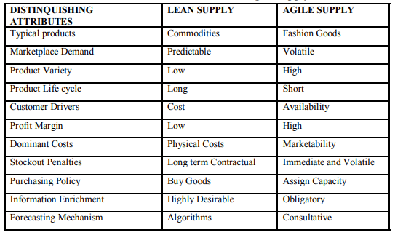
Exhibit 4: Attributes of Lean and Agile Supply
Source: (Ambe, 2010)
The performance of supply chain management is driven by matching supply to demand thereby decrease in costs simultaneously to satisfy consumers. Supply chain strategies could be distinguished where the companies have to accept uncertainty and develop strategies to meet demand. Looking at the attributes of lean and agile supply chain, it is to be evident that both can work together in some conditions which are three ways. The conditions where demand is predictable and for the other products converse is true, then companies use mixed strategy which is known as hybrid strategy. The second approach is Pareto curve approach which is said the decoupling point and the base and surge demand. The third approach is leagility which is paradigm combination of both where it positioned decoupling point so as to fulfill volatile demand by responding downstream with providing scheduling level to upstream from decoupling point (Ambe, 2010).

4.2.2. Cloud Computing making Information Sharing Easy in Supply Chain Management
It is an IT service model where hardware and software computing services are made to deliver to customer on demand over a self service fashion where location and device are independent. Cloud computing services are cost effective, flexible and visible throughout the supply chain process. Cloud computing platform play a Vitol role in demand forecasting where companies can gather sales data through internet performing basic analytics to get accurate statistical demand forecast. These processes decrease the bullwhip effect where stakeholders easily know about the current demand. The combination of cloud computing with EDI will be very effective in demand and order planning in supply chain process. The process is very simple as when the demand generated by customers, distributers send it to the public cloud where everyone throughout the supply chain could see. It also gives benefit in logistics tracking operations to different partners throughout the supply chain. The biggest advantage of cloud computing services that the companies do not require any investment for hardware and software as it is required with ERP (Enterprise Resource Planning) which required external providers. On the contrary, one of the biggest challenge faced by companies are security and privacy when using cloud based approach (Toka and Aivazidou, 2014).
4.2.3. Growth of EDI usage in Supply Chain
EDI (Electronic Data Interchange) is explained as the movement of information between buyers and seller through electronically with the purpose of transactions and to improve customer service along with delivery performance.EDI has many benefits some of them are reduced paperwork, quick information receipt, increase financial flows and reduction in inventories. However some researchers argued that EDI can benefit in mostly quick deliveries but very less empirical studies has been conducted where as it has a huge impact on customer and supplier relationship to exchange information frequently while improving customer satisfaction (Masudin and Kamara, 2017).The companies are exchanging invoices, delivery information, orders via electronically to the supplier to any location wherever they are located. The biggest brands who are relying on EDI are Harrods, Cortefiel, and Printemps which are the popular fashion brands. With the use of EDI, fashion industry can get benefit of faster response times and saved administrative cost. According to survey total of 10% sales has been accounted by electronically in the fashion sector where 23.2% increase in ecommerce worldwide. It also enhances greater visibility throughout the process of supply chain management and effective working procedures in the organization (EdicomGroup, 2017).
4.3. Distribution & Inventory
Technology makes Inventory & Distribution transparent & Traceable
4.3.1. RFID Technology for Track and Trace Items
Fashion industry is entering into next era of technology where goods are being produced using hyper-rapid manufacturing system, which are going to be traced with the use of advance tech inventory management tools.Today,brands are more keen into using combination of different technologies such as sensors, scanner and cloud based technology. The adoption of RFID (Radio Frequency Identification technology) is increasing around the global fashion brands (CBINSIGHTS, 2018). According to author, it is defined as wireless method used to identify items and there is no requirement for visual contact in regard to read or written. The communication capabilities are clearer as the involvement of electronic information with physical items. RFID tags are used in digital catalogues which are cheap, no batteries required and these are denoted as smart stickers. The signals are strong which can read from some distance away and it lessens the time . (Azevedo, 2012).
This technology helps in maintaining better inventory management and reduce related costs as it provide capability to track and trace items which leads to improve efficiency in the fashion supply chain system.Additionally,this technology benefits to fashion supply chain partners to use pull strategy to increase the speed of delivery along with adoption of product customization strategy(Azevedo, 2012). This automated stocking technology also making fast fashion companies are more faster than ever before .The Fast fashion Company Zara is using this technology around their 1,000 stores worldwide and states that it saved the amount of time as earlier it was difficult where employees took 40 hours to scan bar codes from the items on the rack one by one but now they can finish the work within 5 hours with RFID chips. According to retailer Zara, this tech is very effective so they bought 500 million RFID chips as these are reusable as well. On the other hand, Burberry is using this technology for tracking and verification to make customer shopping more engaging and they get experience (CBINSIGHTS, 2018).
4.3.2. Block chain in the Fashion Supply Chain
Block chain is defined as a database which is used to store all transactions across whole supply chain system and it is decentralized, distributed and public ledger. It is more transparent as compared to tradition supply chain system which was centralized and non standardized where data sharing is minimal .Additionally, supplier does not know how and from where manufacturers are getting raw material and retailer have no clue about supplier information of obtaining products. With the use of block chain technology once data cannot be manipulated once it entered. This technology is being used along with Internet of things and RFID to track data at the start from raw material to the production factory and then all the way to produce items to delivered to customer end. This technology helps organization to create end to end digital histories in all of their products by giving unique digital ID or token number at their inventory level. There are very less fashion brands that are using this technology such as Martine Jarlgaard based in London producing collections of smart label and New York Fashion brand Baby ghost. One of the most advantage of this technology to customers, they can discover the history of clothing while scan the digital tag on the product. (Retail News, 2019).

4.4. Distribution
4.4.1. Fashion market expanding through e commerce
The products currently are being tracked by using latest technologies such as RFID and block chain would never be used in traditional retail stores. The companies are now moving to D2C (Direct to consumer) model as consumers are now embracing online shopping as compared to go to physical stores. According to the report, technology has witnessed demise of some of the stores such as JC Penny closed 140 stores in 2017.According to report, it has seen that brits are buying apparel more on online in comparison from stores which is 16.2 billion sales of fashion clothing, accessories and footwear. It has been reported that fashion market has a huge amount of increase which is 17.2% doubled the value since 2012.The online sales of fashion industry has revealed a huge growth from 17% in 2013 to 24% in 2017.However,the total sales of fashion was 1.3% only in 2017 whereas online fashion sales continue to grow. There has been a prediction for the next five years; the online fashion market sale will reach 79% in 2022(Mintel Press Office, 2017).
The emergence of new distribution strategies such as brick and mortar as a service where organization designs, build and manage short term stores for brands and retailers for just 90days.Now online strategy is in its boom as pop ups ,kiosks and D2C brands came into existence. With the use of social media and online marketing strategies companies such as Everlane, Bonobos and All birds are creating their markets with the help of loyal customer followers. So D2C model cutting middle man retailer and no bulk ordering where highly visual platforms are highly effective ‘SEE –NOW BUY-NOW’ button drive sale conversion. The other e commerce strategy using by Ever lane’s company is ‘Choose What You Pay’ feature where they ask from customer to recommend price according to the past season and then they allocate their production. The traditional brand like Tommy Hilfiger also moving to more D2C -focused while seeing the popularity (CBINSIGHTS, 2018).
.
4.5. Retail & Virtual Merchandising
Tech makes supply chain act with quick Responsiveness
4.5.1. AR/VR Redefine Online and In Store Experience
According to author, the real world objects integrated with the real time use of information with the use of text, graphics, audio and other virtual enhancements is called Augment reality. On the other hand, virtual reality is stated that 3D computer generated environment through immersive head mounted displays respond to a user in a natural way. In today era, retail is moving to digitization and changing the way they worked in traditional era. Almost $2.4 trillion industry is now moving to augment reality as 64% consumers think that this helps when they do shopping. The big example of Retail giant Zara, they are using this technology for in-store displays. Consumers can see models wearing latest clothing while holding their mobile devices in front of selected shop window. The company is also using augment reality for online purchases as well. Another example of GAP, they have made augment reality app named as Dressing Room where customer can try clothes anywhere with the use of Google tango device. On the other hand virtual reality is using by Amazon e commerce giant, they have invented mirror where customers can try on clothes while seeing themselves on gala floor or swimsuit in a beach (Milevo, 2019).
4.5.2. Skip Stages and move straight to Omni Channel Retail
In a real world fashion, the retailers are now moving fast with the changing fashion environment quickly; the benefit could be achieved by adding e commerce as a new channel and these companies are enjoying success which are managing integration between physical and ecommerce retail channels as seen in below figure.
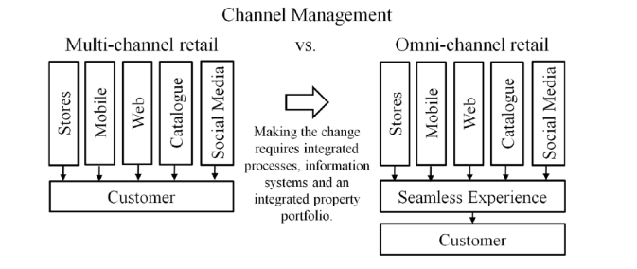
Exhibit 5: Omni Channel Retail
Source: Kayikei, 2018
According to author, it is defined as the business where customers received same seamless experience and get information at every stage from retailer with different devices.Additionally, there is a challenge involve with Omni channel experience for the organizations, where customer easily search online through mobile device and place order while sitting on a bus or train and would like to pick an order from brick and mortar store near by their location on the same day. The more difficulty to meet the demand for these types of customers are they want every information at each step for the delays or the order is at proper time. So, retailers in this case need to be more holistic view about the products available at inventory level in Omni channel environment so that they can easily fulfill their orders from any location and ship them to any area where products are needed. On the other hand, multi channel approach where customers contact retailers independently through different channels such as social media and emails and retailers have not focused to provide seamless experience at every touch point to customer by sending information at every step (Kayikei, 2018). According to survey, there are top ten retailers who are best in their digitization, retailer Mango is best in using Omni channel strategy and topshop denoted as number one digital Genius (Halliday, 2016).

5. Critical Analysis of Agile Supply Chain of Fast Fashion Retailers-Zara & H&M
To explain this, author has chosen the super responsive Fast Fashion Retailers-Zara and H&M so as to give more depth understanding of technologies worked for both.
The two biggest names of fast fashion retailers are H&M and Zara, the parent company of Zara named Inditex has reported 7% growth in profits in 2017 where as H&M has seen fallen by 62% in the first quarter of 2018 despite the decrease H&M had better deals for the shoppers (Taylor, 2018).The biggest star is denoted as Zara which has estimated worth $100 billion market capital in 2015 and only Nike is accounted to come closer. The operational theme for this company is agility adopting at every stage from product development to retail throughout the supply chain.
5.1. Vertically Integrated SCM System
Zara’s growth strategy achieved through diversification with vertical integration as it adapted couture designs, manufactures, distributers and retail clothes in two weeks time as they appear in catwalks and it is in comparison with the fashion industry which took 6 months to produce. The retail giant is delivering fashionable, trendy clothes through control and integrated process which is known as Just in Time production. Zara has in-house production which helps them to reserve their capacity of 85% for in season adjustments (Trade gecko, 2018).H&M is also similar vertical coherent but their designers follow trend setters and they look for music festivals for vintage looks.H&M’s design managers are mostly closely linked with production offices so they sometimes did wrong prediction for latest trends.H&M lead time is double in comparison with Zara, so it has considered to be slow brand for fast fashion market and suppliers may compromise in regard with quality due to get benefit of high profit margin.H&M is also seeing more pressure in regard with price for their budgeted clothes with Primark for their Germany market(The Irish Times, 2019).

5.2. Quick New Product Introduction Capability
The supply chain process of Zara is central which support their core strategies, where the company took 4-6 weeks which is extraordinary fast to launch a product in a store from sketch and whole level process require agility which they are best. Zara is now introducing more than 20 collections a year as it did few collections a year and every Zara stores get new products twice a week. On the contrary, H&M releases 16 product collections a year less than Zara and the production time is few weeks to 6 months but trendy clothes they produce faster with quick delivery time (Holland, 2017).In addition to this line of argument, other author supported this and said Zara has the capacity to carry upwards of 11,000 items per year as compared with their competitor which is 2,000-4,000 in their stores. Zara produce only 15-25% of seasoned products and 50% will be designed in the middle of season which becomes popular (Great, 2016). According to author, Zara & H&M disrupted the fashion market by providing new collections so fast but some of the other brands such as Burberry, Tom Ford, Michael Kors, Rebecca Minkoff and other high profile names have reduced drastically their lead time to launch new product. (Holland, 2017).

5.3. Advance Technology in SCM
Managers from H&M are focusing much of their time on warehouse automation; Meta data analysis and RFID technology where employees can easily find where are clothes and move them quickly according to shortages and oversupply. They are also aiming to take benefit with RFID tags technology to check stock less then sixth times in actual counting period. On the contrary, Inditex has already implemented these technologies across all Zara operations for the fast movement (The Irish Times, 2019).
5.4. Lean Inventory Management
Zara has strong strategy of lean from all the way raw material to finished goods in managing inventory level where they will not keep dead stock or excess inventory in their warehouse. Zara is following Inventory optimization model where company delivered products to every retail store according to the requirement twice in every week. The stock for every product will be limited and very strict so that all stores could get only items which they want (Trade gecko, 2018).On the contrary, H&M has struggled to sold approximate $4.3 billion of inventory, the main big reason of slow supply chains and low level of technology adopted at inventory levels which is almost equal to traditional supply chain systems and visibility issues as well (Kondraci, 2018).
5.5. Customer Oriented Retailer
Zara excels brand image and revenue by pulling customers as compared to H&M which works on pushing its brand and products out to the user. The main big difference is Zara evolve in the marketing strategy of 4E’s-Experience replaces product, Exchange is new price,Evangalism is now promotion and Every place Is new place, whereas H&M still focused on old marketing strategy of 4P’s-Product,Price,Promotion and Place. Zara is giving higher exchange value to the loyal customers with the higher profit margins .The Company is pulling customers and recognizes them as brand influencer to improve in various aspects of their business. For instance, Zara has high social media followers, 25million on facebook, 16 million on instagram and over one million on Twitter (Danziger, 2018).
According to author of this report, Zara is the most quickest fashion brand and managed well with agility in every stage of supply chain whereas H&M need to improve in their supply chain systems to compete in the Fast Fashion market.H&M have to adopt and invest in latest technologies otherwise it will be too late and they can even lost from the market. Zara believe customer should get treated like a king so that they are working to provide that kind of experience to the customer whereas H&M have less focus around customer but more focus on profit that is the reason they are behind in every manner.

6. Future Vision of Technology in Fashion Industry
The author of this paper said that there is a huge opportunity of technology in fashion industry in Future. The vision is very clear which is focused on high tech shopping environment will be given to customer in future. According to report, retailers are spending in technology has seen growth which 3.6% in 2019 globally and that could be continue for next two years. It has been seen that online and mobile shopping are becoming disruptive forces and predicted that retail e commerce giant Alibaba and Amazon will take 40% of market share in 2021 which would be increased by 33% in past year 2017 (McDonald, 2018).
6.1. Future Personalized Designer Clothes with Artificial Intelligence
This technology make customer life easier as they are more influenced by instagram and social media, they can decide their design while looking at mall and visit brand website where they can pick a garment type as per budgeted price. This technology viewed their past purchase history, check brand’s ecommerce and physical stores, then the algorithm make 3-5 most suitable designs within seconds according to the customer preference, body measurement ,lifestyle and their interests and they can choose from them(Makulova, 2018).
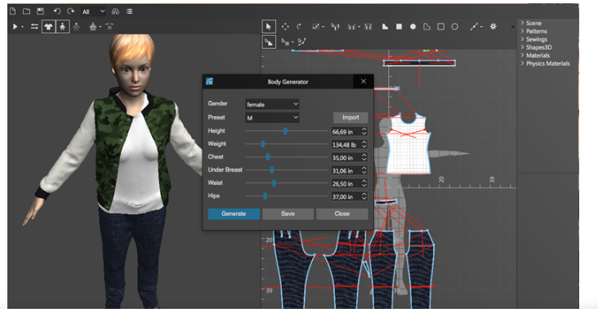
Exhibit 6: 3D Modeling
Source: Makulova, 2018
The whole shopping will be completed in less than 5 minutes as the system made the clothes as per customer body type so there will be 100% fit and less possibility of return the product. The whole journey of buying will be completed in 2-3 days including delivery at customer end as robots will sew the garments, fabrics will be 3D printed and local skilled workers will check the quality, packed the garment in a biodegradable wrap and dispatch to customer through drone delivery. This will be future of fashion: fast, efficient in every manner, sustainable and ethical (Makulova, 2018).

6.2. Future Smart Clothes
Innovative fashion companies will be looking in the future developments of Smart Clothes. Due to the increase usage of smart phones, the clothes connected to wearables through technology and it will communicate with the body through Internet of Things which is called smart clothes.

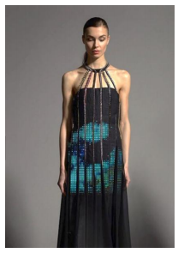
Exhibit 7: LED Dress by CuteCircute
Source: Behr, 2018

The fabric used in the clothes will connect with sensor technology provide a more accurate data of body such as heart rate, lung activity which would be helpful for sportsperson. Many companies are experimenting with this technical enhancements attached to the garments such as integrating lights. The startup company named loomia has designed clothes which provide heat and glow at certain situations. London based company CuteCircute made a twitter dress which will change color when a person receives twitter message as shown in above exhibit. The companies such as Google and Levi Strauss is taking a step further, they are planning to make a clothe which will be attached to Smartphone, for instance Levi’s Jacket when a person wipe off on the sleeves of the jacket, it will automatically play a music, navigation system will start or person can even get a call from smart phones (Behr, 2018).Furthermore, the wearable tech market is a fast moving market which will be worth $30bn globally in year 2020(Verdict.co.uk, 2019).

6.3. Future Shopping through Virtual Mirrors
According to the survey, it has been estimated that AR and VR market is growing very fast and it would hit the revenue of $150bn by year 2020.The advance technology always providing solutions and making the life easier in every manner. Another survey conducted of people approximate 1,013 of age between 19-49 who were very interested in Virtual Reality which carries percentage of 44% and 26% were less interested. The virtual mirror is also act as virtual fitting rooms with the combination of two technologies such as RFID and augments reality. In this case, the customer came with the clothes in front of virtual mirror then it superimposed the body of the customer and the image seen in the mirror will give real appearance. The interesting part is imaging also follow the movement of the customer standing in front. There is a light available as well in the mirror which gives day and night experience about the dress looks so the customer can get idea while not physically wear the dress but get actual idea as seen in below picture .(Quytech, 2018).

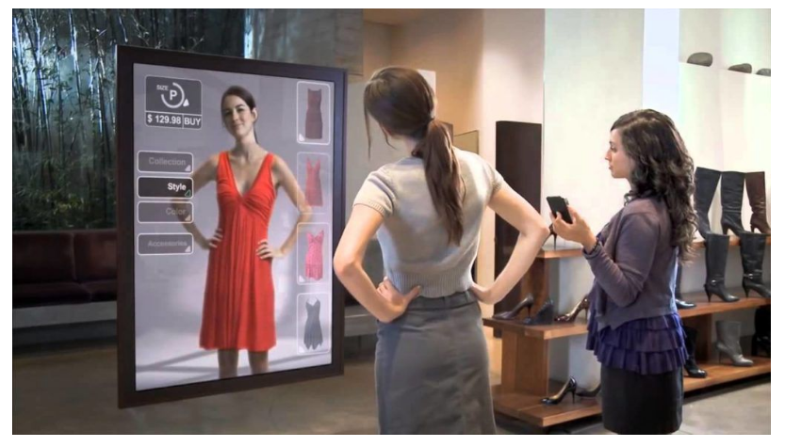
Exhibit 8: Interactive Mirrors
Source: Quytech, 2018
The fashion companies are now exploring their business with the use of various technologies such as augmented reality, virtual mirrors and wearable technologies. One of the big ecommerce giant Amazon are now experimenting virtual mirrors where customers can try clothes while sitting at home via online. The mirror would create a blended image as it has in built cameras, projectors and mix of displays. It then generates a model while scanning the environment around and then examined the face and eyes of the customer to see a reflection of the object. When the whole process is completed then the real product will created while transmitting that virtual clothes and scene through the mirror (Verdict.co.uk, 2019).
6.4. Future High Tech Shopping Centre
The shopping malls in future which will be in- build with high technology, which is testing by one of the agency named Westfield’s ‘Destination 2028’.The possible shopping centre of the future hanging sensory gardens and Artificial Intelligence enabled walkways which gives consumer a fantastic shopping experience. This will completely change the way we do shopping in current era and also in the traditional times (Verdict.co.uk, 2019).
It has been declared that today customers want more personalized products so companies are now innovating new business models to give them more personal experience. Due to emergence of more online shopping, now retailers are looking ways to get customers in store as well so that they could get benefit from both ways. One of the sports company, Adidas they are testing in their pop –up shops with the use of body scanner they will measure and then will be make by 3D knitted machine to design sweaters within a matter of hours. The companies wanted to change retail experience so that it would not just became transaction machine, they visit store get knowledge about the brand and also know who is making their clothes in front of their eyes. Thus in this way companies can add another value to their business by combining in store customization into physical (Bain, 2017).

7. Adverse Effect of Technology on Retailers
The advance technology is giving many benefits to the consumer as well as companies but there are some adverse effects as well, which has seen biggest impact on UK physical stores shutting down in the current time. The negative impact on consumer mind that if they are easily get everything via online shopping then there is no need to go to stores but that also does not satisfy them completely. There are many adverse effects but author listed some of them which are more relevant to the topic.
7.1. Physical Stores Scales Down
The rise of online shopping has make traditional retailers life difficult as the shops are closing day by day. The British high street was enjoying golden period in 1960’s when mass production of products pushed the retailers to reduce the price. According to UK cards Association, brits are spending more on online as compared to any other nation which is 4,611 pounds per person. The supply chain software has been given to 70 retailers out of 100 by one of the JDA software employee name Jason Shorrok saying that there is need to work on reshaping the high street retailers (Grut, 2017).
According to Pwc report, there will be around 2,692 stores has already disappeared from the total 500 popular high streets from United Kingdom in the first half of 2018. The two sectors have effected by online shopping are fashion and electrical stores. London is the most effected region and Fast fashion retailer New look may also losing 120 stores around the UK (BBC News, 2018).
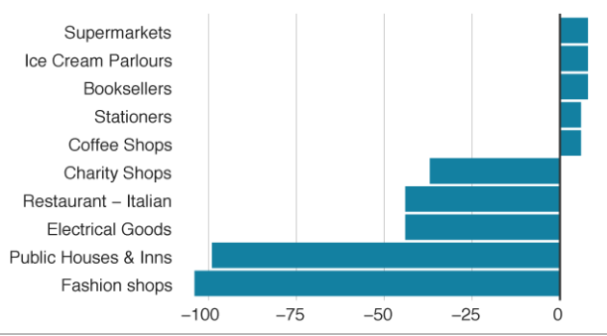

Exhibit 9: Fashion Shops are closing down from High Street.
Source: BBC News, 2018

As shown in above graph, it has seen that 104 fashion shops has huge decline and as well other sectors also affected. The Chancellor Phillip has declared to reduce business rate bill by third of 500,000 small retailers by spending 900m pound. He has also said that new tax will be imposed on online firms to pay less staff and business rates (BBC News, 2018).
7.2. Higher Percentage of Product Return
According to author of this paper, it has been found that customer could not get experience to touch the fabric of the product. The customer could not feel how the shoes are whether they are comfortable or it’s difficult to walk with them. As per author’s perspective, we should have feel of the product before purchasing any item otherwise there will be seen higher rate of return of products which would have adverse effect on the companies.
According to survey, it has been stated that biggest reason of returns are the products are not in good condition, they are either defective or poor quality. The more worst in the fashion products where sometimes the dress are different when it comes as shown online and also they found the size is wrong. The most industries are affected in this region are fashion which is having second highest return percentage of 16.50%, Media and department stores as shown in below figure(Logistic Matter, 2018).

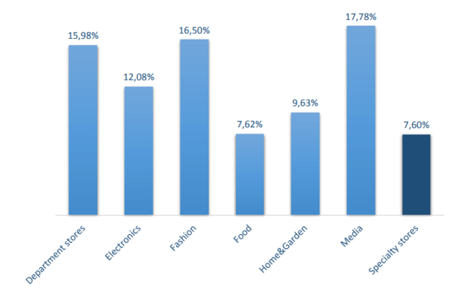
Exhibit 10: Return Percentage per Industry,UK
Source: (Logistic Matter, 2018)
Author further give more depth views about the biggest drawback of online shopping and it would create difficulty for customers as they have to return products as some companies charges for shipping while returning products and retailers on the other side did not know who is returning the item.
8. Conclusion
Supply Chain systems are complicated to develop fully digitally for every organization and many companies are not yet succeeded in implementing those techniques in their processes. Some of the digital applications are not being used globally yet but there will be chances to develop in the next 5 to 10 years. Companies who has already adopted and working to improve their standards totally digitization will be in the race from difficult to benefit advantage in the era of Industry 4.0 .The companies will not only get advantage in regard with greater efficiency but also increase their market share, customer satisfaction and revenue streams. Digitization is opening up more opportunities for the companies to implement new innovative business models. The new world of Digitization allows fashion companies to share information transparently where buyer and supplier can easily generate effective results.
The emergence of latest technologies helped organizations to reduce their lead time as which is necessary in the age of fast fashion where fashion is not limited to two seasons. Digital world also benefit for not only companies but also customers where they can also have power to know about who is making their clothes and they are now closely related with the organization. The companies are also testing new techniques where customers visit the store and in front of their eyes clothes will be ready by 3D printing. Advance technology not only give good fortune but also have some adverse effects as consumers are no longer interested in physical experience and it could have more worst in future, where Generation Z is more digitized.
The author of this paper analyzed the fashion supply chain systems in comparison with traditional way of working and focus was to understand the technology impact in every stage of the supply chain.Overall, the whole process has changed from design to retail which is quick, responsive and agile as compared to traditional retail.

9.References
Ambe, I. (2010). Agile Supply Chain:Strategy for Competitive Advantage. [online] 4. Available at: http://isma.info/uploads/files/005-agile-supply-chain-strategy-for-competitive-advantage.pdf [Accessed 1 May 2019].
Bain, M. (2017). A fantastical new world of high tech,high concept stores is here. [online] Available at: https://qz.com/956745/retail-experiments-from-farfetch-nike-and-amazon-offer-visions-of-the-store-of-the-future/ [Accessed 7 May 2019].
Basak, A., Seddiqe, M., Islam, M. and Faruk, M. (2014). Supply Chain Management in Garments Industry. Global Journals of Management and Business Research, [online] 14(11). Available at: https://globaljournals.org/GJMBR_Volume14/4-Supply-Chain-Management-in-Garments.pdf [Accessed 20 Apr. 2019].
BBC News. (2018). Retailers shut 2700 shops in first half of the year. [online] Available at: https://www.bbc.co.uk/news/business-46142025 [Accessed 8 May 2019].
Behr, O. (2018). Digital Innovation In the Fashion Industry. Journal of Technology and Innovation Management, [online] 2(1). Available at: http://file:///C:/Users/Compaq/Downloads/JTIM_2018_002_1_DigitalInnovationintheFashionIndustry.pdf [Accessed 8 May 2019].
Bhardwaj, V. and Fairhurst, A. (2010). Fast Fashion:Response to Changes in the fashion Industry. [online] 20(1). Available at: https://www.researchgate.net/publication/258418199_Fast_Fashion_Response_to_changes_in_Apparel_Industry [Accessed 21 Apr. 2019].
CBINSIGHTS. (2018). The Future of Fashion:From Design to Merchandising. [online] Available at: https://www.cbinsights.com/research/fashion-tech-future-trends/#prd [Accessed 26 Apr. 2019].
Ciarniene, R. and Vienazindiene, M. (2014). Agility and Responsiveness Managing Fashion Supply Chain. International Strategic Management Conference. [online] Available at: https://core.ac.uk/download/pdf/82112308.pdf [Accessed 22 Apr. 2019].
Consulting.ey.com. (2016). The rise of digitally driven supply chain ecosystem. [online] Available at: https://consulting.ey.com/the-rise-of-the-digitally-driven-supply-chain-ecosystem/ [Accessed 25 Apr. 2019].
Danziger, P. (2018). Why Zara Succeeds. [online] Forbes. Available at: https://www.forbes.com/sites/pamdanziger/2018/04/23/zaras-difference-pull-people-in-not-push-product-out/#5475edf123cb [Accessed 11 May 2019].
Detexcorp. (2019). Fast Fashion Retail Success in Today's E-Commerce Supply Chain. [online] Available at: https://www.datexcorp.com/fast-fashion-retail-success-in-todays-e-commerce-supply-chain/ [Accessed 21 Apr. 2019].
EdicomGroup. (2017). Growth of ecommerce driving use of EDI in Fashion Industry. [online] Available at: https://www.edicomgroup.com/en_US/news/10312-growth-of-e-commerce-driving-use-of-edi-in-the-fashion-industry.html [Accessed 3 May 2019].
Gesing, B., Peterson, S. and Michelsen, D. (2018). Artificial Intelligence in Logistics. [online] DHL Customer Solutions & Innovation. Available at: https://www.logistics.dhl/content/dam/dhl/global/core/documents/pdf/glo-artificial-intelligence-in-logistics-trend-report.pdf [Accessed 2 May 2019].
Gorepati, K. (2016). Zara's Agile Supply Chain is the source of its competitive advantage. [online] Available at: https://www.digitalistmag.com/digital-supply-networks/2016/03/30/zaras-agile-supply-chain-is-source-of-competitive-advantage-04083335 [Accessed 11 May 2019].
Grut, W. (2017). How the internet is remaking the British High Street. [online] BusinessInsider.com. Available at: https://www.businessinsider.com/future-british-high-street-internet-brexit-retail-2017-8?r=US&IR=T [Accessed 9 May 2019].
Gulberti, G. (2018). 3 reasons the supply chain in the fashion industry is changing. [online] Launchmetrics.com. Available at: https://www.launchmetrics.com/resources/blog/fashion-industry-supply-chain [Accessed 22 Apr. 2019].
Halliday, S. (2016). UK Fast fashion stores top L2's digital index. [online] Fashion Network.com. Available at: https://uk.fashionnetwork.com/news/UK-fast-fashion-stores-top-L2-s-digital-index-Topshop-is-number-one,752203.html#.XNSMo_kzbDc [Accessed 27 Apr. 2019].
Holland, D. (2017). [online] Retail Dive. Available at: https://www.retaildive.com/news/report-ultra-fast-fashion-players-gain-on-zara-hm/443250/ [Accessed 10 May 2019].
Kayikei, Y. (2018). E-commerce in logistics and supply chain management. [online] Research gate. Available at: http://file:///C:/Users/Compaq/Downloads/E-Commerce-in-Logistics-and-Supply-Chain-Management%20(1).pdf [Accessed 20 Apr. 2019].
Kellett, S. (2018). How to use Artificial Intelligence in Online Fashion Retail. [online] Exponea.com. Available at: https://exponea.com/blog/impact-artificial-intelligence-online-fashion-retail/ [Accessed 3 May 2019].
Kondraci, C. (2018). Next Gen Supply Chain:H&M low Tech Approach to Inventory Management. [online] Available at: https://www.mmh.com/article/nextgen_supply_chain_hms_low_tech_approach_to_inventory_management [Accessed 10 May 2019].
Makulova, N. (2018). The concious Future of Fashion Retail. [online] Available at: https://nataliyamakulova.com/the-conscious-future-of-fashion-retail-e926a87ce9ea [Accessed 4 May 2019].
Masudin, I. and Kamara, M. (2017). EDI and Demand Forecasting. [online] 18(2). Available at: http://file:///C:/Users/Compaq/Downloads/Electronic_Data_Interchange_and_Demand_Forecasting.pdf [Accessed 4 May 2019].
McDonald, C. (2018). Retail Tech will grow 3.6% in 2019. [online] Available at: https://www.computerweekly.com/news/252451508/Retail-tech-spending-will-grow-36-globally-in-2019-predicts-Gartner [Accessed 13 May 2019].
Milevo, G. (2019). How Augment reality is redefining Fashion Industry. [online] Arpost.co. Available at: https://arpost.co/2019/02/11/how-augmented-reality-is-redefining-the-fashion-industry/ [Accessed 27 Apr. 2019].
Mintel Press Office. (2017). Brits Hangup Online Fashion. [online] Available at: https://www.mintel.com/press-centre/fashion/uk-online-sales-of-clothing-fashion-accessories-and-footwear-grow-by-17-in-2017 [Accessed 25 Apr. 2019].
Mskinsey & Co. (2017). The state of fashion 2018. [online] Available at: https://cdn.businessoffashion.com/reports/The_State_of_Fashion_2018_v2.pdf [Accessed 3 May 2019].
Nayak, R., Padhye, R., Wang, L., Chatterjee, K. and Gupta, S. (2015). The role of mass customization in apparel industry. International Journal of Fashion Design, [online] 8. Available at: https://www.researchgate.net/publication/277969002_The_role_of_mass_customisation_in_the_apparel_industry [Accessed 23 Apr. 2019].
Quytech. (2018). How Virtual Mirror Technology will change the way you shop. [online] Available at: http://www.quytech.com/blog/how-virtual-mirror-technology-will-change-the-way-you-shop/ [Accessed 11 May 2019].
Retail News. (2019). Blockchain in the business of Fashion. [online] Available at: https://www.retailnews.asia/blockchain-in-the-business-of-fashion/ [Accessed 26 Apr. 2019].
Schrauf, S. and Berttram, P. (2016). How digitization makes the supply chain more efficient,agile and customer focused. [online] pwc. Available at: https://www.strategyand.pwc.com/media/file/Industry4.0.pdf [Accessed 20 Apr. 2019].
Sliegh, S. (2018). The UK Fashion industry is worth £32 billion to UK Economy. [online] Evening Standard. Available at: https://www.standard.co.uk/fashion/uk-fashion-industry-32-billion-uk-economy-british-fashion-council-caroline-rush-a3934781.html [Accessed 3 May 2019].
Sparks, L. (2010). Supply chain Management and Retailing. An International Journal, [online] 11, p.2. Available at: https://stirlingretail.files.wordpress.com/2011/04/sparks-in-scfij-final-proofs.pdf [Accessed 20 Apr. 2019].
Taylor, J. (2018). We visited H&M and Zara to see which one is better store. [online] Business Insider. Available at: https://www.businessinsider.com/hm-zara-compared-photos-details-2018-5?r=US&IR=T [Accessed 10 May 2019].
The Irish Times. (2019). [online] Available at: https://www.irishtimes.com/business/retail-and-services/h-m-too-slow-for-fast-fashion-world-1.3030729 [Accessed 10 May 2019].
Thomas.net. (2018). [Online] Available at: https://news.thomasnet.com/featured/the-pros-and-cons-of-an-ai-based-supply-chain/ [Accessed 12 May 2019].
Toka, A. and Aivazidou, E. (2014). Cloud Computing in Supply Chain Management :An Overview. [online] Research Gate. Available at: http://file:///C:/Users/Compaq/Downloads/igi_global_book_chapter_toka_2012.pdf [Accessed 2 May 2019].
Tradegecko. (2018). Zara Supply Chain Analysis. [online] Available at: https://www.tradegecko.com/blog/zara-supply-chain-its-secret-to-retail-success [Accessed 8 May 2019].
Verdict.co.uk. (2019). [online] Available at: https://www.verdict.co.uk/future-of-fashion-tech/ [Accessed 11 May 2019].
Walch, K. (2019). AI in fashion design and retail takes centre stage. [online] Techtarget. Available at: https://searchenterpriseai.techtarget.com/feature/AI-in-fashion-design-and-retail-takes-center-stage [Accessed 3 May 2019].
Wen, X., Choi, T. and Chung, S. (2018). Fashion Retail Supply Chain Management. International Journal of Production Economics. [online] Available at: https://www.researchgate.net/publication/328711222_Fashion_Retail_Supply_Chain_Management_A_Review_of_Operational_Models [Accessed 3 May 2019].

