

Arron Simpson

ACDB 5011: Instrumentation and Control

Control System Design

University of Wales Trinity Saint David
Ordnance, Munitions and Explosives Professional Degree Apprenticeship

Academic Year: 2025- 2026

Supervisor: Steve Mosey
Jan 2026

Table of Contents

Abstract 3
Aim 4
Introduction 4
Method 6
Results 9
Discussion 14
Conclusion 14
Appendix 1 – Transfer Function Validation 16

Table of Figures

Figure 1 – PID Simulation Set Up 7
Figure 2 – Manually Tune Controller 8
Figure 3 – Tuned Parameters 8
Figure 4 – Scope Block Results 10
Figure 5 – Matlab System Transfer Function 10
Figure 6 – Pole Locations 11
Figure 7 – Root Locus 12
Figure 8 – Nyquist Diagram 1 12
Figure 9 – Niquist Diagram 2 13
Figure 10 – Nyquist Diagram 3 13

Abstract
This report presents the design and validation of a PID controller for an angular positioning system on a Close-In Weapon System (CIWS) turret. The plant is modelled as a second-order transfer function $G\left(s\right)=\frac{1}{as^{2}+bs+c}$ and simulated using MATLAB/Simulink. The controller was created and tuned to meet the specified performance criteria: settling time within two seconds following a unit-step command and overshoot less than five percent. Classical control methods (root locus and frequency-response analysis), together with practical measures (anti-windup and derivative filtering), were employed to achieve robust performance. The resulting design exhibits a phase margin of approximately 86.4° with an effectively infinite gain margin, indicating strong stability margins for this safety-critical application. of 86.4° and infinite gain margin, indicating robust stability for safety-critical applications.

Aim
- The aim of this study is to design, tune, and validate a PID controller for a CIWS turret angular positioning system, ensuring compliance with specified performance criteria: settling time under two seconds and overshoot below five percent.

Introduction
- Control systems are an essential part of modern engineering, enabling machines and processes to operate predictably and meet specified performance objectives. A control system can be defined as an arrangement of physical components designed to regulate, command, or manage the behaviour of a system so that it achieves a specified output or performance objective. Control systems are widely used across mechanical, electrical, aerospace, chemical, and defence engineering applications, ranging from simple domestic appliances to complex autonomous vehicles and weapons systems.
- The primary objective of a control system is to ensure that a system’s output follows a desired reference input while maintaining stability, accuracy, and efficiency, even in the presence of disturbances or uncertainties [1]. Control systems are generally classified into open loop and closed loop (feedback) systems, depending on whether feedback from the output is used to influence the control action.
- Open Loop Control Systems. An open loop control system is one in which the control action is independent of the output. As in, the system does not measure or correct its output, and the input command is applied regardless of whether the desired result is achieved. The system assumes that the relationship between input and output is fixed and predictable.
- An example of an open loop system is a domestic washing machine operating on a timer. The machine runs for a pre-set duration without sensing whether the clothes are clean. Other examples include traffic light timers, electric kettles without thermostats, basic conveyor belt systems, microwaves ovens, and toasters.
- Open loop systems are generally simple, inexpensive, and easy to design. However, they are sensitive to external disturbances and changes in system parameters. For example, variations in load, temperature, or wear can lead to significant deviations from the desired output. As a result, open loop control is typically used only where high accuracy is not required or where operating conditions are well known.
- Closed Loop Control Systems. A closed loop control system, also known as a feedback control system, continuously monitors its output and compares it with a desired reference value. The difference between the reference input and the measured output, known as the error signal, is used to adjust the control action. This feedback mechanism allows the system to automatically correct deviations and reduce the effect of disturbances [1].
- An example of a closed loop system is a heating system controlled by a thermostat. The thermostat measures the room temperature and compares it to the desired setpoint. If the temperature is too low, the heater is switched on, if it is too high, the heater is switched off. Other examples include cruise control in vehicles, aircraft autopilot systems, robotic manipulators, missile guidance systems, and industrial process control [2].
- Closed loop systems are generally more accurate and robust than open loop systems. However, they are more complex, require sensors and additional components, and can suffer from instability if not properly designed.
- Control System Theory. The analysis and design of control systems are based on mathematical modelling of dynamic systems. Most physical systems are represented using differential equations, which describe how system variables change over time. For linear time-invariant systems, these equations can be transformed into the Laplace domain, allowing the use of transfer functions to relate system inputs and outputs [3].
- A transfer function expresses the ratio of the output to the input as a function of the complex variables. It provides insight into important system characteristics such as stability, steady-state error, and transient response. Key performance measures include rise time, overshoot, settling time, and steady-state accuracy [4].
- Feedback control theory shows that introducing negative feedback can improve system stability, reduce sensitivity to parameter variations, and reject disturbances. However, excessive feedback gain can lead to oscillations or instability. As a result, controller design involves selecting appropriate control laws, such as Proportional, Proportional Integral, or Proportional Integral Derivative controllers due to their simplicity, effectiveness, and ease of implementation [5].
- Proportional (P) Controllers. A proportional controller applies a control input that is directly proportional to the error signal:
  - $u(t)=K_{p}e(t)$
- Proportional control increases the responsiveness of a system by amplifying the error signal. As the proportional gain increases, the system generally responds faster and steady-state error is reduced. However, proportional control alone cannot usually eliminate steady-state error entirely, particularly in systems subject to constant disturbances or load changes. Excessive proportional gain can also lead to overshoot and oscillations and may cause instability. Illustrating an important trade-off in control design: improving speed and accuracy often reduces stability margins.
- Proportional - Integral (PI) Controllers. A PI controller introduces an integral term that accumulates error over time:
  - $u(t)=K_{p}e(t)+K_{i}∫e(t) dt$
- The integral term accumulates error over time, allowing the controller to eliminate steady-state error completely for many systems. This makes PI controllers particularly suitable for applications such as motor speed control, temperature regulation, and process control. However, integral action introduces additional phase lag into the system, which can reduce stability margins and slow the transient response. Poorly tuned PI controllers may result in oscillatory or sluggish behaviour.
- Proportional–Integral–Derivative (PID) Controllers. A PID controller combines proportional, integral, and derivative actions:
  - $u\left(t\right)=K_{p}e\left(t\right)+K_{i}∫e\left(t\right) dt+K_{d}\frac{de\left(t\right)}{dt}$
- PID controllers offer greater flexibility than P or PI controllers and are capable of achieving fast, accurate, and stable performance when properly tuned. As a result, they are the most commonly used controllers in industrial applications. However, derivative action is sensitive to noise and must be applied carefully in practical systems. The derivative term predicts future error trends and provides a damping effect, which reduces steady-state error (integral action), improves transient response (derivative action), increases damping and reduces overshoot, and enhances overall stability when properly tuned.
- Stability Analysis – Pole Locations. The stability and dynamic behaviour of a control system are closely related to the poles of the closed-loop transfer function:
  - Poles in the left-half of the complex plane indicate a stable system;
  - Poles in the right-half plane indicate instability;
  - Poles on the imaginary axis indicate marginal stability.
- The real part of a pole determines how fast system responses decay, while the imaginary part determines oscillatory behaviour. Complex conjugate poles result in oscillations, with their distance from the imaginary axis indicating the level of damping. Controllers influence pole locations by changing the closed loop dynamics, allowing engineers to shape system behaviour through feedback [6].
- Stability Analysis – Root Locus Method. The root locus method is a graphical technique used to study how the closed-loop poles of a system move in the complex plane as a system parameter, typically controller gain is varied. Root Locus analysis provides:
  - Stability limits;
  - Transient response trends;
  - The effect of proportional gain on pole locations.
- Increasing proportional gain often moves poles from stable regions toward the imaginary axis, eventually leading to instability. Root locus analysis is especially useful for understanding how P, PI, and PID controllers affect system dynamics and for selecting appropriate controller gains.
- Stability Analysis – Frequency Response and Nyquist Plots. Frequency response analysis examines how a system responds to sinusoidal inputs of varying frequency. It is particularly useful for assessing stability and robustness in the presence of uncertainty and unmodelled dynamics.
- The Nyquist plot is a graphical representation of the frequency response of the open-loop transfer function plotted in the complex plane as the frequency varies from 0 to ∞. The Nyquist stability criterion relates the number of encirclements of the critical point (−1, 0) to the number of unstable poles in the system, helping to:
  - Determine closed-loop stability
  - Assess robustness to gain and phase variations
  - Evaluate the effect of controller design on stability
- P, PI, and PID controllers modify system dynamics by introducing additional poles and zeros into the transfer function. These changes affect pole locations, root locus trajectories, and frequency response characteristics. Stability analysis tools such as pole plots, root locus, and Nyquist diagrams predict how controller parameters influence system behaviour and to design controllers that balance speed, accuracy, and robustness [7].

Method
- A PID control system was developed using Simulink in MATLAB. The system begins with a Step block, which generates the input signal. An Add block was included to perform addition and subtraction on the input signals; it was configured as “+ –”, meaning it adds the first input and subtracts the second, thereby creating the error signal.
- A PID Controller block was then added to compute the control signal based on the difference between the reference input and the feedback signal. The process dynamics were represented by a Transfer Function block, which defines how the system responds. The transfer function was derived using the last three digits of a student number plus one, resulting in 8, 1, and 5. Therefore, the process model is:
  - Process = $\frac{1}{8s^{2}+s+5}$
- To visualise the system’s behaviour, a Scope block with four inputs was included. The scope serves as a measurement tool, providing a graphical representation of signals at each stage of the simulation. The complete simulation setup is shown in Figure 1.
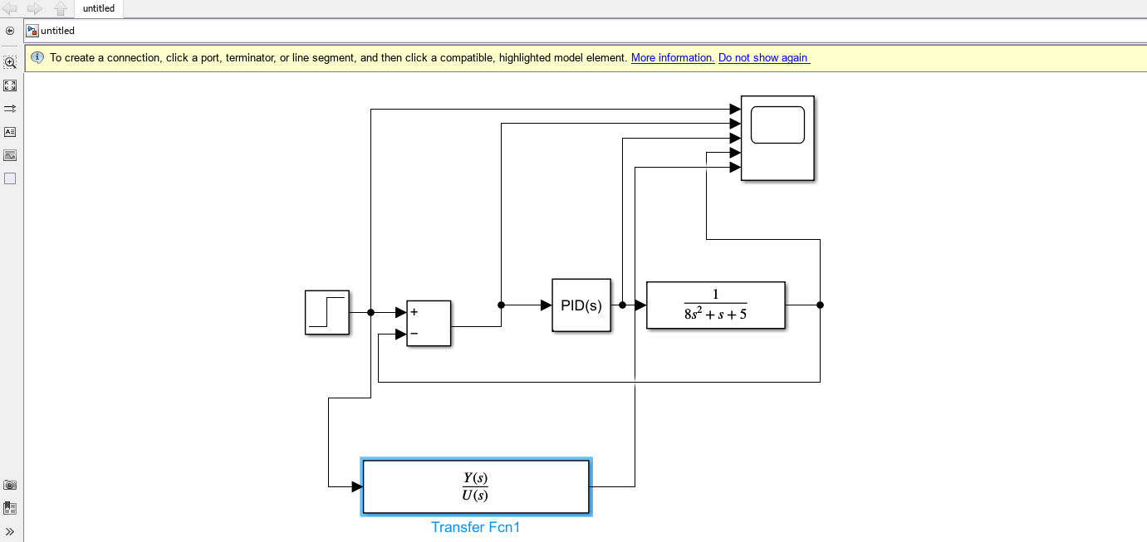
Figure 1 – PID Simulation Set Up
- The PID controller was tuned to achieve a response with less than 5% overshoot and full control within two seconds. MATLAB’s autotune function was initially used to adjust the parameters for what the software determined as the most efficient response. Following this, the system was manually fine-tuned to further improve the response time and transient behaviour, ensuring compliance with the specified success criteria.
- The results of these tuning steps are illustrated in Figure 2 and Figure 3. The final manually tuned controller parameters are as follows:
  - K_{p} (proportional gain) as 208.147949107299
  - K_{i} (integral gain) as 32.4197276475923
  - K_{d} (derivative gain) as 166.092768099571
  - N (filter coefficient) as 2380.46080715379
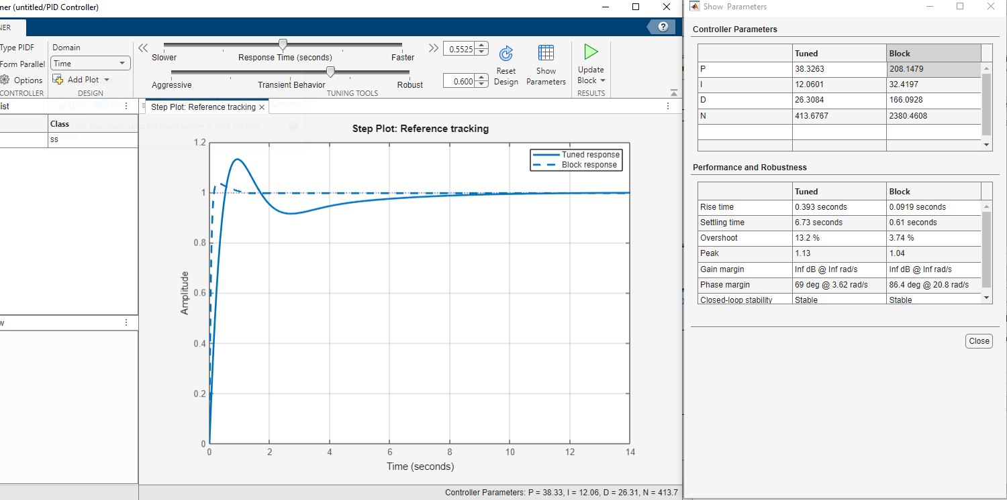
Figure 2 – Manually Tune Controller
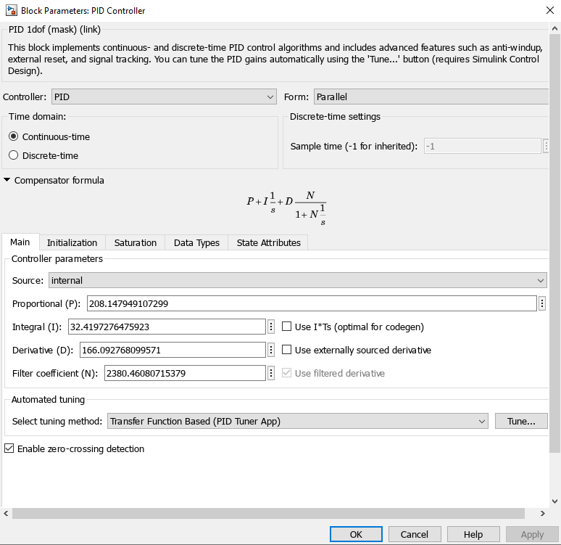
Figure 3 – Tuned Parameters

Results
- The results obtained from the simulation demonstrate that the designed PID controller successfully meets the specified performance requirements for the CIWS turret angular positioning system. The time-domain response shown in Figure 2 and Figure 4 shows that the closed-loop system is capable of accurately tracking a unit step reference input with a settling time of less than two seconds and a peak overshoot of less than five percent. These results satisfy the design criteria stated in the Aim and are consistent with the expected behaviour of a well-tuned PID controlled system.
- The error signal decays rapidly to zero, confirming that steady-state error has been effectively eliminated. This behaviour is attributed to the integral term of the PID controller, which accumulates error over time and drives the steady-state error to zero. The elimination of steady state error is a known advantage of PI and PID control compared to proportional only controllers [8].
- The closed loop system transfer function generated in MATLAB (Figure 5) matches the analytically derived transfer function presented in Appendix 1, validating the simulation model. Agreement between analytical and simulation results is essential for confidence in controller performance predictions and is standard practice in classical control system design.
- Pole location analysis, shown in Figure 6, confirms that all closed loop poles lie in the left-half of the complex plane, demonstrating that the system is stable. The dominant poles form a complex conjugate pair with relatively large negative real parts, indicating a fast response with good damping. This pole configuration explains the low overshoot and short settling time observed in the time domain response.
- The root locus plot in Figure 7 shows the movement of the closed loop poles as the controller gain varies. For the selected controller parameters, the root locus remains entirely within the left plane, indicating that the system remains stable across a range of gain values. This demonstrates that the controller design provides a reasonable degree of robustness to gain variations. Root locus analysis is commonly used to assess stability margins and to guide controller tuning, and the observed behaviour aligns with control theory [5].
- Frequency domain analysis using Nyquist plots (Figure 8, Figure 9 and Figure 10) confirms the stability and robustness of the control system. The Nyquist diagrams show no encirclement of the critical point (−1, 0), indicating closed-loop stability according to the Nyquist stability criterion. The significant separation between the Nyquist curve and the critical point corresponds to a large phase margin (86.4°) and an effectively infinite gain margin. Large stability margins are particularly important in safety-critical defence systems such as CIWS, where robustness to modelling uncertainty, external disturbances, and component variation is essential [7].
- Overall, the simulation results demonstrate that the designed PID controller would achieve fast, accurate, and stable performance. The consistency between time domain responses, pole based stability analysis, root locus behaviour, and Nyquist stability assessment provides strong evidence that the controller design is both theoretically sound and suitable for application to a CIWS turret positioning system.
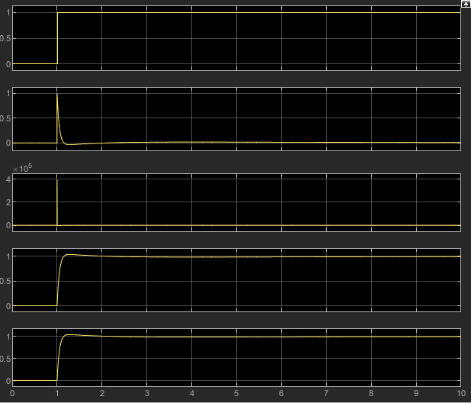 | 1 = Set point (Targeting System)  2 = Error Signal  3 = Controller Effort  4 = Plant output  5 = Validation
Figure 4 – Scope Block Results
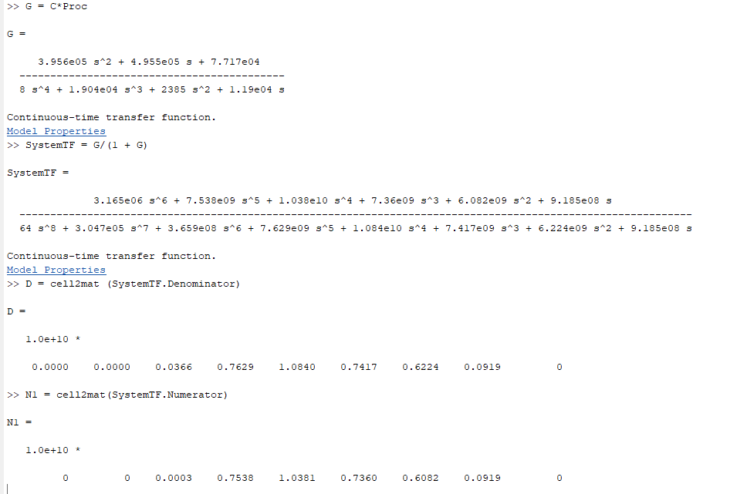
Figure 5 – Matlab System Transfer Function
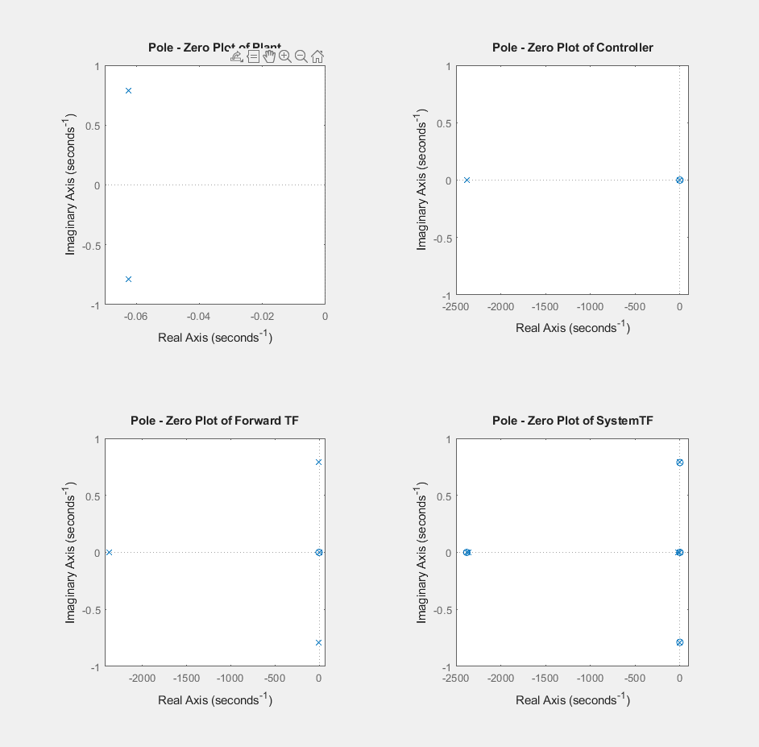
Figure 6 – Pole Locations

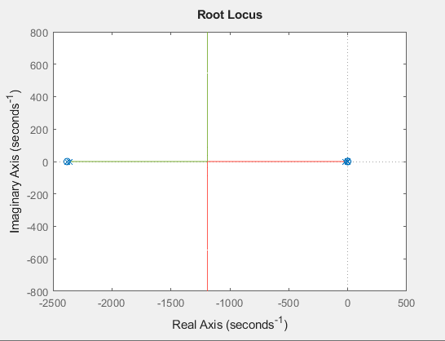
Figure 7 – Root Locus

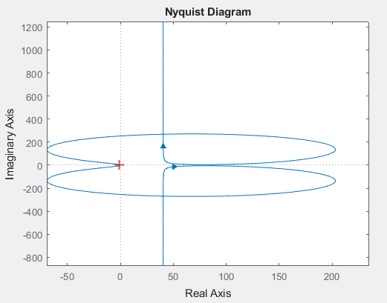
Figure 8 – Nyquist Diagram 1

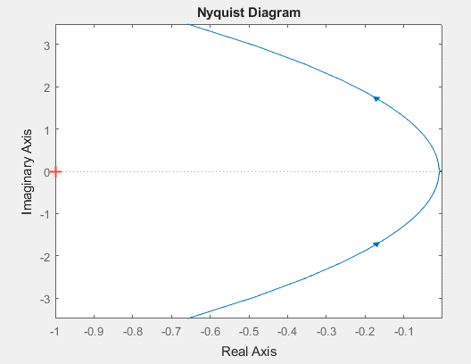
Figure 9 – Niquist Diagram 2
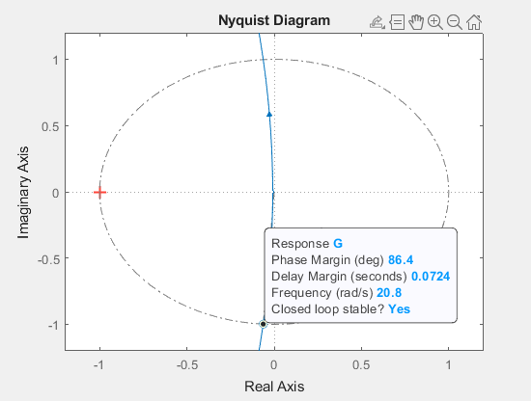
Figure 10 – Nyquist Diagram 3

Discussion
- The results of this study demonstrate that a properly tuned PID controller can achieve fast, accurate, and stable angular positioning for a CIWS turret system. The observed transient performance, characterised by a settling time of less than two seconds and overshoot below five percent, aligns with control design objectives for precision motion systems XX. These results indicate that the chosen proportional, integral, and derivative gains provide an effective balance between responsiveness and stability [9].
- Despite these positive results, the study is limited by the use of a linear plant model. Real CIWS systems exhibit nonlinear effects such as friction, actuator saturation, and structural flexibility. Future work should address these factors to further validate controller performance under realistic operating conditions.

Conclusion
- This study has demonstrated that a properly tuned PID controller can provide fast, accurate, and stable angular positioning for a CIWS turret system. The controller met all specified performance criteria, including minimal overshoot, rapid settling time, and zero steady-state error.
- Stability was verified using pole location analysis, root locus methods, and Nyquist plots, all of which confirmed that the closed-loop system is stable and robust. The large stability margins suggest strong tolerance to parameter variations and modelling uncertainty, which is essential for defence applications.

References

[1] | K. Ogata, Modern Control Engineering 5th Edition, New Jersey: Prentice Hall, 2010.
[2] | J. D. P. A. E.-N. G. F. Franklin, Feedback Control of Dynamic Systems 7th Edition, Boston: Pearson, 2014.
[3] | N. S. Wise, Control Systems Engineering 7th Edition, Wiley, 2014.
[4] | R. C. Panda, ntroduction to PID Controllers - Theory, Tuning and Application to Frontier Areas, IntechOpen, 2012.
[5] | J. Prasad, M. N. Jayaswal and V. Priye, Instrumentation and Process Control, I.K. International Publishing House Pvt. Ltd, 2013.
[6] | O. P. M. Abdelhay A. Sallam, Power System Stability Modelling, analysis and control, IET, 2015.
[7] | C. Z. A. R. M. M. E. U. M. B. Mohammad Amin, Nyquist Stability Criterion and its Application to Power Electronics Systems, Wiley, 2019.
[8] | R. H. Bishop and R. C. Dorf, Modern Control Systems 13th Edition, Pearson, 2017.
[9] | J. -H. J. T. Hsiao, “Design of Precision Motion Controllers Based on Frequency Constraints and Time-Domain Optimization,” IEEE/ASME Transactions on Mechatronics, vol. 28, no. 2, pp. 933-944, 2023.

Appendix 1 – Transfer Function Validation

For validation, the forward pass transfer function and system transfer function was calculated.
Taking a = 8, b = 1, c = 5 our transfer function now becomes:
$$G\left(s\right)=\frac{1}{8s^{2}+s+5}$$
Using the PID tuner in MATLAB, the following values were obtained:
Kp: 208.1479
Ki: 32.4197
Kd: 166.0928
N: 2380.4608
So the transfer function of the PID controller will be:
$$K_{p}+K_{i}\frac{1}{s}+K_{d}\frac{s}{\frac{1}{N}s+1}$$
$$208.1479+\frac{32.4197}{s}+166.0928\frac{s}{\frac{1}{2380.4608}s+1}$$

To calculate the forward path transfer function of the system, the controller’s transfer function must be multiplied by the transfer function of the process.
$$\left(208.1479+\frac{32.4197}{s}+166.0928\frac{s}{\frac{s}{2380.4608}+1}\right)×\left(\frac{1}{8s^{2}+1s+5}\right)$$
$$\left(208.1479+\frac{32.4197}{s}+166.0928\frac{s}{\frac{s+2380.4608}{2380.4608}}\right)×\left(\frac{1}{8s^{2}+1s+5}\right)$$
$$\left(208.1479+\frac{32.4197}{s}+166.0928\left(s÷\frac{s+2380.4608}{2380.4608}\right)\right)×\left(\frac{1}{8s^{2}+1s+5}\right)$$
$$\left(208.1479+\frac{32.4197}{s}+166.0928\left(s\left(\frac{2380.4608}{s+2380.4608}\right)\right)\right)×\left(\frac{1}{8s^{2}+1s+5}\right)$$
$$\left(208.1479+\frac{32.4197}{s}+166.0928\left(\left(\frac{2380.4608s}{s+2380.4608}\right)\right)\right)×\left(\frac{1}{8s^{2}+1s+5}\right)$$
$$\left(208.1479+\frac{32.4197}{s}+\left(\frac{395377.3996s}{s+2380.4608}\right)\right)×\left(\frac{1}{8s^{2}+1s+5}\right)$$
$$\left(\frac{\left((s\left(s+2380.4608\right))×208.1479\right)+\left(s+2380.4608\right)32.4197+s\left(395377.3996s\right)}{s\left(s+2380.4608\right)}\right)×\left(\frac{1}{8s^{2}+1s+5}\right)$$
$$\left(\frac{208.1479s^{2}+495487.9166s+32.4197s+77173.8250+395377.3996s^{2}}{s^{2}+2380.4608s}\right)×\left(\frac{1}{8s^{2}+1s+5}\right)$$
$$\left(\frac{395585.5475s^{2}+495520.3363s+77173.8250}{s^{2}+2380.4608s}\right)×\left(\frac{1}{8s^{2}+1s+5}\right)$$
$$\frac{395585.5475s^{2}+495520.3363s+77173.8250}{\left(s^{2}+2380.4608s\right)\left(8s^{2}+1s+5\right)}$$
$$\frac{395585.5475s^{2}+495520.3363s+77173.8250}{8s^{4}+ s^{3}+ 5s^{2}+ 19043.6864s^{3}+ 2380.4608s^{2}+11,902.304s }$$
$$\frac{395585.5475s^{2}+495520.3363s+77173.8250}{8s^{4}+19044.6864s^{3}+2385.4608s^{2}+ 11,902.304s}$$

The block diagram can now be redrawn as for the forward pass transfer function:
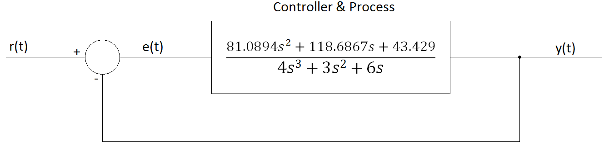
$$\frac{395585.5475s^{2}+495520.3363s+77173.8250}{8s^{4}+19044.6864s^{3}+2385.4608s^{2}+ 11902.304s}$$

Now we remove the feedback loop and calculate the transfer function of the system as a whole.
Using:
$$TF=\frac{G}{1+GH}$$
Where TF is the transfer function of the whole system, G is the forward path transfer function, and H is the transfer function of the feedback loop, in this case $H=1$
$$TF=\frac{\frac{395585.5475s^{2}+495520.3363s+77173.8250}{8s^{4}+19044.6864s^{3}+2385.4608s^{2}+ 11902.304s}}{1+\left(\frac{395585.5475s^{2}+495520.3363s+77173.8250}{8s^{4}+19044.6864s^{3}+2385.4608s^{2}+ 11902.304s}\right)×1}$$
$$TF=\frac{3.165E06s^{6}+7.544E09s^{5}+1.039E10s^{4}+7.363E09s^{3}+6.081E09s^{2}+9.186E08s}{{64s}^{8}+3.047E05s^{7}+{3.659E08s}^{6}+{7.629E09s}^{5}+1.084E10s^{4}+{7.417E09s}^{3}+{6.224E02s}^{2}+9.185E08s}$$
The block diagram for the system transfer function can now be redrawn again as a single block.

$$TF=\frac{3.165E06s^{6}+7.544E09s^{5}+1.039E10s^{4}+7.363E09s^{3}+6.081E09s^{2}+9.186E08s}{{64s}^{8}+3.047E05s^{7}+{3.659E08s}^{6}+{7.629E09s}^{5}+1.084E10s^{4}+{7.417E09s}^{3}+{6.224E02s}^{2}+9.185E08s}$$

$$TF=\frac{3.165E06s^{6}+7.544E09s^{5}+1.039E10s^{4}+7.363E09s^{3}+6.081E09s^{2}+9.186E08s}{{64s}^{8}+3.047E05s^{7}+{3.659E08s}^{6}+{7.629E09s}^{5}+1.084E10s^{4}+{7.417E09s}^{3}+{6.224E02s}^{2}+9.185E08s}$$
y(t)
r(t)

