

Managing Hotel Administration
Student : Antu Bhomik
Student ID : 1818298
Module Code : BMIH6004
Lecturer’s Name : Ka Po Chong

Table of Contents
Introduction 3
Section 1: Reflection on Experience and Personal Development 4
Shadowing Experience in the Human Resources Department 4
Personal and Vocational Development Impact 4
Section 2: Critical Analysis of Work-Based Skills and Technical Knowledge 4
Work-Based Skills 5
Technical Knowledge 5
Section 3: Reflection on Organizational Issues 6
Conclusion and Action Plan 7
References 9

Introduction
Applying Gibbs’ Reflective Cycle to facilitate the details of the learning outcomes for the Human Resources placement in a hotel environment makes the learning process more organized. The first one is Description and this includes getting to know practical methods of recruitment since it will help me address the practical aspects of hiring and be useful to the hotel in terms of its operations. In the Feelings stage self-management skills would be useful in addressing work environmental issues and confidently dealing with stressful HR issues. The Evaluation stage will ensure that I test my problem-solving skills in the area of staffing and training, thus identify with a number of problems and endeavor to build up the capacity to fine tune solutions to real-life HR scenarios. In moving to Analysis, I hope to discover how employee engagement plays out in an organization, particularly, influencing retention rates of employees and consequently, ways of reviving their morale from being fatigued. Thus, in the Conclusion phase, I hope to remodel my outgoing technical skills in the areas of HR management software and labor laws even more tightly. Last is the Action Plan, which will involve the actual exercise and acquiring of the above skills and reflections with the aim of enhancing the staff’s experience as well as enhancing the guest services.
Learning Objectives for the Placement within the Human Resources Department:
• Gain hands-on experience in managing recruitment processes.
• Understand the significance of effective communication in HR operations.
• Develop problem-solving skills relevant to staffing and training.
• Analyze the impact of employee engagement on retention rates.
• Enhance technical knowledge of HR management software and labor laws

Section 1: Reflection on Experience and Personal Development

Shadowing Experience in the Human Resources Department
Shadowing a supervisory position in the Human Resources (HR) department has been an eye-opening experience that deepened my understanding of the vital work-based skills and technical knowledge required in HR to meet organizational and guest service standards (Abdulmajeed et al., 2023). Documentation of the actual involvement in managing recruitment process, provision of training for staff and staff conflict resolution, helped to discuss interpersonal communication, decision making, and managerial particularisms, such as attentiveness to spots in textual material. According to Gibbs reflection model, I was able to understand the role of HR in providing perks that would keep the employees loyal while also keeping quality service high by making sure that employees are compliant with the company’s policy regarding service standards.

Personal and Vocational Development Impact
My academic journey and previous industry experience have contributed significantly to my understanding of communication, teamwork, and task management in HR. Placement experiences and tutorial instruction in academic theory has enabled me to implement knowledge of theoretical concepts (Sadiq et al., 2022). These engagements reflected the importance of communication strategy in how HR acted as a go-between for management and personnel regarding conflict resolution; likewise, how fast and efficient conflict solutions required team effort between HR co-workers. This aspect was also helpful in consolidating on my ability to prioritize and handle multiple tasks, by observing how supervisors address many HR issues simultaneously (Mishchuk et al., 2020). Based on vocational encounters, I have attached more significance to self-skills such as quality listening, sensitivity and flexibility as central mechanics towards providing optimal guest services by strengthening the workforce.

Section 2: Critical Analysis of Work-Based Skills and Technical Knowledge
Administration of economies needs a combination of vocational and professional skills that are relevant for the purpose and performance of the hotel business. From the Shadowing experience in the Human Resources department, I identified important shades of skills & Knowledge needed in the administration of hotels.

Work-Based Skills
Among the enumerated skills, the most crucial one was communication skills. This included not only everyday spoken communication but also written communication in creating informative internal policies and all employee correspondences (Jackson et al., 2022). For example, the participants discussed during a meeting devoted to the topic of onboarding programs key message of the supervisor was aimed at the demonstration of a clear understanding of the expectations of the onboarding participants. This skill is very important when it comes to avoiding distorted transferal of information since it will have an impact on the quality-of-service output.

Technical Knowledge
According to the Gibbs reflection theory, On the technical part of the competencies needed, the expertise in the human resources management software was deemed necessary to help store, process and retrieve records on the employees, making payroll and assigning working schedules (Wycliff et al., 2022). During the shadowing exercise, I noted that the supervisor used software to monitor performance indicators that would inform promotion or training requirements. Knowledge of these systems not only improves the work of administrators and engineers but also contributes to strategic staffing decision making.
Moreover, knowledge of labor laws and enactment is remarkably essential in the management of hotels. Employment regulations are well understood by the supervisors, and the department was directed appropriately during the recruitment and training sessions. This awareness helps the organization to avoid legal complications and at the same time promote nondiscrimination of employees.
Overall, my experience highlighted that work-based skills such as communication, problem-solving, and teamwork, coupled with technical knowledge in HR systems and compliance, are fundamental to effective hotel administration (Dogara et al., 2020). These competencies not only streamline operations but also foster a supportive work environment, ultimately enhancing the guest experience.

Section 3: Reflection on Organizational Issues
During my shadowing experience in the Human Resources department, I encountered a significant organizational issue: high staff turnover. This issue has far-reaching implications in the administration of hotel departments, regarding performance and guest services, as well as the general functioning of the hotel. When established staff members resign, this means that the company takes time and spends extra money to look for new employees, in addition, team dynamics is easily upset and the level of service delivery which customers receive can also be affected. Satisfied customers require service delivery from satisfied employees. Employee disgruntlement leads to attrition meaning high turnover will create service shortages that undermine guests’ satisfactions (Van et al., 2021).
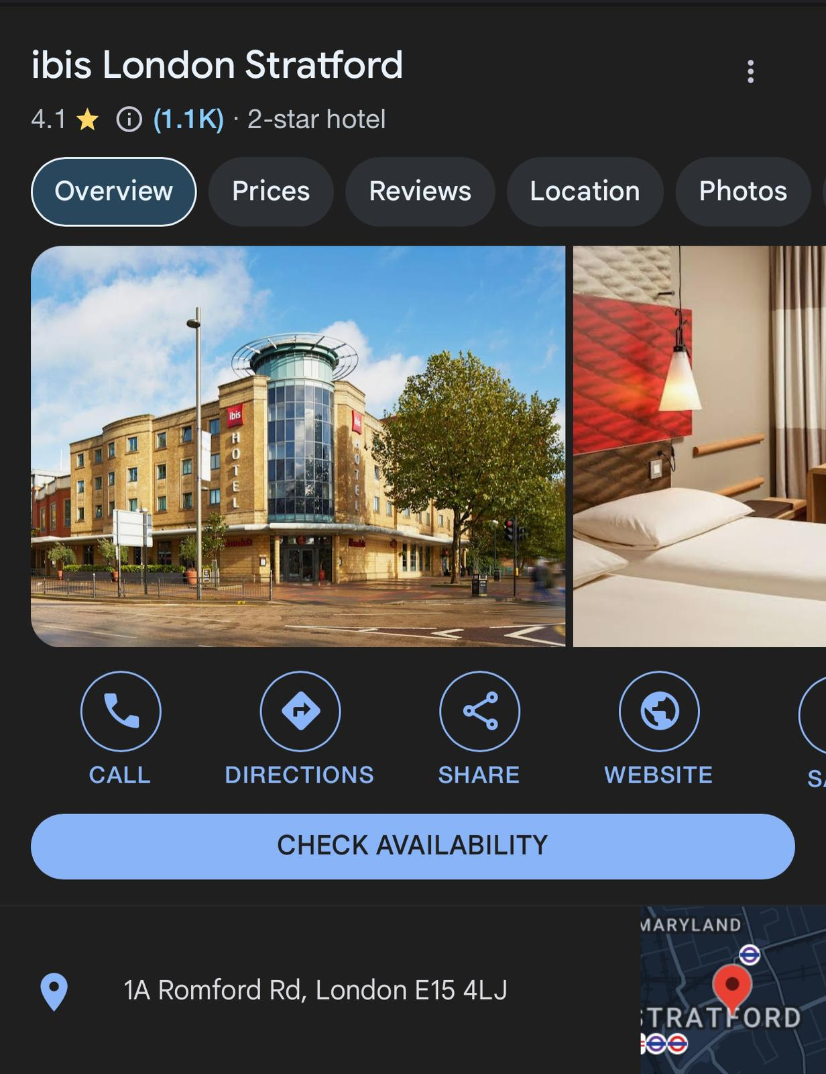
Figure 1: ibis London Stratford location
This has a severe effect on the performance of the department currently, high turnover manifests through the time repeatedly expended on hiring and training their HR staff. This situation takes focus off such essential endeavors that would pull for employee engagement and development which in one way or the other would support the department to contribute to the objectives of the hotel. (Alhalboosi et al., 2021). As a result, guests may meet employees that are not trained enough or are not interested in their work which will have negative impact to guests.
To deal with it I propose the annual launch of a large-scale retention-oriented employee engagement program. This may encompass various, periodic intervention feedback approaches like the stay interviews through which management acquires necessary data in a timely manner to deal with issues affecting the employees. Moreover, using Maslow’s ‘Hierarchy of Needs it may help direct programmes designed to meet needs beyond basic, such as psychological and self-actualization, thus improving satisfaction and organizational commitment levels.

Conclusion and Action Plan
This report details the shadowing program completed in the Human Resources department of a hotel and emphasizes how much the administrative skills and industry know how useful in this field are important. By applying Gibbs’ Reflective Cycle to the shadowing experience done on the Human Resources department of a hotel was helpful in gaining new appreciation of administrative skills and knowledge in this field. Beginning with Description, the shadowing enabled me to engage with different HR tasks and to realize the importance of communication skills, critical thinking and technical skills while handling HR tasks. In Looking at Feelings, I was able to understand that constantly changing staff in operations hindered guest service, and department outcomes, which not only affects the morale of the individuals in the HR department but the staff at large. During the last phase of Evaluation, I understood that most of the areas were connected to employee turnover and job satisfaction in order to improve the guest satisfaction that proved the importance of HR in staff morale. Due to analysis, I was able to relate this understanding to the large role that HR plays in determining organizational success and reinforcing the importance of HR practices in relation to service quality. By Conclusion, I agreed with the lists stating that HR needs humility to continue learning and that it needs desire to work in this field, which convinced me even further.
To further improve my skill set, I plan to take the following specific steps:
- Pursue Relevant Certifications: I will seek certifications in human resource management and conflict resolution to deepen my theoretical knowledge and practical skills.
- Engage in Professional Development Workshops: Attending workshops on effective communication, team dynamics, and employee engagement strategies will provide additional insights and networking opportunities.
- Seek Mentorship: I will identify and connect with experienced professionals in the hotel industry to gain guidance and support in my career journey.
- Participate in Volunteer Opportunities: Engaging in volunteer roles related to HR functions will allow me to apply my skills in real-world scenarios while enhancing my resume.

I confirm that I have not used any AI tools in the research and creation of this assignment. I confirm that I have not presented any AI generated materials as my own work. I confirm I have copies of my drafts, notes, and other resources I used, which I may be asked to provide in evidence.

References
Abdulmajeed, I., Nassreddine, G., Amal, A. and Younis, J., 2023. Machine Learning Approach in Human Resources Department. In Handbook of Research on AI Methods and Applications in Computer Engineering (pp. 271-294). IGI Global.
Alhalboosi, F.H.A., Mawlood, S.J. and Al-halboosi, I.A.M., 2021. Role of ERP systems in improving human resources management processes. Review of International Geographical Education Online, 11(4), pp.1667-1681.
Ali Sulaiman, M.A.B., Ahmed, M.N. and Shabbir, M.S., 2020. Covid-19 challenges and human resource management in organized retail operations. Zenodo, pp.81-92.
Dogara, G., Saud, M.S.B. and Kamin, Y.B., 2020. Work-based learning conceptual framework for effective incorporation of soft skills among students of vocational and technical institutions. IEEE Access, 8, pp.211642-211652.
Jackson, D., Shan, H. and Meek, S., 2022. Employer development of professional capabilities among early career workers and implications for the design of work-based learning. The International Journal of Management Education, 20(3), p.100692.
Mishchuk, H., Bilan, S., Yurchyk, H., Akimova, L. and Navickas, M., 2020. Impact of the shadow economy on social safety: The experience of Ukraine. Economics and sociology., 13(2), pp.289-303.
Prastyaningtyas, E.W., Ausat, A.M.A., Muhamad, L.F., Wanof, M.I. and Suherlan, S., 2023. The Role of Information Technology in Improving Human Resources Career Development. Jurnal Teknologi Dan Sistem Informasi Bisnis, 5(3), pp.266-275.
Sadiq, U., Khan, A.F., Ikhlaq, K. and Mujtaba, B.G., 2022. The impact of information systems on the performance of human resources department. In Strategic Human Resource Management at Tertiary Level (pp. 31-47). River Publishers.
Sawitri, N.N., Susanto, P.C., Suroso, S. and Sihombing, S., 2023. Business Opportunity Human Resource Information System for a Human Resource Department to Create Career Path and Performance Evaluation. East Asian Journal of Multidisciplinary Research, 2(4), pp.1505-1516.
Van der Weele, S. and Bredewold, F., 2021. Shadowing as a qualitative research method for intellectual disability research: Opportunities and challenges. Journal of Intellectual & Developmental Disability, 46(4), pp.340-350.
Wycliffe, L.M., Kisilu, K. and Dimo, H., 2022. The Effect of Work-Based Learning on the Acquisition of Technical Skills amongst Mechanical Engineering Students in National Polytechnics in Western Kenya Region. African Journal of Education, Science and Technology, 7(2), pp.318-328.

