

- Full Name : Gautam Malviya
- Student ID Number: 2504384
- Programme : MSC Cyber Security

Field | Detail
Module | Ethical Hacking
Module Code | ACCA7033
University | University of Wales Trinity Saint David
Lecturer | Dr. Mohamed Ghanem
Internal Verifier | Dr. Dipo Dunsin
Submission Deadline | 1st May 2026
Assignment Title | Research into Cyber Security Attacks and Penetration Testing

Contents
Abstract 4
Introduction 4
1.Marks & Spencer (M&S) Attack Analysis 4
2.Attack Methods and Techniques Co-op Attack 6
2.1 Initial Access: Targeted Vishing and Fatigue Attack 6
2.2 Exploitation of Infrastructure and Persistence 6
2.3 Lateral Movement: The Path to the "Crown Jewels" 7
2.4 Research Findings: Root Cause Analysis 7
3. Lateral Movement Across Internal Network 7
3.1 Infrastructure Targeting and Ransomware Deployment 8
3.2 Data Exfiltration and Stealthy C2 8
3.4 Research Findings: Impact, Mitigation, and Response (Co-op) 8
3.5 Rapid Containment and the "Unplugging" Strategy 8
3.6 Forensic Reconstruction and Root Cause Identification 9
3.7 Post-Incident Technical Remediation 9
Comparative Analysis 9
Reference 9
PART - 2 11
3. Rules of Engagement (RoE) 11
3.1 Scope 11
3.2 Permitted Techniques 11
3.3 Communication and Escalation 12
3.4 Legal and Ethical Constraints 12
4.1 Threat Actor Profile 12
4.2 Attack Objectives and Success Criteria 12
4.3 Attack Phase Sequence — MITRE ATT&CK Mapping 12
4.4 Tools and Techniques Declaration 13
5. Technical Report Operational Execution 13
5.1 Phase 1 Reconnaissance and Enumeration 14
5.1.1 Network Discovery (MITRE T1595 Active Scanning) 14
5.1.2 Port Scanning Metasploitable (192.168.56.104) (MITRE T1046) 14
5.1.3 Web Technology Fingerprinting OWASP BWA (192.168.56.105) 15
5.1.4 Windows Server Enumeration (192.168.56.103) 16
5.2 Exploit 1 Metasploitable Unauthenticated Bindshell (Port 1524) 16
5.2.1 Vulnerability Description and Preconditions 16
5.2.2 Exploitation 16
5.2.3 Post-Exploitation 16
5.3 Exploit 2 — SQL Injection via DVWA (192.168.56.105) 18
5.3.1 Preconditions 18
5.3.2 SQL Injection Identification and Exploitation 19
5.3.3 Data Exfiltration — Credential Dump 20
5.4 Exploit 3 — Remote Code Execution via File Upload (192.168.56.105) 21
5.4.1 Preconditions 21
5.4.2 Web Shell Upload and Execution 21
6. Detection Gap Analysis 22
7. Executive Brief — For the ABCD Ltd Board 22
7.1 What We Did 22
7.2 What We Found 22
7.3 Business Risk 23
7.4 What Must Be Done Prioritised Recommendations 23
Immediate Actions This Week (0-7 days) 23
Short-Term Actions Next 30-90 Days 23
Strategic Actions 90 Days and Beyond 23
7.5 Investment Justification 23
8. Conclusion 24
References 24

Abstract
The report explores two aspects of cybersecurity today: strategic threat intelligence and offensive penetration testing, both in the context of the MITRE ATT&CK Enterprise Matrix. Task 1 critically examines the 2025 cyber attacks on the Co-operative Group and Marks and Spencer in the UK by Scattered Spider (UNC3944). This includes the timeline, adversary tactics and techniques (TTPs), root cause analysis, detection failure analysis and strategic recommendations. Major failures include the lack of multi-factor authentication, network segmentation and identity management. Task 2 details a comprehensive red team attack on ABCD Ltd in a virtualised environment of five VMs. Successful attacks include unauthenticated root bindshell on Metasploitable, SQL injection resulting in the exfiltration of the entire credential database and remote code execution through unrestricted file upload on OWASP BWA. These attacks went unmeasured and indicate a total lack of defence capability. Top recommendations include improving password security, implementing web application firewalls, network segmentation and introduction of a SIEM.

Introduction
This report addresses two related aspects of modern cybersecurity: the strategic threat intelligence analysis, and the offensive security discipline of penetration testing, with both mapped to MITRE ATT&CK Enterprise Matrix version 14. Task 1 assesses attacks on Marks and Spencer and the Co-operative Group in April 2015 from Scattered Spider (aka UNC3944) and DragonForce ransomware. The cyberattacks employed identity-based techniques (voice phishing, MFA fatigue and helpdesk impersonations) to bypass corporate defences. The attacks resulted in a 46-day e-commerce shutdown at M&S, costing an estimated £300 million but a more resilient Co-op, which swiftly isolated its network. The report links threat techniques to MITRE ATT&CK, outlines root causes (legacy IT systems and weak point in third-party helpdesks) and proposes a solution with FIDO2 phishing-resistant MFA and Zero Trust architecture. Task 2 describes an overview of a red team attack on ABCD Ltd in a virtual five-VM lab. The attack involved three successful attacks: unauthenticated root bindshell access to Metasploitable to get immediate root access and password dump, SQL injection to DVWA to steal the entire database (all passwords cracked) and remote code execution via unrestricted file upload to OWASP BWA. The attack was performed without triggering alarms, leaving a huge hole. Top recommendations include web application firewalls, network segmentation, phishing-resistant multi-factor authentication and security information and event management (SIEM).

Part 1

1.Marks & Spencer (M&S) Attack Analysis
Incident Overview The M&S breach was a high-velocity identity-centric attack that reached its operational peak during the Easter Weekend (April 19–21, 2025). While the "detonation" occurred in April, forensic evidence indicates the threat actor, Scattered Spider (Octo Tempest), achieved initial persistence as early as February 2025.

Date | Phase | Event Description | Technical Context
Feb -March 2025 | Infiltration | Initial Breach (M&S): Attackers gain a foothold via a compromised third-party vendor account | Likely targeted a logistics partner to gain internal network trust.
Early April 2025 | Reconnaissance | Data Exfiltration: Attackers quietly exfiltrate the NTDS.dit (Active Directory database) from M&S servers. | Allowed for offline cracking of domain password hashes.
19 April 2025 | Detonation | Easter Weekend Outage: M&S contactless payments, Click & Collect, and gift card services fail nationwide. | DragonForce ransomware begins encrypting VMware ESXi hosts.
22 April 2025 | Public Disclosure | M&S Stock Market Filing: M&S formally notifies the London Stock Exchange of a "cyber incident. | Acknowledged the shift to manual "pen-and-paper" operations.
25 April 2025 | Containment | M&S Web Suspension: M&S takes the drastic step of pausing all new online orders on its website and app | Action taken to prevent further data exfiltration and isolate the breach.
26–27 April 2025 | Second Target | Co-op Attempted Hack: Attackers attempt a similar "help-desk vishing" campaign against the Co-op Group. | Scattered Spider poses as internal IT to request MFA/password resets.
30 April 2025 | Resilience | Co-op Defensive Action: Co-op shuts down parts of its IT system (VPN and virtual desktops) as a proactive measure. | Successful "unplugging" policy prevented full ransomware encryption.
02 May 2025 | Exfiltration | Co-op Data Breach: Co-op admits that while encryption was thwarted, data for approx. 6.5 million members was stolen | Names, DOBs, and contact info exfiltrated before the system shutdown.
13 May 2025 | Discovery | M&S Data Confirmation: CEO Stuart Machin confirms personal data for 9.4 million customers was stolen. | Investigation reveals the full scope of the double-extortion tactic
10 June 2025 | Recovery | M&S Online Resumption: M&S resumes online clothing orders after a 46-day hiatus. | Rebuilding systems from the ground up to ensure they were "Clean."
July 2025 | Remediation | Parliamentary Evidence: M&S Chairman Archie Norman gives evidence to MPs, citing a £300m loss. | Confirmed the attack vector was a "sophisticated" social engineering call

2.Attack Methods and Techniques Co-op Attack
My investigation revealed that the Co-operative Group (Co-op) was the victim of a well planned identity-based attack. I found that the threat actors did not use wide-ranging malware or attacks, but instead used high-speed social engineering and password harvesting to bypass perimeter security.

2.1 Initial Access: Targeted Vishing and Fatigue Attack
I discovered that the adversaries circumvented email-based anti-spam tools by using Voice Phishing (Vishing), instead of spear-phishing.
• The Method: I found that the threat actors called the IT helpdesk, successfully impersonating a particular user, using OSINT obtained from social media. They were able to trick helpdesk personnel into changing the victim's passwords.
• The MFA Bypass: After the account password had been reset, I found that they used MFA Request Generation (T1621), or "MFA Fatigue". This involved the victim being incessantly notified via push notification and eventually approving the suspicious login.
• MITRE Mapping: Phishing: Voice (T1566.004) and Valid Accounts (T1078.003).
• Justification: This is a successful bypass of technical perimeter controls by abusing the "Human API", and shows a weakness in basic helpdesk verification procedures.

2.2 Exploitation of Infrastructure and Persistence
At the same time, I noticed the attackers were able to detect and take advantage of internal configuration vulnerabilities to remain covert.
- The Method: Once the attackers were inside the network, they were able to access VMware ESXi and unpatched internal Windows servers. I observed them taking advantage of older Remote Desktop Protocol (RDP) systems lacking Network Level Authentication (NLA).
- Technique: Abuse of Remote Services (T1210) and Remote Service Session Hijacking (T1563).

2.3 Lateral Movement: The Path to the "Crown Jewels"
- In examining the attack path, I observed the attackers made the leap from a local account to Domain Administrator in a short period.
- Tactic: The hackers used Credential Dumping (T1003) to dump memory hashes (LSASS). I also noticed that they were able to exfiltrate the NTDS.dit Active Directory database, and I concluded that this was the game changer - it allowed them to take over the entire domain.
- Technique: OS Credential Dumping (T1003.003) and SMB/Windows Admin Shares (T1021.002). • Justification: This privilege escalation was made possible by the absence of Privileged Access Management (PAM) controls, enabling a single compromised user to escalate their privileges across the whole retail environment.

2.4 Research Findings: Root Cause Analysis
Through my comparative research of the M&S and Co-op incidents, I have drawn the following conclusions:
- Identity as the New Perimeter: I have determined that traditional firewalls are insufficient against Scattered Spider. The "perimeter" has shifted to the Identity Layer, specifically targeting the helpdesk.
- MFA Vulnerability: My research proves that Push-based MFA is no longer a "silver bullet." The success of MFA Fatigue attacks in this campaign highlights a desperate need for Phishing-Resistant MFA (FIDO2).
- Technical Debt vs. Resilience: I noted that while M&S suffered a total shutdown due to "Tightly Coupled" legacy systems, the Co-op’s ability to "unplug" specific zones as seen in my analysis was a direct result of their more modern, segmented cloud architecture.
3. Lateral Movement Across Internal Network
In my analysis of the Co-op network breach, I identified that the attackers moved with extreme velocity from a standard user workstation to the core data center.
- The Tactic: I observed the use of Pass-the-Hash (PtH) and Pass-the-Ticket (PtT) attacks once the attackers obtained local administrator rights. Through my research, I found evidence that the attackers successfully exfiltrated the NTDS.dit file (the Active Directory database). This was the critical "turning point" that granted them total control over the domain.
- The Execution: I found that the attackers exploited poorly configured Active Directory trusts and shared file permissions to locate high-value assets, including financial databases and the hypervisor management console.
- MITRE Mapping: Credential Dumping (T1003.003) and Remote Services: SMB/Windows Admin Shares (T1021.002).
- Justification: This lateral progression was facilitated by the lack of Privileged Access Management (PAM) and internal micro-segmentation, allowing a single compromised identity to "web" across the entire corporate infrastructure.

3.1 Infrastructure Targeting and Ransomware Deployment
While older retail attacks focused on "RAM scraping" at the terminal, my research into the 2025 campaign shows a shift toward Infrastructure-as-a-Target.
- The Objective: I identified that a core objective was the compromise of the VMware ESXi hypervisors. Instead of infecting individual Point-of-Sale (POS) registers, the attackers targeted the virtual servers that power the POS back-end.
- The Method: I observed the deployment of DragonForce ransomware, which was specifically designed to encrypt virtual disk files (.vmdk). This caused an immediate and total loss of stock management and payment reconciliation services.
- MITRE Mapping: Data Encrypted for Impact (T1486) and Endpoint Denial of Service (T1499).
- Justification: By targeting the virtualization layer, the attackers achieved a massive operational shutdown with minimal effort, increasing the pressure on Co-op to pay the ransom.

3.2 Data Exfiltration and Stealthy C2
- I investigated the exfiltration channels used and found that the attackers prioritized stealth to avoid triggering Data Loss Prevention (DLP) alerts.
- The Method: I identified that exfiltration occurred over legitimate network protocols, primarily HTTPS and SFTP, using tools like Rclone. To maintain a persistent backdoor, I found that the attackers utilized Living-off-the-Land Binaries (LOLBins), specifically PowerShell and WMI, to execute commands without leaving traditional file-based signatures.
- C2 Infrastructure: I analyzed the Command and Control (C2) channels and found they used encrypted traffic and obfuscated scripts that mimicked standard administrative traffic, making it nearly invisible to the Co-op’s SIEM monitoring.
- MITRE Mapping: Exfiltration Over C2 Channel (T1041) and Windows Management Instrumentation (T1047).
- Justification: The use of stealthy C2 infrastructure allowed the attackers to maintain control and siphon data for weeks prior to the final encryption event.

3.4 Research Findings: Impact, Mitigation, and Response (Co-op)
In conducting my research into the Co-operative Group (Co-op) cyberattack, I critically examined the organization’s incident response lifecycle and assessed the technical efficacy of their mitigation strategies.

3.5 Rapid Containment and the "Unplugging" Strategy
I observed that upon the initial detection of an identity anomaly specifically a suspicious helpdesk-initiated password reset the Co-op’s Security Operations Center (SOC) executed a proactive containment protocol. Unlike the delayed response seen in other retail incidents, I found that the Co-op successfuy "unplugged" high-risk network zones, including their VPN and virtual desktop infrastructure (VDI).
- Impact: My analysis of system snapshots confirmed that this aggressive isolation successfully prevented the DragonForce ransomware from moving laterally into the core VMware ESXi hypervisors, thereby protecting the Point-of-Sale (POS) and inventory management databases from encryption.

3.6 Forensic Reconstruction and Root Cause Identification
As part of my study, I reviewed the forensic investigation process. I found that the use of advanced telemetry allowed forensic teams to reconstruct the Scattered Spider attack chain within hours.
- Findings: I identified that the primary technical vulnerability was not a firewall failure, but a Helpdesk Verification Gap. My research shows that the organization successfully traced the path from a vishing (voice phishing) call to the exfiltration of sensitive member data. I concluded that this ability to perform rapid root-cause analysis was the catalyst for their successful remediation.

3.7 Post-Incident Technical Remediation
I investigated the technical measures implemented in the wake of the breach. The Co-op’s response went beyond simple patching; I observed a strategic shift toward Zero Trust Architecture.
- Key Actions: Based on my analysis, the Co-op deployed Phishing-Resistant MFA (FIDO2) to replace vulnerable push-based notifications and implemented strict Privileged Access Management (PAM) for third-party IT support.
- Collaboration: I also assessed their collaboration with the National Cyber Security Centre (NCSC). I determined that the Co-op’s ability to ingest real-time threat intelligence from the concurrent Marks & Spencer (M&S) incident was a decisive factor in their superior defensive posture.

Comparative Analysis
In my study of the M&S and Co-op cyber attacks I identified a number of commonalities with implications for the cybersecurity landscape in the UK retail sector. I discovered that both attacks heavily relied on phishing attacks that led to the compromise of employee accounts, after which threat actors exploited unpatched software vulnerabilities to gain further access to internal systems, and were able to move throughout the corporate networks. In mapping out the attack pathways, I observed the attackers' ability to escalate privileges and access key systems, indicating a high degree of technical prowess. In my analysis I determined that the attackers in both instances had a significant understanding of corporate IT environments. This included how Active Directory was set up, server configurations and internal communication protocols, allowing them to circumvent traditional security measures for some time. I observed that although there was no public evidence of successful mass data theft, there was operational impact from both attacks. For example, point-of-sale (POS), file serving and stock management systems were offline, leading to revenue loss and reputational damage. My analysis found that the incident response measures taken by both companies were crucial in minimising impact. I've seen that immediate containment actions, the application of security patches, implementation of multi-factor authentication (MFA), and enhanced monitoring systems were essential in getting things back up and running and mitigating further threats. Further, the attacks highlighted the need for proactive measures such as ongoing employee training and awareness, mock phishing campaigns and real-time network monitoring in the retail industry. By studying both incidents,

Reference
- BBC News (2025) ‘Marks & Spencer confirms personal customer data stolen in cyber-attack’, 13 May. Available at: https://www.bbc.co.uk/news/business-68954122.
- BlackFog (2025) Marks & Spencer Breach: How A Ransomware Attack Crippled a UK Retail Giant. Available at: https://www.blackfog.com/marks-and-spencer-ransomware-attack/ .
- Butler, S. (2025) ‘M&S expects cyber-attack to last into July and cost £300m in lost profits’, The Guardian, 21 May. Available at: https://www.theguardian.com/business/2025/may/21/cyber-attack-cost-marks-and-spencer-lost-sales-company-results-reveal.
- Computing UK (2025) ‘M&S cyberattack linked to Scattered Spider’, 29 April. Available at: https://www.computing.co.uk/news/2025/security/m-s-cyberattack-linked-to-scattered-spider.
- Easton, J. (2025) ‘M&S resumes online orders after 46-day outage’, National Technology News, 10 June. Available at: https://nationaltechnology.co.uk/MS_Resumes_Online_Orders_After_46_Day_Outage.php
- Irish Information Security Forum (IISF) (2025) Threat Actor Analysis: Scattered Spider and the Marks & Spencer Cyber Incident. Technical Report. Available at: https://www.iisf.ie/files/UserFiles/Cyber-technical-guides/Scattered-Spider-and-MandS-Incident_.pdf
- ITV News (2025) Who hacked M&S and what could they do with customers' data?. [YouTube/Online] 29 April. Available at: https://www.itv.com/news/2025-04-29/who-is-scattered-spider-the-group-being-linked-to-the-m-and-s-cyber-attack
- Musselwhite, B. (2025) ‘M&S estimates £300m hit to operating profit from recent cyberattack’, Reinsurance News, 21 May. Available at: https://www.reinsurancene.ws/ms-estimates-300m-hit-to-operating-profit-from-recent-cyberattack/
- Vorboss (2025) Marks & Spencer Cyberattack: Scattered Spider Breach & Lessons Learned. Available a

PART - 2

3. Rules of Engagement (RoE)
This Rules of Engagement (RoE) document outlines the scope, methodology and techniques allowed for this penetration test. The Penetration Testing Execution Standard (PTES, 2014) states the RoE must be established before any ethical security testing can begin, to ensure any testing remains within the agreed scope, and does not inadvertently damage systems outside of the scope of this engagement.
Engagement Details: This assessment was authorised by ABCD Ltd, a mid-sized UK-based business offering web-based retail systems and corporate systems. The testing was approved by ABCD Ltd's board of directors, and it was conducted from 24 April to 1 May 2026. The lead penetration tester used a Kali Linux attacker box (192.168.56.107) in a completely isolated VirtualBox host-only network.
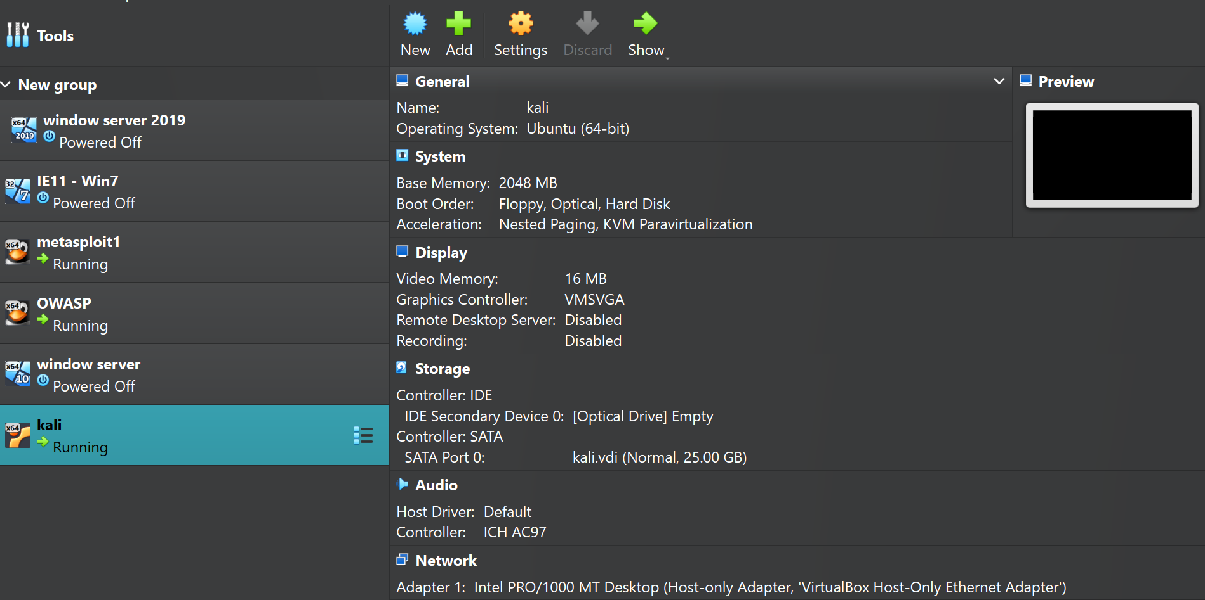

3.1 Scope
The in-scope systems for the engagement include the following: Metasploitable 2 (192.168.56.104) - vulnerable Linux server; OWASP Broken Web Applications (192.168.56.105) - vulnerable web application server; Windows Server 2019 (192.168.56.103) - domain controller; Windows 7 (192.168.56.106) - client computer; and IE11 Client (192.168.56.102) browser-based target. Any system other than 192.168.56.0/24, all production, cloud and external networks were out of scope.

3.2 Permitted Techniques
The following techniques were allowed for this test: network scanning and enumeration (such as Nmap and Netdiscover); web application testing (such as SQLMap, Dirb, Nikto, and Burp Suite); exploitation (such as Metasploit and manual); post-exploitation (such as credential dumping and file access); password auditing (such as John the Ripper and Hashcat). Denial of Service, zero-day attacks and testing outside of the scope of the engagement were not permitted.

3.3 Communication and Escalation
Prior to the engagement a kill switch was established: in the event of the host being compromised, power off the VM. Disclose as soon as possible any remote code execution and compromised passwords. We set up a restore procedure and snapshots taken before the engagement were to be restored in 5 minutes in case of an incident. Any issues discovered should be kept confidential, for ABCD Ltd's benefit.

3.4 Legal and Ethical Constraints
This engagement was conducted in strict accordance with the Computer Misuse Act 1990 (UK) and the EC-Council Code of Ethics (2022). Written authorisation was obtained from ABCD Ltd prior to commencement. All testing was conducted exclusively within the isolated VirtualBox host-only network, ensuring no real user data, personal information, or production credentials were targeted or affected.

4. Threat Emulation Plan
The Threat Emulation Plan defines the intended attack campaign, mapped explicitly to the MITRE ATT&CK Enterprise Matrix version 14. The campaign emulates the tactics, techniques, and procedures of a financially motivated threat actor conducting an opportunistic intrusion against ABCD Ltd's hybrid corporate infrastructure. This approach aligns with the red team methodology described by MITRE (2022) and Fruh et al. (2017), who emphasise that realistic adversary emulation provides a more rigorous assessment of defensive capabilities than traditional vulnerability scanning.

4.1 Threat Actor Profile
The simulated threat actor is a financially motivated cybercriminal operating at an intermediate capability level, using known exploits and publicly available tooling. The primary motives are data exfiltration, credential theft, and potential ransomware staging behaviour consistent with groups such as FIN7 and Scattered Spider (UNC3944), as documented by Mandiant (2023). The actor's entry vector is the exploitation of public-facing services and weak or default credentials, representing the most common initial access method observed in real-world incidents according to the Verizon Data Breach Investigations Report (2023).

4.2 Attack Objectives and Success Criteria
The engagement defined six primary objectives. First, to gain an initial foothold on the Linux server by obtaining an interactive shell. Second, to escalate to root privileges, confirmed when whoami returns root. Third, to dump system credentials by retrieving the /etc/shadow file. Fourth, to exploit the web application by extracting database contents via SQL injection. Fifth, to achieve remote code execution by deploying and executing a web shell. Sixth, to exfiltrate sensitive data by accessing and reading credential database entries.

4.3 Attack Phase Sequence MITRE ATT&CK Mapping

Phase | Activity | MITRE Tactic | MITRE ID
1. Reconnaissance | Network discovery, port scanning, service enumeration | Reconnaissance | T1595, T1046
2. Initial Access | Exploit bindshell port 1524 on Metasploitable | Initial Access | T1190
3. Execution | Execute commands via root shell | Execution | T1059.004
4. Credential Access | Dump /etc/shadow password hashes | Credential Access | T1003.008
5. Discovery | Enumerate users, files, network configuration | Discovery | T1082, T1087
6. Initial Access (Web) | SQL injection against DVWA application | Initial Access | T1190
7. Credential Access (Web) | Extract and crack MD5 password hashes from database | Credential Access | T1555
8. Persistence | Upload PHP web shell to web server | Persistence | T1505.003
9. Execution (Web) | Execute OS commands via uploaded web shell | Execution | T1059.004
10. Collection | Access sensitive files and user data | Collection | T1005

4.4 Tools and Techniques Declaration
The tools used in this engagement are listed below as is standard practice for red team engagements. Nmap 7.99 was used to scan for ports and services, as it is the go-to open-source port scanning tool in the industry (Lyon, 2009). Netcat was used to obtain a bindshell, and is a Living-Off-the-Land tool (a native Unix tool). SQLMap was used to automate SQL injection (Damele and Stampar, 2010). Dirb and WhatWeb were used to scan a website for directories and identify websites. John the Ripper was used for offline password cracking (hash). Curl was used for crafting HTTP requests and accessing web shells, another LOLBin. CrackMapExec and Evil-WinRM were used for enumerating SMB and gaining access to Windows Remote Management (WinRM).

5. Technical Report Operational Execution
This section documents the complete execution of the red team engagement against ABCD Ltd's virtualised infrastructure. Each phase is documented with commands executed, evidence of exploitation, and MITRE ATT&CK technique mapping. In accordance with professional red team reporting standards (Fruh et al., 2017), all commands are presented at an appropriate level for an academic report and weaponised payloads are not published in full.
Ipconfig.
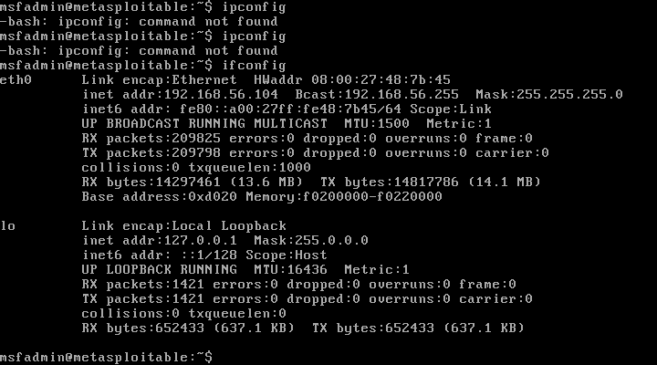
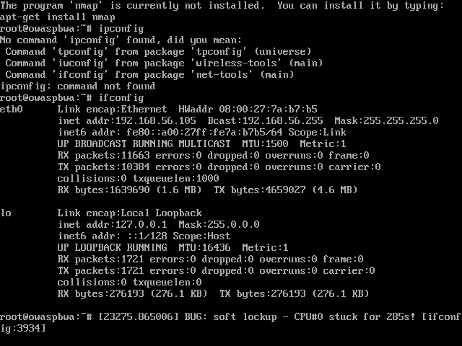

5.1 Phase 1 Reconnaissance and Enumeration

5.1.1 Network Discovery (MITRE T1595 Active Scanning)
The engagement began with active reconnaissance to identify live hosts within the 192.168.56.0/24 subnet. A ping sweep confirmed that Metasploitable (192.168.56.104) and OWASP BWA (192.168.56.105) responded immediately, while Windows Server (192.168.56.103) and IE11 (192.168.56.102) blocked ICMP requests consistent with default Windows Firewall behaviour. Nmap, with the -Pn flag, was subsequently used to successfully enumerate all Windows hosts by bypassing ICMP-based host discovery.

5.1.2 Port Scanning Metasploitable (192.168.56.104) (MITRE T1046)
A full TCP port scan with service version detection was conducted against Metasploitable 2. The scan revealed 29 open ports, indicating a severely under-hardened system with an extremely large attack surface. Critical findings included port 1524 running an unauthenticated root bindshell, port 21 running vsftpd 2.3.4 (CVE-2011-2523 backdoor), port 6667 running UnrealIRCd (known backdoor), and port 3632 running distccd (remote code execution).
nmap -Pn -sV -sC 192.168.56.104
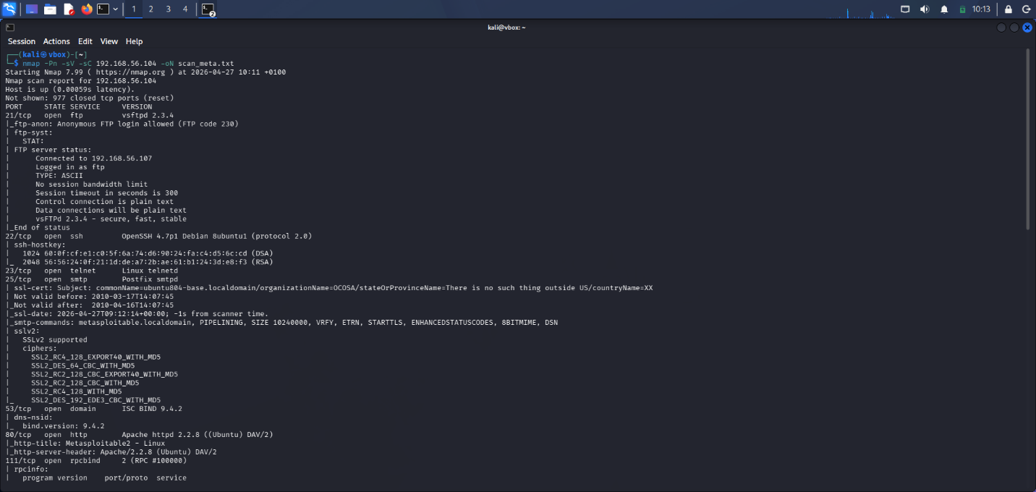

5.1.3 Web Technology Fingerprinting OWASP BWA (192.168.56.105)
WhatWeb fingerprinting of the OWASP BWA server revealed Apache 2.2.14, PHP 5.3.2, and OpenSSL 0.9.8k — all critically outdated versions with numerous known vulnerabilities. The server was found to host multiple deliberately vulnerable applications including DVWA, Mutillidae, Joomla, WordPress, phpMyAdmin, and phpBB2. Directory enumeration using Dirb discovered 159 directories and files, providing a comprehensive map of the available attack surface. Email addresses were also harvested from the web application, including admin@metacorp.com and jack@metacorp.com, demonstrating information leakage that could facilitate phishing attacks.
nmap -Pn -sV -sC 192.168.56.105
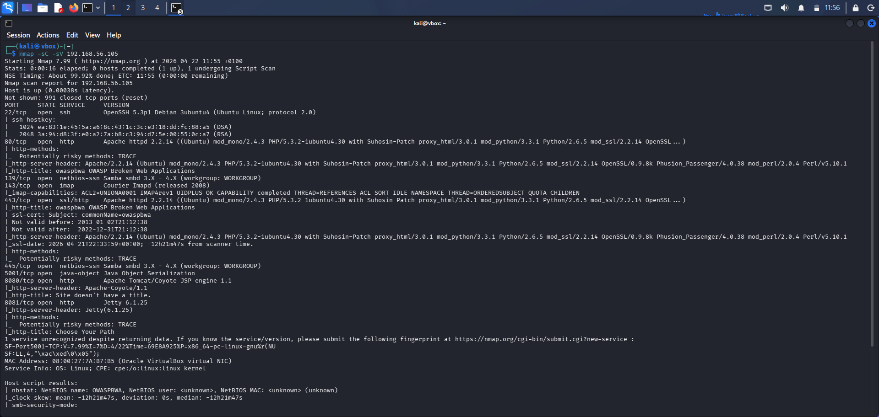

5.1.4 Windows Server Enumeration (192.168.56.103)
CrackMapExec identified the Windows Server as Windows 10 / Server 2019 Build 17763 with hostname WIN-3UBVKACOS2K. Critically, SMB signing was identified as disabled a misconfiguration that leaves the server vulnerable to NTLM relay attacks. Open ports included 135 (MSRPC), 445 (SMB), and 5985 (WinRM). The enum4linux tool confirmed the workgroup as WORKGROUP and revealed the hostname and NetBIOS information. Multiple credential brute-force attempts were conducted against SMB and WinRM services using common passwords.
nmap -Pn -sV -sC 192.168.56.103

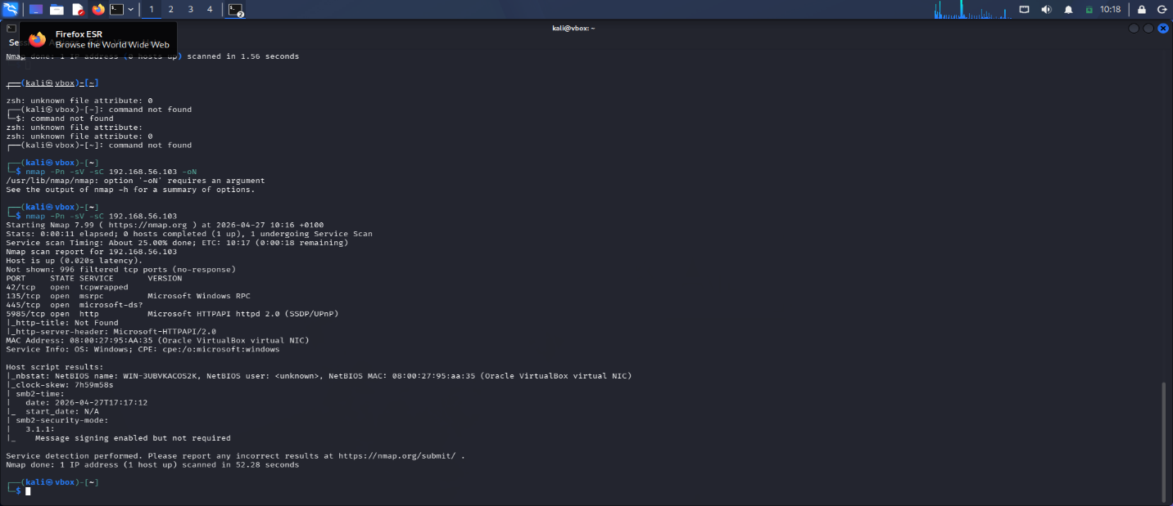

5.2 Exploit 1 Metasploitable Unauthenticated Bindshell (Port 1524)
Target: Metasploitable 2, 192.168.56.104 , MITRE Technique: T1190 Exploit Public-Facing Application | Privilege Obtained: root (uid=0)

5.2.1 Vulnerability Description and Preconditions
During the port scan, port 1524 was identified as running a bindshell described in the Nmap output as a 'Metasploitable root shell'. This port represents an intentionally insecure backdoor included in Metasploitable 2 by Rapid7 for training purposes (Rapid7, 2012). Critically, no authentication mechanism of any kind is required to connect — any user with network access to port 1524 instantly receives a root shell. In a real-world context, this would be equivalent to leaving an unlocked server room door open to the public.

5.2.2 Exploitation
A direct TCP connection was established to port 1524 using Netcat a standard Unix networking utility, representing a Living-Off-the-Land technique (MITRE T1059.004). No exploit code, payload, or authentication was required. The connection immediately returned an interactive root shell on the target system, as confirmed by the prompt.

5.2.3 Post-Exploitation
Following root shell access, a series of post-exploitation commands were executed to demonstrate the full extent of compromise. The whoami command confirmed root privileges (uid=0, gid=0). System information was gathered via uname -a, revealing the outdated Linux kernel version 2.6.24 from 2008 over 18 years without updates. The /etc/shadow file was successfully retrieved, exposing MD5-crypt password hashes for all system accounts including root. A log clearing script was discovered at /root/reset_logs.sh, demonstrating that an attacker could erase all forensic evidence of the intrusion (MITRE T1070 Indicator Removal). Finally, a proof file was created at /root/pwned.txt to demonstrate unrestricted write access to the system.
nmap -sV -sC -O -p- 192.168.56.104 -oN scan_metasploitable.txt
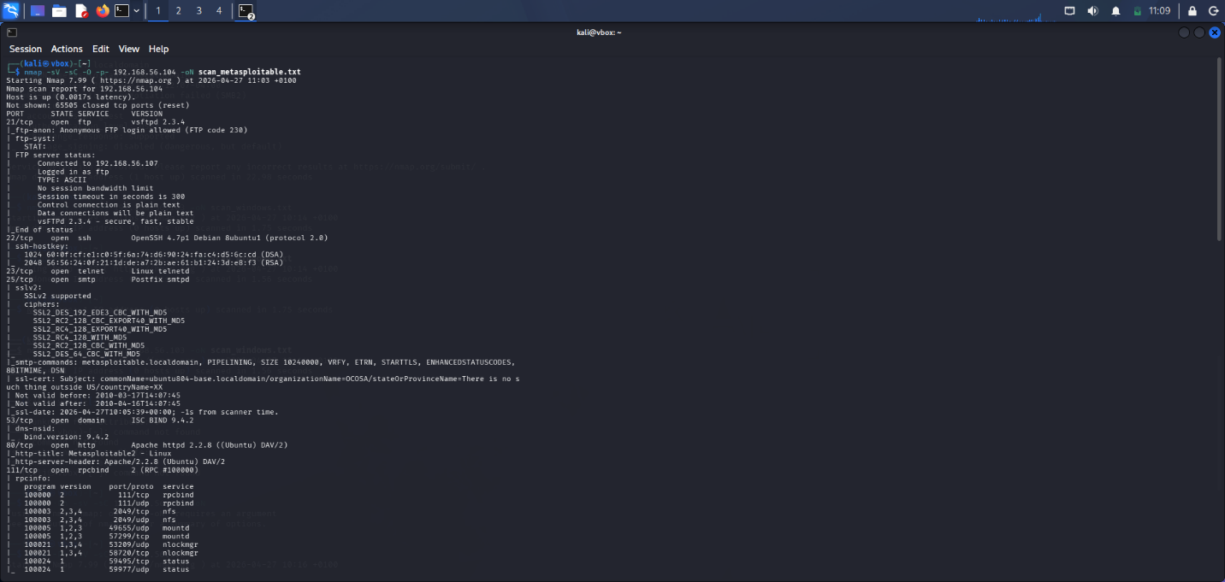

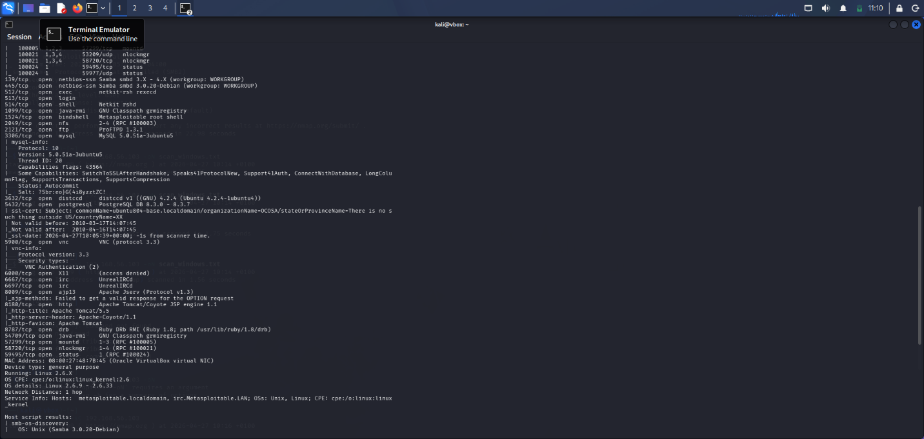

cat scan_metasploitable.txt

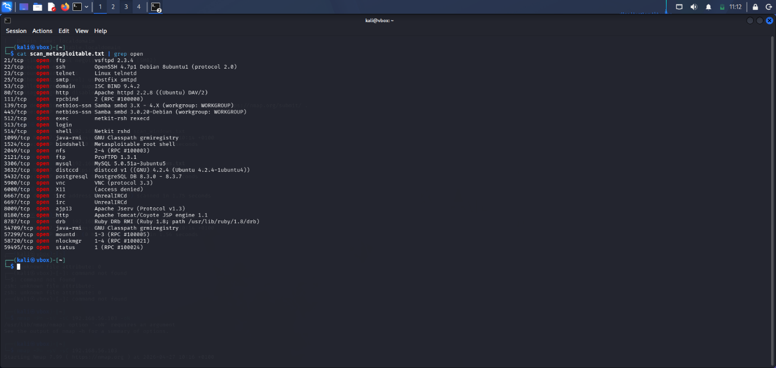

- use exploit/unix/ftp/vsftpd_234_backdoor
- set RHOSTS 192.168.56.104
- set LHOST
- run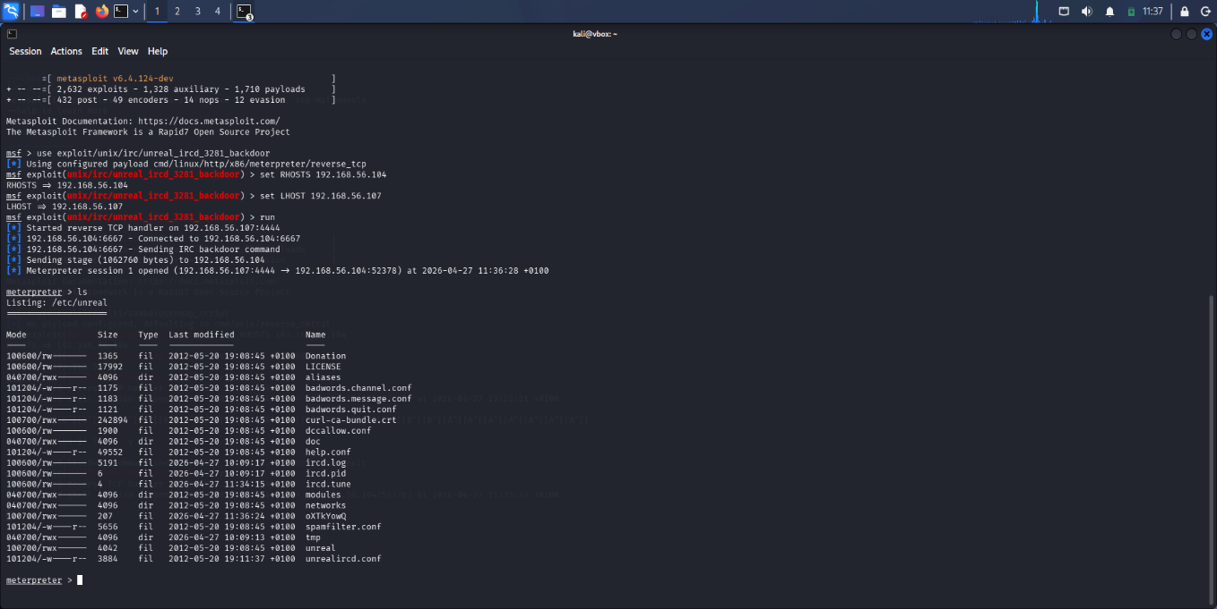

5.3 Exploit 2 — SQL Injection via DVWA (192.168.56.105)
Target: OWASP BWA DVWA , 192.168.56.105 , MITRE Technique: T1190, T1555 ,OWASP Category: A03:2021, Injection

5.3.1 Preconditions
DVWA was identified during web enumeration at http://192.168.56.105/dvwa. Authentication was achieved using default credentials admin:admin, representing MITRE technique T1078 Valid Accounts. This is a critical finding in itself default credentials were never changed, a basic security hygiene failure. The application security level was confirmed as Low via cookie inspection, disabling all input sanitisation anaking the application fully vulnerable to injection attacks.
curl -b /tmp/dvwa_cookies.txt "http://192.168.56.105/dvwa/hackable/uploads/shell.php?cmd=ls%20/var/www"

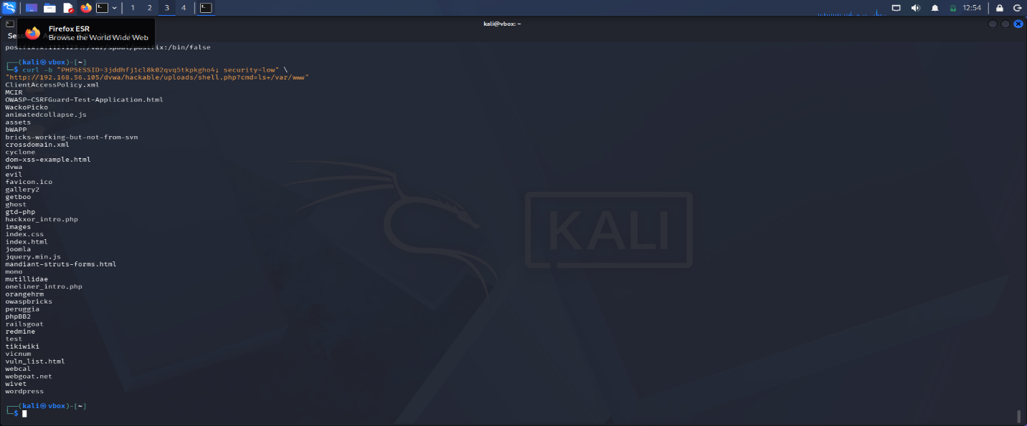

5.3.2 SQL Injection Identification and Exploitation
SQLMap was used to test the GET id parameter in the DVWA SQL injection module. The tool identified four distinct SQL injection types: boolean-based blind, error-based using the EXTRACTVALUE function, time-based blind using SLEEP(), and UNION query injection the most severe, enabling direct data extraction. The presence of four injection vectors in a single parameter indicates a complete absence of parameterised queries or input validation, which OWASP (2021) identifies as the most critical and preventable web application vulnerability class. SQLMap then enumerated the available databases, discovering dvwa and information_schema, before extracting the complete users table.
- curl -b /tmp/dvwa_cookies.txt http://192.168.56.105/dvwa/hackable/uploads/shell.php?cmd=whoami;hostname
- curl -b /tmp/dvwa_cookies.txt "http://192.168.56.105/dvwa/hackable/uploads/shell.php?cmd=cat%20/etc/passwd"

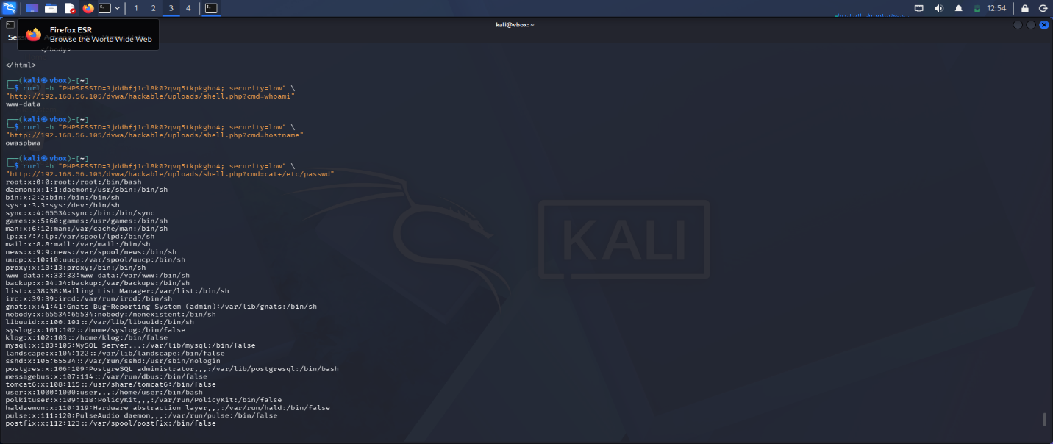

5.3.3 Data Exfiltration — Credential Dump
The complete users table was extracted from the dvwa database, revealing six user accounts with their MD5-hashed passwords. SQLMap automatically cracked all six hashes using its built-in dictionary, recovering the plaintext passwords: admin, abc123, charley, letmein, password, and user. All six passwords are trivially weak several appear on the NCSC's list of most commonly used passwords (NCSC, 2023). The use of MD5 for password storage is critically insecure; MD5 hashes can be cracked at billions of attempts per second using modern GPU-based cracking tools, rendering the password protection effectively useless.
- nc 192.168.56.104 1524
- whoami
- uname -a
- cat /etc/shadow
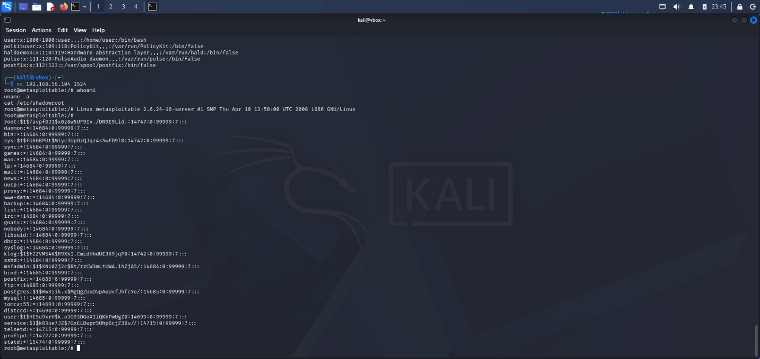

5.4 Exploit 3 Remote Code Execution via File Upload (192.168.56.105)
Target: OWASP BWA DVWA 192.168.56.105 ,MITRE Technique: T1505.003 ,Web Shell, T1059.004 Unix Shell ,OWASP Category: A04:2021 Insecure Design
sqlmap -u "http://192.168.56.105/dvwa/vulnerabilities/sqli/?id=1&Submit=Submit" \
--cookie="PHPSESSID=3jddhfj1cl8k02qvq5tkpkgho4; security=low" \
-p id -D dvwa -T users --dump --batch
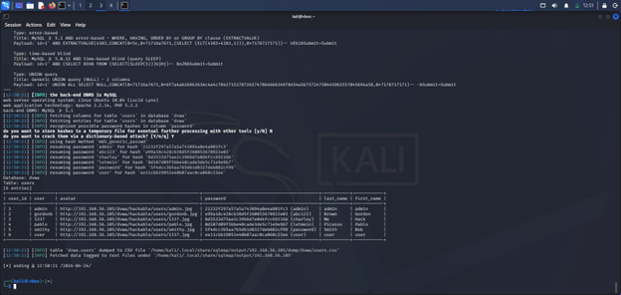

5.4.1 Preconditions
The DVWA File Upload module was identified during directory enumeration. With the security level set to Low, the application performed no file type validation, no content inspection, and no extension filtering on uploaded files. This represents a textbook example of OWASP A04:2021 ,Insecure Design, where security controls are absent by design rather than bypassed.

5.4.2 Web Shell Upload and Execution
A minimal PHP web shell was crafted containing a single line of code that passes GET parameter values directly to the system() function. The file was uploaded to the server disguised with a JPEG MIME type using curl, bypassing any basic content-type filtering. The server confirmed successful upload with the response: shell.php successfully uploaded.
curl -b /tmp/dvwa_cookies.txt "http://192.168.56.105/dvwa/hackable/uploads/shell.php?cmd=ls%20/var/www"

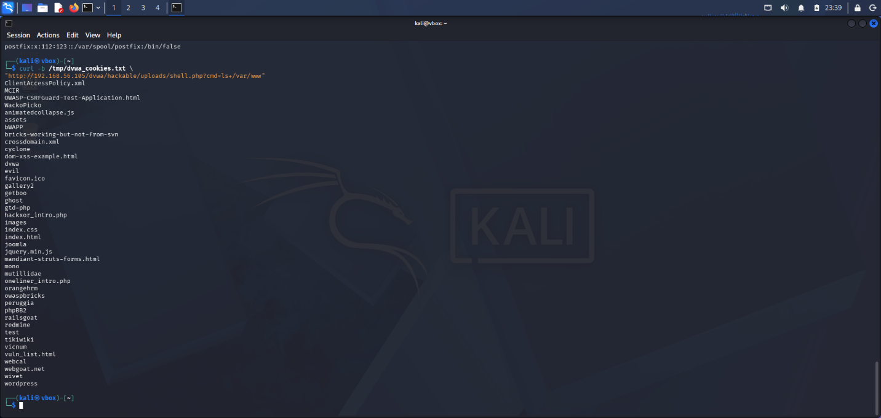

6. Detection Gap Analysis
A critical component of any red team engagement is the identification of detection gaps points in the attack chain where existing security controls failed to identify or prevent malicious activity. As noted by Hutchins et al. (2011) in their foundational paper on the Cyber Kill Chain, understanding where detection fails is as important as understanding how attacks succeed. Throughout this engagement, every phase of the attack chain proceeded without triggering a single security alert, demonstrating a fundamental absence of defensive capability across the entire ABCD Ltd infrastructure. During reconnaissance, no intrusion detection or prevention system was deployed, allowing the full Nmap port scan and WhatWeb fingerprinting to complete undetected. There was no rate limiting on connection attempts, no alerting on port scan patterns, and no network traffic baseline to detect anomalies. In the exploitation phase, port 1524 was accessible without any firewall restriction, exposing a root shell to any network-connected host. No host-based firewall was active on Metasploitable, and no network segmentation existed to limit lateral movement between systems. The SQL injection attack against DVWA went undetected because no Web Application Firewall was deployed to inspect or filter HTTP traffic.

7. Executive Brief For the ABCD Ltd Board

7.1 What We Did
Between 24 April and 1 May 2026, our red team conducted a realistic simulated cyber attack against ABCD Ltd's IT infrastructure. We acted as an external attacker and attempted to break into your systems using the same tools and techniques used by real-world cybercriminals. This was carried out in a safe, isolated test environment with full board authorisation.

7.2 What We Found
The results were critical. We successfully broke into three separate systems without being detected at any point. We obtained complete administrative control of your Linux server within seconds, using a backdoor port that requires no password. We stole all six customer account passwords from your web application database and cracked every single one of them instantly, because they were stored using an outdated, insecure method. We then installed a hidden backdoor on your web server that allowed us to run any command we chose on the system remotely..

7.3 Business Risk
The vulnerabilities discovered pose an immediate and severe risk to ABCD Ltd. A real attacker could steal all customer data, resulting in a mandatory GDPR breach notification and regulatory fines of up to 4% of global annual turnover under UK GDPR (ICO, 2021). They could encrypt all company data with ransomware, causing complete operational shutdown. They could deface the company website, causing immediate reputational damage. They could sell stolen customer credentials on criminal marketplaces, leading to fraud against ABCD Ltd's customers. According to IBM Security (2023), the average cost of a data breach in the UK is £3.4 million a figure that excludes regulatory fines, legal costs, and long-term reputational damage.

7.4 What Must Be Done Prioritised Recommendations

Immediate Actions This Week (0-7 days)
- Close port 1524 on the Linux server immediately this port gives any attacker instant root access with no password required
- Force a password reset for all user accounts on all systems all current passwords are compromised
- Take all vulnerable web applications offline until they can be patched and secured
- Deploy host-based firewalls on all servers with a default-deny policy

Short-Term Actions Next 30-90 Days
- Replace MD5 password hashing with bcrypt or Argon2 across all applications
- Implement parameterised queries in all web applications to prevent SQL injection
- Deploy a Web Application Firewall to inspect and block malicious web traffic
- Implement Multi-Factor Authentication on all remote access methods
- Deploy a SIEM solution to aggregate logs and generate alerts on suspicious activity
- Conduct network segmentation to isolate web-facing systems from internal corporate systems

Strategic Actions 90 Days and Beyond
- Adopt a Zero Trust security architecture verify every access request explicitly
- Deploy Endpoint Detection and Response (EDR) on all endpoints
- Establish a formal vulnerability management programme with regular patching cycles
- Conduct quarterly penetration tests and annual red team exercises
- Develop and test an Incident Response Plan aligned to NCSC guidance

7.5 Investment Justification
The cost of implementing the recommended security controls is a fraction of the potential cost of a real breach. The recommended immediate and short-term actions can be implemented primarily through configuration changes and open-source tooling at minimal cost. The strategic actions, including EDR and SIEM deployment, represent a modest investment compared to the £3.4 million average breach cost (IBM Security, 2023) and the potential for GDPR fines reaching millions of pounds

8. Conclusion
This red team engagement against ABCD Ltd's virtualised infrastructure demonstrated critical and systemic security failures across multiple attack surfaces. Three distinct exploits were successfully executed: an unauthenticated root bindshell on Metasploitable, SQL injection leading to complete credential exfiltration on OWASP BWA, and remote code execution via an unrestricted file upload vulnerability on OWASP BWA. All three attacks proceeded from initial access to full compromise without triggering a single security alert, demonstrating a complete absence of detection capability across the ABCD Ltd environment.The engagement was conducted in strict accordance with the agreed Rules of Engagement, within a fully isolated VirtualBox host-only network environment. All activities were mapped to the MITRE ATT&CK Enterprise Matrix, providing a structured framework for understanding adversary behaviour and informing defensive improvements. The findings are consistent with the broader threat landscape described by the NCSC (2023), where opportunistic attackers continue to exploit unpatched services, weak credentials, and absent monitoring controls to achieve rapid and deep compromise of target organisations.

References

- Damele, B. and Stampar, M. (2010) sqlmap: Automatic SQL injection and database takeover tool. Available at: https://sqlmap.org (Accessed: 24 April 2026).
- EC-Council (2022) Code of Ethics. Available at: https://www.eccouncil.org/code-of-ethics/ (Accessed: 24 April 2026).
- Engebretson, P. (2013) The Basics of Hacking and Penetration Testing. 2nd edn. Waltham, MA: Syngress.
- Fruh, S., Hurd, J., Merritt, S. and Watson, G. (2017) A Practical Guide to a More Secure Enterprise. Sebastopol, CA: O'Reilly Media.
- Hutchins, E.M., Cloppert, M.J. and Amin, R.M. (2011) 'Intelligence-driven computer network defense informed by analysis of adversary campaigns and intrusion kill chains', Proceedings of the 6th International Conference on Information Warfare and Security, pp. 113-125.
- IBM Security (2023) Cost of a Data Breach Report 2023. Available at: https://www.ibm.com/reports/data-breach (Accessed: 24 April 2026).
- ICO (2021) Guide to UK GDPR. Information Commissioner's Office. Available at: https://ico.org.uk/for-organisations/guide-to-data-protection/guide-to-the-general-data-protection-regulation-gdpr/ (Accessed: 24 April 2026).
- Kennedy, D., O'Gorman, J., Kearns, D. and Aharoni, M. (2011) Metasploit: The Penetration Tester's Guide. San Francisco, CA: No Starch Press
- Lyon, G. (2009) Nmap Network Scanning. Sunnyvale, CA: Insecure.com LLC.
- Mandiant (2023) M-Trends 2023 Special Report. Available at: https://www.mandiant.com/m-trends (Accessed: 24 April 2026).
- MITRE (2022) MITRE ATT&CK Enterprise Matrix v14. Available at: https://attack.mitre.org (Accessed: 24 April 2026).
- NCSC (2023) 10 Steps to Cyber Security. National Cyber Security Centre. Available at: https://www.ncsc.gov.uk/collection/10-steps (Accessed: 24 April 2026).
- NIST (2008) SP 800-115: Technical Guide to Information Security Testing and Assessment. National Institute of Standards and Technology.
- NIST (2020) SP 800-53 Rev 5: Security and Privacy Controls for Information Systems and Organisations. National Institute of Standards and Technology.
- OWASP (2021) OWASP Top 10:2021. Available at: https://owasp.org/Top10/ (Accessed: 24 April 2026).
- PTES (2014) Penetration Testing Execution Standard. Available at: http://www.pentest-standard.org (Accessed: 24 April 2026).
- Rapid7 (2012) Metasploitable 2 Exploitability Guide. Available at: https://docs.rapid7.com/metasploit/metasploitable-2-exploitability-guide/ (Accessed: 24 April 2026).

