Jorna Ali (1706149)


Project Planning and Management in the work place
BMSK5004

Contents
Introduction 2
What is a Project? 2
Project Life Cycle 2
Initiation Phase 2
Belbin’s Team Roles 2
Scope 2
Planning Phase 3
Quad Chart 3
Iron Triangle 3
Risk Assessment 3
Work Breakdown Structure 3
Gantt Chart 4
PESTLE 4
Stakeholder Analysis 4
Execution Phase 5
Closure Phase 5
Evaluation 5
Project Management Skills Evaluation 5
Conclusion 6
References 7
Appendices 9
Appendix A – Quad Chart 9
Appendix B – Iron Triangle 10
Appendix C – Risk Assessment 11
Appendix D – Work Breakdown Structure 12
Appendix E – Gantt Chart 13
Appendix F – Stakeholder Analysis 14

Introduction
The following report will provide a critical assessment of the implementation tools used in the development stages and carrying out of the project and its management.

What is a Project?
According to Beech (2014), a project is an art, a science and a business that requires a research and planning method suitable to achieve the particular aim of the project. Project Management, then, is “the application of knowledge, tools, and techniques to project activities to meet the project requirements” (Forbes, 2000).

Project Life Cycle
According to the Project Management Institute (2019), the project life cycle is “an important tool used by managers to deliver projects to clients successfully”. There are four phases to the project life cycle:
- Phase 1: The Initiation Phase
- Phase 2: The Planning Phase
- Phase 3: The Execution Phase
- Phase 4: The Closure Phase
Project life cycle is a structured approach for delivering a project (Archibald, 2016). It allows the team to identify the progression of the project itself and defines the activities and output of each phase. Roles and responsibilities are assigned according to the project phase, making it clear for the team to understand what they should be doing. The project manager can link progress directly to each phase and recognise the completion of the phases (Westland, 2006).

Initiation Phase
The group were informed that they would be providing a service to Swansea Council for Voluntary Service. This is the ‘umbrella organisation’ for voluntary activity that offers support, development and representation of voluntary organisations, volunteers and communities in the county (SCVS, 2019). SCVS is a partner of the Black and Minority Ethnicity (BME) skills project, which helps community groups and organisations in advancing skills and prior experience.

Belbin’s Team Roles
The team previously took a Belbin test to identify behavioural strengths and weaknesses in the workplace (Belbin Associates, 2019). The author’s skills were identified as communication, leadership, team management, self-motivation and time management. Taking everyone’s strengths and weaknesses into consideration, Marjana Khatun was elected as team leader, as she brings a number of leadership qualities to the team such as confidence and good communication skills.

Scope
The project itself was called Demystifying Strategic Business Planning, and its scope was developed to provide the Swansea Council for Voluntary Services (SCVS) and their organisations with the knowledge to create a suitable business plan. Scope itself can be defined as the common understanding between stakeholders about the project is, what goes into it and what factors lead to its success (Stoehr, 2001). In this instance the information was specifically directed to small community groups through BME skills project with SCVS and EYEST in Swansea to give them further information about improving or starting up new companies.

Planning Phase

Quad Chart
A Quad chart was designed by the team (see Appendix A) to work through the process of strategic planning for business. These are called a quad chart because they are divided into four sections to illustrate the data (Paladino, 2010). The sections of the chart are labelled purpose, customers, desired end results and measures of success (Paladino, 2010). A quad chart is easy and quick to read as all parts of the contents are sorted clearly, therefore the team can identify the purpose of the project, who their customers are, the project’s desired results and the measures of success.

Iron Triangle
The Iron Triangle tool (Pollock, et al, 2018) (see Appendix B) was used to look at the cost of doing the project, what the product is and how much time it might take to deliver it to the customer. All three of these elements are needed to make the project work. The cost of implementing it is covered by Swansea council, the product is equally significant as the knowledge shared during the delivery of the workshop should be relevant and precise within a timescale of five weeks. The Iron Triangle can be seen as an effective tool to use at this stage as it can establish the relationship between important areas of project management and so setting a structure for those involved to work with. However, there can be potential issues including ignoring the effect upon business and not focusing on long term thinking (Simms, 2015).

Risk Assessment
This process involves looking at how the outcomes and objectives of the project might change because of the risk events. The risks are identified and analysed to “assess the qualitative and quantitative impact of the risk on the project so that appropriate steps can be taken to migrate them” (Westland, 2006). The risk management table gives an in-depth indication of what is considered high, medium and low risk for the project (Woods, 2011). Risk assessment is necessary because unwanted events or situations can lead to failure of the project. Risk Management is an approach in which the team can identify, analyse and mitigate the risks that can affect the project and it therefore helps to avoid any disasters (Raftery, 1994). One of the identified risks of the project was that the workshop room itself was too small, therefore the team could only invite a limited amount of participants (see Appendix C). Another issue was technical problems with the projectors. To avoid risks, the team took a blackboard pen to write on the board as a backup plan in order to retain the attention of the audience and to get them to engage more.

Work Breakdown Structure
Work breakdown structure (WBS) comprises listing every task the team needs in order to complete the project (Gregory T. Haugan, 2008). The team used a WBS tool to segment the project into smaller components (see Appendix D). This helps the project to deliver the work into manageable sections. This is important for the project manager because she can oversee the tasks more effectively than the complex activities. Tasks must be measurable and independent, with clearly defined limits (Campbell, Baker and Baker, 2014). By using WBS it helped the team define, assemble and look at the overview of the project. It was managed through monitoring, allocating resources and assigning responsibilities. The project manager can thus cross-check every part to see that nothing is missing.

Gantt Chart
Team meetings and regular communication are very important in a project to build a team’s objectives (Project Management, 2018). A project should start with a communication plan where all ideas are set out. These ideas need to be shared and discussed within the meetings for the project and its development to be effective. The use of a Gantt chart in this instance can set out all of the information in a visual format for the group (see Appendix E).
The Gantt chart is a flexible tool which is presented in a graph format. It allows a practical and intuitive outlook of activities as well as the progression of each stage (Geraldi and Lechter, 2012; Young, 2013; Steffan, 2008). It’s a highly effective tool to use in project management. The team had created a Gantt chart to follow the schedule smoothly. The chart helped assess how long the project should take, to determine the resources needed and it also helped with time management.
.

PESTLE
A PESTLE (Political, Economical, Social, Technological, Legal and Environmental) analysis is a kind of framework that can be used to assess the wide-ranging factors that may have a huge impact on the performance of an organisation (PESTLE Analysis, 2019). By analysing PESTLE according to the project, the most important issues for the team are the Social, Technological and Legal factors involved, although the other aspects are also present and would be considered, however they don’t apply in this project.
Social aspects of the project look at different views of the participants and the planned timing of the workshop according to people’s needs (PESTLE Analysis, 2019). The team have identified 10am to 1pm as the best time to fit the social needs of the target audience. This is because it fits in with the voluntary organisations that will be attending, and it fits in with the demands of those present who may be parents of young children.
A technological factor of the project is that the team members have been emailing each other with all the work they have been completing to prevent the risk of losing it. On the day of the workshop itself it was suggested to take in a black board pen in case of a technological failure with the projector and also to have other activities planned for the participants to get them engaged.
Due to legal requirements, the team were told by SCVS not to advise the participants, but only to give out information. This was because the participants may have complained if they received incorrect advice which could lead to problems for the organisation. All trainers and participants needed to sign consent forms to allow storage and process information in line with GDRP law. GDRP law refers to general data protection and concerns the privacy of individuals (European Commission, 2019). If PESTLE had not been used, incorrect information could have been passed on, resulting in problems for the organisation. Furthermore, a back-up plan for technology could have been neglected and timing issues could have arisen.

Stakeholder Analysis
Stakeholder Analysis is an important technique for stakeholder identification and analysing their needs. It is used to identify all key (primary and secondary) stakeholders who have a vested interest in the issues with which the project is concerned. Managing stakeholder helps to ensure that the projects succeed where others might fail (Gudda, 2011). A stakeholder analysis was created to identify and understand stakeholders in this specific project (see Appendix F). The effect of this was to identify who the stakeholders were to give an overview to the team of how to plan their project based upon the interests and business relationships of the stakeholders.

Execution Phase
The team has moved to the execution phase of the life cycle (Westland, 2006). Everything that was planned during the five weeks of the project was included in its implementation. A SWOT analysis was conducted to find out the strengths and weaknesses of participating organisations. The life cycle of the entire project culminated in the presentation during the workshop in which all team members took part. There was no specific tool used during the execution phase itself, but they were part of the process leading up to it. The execution phases involved the entire team presenting the project to members SCVS team.

Closure Phase
The closure phase of the life cycle (Westland, 2006) for the team members occurred when they had completed their project. It also involved opportunities for the audience to feed back their responses to the project proposal. One of these was the recommendation to not use complicated business terminology during the presentation as it could be hard to understand. The Gantt chart and WBS chart was updated to show the completion of the project.

Evaluation
At the end of the workshop, an evaluation form was given out to the participants to fill out and comment on the team’s performance. All of the team members were impressed with the feedback which made them feel proud of the whole project. An evaluation is critical to assess the success of the project, giving a chance for improvement in future proposals. The viewpoint of the audience has to be taken on board in order to make the whole project an effective one (Tache and Ispasoui, 2013).

Project Management Skills Evaluation
Throughout the project the author attended meetings with their group, and all of the charts were created together. The input that the author provided to this process included the following:
- A business that had been created as part of a group project in the first year of study.
- A presentation
- Poster for the day
- A SWOT with the participants
On the day of the presentation itself, the author contributed an example of an effective business plan which was called ‘Fitness Guru’ and had been developed as part of a group activity. The author was described as confident, communicative and professional and all of the participants thought the author was actually a successful businesswoman because of their professionalism.
For future projects and presentations, the author realises that they should focus on continuing to be confident and professional, but also to present with enthusiasm and directness to the audience, as this keeps their attention. The author would also make the following adjustments:
- Project management could be improved by implementing the tools used more thoroughly.
- Time management was very effective, and so must be repeated in future projects.
- Communication between team members was excellent and should also be repeated at this level for future projects.
- Delegation was highly effective which resulted in excellent teamwork.
- Matching tasks to skills depend on good communication and understanding on the part of the team leader.
- Leadership has to be determined upon individual strengths and also needs excellent communication skills.

Conclusion
Overall, the author believes that this was an effective project, because everything was done according to the Project Management lifecycle and on the day of the execution of the workshop the team had excellent feedback from the audience. In the future, however, the team would organise different types of activities for participants to get involved in, to engage them even more. This is because people learn far better when they are involved in practical activities (Jasper, 2003) and this was perhaps not implemented well enough during the project. The author identifies that some of the tools used were very similar and were perhaps not needed for the success of the project. For example, some of the information on the chart used overlapped and this might have been confusing. However as stated the author was very pleased with the project overall.

References
Archibald, R. D. (2016). Project Life Cycle Economics. In: M. Pica, ed. Cost Estimation, Management and Effectiveness in Construction Project. London: Routledge Publisher, p-10.
Beech, J., (2014) Doing Your Business Research Project. London. Sage.
Belbin Associates, (2019) The Nine Belbin Team Roles. [Online] Available at:https://www.belbin.com/about/belbin-team-roles/ [Accessed 13 May 2019]
Campbell, G., Baker. K. (2014). The complete idiot’s guide to project management. 3rd ed. New York: Alpha Books.
European Commission (2019) Data Protection [Online] available at: ec.europa.eu/dataprotection [accessed 27 May 2019]
Forbes, D., (2000) Project Management Information Systems. Washington DC: Transportation Research Board.
Geraldi, J. and Lechter, T. (2012), ‘Gantt charts revisited’, International Journal of Managing Projects in Business, 5(4), pp. 578-594. [online]. Available at: https://search-proquest-com.ezproxy.uwtsd.ac.uk/docview/1112229712?accountid=130472&rfr_id=info%3Axri%2Fsid%3Aprimo, [Accesssed 25 05 2019].
Gudda, P., (2011). A Guide to Project Monitoring & Evaluation. Bloomington. Authorhouse
Gregory T. Haugan, P. (2008). Work Breakdown Structures for Projects, Programs and Enterprises. Viennea: Library of Congress Cataloging-In-Publication Data.
International Relations Online at American University (2015) Project Design, Monitoring and Evaluation [Online] available at:https://www.youtube.com/watch?v=ORUoKphGbQ4 (accessed 1/06/1019)
Jasper, M. (2003) Beginning Reflective Practice. Cheltenham. Nelson Thornes
Paladino, B. (2010). Innovative corporate performance management: five key principles to accelerate results, New Jersey & Sons, pp.300
PESTLE Analysis, (2019) What is PESTLE Analysis? A Tool for Business Analysis. [Online] Available at: https://pestleanalysis.com/what-is-psetle-analysis/ [Accessed 20 May 2019].
Pica, M (2016). Project life cycle economics: cost estimation, management and effectiveness in Construction project, London: Routledge
Pollack, J., Helm, J., & Adler, D. (2018). ‘What is the Iron Triangle, and how has it changed?’, 11(2), International Journal of Managing Projects in Business, [Online]. Available: http://search-proquest-com.ezproxy.uwtsd.ac/docview/2033215603?accountid_id=info%3Axri%Fsid%3Aprimo, [2019, 05, 23]. (pp.527-547).
Project Management (2018). Advantage and Disadvantages of Gantt Charts. [Online] Project-Management.com. Available at: https://project-management.com/advantages-and-disadvantages-of-gantt-charts/ [Accessed 28 May 2019].
Raftery, J. (1994). Risk analysis on project management. London: E & FN SPON, p.5 - 10
SCVS, (2019) Swansea Council for Voluntary Service. [online] Available at:https://www.scvs.org.uk/about-us [Accessed 17 May 2019]
Simms, J. (2015). 10 ways the Iron Triangle destroys project success. [online] Project Manager. Available at: https://projectmanager.com.au/10-ways-the-iron-triangle-destroys-project-success/ [Accessed 25 Jun. 2019].
Stoehr, T., (2001) Managing e-business Projects. Hamburg. Springer Science & Business Media
Tache, F. and Ispasoui, C., (2013).’The dynamic of project monitoring and evaluation mechanisms within modern organisations’. Revista de management comparat International, 14(4), pp. 628-636. [online]. Available at: https://search-proquest-com.ezproxy.uwtsd.ac.uk/docview/1501910151?OpenUrIRefld=info:primo&accountid=130472 [Accessed 12 06 2019].
The Project Management Institute (2019) Critical Success Factors: Project life cycle [online] available at: https://www.pmi.org/learning/library/critical-success-factors-project-life-cycle-2131 [Accessed 1 June 2019]
Westland, J. (2006). The Project Management Life Cycle. London: Kogan Page Limited.
Woods, M. (2011). Risk Management in Organisations. London: Routledge Taylor and Francis Group

Appendices

Appendix A – Quad Chart
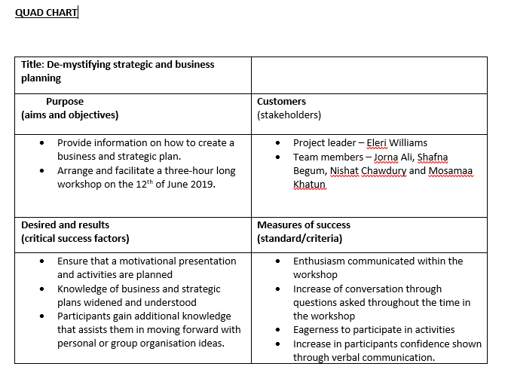

Appendix B – Iron Triangle
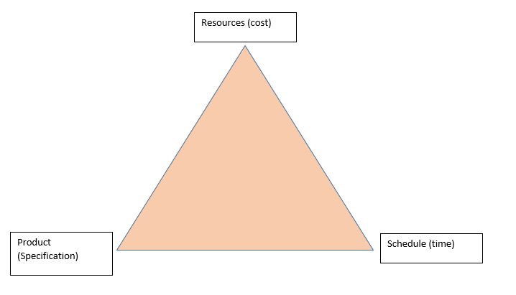

Appendix C – Risk Assessment
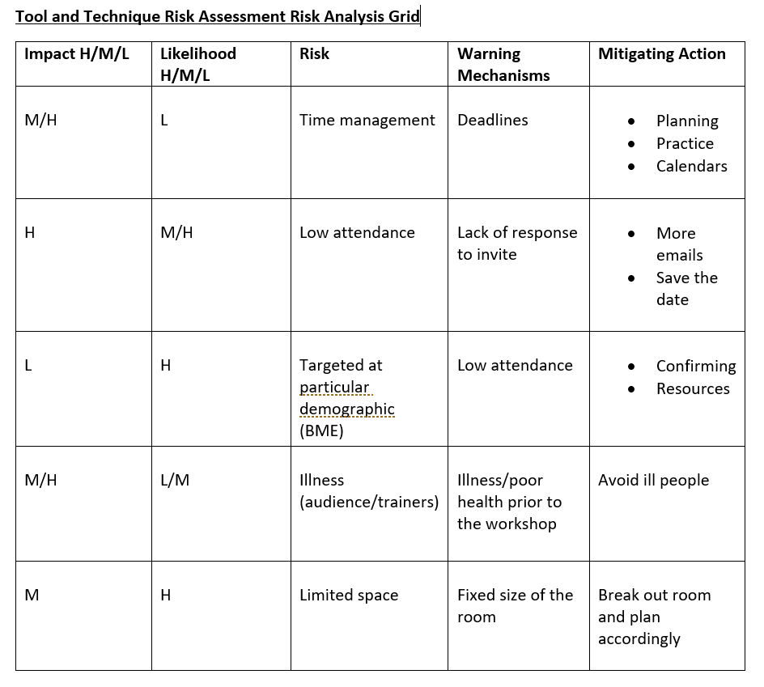

Appendix D – Work Breakdown Structure
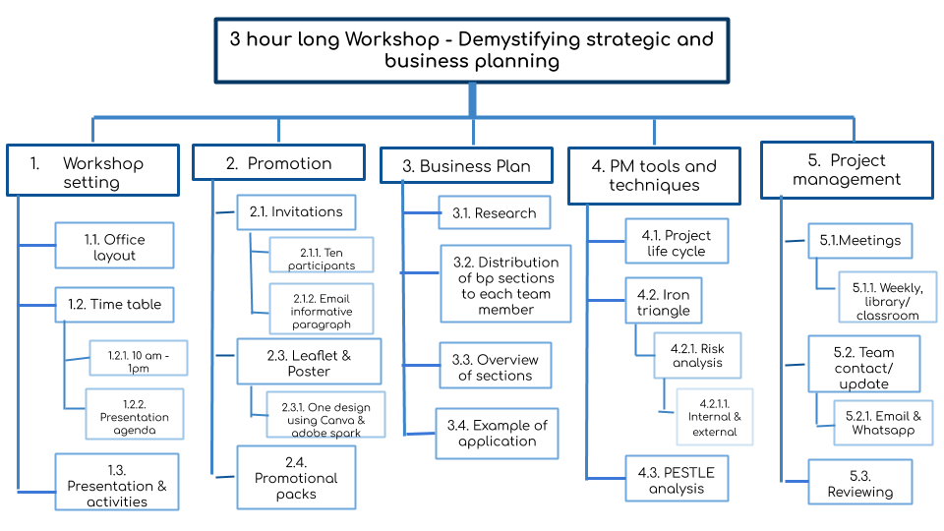

Appendix E – Gantt Chart
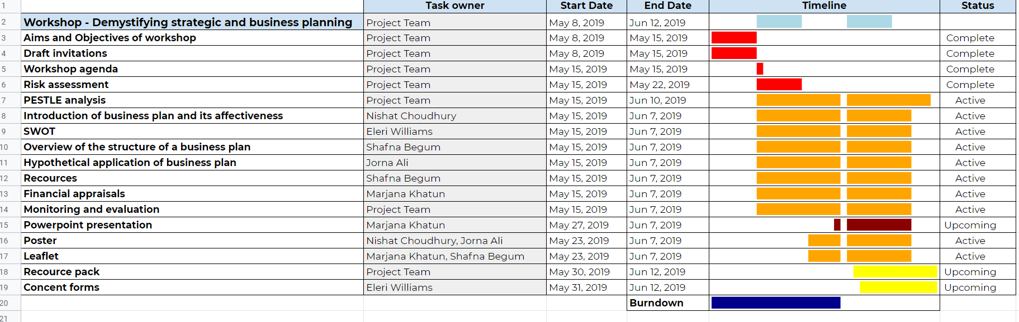

Appendix F – Stakeholder Analysis


