Report

Sustainable Business Revenue Generation Plan
Outsourcing housekeeping department
Pro and Cons

Student name: Laura Popescu
Student number: 211092
Module: Financial Management for the Hotel Industry
BMIH 5007
Tutor: Dale Clarke

Table of content

Executive summary……………………………3
Introduction………………………………………3
Main body…………………………………………3
CRS and housekeeping………………………5
Conclusion………………………………………..6
Reference list……………………………………7
Appendix …………………………………………9

Executive summary

This report will outline the importance of the housekeeping team within the hotel industry and determine if outsourcing this department will have any financial implications, if cost-effectiveness is a more critical factor than customer satisfaction, and how these factors can be gathered. A multitude of examples regarding hotel companies that outsourced their housekeeping department will be presented and evaluated if it was a good decision. After that, it can be decided whether outsourcing such an important department is a good idea or not, and recommendations will also be offered in order to provide a better business and increase business performances.

Introduction

This essay will discuss whether it is a good idea or not to outsource the housekeeping department within the hotel industry, emphasising on International Hotel Group as a chosen hotel. Comparing IHG decisions regarding the chosen subject with other organisations will be made. Another essential factor to be discussed is that outsourcing affects the business financially and regarding quality services.
As an introduction, Intercontinental Hotel Group is one of the world’s leading hotel companies, spread around the globe in over 100 countries and has 18 hotel brands in its portfolio. A big company with over 345000 employees works hard daily to deliver great customer service and keep the standards as high as possible.(IHG,2023). The second most important role in the hotel industry is held by the housekeeping team, who must be well-trained and aware of the quality standards that the hotels have in place and continue offering customers high-standard services that lead further to increasing customer satisfaction and increasing retention rates. The job that the housekeeping team is entitled, plays a crucial role which impacts customer experiences. The risks of outsourcing the housekeeping department will also be discussed after a better understanding of the implications of this process is offered in the main body of the report.

Main Body

Indeed Team (2022) states that when a company subcontract some of its work to another organisation that specialises in those tasks, it is called outsourcing. A Third-party organisation can complete the work at lower costs, allowing the contractor company to focus on other departments or tasks. Generally, the outsourcing process in the hospitality industry is done because there is a short-staff situation, the business needs to afford or wants to spend more money to train their staff, or there needs to be more staff in the department. Outsourcing the housekeeping department should prioritise hotel staff to focus more on the guest experience. (MasterCorp Inc., 2013).
In 2021 Milind Panchal stated that the outsourcing trend started at the end of 1980, having as a purpose cost-savings and that the hospitality industry outsourced mainly huge events.
Annu Knot (n.d) stated in one of her works promoting an outsourcing company that the hospitality industry developed very fast in the last years and that outsourcing departments from the hotel can allow hoteliers to focus more on creating great experiences and let the professionals handle the hard job.
When outsourcing hotel departments, the management team’s tasks change, becoming managers of inter-organizational relationships and managing the relations with external suppliers. (Gonzalez, Llopis and Gasco, 2011).
A fear that the leadership might have when outsourcing the housekeeping department could be regarding the quality standards of the services offered by the employed company, but this is less likely to happen as the company who is hired must have professional staff who are professionally trained for the job done, reassuring the hotel management that the services offered are following high standard services. A contract specification is required for a stable connection between the hotel and the contractor. Contract specifications must provide information about the methods, products used and all other details that the parties must follow as the hotels get the best results from this contract. (Jitendra Das, 2020).
On the other hand, hiring an outside company to deal with the housekeeping department has many pros. Emphasising the financial part, outsourcing the housekeeping department could save the company money as the hotel knows from the beginning what are the costs per room, not need to spend time on planning housekeeping operations, dealing with the absence of the staff, or maintaining the equipment needed as the contracted team can do all that for a fixed price. Knowing from the beginning the budget planned for a whole department by hiring an external company allows the business to plan the finances better to gain profit.
There was no information found about Intercontinental Hotel Group regarding outsourcing the housekeeping department in their hotels, and this is because all their statements provide information about the training offered to their employees. IHG emphasises their employees' specialisation and raises awareness about the problems that might occur, ensuring the services are delivered daily at high standards, insourcing the housekeeping department as the best option, as everything can be controlled.
Promoting an external company that can help companies outsource some of the departments, JD Cruzate (2022) states that while outsourcing, chairs might have less control over the outsourced departments. This does not mean they are out of control of that area, but the job might look different because someone else is in charge. Here comes the trust the management team has in the company hired and the connection between these two. A better understanding of the services offered and a firm contract will create bonds leading to excellent services and satisfaction.
Outsourcing Company
An example of a company that hotels can outsource the housekeeping department is Rare Hospitality. This company provides services for many industries as the corporate sector, health sector, manufacturing, education, and hospitality industry. Emphasising the hospitality industry, Rare Hospitality is contracted by St. Regis Hotel and Resorts and Courtyard. Part of Marriott International, the hotels need to ensure that the property cleanliness is a priority that must be noticed. Rare Hospitality has been offering its services to many more properties, offering high standard service for some institutions for many years. An excellent example of a long-time connection is with Pallazio Hotels in Dubai, which has been working together since 2014. The hotel reported that they achieved better cost-effectiveness and account management since they outsourced their housekeeping department. (Rare Hospitality, 2021)
An article was written on the fisherphillips website back in 2017 regarding high-profile outsourcing that leads to high-profile protests, giving as an example the situation when Hyatt Hotels Corp. fired 98 housekeepers, replacing them with an outside organisation who would pay only half of the wages earned by the fired employees. Thinking about cost saving, the company took the worst decision, profoundly affecting the business. Firing the employees led to protests, and many companies stopped working with Hyatt hotels. This example shows another face of the coin regarding important decisions taken while financial difficulties occur without being fully aware of the consequences. This does not necessarily mean that outsourcing is causing problems. Still, it is a lesson for all the hoteliers who tend to take decisions only based on the financial part of the business, not taking into consideration any other aspects.
An essential factor influencing the decision regarding outsourcing or not housekeeping department could be the customer’s opinion. Recently, THE NEW LANDSCAPE OF HOUSEKEEPING AND HYGIENE (2021) conducted a survey evaluating the customer’s opinions regarding what areas of the hotels concern them regarding cleaning and sanitation. The customers most voted for their guestroom followed very close by the state of elevators, restaurants, and gyms. In the appendix one can be found the study chart. Especially after covid-19, hoteliers must understand that the state of the whole building has a massive impact on customers and if not outsourcing the housekeeping department, they must make sure that the standards are high and the services provided can and will delight customers.

Commitment to CRS /IHG
CRS is an acronym representing Corporate Social Responsibility and relates to hotels’ practices while sustainably operating the business. Intercontinental Hotel Group has a programme that helps all the brands who joined the big company to adhere to sustainable practices while operating businesses.
A well-structured plan gives the companies a purpose to fight and work hard to achieve their targets.
InterContinental Hotel Group has vital targets until the end of 2030 regarding their waste reductions, reduced energy usage, implementation tools to reduce the water footprint of their hotels and many other targets that will help reduce their footprints. A table with the 10-year responsible business plan of Intercontinental Hotel Group will be provided in Appendix 2.
Keeping the housekeeping team in-house and choosing not to outsource this critical department assures the mother Company that the targets will be reached and the services will be delivered at the same standards daily. As IHG is investing an important amount of money in offering professional training to their employees, outsourcing a department after investing that much will be a loss of resources and time. Continuously improving employees’ training and creating opportunities makes employees feel like another family, someone who cares for them and wishes them well. Outsourcing departments, especially housekeeping, will mean many job losses, many connections between staff will be lost, and all the invested time will be wasted. Even if the employee lifecycle has an end, managing to keep the employees for longer periods creates connections that are not easy to forget.

Conclusion and Recommendations
As the housekeeping department’s work directly impacts the guest’s experience in a hotel, the team must be prepared to offer the best service they can, as their work directly impacts customer retention and, implicitly, the business. They clean and prepare the guestrooms, but their other responsibilities are cleaning and maintaining the hotel. (Sachin Gupta, 2021). The customer’s impression, at first sight, directly impacts their experience and represents over half of the weight regarding the decision on booking again or not with the hotel.
Outsourcing is a good option if the tasks and the time left do not allow the management team to handle other issues besides those already on hand. Still, the importance of quality services must be prime and here comes the decision or not to outsource the department. Intercontinental Hotel Group is a vast company, so setting its standards is necessary. Different service standards offered by the same brand led to inconsistency, leading forwards to image damage, a loss of trust or even falling sales figures. Outsourcing housekeeping could help the company to save money, but only if the standards are the same in all the hotel brands. As a recommendation, the best option for the Intercontinental Hotel Group is to keep insource the housekeeping departments in their hotels, offering the best training possible and ensuring employees are delivering inequality services.
An essential factor to consider before outsourcing the housekeeping department is if the external company ends the contract sooner. The hotel still needs a housekeeping team, as the department was outsourced, so there is no team to work with. The management team must train and prepare other employees in case this situation occurs or as well could have a backup contract with another external company that could provide an emergency housekeeping team who is ready to come into action as soon as needed. The manager’s soft and hard skills must be fully developed to deal with this kind of situation and to be able to act soon and promptly Indeed, it is a hypothetical situation that is less likely to happen, as nowadays, contracts between the hotel and the hired company are very strict. If situations like this occur, there is a tremendous amount of money to be paid as compensation, and no company wants it to happen.

Reference list
Cruzate, J.D. (2022). Hospitality Outsourcing: Pros and Cons. [online] MCVO Talent Outsourcing Services. Available at: https://www.mcvotalent.com/hospitality-outsourcing-pros-and-cons/ [Accessed 8 Mar. 2023].
Das, J. (2022). CONTRACT SERVICES in Housekeeping Department. [online] www.youtube.com. Available at: https://www.youtube.com/watch?v=1vJQgZfuDEc [Accessed 8 Mar. 2023].
Dixit, S. (2022). What are Benefits Of Outsourcing Housekeeping Services In Hotels. [online] Rare Hospitality. Available at: https://www.raregrp.com/what-are-benefits-of-outsourcing-housekeeping-services-in-the-hotel-and-hospitality-industries/#:~:text=Outsourcing%20housekeeping%20services%20has%20its%20advantage.%20Many%20hotels [Accessed 8 Mar. 2023].
GONZALES, R., Llopis, J. and Gasco, A.J. (2011). (PDF) What do we know about outsourcing in hotels? [online] ResearchGate. Available at: https://www.researchgate.net/publication/233011879_What_do_we_know_about_outsourcing_in_hotels.
Gupta, S. (2021). Housekeeping department | Importance of housekeeping department | Hospitalitystudybuddy. [online] hospitalitystudy. Available at: https://www.hospitalitystudybuddy.com/2021/06/housekeeping-department-importance-of.html.
hosco (2016). Operation: Outsourcing - What’s Next For Hotels. [online] hosco. Available at: https://advice.hosco.com/en/outsourcing-and-whats-next-for-hotels/#:~:text=While%20hotel%20departments%20such%20as%20laundry%20service%2C%20housekeeping%2C [Accessed 8 Mar. 2023].
IHG (n.d.). 404. [online] IHG Development. Available at: https://development.ihg.com/sites/ihgplc/files/IHG/A%20sustainable%20business/I-H-G-R-B-R-Interactive-280222.pdf [Accessed 8 Mar. 2023].
IHG (2019). About us. [online] InterContinental Hotels Group PLC. Available at: https://www.ihgplc.com/en/about-us.
IHG (2022). True Hospitality for Good. [online] Available at: https://www.ihgplc.com/en/-/media/ihg/annualreports/2022/annual-report-2022.pdf?la=en&hash=167797C0C5A95078FBBF51E91CB0A7AE [Accessed 6 Mar. 2023].
Inc, R. services (2023). Top Benefits Of Outsourcing In Hospitality Industry - Rely Services. [online] Rely services Inc. Available at: https://www.relyservices.com/blog/importance-of-bpo-in-hospitality-industry.
Indeed Editorial Team (2022). What is outsourcing and how does it work? (Plus advantages). [online] Indeed Career Guide. Available at: https://uk.indeed.com/career-advice/career-development/what-is-outsourcing.
MasterCorp Inc. (2013). Why Outsource? [online] www.youtube.com. Available at: https://www.youtube.com/watch?v=ahU9_BwIVkI [Accessed 8 Mar. 2023].
MRicciardi (2017). Fisher Phillips | Outsourcing In The Hotel Industry – Beware Of The Pitfalls. [online] Fisher Phillips. Available at: https://www.fisherphillips.com/news-insights/outsourcing-in-the-hotel-industry-beware-of-the-pitfalls.html.
Net, H. (2021). 2021 Housekeeping And Hygiene Study Reveals Guests Expectations Have Shifted In A Big Way. [online] Hospitality Net. Available at: https://www.hospitalitynet.org/news/4104382.html.
PANCHAL, M. (2021). Outsourcing in the hospitality Industry. [online] www.linkedin.com. Available at: https://www.linkedin.com/pulse/outsourcing-hospitality-industry-milind-panchal#:~:text=In%20this%20era%20of%20business%20process%20outsourcing%2C%20even [Accessed 8 Mar. 2023].
Tech, R. (2021). Hospital Housekeeping Services Provider, Top Facility, Hospitality Management Company, Mumbai, India. [online] Rare Hospitality. Available at: https://www.raregrp.com/ [Accessed 8 Mar. 2023].
Tech, R. (n.d.). Pallazio Hotels and Leisure LTD. [online] Rare Hospitality. Available at: https://www.raregrp.com/project/pallazio-hotels-and-leisure-ltd/ [Accessed 8 Mar. 2023].
Velox Servizi (2018). Velox Servizi - Outsourcing Hospitality. [online] www.youtube.com. Available at: https://www.youtube.com/watch?v=D4jyHkwUACc [Accessed 8 Mar. 2023].

Appendix

1.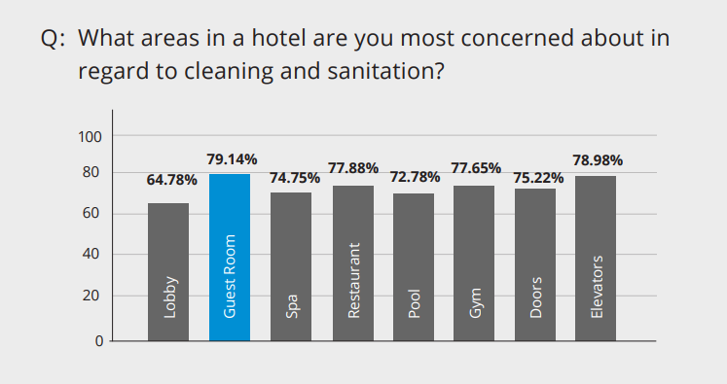
The New Landscape of Housekeeping and Hygiene (2021) Don’t Forget the Remote Control

2.
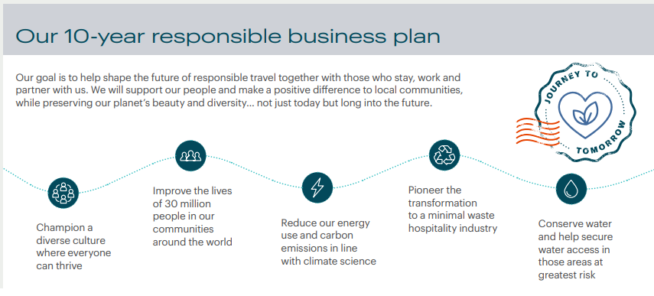
Intercontinental Hotel Group (2022) 10-year responsible business plan

