Student Name: Gabriella Wilde
Student Number: 1700287
Programme of Study: BA Illustration
Module: M4X01559
Tutor: Ryan Moule and Martin Bush

Curatorial Text – ‘Accept and Adapt’ = 1313 words

Accept and Adapt
‘Accept and Adapt’ focuses on the theme of inclusion regarding disability within art. An “exhibition itself ceases to be basically a self-contained, static condition and becomes more and more an aggressive energy seeking to transform the visitor. The visitor is another energy, ... Both energies interact.” (Dorner,1947 cited in Steeds) This infers that the exhibition and visitor are co-dependent; thus, it seems clear that to celebrate inclusivity, an exhibition should be inclusive to its audience. Exhibitions are quiet, artwork is distanced, and descriptions are on small, fixed plaques– this can make exhibitions unfulfilling for disabled individuals. For an exhibition that aims to promote disabled artists, it seems contradictory to display work that is not accessible– “serving people with disabilities is vital to fully attain equality and equity.” (Lwoga & Mapunda, 2018)
Due to the niche nature of the topic, many artists featured are outside of the canon: “Among the disabled artists of the past, the most referred to are the so-called freaks… and the painter Frida Kahlo.” (Solvang, 2012). As one of the most prevalent disabled artists, it was essential to include Kahlo’s work, her depictions of her own disability resonate with many. One writer states, “When [they] first saw the work of Frida Kahlo, it was ‘wow’. First time my whole story was told. Even if she was Mexican and we did not speak the same language, she gave me my story.” (Solvang, 2012). This signifies the importance of representation, as valid representation can result in the sublime- evoking a feeling or emotion beyond language.
“Without identity, there is no diversity.” (Sarkozy, 2011;117 cited in Jones). This implies the need to embrace ourselves to celebrate our differences; “… inclusion is not to blend in and … does not deny the celebration of difference.” (Solvang, 2012). Many disabled people view their disability as a strong part of their identity- it influences their lifestyle, learning, and community. Although their disability does not define them, it impacts their lives; thus, disabled artists should have a fair chance to succeed without eradicating their disabled identity.
In contrast, sociologist Tom Shakespeare believes “the goal of disability politics should be to make disability as irrelevant as possible” (Shakespeare, 2006 cited in Solvang, 2012). Although this does not completely eradicate the disabled identity, it suggests it should not be important when considering the individual’s work. This is echoed by disability studies specialist, Lennard Davis- “Following postmodernism, Davis identifies an era of dismodernism where disability, that is, the idea that we are all non-standard, becomes a general lens for understanding the world.” (Solvang, 2012) Whereas this may benefit equality, as part of their identity, disability can feature heavily in the work of disabled artists. For example, they may depict their experience, or have an adapted technique for their needs, such as using raised lines to navigate the canvas, or painting with their mouths. In these cases, the artists’ disability is engrained in the subject matter and creation of their work, therefore cannot be irrelevant.
The exhibition aims to reduce the plight of disabled artists. “…Disability is culturally de-valued”, consequently, artists with disabilities may face discrimination. For artists with psychiatric disabilities, “the quality of their creations is often made less credible when associated with their diagnoses.” (Tillyer & Accordino, 2002) This demonstrates that stigma remains today, despite prominent, successful artists, such as Kusama, Pollack, and Rothko, having psychiatric disabilities; producing an exhibition that challenges and defies this stigma could lead to progression. The stigma continues as disabled artists can suffer prejudice from professionals in the art community, a playwright observed that “Professional critics will not come and review work by disability-art-identified artists.” (Solvang,2012) It is viewed as “amateur”, “on a hobby level”, or “as therapy”, undermining the works of aspiring artists.
“An exhibition differs from all other media of communications, because it alone can simultaneously transmit information visually, acoustically and by touch” (Klaus Franck, 1961;29 cited in Steeds). This demonstrates how the exhibition environment holds the potential to be an inclusive experience that can be enjoyed by all, appealing to a variety of senses.

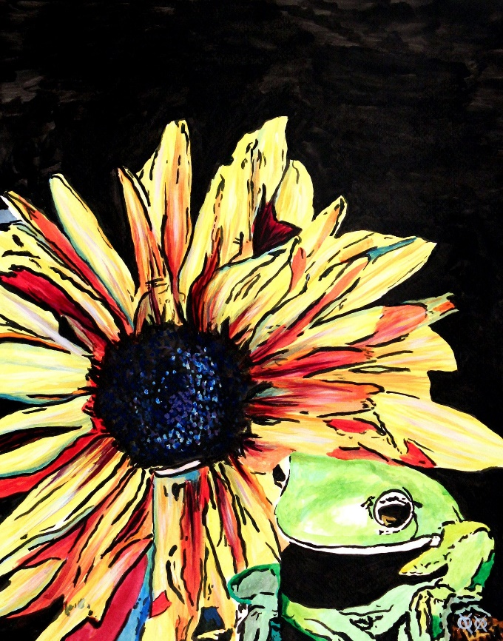
John Bramblitt, Frog and Flower
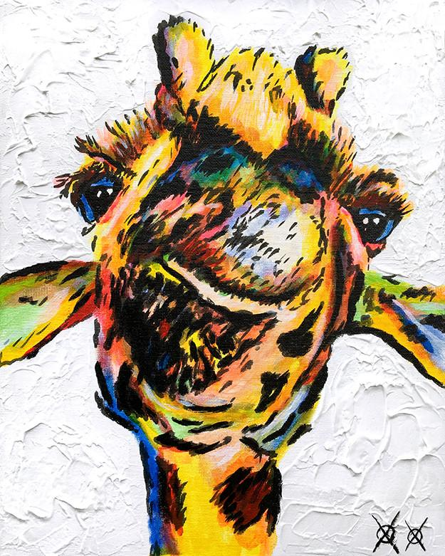
John Bramblitt, Grin
As a contemporary artist that took up painting after losing his sight, John Bramblitt’s work is focused on being aesthetically pleasing, using a raised line technique to navigate his way around the canvas. He frequently uses an array of bright, bold colours; however, the vivid yellow dominates in Frog and Flower, and Grin. The solid black and white backgrounds create a strong contrast with the colours within each painting and between the paintings. In addition to the vibrant colours, these pieces would accommodate visually impaired visitors due to the strong textures in the backgrounds, particularly in Grin.
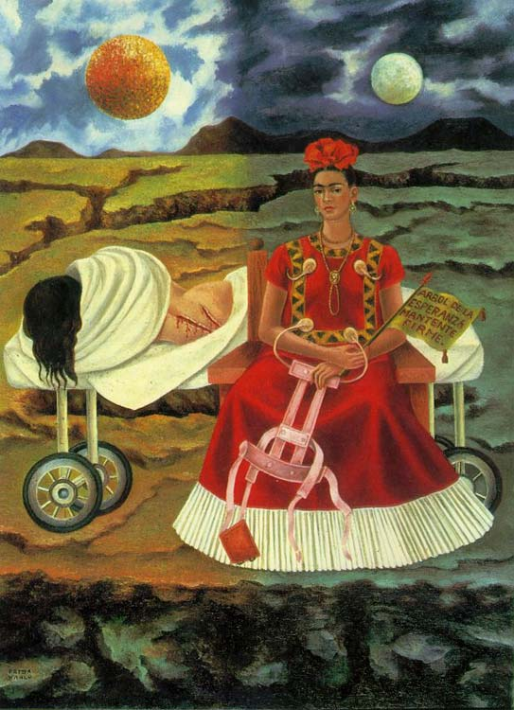
Frida Kahlo, Tree of Hope, Keep Firm, 1946
Kahlo has already been noted as one of the most prevalent disabled artists (Solvang, 2012); defying the tropes of canon artists. Tree of Hope, Keep Firm, (1946) is a particularly powerful piece as it shows that her character and experience with disability is not two-dimensional. The Frida depicted on the left seems damaged, and helpless, pitying herself having just been operated on. However, the Frida on the right seems fierce and defiant; she sits proudly, holding her back brace as though, like many disabled artists and activists, she is “refusing the crippling gaze of an ableist society” (Davidson, 2005), demonstrating that “power resides in disability pride.” (Solvang, 2012)
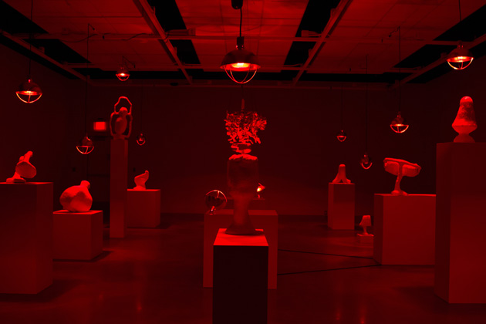
Emilie Gossiaux and Nathan Abbe, Unfixtures, 2016 (Installation View)
Gossiaux and Abbe collaborated to create a series of wax lamps that, placed under heat lamps, slowly melt away to reveal the metal frame. Having lost her sight and with limited hearing, Gossiaux is particularly keen on creating and encouraging multisensory art. This installation makes full use of the exhibition experience as visitors can feel the wax lamps, and warmth from the heat lamps, they can also smell the wax melting, and can see the visual set up and design. As the heat lamps are the only light source, this could restrict sight, which could also lead to an insightful, immersive experience for non-disabled visitors.
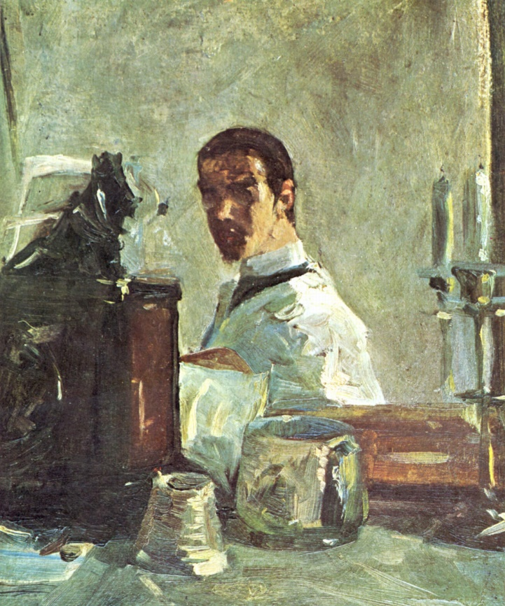
Henri de Toulouse-Lautrec, Self-portrait in Front of a Mirror, 1883
Due to his physical disability, Toulouse-Lautrec was “marginalised from the lifestyle of his aristocratic class.” (Hodder et al., 2015) This rejection may have aided the ambiguity of Self-portrait in Front of a Mirror – grand, yet bleak, which could represent his struggle with his own identity. Despite this, “he used his art to satirise his deformities and attack any patronising sentimentality directed towards him.” (Hodder et al., 2015) The fact that Toulouse-Lautrec’s 19th Century view is mirrored by contemporary disabled artists whose work is seen as “amateur” or “therapy” (Solvang, 2012) demonstrates the need for an art community that celebrates disabled artists on the same level as non-disabled artists, rather than pitying them.
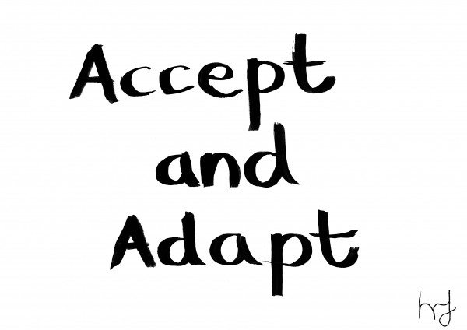
Henry Fraser, Accept and Adapt
Henry Fraser’s Accept and Adapt, creates a statement with its simplicity. After becoming paralysed from the neck down, this mouth painting demonstrates how Fraser, like many of the artists selected for the exhibition, has accepted his circumstances and adapted his technique to fit his needs. The message is positive and progressive, emphasising the possibility for growth rather than hinderance. Accept and Adapt epitomises an underlying theme of the exhibition, consequently, becoming the title of the exhibition.
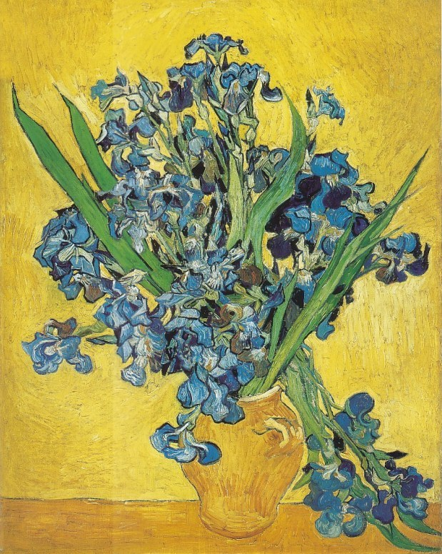
Vincent Van Gogh, Irises, 1890
Vincent Van Gogh is speculated to have had temporal lobe epilepsy and bipolar disorder. Irises, (1890) was chosen as it has been reproduced as part of The RELIEVO Collection for Feeling Van Gogh, which allows visually impaired visitors to touch and interact with models and reproductions of Van Gogh’s work. This demonstrates that the piece is heavily textured with his signature bold streaks. Furthermore, the colours are vibrant, making the flowers and leaves easily discernible from the background. As stated by a visitor in the Feeling Van Gogh video, “I still remember the images, and in this way I can colour them in” (Van Gogh Museum, 2016); this demonstrates that the familiarity with Van Gogh from his place in the canon can help visitors that have lost their sight to engage with the piece in conjunction with their memory.
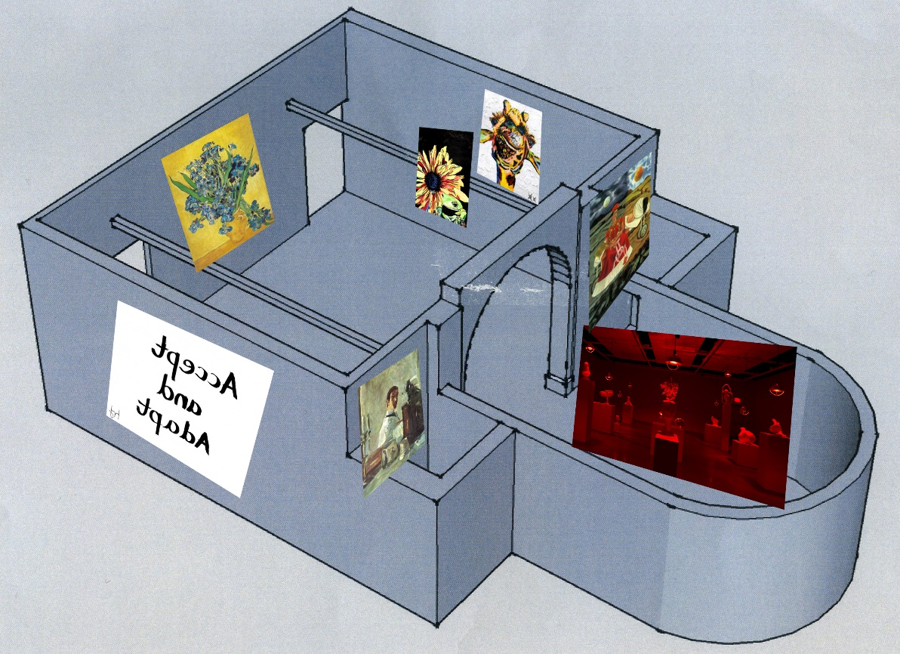
Exhibition floor plan

Bibliography
Bramblitt, J., Frog and Flower [Oil on canvas]. Private collection.
Bramblitt, J., Grin [Oil on canvas]. Private collection.
Davidson, M., (2005), ‘Concerto for the Left Hand: Disability (in the) Arts’, PMLA. Publications of the Modern Language Association of America, 120(2): 615-619, JSTOR Arts and Sciences III [Online]. Available at: http://www.jstor.org.ezproxy.uwtsd.ac.uk/stable/25486195?seq=1#page_scan_tab_contents (Accessed on: 25 February 2018)
Dorner, A., (1947), ‘The Way Beyond ‘Art’: The Work of Herbert Bayer, in Steeds, L. (ed), Documents of Contemporary Art: Exhibition. London: Whitechapel Gallery :
Franck, K., (1961), ‘Exhibitions’, cited by Beck, M., (2009), ‘The Exhibition and the Display’, in Steeds, L. (ed), Documents of Contemporary Art: Exhibition. London: Whitechapel Gallery : 29
Fraser, H. Private collection.
Gossiaux, E.; Abbe, N., (2016). Unfixtures, [Installation]. Private collection.
Hodder, A.; Huntley, C.; Aronson, J.K.; Ramachandran, M., (2015), ‘Pycnodysostosis and the Making of an Artist’, Gene, 555(1): 59-62, Elsevier SD Freedom Collection [Online]. Available at: https://www-sciencedirect-com.ezproxy.uwtsd.ac.uk/science/article/pii/S0378111914011093 (Accessed on: 11 February 2018)
Kahlo, F., (1946). Tree of Hope, Remain Strong [Oil on masonite]. Daniel Filipacchi Collection, Paris.
Lwoga, N.B.; Mapunda, B.B., (2018), ‘Challenges Facing Accessible Tourism in Cultural Heritage Sites: The Case of Village Museum in Tanzania’, Revista de Turism – Studii si Cercetari in Turism, (24): 45-55, Hospitality & Tourism Complete, EBSCOhost [Online]. Available at: https://web-a-ebscohost-com.ezproxy.uwtsd.ac.uk/ehost/detail/detail?vid=0&sid=9b633fb2-80c6-4194-9c7c-c000e7e67747%40sessionmgr4006&bdata=JnNpdGU9ZWhvc3QtbGl2ZQ%3d%3d#AN=127124966&db=hjh (Accessed: 25 February 2018)
Solvang, P.K., (2012), ‘From Identity Politics to Dismodernism? Changes in the Social Meaning of Disability Art’, Alter – European Journal of Disability Research, 6(3): 178-187, Elsevier SD Freedom Collection [Online]. Available at: https://www-sciencedirect-com.ezproxy.uwtsd.ac.uk/science/article/pii/S1875067212000478 (Accessed: 25 February 2018)
Jones, A., (2012), Seeing Differently: A History and Theory of Identification and the Visual Arts. Oxon: Routledge.
Tillyer, M.D.; Accordino, M.P., (2002), ‘Painting with a Broad Brush: Professional Careers for Artists with Psychiatric Disabilities’, Psychiatric Rehabilitation Journal, 25(3): 265-273, PsycARTICLES, EBSCOhost [Online]. Available at: https://web-b-ebscohost-com.ezproxy.uwtsd.ac.uk/ehost/detail/detail?vid=0&sid=0f666d61-99e5-4ec8-8617-258726eacbb2%40sessionmgr120&bdata=JnNpdGU9ZWhvc3QtbGl2ZQ%3d%3d#AN=2002-00859-006&db=pdh (Accessed: 25 February 2018)
Toulouse-Lautrec, H., (1882-1883). Self-Portrait in Front of a Mirror [Oil on cardboard]. Musee Toulouse-Lautrec, Albi.
Van Gogh, V., (1980) Irises [Oil on canvas]. Van Gogh Museum, Amsterdam.
Van Gogh Museum. (2016) Feeling Van Gogh – a programme for the blind and visually impaired visitors. Available at: https://www.youtube.com/watch?time_continue=87&v=JhbthPM_EI8 (Accessed: 12 April 2018)

