

Practice-Based Research
LCHS7008
Component 2-Written Research Proposal

The Role of Clinical Leadership in Reducing Medication Errors in the NHS: A Systematic Review
Student ID: 2433934
Name: Himalaybhai Sureshbhai Mandanaka
Lecturer Name: Dr Zeno Leung

Table of Contents
1. Research background and problem statement 4
2. Literature Review 5
2.1 Medication errors in healthcare and the NHS 5
2.2 Role of clinical leadership in healthcare safety 6
2.3 Clinical leadership and medication safety in the NHS 7
2.4 Theoretical Framework 8
2.5 Literature Gap 9
3. Rationale for the study 9
4. Research aim, objectives, and research question 9
4.1 Aim 9
4.2 Objectives 9
4.3 Research Question 10
4.4 PICO Framework 10
5. Research methodology 11
5.1 Research philosophy 11
5.2 Research approach 12
5.3 Methodological choice 12
5.4 Research strategy 12
5.5 Time horizon 13
5.6 Data collection 14
5.7 Data analysis 15
6. Ethical considerations 15
7. Implications of the research 15
8. Plan of Work and Time Schedule 16
Reference List 19

1. Research background and problem statement
Medication errors are significant issues in the NHS as they impact patient safety, clinical work and organisational performance (Adams, 2022). In that case, electronic prescribing and barcode administration have been implemented as a solution to the problem, there are errors in the process of prescription, dispensing, and administration (Saha et al., 2025). It reflects the system and tools in which medication safety is determined, along with behavioural and organisational factors. 66% of people are satisfied with the free care services of the NHS, and 52% of people are satisfied with better quality NHS care (Statista, 2023). Clinical leadership has become one of the driving forces of safety culture, communication, and accountability (Kirkpatrick et al., 2024)). Effective clinical leaders influence better practice, foster compliance with guidelines and provide a culture in which personnel are free to report and learn about adverse medication events (Adams, 2022).
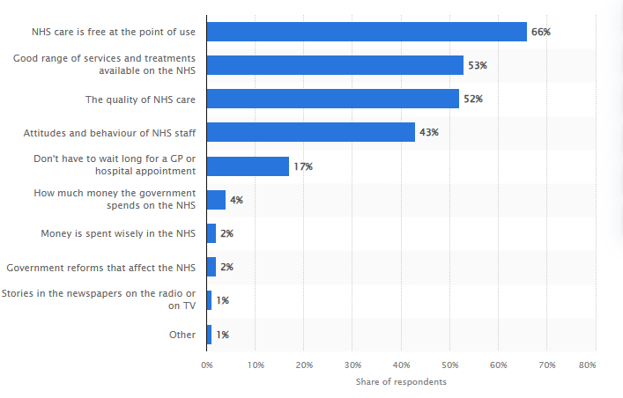
Figure 1: Public satisfaction with NHS services
(Source: Statista, 2023)
Leadership programs introduced by NHS trusts are not always clear on the strategies that can result in quantifiable changes to medication safety (Elliott et al., 2024). In that case, clinical leadership plays a crucial role in preventing medication errors in the context of the NHS, the existing evidence concerning the role of clinical leadership in medication error reduction (Elliott et al., 2024). Lack of available consolidated insight inhibits decision-makers in the designing of focused leadership development programmes and efficient allocation of resources (Kirkpatrick et al., 2024).

2. Literature Review

2.1 Medication errors in healthcare and the NHS
According to Al-Hadithy et al. (2023), the problem of medication errors is one of the most prominent in the system of healthcare system and the NHS, with the volume and complexity of healthcare services. These issues are made at different points, such as prescribing, dispensing, administration and monitoring of drugs. In this context, Ford and Michalek (2025) stated that they are related to human factors such as communication breakdowns, distractions, exhaustion and poor supervision. Breach of systems, such as irregular protocols and work overloads, add to error risk. According to Statista (2025), global medication error reporting revenue has reached $326M in 2018 and is projected to reach $790M by 2026, with errors causing significant annual deaths. In the NHS, medication errors impose a strain on the clinical team, cause more issues to patients and result in a longer hospital stay and unnecessary operations and expenses (Hofmann and Vermunt, 2021). As opined by Elliott et al. (2021), though these technological methods as an electronic prescribing system and barcode system, can assist in the minimisation of risks based on behaviour, decision-making, and organisational culture.
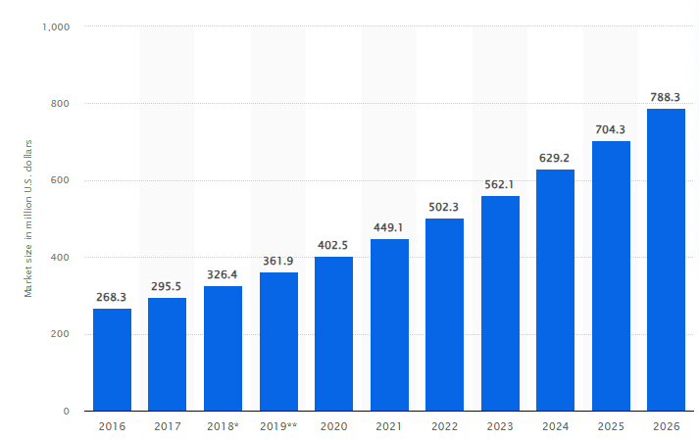
Figure 2: Revenue of medication error reporting globally
(Source: Statista, 2025)

2.2 Role of clinical leadership in healthcare safety
According to Alrowily et al. (2025), clinical leadership is a key factor in the development of the safety culture of healthcare organisations. Leaders shape the activities of teams in focusing on patient safety, following medication regimens and reporting concerns or near misses (Özyurt et al., 2021). Özyurt et al. (2021) also stated that strong clinical leaders provide the environment in which the staff members feel able to follow safe practice. The visibility as a leadership behaviour and active participation in the ward activities, as well as effective communication, lead to increased team cohesion and improved safety outcomes (Saha et al., 2025). As supported by Hofmann and Vermunt (2021), clinical leaders can implement safety in practice by using proper medication practices and enforcing responsibility. In case of poor leadership and inconsistent teams can lead to poor coordination, compliance with medication instructions, and the chances of errors increase (Ford and Michalek, 2025). According to Statista (2024), 46% of adults perceive limited access to treatment and long wait times as the biggest issue in healthcare, while 45% viewed staff shortages as the biggest problem.
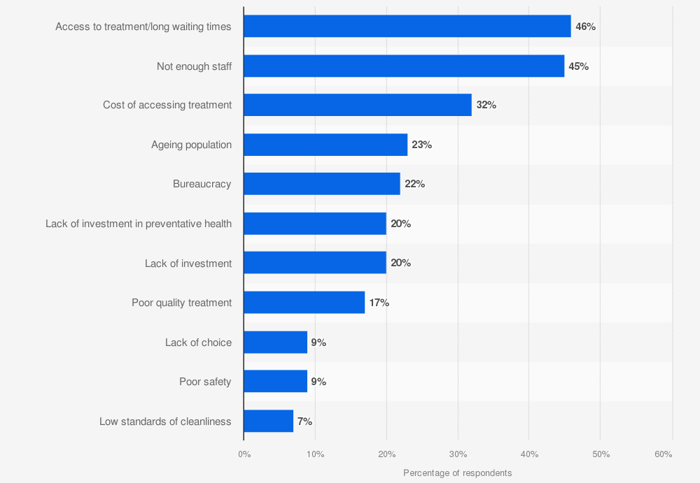
Figure 3: Issues in the global healthcare system
(Source: Statista, 2024)

2.3 Clinical leadership and medication safety in the NHS
According to Saha et al. (2025), clinical leadership is becoming widely acknowledged in the NHS as a needed intervention to enhance medication safety. Nurse managers, pharmacists and top clinicians, among others, at the NHS control the way medication processes are tracked and appraised. Adams (2022) stated that safety issues, multidisciplinary leadership rounding, and leadership-based training programme interventions have demonstrated possible communication improvements, less variation in management, and improved making and reporting. Elliott et al. (2024) supported that another responsibility of clinical leaders is to strengthen the culture of learning, which ensures that medication incidents are discussed positively and positive changes are enforced. However, the effectiveness of leadership styles is not well-studied, and certain interventions have not been properly evaluated. Kirkpatrick et al. (2024) stated that fluctuation in leadership styles, work pressure and organisational limiting factors have an additional impact on outcomes.

2.4 Theoretical Framework
Systems Theory
Systems Theory is involved in offering an inclusive perspective of the ways that medication issues and their impact on medical leadership in enhancing safety in the NHS (Markovsky and Dörfler, 2021). It considers healthcare as a complicated system consisting of interrelated elements such as people, processes, environments and organisational structures (Ontañón, 2025). Based on this view, medication errors are based on personal and structural issues, including a low flow of communication, unequal protocols, lack of roles and poor interdepartmental coordination (Fernandopulle, 2021). Clinical leadership is important in reinforcing such interactions in the system, in that processes are aligned, information is exchanged effectively, and safety barriers are constantly maintained (Markovsky and Dörfler, 2021). The leaders affect the reactions of the teams to the pressures on the system, workload management, and adaptation to the shifts in clinical needs (Sikalgar et al., 2025). Clinical leaders contribute to building resilient medication systems, reducing the likelihood of error occurrence or alleviating clinical incidents by locating systemic vulnerabilities and fostering collaboration, standardisation, and lifelong learning (Ford and Michalek, 2025).
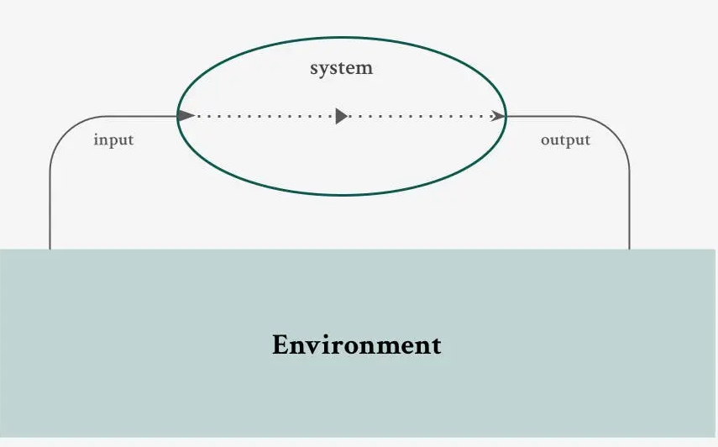
Figure 4: Systems Theory
(Source: Ontañón, 2025)

2.5 Literature Gap
The current literature has acknowledged the significance of clinical leadership, but the data on this area is limited, which gives rise to methodological inconsistencies in existing studies on NHS medication safety (Kirkpatrick et al., 2024). Conclusion of findings needs to be formulated through a systematic review to establish the effective leadership practices in the NHS settings.

3. Rationale for the study
The problem of medication errors remains persistent in the NHS despite the improvement in technology, rules and strategic measures (Al-Hadithy et al., 2023). The communication, teamwork, reporting of incidents and following of medication procedures are forms of mentoring depending on leadership, which is a necessary element in error reduction (Ferreira et al., 2022). However, the existing literature on the effect of leadership in the context of the NHS is limited, and there are few previous studies available in a systematic way (Hofmann and Vermunt, 2021). This study is focused on providing a synthesis of existing findings, effective clinical leadership practices. The evidence will be used to offer evidence-based leadership advice, which will in turn improve medication safety in the NHS services.

4. Research aim, objectives, and research question

4.1 Aim
The aim of this study is to systematically examine how clinical leadership influences the reduction of medication errors within NHS healthcare settings.

4.2 Objectives
- To identify the types of clinical leadership interventions used to improve medication safety in NHS settings.
- To evaluate the impact of these interventions on medication-error rates and related safety outcomes.
- To examine the leadership behaviours and competencies most strongly associated with improved medication safety.
- To explore organisational and contextual factors that influence the effectiveness of clinical leadership interventions.

4.3 Research Question
RQ1. How does clinical leadership, compared with standard practice or no leadership intervention, influence the reduction of medication errors in NHS healthcare settings?

4.4 PICO Framework
Population | Intervention | Comparison | Outcome
Clinical staff working within NHS healthcare settings (nurses, doctors, pharmacists, clinical leaders) (Adams, 2022).. | Clinical leadership interventions, behaviours or programmes aimed at improving medication safety (Alrowily et al., 2025). | Usual practice, no leadership intervention or pre-intervention baseline conditions (Elliott et al., 2021). | Reduction in medication errors, improved reporting, and strengthened medication-safety processes (Ford and Michalek, 2025).
Table 1: PICO Framework
(Source: Self-generated, derived from Waldrop and Dunlap (2024))

5. Research methodology

5.1 Research philosophy
The research philosophy will be based on interpretivism research philosophy, which demonstrates the idea that human interaction, contextual factors and subjective experiences define the organisational behaviours, leadership practices and the outcomes of medication safety (Mishra and Alok, 2022). It is based on the realisation that leadership is not a technical role but a social process that is aligned with team dynamics and workplace culture (Mwita, 2024). According to Mwita (2024), An interpretivist position enables the review to reflect upon the ways in which leadership behaviours are perceived, practised and experienced in NHS settings. Through the combination of various types of evidence, the research is expected to produce context-dependent practical outcomes that can be used to make decisions in the NHS (Al-Hadithy et al., 2023).
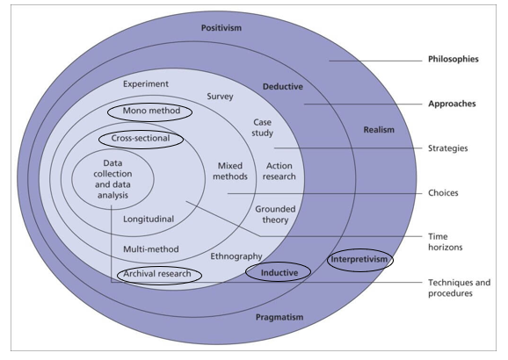
Figure 5: Research Onion
(Source: Saunders et al., 2023)

5.2 Research approach
This paper will use an inductive research methodology, and themes, relationships, and patterns are derived from the literature as opposed to being indicated by a set theoretical presumption (Mishra and Alok, 2022). The choice of induction can be explained by the fact that the objective is to determine the impact of clinical leadership on medication safety, which failed to identify the unified evidence (Firdaus et al., 2021). As mentioned by Okoli (2023), the review reveals the existence of repeated leadership interventions, behaviours and contextual factors that influence medication errors through the systematic synthesis of available studies. An inductive approach facilitates building evidence-based knowledge and conceptualisation, which can be translated into future research and inspire NHS leadership efforts (Mazhar et al., 2021).

5.3 Methodological choice
The study will employ a mono-method qualitative secondary analysis in interpreting and synthesising the results of the existing literature (Lim, 2024). In that case, this study is focused on the qualitative aspects to maintain the review process using qualitative synthesis techniques in which patterns in individual studies are interpreted (Lim, 2024). This methodological choice is aligned with both the interpretivism philosophy and inductive method as it helps in developing the comprehending meanings, contexts and processes as opposed to making statistical generalisations (Pandey and Pandey, 2021). However, when there are similar quantitative outcome measures such as the decrease in error rates, they will be effective to offer better evidence underpinning in future (Saunders et al., 2023).

5.4 Research strategy
An archival research strategy will be applied in this research, and a systematic and thorough search of academic databases and the sources of previous literature will be used (Yadav, 2022) The plan involves aligning with search strings, using Boolean operators, conducting searches in various platforms, filtering the evidence and integration results (Mishra and Alok, 2022). The plan will facilitate transparency, extensiveness and repeatability. The database searches will be supplemented by citation chaining, forward searching, and reference list checks performed to prevent excluding of the potentially relevant studies (Lim, 2024). The screening process will be recorded in the PRISMA flowchart as the following image.
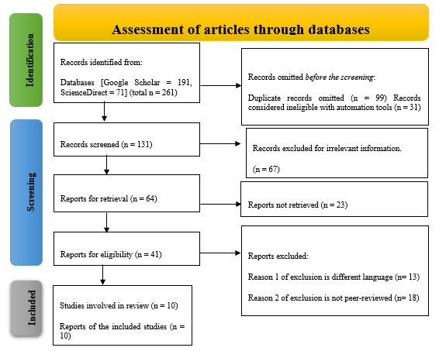
Figure 6: PRISMA flowchart
(Source: Self-generated, idea derived from Selçuk, 2019)

5.5 Time horizon
The study will focus on the cross-sectional time horizon as it is research that examines existing literature at one time (Susilawati et al., 2025). The study is not based on a longitudinal study as it does not require gathering of primary data (Pandey and Pandey, 2021). However, the review will cover the events of the last 5 years to include the contemporary NHS setting, recent leadership concepts and advanced medication-safety incidences.

5.6 Data collection
The process of data collection will entail access to secondary data in academic databases and grey literature (Verma et al., 2024). Systematic literature review will be followed and presented focusing on approx. 10 articles. The organisation of the process will be used to capture and assess all the relevant studies based on established eligibility criteria (Susilawati et al., 2025). The key data sources will be PubMed, CINAHL, ScienceDirect, ResearchGate and Wiley Library, as well as Google Scholar. Moreover, the keywords and Boolean operators AND, OR will be used to refine results that will be effectively used in this research (Saunders et al., 2023)
"clinical leadership", "leadership behaviours", "nursing leadership", "medical leadership", "transformational leadership", "medication error", "drug error", "prescribing error", "administration error", "adverse drug event", "medication safety", "NHS", "National Health Service", "UK healthcare", "United Kingdom hospital"
Inclusion and exclusion criteria
Inclusion criteria | Exclusion criteria
Publications from 2021 onwards will be included. | The articles and journals published before 2021 will be excluded.
Peer-reviewed articles and journals will be included. | The sources which are not fully accessible and paid are excluded.
Sources that are written in the English language will be included. | Sources that are not written in English will be excluded.
Table 2: Inclusion and exclusion criteria
(Source: Self-generated, derived from Yadav, 2022)

5.7 Data analysis
The process of data analysis is organised and systematised (Verma et al., 2024). In this initial stage, the selected studies will be arranged in a data extraction matrix, and the results will be recorded (Pandey and Pandey, 2021). After extraction, the review will incorporate thematic synthesis, which involves coding of the information that is in context and identification of recurring themes, as well as developing themes that highlight the ways the role of clinical leadership can be relevant to medication errors (Terry et al., 2017). Thematic data analysis is appropriate to be used to synthesise various forms of data and to identify patterns across studies (Mazhar et al., 2021). It will implement thematic findings to quantitative measures where error rates have been decreased under the quantitative measures (Terry et al., 2017).

6. Ethical considerations
Since the entire study is founded on the secondary systematic literature review, there were no direct interactions with human participants, gathering personal data, or clinical interventions. In that case, the formal permission of ethics is not usually needed (Okoli, 2023). However, the study will comply with the known ethical standards to promote integrity, transparency and accountable information use (Pietilä et al., 2019). None of the sources included will be misrepresented or plagiarised. The review will be based on published studies and previous literature available in the initial aspect that will not involve access to confidential or identifiable patient details (Mazhar et al., 2021). The other ethical responsibility involves the critical evaluation of the quality and limitations of research to avoid biased conclusions (Pietilä et al., 2019). The objective of this study will not practice selective reporting, and the synthesis process will comply with the original context of the study findings (Mazhar et al., 2021). Any conflicts of interest that are found in the included studies will be disclosed. Moreover, the review will be done using PRISMA guidelines, which enhance transparency and accountability in reporting (Verma et al., 2024).

7. Implications of the research
The significant implications associated with this research are for the NHS policy, development of clinical practice and organisational leadership (Al-Hadithy et al., 2023). The study can assist the NHS organisations to develop targeted leadership training by synthesising evidence on the role of clinical leadership on medication safety by demanding the focus on the fundamental issues behind medication errors (Özyurt et al., 2021). Recognition of successful leadership behaviours and interventions will empower healthcare managers to enhance safety culture, facilitate communication and reinforce multidisciplinary work teams across the clinical environment (Adams, 2022). The results have the potential to form the training of professionals dealing in the field of nurses, pharmacists and medical staff, to enhance competencies associated with leadership, which lead to safer medication practices (Hofmann and Vermunt, 2021). At the policy level, the study can inform resource distribution and development of the systems, enhancing the better incorporation of the leadership functions into the patient-safety goals (Kirkpatrick et al., 2024). In addition, contextual barriers and facilitators will be known to enable organisations to fit their interventions to their contexts (Elliott et al., 2024).

8. Plan of Work and Time Schedule
Based on different set of activities, the proposal has been planned and then after approval, the dissertation will be executed following those activities using suitable time plan tool (Ramachandran and Karthick, 2019). These activities have been visually represented using Gantt chart tool.
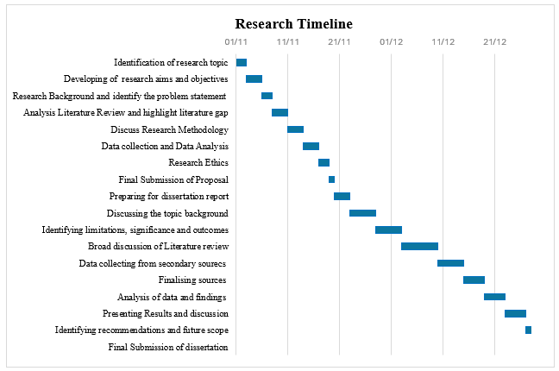
Figure 7: Gantt Chart
(Source: Self-generated, idea derived from Ramachandran and Karthick, 2019)
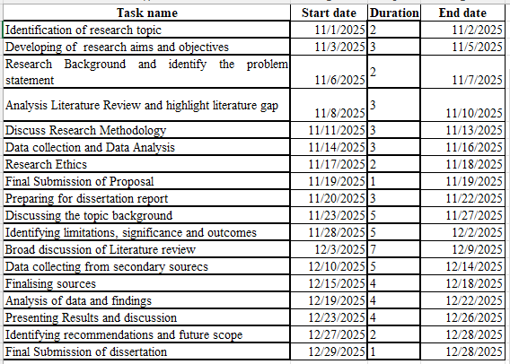

Reference List
Adams, D.E., (2022). Leadership for reducing medical errors via organisational culture: a literature review. Measuring Business Excellence, 26(2), pp.143-162. https://www.emerald.com/insight/content/doi/10.1108/mbe-06-2021-0079/full/html
Al-Hadithy, N., Knight, K., Gopfert, A., Van Hove, M. and Garcia, X.V., (2023). Vital role of clinicians in reducing the NHS carbon footprint through smarter procurement decisions. BMJ leader, pp.leader-2022. https://bmjleader.bmj.com/content/leader/early/2023/08/04/leader-2022-000722.full.pdf
Alrowily, A., Alfaraidy, K., Almutairi, S., Alamri, A., Alrowily, W., Abutaleb, M., Zaitoun, M., Sarawi, W. and Aljead, M., (2025). High-risk medication errors: Insight from the UK National Reporting and learning system. Exploratory Research in Clinical and Social Pharmacy, 17, p.100531. https://www.sciencedirect.com/science/article/pii/S2667276624001288
Elliott, R.A., Camacho, E., Campbell, F., Jankovic, D., Martyn-St James, M., Kaltenthaler, E., Wong, R., Sculpher, M. and Faria, R., (2024). Prevalence and economic burden of medication errors in the NHS in England: rapid evidence synthesis and economic analysis of the prevalence and burden of medication error in the UK. https://orda.shef.ac.uk/articles/report/PREVALENCE_AND_ECONOMIC_BURDEN_OF_MEDICATION_ERRORS_IN_THE_NHS_IN_ENGLAND_Rapid_evidence_synthesis_and_economic_analysis_of_the_prevalence_and_burden_of_medication_error_in_the_UK/25218950/1/files/44544338.pdf
Elliott, R.A., Camacho, E., Jankovic, D., Sculpher, M.J. and Faria, R., (2021). Economic analysis of the prevalence and clinical and economic burden of medication error in England. BMJ Quality & Safety, 30(2), pp.96-105. https://qualitysafety.bmj.com/content/30/2/96.abstract
Fernandopulle, N., (2021). To what extent does hierarchical leadership affect health care outcomes?. Medical journal of the Islamic Republic of Iran, 35, p.117. https://pmc.ncbi.nlm.nih.gov/articles/PMC8683790/
Ferreira, T.D.M., de Mesquita, G.R., de Melo, G.C., de Oliveira, M.S., Bucci, A.F., Porcari, T.A., Teles, M.G., Altafini, J., Dias, F.C.P. and Gasparino, R.C., (2022). The influence of nursing leadership styles on the outcomes of patients, professionals and institutions: an integrative review. Journal of Nursing Management, 30(4), pp.936-953. https://onlinelibrary.wiley.com/doi/abs/10.1111/jonm.13592
Firdaus, F., Zulfadilla, Z. and Caniago, F., (2021). Research methodology: types in the new perspective. Manazhim, 3(1), pp.1-16. https://ejournal.stitpn.ac.id/index.php/manazhim/article/download/903/760
Ford, E.H. and Michalek, C., (2025). Medication Safety Officers: A pillar of patient safety in hospital pharmacy. Farmacia Hospitalaria. https://www.sciencedirect.com/science/article/pii/S1130634325000893
Hofmann, R. and Vermunt, J.D., (2021). Professional learning, organisational change and clinical leadership development outcomes. Medical Education, 55(2), pp.252-265. https://asmepublications.onlinelibrary.wiley.com/doi/abs/10.1111/medu.14343
Kirkpatrick, I., Altanlar, A. and Veronesi, G., (2024). Doctors in leadership roles: consequences for quality and safety. Public Money & Management, 44(6), pp.515-522. https://www.tandfonline.com/doi/abs/10.1080/09540962.2023.2217344
Lim, W.M., (2024). What is qualitative research? An overview and guidelines. Australasian Marketing Journal, p.14413582241264619. https://journals.sagepub.com/doi/pdf/10.1177/14413582241264619
Markovsky, I. and Dörfler, F., (2021). Behavioral systems theory in data-driven analysis, signal processing, and control. Annual Reviews in Control, 52, pp.42-64. https://www.sciencedirect.com/science/article/pii/S1367578821000754
Mazhar, S.A., Anjum, R., Anwar, A.I. and Khan, A.A., (2021). Methods of data collection: A fundamental tool of research. Journal of Integrated Community Health, 10(1), pp.6-10. https://www.researchgate.net/profile/Syeda-Ayeman-Mazhar/publication/356269289_Methods_of_Data_Collection_A_Fundamental_Tool_of_Research/links/61fe7e23870587329e943cd1/Methods-of-Data-Collection-A-Fundamental-Tool-of-Research.pdf
Mishra, S.B. and Alok, S., (2022). Handbook of research methodology. https://dspace.unitywomenscollege.ac.in/bitstream/123456789/1319/1/BookResearchMethodology.pdf
Mwita, K., (2024). Understanding research philosophies and designs: A guide for early-career researchers. Available at SSRN 5159625. https://papers.ssrn.com/sol3/papers.cfm?abstract_id=5159625
Okoli, C., (2023). Inductive, abductive and deductive theorising. International Journal of Management Concepts and Philosophy, 16(3), pp.302-316. https://www.inderscienceonline.com/doi/abs/10.1504/IJMCP.2023.131769
Ontañón, M. (2025). Systems Theory - The Decision Lab. [online] The Decision Lab. Available at: https://thedecisionlab.com/reference-guide/psychology/systems-theory.
Özyurt, E., Avcı, K. and Şenel, F.Ç., (2021). The impact of clinical leadership on quality and accreditation studies in health services. Journal of Basic and Clinical Health Sciences, 5(3), pp.221-232. https://dergipark.org.tr/en/doi/10.30621/jbachs.955272
Pandey, P. and Pandey, M.M., (2021). Research methodology tools and techniques. Bridge Center. http://dspace.vnbrims.org:13000/jspui/bitstream/123456789/4666/1/RESEARCH%20METHODOLOGY%20TOOLS%20AND%20TECHNIQUES.pdf
Pietilä, A.M., Nurmi, S.M., Halkoaho, A. and Kyngäs, H., (2019). Qualitative research: Ethical considerations. In The application of content analysis in nursing science research (pp. 49-69). Cham: Springer International Publishing. http://repository.unimus.ac.id/7928/1/Helvi%20Kyng%C3%A4s%2C%20Kristina%20Mikkonen%2C%20Maria%20K%C3%A4%C3%A4ri%C3%A4inen%20-%20The%20Application%20of%20Content%20Analysis%20in%20Nursing%20Science%20Research%20%282020%2C%20Springer%29%20%5B10.1007_978-3-030-30199-6%5D%20-%20libgen.li.pdf#page=53
Ramachandran, K.K. and Karthick, K.K., (2019). Gantt chart: An important tool of management. Int. J. Innov. Technol. Explor. Eng, 8(7), pp.140-142. https://www.researchgate.net/profile/Ramachandran-K-K-3/publication/358234055_Gantt_Chart_An_Important_Tool_of_Management/links/61f78cc7007fb5044727d77d/Gantt-Chart-An-Important-Tool-of-Management.pdf
Saha, K., Patel, B. and Paladini, S., (2025). The role of leadership and cultural barriers in the adoption of lean six sigma in clinical pharmacy practice and medicine waste reduction. The case of NHS-UK. International Journal of Quality & Reliability Management, 42(3), pp.809-836. https://www.emerald.com/insight/content/doi/10.1108/IJQRM-02-2024-0069/full/html
Saunders, M. N., Lewis, P., and Thornhill, A. (2023). Research Methods for Business Students.-.https://research.birmingham.ac.uk/en/publications/research-methods-for-business-students-3
Selçuk, A.A., (2019). A guide for systematic reviews: PRISMA. Turkish archives of otorhinolaryngology, 57(1), p.57. https://link.springer.com/content/pdf/10.1186/s13643-021-01671-z.pdf
Sikalgar, F.R., Bangera, D., Kumar, M.P., Paul, Y. and Muralidharan, S., (2025). A Review of Leadership Theories in Healthcare. Journal of Pharmacy and Bioallied Sciences, 17(Suppl 1), pp.S163-S165. https://journals.lww.com/jpbs/_layouts/15/oaks.journals/downloadpdf.aspx?an=01438291-202505001-00046
Statista. (2023). Reasons for satisfaction with the NHS 2023| Statista. [online] Available at: https://www.statista.com/statistics/696571/satisfaction-with-nhs-overall-united-kingdom-uk/?srsltid=AfmBOopbzZInTKKdXupUQxJp74mPw0fS6twRddMbBeyFw_gvJg3XFX2p
Statista. (2024). Leading problems in healthcare systems worldwide 2024| Statista. [online] Available at: https://www.statista.com/statistics/917153/leading-problems-healthcare-systems-worldwide/?srsltid=AfmBOooCLhvWlbh_NUZ3nRGARVZGvq0vY-uLu4JyJK8LEpXsLICoKPXf
Statista. (2025). Medication error reporting market revenue worldwide 2016-2026| Statista. [online] Available at: https://www.statista.com/statistics/1042228/medication-error-reporting-market-size-worldwide/?srsltid=AfmBOor2IlXYvacl25B6YHB0bGEKLDHWU3Lh9lk5fJiLaURPDxBSQCiV
Susilawati, A., Al-Obaidi, A.S.M., Abduh, A., Irwansyah, F.S. and Nandiyanto, A.B.D., (2025). How to do research methodology: From literature Review, bibliometric, step-by-step research stages, to practical examples in science and engineering education. Indonesian Journal of Science and Technology, 10(1), pp.1-40. https://ejournal.upi.edu/index.php/ijost/article/view/78637
Terry, G., Hayfield, N., Clarke, V. and Braun, V., (2017). Thematic analysis. The SAGE handbook of qualitative research in psychology, 2(17-37), p.25. https://uwe-repository.worktribe.com/index.php/OutputFile/888534
Verma, R., Verma, S. and Abhishek, K., (2024). Research methodology. Booksclinic Publishing. https://hpuniv.ac.in/hpuniv/upload/uploadfiles/files/3_5.pdf
Waldrop, J. and Dunlap, J.J., (2024). CE: Beyond PICO—A new question simplifies the search for evidence. AJN The American Journal of Nursing, 124(3), pp.34-37. https://journals.lww.com/ajnonline/fulltext/2024/03000/ce__beyond_pico_a_new_question_simplifies_the.19.aspx
Yadav, D., (2022). Criteria for good qualitative research: A comprehensive review. The Asia-Pacific Education Researcher, 31(6), pp.679-689. https://link.springer.com/article/10.1007/s40299-021-00619-0

