Table of Contents
List of Figures 3
List of Tables 3
Introduction 4
Project outline/description/scope based on project 5
Scope 6
Stakeholder analysis 8
Stakeholder Grid 8
Work Breakdown Structure (WBS) 12
Market Research Competitors 13
Stakeholders Register 13
The cycle of a generic project 14
Consideration of resources or budget 17
Cost 20
Developing a team at distinct stages 22
Team relationships. 23
An outline Project Schedule/ Gantt chart 23
A Risk Assessment 24
Risk Treatment 27
A Project Network 31
Suggestions 32
Conclusion 32
References 33

List of Figures
Figure 1. Source: (Connor et al. 2018) 8
Figure 2. Source: The cycle of a generic project (Heagney, 2012) 14
Figure 3. Source: Project Life Cycle (Heagney, 2012) 15
Figure 4. Source: Scope (Atkinson, 1999) 20
Figure 5. Source: The Tuckman Linear Model (Tuckman, 1965) 22
Figure 6. Source: Brainstorm (Heagney, 2012) 24
Figure 7. Source: Risk Analise (Covello, and Mumpower, 1985) 25
Figure 8. Source: Risk Treatment (Heagney, 2012) 27
Figure 9. Source: Structure Risk (Heagney, 2012) 28
Figure 10. Source: Risk matrix (Heagney, 2012) 30
Figure 11. Source: Fishbone diagram (Ilie and Ciocoiu, 2010) 31
Figure 12. Source: Project Network (Heagney, 2012) 31

List of Tables

Table 1. Source: (Murray-Webster and Simon, 2006) 6
Table 2. Source: Quad Chart (Newell et al. 2006) 7
Table 3. Source: Swot analyse (Leigh, 2009) 10
Table 4. Source: Pestle (Widya et al.2018) 11
Table 5. Source: (Heagney, 2012, p.2) 12
Table 6. Source: WBS (Heagney, 2012, p.4) 12
Table 7. Source: Amazon sells (Organic olive oil, 2022; Amazon Associate, 2020) 13
Table 8. Source: (Heagney, 2012, p.4) 13
Table 9. Source: Gantt chart (Atkinson, 1999) 24
Table 10. Source: Cause of Risk (Heagney, 2012, p.9) 26
Table 11. Source: Matrix Approach (Aiginger and Sieber, 2006) 29
Table 12. Source: (Heagney, 2012, p.12) 29

Introduction

This paper seeks to create a new company called Triple O, which stands for organic olive oil. This project aims to stabilize businesses, improve quality of life and start with a profit of at least £40.000. Additionally, Triple "O" must have a good scope and be successful in their business. Research the market, identify distributors, and identify customers. This report shows how legal requirements are met. To control the money of a business, an accountant is essential. Create a limited company and strive for success in the future. A new project will be launched to import olive oil from Portugal to England. Birmingham's industrial area is home to the store. The budget is £50,000, with the farmer receiving a 25 per cent stake in the partnership or supplier as a farmer. They are four staff members operating 8 hours per day. It is still the responsibility of a project manager to focus on stakeholders and the iron triangle performance metrics of cost, time, and scope. However, the focus of research has shifted to customer satisfaction and the achievement of a project's strategic goals.

Project outline/description/scope based on project

Before the plan (Belassi and Tukel, 1996.):

- Organising a successful redesign.

- Lead project from start to finish.

- Timely updates to key stakeholders.

- Integrated communications and training.

- Improved sales by completing the project ahead of schedule and on budget.

After the plan:

  - Achieved a 30% lead generation increase through a website redesign.

  - Two weeks ahead of schedule and £50,000 under budget.

  - Four staff members were recruited and managed.

  - Assessment of project contingencies and risks; developed work breakdown structure and timeline.

  - Maintain communication with key stakeholders and train staff across departments after project completion.

Smart Analysis

Specific -Selling olive oil to customers in the UK.

Measurable – Selling the product in litres.

Achievable – Arrived on time for the customers.

Realistic – To keep the items in place from the store to the final consumer.

Time bounded – To get the product on time by 24 hours delivery. Any part of the UK (Tables 1 and 2).

Scope

Table 1. Source: (Murray-Webster and Simon, 2006).

    - A Farmer
- Twice a week
Supplier
Delivery
- 3 Times
- 28 by order

  - Customers
  - Consumers

Satisfation

A project's scope represents anything that must be done for the project to succeed. Therefore, project managers and stakeholders must identify and document the scope of the project from the start. The business had a supplier twice a week and delivery three times by our team drivers. The performance on delivery is 28 hours after ordering any kind of customer (PMI, 2004).

Project managers must know their scope constraints to accurately estimate project costs and schedule labour. It can cause a domino effect to change a project's scope at any stage, as you would expect. Delivery dates can be pushed back, labour costs can increase (Nicholas, 2001).

Quad Chart

Table 2. Source: Quad Chart (Newell et al. 2006).

Title – To import olive oil from Portugal to the UK
Purpose | Stakeholders
- Olive oil nature or extra virgin.  - To share the quality of the product.  - To get a better price.  - To get a good profit.  - To give a small, tasty gift to our guests.  - Innovation on delivery. | - Community  - Government/ Council  - Farmers  - Customers  - Suppliers  - Distributors  - Employees
Critical Success Factors |  | Standards/Criteria
- Encourage you to create.  - Time, cost and quality performance.  - Dreams must be evaluated for their reality.  - Punctuality and honesty. | - Inspections  - Labelling  - Packaging  - Learning and team development

The triple "O" means organic olive oil. The company was founded by two family members of olive oil growers in Portugal and an international group of food exporters. It is a leader in private-label programs for high-quality extra virgin olive oil and traceable premium foods.

Product Types

Olive oil is available as virgin, extra virgin, and refined oil under the Triple "O" brand.

For sale:

Extra virgin olive oil has an acidity of less than or equal to 0.8%. There is no defect in its taste and aroma. Raw or seasoned, it is ideal.

Olive oil with less than 2% acidity. Natural flavour and aroma defects may occur. Cooking with it is easy.

Refined olive oil combined with virgin olive oil. A cheaper oil. Make fries with it.

Stakeholder analysis

Definition

People who have an interest in a project are usually taken to include those affected by it. Maps of stakeholder interest and influence allow visualizing the project's various stakeholders. Using stakeholder mapping techniques, the author assumes that stakeholders are in control of the project. Stakeholder groups have more power and an interest in the project, but few can maintain their influence and interest (Murray-Webster and Simon, 2006).

This system is a framework that identifies issues and solves problems, rather than trying to solve them all at the same time.

Stakeholder Grid
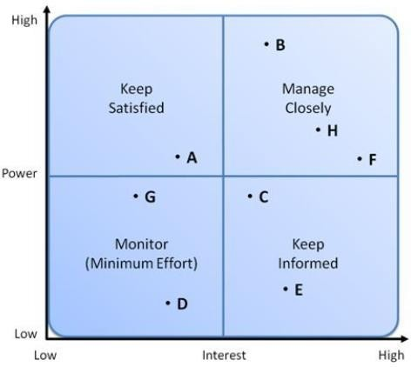
Figure 1. Source: (Connor et al. 2018).

Key:  - Government/ Council  - Customers | - Distributors  - Farmers  - Competitors | - Employees  - Community  - Supplier

Manage:

Make every effort to satisfy the staff with training and clear communication.

Satisfaction:

Customer and staff members to keep a good service at the workplace.

Be informed:

Update customers.

Monitor:

Monitor these people but avoid overcommunicating.

Time, cost and quality performance.

Analysing stakeholders

- Problems are perceived differently by diverse groups.

- Consider diverse viewpoints to increase consensus.

SWOT Analise with Internal Stakeholders (Table 3).

Table 3. Source: Swot analyse (Leigh, 2009).


- Face to face
- Innovattion product
- Packaging
- Different taste
- Appearance very different quality
- Price
- Competitors
- Delays
Strengths
Weaknesses
Opportunities
Threats
- The best quality
- Market expansion
- Healthy product
- Profit in different market
- Economic crises
- Low price competitions
- Goods
- Fast moving consumer

External Stakeholders

They do not work inside the company, but it is helpful and supports the business’s growth and development for the future (Murray-Webster and Simon, 2006).

Table 4. Source: Pestle (Widya et al.2018).
Political
- Government policy on both countries.
- Brexit.
- The war in Ukraine.
- The stability trade.
- Inflexion rate, economic shrinking.
- Economic growth.
- Unemployment rate.
Economic •Prices increase.
Social
- Lifestyle attitudes.
- Cultural barriers.
- To give them better quality on product from Portugal production.
- Target demographics.
Technologi cal
- Level of innovation.
- Internet availability and speed.
- It will be ordering online by using the app.
- Cybersecurity.
Legal
- Health and safety.
- consumer safety.
- Discrimination law.
- Copyright of brand protect.
- Area industrical.
- Recycling bottles of product.
- Low pollution.
Environment •Sustainability.

Factors contributing to planning failure

Table 5. Source: (Heagney, 2012, p.2).

External Environment | Planning | Plan Execution
- The war between Ukraine and Russia.  - Natural calamities.  - Oil commodities and world Prices.  - Pandemic disease Covid-19. | - Lack of consultation with key stakeholders.  - Poor governance.  - Lack of transparency.  - Poor communication.  - Failure to integrate lessons from the main plan. | - Budget delays.  - Inflexibility  - Conflicting interests of Stakeholders.  - Political interference.  - Time and cost overruns.

Work Breakdown Structure (WBS)

WBS should be created by experts with deep knowledge of the area in question, not by a top-down approach. It assumes that all team members are knowledgeable about the domain and understand the project requirements (Heagney, 2012, p.3).

Table 6. Source: WBS (Heagney, 2012, p.4).

Organic Olive
Oil
Buy
Importing
Store
Transport
Promotion
Customers
Sailboat
Supplier
Portugal
Rent - Price
Vouchers
Restaurant
Taxes
between both countries
Van
Discounts
Research
Layout - Office
Local
Community
Track
Offer/Gift
Market
Paperwork
In Birmingham
Industrial
Area
School
Cantina
Cost
Advertiser
Hotels
Contract
Rules
Faster assess

Market Research Competitors

The analysis revealed that Amazon sells organic olive oil to the UK.

Table 7. Source: Amazon sells (Organic olive oil, 2022; Amazon Associate, 2020).

Competitors | Olive oil origin | Price Per Litre
Clearspring | Italy | £23.50
Odysea | Greek | £11.99
Gallo | Portugal | £9.80
Triple “O” | Portugal (company) | £8

Table 8. Source: (Heagney, 2012, p.4).

Stakeholders Register

Stakeholders | Important | Interest/ Power | How to Engage | Level of Engagement
Supplier | External | Middle | Contract with farmer  Video call. | Supportive
Government/ Council | External | High | E- Email, Meetings | Unaware/ Neural
Employees | Internal | High | Contract, training and face-to-face. | Supportive
Customers | Internal | High | Face-to-face, phone call. | Leading
Distributors | Internal | Middle | Email, call phone and meeting. | Supportive
Employees | Internal | High | Face-to-face, call phone and meeting. | Supportive
Community | External | Lower | Face to face. | Resistant

The different engagement levels of the stakeholders can be classified as follows:

- Needs.

- Expectation.

- Interest.

- Potential impact.

The cycle of a generic project



1
Identification
5
Evaluation
2
Design and Feasibility

3
Appraisal and Approval

Figure 2. Source: The cycle of a generic project (Heagney, 2012, p.5).

4
Implementation

Identification (Figure 2):

  - Importing and selling olive oil.

  - Stakeholders.

  - Setting order and delivery.

Design and Feasibility

  - Market research.

  - Technical Analise – Communication and information clear for the best service.

Appraisal and Approval

  - Technical - Standards and technology to be used app.

  - Institutional – Structure place, staff, policies and previous experience.

  - Safeguard policies – environmental protection, gender and resettlement issues.

Implementation:

  - Sign the contract with stakeholders.

  - Tactical and logistical components. Each step and how long it will take are described under techniques. Supplies and materials are the responsibility of coordination.

Evaluation:

  - If there are deviations from the plan, corrective action is taken to get the project back on course, or the plan is changed and approved.

Project Process

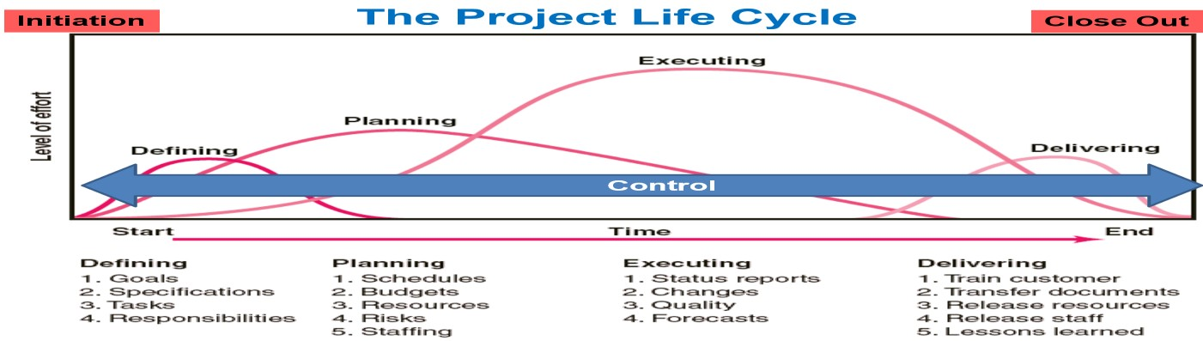

Figure 3. Source: Project Life Cycle (Heagney, 2012, p.6).

Initiation (Figure 3):

- Project failures are often caused by poor planning.

- Being kind is my goal.

- Planning is the biggest problem!

Planning:

- Poor planning is one of the major causes of failure.

- If you are just kidding yourself.

Executing

- Project execution consists of two parts.

- Objects can be tangible or intangible.

Monitoring

- Compares project work with a target, then corrects for actions that differ from it.

Delivering

- The items are transported by the supplier to England and from the store to the customer's door.

Close Out:

- Involves reviewing the project after it has been completed.

Consideration of resources or budget

Bar chart 1. Spending weekly.

Spending weelky

2500
Task C 57
60
3000
Task B 57
100
800
Task A 20
40

0
500
1000
1500
2000
2500
3000
3500
£/Wk £/Hr Hour/Wk

The schedule below is a bar chart. The work is simple. Considering 40 hours of labour per week at £20 per hour, Task A costs £800 per week. A weekly cost of £3,000 is based on one hundred hours of work at £30 per hour. Assuming 60 hours per week at £40 per hour, Task C spends £2,400 per week (Pie chart 2).

Pie chart 2. Cumuative Spending.

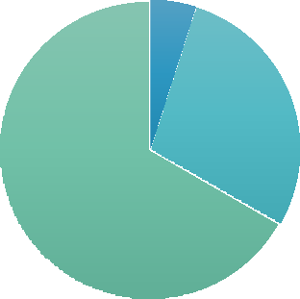
Cumulative Spending
Cumulative
Spending, 800,
800, 5%
Cumulative
Spending, 6200,
10800, 67%
Cumulative
Spending, 3800,
4600, 28%
800 3800 6200

Bar chart 3 - Finance.

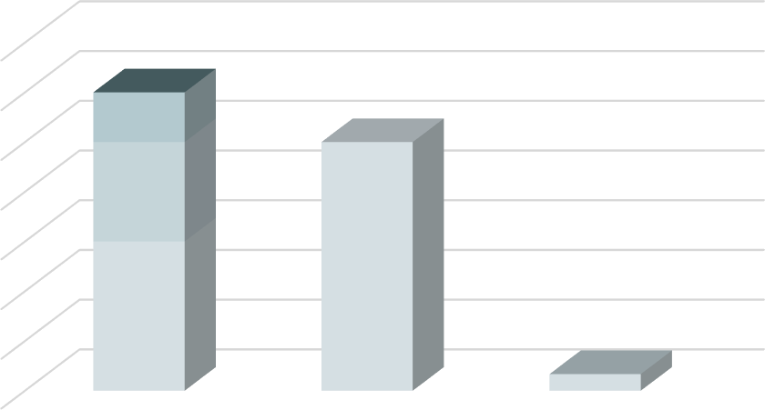
Finance
70000

60000
1
10000
50000
20000
40000

30000
50000
20000
30000
10000
33040
0
Loan
Budget (£)
Profit

Material and labour costs are included in the project cost as any additional elements needed to complete the project on time (Bryde, 1997).

Prices are always on clients' minds. Estimating the cost of a project accurately is not easy for project managers. Costs will inevitably change if the scope or timelines change (Bar chart 3).

Cost constraints lead to:

Pricing changes are unanticipated.

Costs of recruiting and staffing.

Deliverables added to the project.

Bar chart 4. Time – Delivery.
Performance, 100%
Time – Delivery
04:48
04:48
Orders, 1
00:00
Performance, 90%
Stock, 90%
00:00
19:12
19:12
14:24
Hours, 12:00
14:24
Performance, 100% Orders, 100%
09:36
Hours, 17:00
Hours, 14:00
Stock, 90%
Stock, 17:00
09:36
04:48
Orders, 08:00
04:48
00:00
00:00

 | Hours | Performance | Orders | Stock
Distribution | 14:00 | 100% | 08:00 | 90%
Customer | 17:00 | 100% | 100% | 17:00
Supplier | 12:00 | 90% | 1 | 90%

Clients expect a project delivery date for any assigned project. In the project management triangle, time constraints are often the biggest obstacle chart Time (Bar chart 4).
The project can be delayed by unanticipated challenges for the team or delays in materials, making meeting fixed deadlines difficult. Due to time limitations, any impact on the time constraint can lead to additional labour costs or significant changes to the scope of the project (Bryde, 1997, p.1).

Time constraints affect projects in the following ways:

Vendor delay.

From the client, added deliverables.

Overestimating a project's duration.

Bar chart 4 - Cost.

Cost
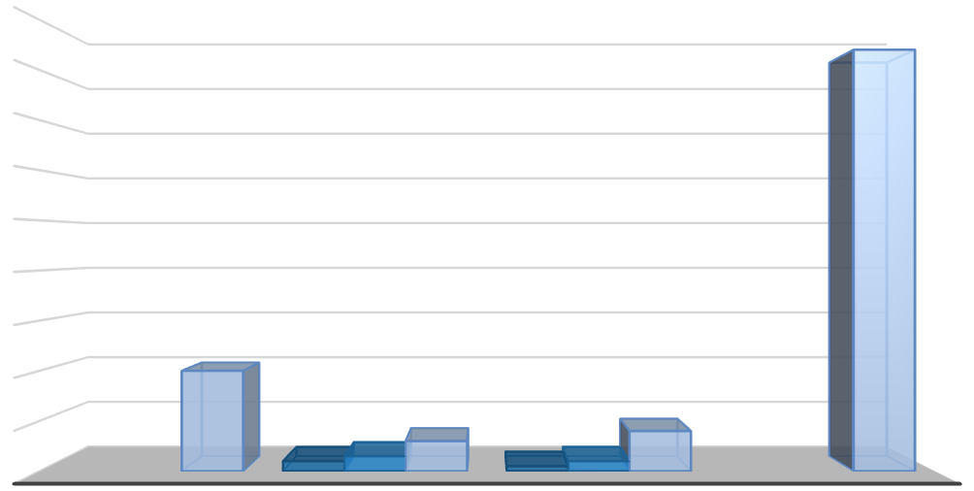
week 2 weeks 4 weeks
4500
4200
4000

3500

3000

2500

2000

1500
1000
1000

500
300
400
100
150
50
100
0
RENT OF STORES
DISTRIBUTION
BILLS
STAFF

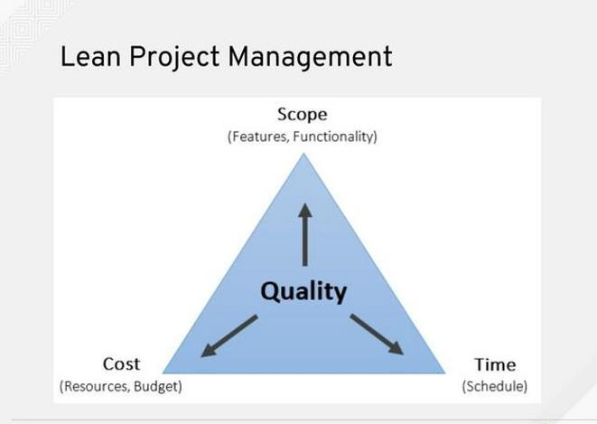

Figure 4. Source: Scope (Atkinson, 1999).

Project managers must balance the three factors within the project management triangle to plan, schedule, and deliver a successful project (Bar chart 4).

To improve the overall quality of the project and ensure a positive experience for all involved, a project manager should identify stakeholder expectations and constraints.

When using the project management triangle to guide decisions, project managers can ensure that the client's best interests are served (Bryde, 1997, p.2).

Triangle project management applications include:

Communicate better with clients

According to a PMI (2004) study, 56 per cent of all failed projects are caused by poor communication.

Project management triangle: how does it help? Iron triangles can assist project managers in explaining project restrictions to stakeholders and clients with limited project management knowledge or experience.

Project Adaptation

It is all too common for project managers to face changes in scope, timeline, and budget. Having a solid understanding of the project management triangle allows managers to adapt and pivot to sudden changes.

Delivering quality

Delivering a quality project to the client is the goal of a project manager. It is possible to achieve success throughout all projects by deploying the project management triangle (Orr, 2016).

Developing a team at distinct stages
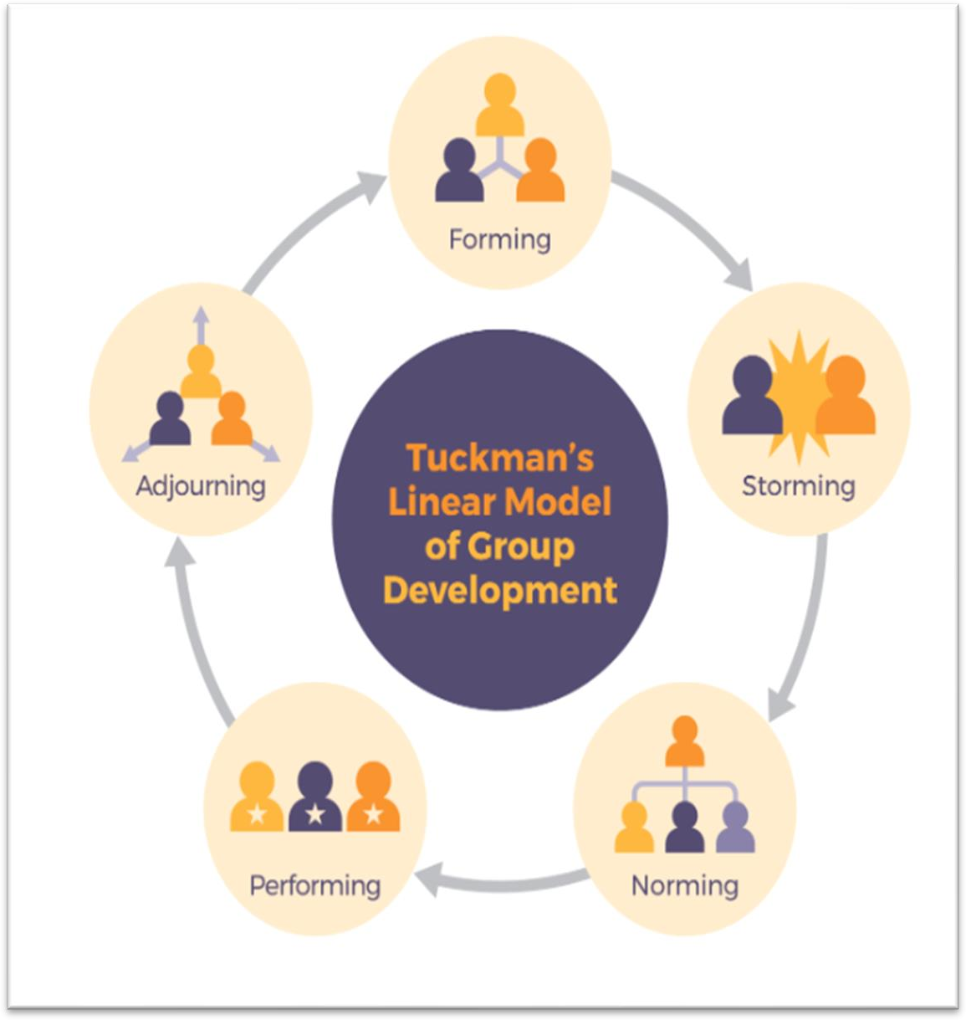
Figure 5. Source: The Tuckman Linear Model (Tuckman, 1965).

According to Tuckman (1965), there are five stages:

Formulating: The first time you meet staff or team members, get to know each other and decide what the job should do. As driving the track to do delivery and take order by customer.

Storming: Direct communication takes place and members of the staff get to know one another. During this stage, conflicts often arise between team members.

Norming: Managing members of employees establish communication and work rules. Each group member has a position to fast delivery and follow the role in 24 hours.

Performing: The ordering of product has delivery on time with complaints.

Adjourning: Participants leave. When the staff know the product well and feeling not interested in target, they will change their job.

Team relationships.

Managing a team involves four general issues: goals, roles, responsibilities, and procedures (Heagney, 2012, p.7). Developing a team begins with clarifying the mission, goals, and objectives of the team. There are various stages a team or group goes through on its way to maturity. Managers need to be prepared to deal with behavioural problems that may arise during a project (Carter et al. 2008).
- Goals or targets.

- Responsibility and roles.

- Methods.

- Interactions.

An outline Project Schedule/ Gantt chart

The project Activities process below is taken working four weeks schedule by the first order until four. The system has the staff in charge of also the percentage of products in stock and delivery by three times a week (Merriam, 1988).

Table 9. Source: Gantt chart (Atkinson, 1999).
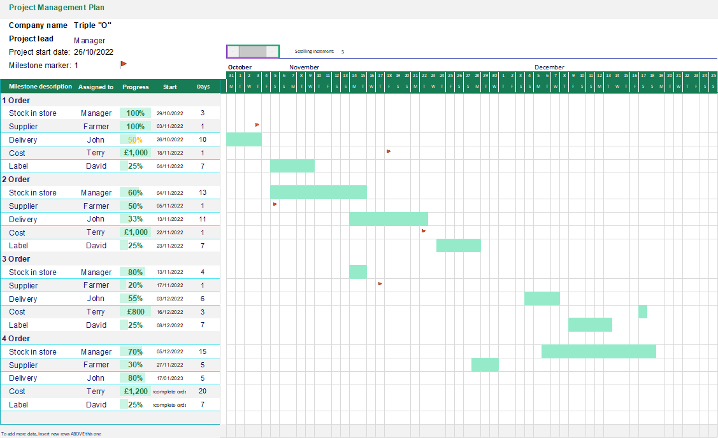

A Risk Assessment

Techniques for identifying risks with brainstorming (Faustman and Omenn, 2008).

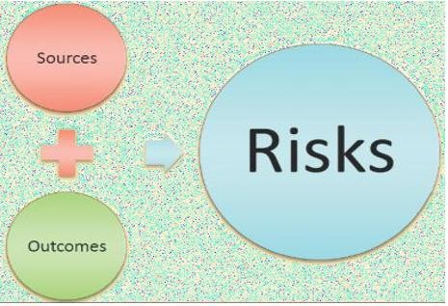

Figure 6. Source: Brainstorm (Heagney, 2012, p.8).

Managing project risks (Covello, and Mumpower, 1985).

- Risk definition.

- Failure reasons.

- Analyse risk.

- Evaluate risks.

- Mitigation plan development.

Risk mitigation

When a project manager understands which constraints are fixed and where flexibility exists, obstacles can be resolve and results achieve. While risks are inevitable, project managers can mitigate risks by understanding the iron triangle of critical thinking, problem-solving and decision-making that underpins business development (Perrow, 1999), (Figure 7).
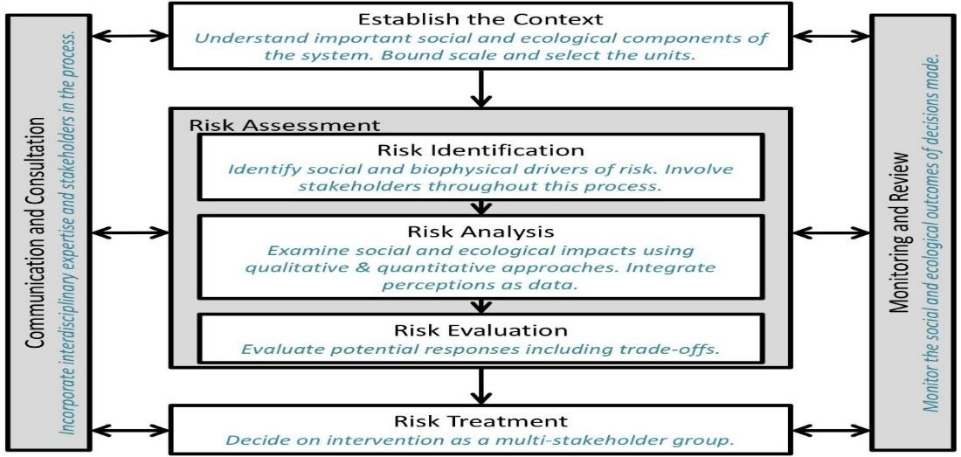

Figure 8. Source: Risk Analise (Covello, and Mumpower, 1985, p.3).

Risk at the workplace (Starr et al. 1976).

Table 10. Source: Cause of Risk (Heagney, 2012, p.9).

Risk | Risk mitigation | Risk prevention | Contingency Plan
Delivery delay | No | yes | - Delivery 2-3 days earlier than requested by the customer.
Supplier | Yes | yes | - Take advance with another supplier or farmer.
Contract with customers agrees on the unit at the end. | Yes. | Yes. | - Act by the court.  - Change the supplier.  - Insurance policy.  - Take time and cost.
Quality of product | Yes. | No | - Change the supplier.  - Active insurance in case of allergies.  - causes allergies.

Unexpected Side Effects of Olive Oil (Table 10):

- A factor that contributes to acne.

- Allergic reactions may occur.

- Rashes the skin.

Risk Treatment
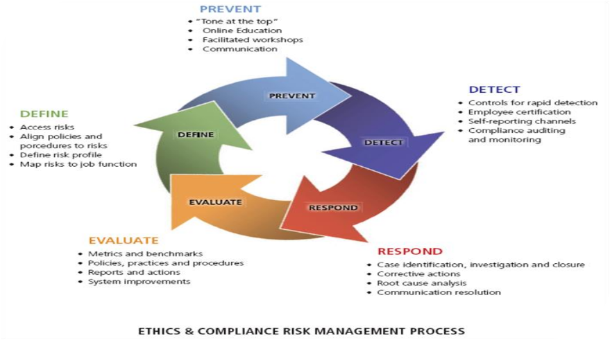

Figure 9. Source: Risk Treatment (Heagney, 2012, p.10).

The tool "4 T's" can be combined to reduce risks in one of four ways (Figure 10).

Tolerate

Low-level or too-expensive risks are often excluded. The cost of mitigation is prohibitive.

Treat

Control it somehow.

Prevent or reduce the impact.

Terminate

All risks are eliminated through treatment.

Limit the risk by doing things differently, where possible.

Transfer

A third party assumes the risk.

Taking on the risk; transferring business and reputational risk cannot be done.

Not all risks are bad

Taking these steps can turn risk into a benefit. To take a risk, you must first build your confidence.

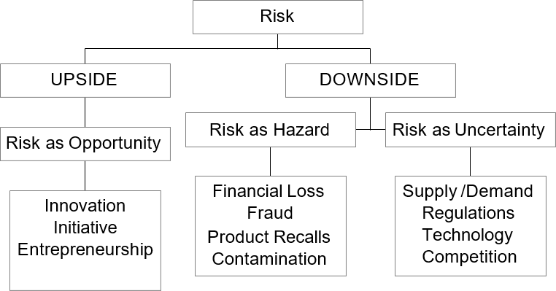

Figure 11. Source: Structure Risk (Heagney, 2012, p.11).

Controlling and treating risks (Figure 12).

Taking on unexpected risks can cause a project to spiral out of control. Performing a risk analysis in this manner may reduce any risks. It is also crucial that risk analysis is always conducted positively (Figure 13). If a team member is highly analytical or tends to be negative in general, this should be pointed out to them (Aiginger and Sieber, 2006).

When managing small projects, the Project Manager may simply include the risks and proposed actions in the Project Initiation Document. The risk workshop should be conducted with key stakeholders in large projects. To help record, track, and communicate risks and mitigation measures, a Risk Log should be established (Heagney, 2012), (Apply on Table 11).

Table 11. Source: Matrix Approach (Aiginger and Sieber, 2006).

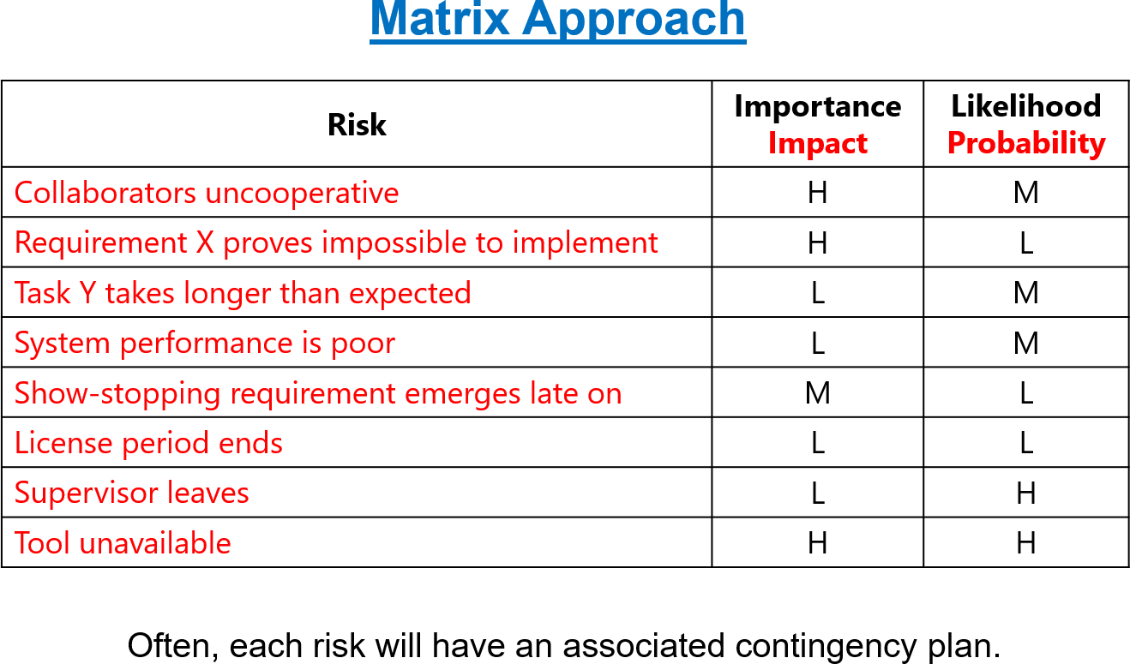

Table 12. Source: (Heagney, 2012, p.12).

Key: H=high, M=middle, L= lower.

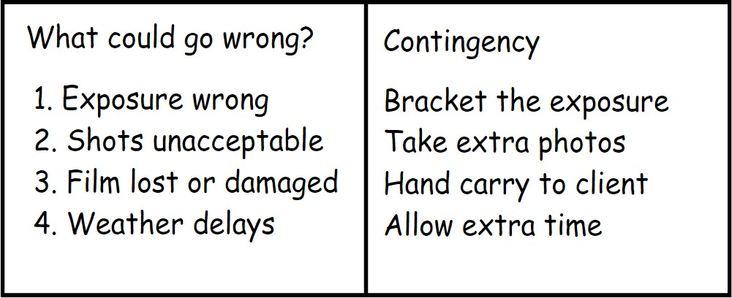

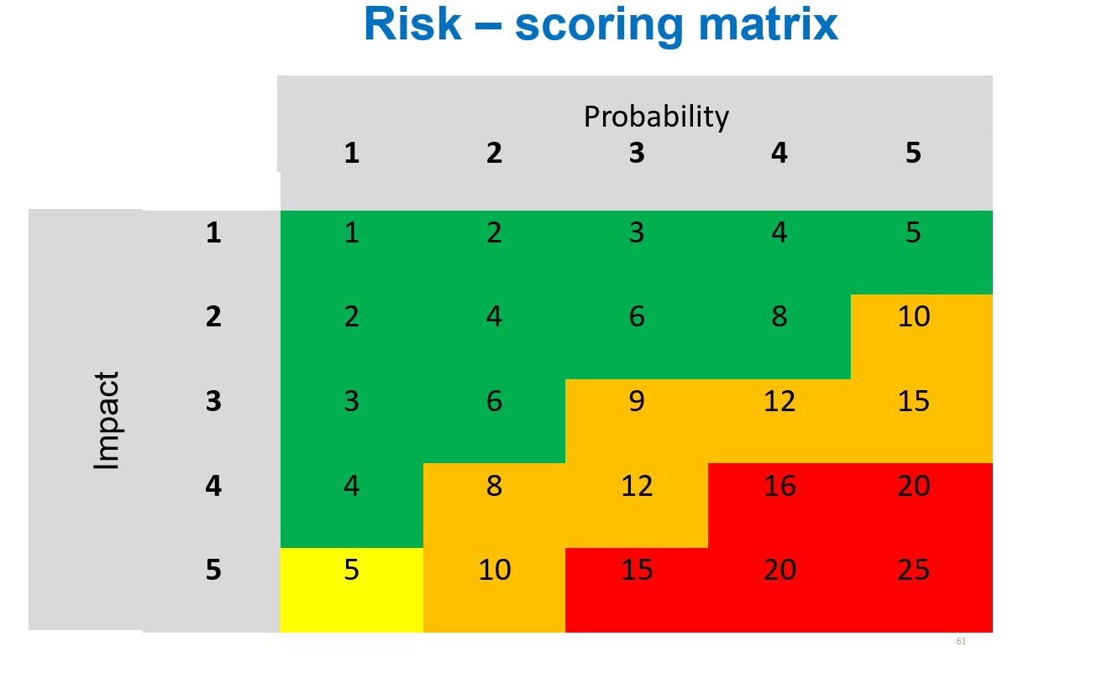

Figure 14. Source: Risk matrix (Heagney, 2012, p13).

Key of impact: Red=negative, Yellow= lower, Orange= middle and green=positive (Figure 15).

The worse scenario is a delayed project. It means the product from Triple “O” does not arrive on time to the customer (Table 12). To solve the problem, follow the stage to get the target done for the Satisfaction of quality (Reckwitz, 2002), (Table 13).

- Processes for managing change are inadequate.

- An unplanned increase in scope.

- It is off-limits for everyone to discuss Project Overruns and Personnel Issues.

- Overruns and delays in the project.

- Inadequate defined work breakdown structures that detail project requirements into manageable work items, tasks, and resources.

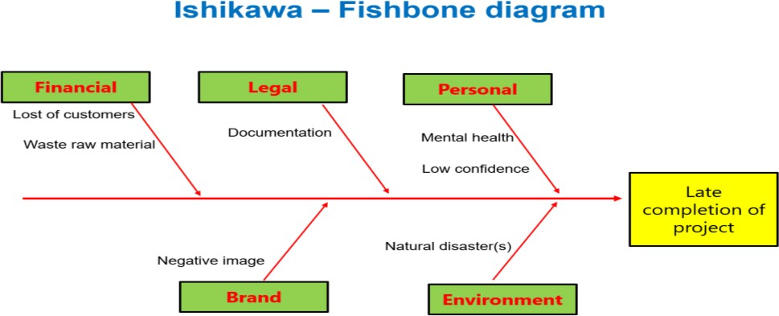

Figure 16. Source: Fishbone diagram (Ilie and Ciocoiu, 2010).

As can be seen from the fishbone diagram. Is it possible to understand the big picture when priorities are delayed in project management? (Ilie and Ciocoiu, 2010), (Figure 17).

A Project Network

An illustration of how the project is linked, interdependent, and completed;

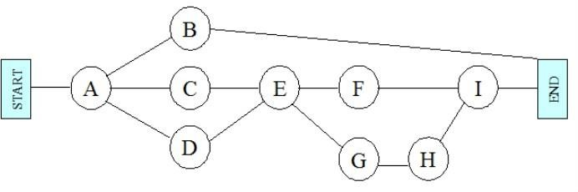

Figure 18. Source: Project Network (Heagney, 2012, p.14).

Key
STARD = Import olive oil from Portugal | F= Delivery
A=Farmers | G=Agent transport
B=Contractors | H=Amazon delivery
C=Supplier | I= Customer
D= Distribution | END=Satisfaction guests
E=Stores

Suggestions

Determine the most important performance drivers for each stage of the project development cycle and analyse them. In addition to evaluating how sophistication innovation goal setting, the alliance among important performance variables and productivity is evaluated, it is also suggested to examine the knowledge level of the organisation. There should be a project closure checklist completed before a project can be considered finished. There is a clear benefit to being able to understand what constitutes successful stakeholder management practices for both businesses and individuals.

Conclusion

This paper has identified project stakeholder management research and engagement with Swot to analyse Internally and Pestle external. Including an examination of the performance definition and a discussion of important success tools in project management. This work examined the evolution of the conventional technique. Success has changed dramatically over the years, as has our understanding of what it means. Management projects have penetrated diverse business domains, but more research is needed on this and any other key criteria. Due to the complexity, predictability, and demands of projects, it is always important to determine how to measure success in the work. Any fields are unknown in the success description, such as human resources, information management, and innovation of project management methods and techniques that are based on this synopsis. The restricted field of the success description relies on this risk assessment overview.

References

Aiginger, K. and Sieber, S., (2006). The matrix approach to industrial policy. International Review of Applied Economics, 20(5), pp.573-601.

Amazon Associate. (2020, 10 22). CRAZY-SIMPLE OLIVE OIL BEAUTY USES.
Retrieved 10 02, 2022, from https://everblossom.net/olive-oil-beauty/
Atkinson, R., (1999). Project management: cost, time and quality, two best guesses and a phenomenon, it is time to accept other success criteria. International journal of project management, 17(6), pp.337-342.

Avots, I., (1969). Why does project management fail? California management review, 12(1), pp.77-82.

Belassi, W. and Tukel, O.I., (1996). A new framework for determining critical success/failure factors in projects. International journal of project management, 14(3), pp.141-151.

Besner, C. and Hobbs, B., (2006). The perceived value and potential contribution of project management practices to project success. Project management journal, 37(3), pp.37-48.

Boehm, B.W. and Ross, R., (1989). Theory-W software project management principles and examples. IEEE Transactions on Software Engineering, 15(7), pp.902-916.

Brown, A. and Adams, J., (2000). Measuring the effect of project management on construction outputs: A new approach. International Journal of project management, 18(5), pp.327-335.

Bryde, D.J., (2003). Project management concepts, methods and
application. International Journal of Operations & Production Management, 23(7), pp.775-793.

Bryde, D.J., (1997). Underpinning modern project management with TQM principles. The TQM magazine.

Carter, C., Clegg, S.R. and Kornberger, M., (2008). So! Map box: editorial essays: Strategy as practice? Strategic Organization, 6(1), pp.83-99.

Connor, P.M., Axon, C.J., Xenias, D. and Balta-Ozkan, N., (2018). Sources of risk and uncertainty in UK smart grid deployment: An expert stakeholder analysis. Energy, 161, pp.1-9.

Covello, V.T. and Mumpower, J., (1985). Risk analysis and risk management: a historical perspective. Risk analysis, 5(2), pp.103-120.

Faustman, E.M. and Omenn, G.S., (2008). Risk assessment. Casarett and Doull’s toxicology: The basic science of poisons, pp.107-128.

Guide, A., (2001). The project management body of knowledge (pmbok® guide). In Project Management Institute (Vol. 11, pp. 7-8).

Heagney, J., (2016). Fundamentals of project management. Amacom. Available at: https://search-ebscohost- com.ezproxy.uwtsd.ac.uk/login.aspx?direct=true&db=nlebk&AN=388987&site=ehost- live (Accessed: 25 October 2022).

Ilie, G. and Ciocoiu, C.N., (2010). Application of fishbone diagram to determine the risk of an event with multiple causes. Management research and practice, 2(1), pp.1-20.

Leigh, D., (2009). SWOT analysis. Handbook of Improving Performance in the Workplace: Volumes 1‐3, pp.115-140.

Merriam, S.B., (1988). Case study research in education: A qualitative approach. Jossey-Bass.

Murray-Webster, R. and Simon, P., (2006). Making sense of stakeholder mapping. PM World today, 8(11), pp.1-5.

Newell, S., Bresnen, M., Edelman, L., Scarbrough, H. and Swan, J., (2006). Sharing knowledge across projects: limits to ICT-led project review practices. Management Learning, 37(2), pp.167-185.

Nicholas, J.M., (2001). Project management for business and technology: Principles and practice.

Organic olive oil. (2022). amazon.co.uk. Retrieved 10 23, 2022, from https://www.amazon.co.uk/Clearspring-Extra-Virgin-Italian- Olive/dp/B01GHSTFA4/ref=sr_1_8?crid=208J42Z1RAOKB&keywords=clearspri

ng&qid=1666496071&qu=eyJxc2MiOiI3LjA5IiwicXNhIjoiNi43OSIsInFzcCI6IjYu NjYifQ%3D%3D&s=grocery&sprefix=cleaspring%2Cgrocery%2C230&sr
Orr, J.E., (2016). Talking about machines: An ethnography of a modern job. Cornell University Press.

Perrow, C., (1999). Normal accidents: Living with high-risk technologies. Princeton university press.

PMI, A., (2004). Guide to the project management body of knowledge. In Project Management Institute (Vol. 130).

Reckwitz, A., (2002). Toward a theory of social practices: (A development in culturalist theorizing. European journal of social theory, 5(2), pp.243-263.

Starr, C., Rudman, R. and Whipple, C., (1976). The philosophical basis for risk analysis. Annual review of energy, 1(1), pp.629-662.

Tuckman, B.W., (1965). Developmental sequence in small groups. Psychological Bulletin, 63(6), p.384.

Weiss, A., (2002). A brief guide to competitive intelligence: how to gather and use the information on competitors. Business Information Review, 19(2), pp.39-47.

Widya Yudha, S., Tjahjono, B. and Kolios, A., (2018). A (PESTLE) policy mapping and stakeholder analysis of Indonesia’s fossil fuel energy industry. Energies, 11(5), p.1272.

