
Opportunities for female leaders in 21st Century Organistion


January 12, 2023

University Of Wales Trinity Saint David

Ancuta Elena Gidoiu

Student number 1905822
Summary
This study includes a detailed plan outlines the steps necessary to improve the progress of women in Professional Football, including raising awareness and increasing opportunities in terms of education, professional qualifications and leadership roles. It includes the roles and responsibilities of the relevant parties and considers potential challenges, as well as expected results. It is recommended that there be an emphasis on equal opportunities, gender-inclusive policies and proactive mentorship programs. Additionally, social projects should be developed to promote inclusion and transparent accountability to assess progress should be assessed.

Table of Contents
Summary 1
Table of Figures 2
1. Implementation Plan 3
1.1 Rationale 3
2. Aims and Objectives 3
2.1 Action Plan 3
2.2.1 Time Plan 3
2.2.2 Risk Management and Strategies 3
3. Recommendations 4
4. Conclusion (average of 10% of word count) 4
Bibliography 5
Appendix 6
Appendix 1 6
Appendix 2 6
Appendix 3 6

Table of Figures
Figure 1 - Map of the World 4
Figure 2 – Example 4
Figure 3 - The Role of .... 4

Implementation Plan

1.1 Introduction
Professional football has traditionally been a male dominated sector. Despite ongoing efforts by various institutions, there is still an underrepresentation of women in leadership roles in the industry. This assignment will provide a comprehensive analysis of the progress of women in gaining leadership roles in professional football and create an implementation plan. This plan will include critical analysis of the role of education, the evaluation of assumptions, and a reflection of the impacts of self-awareness, communication, political approaches, discrimination, and diversity on the progression of women in football. Additionally, a risk plan and time plan will be created to monitor and evaluate the implementation effectively.

2. Rationale
This implementation plan is being created to identify and address the barriers preventing the progression of women in professional football. By critically evaluating the role of education, assumptions about female aspirations, and examining self-awareness, communication, political approaches, gender discrimination, power struggles, diversity and organisational culture in the sector, the plan will provide an actionable strategy for overcoming the issues and facilitating greater leadership opportunities for women in the sport. Through the plan, we aim to identify and address the systemic issues that prevent women from progressing in professional football. We also seek to understand how public perception and organisational culture shape the opportunities available to women in the sector, and how to better support female leadership in the sport (Griffin et al., 2020). Ultimately, this plan will set out steps to create a more inclusive and equal environment in professional football.

2.1 Aims and Objectives
Define goals/milestones of the plan
Aims:
-To analyse the role of education in the progression of women to leadership roles in professional football.
-To evaluate assumptions regarding women and their aspirations in professional football.
-To discuss self-awareness, communication, political approaches in organisations, gender discrimination, power struggles, diversity in the workplace and organisational culture related to the progression of women to leadership roles in professional football.
Objectives:
-To critically analyse the role of education in facilitating career opportunities for women in professional football.
-To critically evaluate assumptions regarding women and their aspirations in professional football.
-To make recommendations for development in the area of education in order to facilitate the progression of women to leadership roles in professional football.
-To make recommendations for overcoming any negative assumptions related to women and their aspirations in professional football.
-To discuss self-awareness, communication, political approaches in organisations, gender discrimination, power struggles, diversity in the workplace and organisational culture related to the progression of women to leadership roles in professional football.
Goals/Milestones for the above objectives
Goals 1:
-Research existing education initiatives to facilitate career opportunities for women in professional football.
-Identify gaps in existing initiatives and make recommendations for development.
Goals 2:
-Research existing assumptions regarding women and their aspirations in professional football.
-Identify and evaluate any negative assumptions.
-Make recommendations for overcoming negative assumptions using contemporary management or leadership theories.
Goals 3:
-Research existing policies and initiatives related to self-awareness, communication, political approaches in organisations, gender discrimination, power struggles, diversity in the workplace and organisational culture.
-Identify gaps in existing initiatives and make recommendations for development.

2.2 Action Plan
I. Action Steps: | II. Responsible Person: | III. Deadline: | IV. Necessary Resources: | V. Potential Challenges: | VI. Expected Results:
1. Deliberate information through lectures and discussion on the importance of developing equal opportunities for female participation in Professional Football leadership roles. | 1. Lectures to be delivered by internal and external experts on the importance of developing equal opportunities for female participation in Professional Football leadership roles (Valenti et al., 2018). | 1. Lectures to be delivered on the importance of developing equal opportunities for female participation in Professional Football leadership roles within 6 months. | 1. Lectures - A qualified professional with proven experience and knowledge in the field. | 1. Lack of knowledge and awareness of the issue among society. | 1. Increase in female participation at the decision-making level.
2. Advocate for diversity and gender equality in the Board of Professional Football clubs. | 2. Advocacy for diversity and gender equality in the Board of Professional Football clubs to be coordinated from the club level. | 2. Advocacy for diversity and gender equality in the Board of Professional Football clubs to be initiated as soon as possible. | 2. Advocacy - A recognized diversity advocate and/or a working group of diversity advocates. | 2. Unwillingness of Professional Football clubs to implement the changes (Knoppers et al., 2022). | 2. Increased opportunities for female athletes and leaders.
3. Develop and introduce specific training courses for female support workers in Football clubs and make education and professional qualification more accessible. | 3. Development and introduction of specific training courses for female support workers in Football clubs to be undertaken by the Education and Professional Qualification Board (Dunn, 2016). | 3. Development and introduction of specific training courses for female support workers in Football clubs to be done within 12 months. | 3. Training Courses - Experienced trainers and/or researchers with knowledge in the field. | 3. Lack of qualified personnel to lead the initiatives. | 3. Positive changes in public perception of female leaders in Professional Football.
4. Increase awareness of the Professional Football industry amongst youths and young adults, especially women. | 4. Increase in awareness of the Professional Football industry amongst youths and young adults, especially women, to be coordinated by Marketing & Communications Department. | 4. Increase in awareness of the Professional Football industry amongst youths and young adults, especially women, to be done within 6 months. | 4. Awareness - Experienced journalists and/or marketing professionals with specialized knowledge in the field are needed to increase awareness amongst youths and young adults. | 4. Negative biases towards women leadership in the industry. | 4. Increased awareness of the issue and the importance of encouraging gender parity and diversity within the sport, both on and off the field.
5. Create and execute marketing communication plans, to highlight women's participation in Professional Football and spread positive messages about equal opportunities for female leadership in the industry. | 5. Creation and communication of marketing campaigns to highlight women's participation in Professional Football, and spread positive messages about equal opportunities for female leadership in the industry to be coordinated by Marketing & Communications Department. | 5. Creation and communication of marketing campaigns to highlight women's participation in Professional Football, and spread positive messages about equal opportunities for female leadership in the industry to be done within 12 months. | 5. Marketing - Professionals in the area of marketing and communication, for the creation and communication of marketing campaigns (Woodward, 2017). | 5. Limited availability of resources and funding for initiatives. | 5. Development of support networks and mentorships, to help women develop their leadership and management skills.
6. Develop and support mentorships for female leaders in Professional Football. | 6. Development and support of mentorships for female leaders in Professional Football to be coordinated by the Mentorship Department (Lago et al., 2022). | 6. Development and support of mentorships for female leaders in Professional Football to be done within 18 months. | 6. Mentorship - A working group of mentorships with extensive knowledge in the field and experience in mentoring. | 6. Internal Conflict | 6. Increased engagement of followers and fans of Professional Football, who are eager to support this positive change.
7. Ensure uncompromising support for female leaders (both within and outside Football circles) and encourage their participation in the industry. | 7. Uncompromising support for female leaders (both within and outside Football circles) and encouragement of their participation in the industry to be coordinated by HR Department. | 7. Uncompromising support for female leaders (both within and outside Football circles) and encouragement of their participation in the industry to be done within 24 months. | 7. Support - HR and other support departments, to ensure uncompromising support for female leaders and encourage their participation in the industry (Webster et al., 2019). | 7. Internal Pressure to perform all time | 7. Better representation

2.2.1 Time Plan
Timeline:
Week 1: | Research and review existing literature related to education, assumptions, self-awareness, communication, political approaches in organisations, gender discrimination, power struggles, diversity in the workplace and organisational culture related to the progression of women in professional football.
Week 2: | Analyse the role of education in the progression of women to leadership roles in professional football.
Week 3: | Evaluate assumptions regarding women and their aspirations in professional football.
Week 4: | Discuss self-awareness, communication, political approaches in organisations, gender discrimination, power struggles, diversity in the workplace and organisational culture related to the progression of women to leadership roles in professional football (Archer and Prange, 2019).
Week 5: | Develop an implementation plan based on the findings and make recommendations for development in this area.
Week 6: | Finalise the assignment and submit.

2.2.2 Risk Management and Strategies
Risks:
1. Lack of knowledge and awareness of the issue amongst society.
2. Unwillingness of Professional Football clubs to implement the changes.
3. Lack of qualified personnel to lead the initiatives.
4. Negative biases towards women leadership in the industry.
5. Limited availability of resources and funding for initiatives.
Mitigation Strategies:
1. Utilise existing networks to extend and reach audiences who may not be aware of the issue.
2. Raise awareness of the need for gender equality amongst decision makers in the industry.
3. Connect and collaborate with educational institutions, fem-tech groups, and any other relevant organisations to source qualified personnel.
4. Invest in research and data to create a better and more informed evidence base of gender leadership issues, to help inform and support initiatives.
5. Advocate for increased representation of women on boards and in executive positions.
6. Advocate and lobby, to allocate resources and funding to initiatives that promote gender parity and diversity (Cornwall, 2016).
7. Increase awareness amongst youths and young adults of the importance of gender parity and diversity, including through social platforms.
8. Work with experienced mentors, to ensure the development of leadership and management skills among women within the industry.
9.Continuously apply pressure to decision makers to ensure positive change is actioned.
10. Develop and apply a diversity and inclusion policy that can be implemented across the industry, with clear measures and targets (Tandon, 2016).

Recommendations
• Promote and ensure equal opportunities for women in Professional Football, both in terms of access to education and professional qualifications and in leadership roles.
• Create and implement gender-inclusive policies and practices in Football Academies and training centres.
• Raise awareness of women's participation in the sport to encourage more female participation in the sport.
• Utilize all available communication channels to propagate positive messages about equal opportunities, diversity and inclusion in the industry.
• Develop a formal strategy of mentorship for female leaders, utilizing both internal and external resources (Sharaunga et al., 2019).
• Encourage more involvement of female representatives at the decision-making level.
• Develop social initiatives and projects which are focused on removing any gender bias in the sport.
• Integrate gender equality education into the syllabus of Football academies and training courses.
• Recruit personnel with a proven track record of commitment to gender parity in the sport.
• Create accountability and transparency within the industry by regularly assessing progress and results (Yount et al., 2018).

Conclusion
In conclusion, it is evident that gender parity and diversity in Professional Football is still lagging behind. It is important to note that much of the responsibility of this lagging progress lies with the public perception, lack of knowledge and awareness, lack of resources and the unwillingness of the sports industry to proactively address the issue. Therefore, in order to address the gender imbalance, it is essential to focus on the right initiatives and strategies, with a multi-pronged approach. This includes initiatives such as increased awareness, equal opportunities for education and professional qualification, advocacy, campaigns and marketing communications plans, mentorship as well as support for women leaders. Adopting such approaches is absolutely essential in order to achieve a gender equitable environment in Professional Football, where women have the same opportunities to participate and lead at all levels. In order to address the gender imbalance, it is essential to focus on the right initiatives and strategies, with a multi-pronged approach. This includes initiatives such as increased awareness, equal opportunities for education and professional qualification, advocacy, campaigns and marketing communications plans, mentorship as well as support for women leaders. Adopting such approaches is absolutely essential in order to achieve a gender equitable environment in Professional Football, where women have the same opportunities to participate and lead at all levels.

Bibliography
Archer, A. and Prange, M., (2019). ‘Equal play, equal pay’: moral grounds for equal pay in football. Journal of the Philosophy of Sport, 46(3), pp.416-436.
Cornwall, A., (2016). Women's empowerment: What works?. Journal of International Development, 28(3), pp.342-359.
Dunn, C., (2016). Football and the women's World Cup: organisation, media and fandom. Springer.
Griffin, J., Larsen, B., Horan, S., Keogh, J., Dodd, K., Andreatta, M. and Minahan, C., (2020). Women's football: an examination of factors that influence movement patterns. The Journal of Strength & Conditioning Research, 34(8), pp.2384-2393.
Knoppers, A., de Haan, D., Norman, L. and LaVoi, N., (2022). Elite women coaches negotiating and resisting power in football. Gender, Work & Organization, 29(3), pp.880-896.
Lago, I., Lago-Peñas, S. and Lago-Peñas, C., (2022). Waiting or acting? The gender gap in international football success. International Review for the Sociology of Sport, 57(7), pp.1139-1156.
O'Hara, C. and Clement, F., (2018). Power as agency: A critical reflection on the measurement of women’s empowerment in the development sector. World Development, 106, pp.111-123.
Sharaunga, S., Mudhara, M. and Bogale, A., (2019). Conceptualisation and measurement of women's empowerment revisited. Journal of Human Development and Capabilities, 20(1), pp.1-25.
Tandon, T., (2016). Women empowerment: perspectives and views. The International Journal of Indian Psychology, 3(3), pp.6-12.
Valenti, M., Scelles, N. and Morrow, S., (2018). Women’s football studies: An integrative review. Sport, business and management: an international journal.
Webster, K., Chen, C. and Beardsley, K., (2019). Conflict, peace, and the evolution of women's empowerment. International Organization, 73(2), pp.255-289.
Woodward, K., (2017). Women’s time? Time and temporality in women’s football. Sport in Society, 20(5-6), pp.689-700.
Yount, K.M., Peterman, A. and Cheong, Y.F., (2018). Measuring women's empowerment: a need for context and caution. The Lancet Global Health, 6(1), p.e29.

Appendix

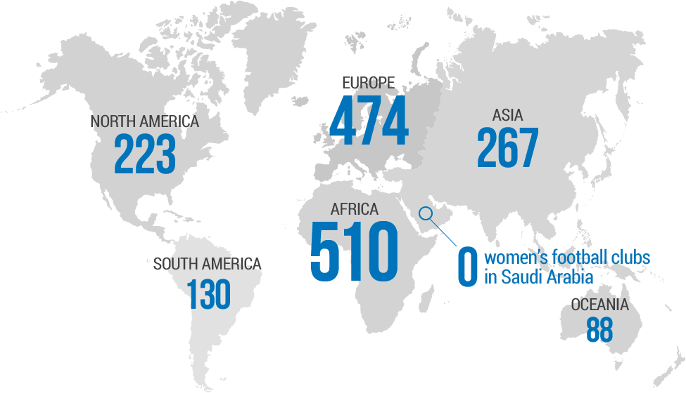
Figure 1 - Women's football Clubs/teams around the World
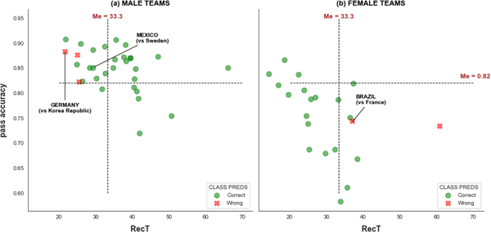
Figure 2 – Example difference between men's and women's football
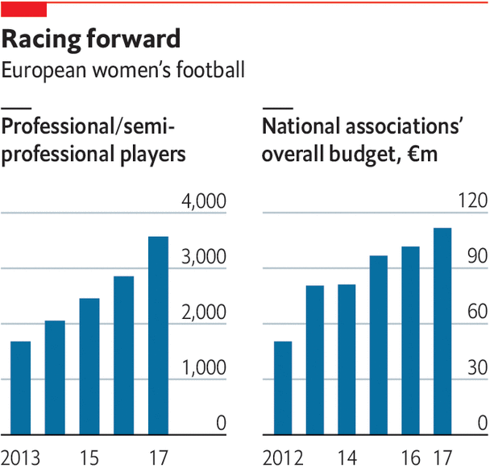
Figure 3 - The Role of Women's football

