

Assessment 1
Title: Assessment component - Individual report

Name: Shaunakkumar Patel
Student ID: 2504923
Module Name: Strategic Management
Module Code: LCMB70_LON
Lecturer’s Name: Andry Rakotovololona
Word Count: 5158

Term 2

Table of Contents
Section 1 4
1. Organizational Context and Overview 4
1.1 Organizational Context 4
1.2 Industry Overview 5
2. External and Internal Environment Analysis 6
2.1. PESTLE Analysis 6
2.2. Porter’s Five Forces 8
2.3. Porter’s Diamond Model 9
2.4. VRIO Analysis 10
3. CSR and Sustainability objectives 11
3.1. Discuss the CSR strategy of Adidas 11
3.2. Alignment of the CSR strategy with the business objectives of Adidas 12
4. Comprehensive and holistic view of the organization 13
4.1. Balanced Scorecard 13
5. Strategic Choices and Implementation 17
5.1 Ownership Advantage 17
5.2 Location Advantage 17
5.3 Internalization Advantage 18
5.4 Critical Assessment 18
5. Strategic Evaluation and Recommendations 19
5.1. SWOT Analysis 19
5.2. Ansoff’s Matrix 20
5.3. Recommendation for Improving Business Strategy 22
Section 2 23
1. Gibbs’ Reflective Cycle 23
1.1 Description 23
1.2 Feelings 24
1.3 Evaluation 24
1.4 Analysis 24
1.5 Conclusion 25
1.6 Action Plan 25
Reference 27
Appendices 34
Appendix 1: GDP growth of Germany 34
Appendix 2: Poverty Scale of Germany 35
Appendix 3: Adidas Market Share in the US 36

Section 1

1. Organizational Context and Overview

1.1 Organizational Context
Adidas is a renowned German-based sportswear manufacturer of athletic shoes and apparel, and its three-stripe trademark recognizes the company. Adidas is also famous for its endorsement deals, which include NBA star Derrick Rose and the Argentine-born football star Lionel Messi, who signed a lifetime contract with Adidas in 2017 (Lewis, 2024). Adidas was founded by Adolf "Adi" Dassler, who began making his own athletic shoes and sporting goods in the 1920s (EBSCO, 2022). During the 1940s, the brothers had a falling out, and the company split. Later, from the 1950s to the late 1980s, the company's popularity, now known as Adidas, continued to increase, and it became a global brand (EBSCO, 2022). In 2006, the company changed its name to Adidas AG after acquiring Reebok (Refer to Figure 1). Adidas operates a hybrid business model in which the company is focused on designing, marketing, and distributing athletic or lifestyle footwear, apparel, and accessories. Adidas’ revenue stream includes sales generated by 57% of footwear as of 2023 (Adidas, 2024b).
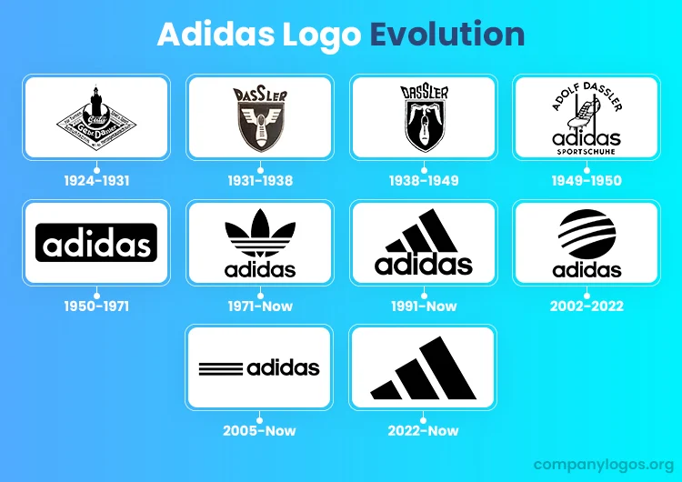
Figure 1: Adidas Logo Evolution
(Source: Kamal, 2024)
Mission: “To be the best Sports Brand in the World” (Adidas, 2025b).
Vision: “Adidas strives to be the global leader in the sporting goods industry, living with a passion to build a sporting lifestyle” (Fashion Gear, 2026).

1.2 Industry Overview
The global sportswear market is growing rapidly with many competitors. The market is estimated to have an estimated market size of $335.92 billion in 2023, which is expected to reach $646.01 billion by 2030, growing at a CAGR of 9.9% between 2024 and 2030 (Grand View Research, 2024) (Refer to Figure 2). Some of the key players of the global sportswear market include Nike, Adidas, Puma, Lululemon, and Under Armour, with their top product segments based on technology that enhances their performance, including moisture-wicking and eco-friendly materials.
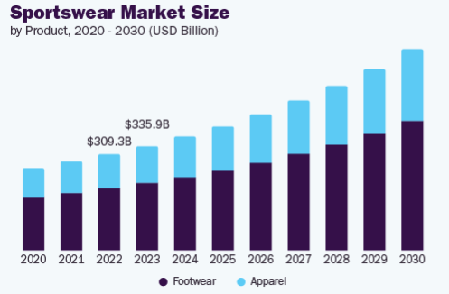
Figure 2: Sportswear Market Size
(Source: Grand View Research, 2024)
Major competitors of Adidas in the global sportswear and footwear market are NIKE Inc, Lululemon Athletica Inc, Puma SE, and New Balance Athletic Inc (Global Data, 2026). Adidas is the second-largest sportswear manufacturer in the world, in Europe behind Nike (Sabanoglu, 2022). This brand holds approximately 21% of the global sportswear market share (Sabanoglu, 2022). It has a very strong position in the market for lifestyle products, especially in the field of footwear and apparel. According to the preliminary results, the company reported a record revenue of €24,811 million ($26.3 billion) for the full year 2025 (Adidas, 2025a). The company is motivated by the success of its turnover, with strong demand for core products and double-digit growth in key markets.

2. External and Internal Environment Analysis

2.1. PESTLE Analysis
Political: Germany’s political environment tends to be stable before the 2024 elections, where the new party AfD has significant power in the two states of Germany. The existence of the stable government supports the progress of supportive business culture (Kinski and Brause, 2025). The present government was facing the dissolution of the traffic light coalition within the country, but the entire situation is considered favourable for Adidas. Besides political instability, Germany is facing a politically influenced crime rate rising by 40% (Kinski and Brause, 2025). ). Politically, Germany is facing economic recession, instability, the rise of the far-right, immigration pressures, and a new political party named the far-right Alternative for Germany (AfD) (Human Rights Watch, 2024). [Favourable]
Economical: According to a report of the European Commission (2025), Germany is economically stable, as can be seen through its GDP rise in 2024 by 0.2%. Germany’s inflation has decreased to 2.3, which counts as a positive impact on the market in 2025. Germany’s per capita GDP has risen to 55800.22 USD in 2024 (The Global Economy, 2026) [Refer to Appendix 1]. The decreasing unemployment rate showing the positive economic growth of the nation that supports development. Germany’s unemployment rate is also decreasing to 3.6% fin the year of 2025, which indicates the rise in the employment market and the economic aspects are counted as favourable. [Favourable]
Social: Germany’s Poverty scale has increased, and scales the risk of poverty in 2023 to 33.106 euros for a two-adult household in 2023 (Statista, 2025) [Refer to Appendix 2]. The existence of the high risks of poverty indicates the low consumer spending of the consumers that shows issues for the business. Political implications to prioritise the anti-racist and anti-discriminatory theories of the activities in Germany’s culture have proven to be a failure. Immigrant communities in the country are facing huge discriminatory and racist behaviour that results in politically influenced crimes (Human Rights Watch, 2025). The existence of the discriminatory and racist culture indicates domination within the external market environment. This entire situation provides an unfavourable condition for Adidas' business growth and market capture in Germany. [Unfavourable]]
Technological: Germany’s different sectors are adopting Big Data and Cybersecurity technologies to transform the digital environment, which is widely used in Germany’s market sector. Germany’s ICT market is valued at 187.8 USD in 2024 (International Trade Administration, 2025). German companies and the medical sector are adopting new technologies. 46% of German companies have introduced cloud computing in their business processes, and the country has a second largest Cybersecurity market within the Europe. Companies are also introducing ERP solutions and smart social business channels to their customers that support digitization and ensure favourable conditions for Adidas. [Favourable]
Legal: Germany has laws for press freedom, workers' rights and the balance of wage and working hours for establishing a better organizational structure. The country also has safety and health regulations for job purposes, and the freedom to associate and bargain collectively for their rights (United States Department of State, 2026). Germany has regulations on worker rights which has implemented wage and work hour laws (United States Department of State, 2026). [Favourable]
Environmental: Germany has a large water resource, and it invests more in renewable energy resources for energy production for stepping increased years. In 2024, this energy consumption rose by 56%, but it also now depends on the natural energy resources in large numbers (OECD, 2025). The increasing renewable energy consumption indicates the existence of the improvement of sustainability. Thus, the decreasing rate of emission the progress of the recycled manufacturing and eco-friendly progress of the industry. The country’s GHG emission is decreased by 9.19 in the per person indicator, which improves the environmental factor. [Favourable]

2.2. Porter’s Five Forces
Porter’s Five Forces Analysis of Adidas from Table 2 identified the internal factors of the company within the sportswear, athletic footwear, and sports apparel industry. This table also identifies the level of threats of the factors by evaluating the impact on Adidas.
The threat of new entrants is low due to the strong brand loyalty of the key players such as Adidas, Nike, Puma and other brands. According to Sarkar (2023), this industry also requires high capital for investment and other financial performances. Therefore, the existence of this particular issue increasing the risks for the new businesses to start their operations in Germany.
The bargaining power of suppliers is also considered low, which fosters a large network of suppliers within the industry. Li (2023a) stated that this factor also led Adidas to witness a high supplier density for the materials. Thus, the improved number of suppliers’ availability indicates the uninterrupted supply of the raw materials that supports manufacturing of the goods and timely delivery of the services.
The bargaining power of customers of Adidas is high, which opens access to other alternatives for the customers (Li, 2023b). This factor also highlights that the customers of this industry have access to a lot of information about the industry itself. The presence of high alternative makes it challenging for the brands to offer innovative products and it increases the consumers power to bargain.
Moreover, the threat of substitutes to Adidas is a moderate level of threat. According to Sarkar (2023), this factor highlights that there is a high availability of alternatives, which are generic, counterfeit and fashion-oriented within the sportswear, athletic footwear, and sports apparel industry. The existence of substitute products attracts the consumer towards themselves that improves the risk of competition within the industry.
Lastly, Adidas highlights its high competitive rivalry with strong competition from the key players of this industry, such as Nike, Puma, Under Armour and other brands for market share (Li, 2023a). Therefore, the existence of strong competitors creates huge pressure on the brands to maintain their uniqueness to make their customers to stay loyal towards the brand.

2.3. Porter’s Diamond Model
According to Tan (2025), this model focuses on the environment of the home country by emphasizing innovation, international competitiveness and long-term success. Figure 3 classifies the four main domains of this model, such as factor conditions, demand conditions, related industries, and firm strategy. Porter’s Diamond Model, developed by Michael Porter, can be used to maintain the competitive edge of Adidas in the global sportswear market by understanding its alignment with the factors of this model.
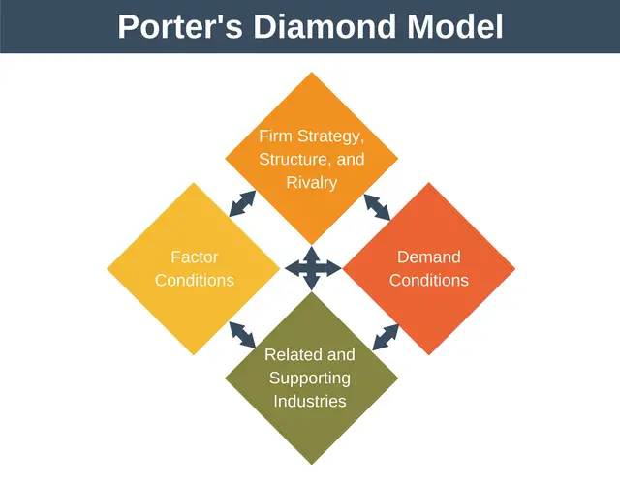
Figure 3: Porter’s Diamond Model
(Source: Denis, 2018)
Factor Conditions: This company operates in Germany by focusing on innovation, R&D, and engineering, while maintaining high quality and durability (Faccia, Le Roux and Pandey, 2023). Adidas also focuses on the strong domestic infrastructure in Europe to foster seamless supply chain management.
Demand Condition: The European and global consumers of this industry are often considered highly sophisticated customers. Li (2023b) identified that the customers of Adidas demand high-quality, stylish and sustainable products, which this brand provides positively.
Related and Supporting Industries: Adidas depends on the huge network of suppliers in Asia, with 65% of collaborative manufacturing partners, to foster long-term relationships (Adidas, 2024). Additionally, this brand also fosters a strong relationship with the sports organizations, teams such as FIFA, NBA, to provide a supportive industry.
Firm Strategy, Structure, and Rivalry: Adidas is facing strong competition from the key players of this industry, such as Nike, Puma, Under Armour and other brands for market share (Sahu, 2025). This pushed Adidas to focus on product differentiation heavily.

2.4. VRIO Analysis
Resources | Valuable | Rare | Easy to Imitate | Organizational | Advantage
Brand Equity and Image | ✓ | ✓ | ✓ | ✓ | Sustained Advantage
R&D / Innovation | ✓ | ✓ | ✓ | ✓ | Sustained Advantage
Supply Chain Management | ✓ | ✓ | X | ✓ | Temporary Advantage
Marketing Strategy | ✓ | ✓ | ✓ | ✓ | Sustained Advantage
Table 3: VRIO Analysis of Adidas
(Source: Self-developed)
Analysis:
The key resources of Adidas have been aligned with the competitive advantage in Table 3. The brand equity and image of Adidas is considered valuable, rare, easy to imitate and organizational. This indicates a sustained competitive advantage of Adidas by fostering collaboration with FIFA, Olympics to enhance the brand recognition (Adidas, 2024). On the other hand, the R&D and innovation of this company also highlight sustained competitive advantage with its valuable, rare, easy to imitate and organizational factors. This brand implements R&D in product technology to deliver more unique products to its customer base (Li, 2023b). Moreover, the supply chain management of Adidas fosters temporary advantage by its characteristics of value, rarity and organizational strategy. This resource of the company also fails to maintain its brand uniqueness, as this factor is easy to imitate. Yet, Adidas focuses on eco-friendly materials by maintaining its sustainable practices in its supply chain management (Adidas Group, 2024b). Lastly, the marketing strategy of Adidas is also valuable, rare, easy to imitate and organized. It depicts a sustained competitive advantage in its marketing of Adidas through collaboration with FIFA and the Olympics (Adidas, 2024). As per the discussion, it can be said that Adidas need to focus on its supply chain management by adopting some effective strategies.

3. CSR and Sustainability objectives

3.1. Discuss the CSR strategy of Adidas
According to the Annual Report of Adidas (2023), it has also taken some CSR strategies for impacting environmental sustainability for innovation, supply chain and value creation and also intends to achieve carbon neutrality by 2050. The company is transforming the raw material and operations within the complete value chain to reduce 30% GHG emissions by 2030 (Adidas, 2023). Adidas is targeting to achieve complete decarbonization between 2025 to 2030 through controlling operations, which also results in scope 1 and 2 carbon neutrality. The company provides skills training and development to the underprivileged children in the urban and rural schools in sports.

3.2. Alignment of the CSR strategy with the business objectives of Adidas
The annual report of Adidas already has a significant focus on CSR strategies that integrate sustainability into the operations of the company. Therefore, it focuses on the SDG goals to achieve and creates commitment for sustainable development in the company. In Figure 4, the sustainability approaches of the company are depicted, and it establishes a primary significance for the objectives of the company (Adidas, 2021). Two of the most significant objectives the company focuses on and aligns with the CSR strategies for sustainability are ensuring labour rights for the migrant workers and inspiring the teams for the consumers around the world, daily (Adidas, 2021). Therefore, it needs to align the factors for sustainability with brand equity, operational efficiency, innovation, the “Own Game Strategy”, and others.
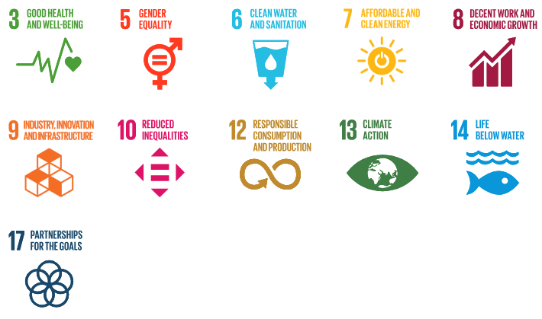
Figure 4: Sustainability Roadmap of Adidas
(Source: Adidas, 2021)
Naoum and Altmann (2025) have stated that Adidas is known to have a sustainability program that is an integral part of the business model of the company. This program focuses on several strategies, for strategies such as vegan products, partnerships with others and reducing plastic packaging.

4. Comprehensive and holistic view of the organization

4.1. Balanced Scorecard
Perspectives | Strategic Objectives | Key Performance Indicators (KPIs) | Key Initiatives
Financial | Maximization of the shareholder value and an increase in profitability. | - Currency-neutral revenue growth  - Operating margin | - Optimization of operating working capital  - Enhancement of the capital expenditure for effectiveness
Customer | Keeping the values and needs of the customers in mind for improving operations and maintaining relationships with them. | - Net Promoter Score (NPS)  - Market share and e-commerce net sales. | - Digital Transformation through apps and digital touchpoints.  - Expansion of Direct-to-consumer (DTC) channels.
Internal Process | Evaluation of the sustainability choices for innovative product development. | - Percentage of sustainable products.  - Brand health metrics | - Utilization of sustainable materials  - Advancement in product innovation.
Learning and Growth | Development of a diverse and inclusive workforce with a robust focus on the consumers. | - Employee Engagement Index  - Net Promoter Score for the Employees | - Implementation of surveys  - Diversity and inclusion initiatives
Table 4: Balance Scorecard of Adidas
(Source: Self-Created)
Analysis
Financial: The strategic objectives for the financial perspective of the company are maximization of the shareholder value and an increase in profitability, and for this objective, the company can focus on two significant KPIs, through initiatives for robust success. In 2023, the company faced a total of 5% decrease in its total sales growth; however, it surged by up to 10% of profit in 2024 (Refer to Figure 5) (Global Data, 2026).
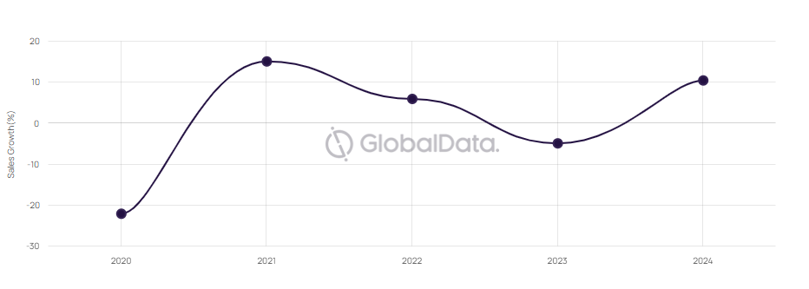
Figure 5: Sales Growth of Adidas (2020 - 2024)
(Source: Global Data, 2026)
The Performance chart of Adidas from Global Data (2026) depicts that 2024 had the highest amount of revenue and performance rate, increasing up to $25,623 million (Refer to Figure 6). The company also use significant initiatives, including optimization of operating working capital, and enhancement of the capital expenditure for effectiveness, for stable revenue growth.
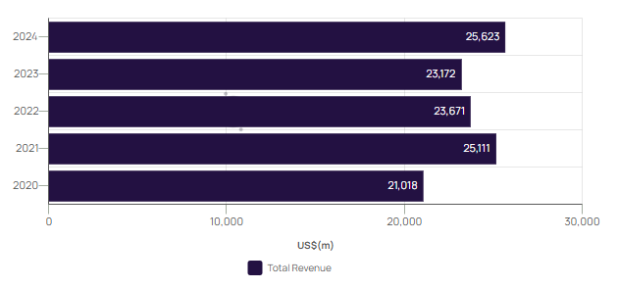
Figure 6: Performance Chart of Adidas (2020 - 2024)
(Source: Global Data, 2026)
Customer
Adidas take initiatives to keep the values and needs of the customer to improve the operations and maintain their relationship with the customers. In order to improve the digital transformation through apps and digital touchpoints, the company invests more than €1 billion by 2025 (Adidas, 2021a). Adidas has shifted from traditional marketing to strengthen interactive marketing in real-time, which helps in building brand loyalty and customer satisfaction. Adidas is expanding its Direct-to-Consumer (DTC) channels quickly; the company is aiming for 50% of total sales from its own digital and physical channels by 2025 (Adidas, 2024a). Double-digit growth in wholesale as well as across all of the company’s direct-to-consumer channels indicates the high demand for the company’s products.
Internal Process
In order to enhance the evaluation of the sustainability choices for innovative product development, Adidas take some initiative. Adidas is moving towards sustainable materials through replacing all virgin polyester with recycled polyester (already achieving 96% by 2023) and using 100% more sustainable cotton since 2018 (Adidas, 2023). Adidas has achieved advancement in product innovation in their products, including Future craft Strung, 3D printed 4D midsoles, sustainability products such as Parley Ocean Plastic, and products for women and adaptive athletes (Bell, 2024). Adidas is a pioneer in product innovation due to its sustainability, 3D printing for manufacturing, and the use of artificial intelligence for product development for performance products.
Learning and Growth
Adidas developed a diverse and inclusive workforce with a robust focus on consumers for their learning and growth. Adidas uses employee engagement surveys through a strategic shift from monolithic, less frequent assessments to a "listening" approach, emphasizing the importance of real-time feedback, high response rates, and insights to drive company culture (Adidas, 2021b). In order to achieve the initiative, Adidas has incorporated the idea of Diversity, Equity, and Inclusion (DEI) as an integral part of the "Own the Game" strategy to create a sense of belonging for employees to increase their engagement, satisfaction, and retention.

5. Strategic Choices and Implementation

5.1 Ownership Advantage
Adidas adopts strong tangible assets, involving high-reputation brands, R&D capabilities and global recognition. The customers of Adidas demand high-quality, stylish and sustainable products, which this brand provides positively (Kim and Choi, 2025). This helps the company to maintain its brand image with innovative and stylish products. Adidas also heavily invests in its R&D to develop its operational performance by implementing more advanced technologies. This brand also focuses on sports by collaborating with sports organizations such as FIFA, the Olympics and others (Adidas, 2024). This brand also focuses on the D2C and digital transformation. Additionally, this company also maintains its sustainable practices by including recycled materials (García-Sánchez and Carnicero-Martínez, 2026).

5.2 Location Advantage
Adidas also emphasizes some emerging markets, such as China, Indonesia, and Vietnam, by maintaining its own design studios in Germany. The headquarters of this company is considered the “World of Sports" campus by integrating corporate, design and development within the same location (Adidas Group, 2024a). Adidas operates a hybrid business model in which the company is focused on designing, marketing, and distributing athletic or lifestyle footwear, apparel, and accessories. According to Table 1, the political implications of Germany prioritizing the anti-racist and anti-discriminatory theories of the activities in Germany’s culture have proven to be a failure. Germany’s different sectors are adopting cybersecurity technologies to transform the digital environment, which is widely used in Germany’s market sector, which helps Adidas to adopt digitalization positively. Yet, this brand faces strong competition from the key players of this industry, such as Nike, Puma, Under Armour and other brands for market share.

5.3 Internalization Advantage
Adidas emphasizes the control of its value chain, which includes the production, distribution and marketing strategy. The main goal of this company is to protect its brand image by fostering advanced technology (Serang et al., 2025). This company involves R&D and innovation to maintain its market position in a competitive market. This brand implements R&D in product technology to deliver more unique products to its customer base (Li, 2023b). Adidas fosters collaboration with FIFA and the Olympics and aims to enhance its brand recognition. Adidas in Germany also optimizes logistics and speed by declining its dependency on the third party logistics partners.

5.4 Critical Assessment
The OLI framework is also known as the Eclectic Paradigm, which was developed by John Dunning. This framework helps to identify the organization’s FDI on the basis of ownership, location and internalization advantages (Bhandari et al., 2023). Figure 7 also represents the three advantages of the OLI framework.
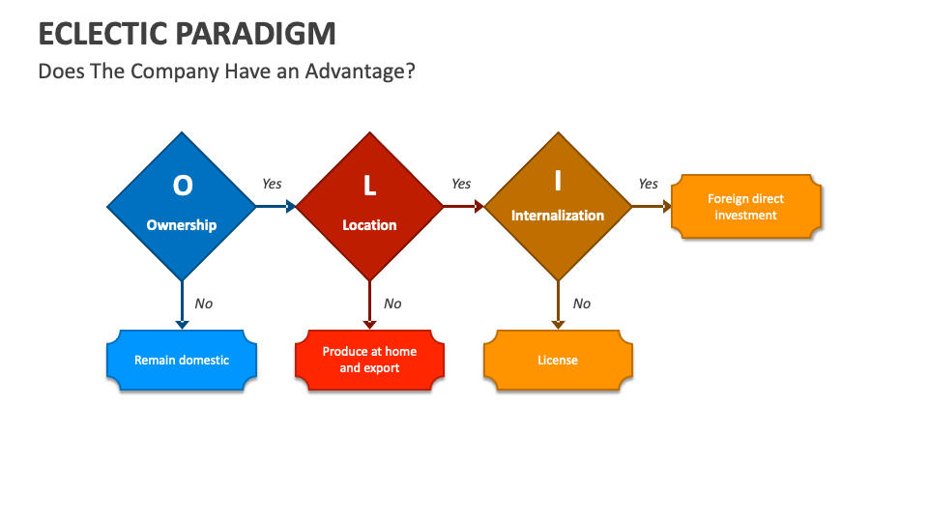
Figure 7: OLI Framework
(Source: Collidu, 2023)
This company needs to elevate digital marketing by imposing hyper-localization. Adidas focuses on the urban areas by leveraging AI in its digital marketing campaigns. This marketing strategy can also help the company to enhance its brand image by implementing more unique, innovative and stylish products (The Shorty Award, 2025). On the other hand, it also operates a hybrid business model to expand its business in the footwear and accessory industry. Lastly, Adidas also needs to integrate product development, which led the company to manufacture unique and new products to mitigate the challenges to expand its business in the emerging market.

5. Strategic Evaluation and Recommendations

5.1. SWOT Analysis
Strength | Weakness
- Double-digit growth in the global markets and channels (Adidas, 2024a).  - Global presence and distribution (Adidas, 2024a)  - Diverse portfolio.  - Digital presence.  - Extended brand partnership (Adidas, 2024a). | - Dependence on the sports market.  - Supply chain complexity (AFP, 2026).  - Limited presence in the market.  - Premium pricing (AFP, 2026).
Opportunity | Threats
- Stable political environment.  - High GDP.  - Innovation.  - Expansion in the emerging market. | - High competition.  - Discriminatory and racist culture.
Table 5: SWOT Analysis
(Source: Self-Created)
Analysis: SWOT analysis discusses the summary of the internal and external analysis of the company’s internal and external market. Adidas demonstrates impressive strength through its double-digit growth globally, extensive reach worldwide, diverse product offerings, robust digital footprint, and brand partnerships. However, areas of weakness include high dependence on the sports market, intricate supply chain management, minimal market penetration in certain markets, and premium pricing that may act as an impediment for consumers. On the other hand, opportunities of the company lie in stable political scenarios, robust GDP growth in many markets, sports technology advancements, and emerging markets. The threats include the presence of high competition from global sportswear companies and the possibility of social issues such as discriminatory or racist cultures. Overall, Adidas has a better opportunity in the market for expansion their business.

5.2. Ansoff’s Matrix
The Ansoff matrix is used for providing a market planning strategy for strategizing while entering a new market with a critical description of the existing market. The Ansoff matrix involves four factors to study the market situation and plan the strategy to increase sales in the market (Refer to Figure 8).
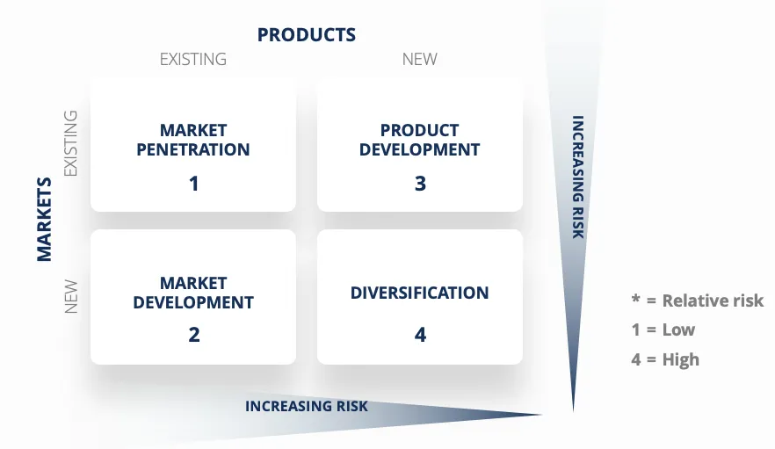
Figure 8: Ansoff Matrix
(Source: Peterdy, 2022)
Market penetration helps increase sales of existing products in the current country. According to Reid (2025), Adidas' sales increased its market share to 8.9% in 2024, compared with other brands in the US market [Refer to Appendix 3]. In the process of entering a new market, Adidas should innovate new products according to the market's needs. Adidas work with 100% recycled materials to sustain the environmental aspects around the world (Adidas, 2023). Diversification refers to innovating new products in a new market by transforming old products and introducing new ones. Market development involves the idea of increasing sales of an existing product in a new market that supports the company's growth. According to an article by Global Data (2024), Adidas already expanded business across Asia-Pacific, Africa, Europe, America and Middle-east. Market development improvements can be implemented through the digital transformation of the operations, collaborations with media, and providing affordable prices as per the market needs. In different countries, Adidas should focus on innovation and sustainability for the significant countries’ market exposure, by improving the supply chain and in-house production.

5.3. Recommendation for Improving Business Strategy
Accelerate Hyper-Localized Digital Marketing: The brand is focused on urban areas; the company can use the power of AI to hyper-localize its app and marketing presence in smaller regions. Leveraging hyper-local language digital marketing campaigns in high-potential and underserved markets such as Southeast Asia for "Direct-to-Consumer" marketing, as opposed to global marketing campaigns.
Integrate Circularity in Product Development: Adidas produces some disposable products; the company can develop the product to move beyond the use of recycled products towards a full "Take Back and Recycle" business model for all core product lines. Scale the "Made to be Remade" business model for the Ultraboost shoe line, whereby customers return the shoes for a discount (The Shorty Award, 2025). Thereby reducing waste and increasing brand loyalty, as seen with the best companies in the circular economy. The company needs to improve its product supply chain policy for the uniqueness of its products.
5.4. Justification of Recommendation
Hyper-localization in the significant region supports increased sales and brand reach to every part of the country for growing market share, sales and marketing. This strategy can be implemented through brand collaborations, competing with localized popular brands, and increasing DTC sales in that country. According to Witte (2018), Nike has implemented a hyper-localization strategy with specific cultures curated in different locations. Circularity refers to the idea of the production of a product, then repair and reuse after that. Puma has started their “Circular Lab” in the production process for reusing made products and raw materials in 2021 (Puma, 2026). It decreases the production time, production costs and values the company policies.

Section 2

1. Gibbs’ Reflective Cycle
The Gibbs’ Reflective Cycle is a theoretical model for evaluating personal development and qualities for completing any task. The six steps of the framework focus on providing a basic structure for the assessment of one’s reflective account (Refer to Figure 9) (McLeod, 2025).
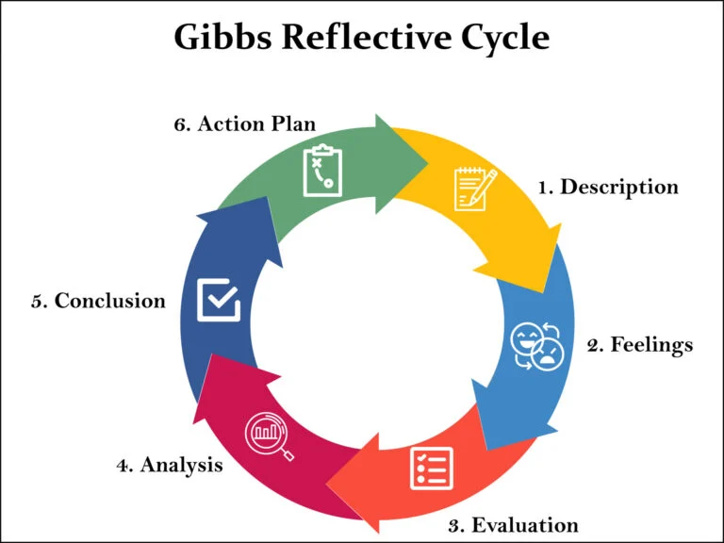
Figure 9: Gibbs’s Reflective Cycle
(Source: McLeod, 2025)

1.1 Description
This stage is used for providing an overview of a task and how it can impact my personal improvement. At the beginning of the report, I studied the topic and chose the company, that is, Adidas, for a proper and robust analysis. I have searched for all the necessary data, articles, reports and journals I am going to use for this assessment, so it can become easier for me. Finally, I have assessed the internal and external assessment through various frameworks, including the PESTLE Framework, Porter’s Five Forces Analysis, Porter’s Diamond Model and VRIO Analysis for finding out its external market and industry, and its competitive advantage in Germany. Then I focused quite a lot on the CSR management and sustainability of the company, along with providing a holistic view of it. The strategic choices of the company are evaluated through the OLI framework. Finally, through the SWOT analysis and the Ansoff Matrix, I have analyzed the current strategies followed by the company, with recommendations.

1.2 Feelings
I faced quite a dilemma while analyzing the operations of Adidas, since the company had a significant growth in recent times. However, during the assessment of the external analysis, I felt helpless, as analyzing all the factors of the PESTLE was quite challenging, mostly regarding its data collection. Even though I have used the annual report of the company from 2022 to 2025, I still feel there are some parts where I may need to put much more emphasis on the strategies used by the company. However, at the end, I have provided enough evidence through various charts to provide the maximum amount of insight into the strategies and operational methods used by the company.

1.3 Evaluation
There were many ups and downs during my assessment of this report, as I had taken a long time searching for journals and annual reports to make it quite critical. Therefore, it was mostly negative for me at the beginning of the assessment. Then the rest of the report was conducted by me quite easily. I have also gained significant help and guidance from my friends and mentor for this assessment. They have also provided me with an understanding of ethics while researching for this topic and the company. This ethical view and guidance helped me to submit this report within the deadline.

1.4 Analysis
After the assessment of this report, I have understood the challenges of my assessment and research process. As mentioned before, this task faced significant ups and downs. However, it also helped me gain several skills and improve already existing skills. I have mentioned that I had an issue in researching for journals and reports, but the analysis of the journals and reports was quite easy for me. However, I did not use any kind of time-schedule or management tools, which could have provided me with a robust structure for this assessment. Atlassian (2026) have stated that time management is a significant skill anyone can get by improving their time-control for various activities. Therefore, it is significant for my improvement in time management.
I already had robust writing and proofreading skills; thus, this assessment has significantly improved my research skills for this assessment. In this regard, Arisah et al. (2024) have stated that proofreading is a significant skill in writing, since it can improve the academic and professional life of a person. This skill significantly improves one’s grammar and spelling in both professional and social life (Arisah et al. 2024). However, to make it more effective, I need to focus on taking a break in between studies, reading aloud, targeting issues I am facing, and using tools for improvement.

1.5 Conclusion
After this reflective assessment, I can say that overall, this report has helped me to evaluate both my strengths and weaknesses, and how it impacted me positively or negatively. Therefore, I have learned that my strengths are writing and proofreading and having a better focus on my tasks. However, this also brings out my weaknesses that include bad time management and poor research skills. Therefore, through this report, not only have my weaknesses improved, but my strengths have also further improved in finishing various tasks.

1.6 Action Plan
This assessment has helped to gain a significant understanding of my strengths and weaknesses, as it has caused benefits and mishaps in my tasks. Therefore, the main focus behind creating this action plan focuses on my areas of improvement, suggested actions, supports or resources I need, and time-frame. I need to significantly improve my time management and research skills for any future assessment. For time management, I need to focus on prioritizing immediate tasks, minimizing distractions using breaks and the “Eat the Frog” method, within 1 month. Therefore, I believe that the consideration of this strategy will be helpful to complete all the allocated tasks within the deadline and as per the priority. Thus, in order to improve this skill, I would require 1 month to manage all my tasks within time. For my research skills, I need to understand areas of interest and use tools for advanced engine optimization, through practical skill building in online platforms, and using research tools such as EndNote, Google Scholar, and other online websites and apps, within 4 months. I personally feel that the progress of the research skills supports the engagement of the relevant and valid information that might help me to generate more valuable outcome through the task. I also trust that the development of these skills will be helpful to attract more competitive advantages for me to obtain success in the professional filed.

Reference
Adidas, 2021. Adidas presents growth strategy ‘Own the Game’ until 2025. Available at: https://www.adidas-group.com/en/media/press-releases/adidas-presents-growth-strategy-own-the-game-until-2025. [Accessed on 3rd March 2026]
Adidas, 2023. Environmental Impacts. Available at: https://report.adidas-group.com/2023/en/group-management-report-our-company/sustainability/environmental-impacts.html#:~:text=We%20supported%20our%20suppliers%20by,on%20how%20to%20reduce%20emissions. [Accessed on 3rd March 2026]
Adidas, 2026. CSR Policy. Available at: https://www.adidas.co.in/help/company-information/csr-policy [Accessed on 3rd March 2026]
Adidas (2021). Strategic Focus Area and Targets. [online] Adidas Annual Report 2021. Available at: https://report.adidas-group.com/2021/en/group-management-report-our-company/sustainability/strategic-focus-area-and-targets.html [Accessed 7 Mar. 2026].
Adidas (2021a). adidas presents growth strategy ‘Own the Game’ until 2025 - adidas Group. [online] Adidas-group.com. Available at: https://www.adidas-group.com/en/media/press-releases/adidas-presents-growth-strategy-own-the-game-until-2025 [Accessed 7 Mar. 2026].
Adidas (2021b). Our People. [online] adidas Annual Report 2021. Available at: https://report.adidas-group.com/2021/en/group-management-report-our-company/our-people.html [Accessed 7 Mar. 2026].
Adidas (2023). Environmental impacts. [online] Adidas Annual Report 2023. Available at: https://report.adidas-group.com/2023/en/group-management-report-our-company/sustainability/environmental-impacts.html [Accessed 7 Mar. 2026].
Adidas (2024). adidas Group. [online] adidas. Available at: https://www.adidas-group.com/en/sustainability/people/supply-chain [Accessed 7 Mar. 2026].
Adidas (2024a). adidas reports strong results for 2024 and expects top- and bottom-line momentum to continue in 2025. [online] adidas. Available at: https://www.adidas-group.com/en/media/press-releases/adidas-reports-strong-results-for-2024-and-expects-top-and-bottom-line-momentum-to-continue-in-2025 [Accessed 7 Mar. 2026].
Adidas (2024b). Business Model Overview - adidas Annual Report 2024. [online] Adidas Annual Report 2024. Available at: https://report.adidas-group.com/2024/en/group-management-report-our-company/description-of-business-model/business-model-overview.html [Accessed 7 Mar. 2026].
Adidas (2025a). adidas Group. [online] adidas. Available at: https://www.adidas-group.com/en/media/press-releases/adidas-reports-record-revenues-in-2025-and-launches-share-buyback [Accessed 7 Mar. 2026].
Adidas (2025b). Profile. [online] Adidas. Available at: https://www.adidas-group.com/en/about/profile [Accessed 7 Mar. 2026].
Adidas Group (2024a). 2024 ANNUAL REPORT. [online] Available at: https://report.adidas-group.com/2024/en/_assets/downloads/annual-report-adidas-ar24.pdf [Accessed 7 Mar. 2026].
Adidas Group (2024b). adidas Group. [online] adidas. Available at: https://www.adidas-group.com/en/sustainability/planet/materials.
AFP (2026). Adidas shares slump on downbeat profit outlook | Macau Business. [online] Macau Business. Available at: https://macaubusiness.com/adidas-shares-slump-on-downbeat-profit-outlook/ [Accessed 7 Mar. 2026].
Arisah, S., Wijayatiningsih, T.D. and Mulyadi, D. (2024). Proofreading: Avoiding Mistake in Writing Process. Proceedings Series on Social Sciences & Humanities, [online] 18, pp.346–352. Available at: https://www.researchgate.net/publication/384333550_Proofreading_Avoiding_Mistake_in_Writing_Process [Accessed 7 Mar. 2026].
Atlassian (2026). Time Management Strategies & Tips | The Workstream. [online] Atlassian. Available at: https://www.atlassian.com/work-management/project-management/time-management [Accessed 7 Mar. 2026].
Bell, J. (2024). How Adidas Upped Its Game on Product Innovation. [online] WWD. Available at: https://wwd.com/footwear-news/shoe-industry-news/adidas-innovation-running-olympics-1237702954/ [Accessed 7 Mar. 2026].
Bhandari, K.R., Zámborský, P., Ranta, M. and Salo, J. (2023). Digitalization, internationalization, and firm performance: A resource-orchestration perspective on new OLI advantages. International Business Review, [online] 32(4), p.102135. doi:https://doi.org/10.1016/j.ibusrev.2023.102135.
Collidu (2023). Eclectic Paradigm. [online] Collidu.com. Available at: https://www.collidu.com/presentation-eclectic-paradigm [Accessed 7 Mar. 2026].
Denis, G. (2018). Expert Program Management. [online] Expert Program Management. Available at: https://expertprogrammanagement.com/2018/04/porter-diamond-model/ [Accessed 7 Mar. 2026].
EBSCO (2022). Adidas (company) | EBSCO. [online] EBSCO Information Services, Inc. | www.ebsco.com. Available at: https://www.ebsco.com/research-starters/sports-and-leisure/adidas-company [Accessed 7 Mar. 2026].
European Commission, 2025. Economic forecast for Germany: The latest macroeconomic forecast for Germany. Available at: https://economy-finance.ec.europa.eu/economic-surveillance-eu-member-states/country-pages/germany/economic-forecast-germany_en [Accessed on 3rd March 2026]
Faccia, A., Le Roux, C.L. and Pandey, V. (2023). Innovation and E-Commerce Models, the Technology Catalysts for Sustainable Development: The Emirate of Dubai Case Study. Sustainability, 15(4), p.3419. https://doi.org/10.3390/su15043419
Fashion Gear (2026). Adidas, Brand Philosophy, Adidas Shoes, Adidas Original, Adidas Sport Performance, Adidas Style, Fibre2fashion. [online] fashiongear.fibre2fashion.com. Available at: https://fashiongear.fibre2fashion.com/brand-story/adidas/philosophy.asp [Accessed 7 Mar. 2026].
García-Sánchez, I.-M. and Carnicero-Martínez, M. (2026). Sustainability in Fashion Industry: A View Through the Top Ten Multinational Strategies. Administrative Sciences, [online] 16(2), p.90. doi:https://doi.org/10.3390/admsci16020090.
Global Data, 2024. Innovation Ranking – adidas AG. available at: https://www.globaldata.com/store/report/innovation-ranking-adidas-ag/ [Accessed on 3rd March 2026]
Global Data (2026). adidas AG - Company Profile. [online] www.globaldata.com. Available at: https://www.globaldata.com/company-profile/adidas-ag/competitors/.
Global Data (2026). ShieldSquare Captcha. [online] www.globaldata.com. Available at: https://www.globaldata.com/company-profile/adidas-ag/financials/ [Accessed 7 Mar. 2026].
Grand View Research (2024). Global Sportswear Market Size & Share | Industry Trends Report, 2025. [online] Grandviewresearch.com. Available at: https://www.grandviewresearch.com/industry-analysis/sportswear-market [Accessed 7 Mar. 2026].
Human Rights Watch, 2024. Germany: Events of 2024. Available at: https://www.hrw.org/world-report/2025/country-chapters/germany [Accessed on 3rd march 2026]
International Trade Administration, 2025. Germany - Information and Communications Technology (ICT). Available at: https://www.trade.gov/country-commercial-guides/germany-information-and-communications-technology-ict [Accessed on 3rd March 2026]
Kamal, R. (2024). The History and Evolution of the Adidas Logo - Famous Company Logos. [online] Famous Company Logos. Available at: https://companylogos.org/adidas-logo/ [Accessed 7 Mar. 2026].
Kim, J. and Choi, K. (2025). The effects of functional and symbolic brand fit on consumer behavior in co-branding eco-friendly sportswear products. International Journal of Sports Marketing and Sponsorship, pp.1–22. doi:https://doi.org/10.1108/ijsms-07-2025-0314.
Kinski, L. and Brause, S.D., 2025. Germany: Political Developments and Data in 2024: Collapse of the Governing Coalition. Political Data Yearbook, 64(1), pp.231-253.https://onlinelibrary.wiley.com/doi/10.1111/2047-8852.70016
Lewis, R. (2024). Adidas. [online] www.britannica.com. Available at: https://www.britannica.com/money/Adidas-AG [Accessed 7 Mar. 2026].
Li, J. (2023a). Financial Analysis, SWOT Analysis and Poter Five Forces Analysis for Nike. Highlights in Business Economics and Management, [online] 23(2), pp.1164–1170. Available at: https://www.researchgate.net/publication/381564006_Financial_Analysis_SWOT_Analysis_and_Poter_Five_Forces_Analysis_for_Nike [Accessed 7 Mar. 2026].
Li, X. (2023b). Analysis of the Marketing Strategy of Adidas. [online] ResearchGate. Available at: https://www.researchgate.net/publication/373896269_Analysis_of_the_Marketing_Strategy_of_Adidas [Accessed 7 Mar. 2026].
McLeod, S. (2025). Gibbs Reflective Cycle. [online] Simply Psychology. Available at: https://www.simplypsychology.org/gibbs-reflective-cycle.html [Accessed 7 Mar. 2026].
Naoum, K. de and Altmann, A. (2025). Adidas Corporate Social Responsibility (CSR) and Sustainability. [online] Thomasnet.com. Available at: https://www.thomasnet.com/insights/adidas-csr/ [Accessed 7 Mar. 2026].
OECD, 2025. Environment at a Glance: Germany. Available at: https://www.oecd.org/en/publications/environment-at-a-glance-country-notes_59ce6fe6-en/germany_b6b22e70-en.html. [Accessed on 3rd March 2026]
Peterdy, K., 2022. Ansoff Matrix. Available at: https://corporatefinanceinstitute.com/resources/management/ansoff-matrix/ [Accessed on 3rd March 2026]
Puma, 2026. Circularity. Available at: https://about.puma.com/en/circularity. [Accessed on 3rd March 2026]
Reid, H., 2025. Adidas targets larger US market share as Nike struggles. Available at: https://www.reuters.com/business/retail-consumer/adidas-targets-larger-us-market-share-nike-struggles-2025-02-28/#:~:text=Nike's%20share%20of%20the%20global,%2C%20On%20Running%2C%20and%20Hoka. [Accessed on 3rd March 2026]
Sabanoglu, T. (2022). Adidas. [online] www.statista.com. Available at: https://www.statista.com/topics/1257/adidas/ [Accessed 7 Mar. 2026].
Sahu, Y. (2025). The global sports apparel industry is highly competitive, with top players like Nike, Adidas, Puma, Under Armour, and Lululemon leading through innovative strategies, sustainability efforts, and diverse product portfolios. [online] researchgate. Available at: https://www.researchgate.net/publication/388450201_The_global_sports_apparel_industry_is_highly_competitive_with_top_players_like_Nike_Adidas_Puma_Under_Armour_and_Lululemon_leading_through_innovative_strategies_sustainability_efforts_and_diverse_prod [Accessed 7 Mar. 2026].
Sarkar, S. (2023). Porter`s Five Forces Analysis of ADIDAS. [online] Medium. Available at: https://medium.com/@swagniksarkar/porter-s-five-forces-analysis-of-adidas-844e0575b5a0 [Accessed 7 Mar. 2026].
Serang, S., Hi, M., Chair, M. and Adrias, A.M. (2025). Analysis Implementation Strategy Global Operations: A Case Study. Journal La Bisecoman, [online] 6(1), pp.32–46. doi:https://doi.org/10.37899/journallabisecoman.v6i1.1868.
Statista, 2025. Threshold for the risk of poverty on the basis of the yearly equivalised income in Germany 2009-2022, by household size. Available at: https://www.statista.com/statistics/1352926/at-risk-of-poverty-threshold-germany/?srsltid=AfmBOopBVkpvfJHm6TQGvcXqXlErfqTz_8BdM7vkN6fViMUsujFPfJ_- [Accessed on 3rd March 2026]
Tan, K.H. (2025). Porter’s Diamond Model and Global Competitive Advantage Strategic Marketing. ResearchGate. [online] doi:https://doi.org/10.13140/RG.2.2.25399.64161.
The Global Economy, 2026. Germany: GDP per capita, current dollars. Available at: https://www.theglobaleconomy.com/Germany/GDP_per_capita_current_dollars/ [Accessed on 3rd March 2026]
The Shorty Award (2025). Made to be Remade - The Shorty Awards. [online] Shortyawards.com. Available at: https://shortyawards.com/8th-impact/made-to-be-remade [Accessed 7 Mar. 2026].
United States Department of State, 2026. 2024 Country Reports on Human Rights Practices: Germany. Available at: https://www.state.gov/reports/2024-country-reports-on-human-rights-practices/germany [Accessed on 3rd March 2026]
Witte, R., 2018. Nike Is Leveraging Data to Create Local Culture-Specific Retail Locations. Available at: https://www.forbes.com/sites/raewitte/2018/07/16/nike-is-leveraging-data-to-create-local-culture-specific-retail-locations/ [Accessed on 3rd March 2026]

Appendices

Appendix 1: GDP growth of Germany
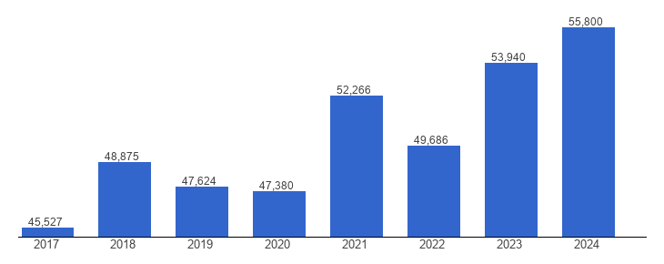
Figure 10: GDP Growth of Germany between 2017 to 2024
(Source: The Global Economy, 2026)

Appendix 2: Poverty Scale of Germany
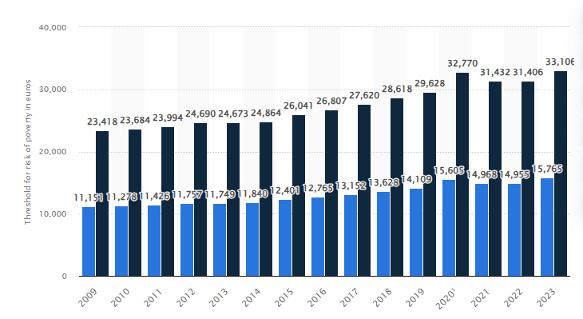
Figure 11: Poverty Scale increase in Germany between 2009 to 2023
(Source: Statista, 2025)

Appendix 3: Adidas Market Share in the US
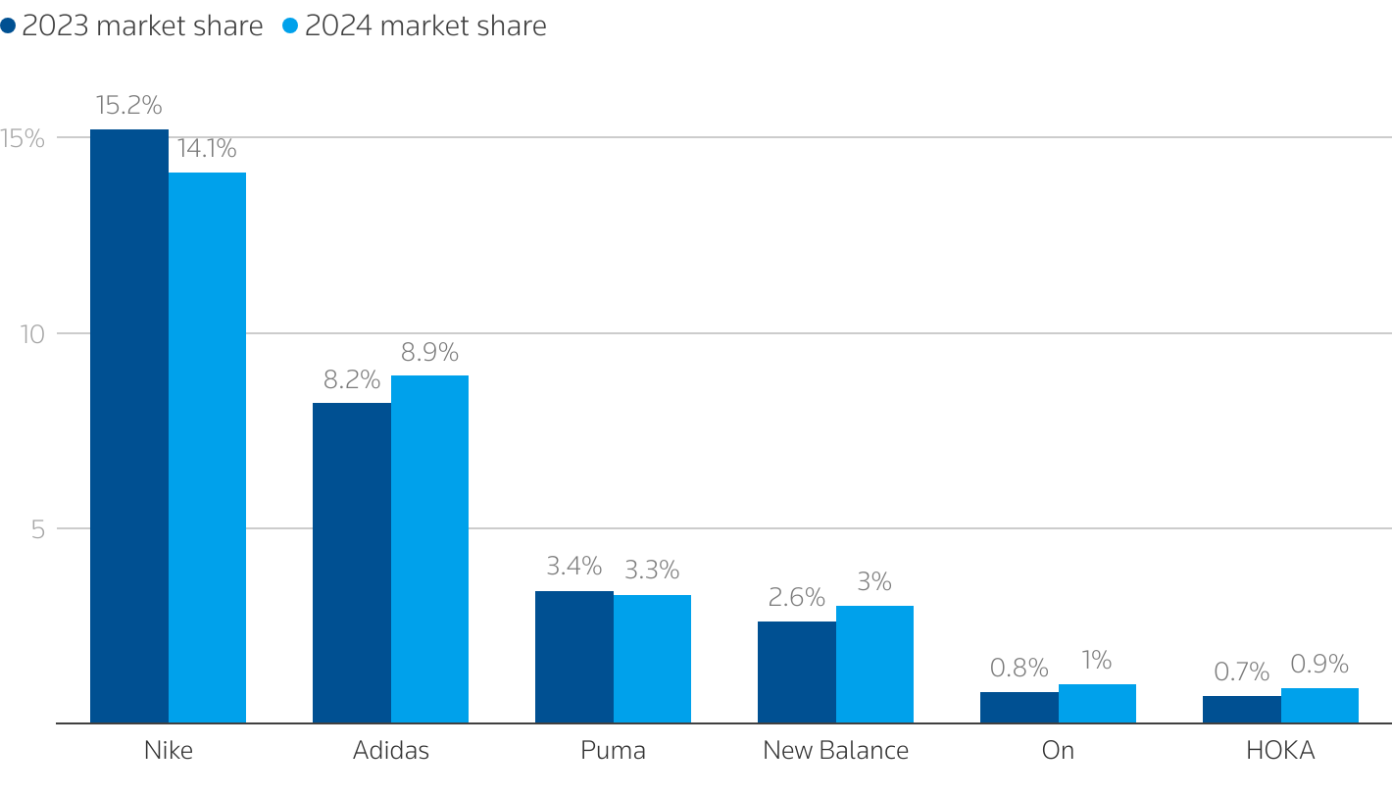
Figure 12: Adidas’ Market Share in the US market
(Source: Reid, 2025)

