Name: George Perkins
Student Number: 1700820
BA Course: Graphic Design

Political Art Zine

Here I will be exploring some of the world’s most famous and fundamental pieces of political artwork, and their importance to how we, as a society, remember certain periods of war and conflict; in which both impact our experience of everyday life. To do this I will be curating an exhibition displaying these pieces of artwork. Art moves alongside politics in many ways. Some artists base their work solely around the ever-changing world of politics, always making their work not only current but also historical. Art can be used successfully to raise controversial subject matters which subsequently leads to society discussing important issues within their present climate. Within the exhibition I will display 5 pieces of artwork which all have political messages including racism, Nazis, war, conflict and death by electrocution. All these pieces of artwork are extremely famous and they all struck up a debate at some point in their time. I will set out my chosen pieces of artwork in time order, so the public get a feel as to which issues became prominent as time progresses.

What is political art? Could it simply be a piece of artwork alongside the politics? “Design is both a political and cultural force for change, although most designers choose not to think about the power it has” Jonathan Barnbrook. From the beginnings of art, it has always mirrored the present time bringing the truth to its audience. As time and politics evolve, so do many artists as they choose to echo their surroundings within their practices, consequently producing political and engaging artwork.

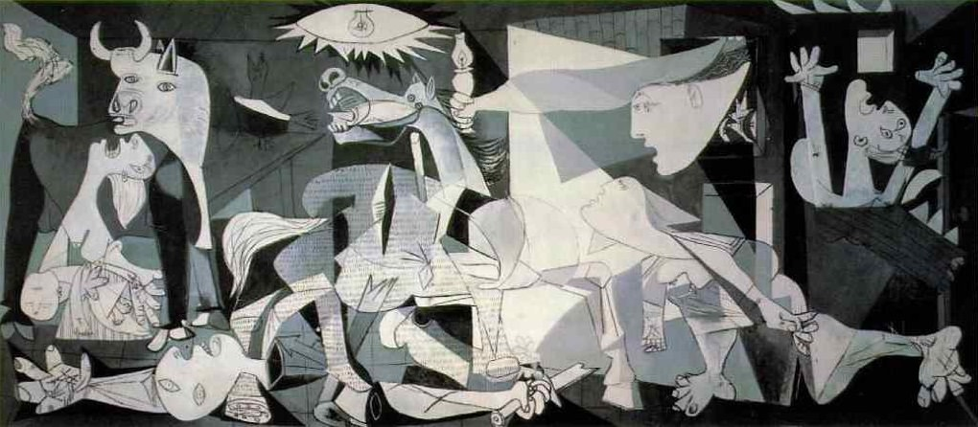Pablo Picasso, Guernica, 1937
Let’s consider Pablo Picasso Guernica (2011) – this is the first painting you see as you enter the exhibition. Firstly, the name Guernica refers back to the place that was bombed by the Nazi’s during the Spanish Civil War. This painting is one of Picasso’s most famous pieces as it conveys such a powerful message. He painted this in reaction to the Nazi’s bombing of the Basque city, as it depicts the tragedies of war and suffering of innocent individuals. The painting has become almost an anti-war symbol as it is such a great reminder of the disaster that conflict brings.

Taking into account the technique within this piece, the colours are almost disregarded in an attempt to exaggerate the drama, creating an animated piece of art. The two dominant components of the painting are the horse and the bull. These are two very important characters in Spanish culture. Being a Spanish national, Picasso has utilised his culture in order to depict the bull as the perpetrator and the horse as the citizens of Guernica. This sparked debate as some sceptics say that Picasso was actually illustrating his ego within the painting. This controversy emphasises the beauty of art as it is always considered differently between people.

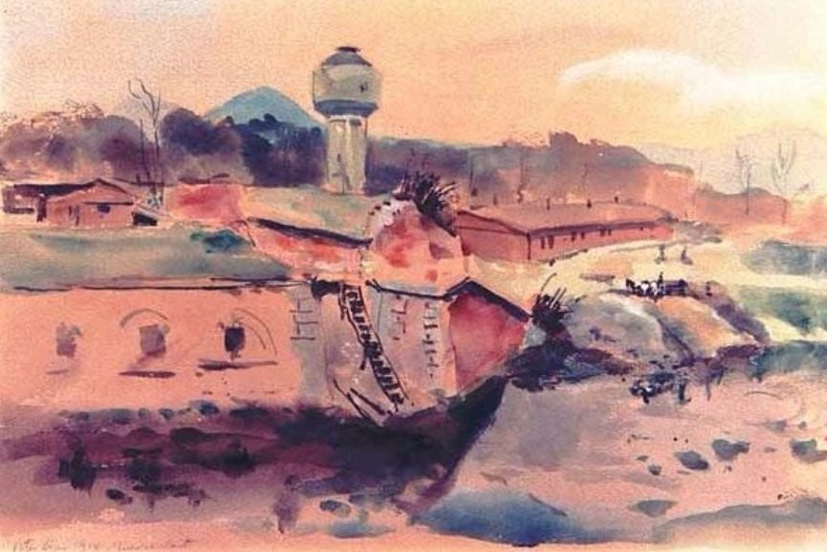
Peter Kien, Watercolor of Terezin, 1944
Here is the second painting in the exhibition, by Peter Kien. Jewish artist Peter Kien was incarcerated in Terezin, where he utilised stolen art supplies in order to produce Watercolour of Terezin. The painting displays the poor conditions in which he was living whilst imprisoned. This piece of art is one of the most important documents remembering the reality of concentration camps and the appalling conditions of prisoners. Concentration camps are considered the epitome of war horror, and in the same year that Kien painted Watercolor of Terezin, he was deported in Auschwitz where he was brutally murdered at twenty-five.

The way in which this piece has been painted reinforces how Kien very literally utilised the small amount of resources that he could find. The pallet of colours are extremely limited which, I feel, gives the painting an extra burst of character. Watercolor of Terezin raised a lot of questions in relation to the way humans act towards their own species, and the torture that innocent people were condemned to. Looking back to those times we as humans must question how our own kind could possibly treat innocent beings in that way. “When we are no longer able to change the situation, we are challenged to change ourselves” Viktor E. Frankl.
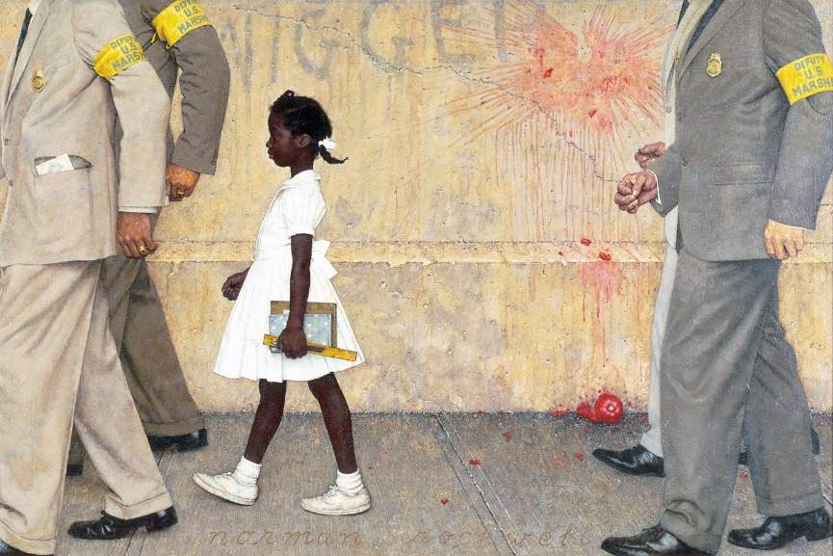
Norman Rockwell, The Problem We All Live With, 1964
Here is the third painting featured in the exhibition. The Problem We All Live With by Norman Rockwell is one of the greatest and most famous politically controversial paintings of all time. The painting depicts a young African-American girl being ushered by four Caucasian U.S marshals to her first day at an all-white school. On the wall behind the girl reads the racial slur “nigger” which further emphasises the level of racism at this time. This painting addresses racism in America and people being affected by this politics.

This painting is extremely realistic in the sense that he has used great detail in the shading of the clothes and skin. This reinforces how this painting documents reality for young Ruby Bridges, as she walks to join the William Franz Public School, six years after the ruling that state laws creating separate public schools for black and white students were unconstitutional. The painting appeared in “Look Magazine” and caused Rockwell an abundance of positive and negative feedback. It caused controversy with the readers of the magazine as some weren’t used to such direct racial commentary from Rockwell.
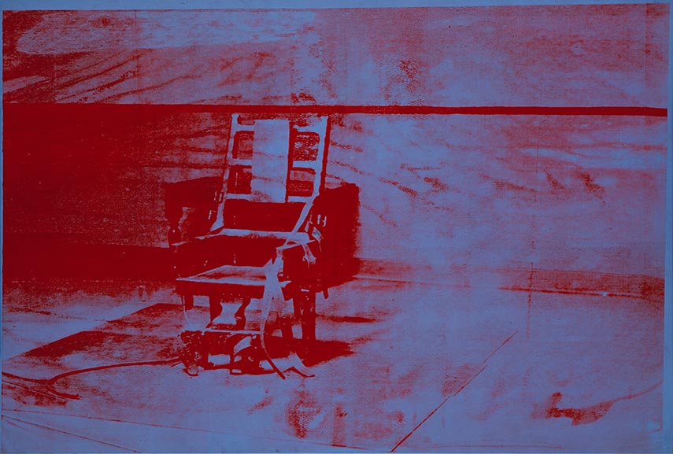
Andy Warhol, Big Electric Chair, 1967.
Big Electric Chair is the fourth piece in the exhibition. Death by electrocution has raised great debate for many years, being outlawed in the majority of states in America; Big Electric Chair portrays exactly that scene. Produced by Andy Warhol, the painting represents a press photograph of the death chamber where Americans Julius and Ethel Rosenberg were killed for giving information about the atomic bomb to Russia during World War II.

The painting was involved in a lot of controversy as it was part of a series of paintings called ‘Death and Disaster’, produced by Warhol. The series raised many political and humanity issues at the time and sparked lots of debate within the public. This painting in particular has such a great sense of eeriness, teamed with the backstory, which makes the viewer start to question their own humanity by allowing this to happen to people. The painting makes the issue seem extremely negative.
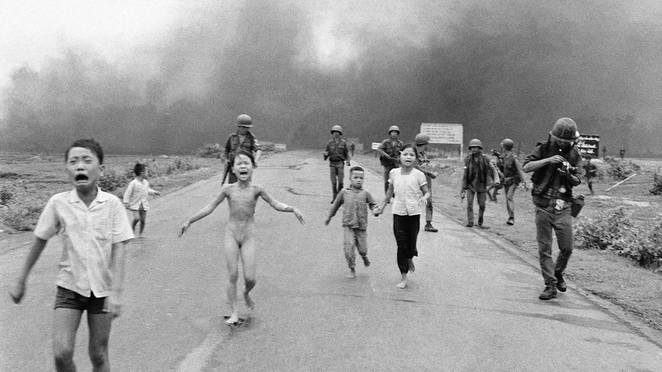
Nick Ut, Napalm Girl, 1972
The final piece we come to in the exhibition is the only non-painting. Napalm Girl is a photograph which encapsulates the horror of the U.S war in Vietnam. The photograph depicts ‘Phan Thi Kim Phuc’ (Napalm Girl) fleeing the scene of a napalm attack in her home village.

This photograph resonates with many people. It’s a photo that’s hard to un-see; a young child, naked, running towards the camera in sheer terror and agony after the napalm attack destroyed her town, her clothes and also her skin. Ut’s photograph of the conflict unveiled to many that the war was doing more harm than good. “Mankind must put an end to war – or war will put an end to mankind” John F. Kennedy. It also sparked debate due to the nudity, causing many publications to override their policies on nudity.

Reference List
Paintings:
Kien, P. (1944) Watercolor of Terezin [Watercolour].
Picasso, P. (1937) Guernica [Oil on canvas]. Museo Nacional Centro de Arte Reina Sofia.
Rockwell, N. (1964) The Problem We All Live With [Oil on canvas]. Norman Rockwell Museum.
Ut, N. (1972) Napalm Girl [Photograph].
Warhol, A. (1967) Big Electric Chair [Silkscreen in and synthetic polymer paint on canvas].
Websites:
Barnbrook, J. Jonathan Barnbrook Quotes. Available at: http://www.azquotes.com/author/50235-Jonathan_Barnbrook (Accessed: 1 May 2018).
Curtis, H. (2015) ‘Electric Chair’, Andy Warhol, 1964. Available at: http://www.tate.org.uk/art/artworks/warhol-electric-chair-t07145 (Accessed: 3 May 2018).
Frankl, V. E. Viktor E. Frankl Quotes. Available at: https://www.goodreads.com/author/quotes/2782.Viktor_E_Frankl (Accessed: 1 May 2018).
Kennedy, J.F. Quote by John F. Kennedy. Available at: https://www.goodreads.com/quotes/118124-mankind-must-put-an-end-to-war---or-war (Accessed 3 May 2018).
Normanrockwellmuseum.org. The Problem We All Live With, 1964. Available at: http://www.nrm.org/thinglink/text/ProblemLiveWith.html (Accessed: 2 May 2018).
R, M. 15 Influential Political Art Pieces. Available at: https://www.widewalls.ch/political-art/ (Accessed: 1 May 2018).
Stockton, R. (2017) The True Story Behind “Napalm Girl”. Available at: http://allthatsinteresting.com/napalm-girl (Accessed 3 May 2018).
Pablopicasso.org. (2009) Guernica, 1937 by Pablo Picasso. Available at: https://www.pablopicasso.org/guernica.jsp (Accessed: 1 May 2018).


